Complicated Diverticulits P3 Western Europe

===============================================

Error reported by user: ezeller@CDI0@tsm10

Severity: Application Error

Date: 06/24/2015 9:15 PM

Fasttrack client version: b179

java.vm.version: 1.4.2_06-b03

os.name: Windows NT (unknown)

sun.boot.library.path: C:\Program Files (x86)\Fast Track Systems\CROCAS (SQACrocas)\jre142\bin

Memory: 8149m

Message: Error opening planning tool

===============================================

Stack Trace is:

com.fasttrack.utilities.FTRuntimeException: Error opening planning tool

com.fasttrack.utilities.FTRuntimeException: Error with slot calculation:

at com.fasttrack.crocas.app.screens.nav01.Nav01Controller.openPlanningTool(Nav01Controller.java:572) at com.fasttrack.crocas.app.screens.nav01.Nav01Controller.openBudget(Nav01Controller.java:456) at com.fasttrack.crocas.app.screens.nav01.Nav01Panel$NavLinkHandler.handleTableLinkClicked(Nav01Panel.java:107) at com.fasttrack.tsm.appbase.tsmgui.FTTableLinkHandler$1.call(FTTableLinkHandler.java:158) at com.fasttrack.mvc.controller.AbstractCommandAction$CommandWorker.construct(AbstractCommandAction.java:90) at com.fasttrack.mvc.controller.AbstractCommandAction$1.call(AbstractCommandAction.java:63) at EDU.oswego.cs.dl.util.concurrent.FutureResult$1.run(FutureResult.java:150) at com.fasttrack.mvc.controller.AbstractCommandAction$CommandWorker.run(AbstractCommandAction.java:79) at EDU.oswego.cs.dl.util.concurrent.PooledExecutor$Worker.run(PooledExecutor.java:383) at java.lang.Thread.run(Thread.java:534)Caused by: com.fasttrack.utilities.FTRuntimeException: Error with slot calculation:

at com.fasttrack.crocas.croplanviews.NodeHelper.doBottomLevelSpread(NodeHelper.java:383) at com.fasttrack.crocas.croplanviews.NodeHelper.calculateLevel(NodeHelper.java:464) at com.fasttrack.crocas.croplanviews.NodeHelper.calculateAll(NodeHelper.java:500) at com.fasttrack.crocas.croplanviews.CroPlanViews.AllTaskGroupToAllTask(CroPlanViews.java:146) at com.fasttrack.crocas.app.screens.croplantool.ResultsTableModel.initialize(ResultsTableModel.java:170) at com.fasttrack.crocas.app.screens.croplantool.FormWiz04.initializeResultsTable(FormWiz04.java:216) at com.fasttrack.crocas.app.screens.croplantool.FormWiz04.load(FormWiz04.java:203) at com.fasttrack.crocas.app.screens.croplantool.FormWiz04.preActiveCustomization(FormWiz04.java:157) at com.fasttrack.mvc.utilities.EditModalDialog.setDisplayPanel(EditModalDialog.java:216) at com.fasttrack.mvc.runner.AbstractApp.displayEditModalViewComponent(AbstractApp.java:125) at com.fasttrack.mvc.runner.AbstractAppController.displayChildModalViewComponent(AbstractAppController.java:221) at com.fasttrack.mvc.runner.AbstractAppController.handleEvent(AbstractAppController.java:461) at com.fasttrack.crocas.app.CROCASSessionController.handleEvent(CROCASSessionController.java:226) at com.fasttrack.mvc.controller.AbstractController.processControllerEventImpl(AbstractController.java:298) at com.fasttrack.mvc.controller.AbstractController.processEvent(AbstractController.java:252) at com.fasttrack.mvc.controller.AbstractController.processControllerEventImpl(AbstractController.java:310) at com.fasttrack.mvc.controller.AbstractController.processEvent(AbstractController.java:252) at com.fasttrack.crocas.app.screens.nav01.Nav01Controller.openPlanningTool(Nav01Controller.java:557) ... 9 more===============================================

Copaxone H2H 48 weeks 20 pts 50 sites

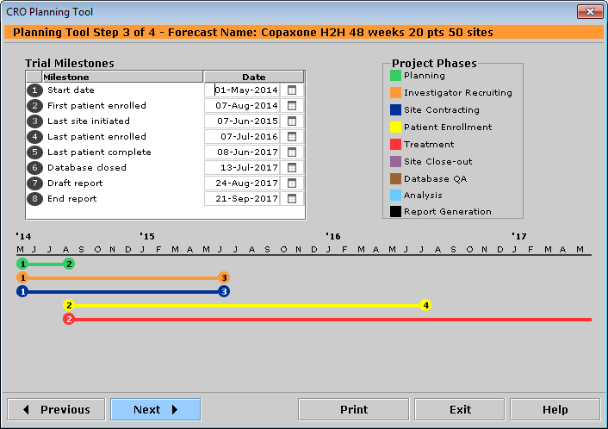

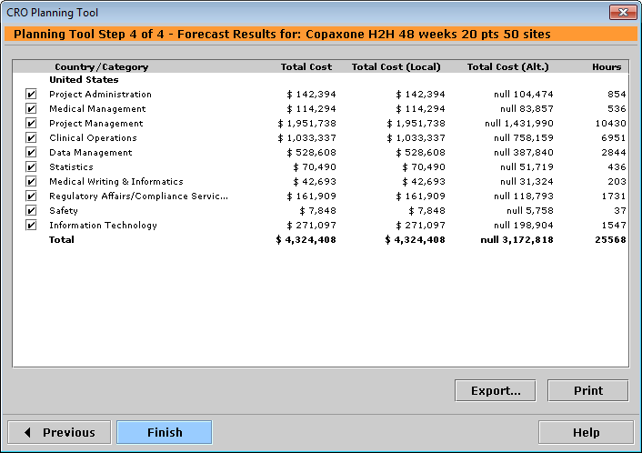

CPlanning Test

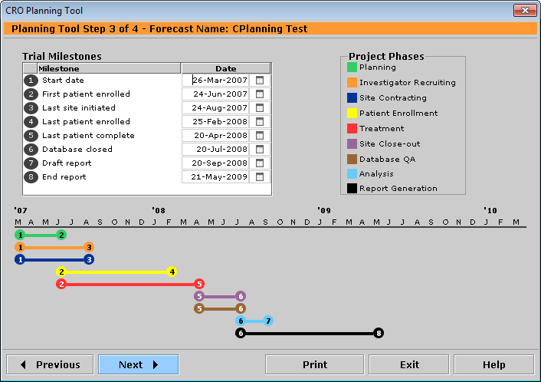

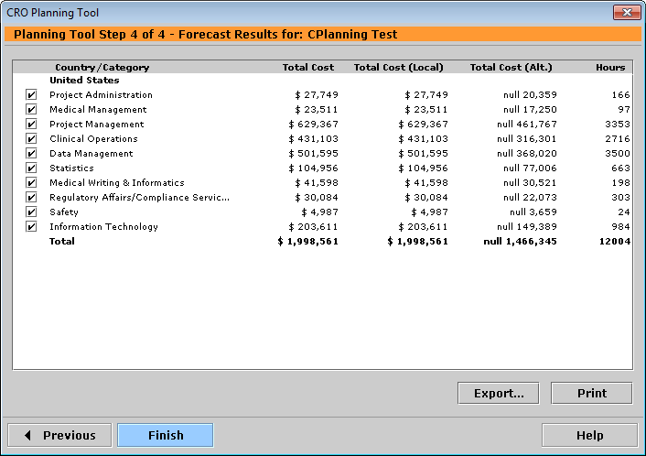

CRC Phase 3

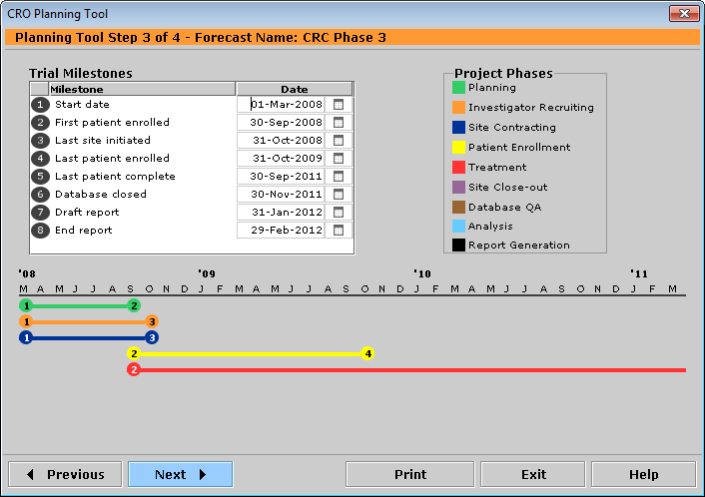

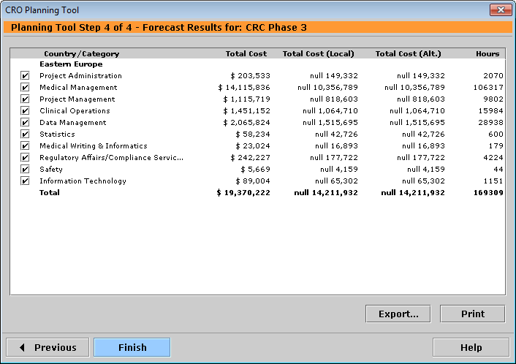

DC - CRO Full service

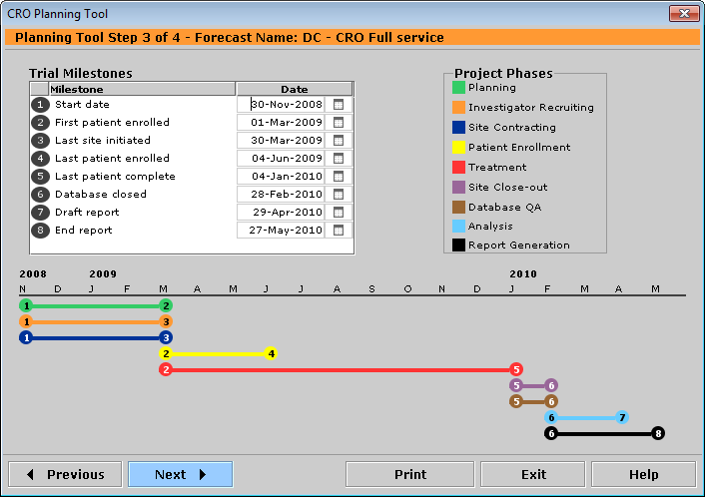

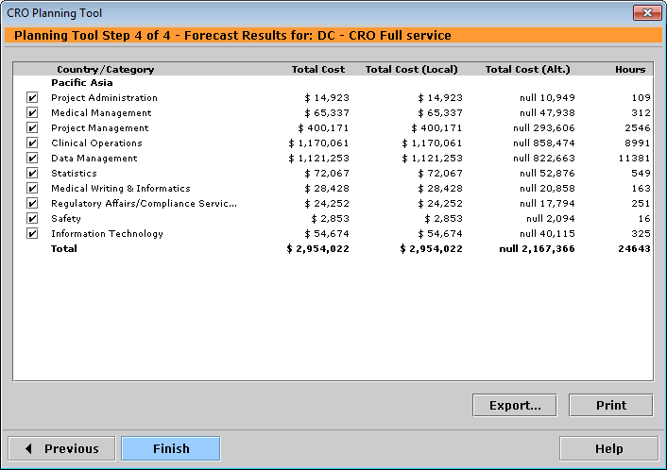

Diabetes 1

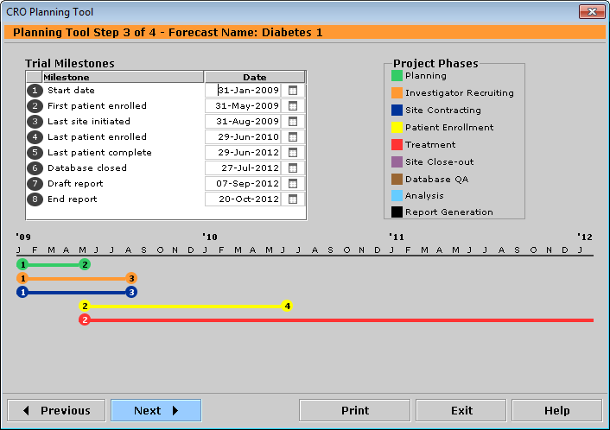

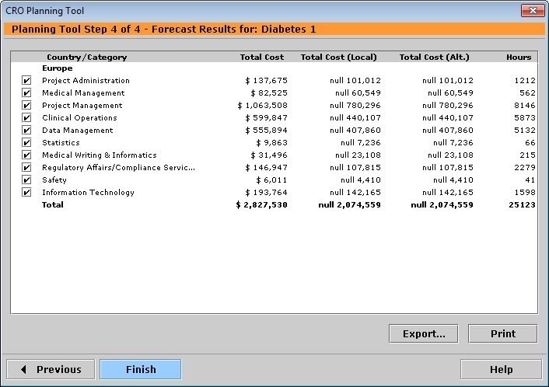

DR-201 Milprosa VR - 1st Yr - 3 sites

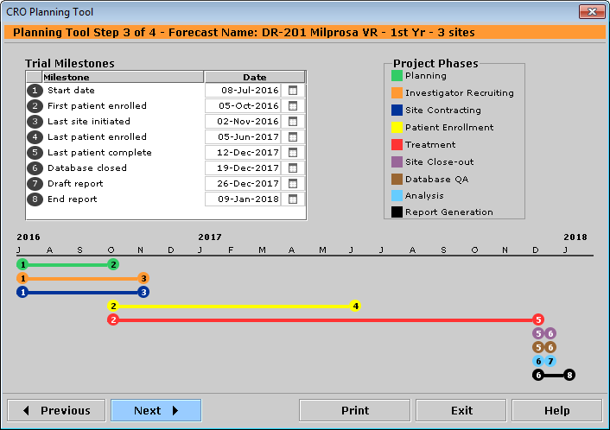

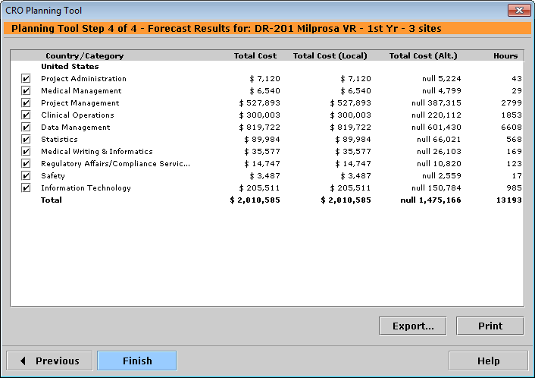

DR-201 Milprosa VR - 3rd Yr - 3 sites

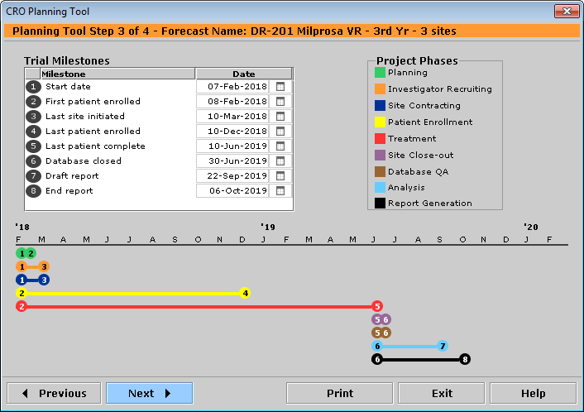

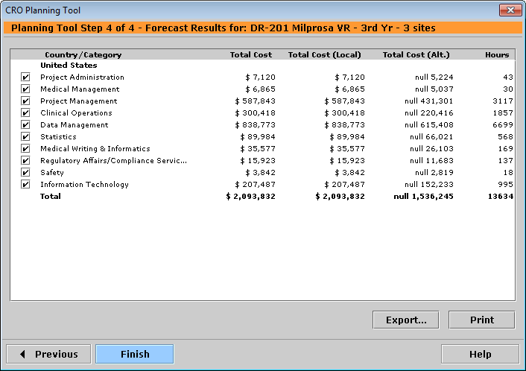

Dummystudy

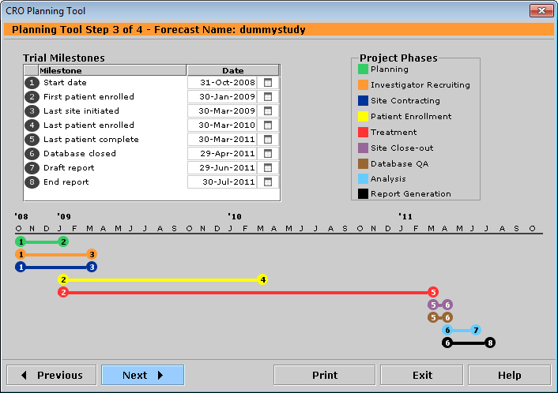

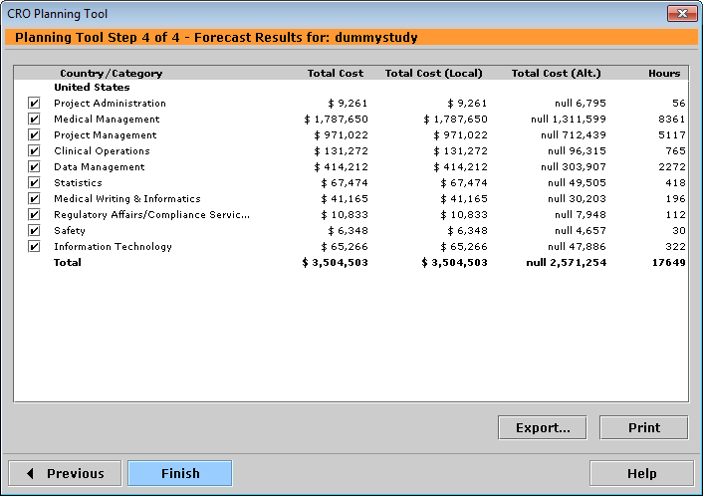

E5501,202 benchmark

