Singapore Polytechnic
School of Electrical & Electronic Engineering
IC4004_IC4003_IC4001 Internship
Written Assignment
OOKA — A GAMIFIED STUDY-HABIT APPLICATION
POWERED BY AN AUTOMATED EXAM-PAPER
EXTRACTION PIPELINE
Diploma in Computer Engineering
Semester 1, 2026/2027
Prepared For: Mr Mohamed Ilyas Fakrudeen Abdul Salam
Prepared By: Ezell Low Qing Wei
Class: DCPE/FT/3B/99
Company: Curious Lab
Company Supervisor: Mr Marcus Yip
Date: 19 July 2026

Abstract
This report documents a 22-week internship at Curious Lab, a Singapore educational-technology company, from 16 March 2026 to 14 August 2026. I joined as the company's sole full-stack developer and was tasked with a problem the founder and my supervisor had identified in their own tuition classes: homework is tedious, and it gives students no immediate feedback. A student can work through an entire set of questions and only discover days later what they got wrong, by which point the learning moment has passed and the habit of practising has already come to feel like a chore.
The solution I designed and built was Ooka, a gamified study application that lets students practise on real examination questions and receive an explanation the instant they answer. Delivering it required solving two problems rather than one. The first was supply: turning a backlog of real examination papers into a structured, machine-readable question bank, which I addressed by building an automated extraction pipeline using OCR and large language models to extract question text, answers, diagrams, difficulty ratings and syllabus codes into Google Sheets and Google Drive. The second was engagement: building the application itself, a React front end and a FastAPI and MySQL back end providing quiz generation, daily challenges, streaks, an experience-point levelling system, a leaderboard, a customisable avatar and a teacher analytics dashboard.
By the end of the internship the pipeline had processed approximately 130 examination papers across five levels — Pure Physics, Combined Physics G3, G2 and G1 Science, and Primary 6 Mathematics — and Ooka was deployed to production and undergoing testing with approximately 22 students. The report describes the design decisions and their trade-offs, the implementation of both systems, the hardest engineering problems encountered and how they were resolved, and reflects on the CDIO skills and self-directed learning the work demanded.

Acknowledgement
I would like to thank Lloyd, the founder of Curious Lab, for entrusting an intern with an entire product and for the direction he gave throughout. I am especially grateful to my supervisor, Mr Marcus Yip, who managed me day to day, answered a great many questions and gave the honest feedback that repeatedly improved the product. I would also like to thank my Liaison Officer, Mr Mohamed Ilyas Fakrudeen Abdul Salam, and the School of Electrical & Electronic Engineering at Singapore Polytechnic for the preparation that made this internship possible.

Table of Contents

(In Word: right-click this table and choose "Update Field" to populate page numbers.)

1. Introduction

1.1 Name, History and Background of Curious Lab
Curious Lab is a Singapore educational-technology (EdTech) company that builds digital tools to help students study more effectively. The company grew out of tuition teaching: its founder, Lloyd, personally teaches the tuition classes that Curious Lab runs, and the problems the company now builds software to solve are problems he first encountered in front of a class. That origin matters, because it means the company's products are shaped by direct observation of how students actually behave rather than by assumptions about them.
The company's current direction is the creation of educational products. Rather than positioning itself as a single application, Curious Lab is assembling an ecosystem of learning tools intended to work together: an application for daily practice on real examination questions, planned monthly report cards so that parents can see their child's progress, and analytics that give teachers visibility of where each student is strong and weak. Ooka, the application I built during my internship, is the first substantial product in that ecosystem.
Curious Lab is a small company, and during my internship I was its sole developer. It operates remotely, with the team working from home and meeting at the tuition centres the company rents when required.

1.2 Internship Details
My internship at Curious Lab ran for 22 weeks, from 16 March 2026 to 14 August 2026. I was attached to the technology function as a full-stack developer — in practice, the company's only developer. My responsibility was the design, construction, deployment and maintenance of Ooka and the content pipeline that supplies it, working under my supervisor Mr Marcus Yip and reporting ultimately to the founder, who made the final decision on what shipped.

2. About the Company

2.1 Company Culture
Curious Lab's culture is defined by two things: its size and the fact that its founder still teaches. Because the team is small, there are no layers between the person doing the work and the person deciding what matters. Work I completed on a Tuesday could be reviewed and shipped that week. There was no approval chain, no ticketing process and no committee — a decision required a conversation with two people, both of whom I spoke to regularly.
Because the founder teaches the tuition classes himself, product decisions were consistently argued from the perspective of real students rather than abstract users. When we debated whether progression should be shown as a grade or as experience points, the deciding argument was not a design preference; it was that a grade would make a student feel judged, and that a student who feels judged practises less. That is the kind of reasoning available to a company whose leadership is still in the classroom.
The demanding side of this culture is autonomy. Working remotely in a small company means nobody is looking over your shoulder, and nobody will structure your week for you. I had to plan my own work, decide what to attempt next, research whatever I did not yet know, and bring problems to my supervisor already framed rather than simply reporting that something did not work. The company's investment in me was not a training programme; it was time to learn and a person to ask. That arrangement rewards self-direction and would frustrate someone who needs structure — a genuine trade-off rather than a straightforward benefit.

2.2 Organisational Structure
The organisational structure during my internship reflected the company's size. The founder, Lloyd, sits at the top and is simultaneously the company's teacher and its decision-maker: he runs the tuition classes and makes the final call on what ships. Beneath that sit three functions: teaching, delivered by the founder himself; technology, where I worked as the developer, managed by my supervisor Mr Marcus Yip; and marketing.
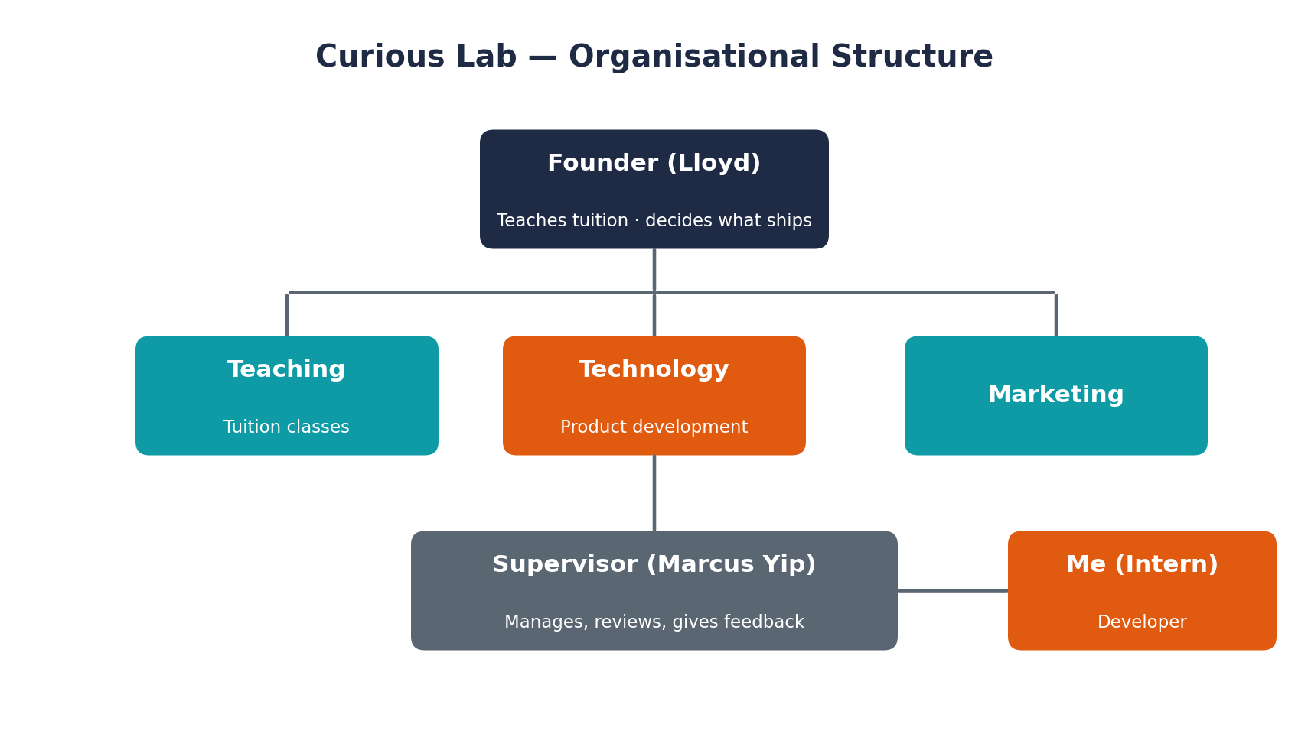
Fig. 2.2.1: Curious Lab organisational structure and reporting lines during the internship.
An important consequence of this structure is the breadth of the technology role. In a larger company, question content would be written and vetted by a curriculum team, the extraction tooling would belong to a data team, the application to a product team, and deployment to an infrastructure team. At Curious Lab all four of those responsibilities sat with one person. I vetted the extracted question content as well as building the systems that produced and served it.

2.3 Workflow and Collaboration
Work at Curious Lab followed a consistent loop. My supervisor and the founder together defined the problem statement and what the company needed solved. I then brainstormed the solution alongside them, designed it, and built it. I vetted the question content the pipeline produced. I gave weekly updates on progress, and met frequently with both to discuss the application's trajectory, the roadmap, and what was urgent against what could wait. The founder made the final decision on what shipped.
This loop is why the product changed direction more than once during the internship, and why those changes were improvements rather than churn. The two largest design changes in the project — the rebrand of the application and the replacement of a grade-style ranking system with a consistency-based experience-point system — both emerged from these discussions rather than from any one person's decision. Feedback was frequent and often substantial: I was regularly given a great deal to change so that the product better suited its target audience of students.

2.4 Interesting Features of the Company
Two features of Curious Lab stand out. The first is that its software is built by the people who teach with it. The teacher dashboard I built exists because the founder wanted to know which topics his own class was weakest in; the feature had a first user before it had a specification.
The second is that Ooka is currently free to the students who use it. In a market where tuition spending is heavily stratified by household income, a company giving away a tool built on real examination papers is making a meaningful choice, and it is a choice a small company can make more easily than a large one with revenue targets to defend.

3. About the Industry

3.1 How the Industry is Organised
Curious Lab operates in Singapore's private education market, a large and unusually competitive sector. Singaporean households spent approximately S$1.8 billion on private tuition in 2024, and more than 70% of students receive some form of tutoring. There are over a thousand tuition centres in Singapore, ranging from large chains such as The Learning Lab down to small boutique operations of the kind Curious Lab itself runs.
The company's current paying customers are the students and parents of its own tuition classes. Ooka itself is presently free and is being tested with those students; the intended commercial model is subscription. The longer-term strategy is to sell the company's tools, Ooka included, into MOE schools.

Competitors and the industry environment
Curious Lab competes on several fronts simultaneously. Its most direct EdTech competitors are companies such as Geniebook, founded in 2015 and having raised roughly US$18 million, which offers AI-personalised worksheets, live online classes and real-time teacher chat; and KooBits, founded in 2007, which offers a gamified mathematics learning platform for primary students and is therefore closest to Ooka's Primary 6 Mathematics and gamification approach. Other online providers such as Superstar Teacher occupy adjacent ground.
Beyond dedicated EdTech firms, the company competes with the entire conventional tuition industry for the same parental spending, and increasingly with free general-purpose AI tools that students already use to have questions explained to them. Finally, the Ministry of Education's own Student Learning Space, the national digital learning platform built with GovTech and launched in 2018, is simultaneously a competitor for students' attention and a demonstration that schools are willing to adopt digital learning at national scale.

Business model and how the company differentiates
Curious Lab's intended business model is subscription-based access to its tools. Its differentiation is not a single feature but an ecosystem argument: practice built on real examination papers rather than generic questions; immediate feedback on every question answered; gamification that makes studying consistent rather than boring; planned monthly report cards so parents can see their child's growth; and a teacher dashboard that surfaces where each student is strong and weak so that teachers can target their help.
There is also a genuine equity dimension. Average household spending on tuition is approximately S$104.80 per month, but that average conceals a wide gap: the top 20% of income earners spend around S$162.60 per month while the bottom 20% spend approximately S$36.30. A free tool built on real examination papers narrows that gap directly, which is a social argument rather than a marketing one, and one of the more compelling reasons a family might choose Curious Lab.

Business strategy — how the company stays relevant
The company's strategy for staying relevant rests on two pillars. The first is keeping pace with the syllabus. During my internship the content had to be migrated to the new MOE syllabus, and I rebuilt both the question bank and the extraction pipeline so that Combined Physics G1, G2 and G3 and Pure Physics were handled as distinct levels. Content that does not match what students are actually examined on has no value, so this work is not maintenance but the foundation of the product's usefulness.
The second pillar is alignment with national policy. MOE's EdTech Masterplan 2030 commits all 360 public schools to hybrid learning environments incorporating learning analytics and AI-assisted feedback tools by 2030. Approximately 97% of Singapore schools already integrate e-learning platforms, supported by more than S$700 million of investment in digital infrastructure. The teacher dashboard I built — class averages, weakest topics, inactive students and per-student consistency tracking — is precisely the learning-analytics capability that masterplan describes. Curious Lab's plan to sell into MOE schools is therefore aligned with a stated national direction rather than being speculative, and the feature that supports that plan already exists.

3.2 Careers in the Industry

3.2.1 Career Prospects
Singapore's EdTech sector sits on a large and growing market with a clear policy tailwind behind it. The combination of a S$1.8 billion tuition market, near-universal school adoption of e-learning platforms, and a national masterplan explicitly calling for learning analytics and AI-assisted feedback means demand for software engineers who understand education is likely to grow rather than shrink.
For polytechnic graduates specifically, small EdTech companies offer something larger firms rarely can: the opportunity to own an entire product early in a career. Over 22 weeks I went from writing an extraction script to owning a deployed production system and the content pipeline behind it. That breadth of experience would be difficult to obtain at a large organisation, where a junior engineer typically owns one component of a much larger system. The honest counterweight is that a small company offers less structure, less formal training and less job security, so the trade-off suits someone who is self-directed and values breadth over specialisation.

3.2.2 Recruitment and Career Progression
I joined Curious Lab through a referral from my former school teacher rather than through a formal hiring pipeline. This is characteristic of companies of this size: without a dedicated human resources function, hiring happens through trust and personal networks rather than structured graduate recruitment programmes.
What the company was looking for was coding ability together with practical experience in artificial intelligence and software development — precisely the areas I had built up while studying Computer Engineering at Singapore Polytechnic. My diploma was not merely useful background for this internship; it was the reason I was considered for it at all.
Career progression in a company of this size does not take the form of a ladder, because there is no ladder to climb. Growth is measured in ownership instead. Over the course of the internship I moved from building a single extraction script to owning an entire deployed product, its content pipeline and its deployment infrastructure. We did discuss my continuing with the company as a software engineer after the internship, although nothing was formalised beyond those discussions.

3.2.3 Training and Attractiveness of the Company
Curious Lab runs no formal training programme and offers no WSQ-certified courses. Instead, the company invested in me in a different currency: I was given ample time to research and learn whatever the work required — optical character recognition was the first example of many — and I always had people I could ask when I became stuck, principally my supervisor.
This is a deliberate contrast with how a large organisation develops staff. A large agency runs structured multi-year development programmes and maintains an internal academy of courses. A small company cannot offer that, so it offers time and access instead. The trade-off is real and worth stating plainly: I learned faster and across a far wider range of technologies than a structured programme would have allowed, but that outcome depended entirely on my own ability to direct my learning. Someone who needed a curriculum would have struggled.
What keeps people at a company like this is the work itself. For me, the attraction was building things that real people actually use. Receiving positive feedback from students who were using something I had built produced a sense of accomplishment I do not believe I would have obtained from work that sat unused in a repository. In a small company the line between what you build and the person it helps is short and visible, which is precisely what larger organisations struggle to offer junior staff.

4. My Work Experience (as an Intern)

4.1 The Intern's Role and How it Fits in the Organisation
My role at Curious Lab was full-stack developer, and because the company had no other engineer, that title covered the entire technical surface of the business. I was responsible for designing and building the systems, deploying and maintaining them, and vetting the question content that flowed through them. There was no component of the product that belonged to somebody else.
This fits into the organisation in a direct way. The founder teaches the classes and identifies what students struggle with; my supervisor and the founder translate that into a problem statement; I turn the problem statement into working software; and the founder decides whether what I have built is good enough to put in front of students. The chain from a problem observed in a classroom to a feature running in production had exactly one engineer in it, and my contribution was the whole of that link.
In short-term company terms, my work gave Curious Lab a functioning product to test with its own students and a question bank of roughly 130 papers that did not exist before. In longer-term terms, it produced the asset the company intends to sell into MOE schools, and the teacher analytics that make that proposition credible.

4.2 The Project — CDIO Stages

4.2.1 Problem Statement (Conceive)
The problem the company put to me was one its founder had observed directly in his own classes: homework is tedious, and it lacks immediate feedback. These are two separate failures with a common consequence. Tedium means students avoid practice or do it without attention. The absence of immediate feedback means that when a student does make the effort, they may not learn whether they were right or wrong until the next lesson, by which time they have forgotten their reasoning and the correction lands on nothing. Together these produce students who practise inconsistently and learn slowly from the practice they do complete.
Delivering a solution required solving two problems rather than one. The first was a supply problem. Practice is only valuable if the questions are the ones students will actually face, which means real examination papers — but those papers exist as PDF and DOCX documents, and manually retyping questions and redrawing diagrams does not scale to the hundreds of papers a useful bank requires. The second was an engagement problem: even with good questions available, students needed a reason to return daily rather than practise once and stop.
The deliverable was therefore an automated pipeline capable of converting real examination papers into a structured, queryable question bank, and a student-facing application built on top of that bank which made daily practice rewarding and returned feedback instantly.

4.2.2 Design — Architecture and Key Trade-offs
The system I designed has four components: a React front end, a FastAPI back end, a MySQL database holding user data, and Google Sheets and Google Drive holding the question content and its diagrams.
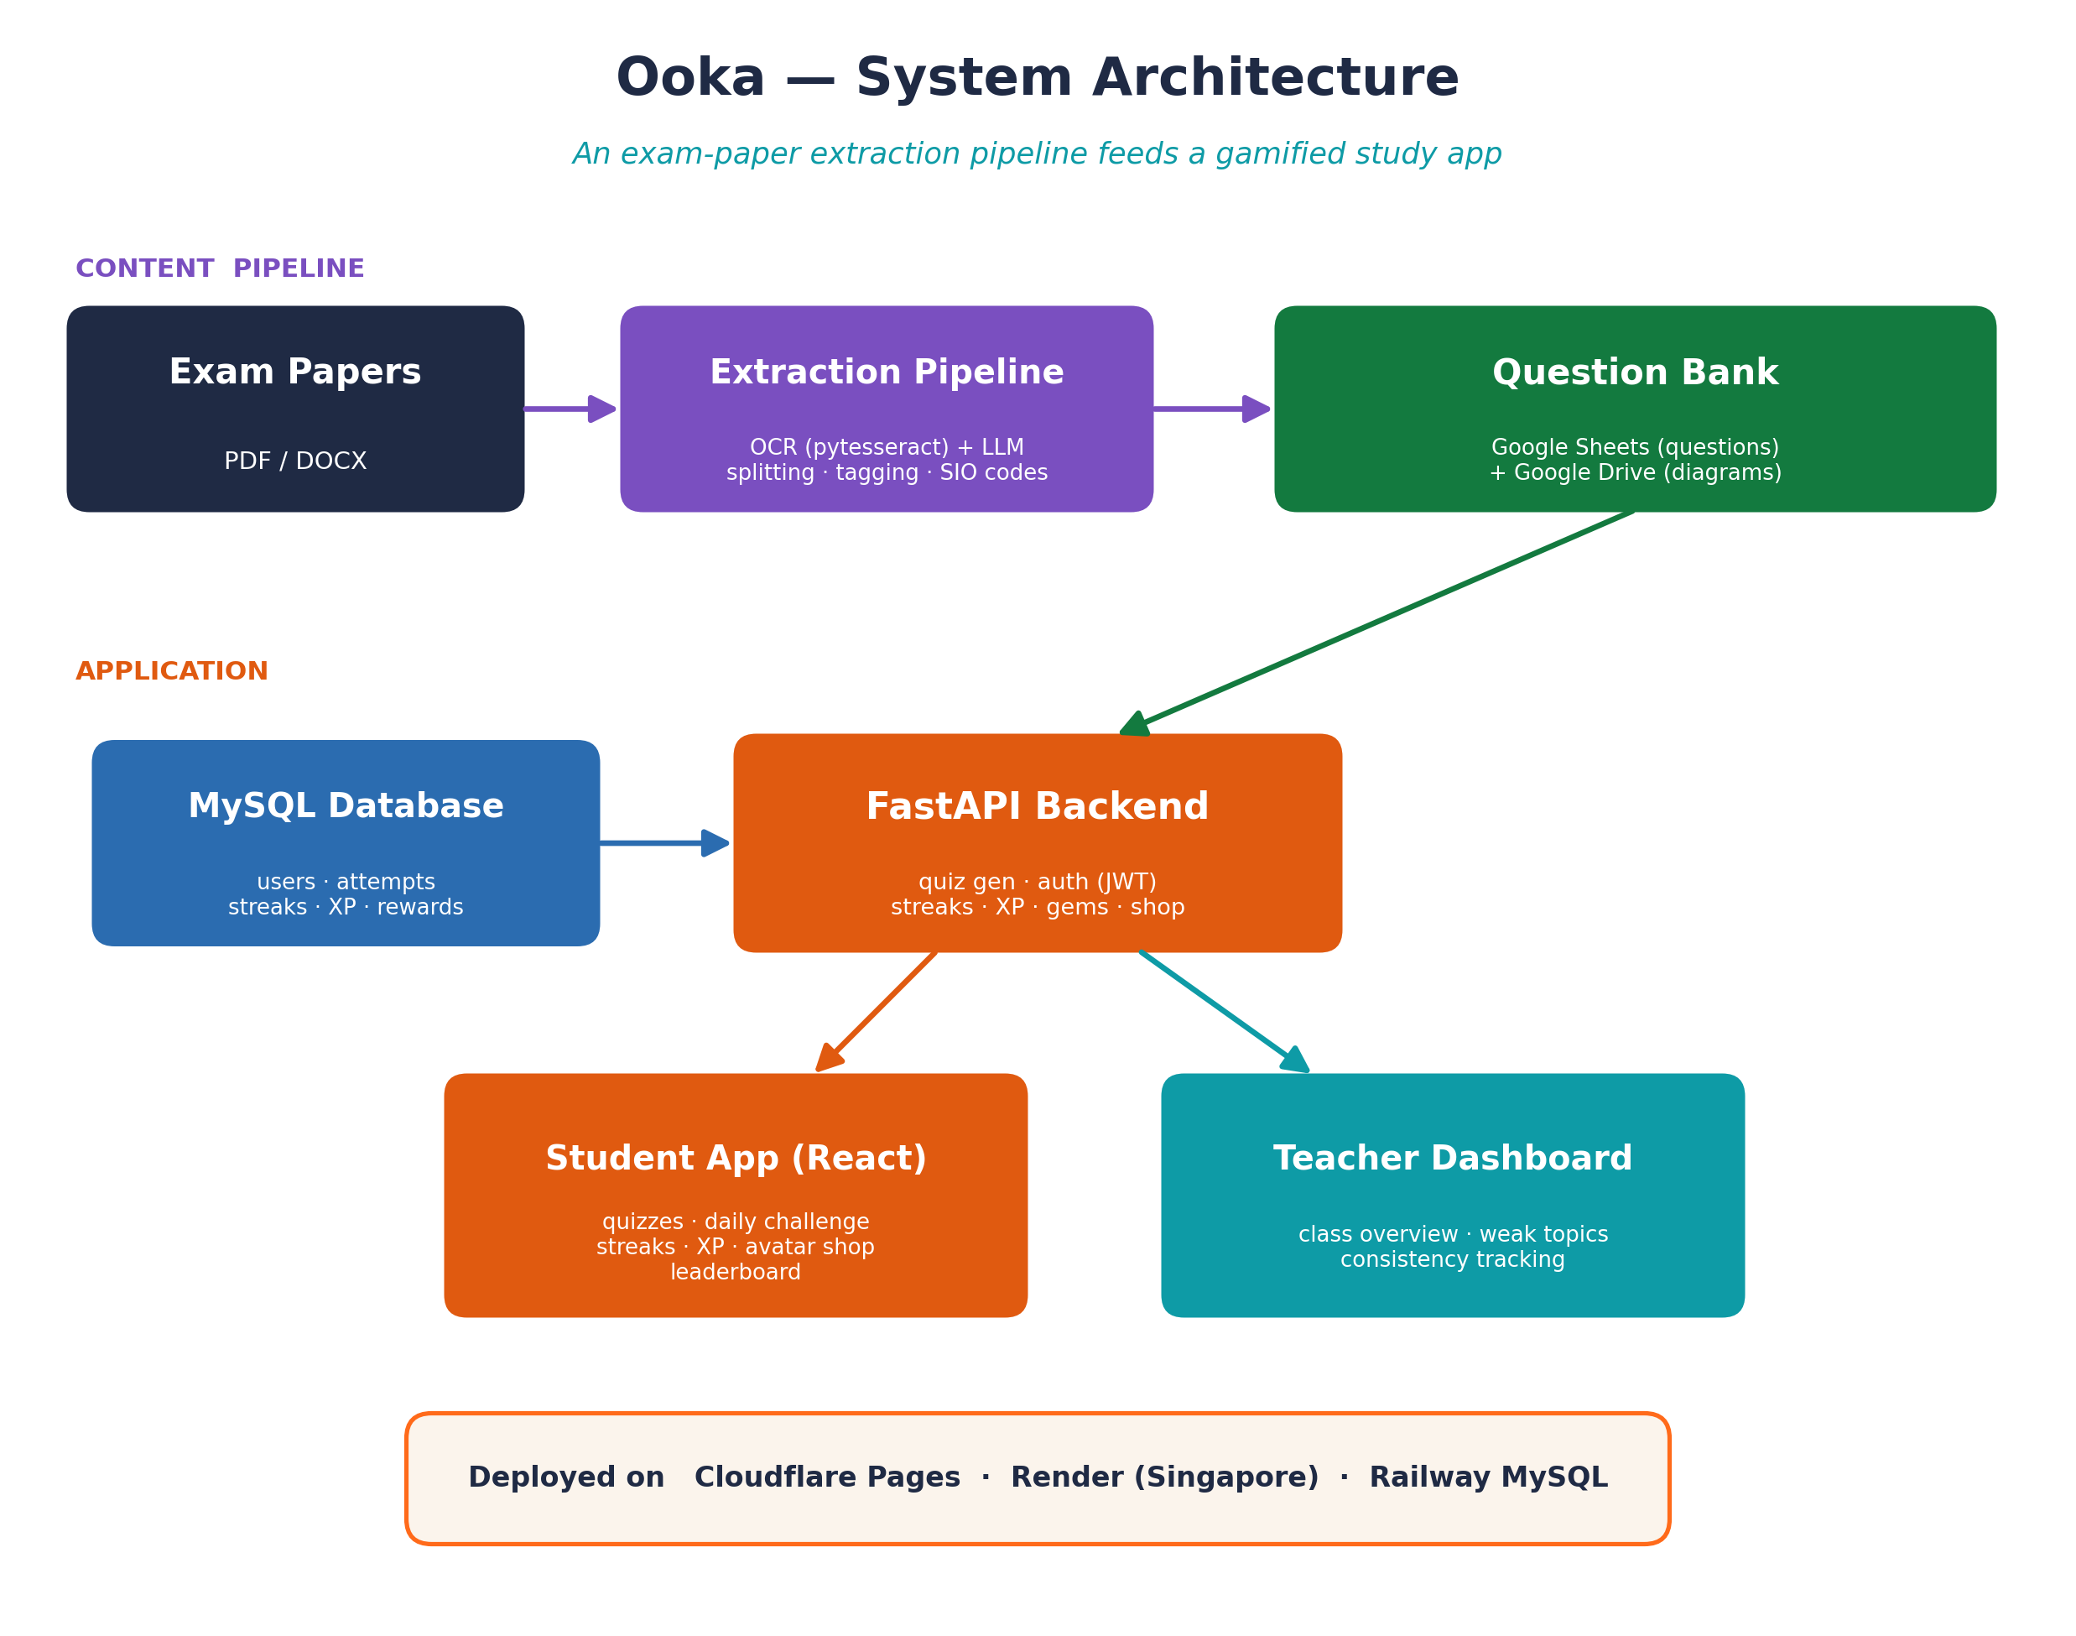
Fig. 4.2.1: Ooka system architecture. The extraction pipeline manufactures the question bank; the application consumes it.
Three design decisions shaped everything that followed, and each involved a trade-off worth stating explicitly.
The first decision was to store questions in Google Sheets rather than in MySQL. The database holds only user data — accounts, quiz attempts, streaks, experience points and rewards — while the questions, answers and diagram references live in spreadsheets, with the diagram images themselves in Google Drive. The cost of this choice is real: I gave up SQL querying and free-text search over the question bank. The benefit is that non-technical content editors, including teachers, can add and correct questions directly in a familiar spreadsheet, with comments, revision history and sharing, without ever touching a database or needing me to deploy a change. For a company where the founder is a teacher rather than an engineer, that autonomy was worth more than query power. Filtering by subject, topic and difficulty happens in Python in memory after loading, which is fast enough at this scale.
The second decision was to load the entire question bank into memory once rather than querying Google Sheets per request. Reading the Sheets API on every quiz request would have been unacceptably slow and would have exhausted the API quota quickly. Instead the back end loads the whole bank into an in-memory cache at startup and reuses it for the lifetime of the process. The trade-off is that an edit to the spreadsheet is not visible until the back end restarts — an acceptable constraint given that content is edited in batches rather than continuously.
The third decision followed from the second: because the question cache, the diagram image cache and the Drive file index all live in process memory, the service runs deliberately as a single process rather than multiple replicas. This keeps cache behaviour correct and predictable at the cost of horizontal scalability, which would require moving those caches to a shared store such as Redis before the user base grew large enough to need it.
A fourth decision, less architectural but equally consequential, was to build the back end as a single FastAPI application rather than splitting it into services. For a solo developer on a fast-moving product this removed all cross-service coordination and allowed very rapid iteration; the cost is a large file that would need modularising before a team could work on it comfortably.

4.2.3 Implement — The Exam-Paper Extraction Pipeline
The pipeline was the first half of the internship and the foundation of everything else. It developed in stages.
I began by researching optical character recognition and its limitations, then used pytesseract to extract text from examination paper PDFs and push it into Google Sheets. Extracting the text proved straightforward; dividing a continuous paper into correctly bounded individual questions did not. My first approach was to run local large language models through GPT4All, including Llama 3 8B Instruct, but the smaller models segmented questions unreliably. I moved the splitting and classification work to Claude, which handled question boundaries, difficulty rating and syllabus matching consistently.
With questions separated, I structured each one into a spreadsheet row containing the question text, the answer options, the correct answer, the associated diagram reference, and a set of classification columns: difficulty, marks, topic, section, the question's setup or context, and the Standard Instructional Objective code, which I matched automatically to each question based on how well the question fitted each objective.
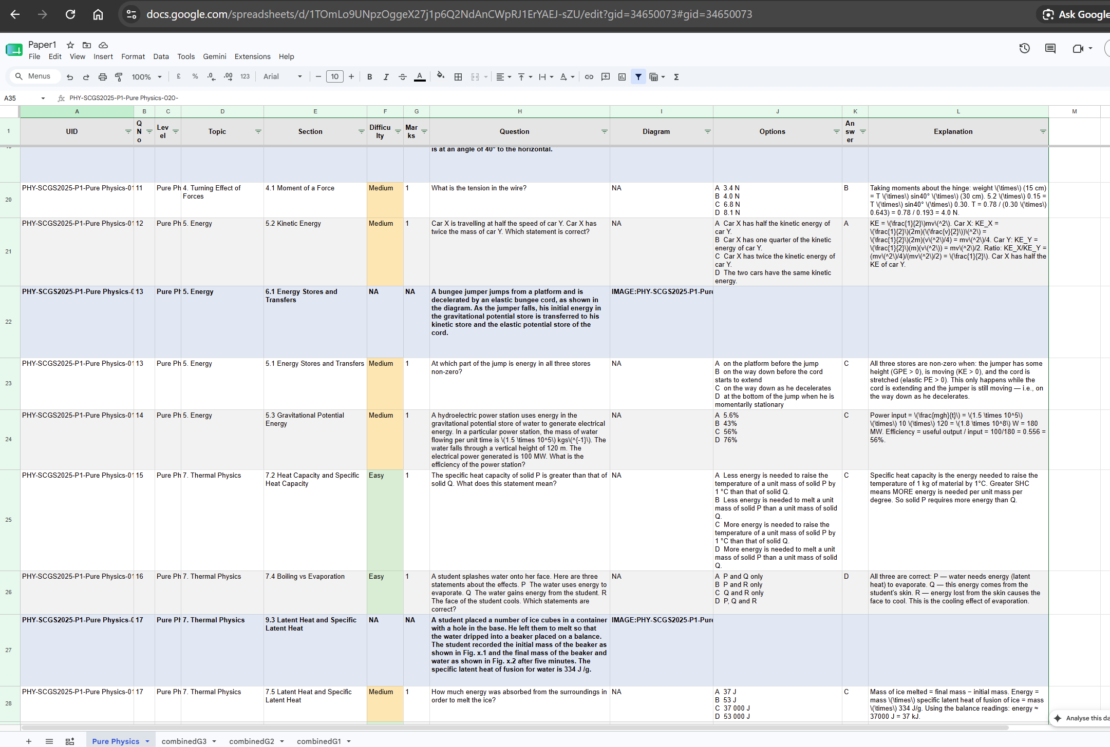
Fig. 4.2.2: The structured question bank. Each row carries the question, diagram reference, options, answer and classification columns, with per-level tabs along the bottom.
A later addition was the Explanation column. Marking schemes usually record only the correct letter, so for questions where the paper provided no worked explanation I had the language model generate one. The back end locates this column by matching the header text case-insensitively rather than by position, so the column can sit anywhere in the sheet; the explanation is attached to the question and returned to the front end, where it is displayed the moment a student submits an answer. This single column is the mechanism by which the application solves the immediate-feedback half of the problem statement.
Midway through the internship the content had to move to the new MOE syllabus. I restructured the spreadsheets and rebuilt the pipeline so that Combined Physics G1, G2 and G3 and Pure Physics were treated as distinct levels, including handling the fact that the G1 tab uses different column headers from the others. I then extended the system to an entirely new subject, Primary 6 Mathematics, which required a separate workbook and image drive, special handling for mathematical symbols and fractions, and the use of a language model to convert non-multiple-choice questions into multiple-choice form so that they would fit the quiz engine.
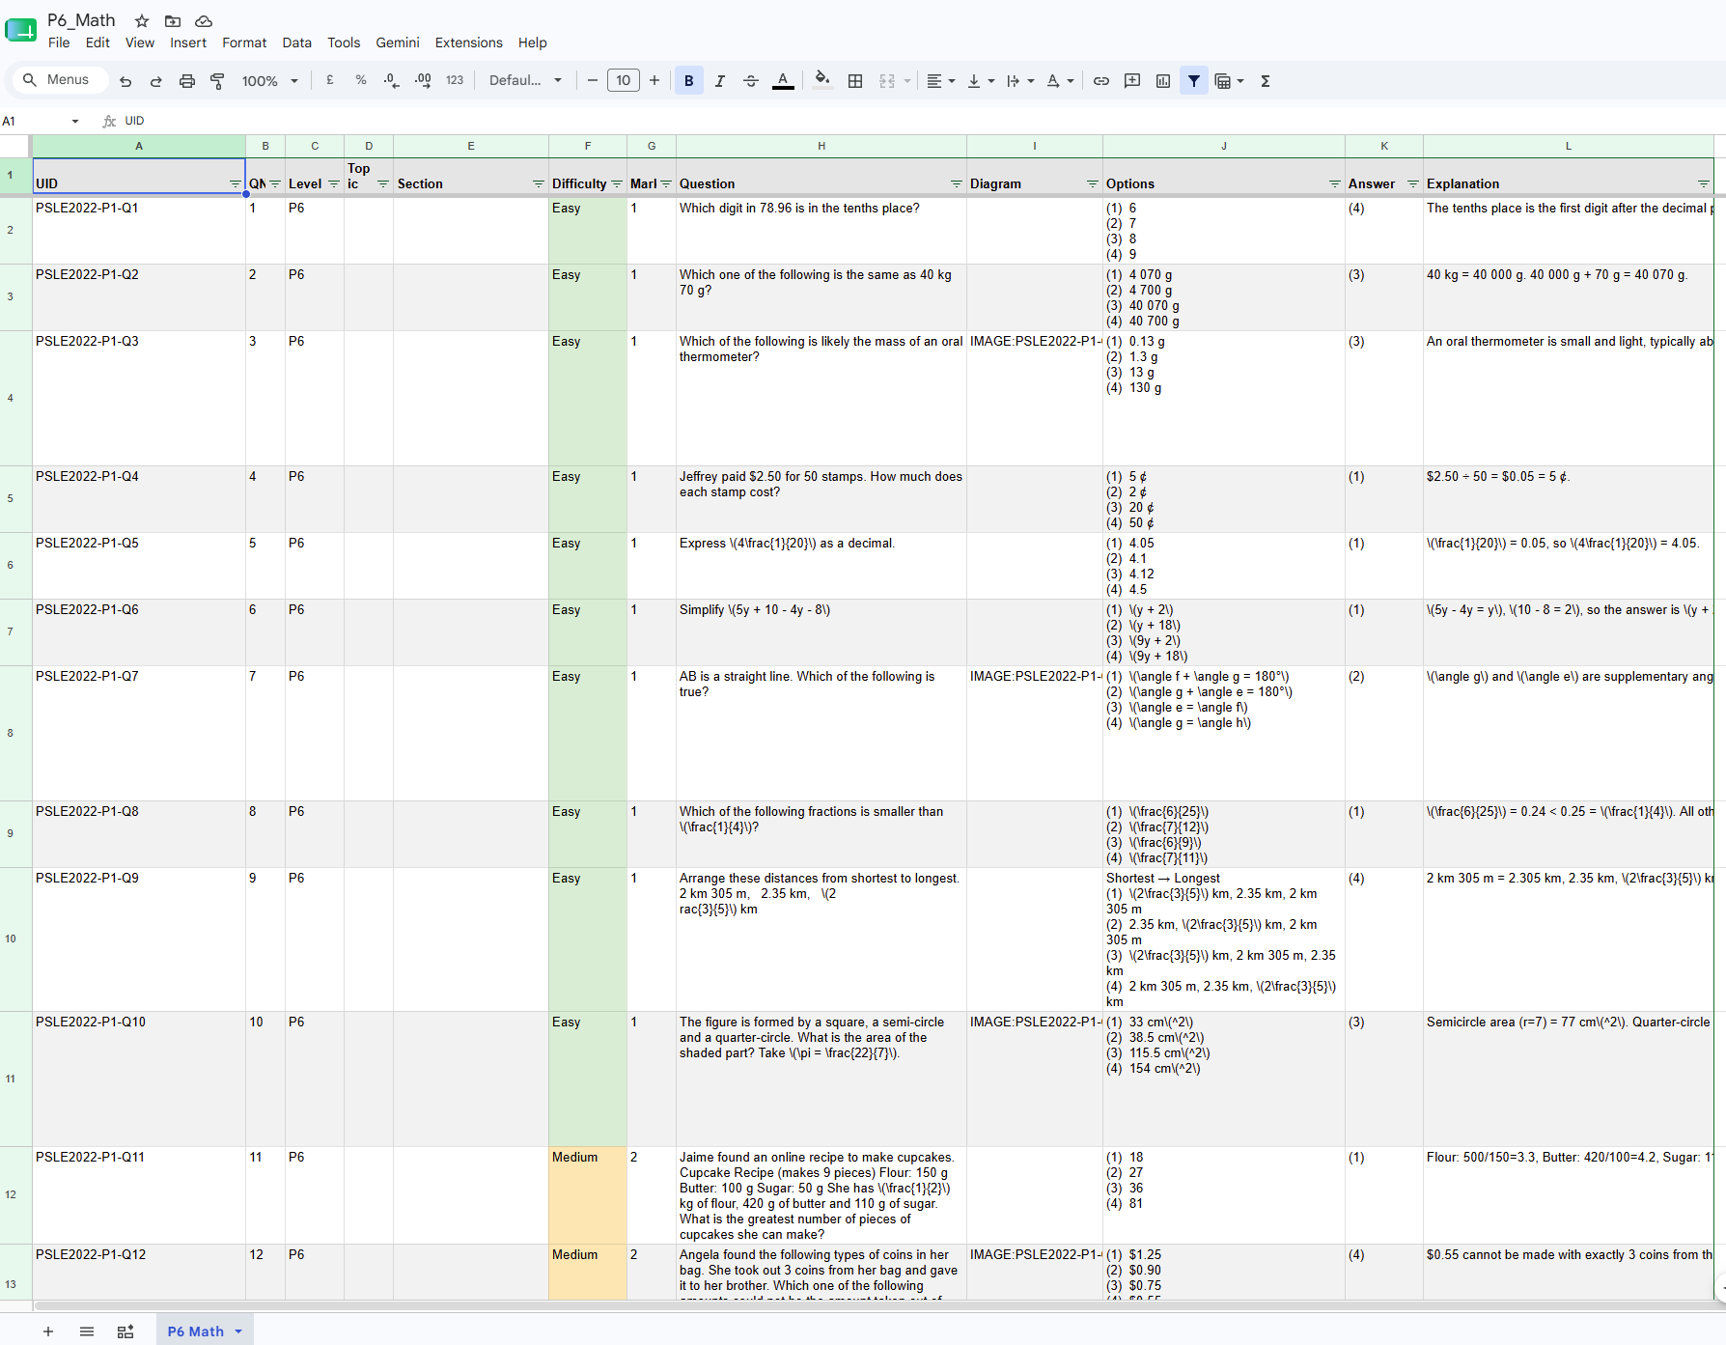
Fig. 4.2.3: The Primary 6 Mathematics bank, showing the LaTeX handling built for fractions, angles and units.
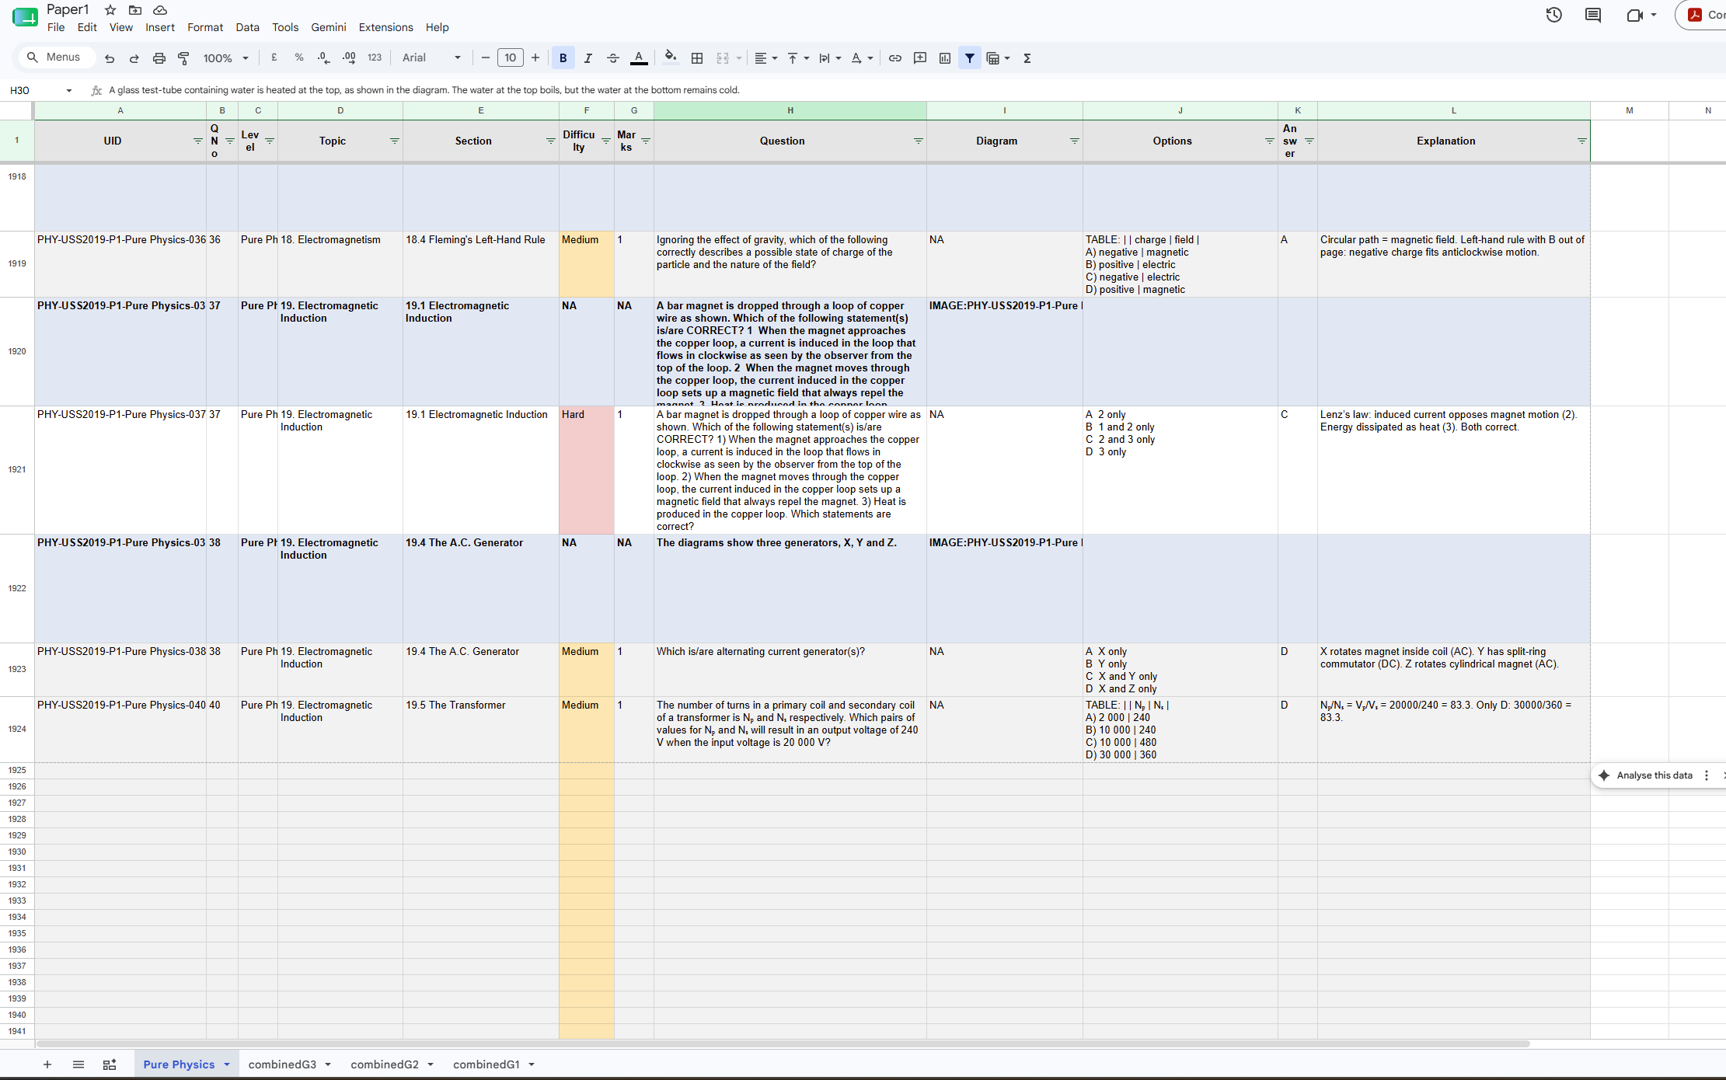
Fig. 4.2.4: Scale of the bank — the Pure Physics tab alone extends beyond row 1,900.
Diagrams are stored in Google Drive, organised into one folder per level with a subfolder per paper. Spreadsheet cells reference them by filename, and the back end resolves those references to real Drive file identifiers at load time.
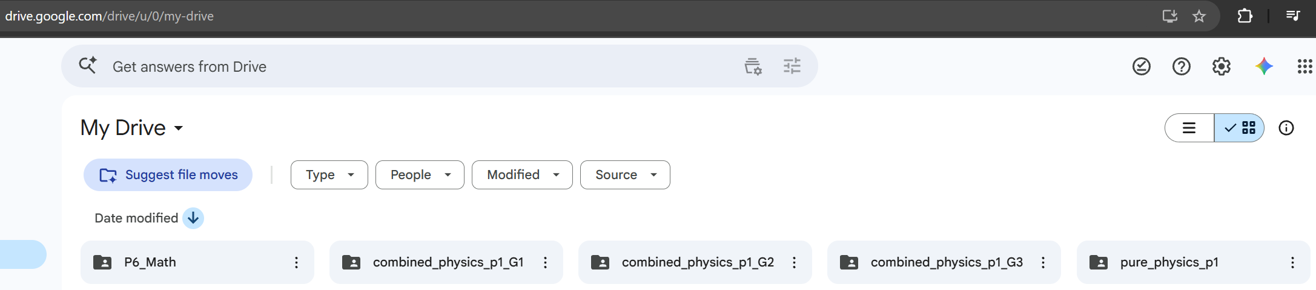
Fig. 4.2.5: Drive organisation — one folder per level.
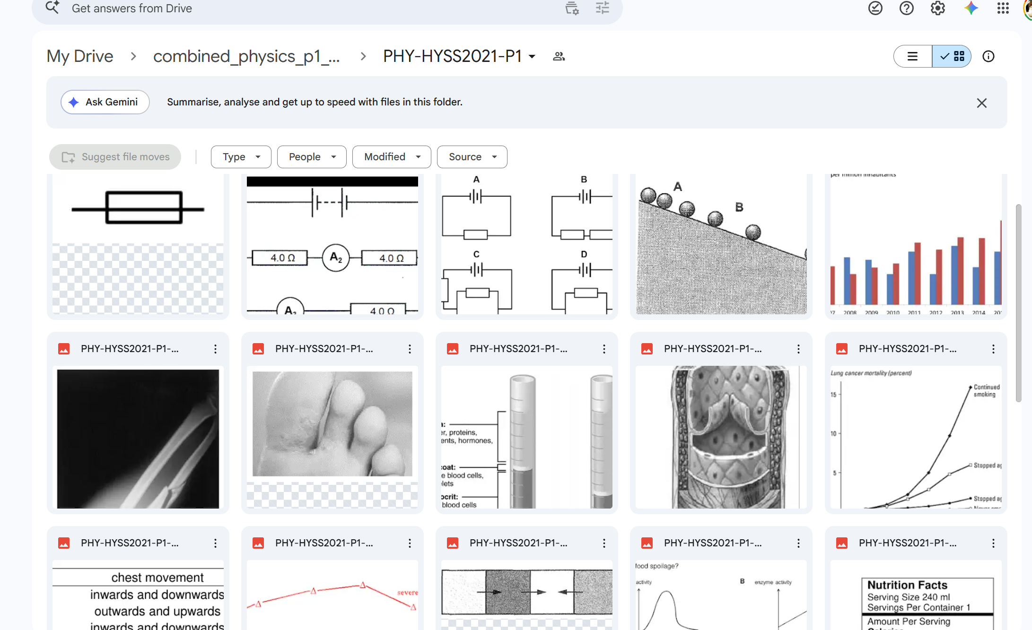
Fig. 4.2.6: Extracted diagrams from a single paper, spanning circuit diagrams, graphs, radiographs, anatomical cross-sections and data tables.

4.2.4 Implement — The Ooka Application
The second half of the internship built the application that consumes the bank. Students choose a subject from the five levels now available, then select topics, a difficulty and a number of questions.
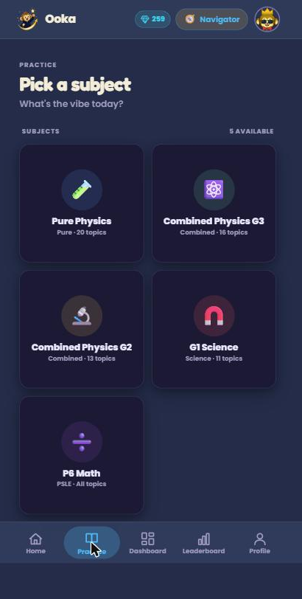
Fig. 4.2.7: Subject selection — all five levels live.
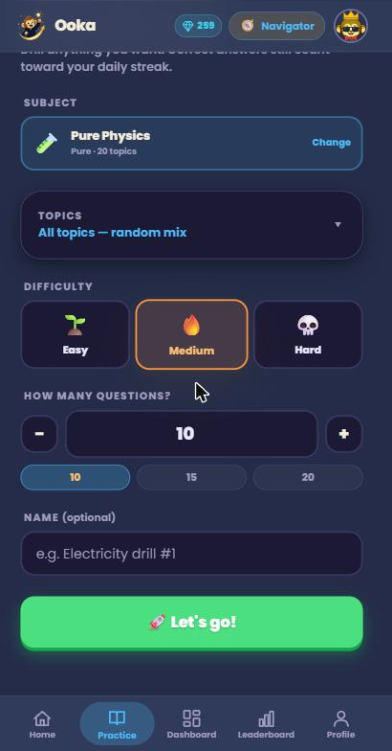
Fig. 4.2.8: The quiz builder.
Before a quiz is submitted the front end queries an availability endpoint and greys out any difficulty that cannot supply the requested number of questions for the chosen topics. If a student selects a combination that cannot be satisfied, the picker automatically snaps to the nearest valid difficulty, preferring the easier option on ties, and animates the change so the student can see it rather than being silently overridden. The back end enforces the same constraint independently, so a malformed request cannot produce a broken quiz.
When a quiz is generated, the back end filters the cached questions by subject, level and difficulty, divides the requested count across the chosen topics, samples randomly from each topic's pool, and resolves any diagram references into image URLs served through its own caching proxy.
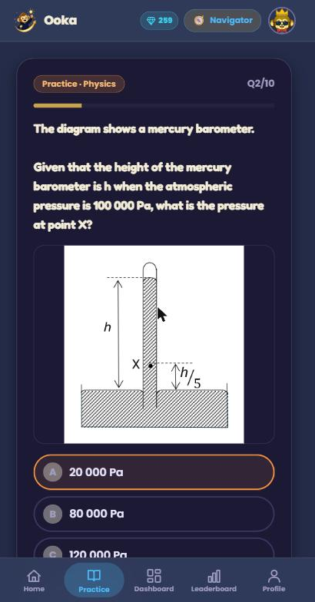
Fig. 4.2.9: A question rendering with its extracted diagram — the pipeline proven end to end.
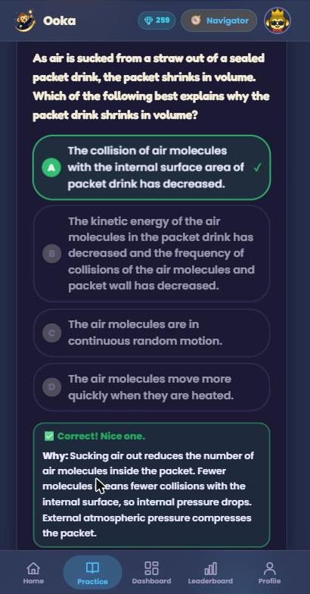
Fig. 4.2.10: Immediate feedback. The explanation appears the moment the answer is submitted.
Around this core sits the gamification that addresses the tedium half of the problem. The daily challenge is deliberately not a fixed set of ten questions but a running counter: a student keeps answering until they have reached their daily goal of correct answers, which means several short sessions across a day count just as much as one long one. Meeting that goal extends a streak, and each student holds one weekly freeze that automatically protects a single missed day so that one bad day does not destroy weeks of consistency.
Every quiz awards experience points and gems. Experience accumulates towards named tiers and, critically, never decreases. Gems are spent in a wardrobe where students customise the Ooka monkey mascot. A leaderboard ranks students by experience across daily, weekly and all-time windows.
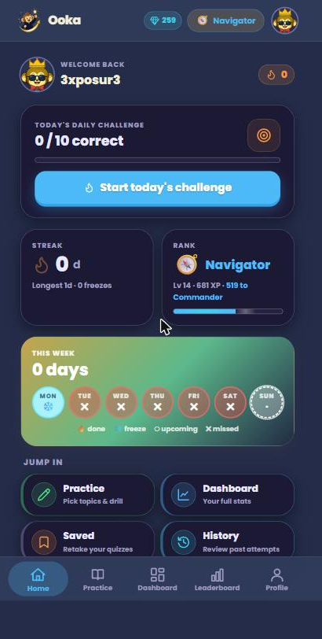
Fig. 4.2.11: The home screen — streak, level and daily challenge.
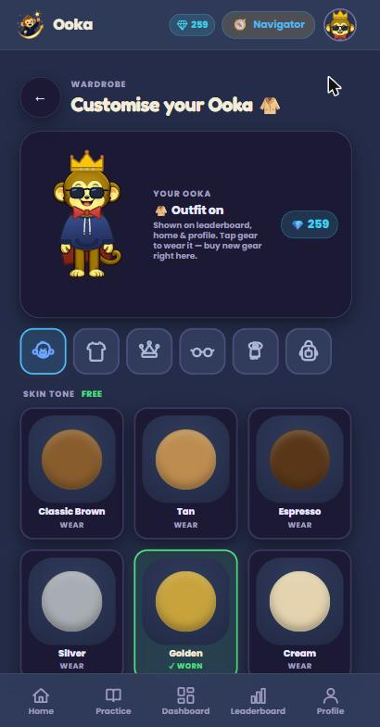
Fig. 4.2.12: The wardrobe and the Ooka mascot.
Students can review their own performance through a statistics dashboard covering overall and first-attempt accuracy, time spent, and a colour-coded per-topic breakdown that makes weak areas immediately visible. Every attempt is stored with the exact questions it contained, so any past quiz can be retaken precisely as it was; retakes do not award experience again, since it has already been earned.
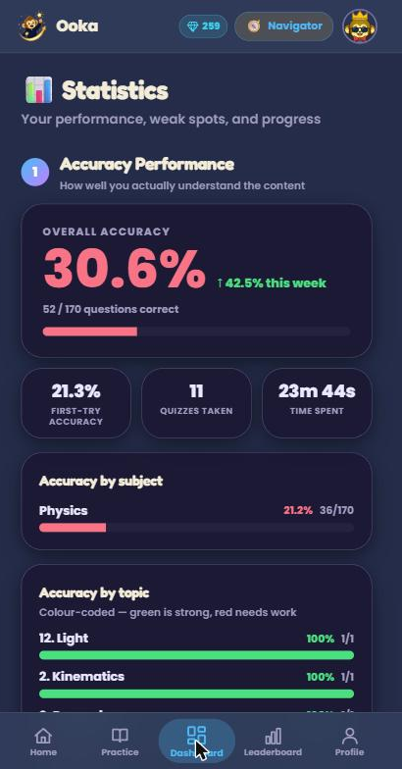
Fig. 4.2.13: The student statistics dashboard.
Authentication supports both email and password sign-up, with passwords hashed using bcrypt, and Google sign-in verified server-side. If a Google login matches an email that already registered with a password, the two are merged onto a single account rather than duplicated. Login tokens are valid for 30 days so that returning students are not logged out mid-use.
Finally, teacher accounts receive a separate read-only dashboard giving a week-at-a-glance view of the class: how many students are active, how many quizzes were taken, the class average and pass rate, the topics the class is weakest in, which students have gone inactive, and per-student consistency. This is the feature that turns the application from a student tool into something a school could adopt.

4.2.5 Operate — Deployment and Testing
Ooka runs in production across three platforms: the front end is hosted on Cloudflare Pages, the back end on Render in the Singapore region, and the MySQL database on Railway, with diagram images served from Google Drive through the back end's caching proxy. Every environment-specific value — database credentials, the token signing secret, Google client identifiers, the service-account key, the public base URL and the CORS allow-list — is supplied through platform environment variables, so no secret is ever committed to the repository. Health checks, the single-replica constraint and CORS origins are declared in configuration files held in the repository so the deployment can be reproduced.
At the close of the internship the pipeline had processed approximately 130 papers — roughly 91 Combined G3, 24 Pure Physics, 7 Combined G2, 3 Combined G1 and 5 Primary 6 Mathematics — and the application was in a test phase with approximately 22 students using it.

4.3 The Hardest Problems I Faced

4.3.1 Reliable diagram extraction from examination papers
This was the single hardest problem of the internship and occupied much of weeks two to six. Extracting the text of a paper was straightforward; extracting the diagrams was not. Cropped images came out inconsistent — sometimes cutting off part of a diagram, sometimes capturing stray text or characters from the surrounding page, frequently full of noise. The underlying difficulty is that every examination paper is laid out differently, so crop parameters tuned to one paper broke on the next.
I iterated on the extraction script for weeks, adding and tuning parameters. To avoid fooling myself about progress I set a concrete acceptance test: five consecutive clean extractions with no issues. I repeatedly failed to reach it, because each new paper format exposed a new edge case. For the Paper 2 answer diagrams, which were the worst offender because text kept being cut out of them, I tried having the language model recreate the diagrams from scratch rather than crop them out of the source.
Diagram recreation proved too unreliable to trust, so I abandoned it and solved the problem differently: for answers, I extracted the entire question and answer together as a single image, which sidestepped the cut-off-text problem completely rather than trying to solve it. For question diagrams I continued tuning through a deliberately tedious testing campaign across many different real paper formats until the pipeline reliably met the five-in-a-row standard, then handed the completed Paper 1 extraction to my supervisor. The final bank spans approximately 130 papers across five levels, which is the practical evidence that the pipeline generalises rather than fitting one layout.
The lesson I took from this is that an acceptance test defined before the work begins is worth more than a subjective sense of progress. Without the five-in-a-row rule I would have declared the extraction finished several weeks earlier than it actually was.

4.3.2 Splitting papers into individual questions
Dividing a continuous examination paper into correctly bounded questions is harder than it appears, because question boundaries are signalled inconsistently across papers. My first approach was to run local language models through GPT4All, including Llama 3 8B Instruct. The smaller models could not segment reliably. I moved the task to Claude, which handled boundaries, difficulty rating and syllabus code matching consistently. The lesson was to match the tool to the difficulty of the task: a small local model was the wrong economy here, and the time spent trying to force it to work exceeded the cost of using a capable model.

4.3.3 Serving the correct diagram every time
Spreadsheet cells reference diagrams by filename, but a browser needs a real URL, and filenames drift in practice — differing in case, in extension, or carrying suffixes such as a trailing setup marker. Large Drive folders introduced a second, subtler failure: the folder listing silently capped at 1,000 files, so once a level's folder grew past that point some questions could no longer resolve their images at all.
I solved this with a file index built at startup that maps every Drive file by exact name, by lowercase name, and by name without extension, and by paginating the folder listing so that the 1,000-file cap no longer applies. An image proxy endpoint resolves references against that index, attempts common extensions, falls back to prefix matching for stale references, streams the bytes, and caches them in memory so that each image is fetched from Drive at most once per process lifetime.

4.3.4 Replacing the ranking system with experience points
My first implementation of progression used Singapore examination grade bands, from F9 up to A1, assigned per subject. On reflection with my supervisor and the founder, this was the wrong design for what Ooka is trying to achieve. A rank that looks like a grade tells a student how clever they are, which made the application feel like another report card. Worse, a bad day could lower the rank — punishing precisely the behaviour the product exists to encourage, since a student who fears losing their grade practises less, not more.
We replaced it with an experience-point levelling system that rewards consistency rather than correctness or level. Whatever level a student is working at and however many questions they get right, steady daily practice moves them forward, and because experience only ever increases, a bad day never sets a student back. This makes progression feel earned rather than judged, and it is the model that successful learning applications converge on. The original rank tables remain in the database, orphaned but not dropped, in case per-subject statistics are revived later.
This was the most valuable design lesson of the internship: a system can be technically correct and still be behaviourally wrong. The ranking system worked exactly as specified. It was the specification that was mistaken.

4.3.5 The rebrand and the avatar system
Partway through production the team decided to rebrand the application, changing its identity, its mascot and its visual direction. The original avatar was assembled from emoji components — hats, glasses and accessories layered over a base. The rebrand centred on a monkey mascot, and the existing artwork would not sit correctly on the new character: assets were designed at fixed pixel sizes and did not reflow when the avatar was rendered larger or smaller, and hard-coded positions drifted whenever the base image changed.
I processed the mascot artwork programmatically using Python imaging libraries: flood-filling the background to transparency, eroding the outer silhouette by a couple of pixels to remove the white anti-aliasing halo that glowed against dark backgrounds while carefully preserving the enclosed white highlights of the eyes, and recolouring in HSV space to generate six skin tones from one source image. I then rewrote the positioning to be expressed as percentages of the avatar's size rather than in fixed pixels, so that a single component renders correctly everywhere from a small navigation chip to a large profile display, and rendered the outfit outside the circular clipping mask so that sleeves were not cut off. The result is one avatar component used consistently across the navigation bar, home screen, profile, leaderboard and wardrobe.

4.3.6 Streak and freeze edge cases
Streaks appear simple and are not. The freeze mechanic in particular introduced a class of bugs where a freeze could be consumed more than once: a freeze would correctly protect a missed day, but subsequent activity could attempt to spend the same freeze again, or a freeze could fire on a day the student had actually completed.
The fixes were structural rather than cosmetic. A uniqueness constraint on the combination of user, subject and date means multiple submissions on the same day update a single record instead of stacking. The streak increments only the first time the daily goal flips to met. A dedicated field records exactly which date a freeze protected, so it cannot be spent twice. The code checks that a day was not already completed before consuming a freeze. And a gap larger than the available freeze budget resets the streak explicitly rather than surviving silently.

4.3.7 Making the application fast
As the question bank and image set grew, the naive implementations would not have held. Reading Google Sheets on every quiz request and re-fetching every diagram from Drive on every view would have made the application crawl and exhausted the API quotas. The optimisations I built were: loading the entire question bank into memory once and serving quizzes from RAM; caching diagram bytes in memory so each image is fetched from Drive at most once per process; fetching every level's spreadsheet tab in a single batched call rather than one call per tab; indexing Drive filenames once at startup so lookups are dictionary hits rather than live searches; addressing images by filename rather than volatile identifiers so that re-uploading a diagram does not break existing references; and code-splitting the front end so that heavier pages load on demand rather than in the initial bundle.

4.4 Skills Required and Company Expectations
The technical skills this role required were React and modern front-end tooling, Python with the FastAPI framework, relational database design with MySQL, authentication and token handling, the Google Sheets and Drive APIs, cloud deployment across three platforms, and practical use of large language models as components within a pipeline rather than as a chat interface. I brought foundations in programming, data structures, databases and machine learning from my Computer Engineering diploma. A substantial proportion of the specific technologies, however — optical character recognition, FastAPI, the Google APIs, the deployment platforms — I learned on the job while building with them.
The company's expectations of me were shaped by its size. Because I was the only developer, there was no expectation that someone would check my work line by line, and no possibility of a task being quietly reassigned if I struggled. I was expected to be punctual for meetings, to deliver weekly updates whether the news was good or bad, to be honest about what was not working, and above all to be self-directed: to research what I did not know rather than wait to be taught it, and to arrive at my supervisor with a framed problem rather than an unexamined error. Professionally the standard was the same as for the permanent staff, because in a company of this size there is no meaningful distinction between the two.

4.5 Working with the Team
Although I was the only developer, the project was collaborative throughout rather than a brief handed over and collected at the end. My supervisor Mr Marcus Yip and the founder Lloyd together defined the problem statement and what the company needed solved. I brainstormed the solution alongside them, and Ooka emerged from those discussions rather than from any single person.
Roles were clearly divided. Marcus managed me day to day, answering questions, reviewing my work and giving feedback. Lloyd made the final decision on what shipped. I did the design, the building and the vetting of question content. Throughout the internship I gave weekly updates so the team always had visibility of what was working and what was not, and met frequently with both to discuss the application's trajectory and roadmap and to agree what was urgent against what could wait.
The feedback loop was substantial rather than ceremonial. I was regularly given a great deal to change so that the product better suited its target audience, and a significant proportion of my work consisted of responding to that feedback rather than building in isolation. Both of the largest design changes in the project — the rebrand and the shift from grade-style ranks to consistency-based experience points — came directly out of these discussions. That loop is what kept the product aimed at students rather than at whatever happened to be most convenient to build.

5. Reflection and Learning Points

5.1 Reflection on CDIO Skills
The internship exercised all four stages of the CDIO framework, and unusually for an intern I was involved in every one of them rather than a single stage.
Conceive. I was given a problem statement rather than a specification, which meant the first task was understanding the problem well enough to decide what to build. Recognising that homework's two failures — tedium and delayed feedback — required two different solutions, and that neither the pipeline nor the application would be useful alone, was itself a conceiving activity.
Design. The design decisions I made carried real trade-offs, and I had to reason about them rather than follow a pattern. Choosing spreadsheets over a database for content sacrificed query power to give non-technical staff autonomy. Choosing an in-memory cache sacrificed live updates for speed. Choosing a single process sacrificed horizontal scalability for cache correctness. Engineering Mathematics and my programming modules gave me the foundation, but the judgement of which cost was worth paying came from thinking about who would actually use each part of the system.
Implement. This was the bulk of the work: building the pipeline and the application, and debugging problems that had no textbook answer. My database modules underpinned the schema design; object-oriented programming shaped how the back end was structured; and my exposure to machine learning and artificial intelligence made it natural to use language models as components in a pipeline rather than treating them as a novelty.
Operate. Deploying across three platforms, keeping secrets out of the repository, defining reproducible configuration and then supporting the system while approximately 22 students used it taught me that shipping is not the end of engineering. The performance work in the final weeks existed only because the system was being operated rather than demonstrated.
Beyond the technical stages, the internship developed the softer CDIO competencies. Communication and teamwork were exercised through weekly updates and roadmap discussions with my supervisor and the founder, and through learning to present a problem in a form someone else could act on. Creativity, innovation and enterprise appeared most clearly in the decision to abandon diagram recreation in favour of extracting the whole question and answer as one image — a solution that worked by sidestepping the problem rather than defeating it. Ethics and responsibility surfaced in a quieter way: I was building for secondary school students, which imposes a duty of care around the accuracy of the content and explanations the application delivers, since a confidently wrong explanation is worse than none at all.

5.2 How Self-Directed Learning Helped Me
Self-directed learning was not a supplementary skill in this internship; it was the mechanism by which the work got done. Curious Lab had no training programme to enrol me in. What it offered instead was time to research whatever the work required and people I could ask when I became stuck. Every significant technology in the final system — optical character recognition, FastAPI, the Google Sheets and Drive APIs, cloud deployment, the practical use of language models within a pipeline — I learned during the internship rather than before it.
Working remotely sharpened this further. With no one nearby to notice that I was blocked, I had to recognise it myself, decide whether to keep investigating or to ask, and frame the question well enough that Marcus could answer it quickly. The abandoned experiments — GPT4All for question splitting, language-model recreation of diagrams — were part of that process rather than failures of it: each one ruled out an approach and pointed towards the one that worked. Knowing when to persist and when to abandon an approach is, I think, the most transferable thing I learned.

6. Recommendations for the Company

6.1 Learning Points that Benefit the Company
The most important learning point I can pass to Curious Lab concerns gamification design. Building the ranking system and then replacing it demonstrated concretely that progression mechanics which measure ability discourage the very practice the product exists to promote, whereas mechanics that measure consistency encourage it. That principle should govern future features: monthly report cards for parents, for instance, will be more effective if they lead with consistency and improvement rather than with a mark, for exactly the same reason the ranks were removed.
The second learning point is architectural. Keeping question content in spreadsheets rather than a database has proven correct for a company whose content editors are teachers, because it lets them work without engineering support. This should be preserved as the company grows, though the absence of live reloading will eventually need addressing.

6.2 Recommendations Made and Contributions to the Company
My contributions were the two systems themselves: a pipeline that has converted approximately 130 papers into a structured bank across five levels, and a deployed application now being tested with roughly 22 students. Beyond delivering them, the recommendations I made and implemented during the internship included replacing grade-style ranks with consistency-based experience points; restructuring the question bank and pipeline to handle the new MOE syllabus levels as distinct streams; adding language-model-generated explanations for questions whose marking schemes provided none, which is what makes immediate feedback possible; and extending the system to Primary 6 Mathematics to prove that the architecture generalises beyond Physics.
I would make three further recommendations. First, add an administrative endpoint that reloads the question bank without restarting the back end; at present a content edit requires a restart, which will not scale once teachers other than the founder are editing content. Second, introduce an automated test suite covering quiz generation, submission, streak awarding and shop redemption, since the application has so far been verified by direct use and a regression in the streak logic would be easy to introduce and hard to notice. Third, and most importantly, add a validation pass over language-model-generated explanations for questions that contain diagrams. During testing I observed an explanation that reached the correct answer while describing the graph incorrectly, stating that a straight line was curved. Students read these explanations and will trust them, so an incorrect description carries a real cost that a spot-check of diagram questions would largely eliminate.

6.3 What the Company Can Do to Remain Competitive
Curious Lab is a small company competing against firms with tens of millions of dollars in funding, so it cannot win on breadth of features. Its defensible advantages are that its software is built by people who teach with it, and that it holds a growing bank of real, structured, syllabus-tagged examination questions that a competitor cannot simply replicate.
The clearest strategic opportunity is the alignment between the teacher dashboard and MOE's EdTech Masterplan 2030, which commits all 360 public schools to hybrid learning with learning analytics and AI-assisted feedback by 2030. The company already possesses a working learning-analytics product. I would recommend pursuing school pilots deliberately and early, while that alignment is a differentiator rather than an expectation, and using the free student tier to build the evidence of usage that a school procurement conversation will require.

7. Careers and My Own Lessons Learnt

7.1 My Own Lessons Learnt
Technically, I learned to build and operate a complete production system rather than a project that runs on my own machine: designing a schema, structuring an API, deploying across cloud platforms, handling authentication and secrets properly, and then supporting the result while real students used it. I also learned to use large language models as engineering components — with the failure modes, cost and reliability characteristics that implies — rather than as a novelty.
The more valuable lessons were not technical. The first is that engineering is iterative and that abandoned approaches are information rather than waste; the local language models and the diagram recreation experiment both had to be tried before the working solution was obvious. The second is that a system can be technically correct and behaviourally wrong, which the ranking system demonstrated. The third is that defining an acceptance test before starting — the five clean extractions in a row — protects you from your own optimism.
About myself, I learned that I work well with autonomy but that autonomy has to be paired with deliberate self-management: working from home in a small company, nobody notices if you spend a day stuck, so recognising it yourself is a skill rather than an instinct. And I learned what motivates me. Building things that real people use, and receiving feedback from students who were using something I had made, gave me a sense of accomplishment I would not have obtained from work that sat unused. That is why I would like to work in this industry after graduating: I feel I am genuinely contributing something to it.

7.2 Suggestions to Better Prepare Students for the Workplace
Reflecting on how my diploma prepared me, the foundations were the right ones — programming, data structures, databases and machine learning were all directly applicable, and the coding and AI experience from my course was the specific reason Curious Lab considered me. What I would suggest to juniors preparing for an internship is threefold.
First, build and deploy something end to end before your internship begins, however small. School projects usually end when the code runs locally; the genuinely difficult and unteachable parts — deployment, environment configuration, secrets, debugging a system you cannot attach a debugger to — all live past that point.
Second, practise self-directed learning deliberately. In a small company nobody will teach you the technology stack. The ability to read documentation, build a small proof of concept, and evaluate whether an approach will work is more valuable than any specific framework you already know, because the framework will differ anyway.
Third, learn to ask questions well. My supervisor's time was the scarcest resource available to me, and a question that arrives with the problem framed, the approaches already tried and a specific point of confusion gets a far better answer than a report that something is broken.
For the course itself, I would suggest more exposure to deploying and operating software rather than only writing it, and to working with third-party APIs and their real failure modes such as rate limits, pagination and stale references. A short unit on using language models as engineering components, including their reliability limits, would also reflect how software is now built. More broadly, the gap I felt most on entering the workplace was not knowledge of any particular language but confidence in approaching an unfamiliar system and working out how it fits together, and that is a habit which can be practised long before an internship begins.

8. Conclusion
My 22-week internship at Curious Lab gave me responsibility I did not expect as an intern: as the company's only developer, I designed, built, deployed and maintained an entire production system from a problem statement rather than a specification. I delivered an automated pipeline that has converted approximately 130 examination papers across five levels into a structured question bank, and Ooka, a gamified study application built on top of it that is now being tested with around 22 students and gives them an explanation the moment they answer rather than days later. Along the way I learned as much from the approaches I abandoned — local language models, diagram recreation, grade-style ranking — as from the ones that worked, and I learned that a design can be technically correct and still be wrong for the people using it. Most of all, building something that real students use has convinced me that this is the industry I want to work in.

References
[1] Ministry of Education, Singapore. "Transforming Education through Technology Masterplan 2030 (EdTech Masterplan 2030)." Available: https://www.moe.gov.sg/education-in-sg/educational-technology-journey/edtech-masterplan
[2] National Institute of Education, Nanyang Technological University. "Singapore's Private Tutoring Boom Reveals the Hidden Cost of Success." Available: https://www.ntu.edu.sg/nie/news-events/news/detail/singapore-s-private-tutoring-boom-reveals-the-hidden-cost-of-success
[3] New in Asia. "Singapore's Obsession With Education Built a S$1.8B Tuition Industry — Now It's Crowded," 20 January 2026. Available: https://newinasia.com/2026/01/20/singapore-tuition-industry-2026-saturation-growth/
[4] Tracxn. "Geniebook — Company Profile, Team, Funding, Competitors & Financials." Available: https://tracxn.com/d/companies/geniebook
[5] Tracxn. "KooBits — Company Profile, Team, Funding, Competitors & Financials." Available: https://tracxn.com/d/companies/koobits
[6] Nexdigm. "Singapore Education Industry Report — Industry Size and Future Outlook." Available: https://www.nexdigm.com/market-research/insights/blog/singapore-education-industry-report/
[7] Government Technology Agency of Singapore (GovTech). "Inside Singapore's digital classroom: How AI is supporting teachers and students." Available: https://www.tech.gov.sg/technews/inside-singapore-digital-classroom-how-ai-is-supporting-teachers-and-students/

Annexes

Annex A — Additional Application Screenshots
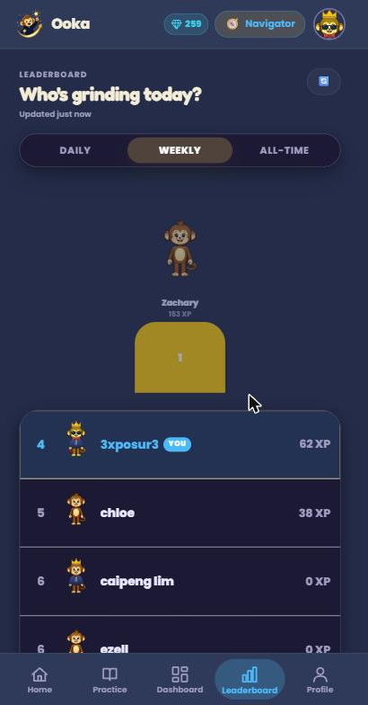
Fig. A.1: Leaderboard with daily, weekly and all-time ranking windows.
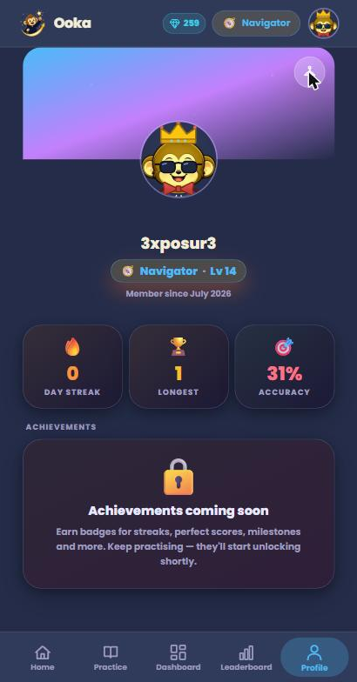
Fig. A.2: Student profile showing avatar, level, streak and accuracy.
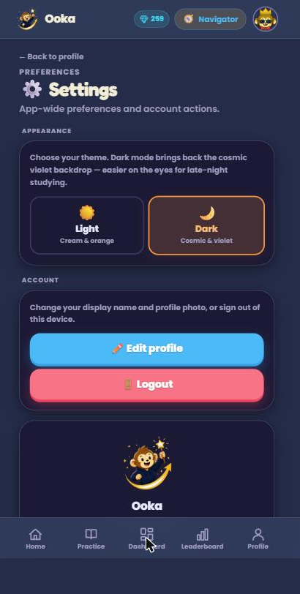
Fig. A.3: Appearance settings — light and dark themes.

Annex B — Question Bank Organisation
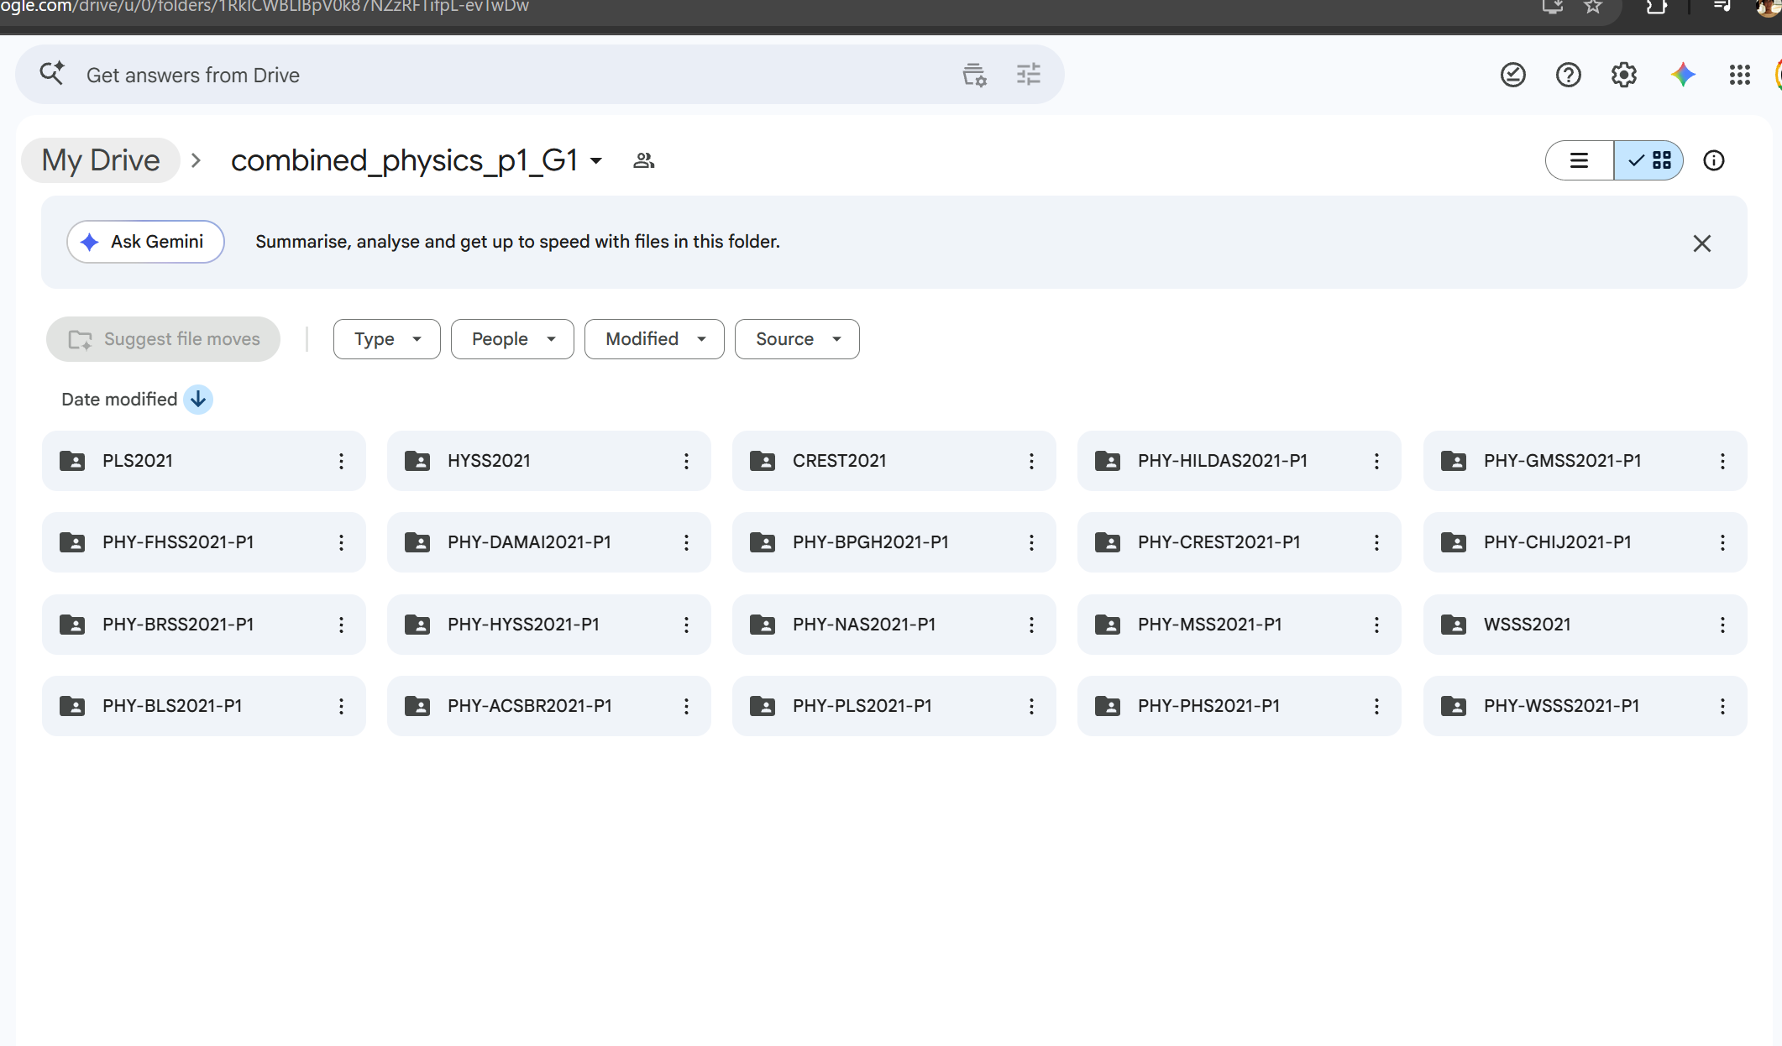
Fig. B.1: Per-paper subfolders within a single level's diagram drive.

Annex C — Principal Competitors Identified
- Geniebook — Singapore, founded 2015; AI-personalised worksheets, live online classes and teacher chat; approximately US$18 million raised.
- KooBits — Singapore, founded 2007; gamified mathematics learning platform for primary students.
- Superstar Teacher — Singapore; online video-based tuition.
- Large tuition chains such as The Learning Lab, among over 1,000 tuition centres in Singapore.
- General-purpose AI assistants, used informally by students to have questions explained.
- MOE Student Learning Space (SLS) — the national digital learning platform, both a competitor for attention and a demonstration of school-level digital adoption.

