Supply Chain Activity Diagram

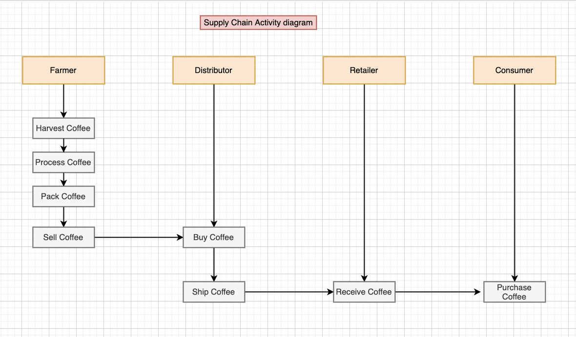

Supply chain Sequence Diagram

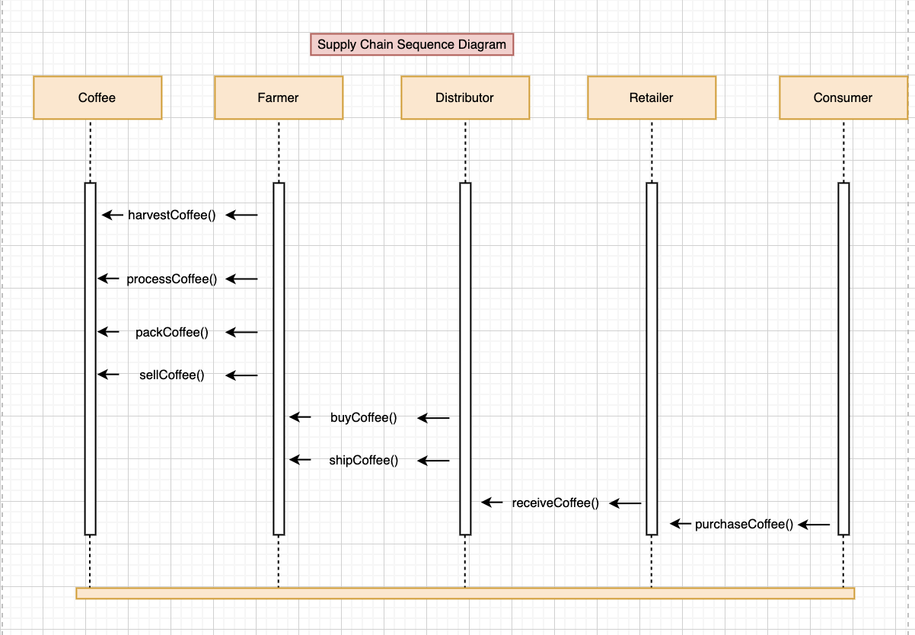

Supply chain Class Diagram

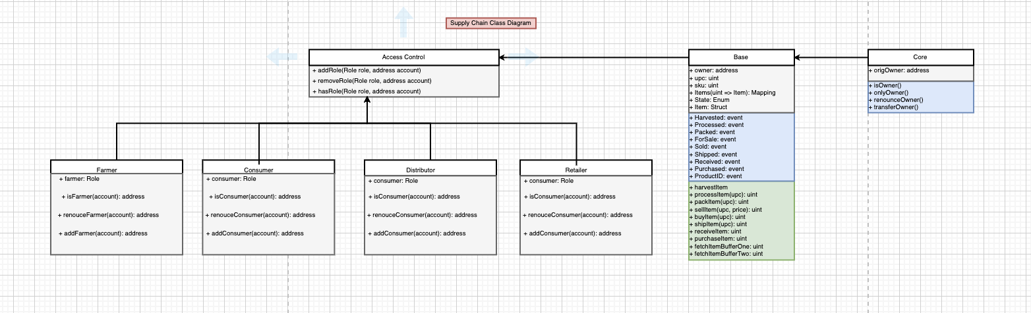

Supply chain State Diagram

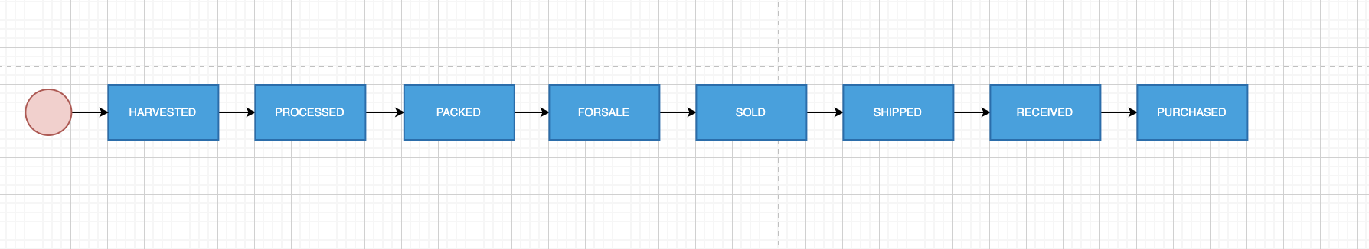

Libraries Used:

* Web3: had to properly link the web3.min.js on the frontend to be able to use ethereums blockchain method
* Truffle-hdwallet-provider: to link infura to my application

Versions:

* Truffle v5.1.67 (core: 5.1.67)
* Solidity v0.5.16 (solc-js)
* Node v12.16.1
* Web3.js v1.2.9

Transaction Hashes and Contract Addresses

FarmerRole

----------------------

> transaction hash: 0xd3d79a54c0eadfc308eda104e5b9f402849994e55c04a2cc06eec53fe711c056

> contract address: 0x6d39Bc9DA68699119816b45e3Edf5468A80aE986

DistributorRole

---------------------------

> transaction hash: 0x8b5860b4b223d038fdaefe13bd5cb8651b8ac006a76f8dff039c6bb561e61a57

> contract address: 0xeea58BC3ad158F86b9dBbb5868E548b9B99BBf45

RetailerRole

------------------------

> transaction hash: 0x3b51071997509e2bb38fbdb8faa1bf4f16e1620e7f486bf96fe2d470ae851705

> contract address: 0x4561C85d1d964F9f0C36f894e64D40A37F0e5A06

ConsumerRole

------------------------

> transaction hash: 0x82f813a8aec942983be4c6ef0a3622394aa4627429737213a839810a2e51e967

> contract address: 0xD092E50e9b08f52D626f7015D72cfa66e7A10FFD

SupplyChain

-----------------------

> transaction hash: 0x14895a4a85f61ebb20e31504ea262b3e2f3714cd36cd087fcedbd8ae1a948fb6

> contract address: 0x1aC546f43399254d5F97c7F78f78fc41d4dA4f72