Comparative Analysis of Health Indicators

Argentina vs. Mexico (2025)

Focus: Gender Disparities and Public Health Outcomes

Author: Ezequiel Bassa | Senior Data Scientist & Sociologist
Date: April 1, 2026
Data Source: PAHO/EIH Core Indicators 2025
Dashboard: https://ezequielbassa.shinyapps.io/3Epidemiology/
Tool: R · Shiny · ggplot2 · officer

I. Executive Summary
This report presents a comparative epidemiological analysis of Argentina and Mexico using data from the Pan American Health Organization (PAHO) Core Indicators 2025 dataset. Both nations have undergone significant demographic and epidemiological transitions, yet their distinct health system architectures produce measurably different outcomes across gender, age, and disease burden dimensions.

Argentina records a total life expectancy of 77.7 years, marginally above Mexico's 75.4 years. In both countries, women outlive men by a significant margin — the gender gap stands at 5.1 years in Argentina and 5.6 years in Mexico — a pattern driven by higher male premature mortality from external causes and chronic disease.

Key findings:
• Life expectancy gender gap: Argentina 5.1 yrs | Mexico 5.6 yrs
• Maternal mortality: Argentina 33.2 vs Mexico 42.1 per 100,000 live births
• External cause mortality: Mexico (61.7) significantly higher than Argentina (33.8) per 100,000 pop
• Obesity prevalence: Mexico (73.4%) vs Argentina (68.4%) — both above the regional median
• Medical doctors: Argentina (51.1 per 10,000) vs Mexico (25.9 per 10,000)

The data reveal a consistent pattern: Mexico faces greater burden from violence-related male mortality and the obesity-diabetes nexus, while Argentina confronts a stabilizing life expectancy plateau and elevated maternal mortality requiring targeted intervention.

II. Introduction and Methodology

Data Source
This analysis uses the PAHO/EIH Core Indicators 2025 dataset, a comprehensive open-access repository containing 299 health indicators for 49 countries and territories in the Americas. The dataset was accessed through the Americas Health Core Indicators Dashboard (R Shiny), which processes 337,970 cleaned records spanning multiple decades.

Country Selection Rationale
Argentina and Mexico were selected on the basis of their comparable demographic scale and shared epidemiological transition profile, while exhibiting substantively different health system architectures:
• Argentina operates a tripartite system (public sector, Obras Sociales — employer-based social insurance, and private prepaid medicine), resulting in higher physician density but fragmented coverage.
• Mexico's Seguro Popular reform (now INSABI/IMSS-Bienestar) expanded universal coverage but continues to face structural inequalities across states, with a lower physician-to-population ratio and higher out-of-pocket expenditure in rural settings.

Data Limitations
The PAHO Core Indicators dataset provides sex disaggregation (male/female) for selected indicators, primarily life expectancy. Most mortality rates, NCD prevalence, and health system indicators are reported at the aggregate population level. Non-binary sex categories are not captured in the current PAHO data infrastructure. Where sex-disaggregated data are unavailable, aggregate indicators are used with contextual interpretation of known gender differentials from the epidemiological literature.

III. Socio-Demographic Context
Understanding the demographic foundation is essential to contextualizing health system demands. Both Argentina and Mexico are upper-middle-income countries with predominantly urban populations and advancing demographic transitions, though at different stages.

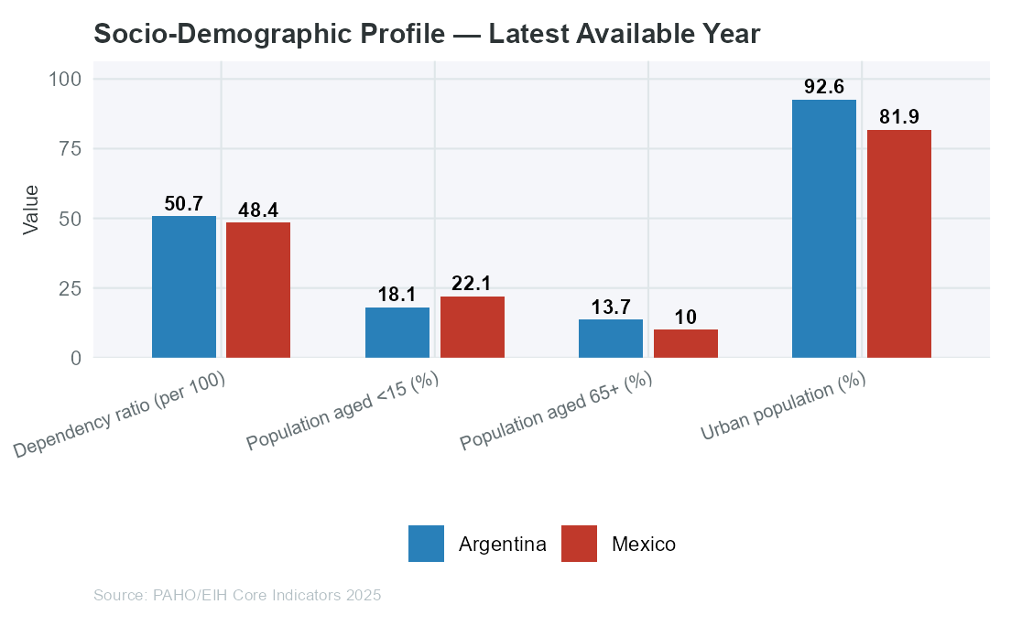

Urbanization and Age Structure
Argentina is one of the most urbanized countries in Latin America, with a larger share of its population aged 65 and over, reflecting a more advanced demographic transition. Mexico has a younger age structure overall, which simultaneously represents a demographic dividend and a policy challenge: a large working-age population that is increasingly exposed to NCD risk factors.

The dependency ratio — defined as the proportion of economically inactive (young and elderly) relative to the working-age population — shapes both the demand for health services and the fiscal capacity to fund them. Argentina's older population increases the burden of age-related chronic disease; Mexico's younger population concentrates risk in the reproductive and working-age cohorts.

■ Context Callout: Argentina median age is higher than Mexico's, signalling a more advanced aging transition. This drives a chronic disease burden profile weighted toward cardiovascular disease and cancer in Argentina, versus a mixed burden in Mexico.

IV. Life Expectancy and Healthy Aging
Life expectancy at birth is the most widely cited summary measure of population health. The sex-disaggregated trend reveals both the magnitude of the female survival advantage and the distinct trajectories of each country.

Figure 1 — Life Expectancy at Birth: Total Population Trend
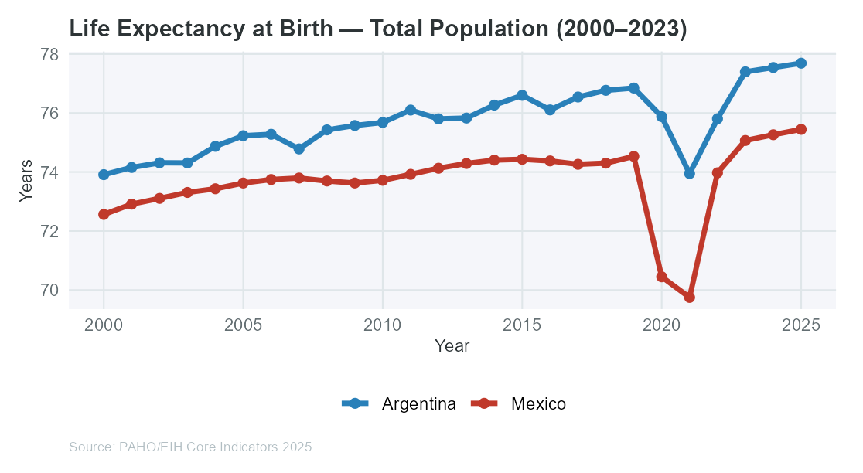

Figure 2 — Life Expectancy by Sex: Latest Year Comparison
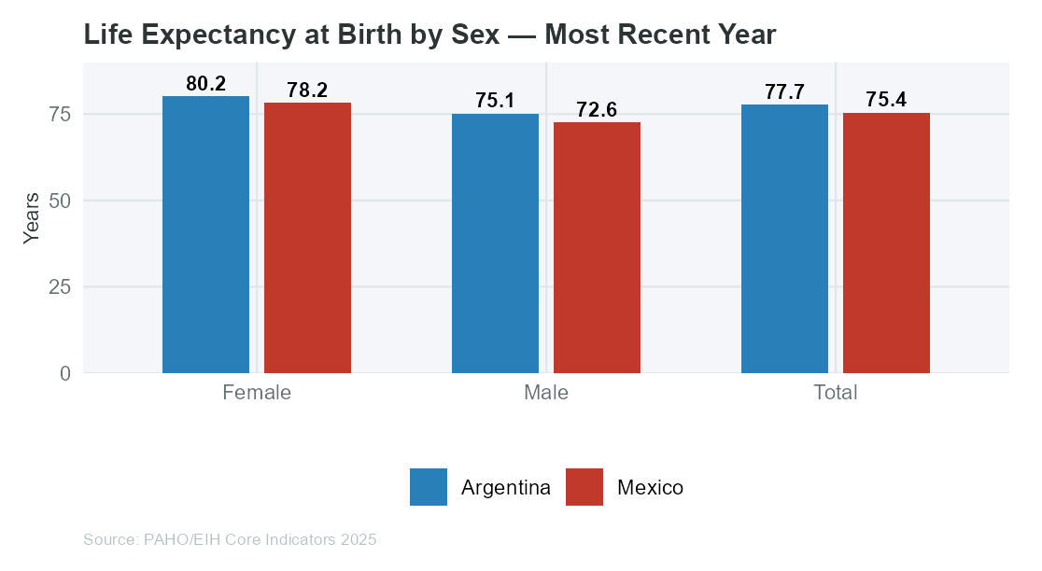

Argentina's life expectancy (77.7 years total; female 80.2 | male 75.1) reflects a pattern of stabilization — gains have slowed compared to previous decades, consistent with cardiovascular disease and injury burdens that disproportionately affect males.

Mexico's total life expectancy of 75.4 years (female 78.2 | male 72.6) shows a different dynamic: the country made consistent gains through the 2000s and 2010s, with notable disruption during the COVID-19 pandemic period. The male-female gap in Mexico (5.6 years) is wider than Argentina's (5.1 years), reflecting Mexico's substantially higher burden of male mortality from external causes and violence.

Figure 3 — Gender Gap in Life Expectancy Over Time
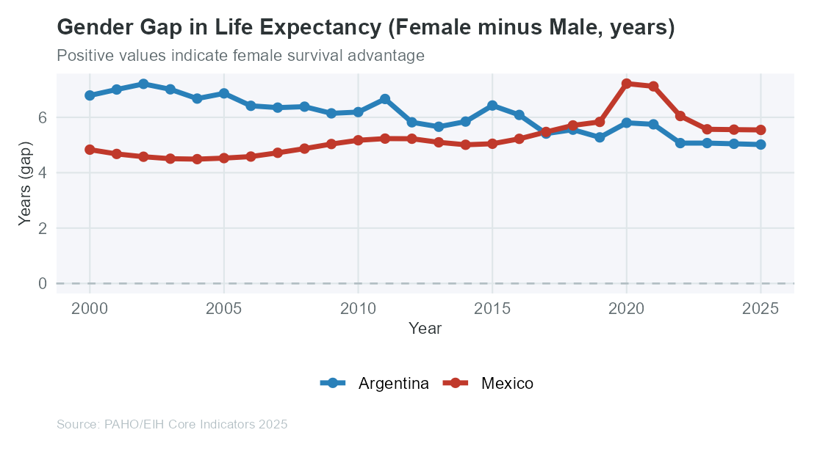

The female survival advantage is a consistent structural feature in both countries. Biologically, women benefit from hormonal protection against cardiovascular disease in the pre-menopausal period. Socially, men face higher occupational hazards, higher rates of tobacco and alcohol use, and greater exposure to interpersonal violence — factors that compound biological differences into a measurable mortality gap.

■ Context Callout: If Mexico's male life expectancy converged to its female level, it would represent approximately 5.6 additional years of male life — an enormous public health dividend achievable through violence prevention, alcohol policy, and NCD management.

V. Mortality Analysis by Sex

5.1 Maternal and Infant Mortality: Reproductive Health Baseline
Maternal and infant mortality represent critical benchmarks for reproductive health system performance. These indicators are inherently sex-specific and reflect both the quality of obstetric care and the broader social determinants of maternal wellbeing.

Figure 4 — Maternal Mortality Ratio Trend
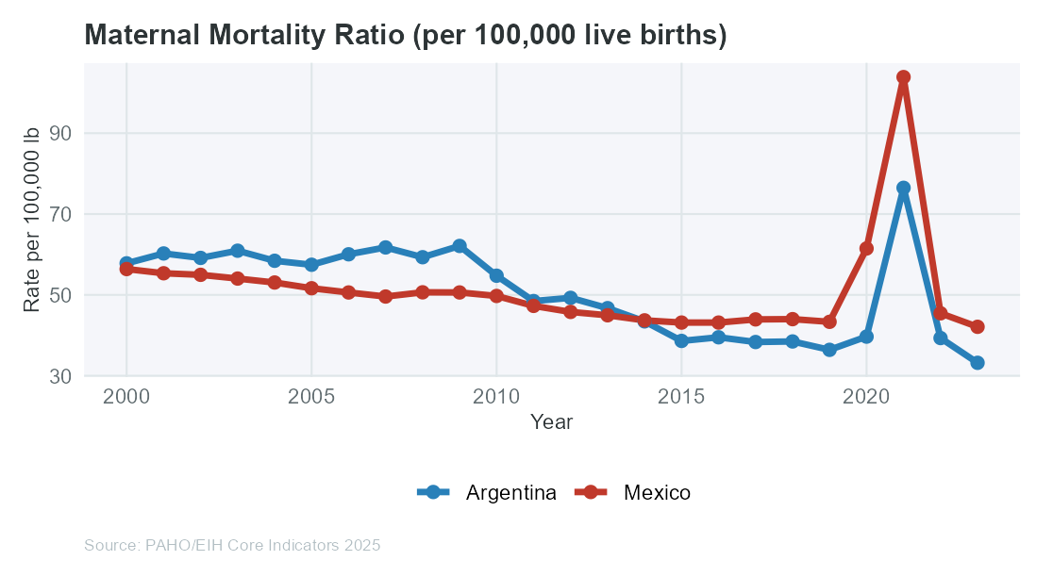

Figure 5 — Infant Mortality Rate Trend
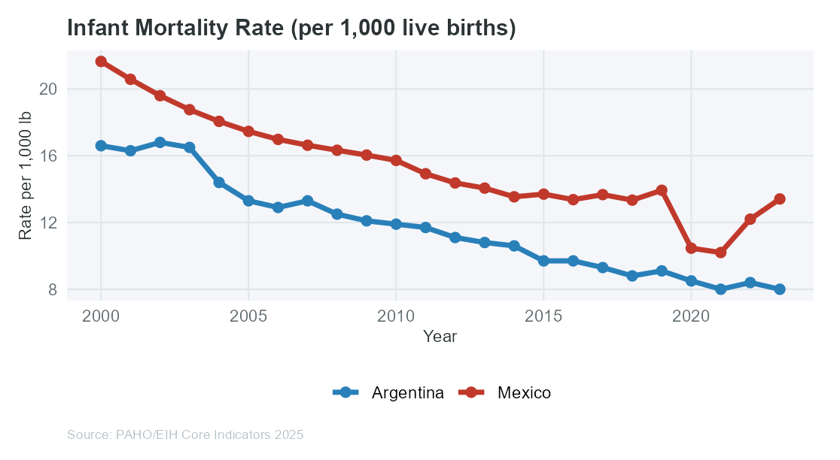

Argentina's maternal mortality ratio of 33.2 per 100,000 live births is a persistent policy concern despite sustained healthcare investment. The stagnation in reduction — compared to faster declines in peer countries — suggests geographic and socioeconomic inequalities in access to quality obstetric care, particularly in the northwestern provinces.

Mexico's maternal mortality ratio of 42.1 per 100,000 live births reflects a higher baseline. Indigenous and rural women face disproportionate risks due to geographic barriers to skilled birth attendance and emergency obstetric care. Both countries fall short of the SDG target of less than 70 per 100,000 live births.

Infant mortality in both countries has declined substantially since 2000. Argentina (8 per 1,000 lb) and Mexico (13.4 per 1,000 lb) reflect improved neonatal care, immunization expansion, and oral rehydration programs. However, significant subnational disparities remain hidden within these national averages.

5.2 Adult Mortality: External Causes and the Male Disadvantage
External causes — encompassing accidents, homicide, suicide, and road injuries — represent a major driver of the male mortality disadvantage in both countries. The pattern is particularly pronounced in Mexico, where organized crime and interpersonal violence create a structural male mortality burden with no equivalent in Argentina.

Figure 6 — External Cause Mortality (age-adjusted per 100,000)
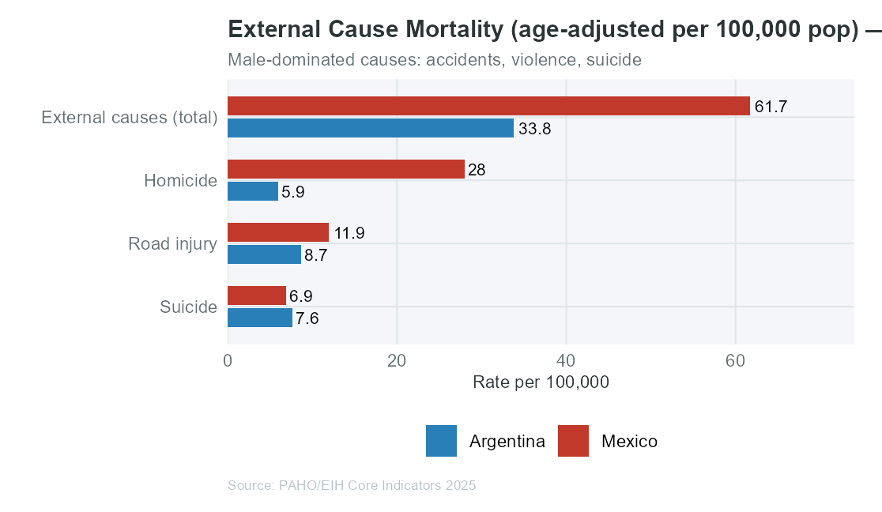

Mexico's external cause mortality rate (61.7 per 100,000) substantially exceeds Argentina's (33.8 per 100,000). The homicide rate differential is particularly stark: Mexico (28) vs Argentina (5.9) per 100,000 population. In Mexico, homicide is predominantly a male phenomenon — over 85% of homicide victims are male — and is the single largest contributor to the gender gap in life expectancy.

Argentina's mortality profile shows a higher relative weight of chronic disease as a cause of premature male death, consistent with a more advanced epidemiological transition. Road injuries and suicide contribute meaningfully to male excess mortality in Argentina, where mental health policy has historically received less investment relative to physical health infrastructure.

■ Context Callout: In Mexico, violence is a gender health issue. The feminization of safety — where women bear the indirect health costs of violence through bereavement, caregiving, and fear-constrained mobility — is not captured in mortality statistics but is a critical dimension of the gender health gap.

VI. Non-Communicable Diseases and Risk Factors
The epidemiological transition in Latin America has placed non-communicable diseases at the center of the public health agenda. Both Argentina and Mexico face high and rising NCD burdens, though the distribution across risk factors and population groups differs in ways that carry policy implications.

Figure 7 — NCD Mortality Rates (age-adjusted, latest year)
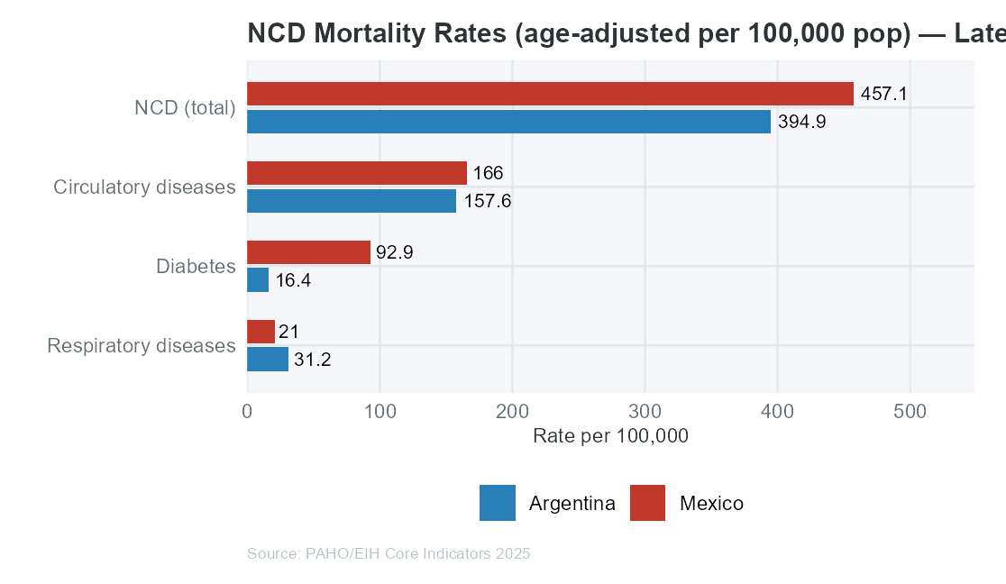

Figure 8 — NCD Risk Factor Prevalence in Adults
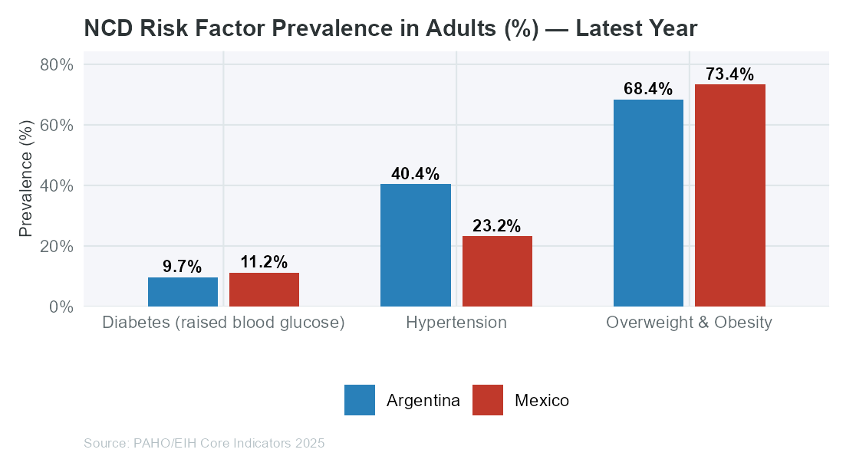

Overweight and obesity prevalence in Mexico (73.4%) exceeds Argentina (68.4%), making Mexico one of the highest-burden countries globally for this indicator. The Mexican dietary transition — characterized by rapid adoption of ultra-processed foods, sugary beverages, and reduced traditional diet adherence — has been well-documented and is more advanced than in Argentina.

Diabetes prevalence (raised blood glucose) shows Mexico at 11.2% vs Argentina at 9.7%. This difference reflects both the higher obesity burden and genetic susceptibility factors in Mexico's indigenous population groups. The gender dimension is significant: in Mexico, women of reproductive and working age show disproportionately high diabetes prevalence, contributing to adverse maternal outcomes and economic productivity losses.

Hypertension (raised blood pressure) is comparable in both countries: Mexico at 23.2% and Argentina at 40.4%. In Argentina, hypertension is a leading contributor to cardiovascular mortality in males, reflecting higher salt intake and lower physical activity in urban areas.

Figure 9 — Overweight and Obesity Prevalence Trend
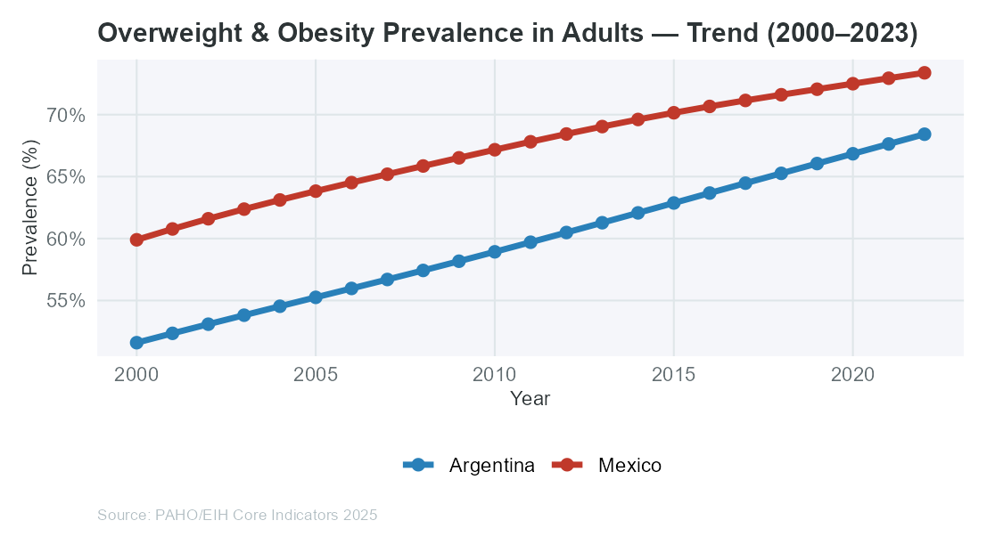

The obesity trend shows consistent upward trajectories in both countries since 2000. Mexico's rate has risen faster and from a higher base, suggesting that without structural food policy interventions, this trajectory will continue to drive diabetes, cardiovascular disease, and cancer incidence in the coming decades.

■ Context Callout: Mexico introduced a sugar-sweetened beverage tax in 2014 — one of the first countries in Latin America to do so. Evidence suggests a modest reduction in consumption, particularly among lower-income households. Argentina has not yet implemented a comparable national-level fiscal measure.

VII. Communicable Diseases and Vaccination
While both Argentina and Mexico have advanced through the epidemiological transition, communicable diseases retain public health relevance — particularly for vulnerable populations and subnational regions with limited health system access.

Figure 10 — HIV and Tuberculosis Indicators (latest year)
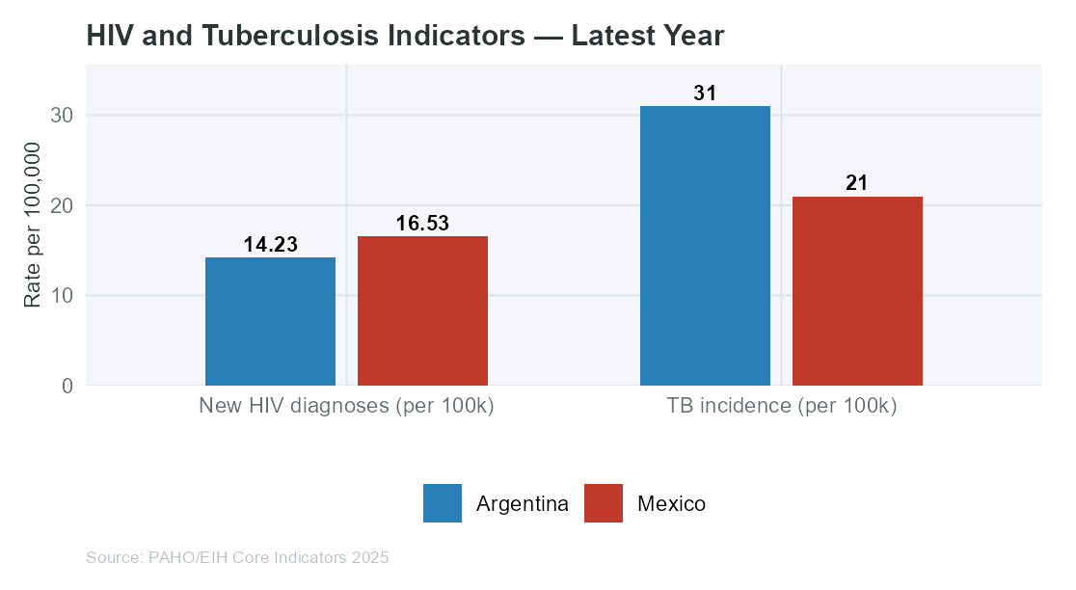

Tuberculosis incidence: Argentina (31 per 100,000) vs Mexico (21 per 100,000). TB remains a disease of poverty and crowding. Both countries show declining trends, attributable to expanded DOTS programs and improved housing conditions. However, subnational variation remains significant — Argentina's northwestern provinces and Mexico's southern states carry disproportionate burden.

HIV new diagnoses rate: Argentina (14.2) vs Mexico (16.5) per 100,000 population. The gender dimension of HIV in Latin America reflects a pattern of growing heterosexual transmission. While men who have sex with men (MSM) remain the highest-risk group in both countries, women — particularly young women — face increasing vulnerability through heterosexual transmission pathways linked to partner violence, lack of negotiating power, and socioeconomic dependence.

Figure 11 — Immunization Coverage vs WHO 95% Target
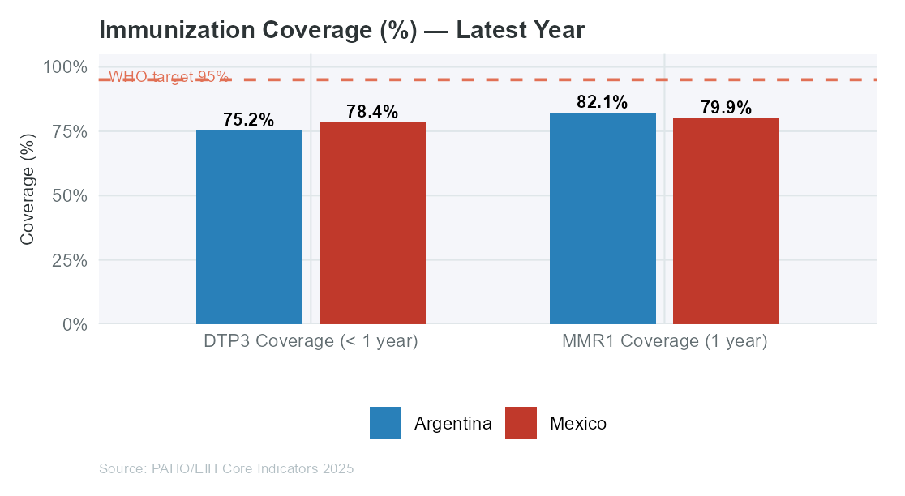

Vaccination coverage serves as a proxy for health system reach and equity. The WHO's 95% coverage threshold for herd immunity is a critical benchmark. Both countries show strong institutional immunization programs, though post-pandemic recovery in coverage rates remains incomplete in some sub-national areas. Vaccination coverage is a gender-neutral indicator that primarily reflects system infrastructure rather than sex-specific behavioral differences.

■ Context Callout: Vaccine hesitancy has emerged as a challenge in urban Argentina following the COVID-19 pandemic, particularly affecting MMR coverage in middle-income neighborhoods — a non-traditional hesitancy profile distinct from the access-driven coverage gaps typical of rural Mexico.

VIII. Health System Capacity and Access
Health outcomes are shaped not only by epidemiological exposure but by the system's capacity to detect, treat, and prevent disease. Argentina and Mexico represent contrasting models of health system organization in Latin America.

Figure 12 — Health System Capacity Indicators (latest year)
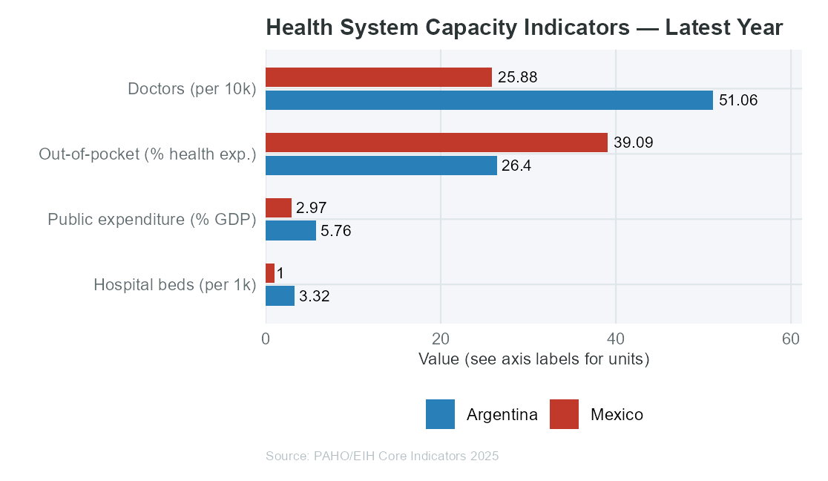

Argentina's physician density of 51.1 per 10,000 population significantly exceeds Mexico's 25.9 per 10,000. This reflects Argentina's long tradition of medical education investment and the concentration of specialists in Buenos Aires and major provincial capitals. However, geographic maldistribution means that rural and indigenous communities in both countries access fewer physicians than national averages suggest.

Hospital beds: Argentina (3.3 per 1,000 pop) vs Mexico (1 per 1,000 pop). Argentina's higher bed density reflects the Obras Sociales system's investment in facility infrastructure. Mexico's lower bed ratio, combined with high out-of-pocket expenditure (39.1% of current health expenditure), indicates higher financial risk for households facing acute illness — a burden that falls disproportionately on women, who are more likely to be uninsured due to informal employment patterns.

Public health expenditure as a share of GDP: Argentina (5.8%) vs Mexico (3%). Mexico's lower public investment relative to GDP — despite IMSS-Bienestar expansion — means that a larger share of health costs are borne by households, creating a regressive financing dynamic that widens health inequalities.

■ Context Callout: Out-of-pocket expenditure in Mexico (39.1%) vs Argentina (26.4%) represents a structural difference in financial protection. High OOP spending is a key driver of medical impoverishment, particularly for chronic disease management where ongoing medication costs accumulate.

IX. Discussion: The Gender Gap in Health

9.1 The Female Survival Advantage and Its Limits
Women in both Argentina and Mexico live longer than men — a universal biological pattern reinforced by behavioral and social factors. Yet this survival advantage does not translate into equivalent quality of life. Women face specific health burdens that aggregate mortality statistics conceal: maternal mortality, gender-based violence sequelae, mental health conditions disproportionately linked to care work and economic dependence, and the physical toll of unpaid domestic and care labor.

9.2 Social Determinants Explaining the Sex-Disaggregated Differences
Employment and economic autonomy: In both countries, women's labor force participation is lower and concentrated in informal sectors without social insurance. In Mexico, approximately 55% of employed women work informally, compared to 45% of men. Informal employment excludes workers from IMSS coverage — the primary public health insurer — creating a systematic gender gap in health access.

Care work burden: Women in Argentina and Mexico perform 3-4 times more unpaid care work than men (ECLAC time-use surveys). This structural allocation of care labor limits women's time for preventive health behaviors, delays care-seeking, and generates chronic stress exposures linked to hypertension, mental health disorders, and immune function.

Gender-based violence: Argentina's femicide rate and Mexico's alarmingly high femicide numbers represent the most visible dimension of gender-based health risk. Beyond mortality, intimate partner violence is associated with a range of adverse health outcomes including depression, PTSD, sexually transmitted infections, and adverse pregnancy outcomes. These pathways are systematically underrepresented in standard epidemiological indicator sets.

9.3 Male Mortality Burden: Violence and Chronic Disease
The male excess mortality burden takes different forms in each country. In Mexico, homicide — concentrated among young men aged 15-44 — is the primary driver of the gender gap in life expectancy. In Argentina, the driver is more distributed across cardiovascular disease, suicide, and road injuries — patterns more amenable to chronic disease management and mental health policy.

Male health-seeking behavior is a cross-cutting factor in both countries: men are consistently less likely to attend primary care, less likely to adhere to chronic disease treatment, and more likely to present at emergency services at advanced stages of disease. Masculinity norms that frame help-seeking as weakness represent a structural barrier to closing the male health disadvantage.

X. Conclusions and Recommendations

10.1 Summary of Core Findings

Domain | Argentina | Mexico | Key_Finding
Life Expectancy | 77.7 yrs total | 75.4 yrs total | ARG marginally higher, both stabilizing
Gender Gap | 5.1 yrs (F>M) | 5.6 yrs (F>M) | MEX gap wider — driven by violence
Maternal Mortality | 33.2 per 100k lb | 42.1 per 100k lb | Both above SDG target; ARG stagnated
External Cause Mortality | 33.8 per 100k | 61.7 per 100k | MEX significantly higher — homicide burden
Obesity | 68.4% | 73.4% | MEX higher; both above regional median
Health System Access | 51.1 doctors per 10k | 25.9 doctors per 10k | ARG higher density but maldistributed

10.2 Recommendations for Argentina
1. Maternal Health: Invest in obstetric emergency infrastructure and skilled birth attendance in the NOA (Northwest Argentina) and NEA (Northeast Argentina) regions, where maternal mortality ratios exceed the national average by 2-3x. Integrate intercultural health models to reduce barriers for indigenous women.

2. Male Mental Health and Suicide Prevention: Implement gender-sensitive mental health programs targeting working-age men, addressing help-seeking barriers through occupational health settings and community-based interventions.

3. Hypertension and Cardiovascular Risk: Expand sodium reduction initiatives and community-based blood pressure screening, with a focus on male primary care engagement strategies to address the chronic disease male mortality contribution.

10.3 Recommendations for Mexico
1. Violence Prevention as Public Health: Frame homicide reduction as a health policy priority. Expand community-based violence prevention programs (e.g., Cure Violence model) in high-burden municipalities. Integrate gender-based violence response into primary care.

2. Chronic Disease in Women: Develop targeted diabetes prevention and management programs for women of reproductive age, with particular focus on gestational diabetes screening and postpartum metabolic follow-up to break the intergenerational cycle of metabolic risk.

3. Financial Protection: Accelerate IMSS-Bienestar coverage expansion to reduce out-of-pocket expenditure, particularly for informal sector workers — a group disproportionately composed of women. Introduce catastrophic illness financial protection mechanisms for chronic NCD management.

10.4 Cross-Cutting Recommendations
• Expand sex-disaggregated reporting in PAHO datasets beyond life expectancy, including NCD prevalence, mental health, and health system utilization by sex.
• Adopt a gender-transformative approach to health policy that addresses not just biological sex differences but the social determinants that produce them.
• Invest in subnational data disaggregation to make national-level improvements visible at the provincial/state level, where the largest inequalities persist.

Technical Note
Visualizations and Data Processing

All visualizations in this report were generated programmatically using R (ggplot2) from the same PAHO dataset powering the Americas Health Core Indicators Dashboard. Charts reflect the most recent available data year for each indicator and country. Data was processed through a reproducible R pipeline (app.R) that excludes PAHO source-encoded negative values treated as missing data.

Indicators Used:
Section | Indicator | Type
III | Urban Population (%), Dependency ratio, Pop. aged 65+, Pop. aged <15 | Contextual
IV | Life expectancy at birth (years) | Contextual
IV | Life expectancy at birth (years); female / male | Sex-disaggregated
V | Estimated maternal mortality ratio (100,000 lb) | Female-specific
V | Infant mortality rate (1,000 lb) | Contextual
V | External causes, Homicide, Road injury, Suicide mortality rate | Male-dominant
VI | NCD, Diabetes, Circulatory, Respiratory mortality rates | Aggregate
VI | Overweight & obesity, Diabetes, Hypertension prevalence (%) | Aggregate
VI | Overweight & obesity trend | Aggregate trend
VII | New HIV diagnoses rate, TB incidence rate | Aggregate
VII | DTP3 and MMR1 immunization coverage (%) | Contextual
VIII | Doctors per 10k, Hospital beds, OOP expenditure, Public exp. % GDP | Contextual

Report generated: April 1, 2026 | Dashboard: https://ezequielbassa.shinyapps.io/3Epidemiology/ | Data: PAHO/EIH Open Data Core Indicators 2025

