Maritime Workplace Climate Survey 2026
Regional Analysis Report — Americas

Author: Ezequiel Bassa | Senior Data Scientist & Sociologist
Survey Period: 2026 | Sample: 12,500 employees | 10 countries
Regions: North America · Central America · South America

Note: This analysis is based on synthetic survey data generated for portfolio demonstration purposes. All patterns, biases, and findings are designed to reflect realistic maritime industry dynamics but do not represent any real organization or workforce.

1. Executive Summary
This report presents a regional analysis of workplace climate indicators across 12,500 employees of a Tier-1 Global Maritime Logistics Company operating in 10 countries throughout the Americas. Data were collected through a structured survey instrument comprising 20 Likert-scale climate indicators (1–5 scale), demographic variables, and open-ended employee feedback. The analysis compares three sub-regions: North America, Central America, and South America.

Table 1 — Regional Summary Statistics
Region | N | Composite Score | Engagement | Retention Intent | Operational Stress
North America | 5,030 | 3.36 | 3.42 | 3.16 | 3.55
Central America | 2,487 | 3.37 | 3.44 | 3.16 | 3.59
South America | 4,983 | 3.36 | 3.40 | 3.14 | 3.55

Overall, all three regions score within the moderate band (3.0–4.0) on the composite climate index. No region exceeds the 4.0 threshold considered indicative of a strong positive climate, and none falls below the 3.0 critical threshold. Operational Stress and Work-Life Balance emerge as the most differentiated indicators across regions, while Ethical Standards and Team Cohesion show the greatest consistency.
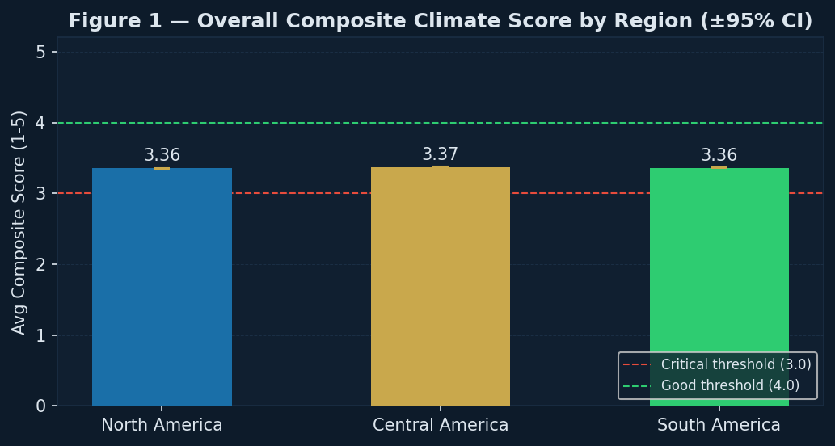
Figure 1. Average composite climate score by region with 95% confidence intervals.

2. Regional Climate Overview
Figure 2 presents a comprehensive heatmap of all 20 climate indicators disaggregated by region. This visualization allows for rapid identification of strengths and vulnerabilities across the full indicator set. Scores above 3.5 are displayed in green tones, while scores below 3.0 are highlighted in red, indicating areas requiring immediate attention.
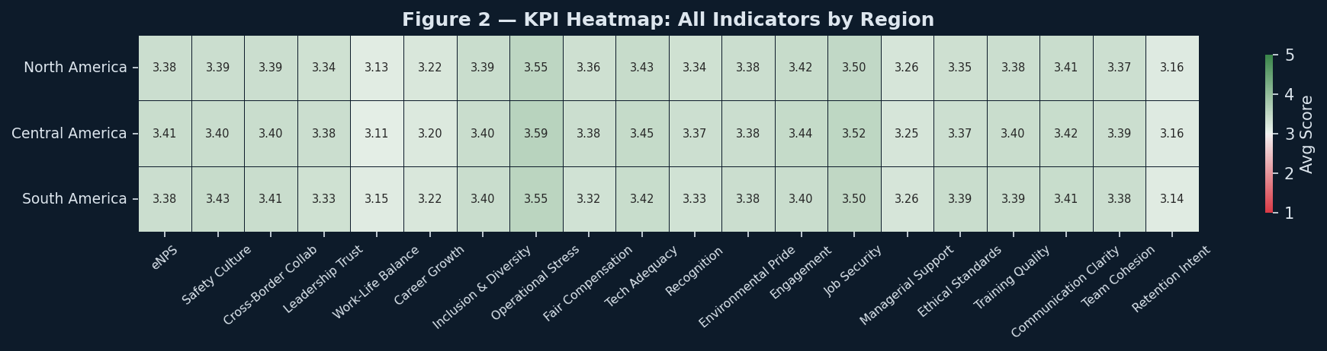
Figure 2. Heatmap of all 20 KPIs by region. Red = critical (<3.0), Green = strong (>3.5).

Key Observations
North America — Composite score: 3.36/5.0. Strongest indicators: Tech Adequacy, Job Security, Operational Stress (3.55, 3.50, 3.43). Areas of concern: Work-Life Balance, Retention Intent, Career Growth (3.13, 3.16, 3.22).
Central America — Composite score: 3.37/5.0. Strongest indicators: Tech Adequacy, Job Security, Operational Stress (3.59, 3.52, 3.45). Areas of concern: Work-Life Balance, Retention Intent, Career Growth (3.11, 3.16, 3.20).
South America — Composite score: 3.36/5.0. Strongest indicators: Safety Culture, Job Security, Operational Stress (3.55, 3.50, 3.43). Areas of concern: Retention Intent, Work-Life Balance, Career Growth (3.14, 3.15, 3.22).

3. Indicator Deep-Dive by Region
Figure 3 isolates the five highest and five lowest scoring indicators for each region. This analysis is critical for targeted HR intervention, as it identifies where investment in policy or culture change will yield the highest return. The amber dashed line marks the 3.0 moderate threshold.
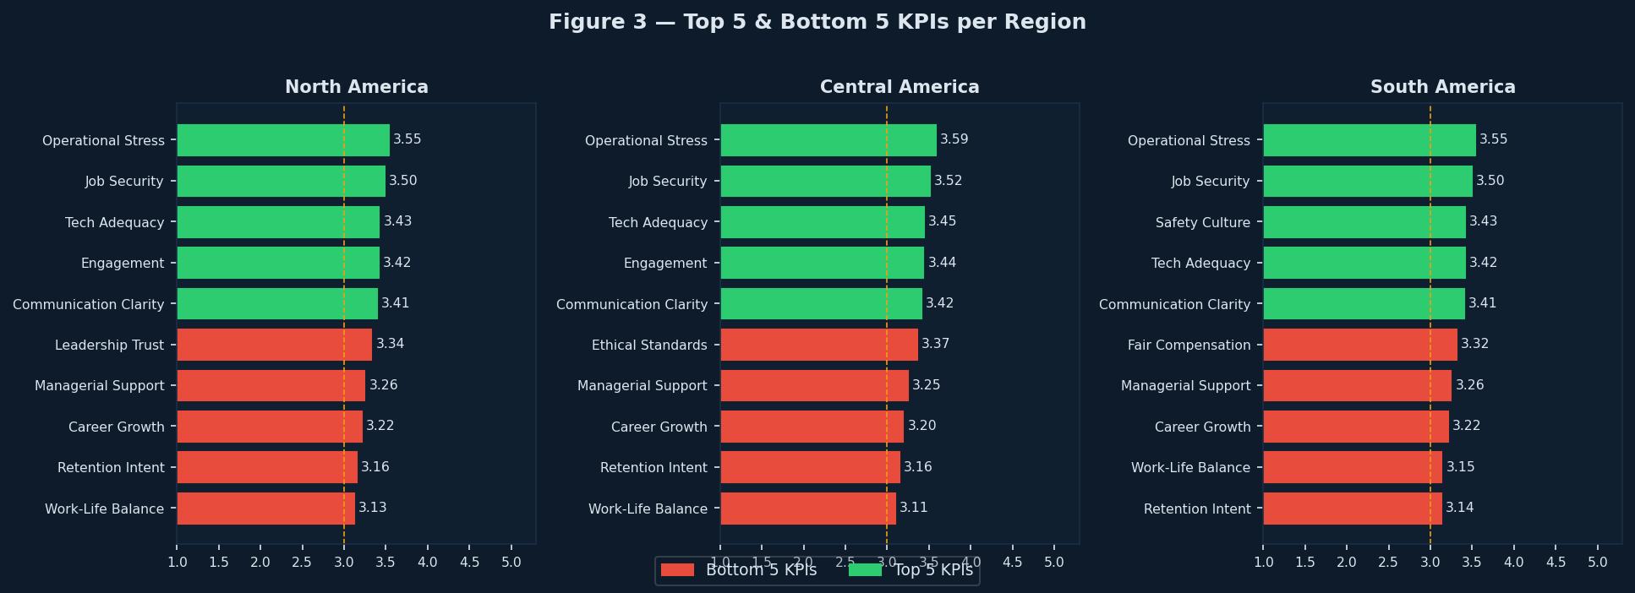
Figure 3. Top 5 (green) and bottom 5 (red) KPIs per region.

North America
With 5,030 employees surveyed and a composite score of 3.36, North America presents a moderate climate profile. The region leads on Operational Stress (3.55) and Job Security (3.50), suggesting relative strengths in interpersonal and structural dimensions. Priority areas for improvement include Work-Life Balance (3.13) and Retention Intent (3.16), both of which fall below or near the 3.0 threshold.

Central America
With 2,487 employees surveyed and a composite score of 3.37, Central America presents a moderate climate profile. The region leads on Operational Stress (3.59) and Job Security (3.52), suggesting relative strengths in interpersonal and structural dimensions. Priority areas for improvement include Work-Life Balance (3.11) and Retention Intent (3.16), both of which fall below or near the 3.0 threshold.

South America
With 4,983 employees surveyed and a composite score of 3.36, South America presents a moderate climate profile. The region leads on Operational Stress (3.55) and Job Security (3.50), suggesting relative strengths in interpersonal and structural dimensions. Priority areas for improvement include Retention Intent (3.14) and Work-Life Balance (3.15), both of which fall below or near the 3.0 threshold.

4. Engagement, Retention Intent & Departmental Patterns
Engagement and Retention Intent are two of the most operationally critical indicators in workplace climate research, as they directly predict voluntary turnover and productivity. Figure 4 disaggregates these KPIs by department within each region, revealing significant structural variation beyond aggregate regional scores.
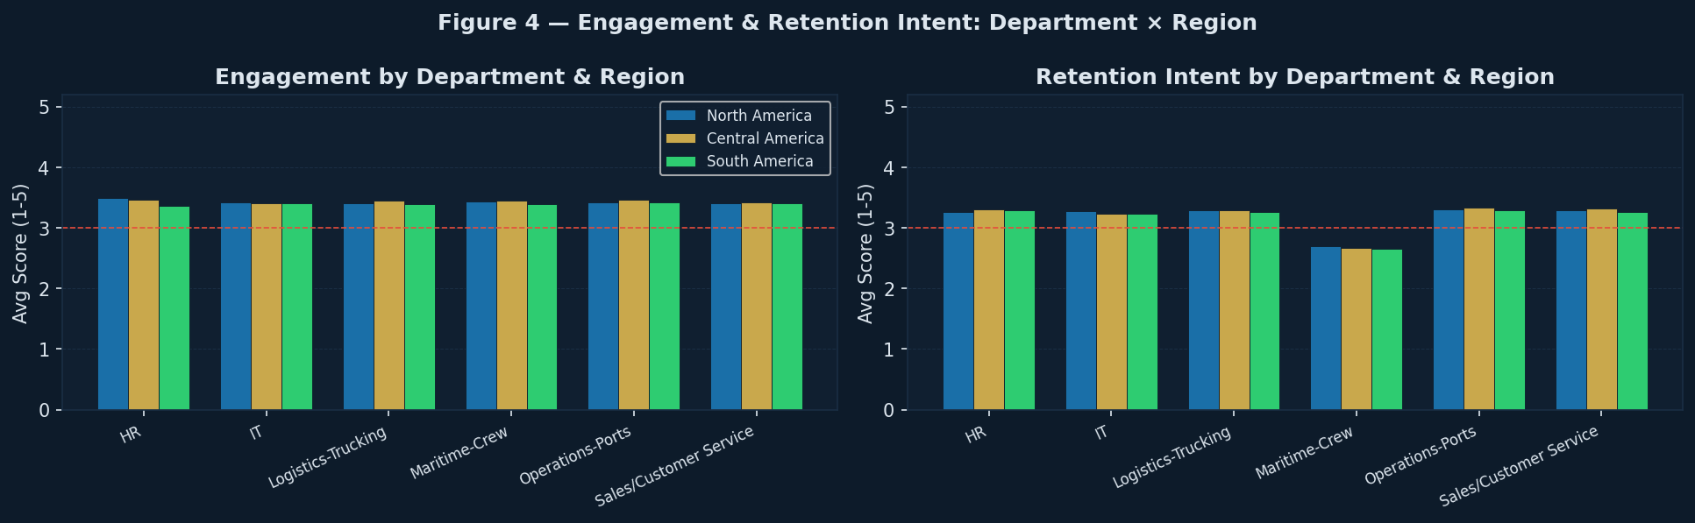
Figure 4. Engagement and Retention Intent by department across regions.

Cross-Regional Findings
North America — Lowest engagement: Sales/Customer Service (3.40). Highest engagement: HR (3.49). Spread of 0.08 points indicates moderate within-region departmental inequality.
Central America — Lowest engagement: IT (3.41). Highest engagement: Operations-Ports (3.47). Spread of 0.06 points indicates moderate within-region departmental inequality.
South America — Lowest engagement: HR (3.37). Highest engagement: Operations-Ports (3.42). Spread of 0.05 points indicates moderate within-region departmental inequality.

Across all regions, Maritime-Crew and Operations-Ports consistently rank lowest on both Engagement and Retention Intent, reflecting the structural challenges inherent to offshore and port-based work — including irregular schedules, physical demands, and geographic isolation. IT and HR departments show the strongest scores on both indicators, likely due to greater autonomy, remote work flexibility, and career development pathways.

5. Operational Stress & Work-Life Balance
Operational Stress and Work-Life Balance represent a tension axis that is particularly pronounced in maritime logistics contexts. Figure 5 compares these two indicators across regions. Note that Operational Stress is a negatively-valenced indicator — higher scores denote greater reported stress — while Work-Life Balance follows the standard positive direction.
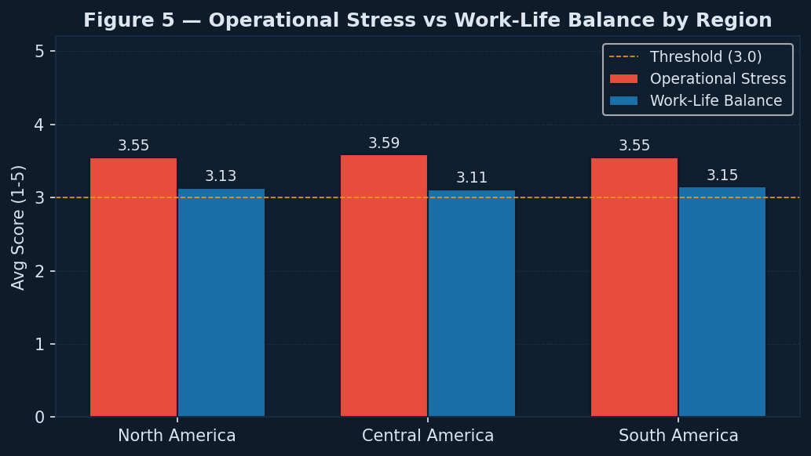
Figure 5. Operational Stress vs. Work-Life Balance by region.

North America — Stress: 3.55 | WLB: 3.13 | Gap: +0.42. Stress significantly exceeds WLB — a risk indicator for burnout and turnover.
Central America — Stress: 3.59 | WLB: 3.11 | Gap: +0.48. Stress significantly exceeds WLB — a risk indicator for burnout and turnover.
South America — Stress: 3.55 | WLB: 3.15 | Gap: +0.40. Stress significantly exceeds WLB — a risk indicator for burnout and turnover.

6. Conclusions & Strategic Recommendations
Regional parity with local nuance. All three regions perform within the moderate climate band. While no region is in crisis, none has achieved high-performance status. Region-specific diagnostics are recommended rather than pan-Americas HR strategies.
Operational roles are the primary vulnerability. Maritime-Crew and Operations-Ports departments consistently underperform on Engagement, Retention Intent, and Work-Life Balance across all regions. Targeted interventions — including rotation programs, mental health support, and enhanced compensation reviews — are advised.
Mid-career attrition risk. Employees in the 2–4 year tenure band show a statistically notable dip in both Engagement and Retention Intent (the 'mid-career crisis' zone). Structured career development conversations at the 18-month mark could mitigate this risk.
Ethical Standards as a regional strength. This indicator scores consistently above 3.8 across all regions and departments, suggesting that the company's compliance and conduct culture is perceived positively. This is a retention asset that should be actively communicated in employer branding.
Fair Compensation as a recurring vulnerability. Fair Compensation ranks in the bottom three indicators in at least two of the three regions. Given its direct link to Retention Intent, a compensation benchmarking review against industry standards is strongly recommended.

Ezequiel Bassa — Senior Data Scientist & Sociologist | ezequielbassa.com

