Mermaid “Coding”

Mermaid is a coding language of sorts. It’s very simple. For complex flow charts, it’s tremendously helpful to keep things clear and organized.

The Basic Setup

The following coding example will be referenced by #1-5.

NodeName1[text that goes in node1]-->NodeName2[text that goes in node2]

The code above generates this:

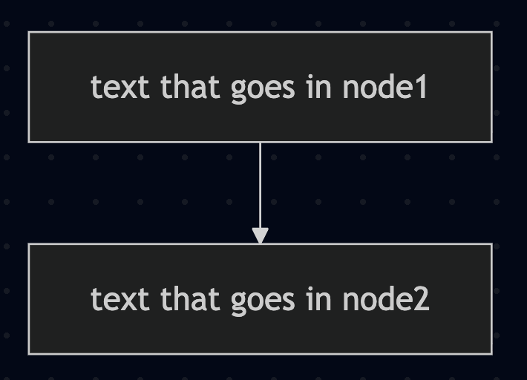

Here’s the breakdown:

- ”NodeName1” and “Nodename2” are, as the names imply, the names of the nodes. These can be anything. They could be “A” and “B” or “1237549” and “3875930” or whatever. To help keep things clear, it’s best to use a node name that reflects the task described.

For example: Nurse_PulseCheck[Check patient’s pulse]

- The next thing following the node name is the shape of the node (rectangle, circle, diamond…). This is determined by whether you use brackets [ ] or any one of the other similar things like parentheses etc…

  - If you use brackets [ ], you get a square node.
  - If you use parentheses, you get a square with rounded corners.
  - If you use squiggly brackets { }, you get a diamond (which, by convention, should be used for decision points).
  - See the cheat sheet link at the bottom for what your options are. There are ~ 30.

Note: Different shaped nodes can imply different things. See “Best Practices” Tab.

Example:

flowchart TD
NodeName1[text that goes in node1]-->NodeName2(is made with parentheses)-->NodeName3{is made with squiggly brackets}

The code above generates this:

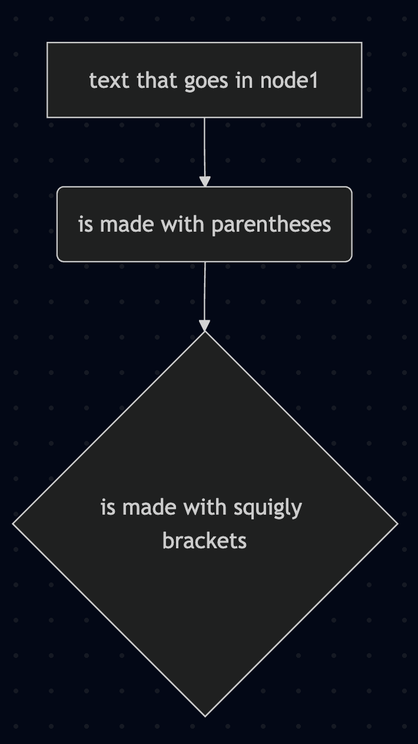

- Then comes the text that you want to show up in the node. Like “Vital signs”

- The close bracket signifies that you’re done with what you want to be contained in the node

- The arrow indicates how you want to connect this node to another node. The arrow shape (two dashes followed by a > sign) gets you… an arrow. Three dashes “- - -“ gets you a dashed line. See cheat sheet tab for all the shapes.

Gettin’ Fancy

That’s the super basics! Now let's get a lil fancy.

- To connect an upstream node to multiple downstream nodes, you have two options:

- List the upstream node multiple times:

- Example:

flowchart TD
NodeName1[text1]-->NodeName2[text2]
NodeName1-->Nodename3[Text3]

The code above generates this:

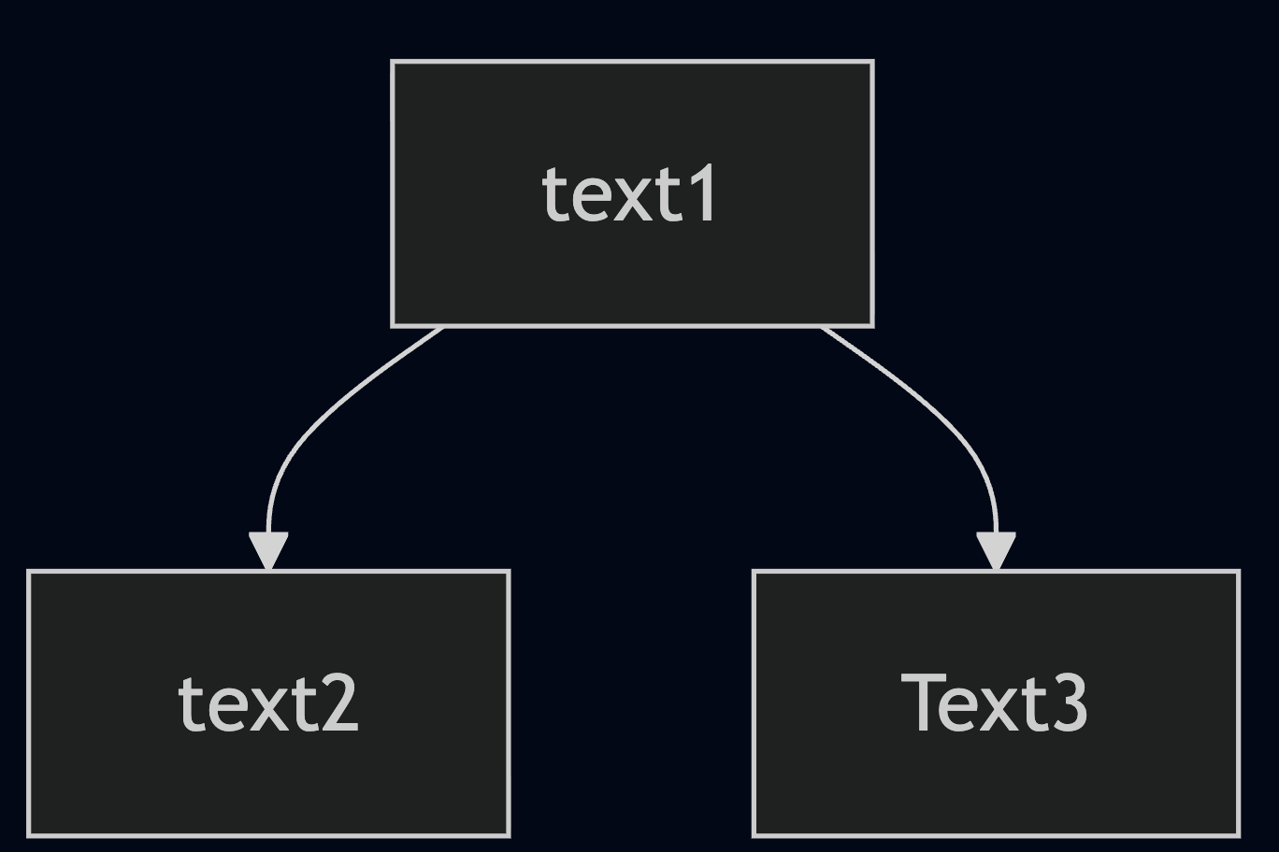

- The same can be reversed to connect 1 downstream to multiple upstream nodes

- Note that the second time a node is referred to in the code, repeating the text content of the node (and its shape) is not necessary.

- List the downstream nodes with & ampersands.

Example:
flowchart TD
NodeName1[text1]-->NodeName2[text2] & Nodename3[Text3]

Renders the same image above.

- If you want the connector between nodes to have text, this is entered after you specify the connector with vertical lines.

Example:

flowchart TD
NodeName1[text1]-->|on Wednesdays|NodeName2[text2]

The code above generates this:

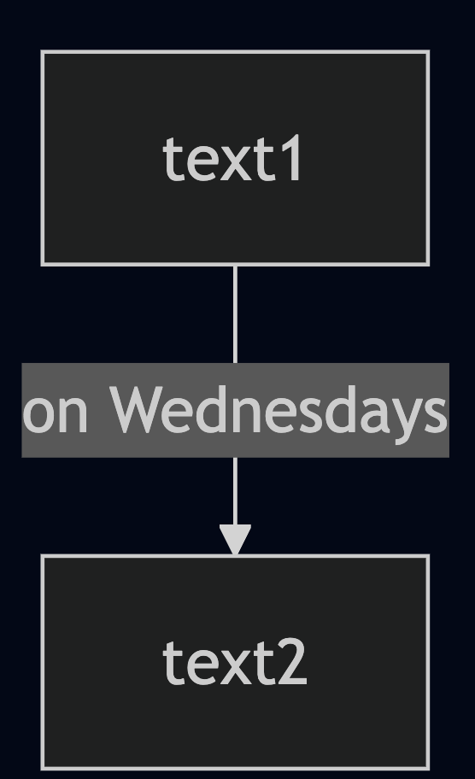

- To add a hyperlink to a node, you need do it like so:

  - click NodeName1 "https://example.com" ["Name of chart you’re linking them to"] [_blank]
  - The stuff in yellow is what you change. Other stuff stays the same.

- The “flowchart TD” part of the code:
  - Flowchart states the type of graph we’re making. Other options are things like pie, timeline, or treemap.
  - TD stands for top down. It specifies the direction of the graph. Other options are things like LR (left to right), RL, or BT (bottom to top).

There’s a bunch of other stuff but most of it is for other types of graphs/visual depictions. But feel free to explore.

Tutorials
https://mermaid.js.org/ecosystem/tutorials.html

Cheatsheet for shapes:
https://mermaid.js.org/syntax/flowchart.html

