Lec_05_Handout.R

ezequielquevedo

2019-04-18

# Class 5 R Graphics  
  
# 2A: Line Plot  
# Read in table  
weight <- read.table("bimm143_05_rstats/weight_chart.txt", header = TRUE)  
# plot to be a filled square, pt size = 1.5X, double line width, scale Y-axis,  
# X-axis title, Y-axis title, Main title  
plot(weight$Age, weight$Weight,   
 pch = 11, cex = 1.5,   
 lwd = 2, ylim = c(2, 10),   
 xlab = "Age (months)", ylab = "Weight (kg)", main = "Baby Weight vs Age")

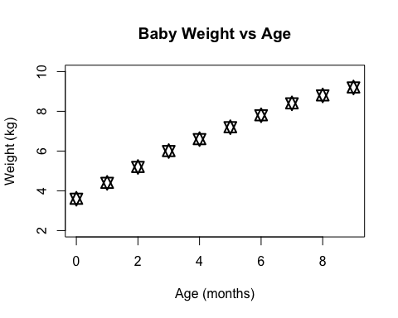

weight$Age

## [1] 0 1 2 3 4 5 6 7 8 9

weight$Weight

## [1] 3.6 4.4 5.2 6.0 6.6 7.2 7.8 8.4 8.8 9.2

plot(weight$Age, weight$Weight)

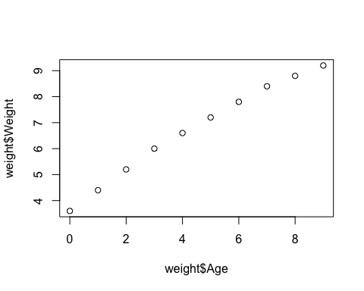

# 2B: Barplot  
# read in table  
# use sep = "\t" as argument for tab delimited data  
nfeatures <- read.table("bimm143_05_rstats/feature_counts.txt",   
 sep = "\t", header = TRUE)  
# View table  
#View(nfeatures)  
# make default barplot  
barplot(nfeatures$Count)

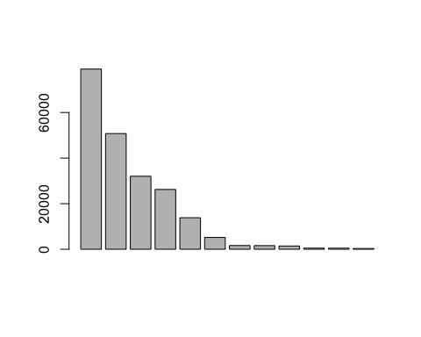

# change global plot margin parameters  
par(mar = c(5.1, 10.1, 4.1, 4.1))  
# make formatted barplot  
barplot(nfeatures$Count,   
 names.arg = nfeatures$Feature, # read in Feature vector as names  
 horiz = TRUE, ylab = "", xlab = "Feature", xlim = c(0, 80000),  
 main = "Feature Counts", las = 1, # las = 1 makes horizontal text labels  
 col = rainbow(12)) # use colors

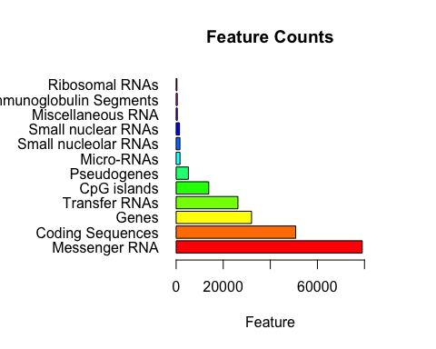

# 2C: Histograms  
x <- c(rnorm(10000), rnorm(10000) + 4) # generate distributions  
hist(x) # default

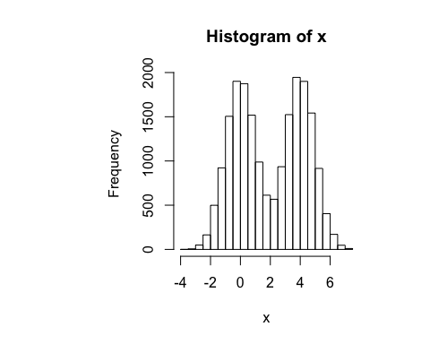

hist(x, breaks = 100)

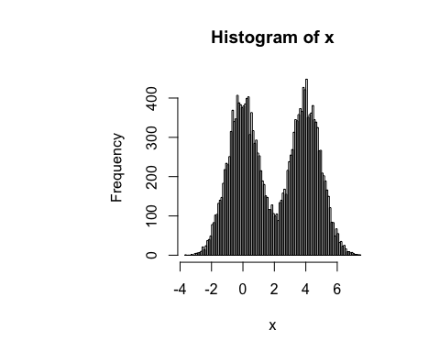

# 3A: Providing Color Vectors  
# read in table using read.delim (US)  
counts <- read.delim("bimm143_05_rstats/male_female_counts.txt")   
#read.delim2 uses comma instead of decimal  
#View(counts)  
par(mar = c(6, 5, 4, 4))  
  
# you can type multipe lines at once by holding down option + command  
barplot(counts$Count,  
 names.arg = counts$Sample,  
 las = 2,  
 col = c("red", "black", "white"),  
 ylim = c(0, 20),  
 ylab = "Frequency")

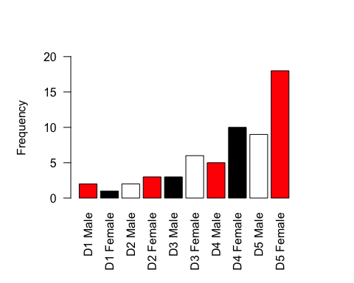

# you can type multipe lines at once by holding down option + command  
barplot(counts$Count,  
 names.arg = counts$Sample,  
 las = 2,  
 col = heat.colors(0), # heat map colors  
 ylim = c(0, 20),  
 ylab = "Frequency")

