4. Architecture, Database and APIs
Author: Noah Bran, Backend Lead. Reviewers: Daksh Kumar, Ezeren Masangcay.
Revision (Oct 20): updated by Sumit Kumar to match the deployed code on main (89ad6c8) and Sections 1, 2 and 5.
Status: Built and deployed. The M2 schema, seed data and all four APIs run on production (sfsu-csc648-06-fall26-team02.vercel.app). Phone → production live position was verified in HSS 349 on Oct 20 (828 pose samples stored across 8 upload periods).

4.1 System architecture
SpatialOS has two clients that only talk to each other through our backend: the Unity iPhone app (localizes with Niantic VPS and sends its pose) and the Next.js web app (home page list/search, /viewer route planning on the 3D scan, /live navigation with the live phone dot). Supabase PostgreSQL 17 stores all data; Supabase Realtime pushes new poses to every open /live page.
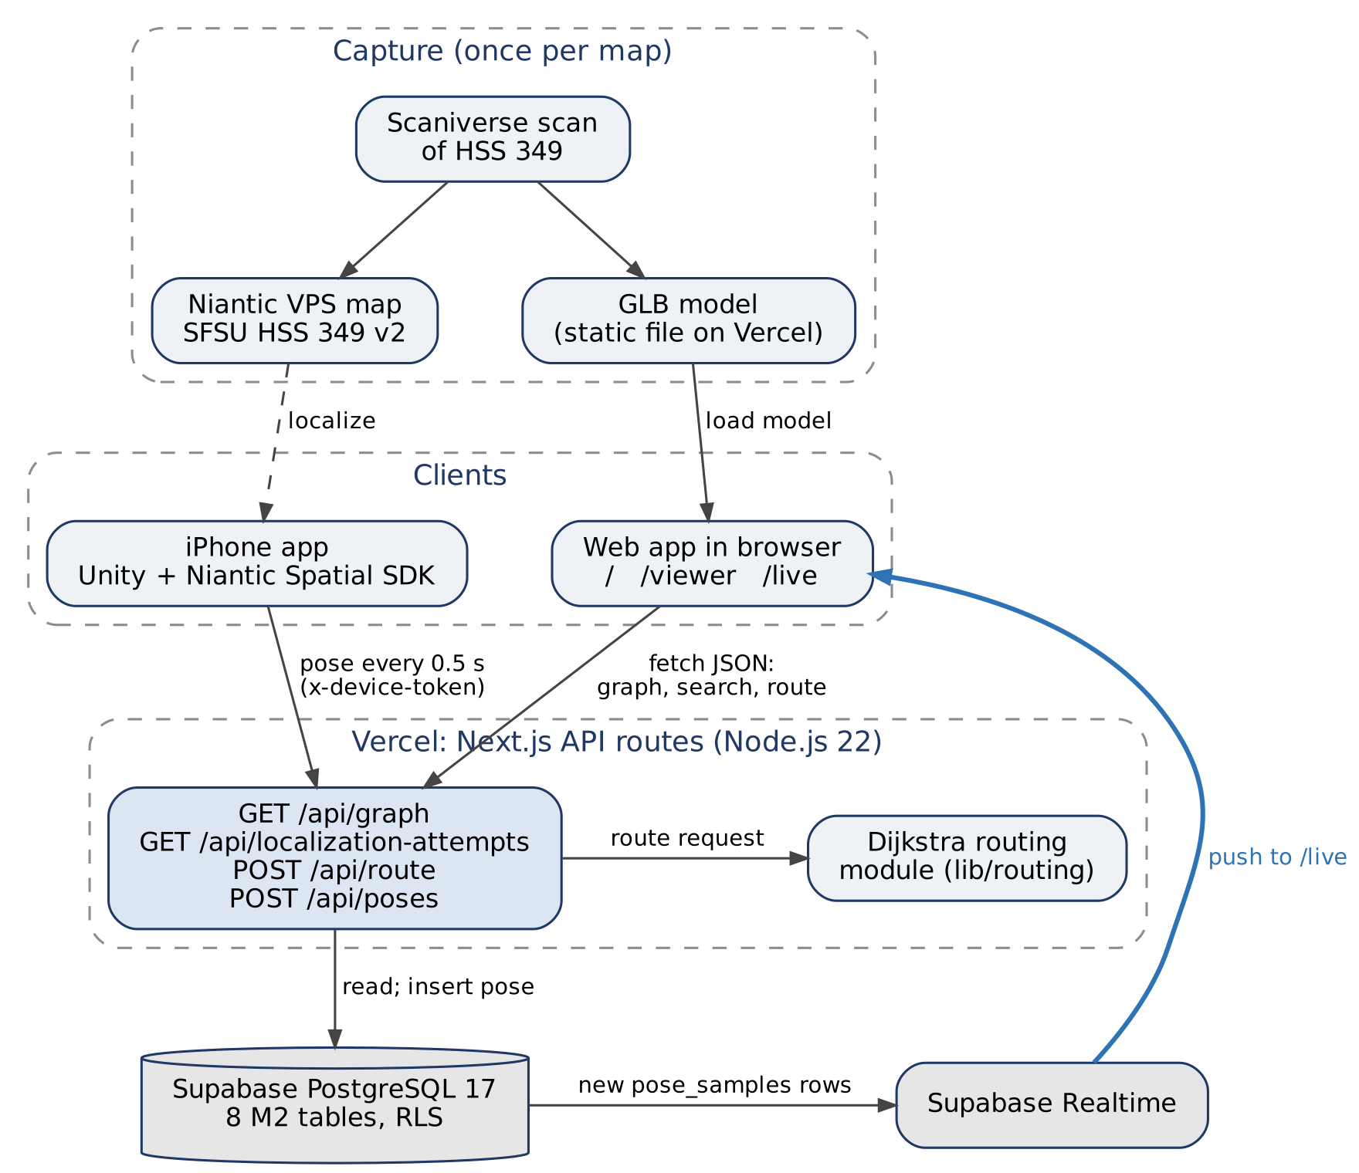
Figure 4.1: M2 system architecture. Diagram source: diagrams/M2_Architecture.dot.
Component | Technology | Role in M2
iPhone app | Unity 6 (6000.3.14f1), C#, Niantic Spatial SDK 4.1, iOS | Localizes against the VPS map; PoseReporter/PoseUploader send the pose every 0.5 s while tracking is valid
Web app | Next.js 16 App Router, React 19, TypeScript, Tailwind, Three.js 0.186 | Home page list/search, /viewer (3D scan + graph + route), /live (2D map + live dot + route + arrival)
Backend | Next.js API routes on Vercel (Node.js 22) | Validation, routing, database access; no separate server
Routing | Team-written Dijkstra (lib/routing) | Shortest route for human or robot profile; unit tested with Vitest
Database | Supabase PostgreSQL 17 with row-level security | All structured data; Realtime publication on pose_samples
3D model | Static GLB, public/models/hss349-v2.glb (4.9 MB) | Served by Vercel. Moves to Supabase Storage with the visual_assets table in M3 (Sections 1.12 and 5)

Spatial frame (no transform in M2). The HSS 349 world frame is the VPS map frame of SFSU HSS 349 v2. The GLB is exported from the same map, and the graph nodes were recorded with the iPhone while localized on it, so model, graph and poses already share one frame. The only conversion is handedness: Unity is left-handed, our world frame is right-handed and Y-up, so /api/poses stores world = (x, y, −z). The viewer draws the graph at the floor height measured in the scan (−1.29 m). This conversion is implemented, but physical alignment is not yet validated: the walking direction (Door → Front) and position accuracy have not been checked against tape-measured reference points (planned M3, with the test points in R14). A frame_transforms table is needed only for maps whose model and VPS frame differ; it is designed in Section 1.12 and planned for M3.
Not built in M2 (designed, planned M3–M4): sign-in and roles, closures and rerouting, robot simulation, localization health and dashboard, Gemini summary, operator map editing.

4.2 Database organization
Migrations are in app/backend/migrations/: 202610110001_m2_foundation.sql (7 tables), pose_samples.sql, 202610190001_hss349_four_destinations.sql, 202610190002_pose_samples_data_origin.sql, plus seeds hss349_seed.sql and milestones/M2/seed.sql. The M0 users and team_members tables are unchanged. Field-level definitions are in Section 1; table and field names here match it exactly.
Table | Main columns | Relationships
sites | site_id, name, description, is_test_site, is_public_demo, active_map_version_id | Has many map versions
map_versions | map_version_id, site_id, version_label, publication_state, world_frame, vps_map_id, vps_status, current_graph_revision, current_path_state_revision, published_at | Owns nodes, segments, destinations, test points, attempts, pose samples
graph_nodes | node_id, map_version_id, graph_revision, label, position {x_m,y_m,z_m} | Endpoints of path segments; anchor of destinations
path_segments | segment_id, map_version_id, label, start_node_id, end_node_id, geometry, distance_m, direction, availability (open/closed), robot_access (allowed/restricted) | Two nodes on the same map and revision
destinations | destination_id, site_id, map_version_id, graph_revision, node_id, name, description, is_active | One node
test_points | test_point_id, map_version_id, label, purpose, reference_position, reference_method, reference_uncertainty_m, reference_is_verified, is_synthetic | Has many attempts
localization_attempts | attempt_id, map_version_id, test_point_id, device_id, sdk_version, mode, data_origin, condition_label, camera_direction, started_at, ended_at, outcome, latency_ms, failure_reason, horizontal_error_m, error_is_valid | One test point; may own pose samples
pose_samples | sample_id, map_version_id, attempt_id, device_id, provider_map_id, provider_pose, world_position, heading_deg, tracking_status (localizing/valid/lost), data_origin (real/synthetic), captured_at, received_at | One map version; optional attempt

Integrity rules enforced in the database. UUID primary keys. Composite foreign keys keep nodes, segments and destinations on the same map and graph revision. Checks reject unknown enum values, empty labels, non-finite positions, self-loops, segment geometry that does not start/end at its nodes, distance_m that differs from the geometry length by more than 0.01 m, and inconsistent attempt timing (success within 30 s with latency ≤ elapsed time; timeout ≥ 30 s; failures need a reason). pose_samples.data_origin only allows real or synthetic; the API (not the constraint) decides the value: poses from the fake-test device, or sent with data_origin: "synthetic", are stored as synthetic; all others as real. Referenced rows cannot be cascade-deleted.
Data in the database now.
Map | Content
SFSU HSS 349 (real scan, b2000000-…-0001) | 4 nodes, 4 path segments (a loop around the room), 4 destinations: Door, Back Corner (Door Side), Back Corner (Far Side), Front of Room. Node positions are single phone readings, not tape-measured. Live pose samples from phone trials
Synthetic M2 demo (20000000-…-0001) | 8 nodes, 10 path segments, 3 destinations (Room 103, Lobby, East room), 5 test points, 10 localization attempts, all labeled synthetic

4.3 Add / delete / search operations per table
M2 has no sign-in, so the only write path from the app is the phone's pose upload. Everything else is read-only in the app and seeded by migration.
Table | M2 operations (app) | Fields involved | Planned (milestone)
sites, map_versions | Display (only published maps of public demo sites) | name, version_label, world_frame, revisions | Administrator publishes a map version (role in Section 1.2) — M3
graph_nodes | Display; search by map (home page table, viewer, /live) | label, position | Operator adds a node by clicking the model (R7.1) — M4
path_segments | Display; search by map; used by routing | label, start/end node, distance_m, availability, robot_access | Closes/reopens (R8.1–R8.2), robot restriction (R17.1) — M3; operator connects nodes (R7.2) — M4
destinations | Display; select as route destination | name, node_id, is_active | Operator renames a destination (R7.3) — M5 if time
test_points | Display as search filter options | label | Developer adds test points — M3
localization_attempts | Search by test point, outcome and point-label text; paging; total count | test_point_id, outcome, q (point label), latency_ms, failure_reason, started_at | Phone app adds attempts (R12.1–R12.2) — M3; CSV export (R15.2) — M5 if time
pose_samples | Add (phone, POST /api/poses); display latest pose and Realtime updates on /live | world_position, heading_deg, tracking_status, captured_at | Replay a recorded walk (R11.1–R11.2) — M5 if time

Routes are computed on request and not stored in M2. No table has a delete operation in the app; corrections are made by reviewed SQL.

4.4 Backend APIs
Full request/response specification: milestones/M2/CONTRACTS.md; shared TypeScript types: app/frontend/lib/spatial/contracts.ts. All four endpoints are deployed and used by the production pages.
Endpoint | Behavior | Used by
GET /api/graph | Query: map_version_id. Returns site, frame, revisions, nodes, path segments, active destinations and synthetic test point options from one database snapshot | Home page, /viewer, /live
GET /api/localization-attempts | Query: map_version_id (required), test_point_id, outcome, q, limit, offset. Lists synthetic attempts; filters combine with AND (test point, outcome, point-label substring q); limit 1–100, offset; returns items and total | Home page attempt search
POST /api/route | Body: map_version_id, start_node_id, destination_id, profile (human/robot). Loads the graph, runs Dijkstra, checks the traversal, returns ordered steps and total distance; unreachable → empty steps and null distance; start = destination → empty route, 0 m | /viewer, /live
POST /api/poses | Header x-device-token. Body: sample_id, map_version_id, device_id, provider_pose (position + quaternion), tracking_status, captured_at, optional provider_map_id, attempt_id, data_origin. Validates, checks the map is published, converts to world (z flip), computes heading_deg, inserts into pose_samples. New sample → 201; retry of the same sample_id → 200 (idempotent, not stored twice). Response: sample_id, world_position | iPhone app

Errors. Graph/search/route: malformed input → 400, unknown or private entity → 404 (without revealing that a private one exists), no search match → 200 with empty items and total: 0, database failure → sanitized 503, routing produced an invalid result → 502 (INVALID_GRAPH if the stored graph cannot be routed, INVALID_ROUTING_RESULT if the returned path fails the traversal check). Poses: bad token → 401, invalid body → 422 with a reason, server error → 500. Responses are not cached, so database edits show on refresh.
Live position flow. Phone localizes → POST /api/poses every 0.5 s → row in pose_samples → Supabase Realtime → every open /live page moves the dot. /live treats the position as live only when tracking is valid and the pose is under 5 s old, picks the nearest node as the route start (0.75 m hysteresis), and shows arrival within 1.0 m of the destination. Sequence diagram: Section 5, Flow 7.

4.5 Access control and credentials
Actor | Access in M2 | How it is enforced
Anyone with the site URL | Read published public demo maps, their graph, destinations and synthetic attempts; request routes | Read APIs use the anon/publishable key only, and RLS allows SELECT only on published maps of sites with is_public_demo = true; real trial records stay hidden
Browser reading poses (/live) | Reads pose_samples directly with the anon key and subscribes to Realtime | Known gap: the current policy allows anon to read every pose sample. Restricting it to public demo maps is planned for M3. Pose samples contain a device label and timestamped position/orientation data; no names or email addresses are stored
iPhone app | Insert pose samples through POST /api/poses only | Shared DEVICE_TOKEN (Vercel env var, constant-time comparison); this one route uses the server-only service-role key to insert. No other write endpoint exists
Team, TA and instructor | Full access in the Supabase dashboard | Supabase project members (invited in M0)

No keys or tokens are in the repository: Supabase keys and DEVICE_TOKEN live in Vercel environment variables, and the phone's uploader.local.json stays outside the repo. The device token will be rotated after M2 grading. Sign-in and the visitor/developer/operator/administrator roles (R1.1–R1.4) are designed in Section 1.2 and planned for M3.

4.6 Third-party APIs, open-source components and tool changes
Component | Use | License / note
Niantic Spatial SDK 4.1 (Unity) | VPS localization on the iPhone | Niantic terms; SFSU org account via TA
Scaniverse | Scan capture, VPS map generation, GLB export | Niantic; shared org credits
Three.js 0.186 + GLTFLoader, OrbitControls | 3D viewer | MIT
@supabase/supabase-js | Database queries and Realtime | MIT
Next.js, React, Tailwind | Web app | MIT
Vitest | Unit tests (routing, validation) | MIT

Changes since M0/M1: phone platform is iPhone (Unity + NSDK) instead of Android; Unity, Three.js and Vitest added to the approved stack (TA approval for these additions should be confirmed); the GLB is served by Vercel in M2 (Supabase Storage from M3); Gemini is not used until M4.

4.7 Validation and remaining work
Verified. Typecheck, lint and 74 tests passed before the final M2 merges (PR #43 → dev, PR #44 → main, Oct 19). SQL tests cover cross-map/revision constraints, geometry, timing and anon access; API tests cover filters, paging, validation, empty results, error sanitization and routing (human, robot, unreachable, zero-distance). On production (Oct 19) /viewer loads the HSS 349 scan with 4 destinations and returns Door → Front of Room = 5.1 m. Phone → production (Oct 20): 828 pose samples reached production across 8 upload periods separated by gaps of more than 60 s, 4 before class (12:33–12:59) and 4 during the in-class demo (14:03–14:40); the live dot updated on /live on other phones and browsers. Upload-period table, query and screenshot: evidence/live-position.md. Evidence: milestones/M2/evidence/.
Remaining (M3). Limit pose reads to public demo maps; enforce R6.4 (no live start from a stale or lost pose); fix HSS 349 map metadata (still v1 seed values); move /api/poses to sfo1 if the dot lags; use active_map_version_id instead of hardcoded map IDs; re-measure nodes.

