SW Engineering CSC648/848
Section 06, Team 02
SpatialOS
Shared Spatial Operations and Localization Reliability
Milestone 3
Appendix I
November 4, 2026
Member | Role
Daksh Kumar | Team Lead
Sumit Kumar | AI Master
Noah Bran | Back-end Lead
Calvin Mei | Front-end Lead
Ezeren Masangcay | GitHub Master
Tyler Duong | Scrum Master

Contents
Item 1: Instructor Feedback and Action Plan
Item 2: Frozen Priority 1 Requirements
Item 3: UML Diagrams
Item 4: Actual Risks
Production site: sfsu-csc648-06-fall26-team02.vercel.app
GitHub: github.com/ezerenm/SFSU-csc648-06-Fall26-team02 (milestones/M3)

Appendix I, Item 1: Instructor Feedback and Action Plan
SpatialOS | SW Engineering CSC 648/848, Section 06, Team 02 | Milestone 3 | November 4, 2026
Feedback from Prof. Song at the M3 review on November 3, 2026, and how the team will address it.

1. Feedback from the M3 review (Nov 3)
- Include a reflection about the project: what we learned and what can be improved. Include comments on using AI for the reflection, AI limitations and risks, and the use of AI in code, source code and understanding.
- Based on a changed route, show in real time how the data is collected, over 2 weeks.
- Collect data and show an analysis of it: errors and anything an operator wants to know. What goes wrong? The operator has to be able to figure it out and debug.
- Show real-time data collection. As the robot moves, there should be an indication that data is being captured in real time, and then the analysis.
- Don't focus on the navigation part anymore. Make data and accuracy the main point of the project.
- On the 2D/3D live map shown in the demo: go with one view in the future, the 3D view, because time is limited.

2. Action plan
Data and localization accuracy are now the main point of SpatialOS. This matches the second half of our project name, Localization Reliability. Navigation becomes the way the simulated robot moves through the area while it collects data, not the feature we show off.
Feedback | What we will do | Requirements | Proposed owner | Done by
Show real-time data collection on a changed route | The simulated robot (robot proxy phone) walks a route. During the run the operator closes a path segment on /operator, the system recalculates the robot route (#64) and the phone keeps capturing on the new route. The live map shows that data is being captured while the robot moves. | R11.1, R12.3, R8.1, R9.2 | Daksh, Sumit (phone); Ezeren (live map) | Nov 10
Collect data for 2 weeks | Collection from Nov 5 to Nov 18 (14 days), following the plan in section 5. Poses and tracking status are saved from day one; attempts and failures from Nov 10, once the attempt API is in. | R12.1, R12.2 | Noah (write API); Tyler (runs) | Nov 5 to Nov 18
Show an analysis of the data | Charts per test point by day (success rate, horizontal error), the health colors (R14) and the Gemini summary (R16.1) on the real data, with every number checked against the data. | R13.1, R13.2, R14, R16.1 | Calvin, Sumit | Nov 20
Errors: what goes wrong, and the operator must be able to debug | A failure list for the operator with type, reason, test point, device, time and the tracking status before the failure, with filters. Each run also gets a summary when it ends. | R12.2, R12.3, R12.4 | Noah, Calvin | Nov 17
Don't focus on navigation anymore | Navigation stays as built and is used to drive the collection runs. Visitor iOS navigation (R20) moves to Priority 2: we build it only if time allows after the data work. Multi-floor navigation stays out of Priority 1. | R20 | Team | Done (Nov 4)
Go with one map view | The 3D view of the scanned room becomes the one view we build on: live phone positions, the robot route, closed segments, the live capture marker and the failure markers all go there. The 2D map stays as built, with no new work. Labels and lines will be made easier to read in 3D, and HSS 349 is rescanned if scan quality hurts it. | R2.2, R12.3 | Ezeren | M4
Reflection, including the use of AI | A reflection section: what we learned, what we would improve, how we used AI (code, source code, understanding, this reflection), and AI limits and risks. Each member writes one paragraph, plus a team summary. | None | All members | With M4
Owners are proposed and confirmed at the next team meeting.

3. Demo record (Nov 3)
What the instructor saw on the deployed site (main, PR #70) at the M3 review, and which inputs were live or synthetic.
Feature | Screen and action | What happened | Input
Niantic VPS localization | iPhone app in HSS 349, then /live | The phone localized and its dot and status chip moved on the live map | Live
Core AI (R16.1) | /health, Explain with AI | Gemini summary of the test-point health, every number checked against the data | Synthetic test-point data (HSS 349 has no test points yet), labeled simulation mode
Operator closure and reroute (R8, R9) | /operator: close, then reopen a path segment | The route was recalculated with a "Path changed" banner, then restored | Live
Simulated robot route (R9.2, R10) | /live: robot destination picked | Orange robot route on robot-allowed path segments | Live robot proxy phone
M2 UX change | /live: one live map with a 2D/3D toggle (M2 feedback: merge Flows 2 and 3) | Switched between the 2D map and the 3D model on one page | Live

4. UI and usability changes since M2
What changed in the user interface in response to the M2 feedback and the problems seen in the M2 demo. All of it is live on the deployed site (main, PR #70).
M2 feedback or problem | Change in M3 | Where (PR)
Merge Flows 2 and 3 into one live map | /live is one page with a 2D map and a 3D tab of the scanned model | /live
Flow 4 needs an operator management screen | /operator: live map of both phones plus a list of path segments with Close, Reopen, Humans only and Allow robots; linked from the home page | #67, #69
A "SIMULATED" label is not a robot mechanism | The robot proxy phone shows as "Simulated robot" with its own orange dot and dashed orange route on robot-allowed paths | #49, #64
M2 demo: the dot froze and the phone always looked valid | Status chip per phone (green, yellow, red, gray), stale after 5 s, "Timed out, try again" after 30 s; polling fallback when Realtime is quiet so the dot keeps moving | #47, #49, #56
M2 demo: no feedback on the phone | The phone shows localizing with seconds, lost, and timed out with a Retry button | #65
Route changes were invisible | "Path changed" banner when a segment closes, the route is recalculated, "Unreachable" when no route exists, closed segments in red and humans-only in pink | #62, #64
Unclear why a live start failed | Gold line from the live position to the nearest path, and a message when the phone is more than 2 m from any path | #48
Health results were numbers only | /health: colored test-point cards and Explain with AI in plain English, with every number checked | #58, #61
Next (M4): a short usability test of /live and /operator with people outside the team (task completion, time, errors), and the one-view decision: the 3D view becomes the main view.

5. Data collection plan (2 weeks)
One collection run. A tester carries the robot proxy phone. The operator picks the robot destination and the system draws the robot route. At each test point on the route the tester stops and the phone saves three localization attempts, each with its outcome and its horizontal error against the measured reference position. The tester restarts localization between attempts. They are repeated attempts at the same spot, with the same phone and room conditions, so results keep the run ID and are reported as repeated attempts. Between test points the phone sends its pose and tracking status (localizing, valid, lost) about once per second. During the run the operator closes a path segment, the route changes, and capture continues on the new route.
What is saved. Pose samples with tracking status and server receive time, localization attempts with outcome and failure type and reason (timeout, tracking loss, network error, map mismatch, cancelled, other), the path segment changes, and the run (start, stop, device) that links them.
Where. HSS 349 on class days: Nov 5 (pose and tracking only), then Nov 10, 12 and 17 with attempts. On other days, a second scanned site, labeled by site in the data; it never counts toward the HSS 349 targets. SEIC 210 is added once it is scanned.
HSS 349 budget. 3 attempt days x 4 runs x 3 attempts per stop = 36 attempts per test point, 180 in total across the 5 test points. The target is 30 per test point (150 total), so we can lose part of one day and still reach it.
Second site. At least 2 runs on each other collection day, reported separately. Every run on both sites also saves pose and tracking data.
Two checks before the first measured run. (1) Run reconstruction: every path segment change is saved with the run ID, time, segment ID and path state revision (part of R11.1; today changes only go to the server log). Check: take one completed run, find the closure, and show the samples and attempts recorded before and after it. (2) Offline failures: the phone keeps each attempt (ID, time, outcome, reason) until the server confirms it, and uploads it after reconnecting, so a network error still reaches the failure list. Check: turn off Wi-Fi during one attempt, reconnect, and find the attempt in the database.
Analysis. Per test point and day: success rate, median horizontal error (verified samples only), health color, shown next to the number of attempts and verified error samples. A day without attempts shows "no observations". Failures by type and reason. How often and how long tracking was lost, and the upload delay. What happened before and after each route change. A Gemini summary of the results, with every number checked against the data.

6. Timeline
When | What must be true
Nov 4 | Priority 1 list frozen (Appendix I, Item 2).
Nov 5 (class) | Collection starts. Pose and tracking runs in HSS 349 (this data is already saved today). The 5 test points are tape-measured twice and saved.
Nov 5 to 9 | Attempt write API (R12.1, R12.2), phone saves attempts at each stop, run start and stop (R11.1). One full test run at the second site by Nov 9.
Nov 10, 12, 17 (class) | HSS 349 attempt days, 4 runs each. Live capture marker (R12.3) by Nov 10.
Other days, Nov 6 to 18 | Second-site runs, kept separate from the HSS 349 target. Failure list (R12.4) by Nov 17.
Nov 18 | Collection ends (14 days).
Nov 18 to 20 | Analysis: charts (R13.1, R13.2), health, Gemini summary on the real data.
M4 (about Nov 24) | Analysis results and reflection in the M4 document. Remaining Priority 1 items: accounts (R1) and the partial items (R3.4, R5.6, R8.3, R10.1).
Dec 8 (M5) | Live capture run in SEIC 210 with the analysis of the 2-week data.

7. Risks to this plan
- Not enough data in 2 weeks. Attempts depend on the attempt API being ready by Nov 9. If it slips past Nov 10, we do 5 runs on each of the 2 remaining class days: 2 days x 5 runs x 3 attempts = 30 attempts per test point (150 in total). Pose and tracking data is collected from Nov 5 either way.
- Room access. HSS 349 is mostly available on class days, so the second site is used for volume.
- Reference measurement error. Test point positions are tape-measured twice. Error values are used only when the reference is verified.
- Scan quality. The professor noted our 3D asset quality is low. We will follow the TA's scanning guidance before scanning SEIC 210 and rescan HSS 349 if it hurts localization.

Appendix I, Item 2: Frozen Priority 1 Requirements
SpatialOS | SW Engineering CSC 648/848, Section 06, Team 02 | Milestone 3 | November 4, 2026
Final Priority 1 list after the professor's M3 feedback. It is frozen from today: every item on it must work by M5.

1. How to read this list
- Subject first. Every requirement names who does it (visitor, operator, developer, tester, the system). None says "user".
- Applies to: Human (visitor or staff), Robot (the simulated robot, run with a robot proxy phone), or Both.
- Status is what works on the production site today (main, deployed Nov 3 after PR #70). Done = working there. Partial = part works, the note says which. Not started = planned for M4.
- Numbers in Where / evidence are GitHub pull requests. Parent IDs are kept from M1 and M2.

2. Where we are
 | Done | Partial | Not started | Total P1
Production site (main, deployed Nov 3) | 36 (70.6%) | 5 | 10 | 51
Nov 3 demo (proposed list, before the freeze) | 36 (76.6%) | 4 | 7 | 47
36 of 51 Priority 1 items work on the production site today (70.6%). Since the proposed list (Nov 3), the operator screen (#67, #69), the phone tracking status (#65) and the simulated robot route (#64) were merged to main (PR #70) and deployed before the 3 pm demo, so on demo day 36 of the 47 items on the Nov 3 list were working (76.6%). After the freeze the list has 51 items: the 47 on the Nov 3 list, minus R20, plus R11.1, R12.3, R12.4, R13.1 and R13.2. The open items are the data collection work below, accounts (R1), and five partial items (R3.4, R5.6, R8.3, R10.1, R11.1).
Partial (5): R3.4, R5.6, R8.3, R10.1, R11.1. Not started (10): R1.1, R1.2, R1.3, R1.4, R12.1, R12.2, R12.3, R12.4, R13.1, R13.2. Every other item in section 4 (36) is Done.

3. Changes after the M3 review
The professor asked us to make data and localization accuracy the main point of the project and to stop focusing on navigation. So:
- Moved to P1: R11.1 record each collection run (was P3), R13.1 success-rate chart and R13.2 horizontal-error chart (were P2). They are the "collect data and show an analysis" part.
- New: R12.3 live capture marker and counts while the robot moves ("indication that data is being captured in real time"), R12.4 failure list for the operator ("what goes wrong, the operator has to be able to debug").
- Moved to P2: R20 visitor iOS navigation (was a new P1 item on Nov 3, not started). We build it only if time allows after the data work; the navigation that already works is used to drive the collection runs.
- Status updated to main as deployed Nov 3: R4.1, R8.1, R8.2, R9.2, R10.2, R10.3, R17.1, R17.2 and R19 are now Done.
- Total: 47 on the proposed list, minus R20, plus 5, gives 51.

4. Priority 1 list
ID | Requirement (subject first) | Applies to | Status Nov 4 | Where / evidence
R1 Access control
R1.1 | A new person (visitor, developer, operator or administrator) can sign up for an account. | Human | Not started | M4. Supabase Auth is in the approved stack.
R1.2 | A registered person can log in and log out. | Human | Not started | M4.
R1.3 | Each account has one active role per site: visitor, developer, operator or administrator. | Human | Not started | M4. Roles from the 4 personas.
R1.4 | Only an operator or administrator can change path segments and destinations. | Human | Not started | M4. Until then, segment changes need the operator token (#67).
R2 Shared environment
R2.1 | The developer captures one SFSU indoor area with Scaniverse and activates it as a Niantic VPS location. | Both | Done | Site SFSU HSS 349, map v2 is Production.
R2.2 | The web app shows the scanned 3D model of the area. | Both | Done | /viewer and the 3D tab on /live.
R2.3 | The web app shows the graph nodes and path segments on the 3D model. | Both | Done | /viewer.
R2.4 | The web app shows destinations as labeled markers (HSS 349: 4, one per node). | Both | Done | /viewer, /live.
R3 Live localization
R3.1 | The visitor phone and the robot proxy phone localize in the site with Niantic VPS. | Both | Done | iPhone app (Unity + NSDK), PRECISE + TRACKING in HSS 349.
R3.2 | The phone sends its pose (position, rotation, tracking state, time) to the server. | Both | Done | POST /api/poses into pose_samples, device token (#35, #65).
R3.3 | The live map shows each phone's position and heading as a dot that moves while the person walks. | Both | Done | /live and /operator, Realtime plus a polling fallback (#40, #49).
R3.4 | The system stops a localization attempt after 30 s with no result and records it as a timeout. | Both | Partial | The phone shows "timed out" with Retry after 30 s, and /live shows "Timed out, try again" (#56, #65). The timeout is not saved as an attempt yet (needs R12.1).
R4 Position status
R4.1 | The live map shows each phone's tracking state: localizing, valid or lost. | Both | Done | The phone sends localizing and lost (#65); status chip on /live and /operator (#47).
R4.2 | The live map marks a position as stale (gray) when the newest message is older than 5 s. | Both | Done | /live, uses the server receive time (#47).
R5 Routing
R5.1 | The visitor selects a destination. | Human | Done | /viewer, /live.
R5.2 | The system computes the shortest route for a person over open path segments. | Human | Done | Dijkstra, POST /api/route; tests include 200 random graphs (#32).
R5.3 | The web app draws the route on the 3D model and on the 2D live map. | Both | Done | /viewer (3D), /live (2D).
R5.4 | The system computes the robot route over open, robot-allowed path segments only. | Robot | Done | profile = robot in POST /api/route (#32).
R5.6 | The operator assigns the simulated robot a destination. | Robot | Partial | "Simulated robot destination" picker on /live (#64). Not saved as a robot command (set_destination) and not sent to the phone yet.
R6 Route start
R6.1 | The visitor can pick a start node manually. | Human | Done | /viewer, /live.
R6.2.1 | The system starts the route at the node nearest the live position, and switches only when another node is at least 0.75 m closer. | Both | Done | /live "My current location".
R6.2.2 | The system attaches the live position to the nearest open path segment. | Both | Done | Gold attach line on /live (#48).
R6.3 | The system rejects a live start more than 2 m from any path segment, with a message. | Both | Done | /live (#48).
R6.4 | The system does not pick a new live start when the position is stale or lost, and keeps the previous start. | Both | Done | /live (#48, #49).
R8 Shared closures
R8.1 | The operator closes a path segment. | Both | Done | Close button on /operator, PATCH /api/segments with the operator token (#67).
R8.2 | The operator reopens a path segment. | Both | Done | Reopen button on /operator (#67).
R8.3 | Open and closed changes appear on every open live map within a few seconds. | Both | Partial | /live and /operator refresh the graph every 3 s and draw closed segments red (#62, #67). /viewer updates only on reload.
R9 Route revision
R9.1 | The system recalculates the visitor's active route after a path segment on it closes. | Human | Done | /live with a "Path changed" banner; tested 10.8 m to 11.1 m (#62).
R9.2 | The system recalculates the simulated robot's active route after a path segment on it closes or becomes robot-restricted. | Robot | Done | Robot route on /live (#64); tested 10.6 m to 11.3 m.
R9.3 | The live map shows "Unreachable" when no permitted route exists. | Both | Done | /live (#62).
R10 Simulated robot (robot proxy phone)
R10.1 | The tester starts a simulated robot run: a second iPhone, registered as the robot, walks the robot route. | Robot | Partial | The robot phone is set by its device ID in the app config (#49). No robot mode switch in the app yet.
R10.2 | The live map shows the simulated robot's position and route, labeled "Simulated robot". | Robot | Done | Orange dot and dashed orange route on /live (#49, #64).
R10.3 | The system, not the robot, recalculates the robot route after a path segment on it closes. | Robot | Done | Same change as R9.2 (#64).
R11 Data collection runs
R11.1 | Moved to P1 (was P3). The system records each data collection run: every pose sample and localization attempt from start to stop, linked to one run. | Both | Partial | Every pose is saved in pose_samples; navigation_sessions and session_id exist (#57). No start and stop yet.
R12 Attempt logging and capture
R12.1 | The system saves every localization attempt with its test point, device and outcome. | Both | Not started | Table and outcomes ready (#57); no write API yet. First item of the data plan.
R12.2 | The system saves every failure with its type and reason: timeout, tracking loss, network error, map mismatch, cancelled, other. | Both | Not started | Failure types defined in the schema (#57).
R12.3 | New. While the simulated robot moves, the live map shows that data is being captured, with live counts of samples, attempts and failures for the current run. When the run ends, the counts stay as the run summary. | Both | Not started | Planned for Nov 10.
R12.4 | New. The operator sees a list of failures (type, reason, test point, device, time, tracking status before the failure) and can filter it, to find out what went wrong. | Both | Not started | Planned for Nov 17.
R13 Evaluation
R13.1 | Moved to P1 (was P2). The operator sees a success-rate chart per test point, by day, over the collection period. | Both | Not started | Planned for Nov 20.
R13.2 | Moved to P1 (was P2). The operator sees a horizontal-error chart per test point, by day, using only verified reference measurements. | Both | Not started | Planned for Nov 20.
R14 Localization health
R14.1 | The system counts localization attempts per test point. | Both | Done | GET /api/health (#58).
R14.2 | The system computes the success rate per test point. | Both | Done | #58.
R14.3 | The system computes the median horizontal error per test point, using only verified reference measurements. | Both | Done | #58; verified errors enforced by a database trigger (#57).
R14.4 | The system counts the verified error samples per test point. | Both | Done | #58.
R14.5 | The system colors each test point green, yellow, red or gray using the Data Definitions 1.14 rules. | Both | Done | /health page (#58, #61).
R15 Search
R15.1 | Anyone can list and search localization attempts by test point, outcome and text. | Both | Done | Home page, GET /api/localization-attempts (#39).
R15.3 | Anyone can list the destinations and path segments (status, robot access) of each public map. | Both | Done | Home page, GET /api/graph (#39).
R16 AI summary
R16.1 | Gemini writes a plain-English summary of the health results for the operator, and every number in it is checked against the data. | Both | Done | /health "Explain with AI" (#60, #61). Core AI.
R17 Robot access
R17.1 | The operator marks a path segment as robot-restricted. | Robot | Done | Humans only and Allow robots buttons on /operator (#67); pink on /live (#64).
R17.2 | A robot restriction stays when the path segment is closed and reopened. | Robot | Done | Separate fields; segment-change test "a robot restriction survives close and reopen" (#67).
R19 Operator dashboard
R19 | The operator sees the visitor and the simulated robot live on one map, with each phone's status, and controls path segments from the same screen. | Both | Done | /operator: live map, status chips and segment panel (#67, #69).

5. Not in Priority 1
Priority 2: R3.5 test-pose label, R5.5 route distance, R6.5 arrival message (all already built), R7.1 and R7.2 map editing on the 3D model, R10.4 pause and R10.5 reset the robot, R18.1 to R18.5 robot blockage report, R18.7 visitor path report, R20 visitor iOS navigation (moved Nov 4, built if time allows).
Priority 3: R7.3 rename a destination, R11.2 replay a recorded run, R15.2 CSV export, R18.6 reject a blockage, R21 navigation across several rooms and floors (new, future work).
Priority 2 and 3 items are built only if time allows after every Priority 1 item works.

Appendix I, Item 3: Updated UML Diagrams (M3)
SpatialOS · CSC 648/848 Section 06, Team 02 · Final, Nov 4, 2026 · UML owner: Sumit Kumar
This item updates the M2 UML (Section 5) to the design we are building for M3. It has one use case diagram, two class diagrams (I.2 domain, I.10 implementation, in I.3.8), six sequence diagrams and one component diagram (I.9, in I.3.7). Names match the code on main as of Nov 4, including the M3 schema (PR #57), rerouting (#62), tracking states (#65), the robot route (#64) and the operator panel (#67, #69). After the M3 review the main point of the project is data and localization accuracy, so the diagrams follow the frozen Priority 1 list (Item 2): Flow 5 is now the data collection run, and navigation items moved to Priority 2 are marked P2. The colors mean the same thing in every figure:
- Blue: built, merged to dev and deployed on main (Nov 4).
- Yellow: partly built, for example the robot route works on /live but robot commands do not exist yet.
- Gray: planned: Priority 1 items for M4, or marked P2 / P3.
Each actor keeps one color in every figure (visitor green, simulated robot orange, operator purple, developer blue, administrator red-orange, external systems gray): the line color in the use case diagram and the band behind its lifelines in the sequence diagrams. Our pages, server and database sit in an outlined "Platform" band. Sources: milestones/M3/uml.

I.3.1 What changed since M2
Most changes come from Prof. Song's M2 feedback (Oct 24 and Oct 26) or from code that is now built.
Topic | M2 design | M3 design | Why
Robot simulation | Server-run SimulatedAgent that moves on its own, labeled SIMULATED | Robot proxy phone: a second iPhone walked along the robot route. /live shows it as "Simulated robot" and routes it on robot-allowed paths (PR #64). Sessions and commands come in M4 (tables in PR #57) | M2 feedback: the simulator needs a real mechanism; Prof. Song suggested the proxy phone
Project focus | Shared navigation, with localization reliability as one part | Data and localization accuracy: collection runs, live capture, failure list, charts (Flow 5). Navigation is used to drive the runs | M3 review (Nov 3); R20 moved to P2
Obstacles and reports | Tester places a SimulatedObstacle; the robot sends an AgentReport | A visitor (R18.7) or the robot proxy (R18.3) reports a problem; the operator confirms, which closes the segment through one PathEvent | Wet-floor scenario: who reports, who acts
Actors | "User" and "tester" | Four personas plus the simulated robot (Figure I.1) | M2 feedback: every requirement needs a subject; four personas
Live status | The phone always reports valid | The phone sends localizing, valid and lost, with a 30 s timeout (PR #65). /live shows a green / yellow / red / gray chip; a route starts only from a green chip within 2 m of a path | Built (R4.1, R6.2.2, R6.3); R3.4 partial: the timeout is not saved as an attempt yet
Rerouting | Realtime events and a revision check | /live polls the graph every 3 s and reroutes the visitor and the simulated robot when the path state changes (PR #62, #64) | path_segments is not in Realtime yet; polling can be swapped in one place
Operator changes | POST with a role check (403) and expected revision | /operator page: PATCH /api/segments with close, reopen, humans only, allow robots. A shared operator token until accounts (R1); a conflicting change gets 409 (PR #67, #69) | No accounts yet; 409 stops two operators overwriting each other
Health and AI summary | Stored MetricSnapshot and AiSummary | Computed per request from the attempts they list; every number in the AI summary is checked against the facts | Built in PR #58, #60, #61; nothing to keep in sync

I.3.2 Use case diagram
- Every use case has a subject (the persona) and its requirement IDs. This answers the "never write user" comment.
- The simulated robot is an actor because the robot proxy phone uses the system the way a robot would: it localizes, follows routes and runs the data collection runs.
- "Data and accuracy" is the main group after M3: a collection run includes recording attempts and failures and the live capture view; the operator debugs with the failure list and the charts.
- Closing or restricting a segment includes "Recalculate active routes": the system replans, never the robot. Reports and confirmations (R18) are P2.
- "Explain health with AI" extends "View localization health". The AI is optional; the health colors come from fixed rules.
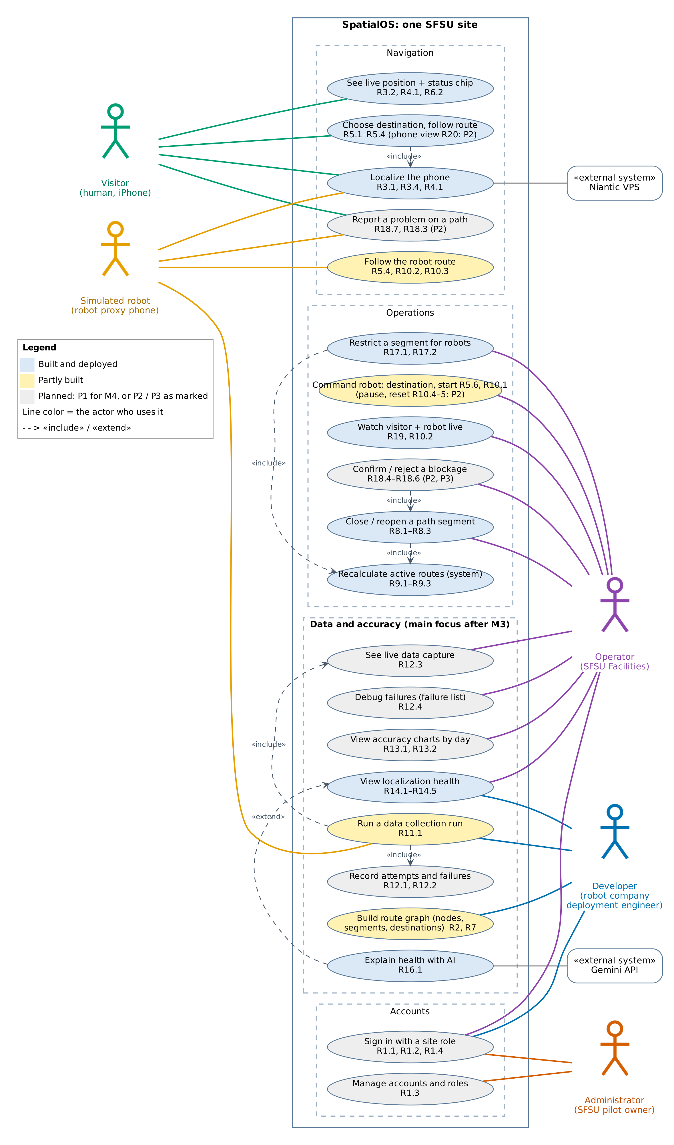
Figure I.1: Use cases for the four personas and the simulated robot

I.3.3 Class diagram
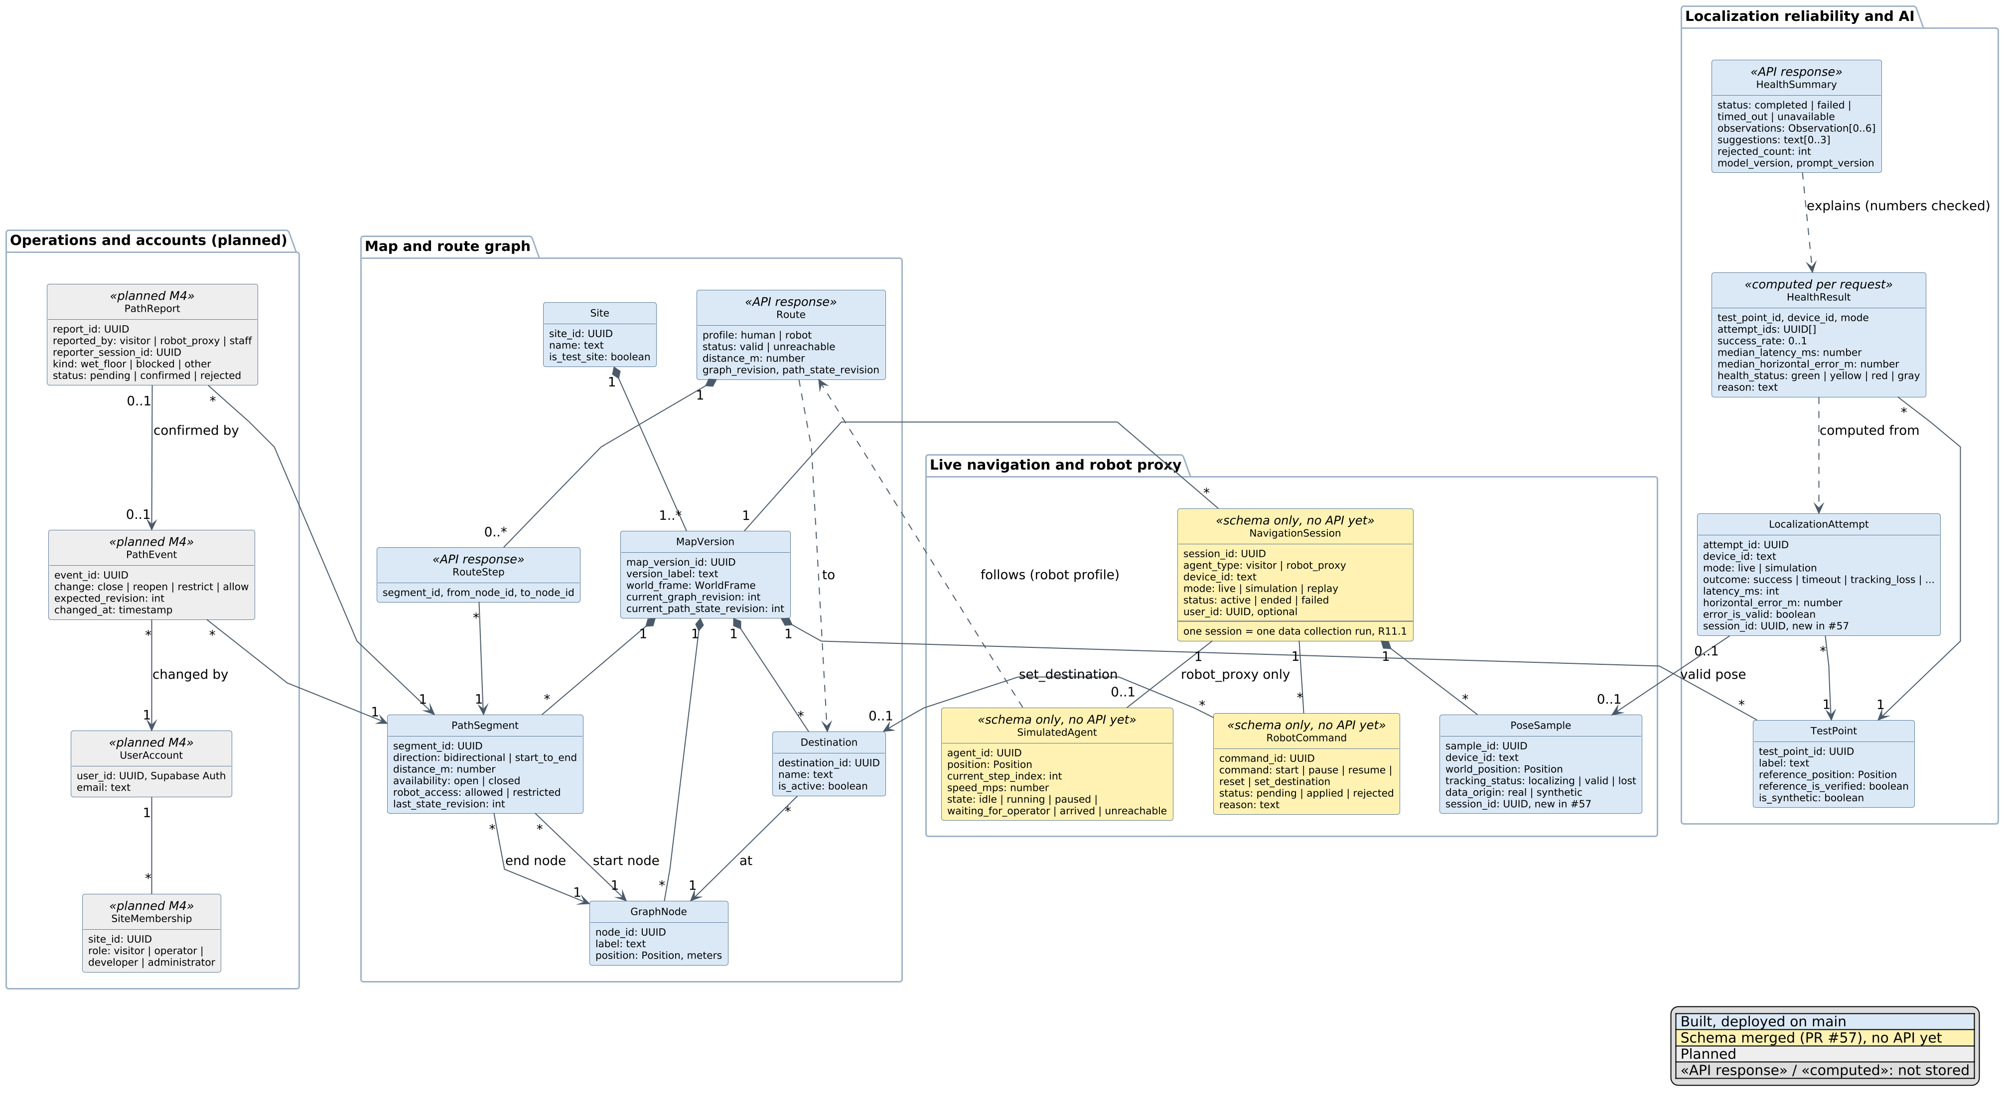
Figure I.2: M3 domain classes (key attributes only; full fields are in the Data Definitions)
- The map and route graph are unchanged from M2: a MapVersion owns its nodes, segments, destinations and test points. Closing a segment changes availability or robot_access and bumps last_state_revision.
- NavigationSession is one class for visitors and the robot proxy (agent_type). A session is also one data collection run (R11.1): its poses and attempts link to it. A robot_proxy session has one SimulatedAgent and receives RobotCommands.
- Route, HealthResult and HealthSummary are not stored. They are computed from the database on each request, so they cannot go stale.
- error_is_valid is true only for a live success with a real pose and a verified test-point reference (database trigger, PR #57). PathReport, PathEvent, UserAccount and SiteMembership are planned; roles are per site.

I.3.4 Sequence diagrams

Flow 1: Localize the phone and show the live position (R3.1, R3.2, R3.4, R4.1)
- The phone reports its status: localizing until the first pose, valid while tracking, lost after losing it, and timeout (with a Retry button) if there is no pose 30 s after picking the site (PR #65).
- A valid sample carries the raw VPS pose every 0.5 s; localizing and lost samples carry no position. The server converts the pose (only Z flips, because Unity is left-handed) and decides data_origin itself.
- /live receives each pose through Supabase Realtime and shows a status chip per phone. 5 s of silence turns the chip gray; 30 s of localizing shows "Timed out, try again".
- If Realtime is quiet for 2 s, /live reads the database itself (every 2 s, then every 5 s after 10 s with no new messages), so the dot does not freeze. Gray uses received_at (server time), not the phone clock.
- A message without a position (localizing or lost) updates the chip but keeps the dot at the last real spot.
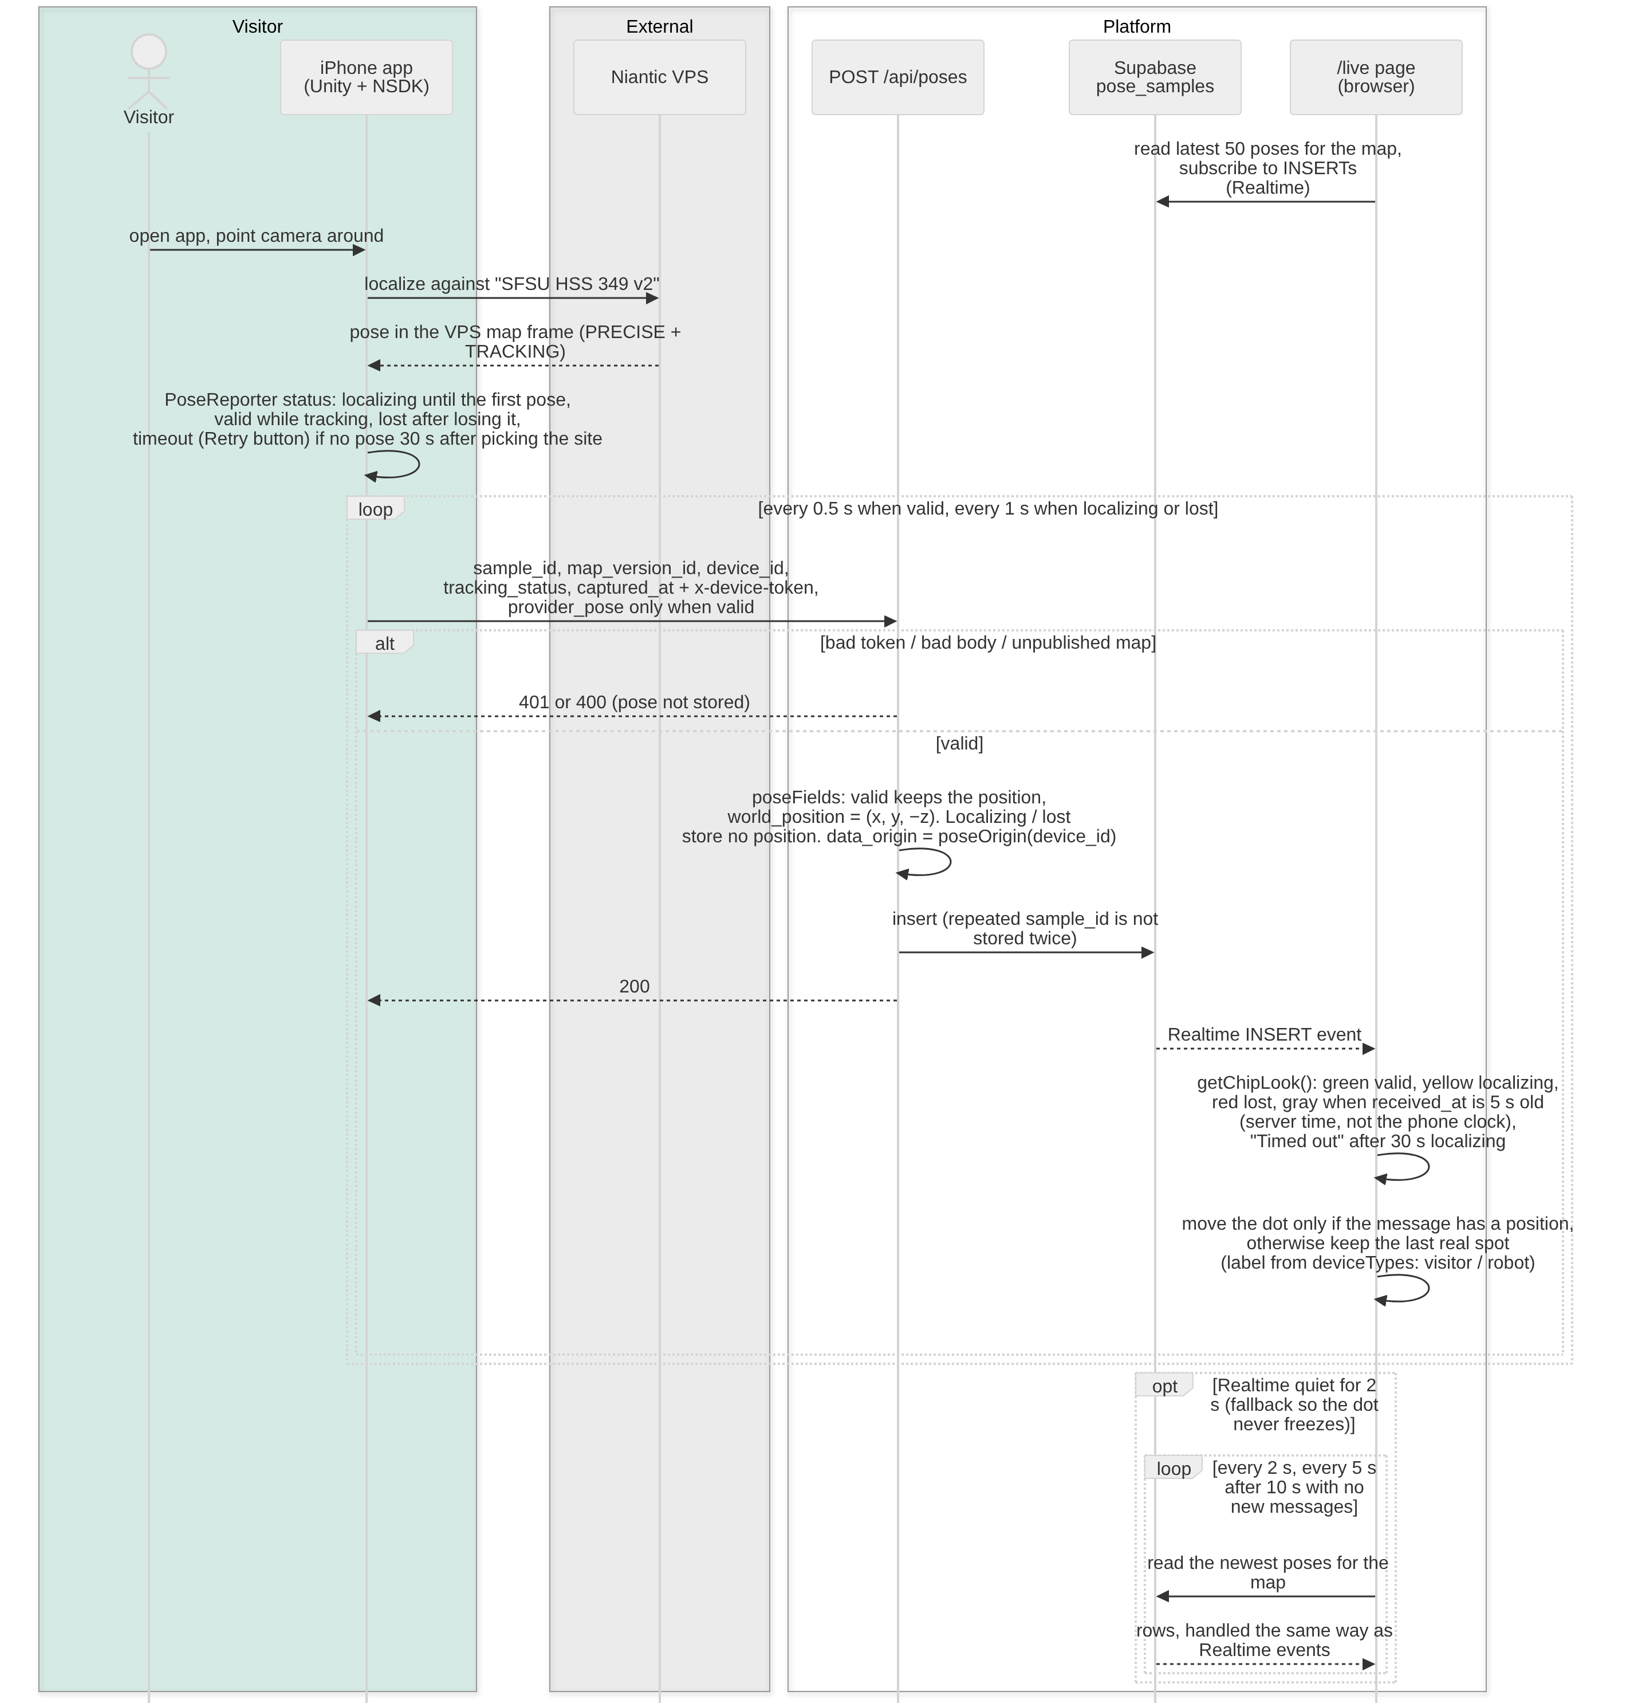
Figure I.3: Localize the phone and stream its live position

Flow 2: Choose a destination and follow the route (R5.1–R5.5, R6.2–R6.4, R20)
- A new start needs a green chip within 2 m of a path. pickStartNode picks the nearer end of that segment and draws the gold attach line. If the chip leaves green, /live keeps the previous start, so an existing route does not disappear (R6.4).
- "Arrived" needs a green chip and 1.0 m or less to the destination, not distance alone.
- The server checks every route against the database graph before sending it. A wrong route returns 502 and is never drawn.
- Humans and the robot use the same routing engine; only the profile changes (the robot profile also skips restricted segments). The route on the visitor's phone (R20) is Priority 2.
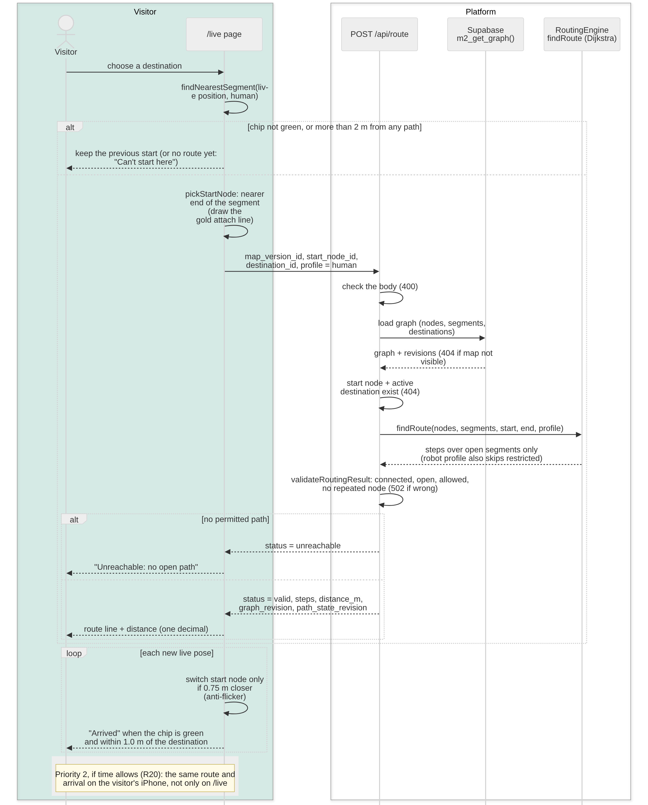
Figure I.4: Route request, start rules and arrival

Flow 3: Wet floor: report, close, and reroute everyone (R18.7, R18.4, R18.5, R8.1–R8.3, R9.1–R9.3)
- This is the end-to-end SFSU pilot scenario: a visitor reports, the operator decides, and the system reroutes both the visitor and the robot.
- Rerouting is built (PR #62, #64): /live asks for new visitor and robot routes only when the path state fingerprint changes. Today only /live shows them (the visitor phone follows with R20). Test: closing "Door to Back corner (door side)" changed the live route from 10.8 m to 11.1 m with a banner; reopening restored 10.8 m.
- Operator close is built (PR #67, #69): /operator shows the live map and a segment list with Close, Reopen, Humans only and Allow robots. Without accounts (R1), writes need a shared operator token (401 without it). The path state revision is bumped only if nobody changed it meanwhile, otherwise 409.
- "Humans only" (R17.1) sets robot_access = restricted, so only the robot route changes. The visitor report and operator confirm steps (R18) are Priority 2.
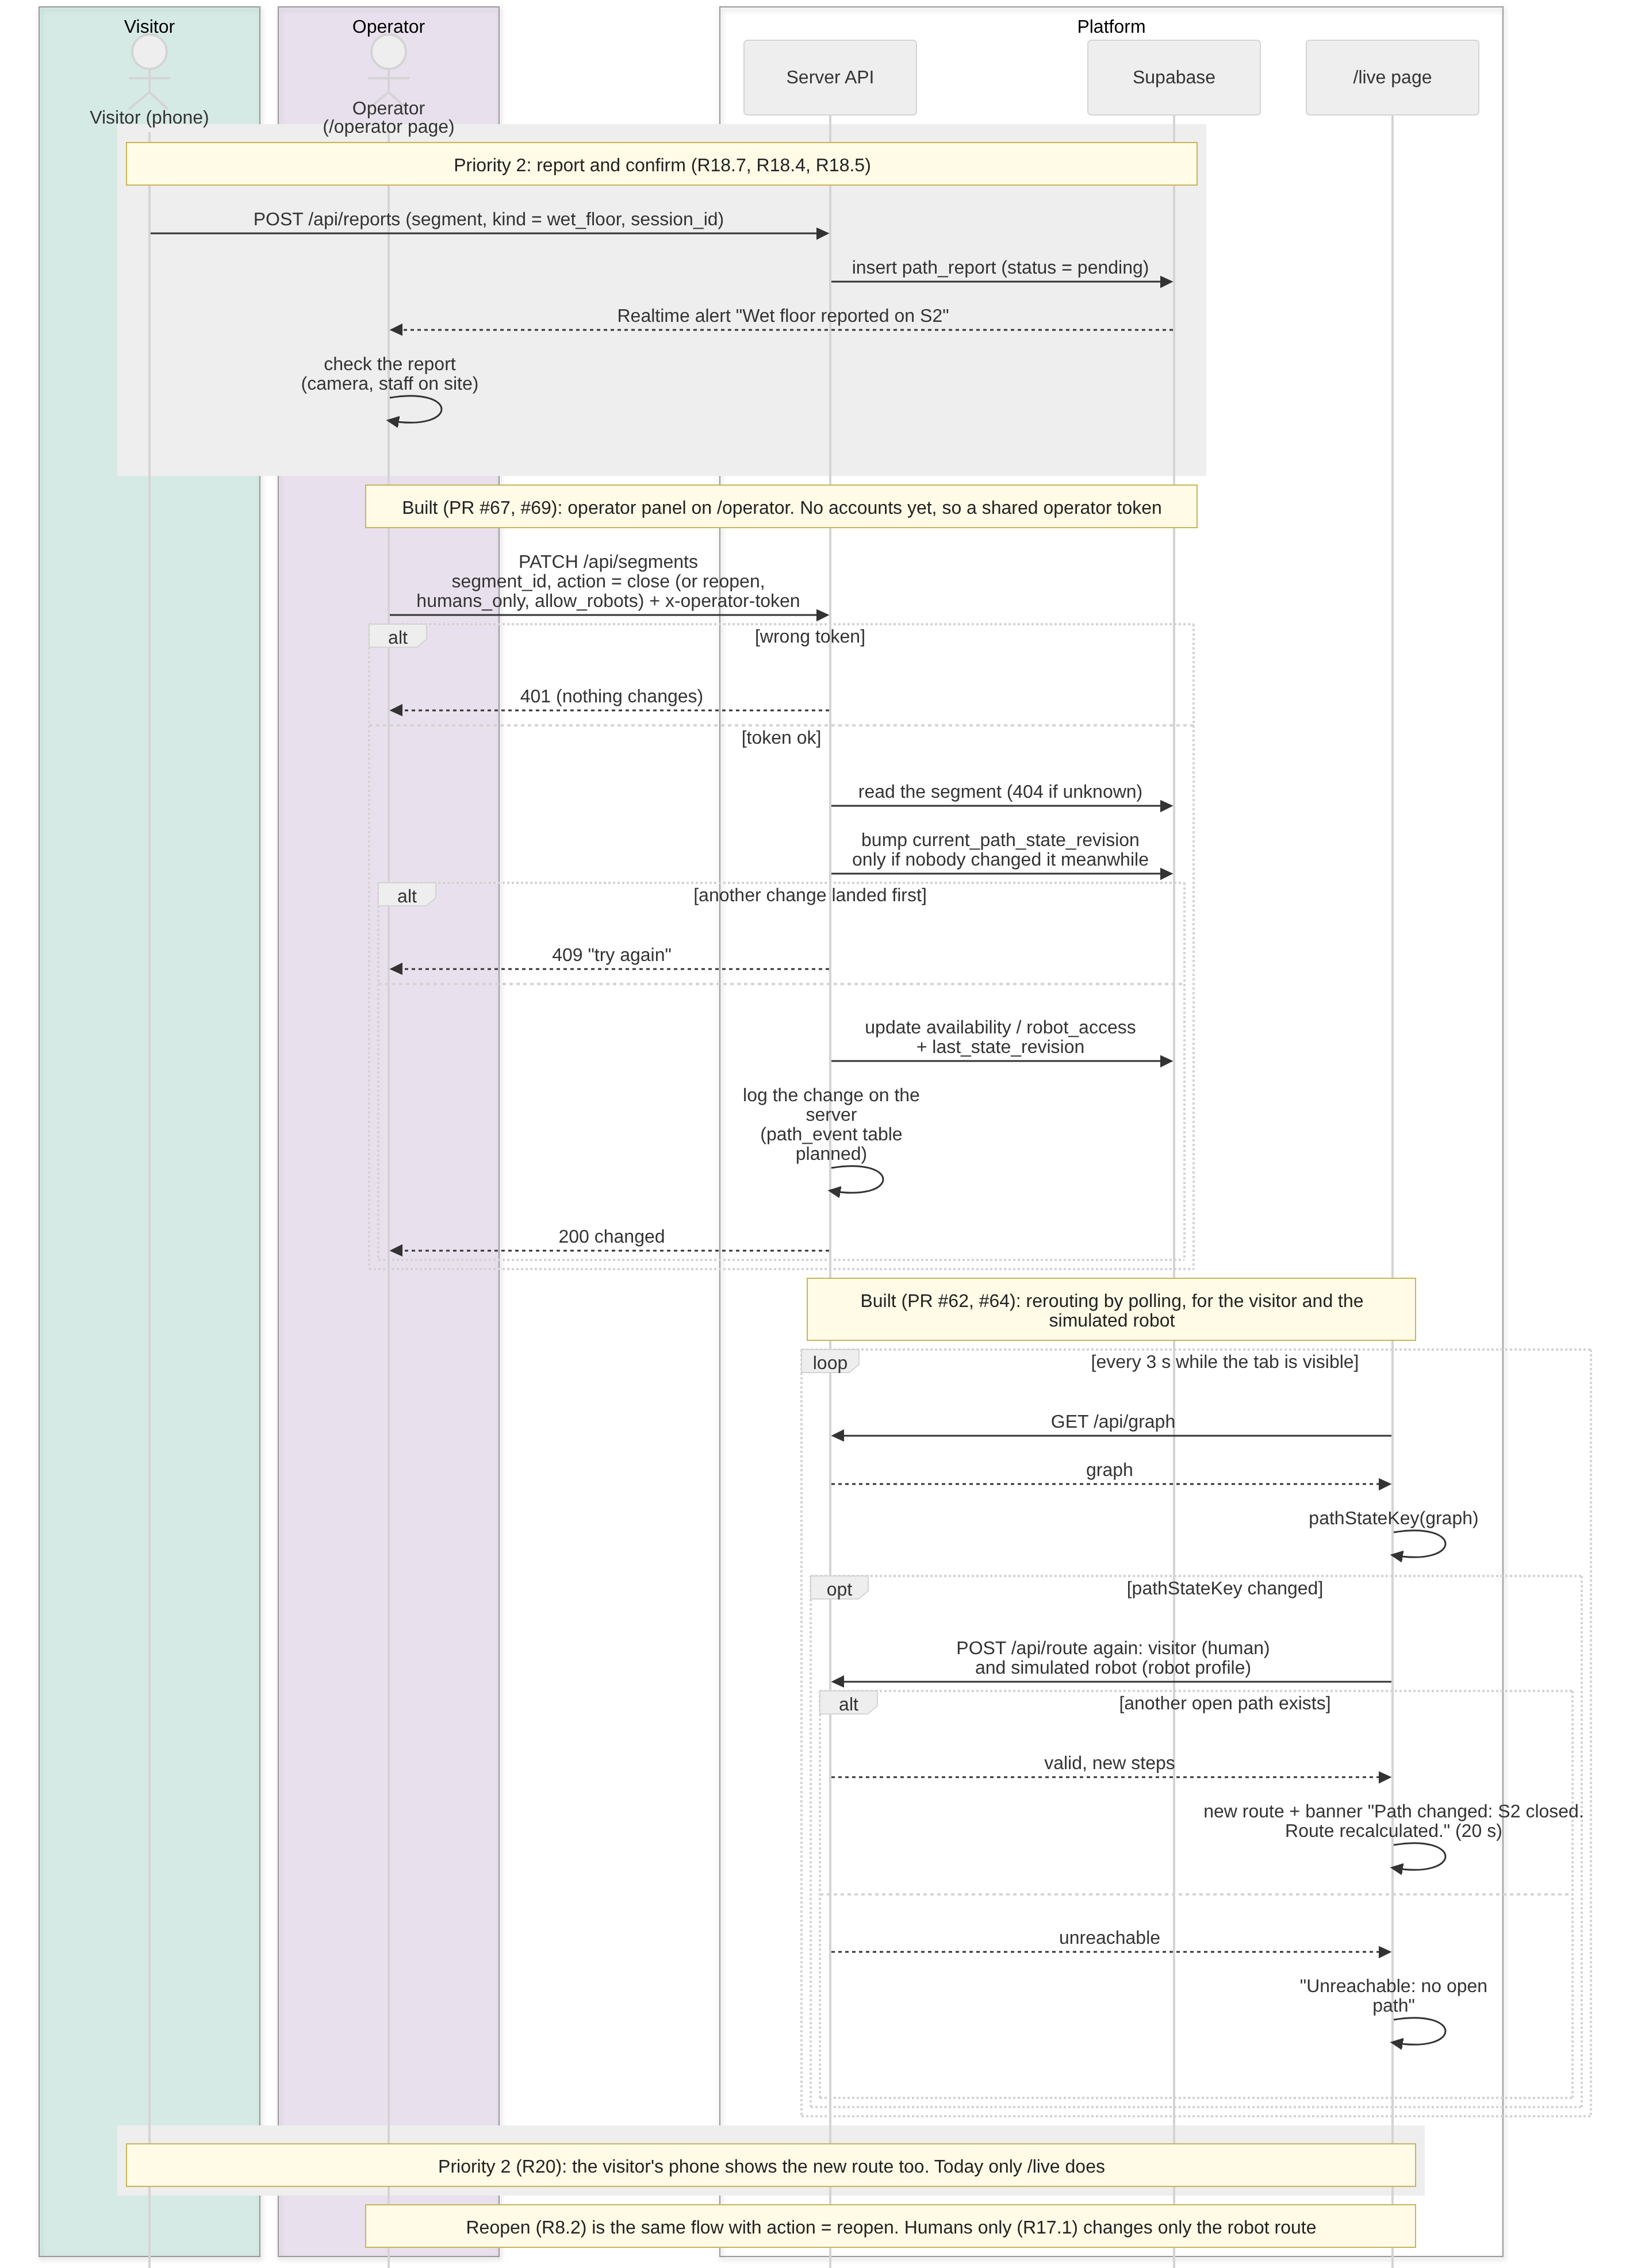
Figure I.5: Wet-floor scenario, from the report to the new routes

Flow 4: Run the simulated robot with the robot proxy phone (R9.2, R10.2, R10.3, R17.1, R19)
- The robot proxy is a real phone that a tester walks along the robot route. Its poses use the same upload as Flow 1, so the live map shows it next to the visitor, labeled "Simulated robot".
- Built (PR #64): a robot destination on /live, the robot start (same rules as the visitor, robot-allowed paths only), the orange robot route, pink "humans only" segments, rerouting and arrival.
- Planned M4: robot sessions and stored commands (R5.6 assign from /operator, R10.1 start), with the next step on the robot phone. Pause and reset (R10.4, R10.5) are P2. The tables are in PR #57; the endpoint names are a proposal.
- In the data plan the robot route drives the collection runs: the robot proxy walks past the test points while data is captured (Flow 5).
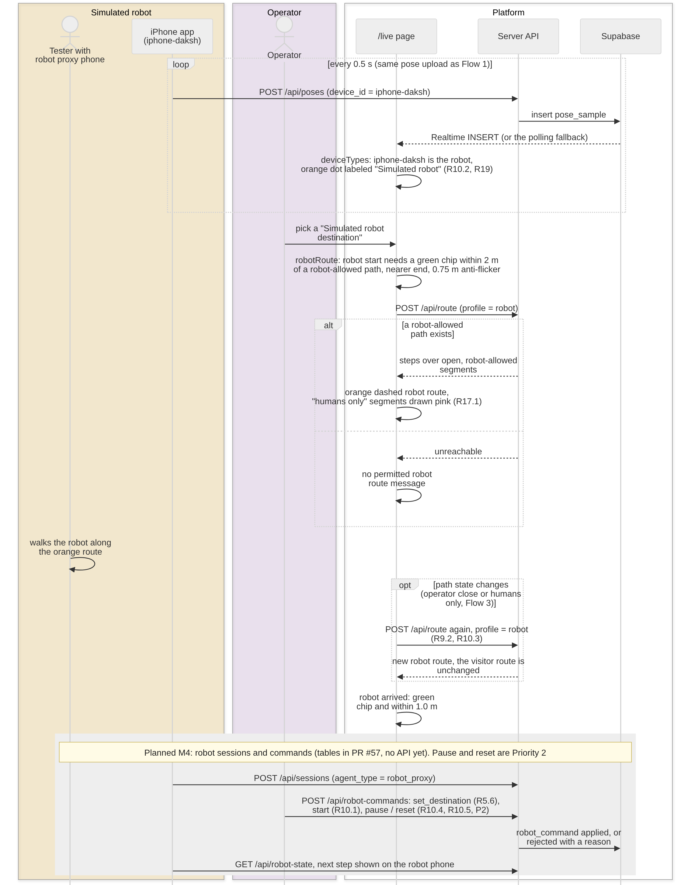
Figure I.6: Simulated robot run with the robot proxy phone

Flow 5: Data collection run: capture, failures and accuracy (R11.1, R12.1–R12.4, R13.1, R13.2, R14)
- This is the main flow after M3. A collection run (R11.1) is one session: the robot proxy walks the route, and at each test point the phone saves three repeated attempts, restarting localization between them (Figure I.7 shows one; the step repeats three times). Each attempt ends as success or a named failure with its reason (R12.1, R12.2).
- While the run goes, the live map marks that data is being captured and shows live counts of samples, attempts and failures (R12.3). When the run stops, the counts stay as the run summary.
- The operator finds what went wrong with the failure list (type, reason, test point, device, time, tracking status before the failure) and the charts per test point by day (R12.4, R13.1, R13.2).
- Built: every pose and tracking status is already saved (#65), and health (R14) is computed per test point and device from completed attempts, with the rule that matched.
- Planned M4 (P1): the attempt write API, run start and stop, the live capture marker, the failure list and the charts. Until real attempts exist, /health uses the labeled synthetic map in simulation mode.
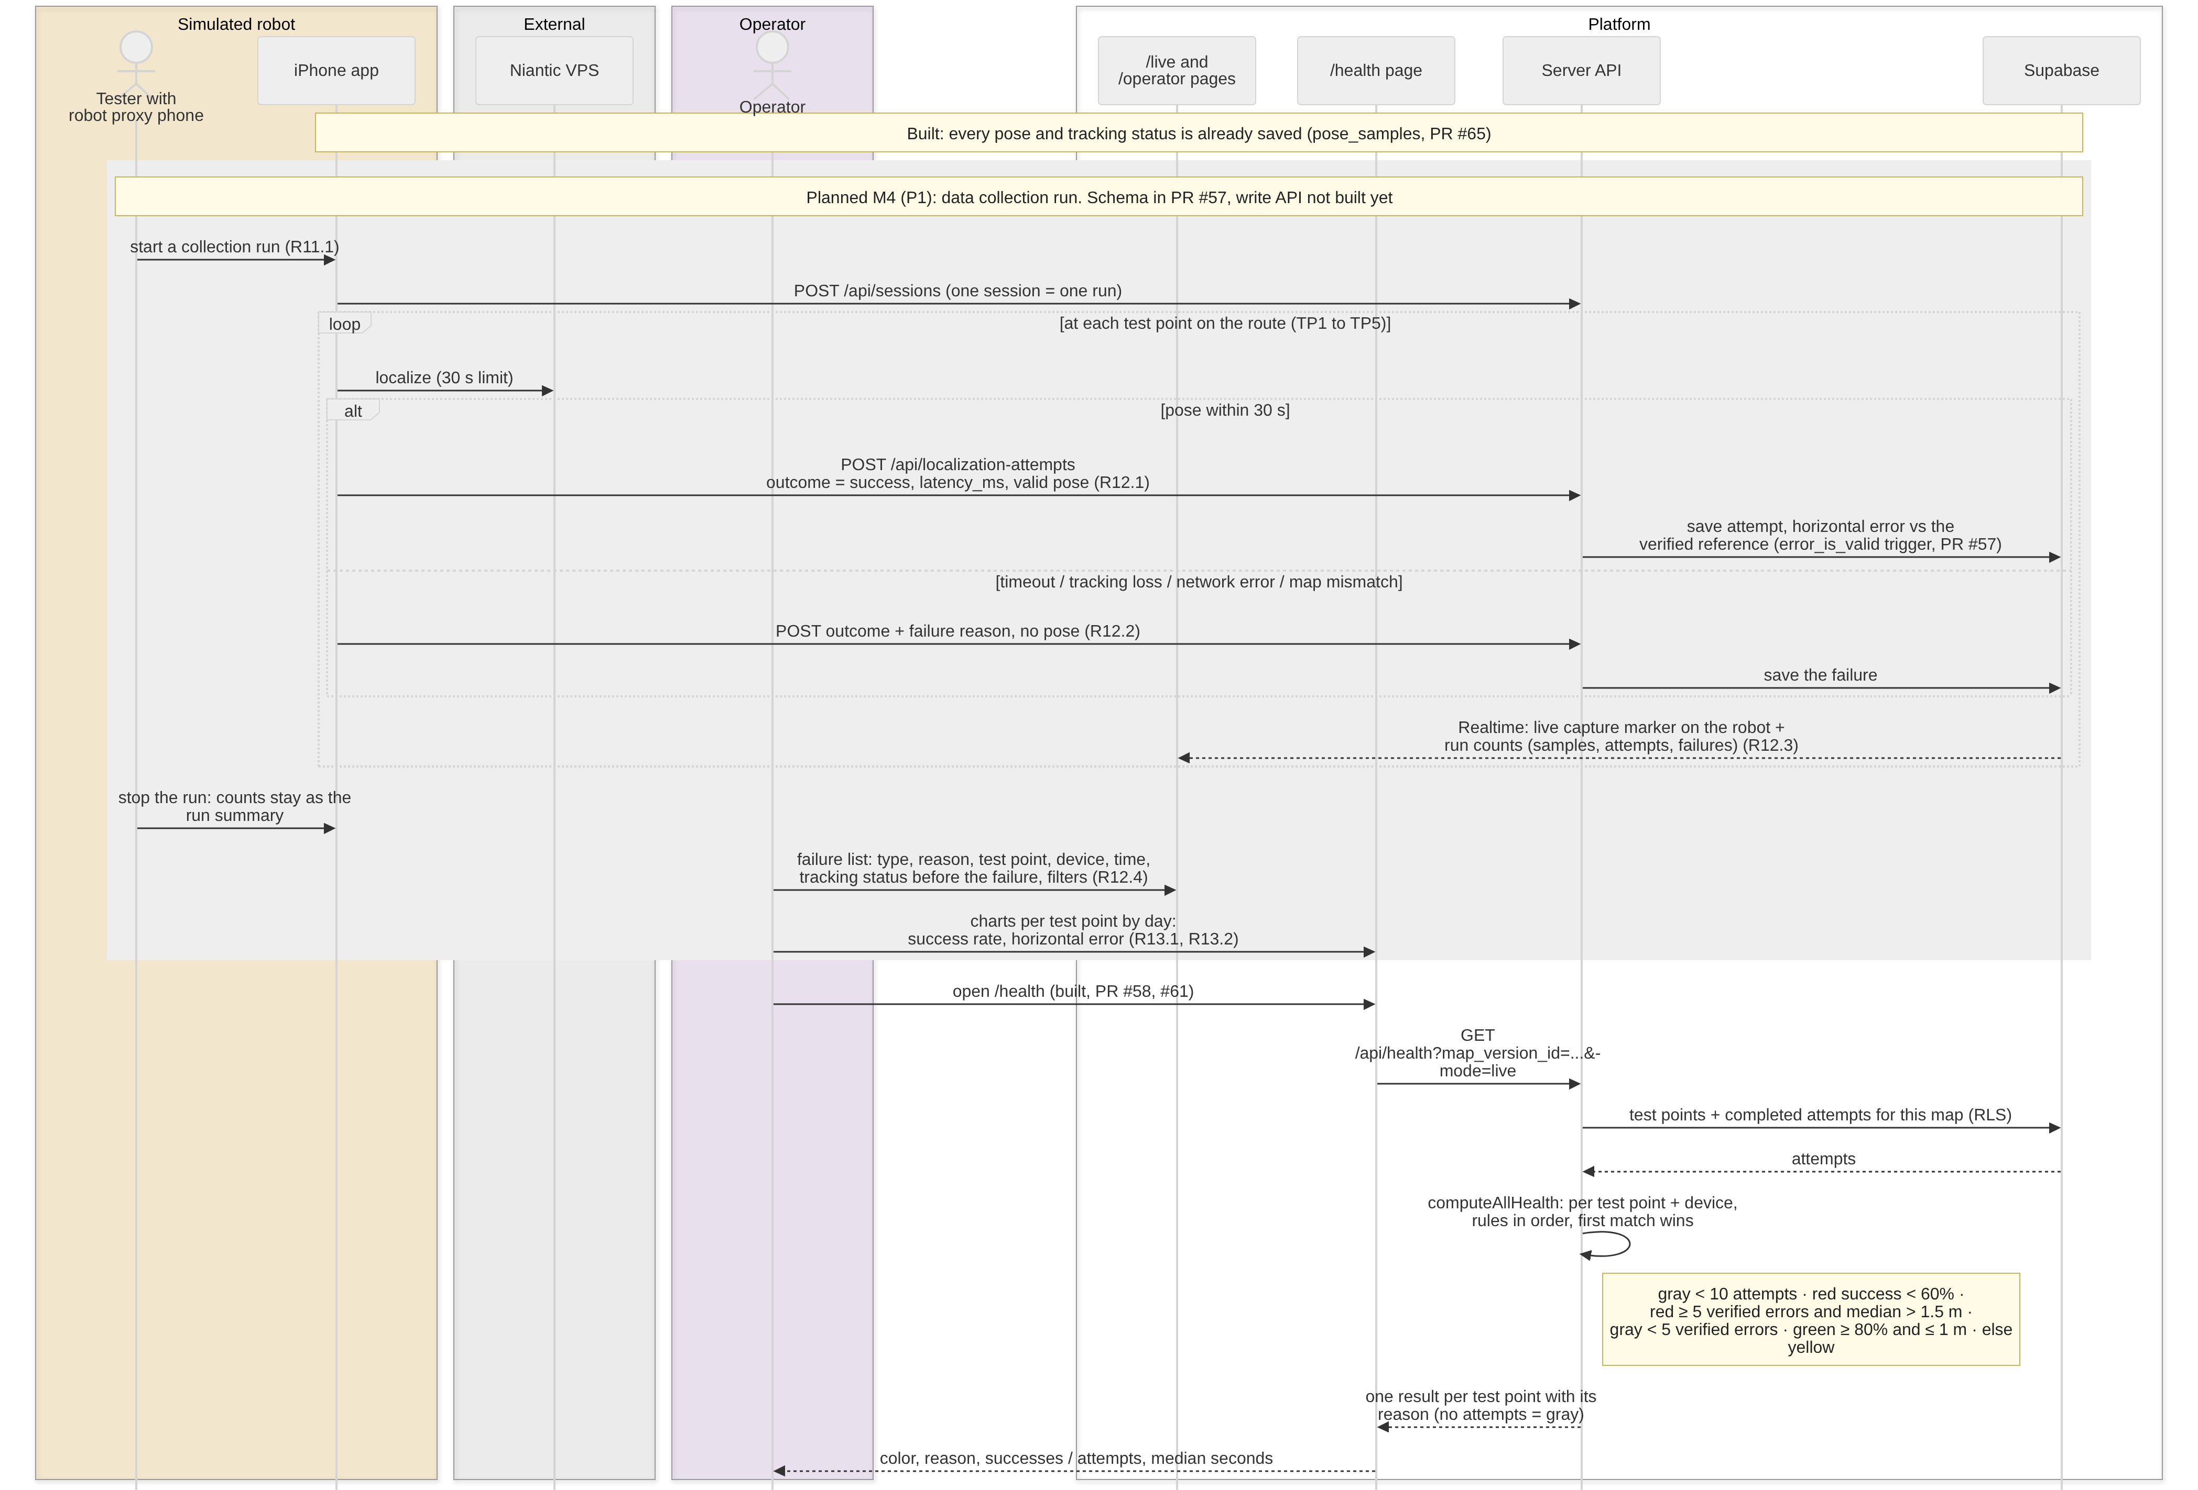
Figure I.7: Data collection run, live capture, failures and health

Flow 6: Explain localization health with AI (core AI) (R16.1)
- Gemini only explains; it never decides a color. The server builds the facts, and any sentence with a number or test point that is not in the facts is dropped.
- The request is a POST, so link previews cannot trigger a paid call. After a valid request it returns 200 with a status (completed, failed, timed out or unavailable), so a Gemini timeout or outage never breaks the page. Invalid requests get the 400 / 404 errors shown in the figure.
- Measured Oct 31: completed in 2.4 s with gemini-flash-lite, 0 sentences dropped. The full flash model timed out at 15 s, so lite is the default. After the collection period it explains the real data, not only the synthetic map.
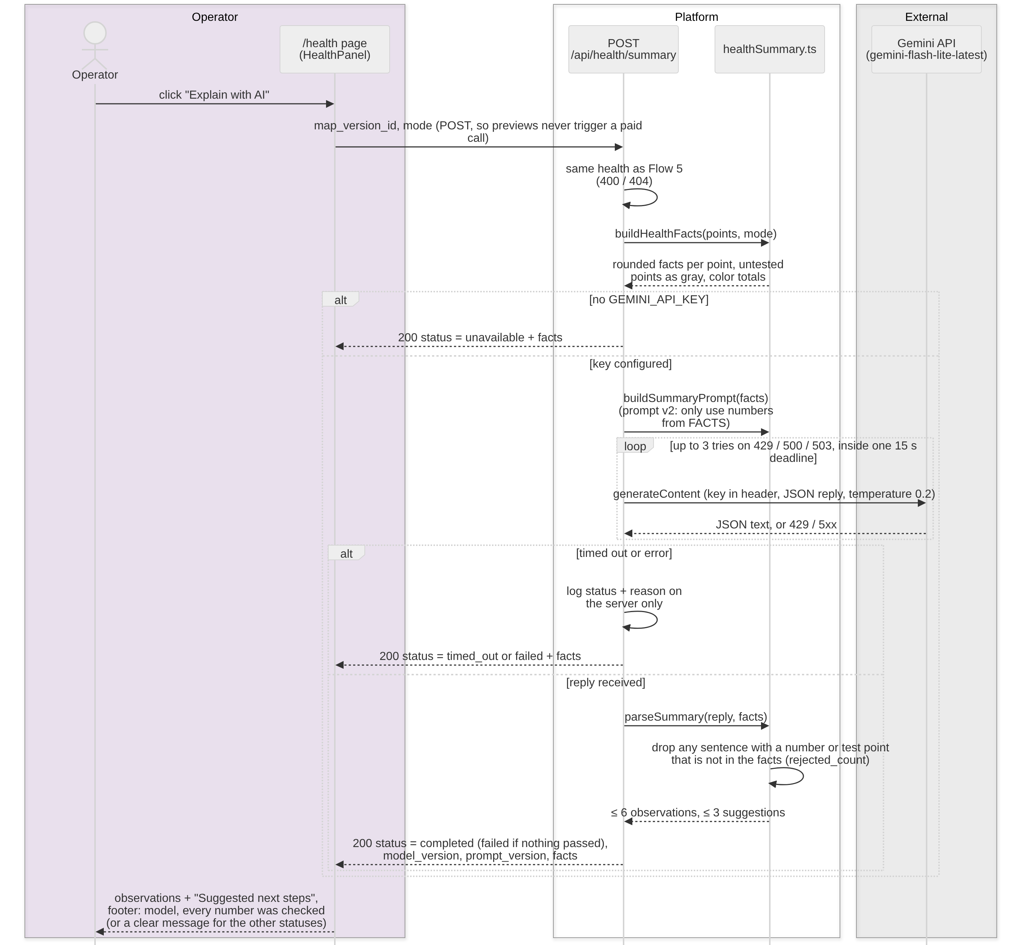
Figure I.8: Explain with AI

I.3.5 Traceability
Flow | Requirements | Main classes | Built (Nov 4) | Still to build
1. Localize + live | R3.1, R3.2, R3.4, R4.1 | PoseSample, NavigationSession | Pose upload with localizing / valid / lost; timeout on the phone and /live, Realtime + polling, status chip | session_id on poses (M4)
2. Route | R5.1–R5.5, R6.2–R6.4, R20 | Route, RouteStep, PathSegment | Route on /live, start rules, arrival | Route on the visitor iPhone (R20, P2)
3. Wet floor | R18.7, R18.4, R18.5, R8.1–R8.3, R9.1–R9.3, R17.1 | PathReport, PathEvent, PathSegment | Operator panel (PR #67, #69), reroute for visitor and robot (PR #62, #64) | Report + confirm (R18, P2), path_event table
4. Robot proxy | R9.2, R10.2, R10.3, R17.1, R19, R5.6, R10.1 | NavigationSession, SimulatedAgent, RobotCommand | Robot on the live map, robot route + reroute (PR #64) | Sessions and commands: R5.6, R10.1 (M4); R10.4, R10.5 (P2)
5. Data collection | R11.1, R12.1–R12.4, R13.1, R13.2, R14 | NavigationSession, LocalizationAttempt, TestPoint, HealthResult | Poses and tracking saved (#65), health API and /health page | Runs, attempt API, live capture, failure list, charts (M4)
6. AI summary | R16.1 | HealthSummary, HealthResult | Done (PR #60, #61) | None

I.3.6 Open design points
We will settle these with the owners in M4.
- Robot identity. The live map labels the robot from a hardcoded device list (M3 stopgap); the schema uses navigation_sessions.agent_type. Proposal: switch to sessions in M4 so any phone can be the robot.
- Robot proxy endpoints. /api/sessions, /api/robot-commands and /api/robot-state are proposed names; the final names come with the M4 sessions PR.
- Operator token. /operator uses one shared token until accounts and roles (R1) replace it. Changes are logged on the server until the path_event table exists.
- Realtime for path segments. Polling every 3 s works now. Adding path_segments to the Realtime publication would make reroutes instant.
- PathReport is a new table for R18.7 and R18.3 and needs a schema change.
- AI summaries are not stored. Keeping a history of summaries would be a new requirement.

I.3.7 Implementation components (added Nov 4)
Figure I.2 shows the domain records. This figure shows the code that owns each behavior and how the parts call each other: which component records a pose, computes health, validates the AI summary, computes a route and changes a path segment. Blue is built and deployed on main; gray dashed is planned for M4.
Design. Domain logic in lib/spatial and lib/routing is plain functions with no database or network calls, so it is unit tested directly. createHandlers receives its dependencies as parameters: a SpatialRepository (the one interface to the database), the routing function and the Gemini caller. Production passes the Supabase repository and the real Gemini caller; the tests pass a stub repository and a fake Gemini, so every handler is tested without the real services.
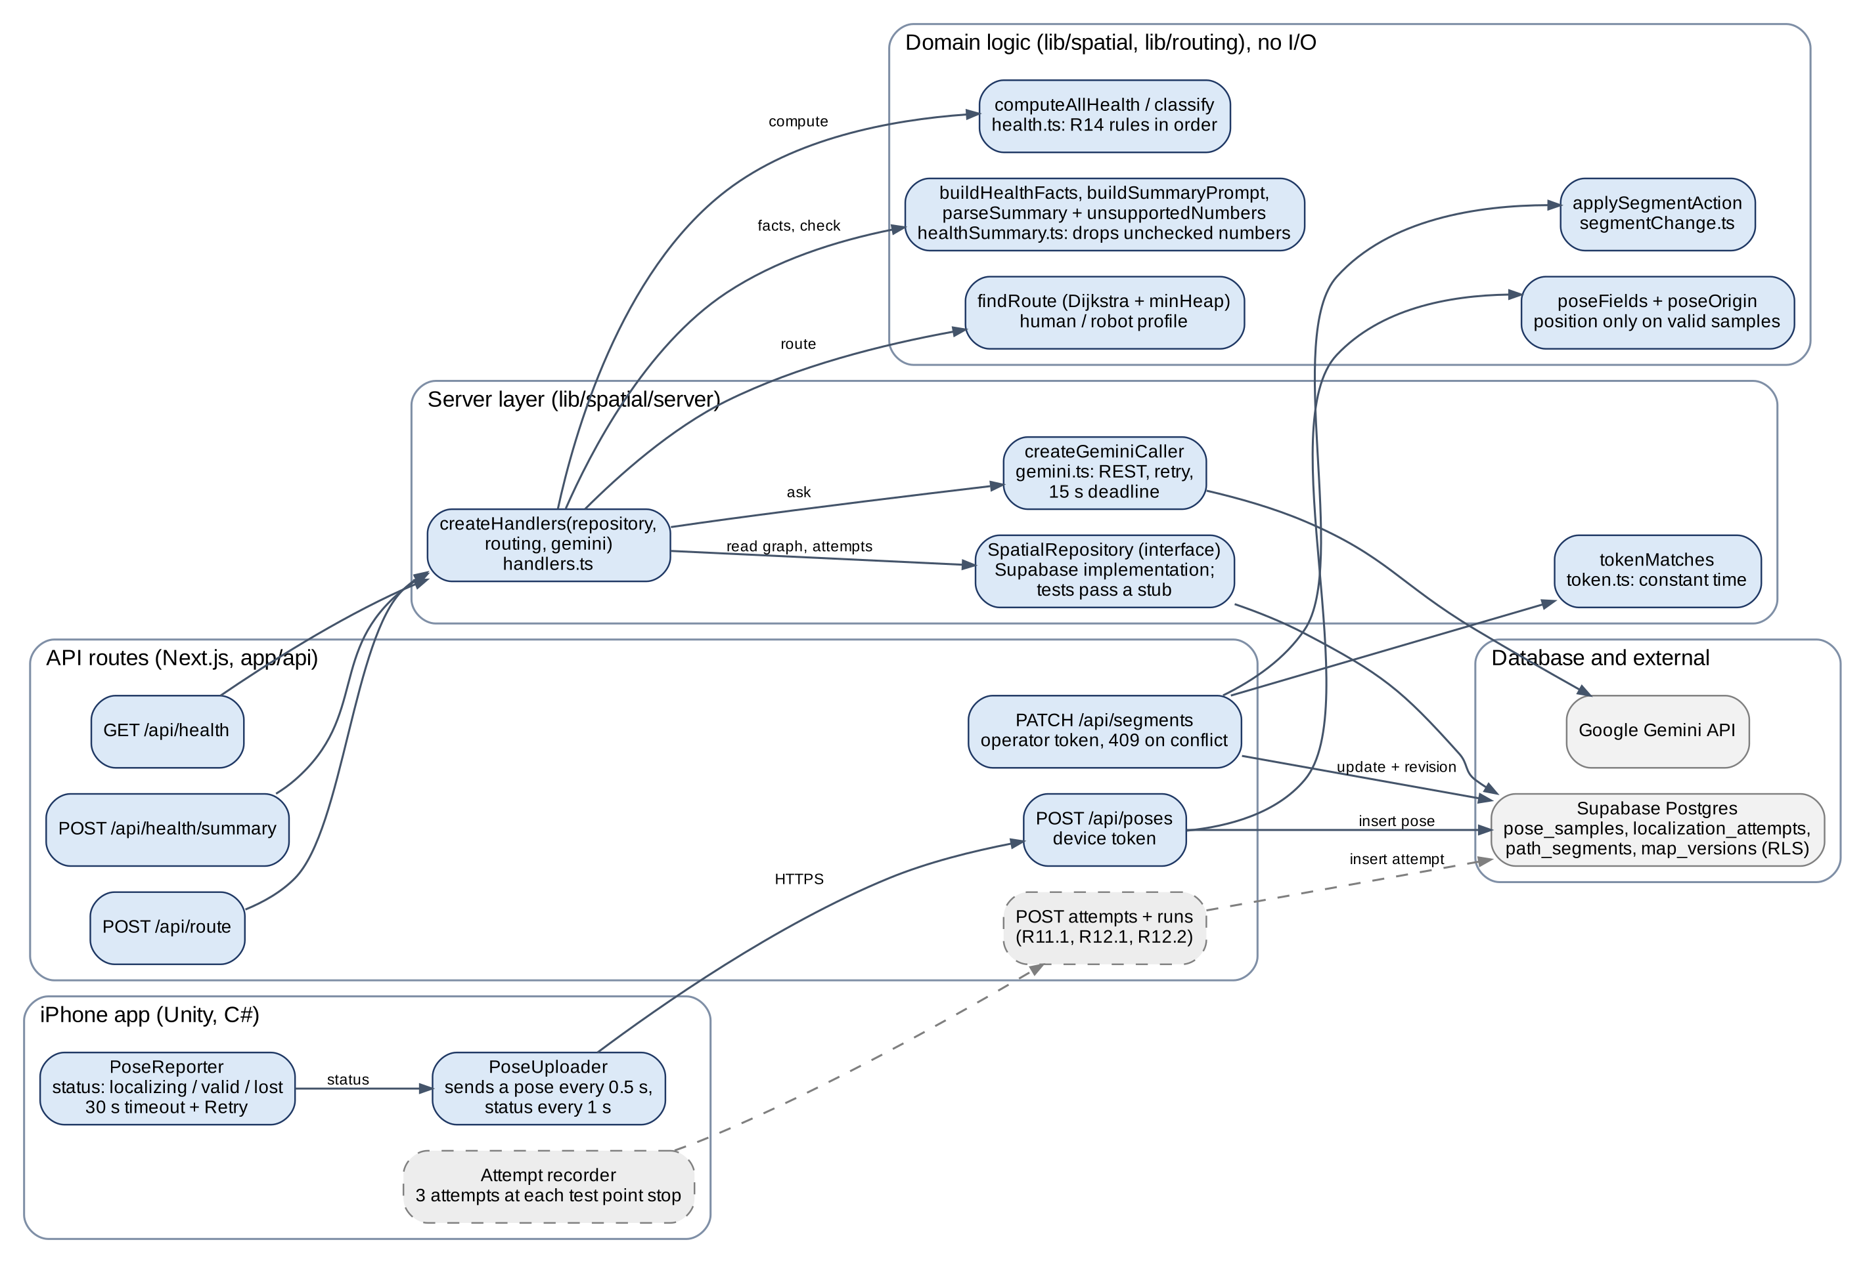
Figure I.9: Implementation components and the behavior each one owns

Which component owns each behavior (Figure I.9 in table form):
Behavior | Owner component | Collaborators | Status
Record a pose and its tracking status | POST /api/poses (app/api/poses/route.ts) | poseFields, poseOrigin (lib/spatial); PoseReporter and PoseUploader on the phone | Built (#35, #65)
Record an attempt and its failure | Attempt and run write handler (planned); attempt recorder on the phone | localization_attempts table; database trigger checks error_is_valid (#57) | Planned, M4 (R11.1, R12.1, R12.2)
Compute localization health | createHandlers().health (lib/spatial/server/handlers.ts) | SpatialRepository.healthAttempts, computeAllHealth and classify (lib/spatial/health.ts) | Built (#58)
Validate the AI summary | createHandlers().healthSummary (handlers.ts) | buildHealthFacts, buildSummaryPrompt, parseSummary, unsupportedNumbers (healthSummary.ts); createGeminiCaller (gemini.ts) | Built (#60, #61)
Compute a route | createHandlers().route (handlers.ts) | routingFunction (server/routing.ts), findRoute with a min-heap (lib/routing) | Built (#32)
Change a path segment | PATCH /api/segments (app/api/segments/route.ts) | tokenMatches (server/token.ts), applySegmentAction (segmentChange.ts), map revision check | Built (#67)
Live map, start rules, rerouting | /live and /operator pages | useGraph and pathStateKey (3 s poll), useLivePhones, useRouteRequest, checkLiveStart (segmentAttach.ts), planRobotStart (robotRoute.ts) | Built (#48, #49, #62, #64)
Live capture marker, failure list, charts | Live capture and failure components (planned) | Run and attempt data from the write handler | Planned, M4 (R12.3, R12.4, R13)

I.3.8 Implementation class diagram (added Nov 4)
The actual implementation types with their fields and operations, taken from the code on main. The phone side is two C# classes. On the server, Handlers depends on the SpatialRepository interface and on a GeminiCaller, both passed in by createHandlers; the Supabase repository and the test stub both implement the interface. The domain modules hold the health rules, the AI number check and Dijkstra routing with a MinHeap. Solid arrows are associations, dashed arrows with a hollow head are implementations, other dashed arrows are uses or throws.
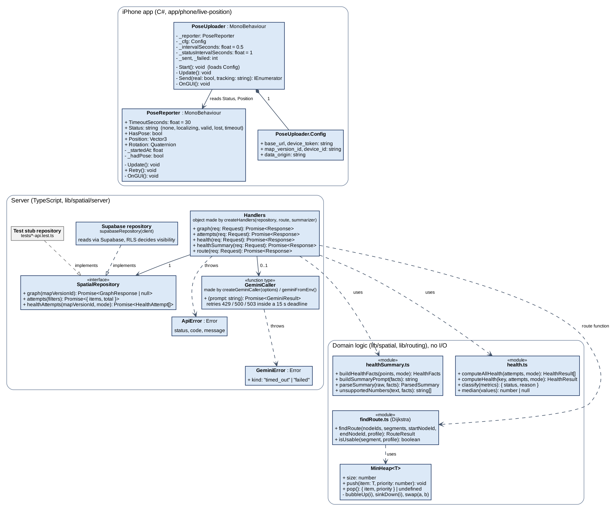
Figure I.10: Implementation classes, interfaces and modules with their operations

Appendix I, Item 4: Actual Risks
SpatialOS | SW Engineering CSC 648/848, Section 06, Team 02 | Milestone 3 | November 4, 2026
Risks we actually hit or found during M3, and how we will handle each one. Updated November 4 after the M3 review.

1. Legal risks
- The AI summary has no login requirement. Anyone with the URL can call POST /api/health/summary and use our Google Gemini quota.
How we will handle it: The endpoint only accepts POST requests, so it cannot be triggered by prefetching. If Gemini fails, the endpoint returns a status message instead of crashing. Login and rate limiting come with accounts (R1) in M4.
- Google Gemini receives our health data. The AI summary sends data to Google.
How we will handle it: The server only sends the numbers it computed (counts, median times, success rates), test point labels and the device ID on each fact row. Gemini never receives device tokens, camera data, poses or raw attempts. We will remove device IDs from the facts or replace them with an anonymous label before they are sent.
- Location data is still publicly readable. PR #57 limits live localization attempts and real test points to published public demo maps so the health page can show real data, but the read policy on pose_samples is still "true", so anyone can read every pose row from any map. Real device IDs are also shown on /live.
How we will handle it: We will replace the pose_samples read policy with one that only allows reads on published public demo maps, like PR #57 does for attempts and test points, as a migration file in the repository. Device IDs will be replaced with session labels, and the new session and robot command tables stay server-only. This matters more now that we will collect 2 weeks of data. Proposed owner: Noah. Target: both in place before the first attempt day (Nov 10). From Nov 5 to 9 the phones use team device labels, and pose and timing records are collected while the current read policy is still active.

2. Technical risks
- The live map could freeze or stutter if Realtime drops. The Vercel functions are not in the sfo1 region yet, and the phone app only counts failed position POSTs on screen; it does not log them.
How we will handle it: PR #49 and PR #56 make /live read the newest rows from the database when Realtime is quiet for 2 s, and slow down to every 5 s after 10 s with no new messages, so the dot keeps moving. We will move the functions to sfo1 and log failed POSTs on the phone so dropped updates show up in the collected data.
- Our free services could hit limits or pause. Supabase pauses idle projects, and the Gemini free tier has usage limits.
How we will handle it: A keep-alive job pings Supabase daily so the project never goes idle. We limit Gemini testing before demos so the free tier is not used up.
- Scaniverse credits are shared with other teams through the TA's pro plan.
How we will handle it: We scan early and check the remaining credit balance before every scan.
- There are no real test points in HSS 349 yet, so /health shows synthetic data. The PR #57 migration was applied to the shared Supabase on Nov 3, so real test points can now be stored.
How we will handle it: We will tape-measure and record 5 HSS 349 test points on Nov 5, the first class day of the data collection.
- The AI health summary timed out with Gemini Flash.
How we will handle it: We switched to Gemini Flash Lite, which answered in about 2 s in testing. The endpoint retries within a 15 s limit and always returns a status message.
- New: Not enough data in 2 weeks. The data collection depends on the attempt write API (R12.1, R12.2) being ready by Nov 9.
How we will handle it: If they slip, we start with the pose samples and tracking status the phone already saves, and add attempts as soon as the API is merged.
- New: Low 3D scan quality. The professor noted our 3D asset quality is low, which can also hurt localization accuracy.
How we will handle it: We will follow the TA's scanning guidance before scanning SEIC 210, and rescan HSS 349 if it affects localization.

3. Skill risks
- Stacked pull requests and base branches were hard to manage. During M3 many pull requests stacked on top of each other.
How we will handle it: Before merging, the GitHub Master checks that each pull request targets dev, and switches the base when the previous pull request merges.
- Ownership of the /live page changed during M3. Sumit wrote the M2 /live page, Ezeren rewrote it for M3, and Sumit then added routing.
How we will handle it: Every change to /live was reviewed by the other member working on it and by one more team member.
- Only Daksh and Sumit can build and run the phone app, and the setup guide is not written yet.
How we will handle it: Daksh and Sumit will write the setup guide in the README. Another member will follow it and build the app on their own phone.
- Database migrations are run by hand by 1 to 2 team members.
How we will handle it: Every change is kept in a migration file with test SQL in the repository. The PR #57 migration was applied to the shared Supabase on Nov 3.

4. Schedule risks
- Most of the M3 code was merged in the last few days before the demo.
How we will handle it: Each pull request was tested and merged on top of the current dev, and all node and routing tests passed before merging.
- The operator screen and the simulated robot route landed on demo day (#64, #67 on Nov 3). The robot mode switch in the app and stored robot commands are still missing.
How we will handle it: Proposed owners: Daksh (robot mode in the app) and Noah (robot commands). Check: one stored set_destination command reaches the robot phone and its route updates, by M4.
- New: Limited access to HSS 349. The room is mostly available on class days, which limits how much data we can collect there in 2 weeks.
How we will handle it: We collect in HSS 349 on class days and use a second scanned site on other days, labeled by site in the data.

5. Teamwork risks
- Two members edited the same page at once.
How we will handle it: The current owner of a page is confirmed in Discord and added to their task card. Anyone who needs to change that page talks to the owner first.
- Code reviews leaned heavily on a few members.
How we will handle it: Every pull request needs at least two reviewers.
- Task cards were not kept up to date, so it was hard to tell if a member was blocked.
How we will handle it: We update task cards every meeting and post blockers in Discord the same day.

6. Risks resolved during M3
- The live position was always shown as valid. The phone now sends localizing and lost (#65), and /live and /operator show a green, yellow, red or gray status, plus "Timed out, try again" after 30 s (#47, #56).
- No operator controls. The operator can now close, reopen and robot-restrict path segments on /operator (#67), and routes update within a few seconds.

