Customer Churn Prediction
- Dataset Overview
Missing values were handled, inconsistent category labels were standardized, and categorical variables were converted into machine-readable dummy variables.
- Dataset shape: The dataset contains 5,630 observations and 20 variables, and its structure was verified before analysis.
- Class distribution: The target variable was moderately imbalanced, with 4,682 non-churn cases and 948 churn cases; the overall churn rate is 16.8%, so a stratified train-test split was used.
- Duplications: There were no duplicated rows and no repeated CustomerID values.
- Categorical label consistency: Several categorical variables contained labels referring to the same concept in different forms, such as Phone / Mobile, CC / Credit Card, and COD / Cash on Delivery. These category names were standardized to improve the consistency and reliability of the categorical analysis.
- Identifier treatment: CustomerID was excluded from modeling because it functions only as an identifier and does not provide predictive value.
- Missing values: Missing values were present in 7 variables and were handled using median imputation for numeric fields.
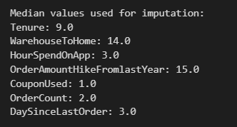
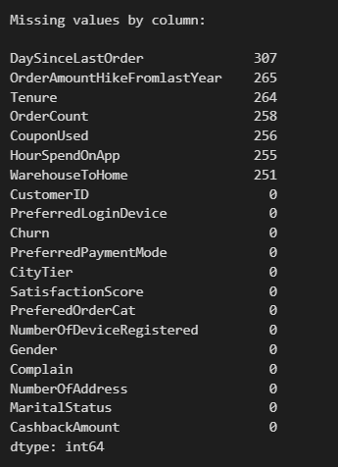
Handling missing values:

- EDA
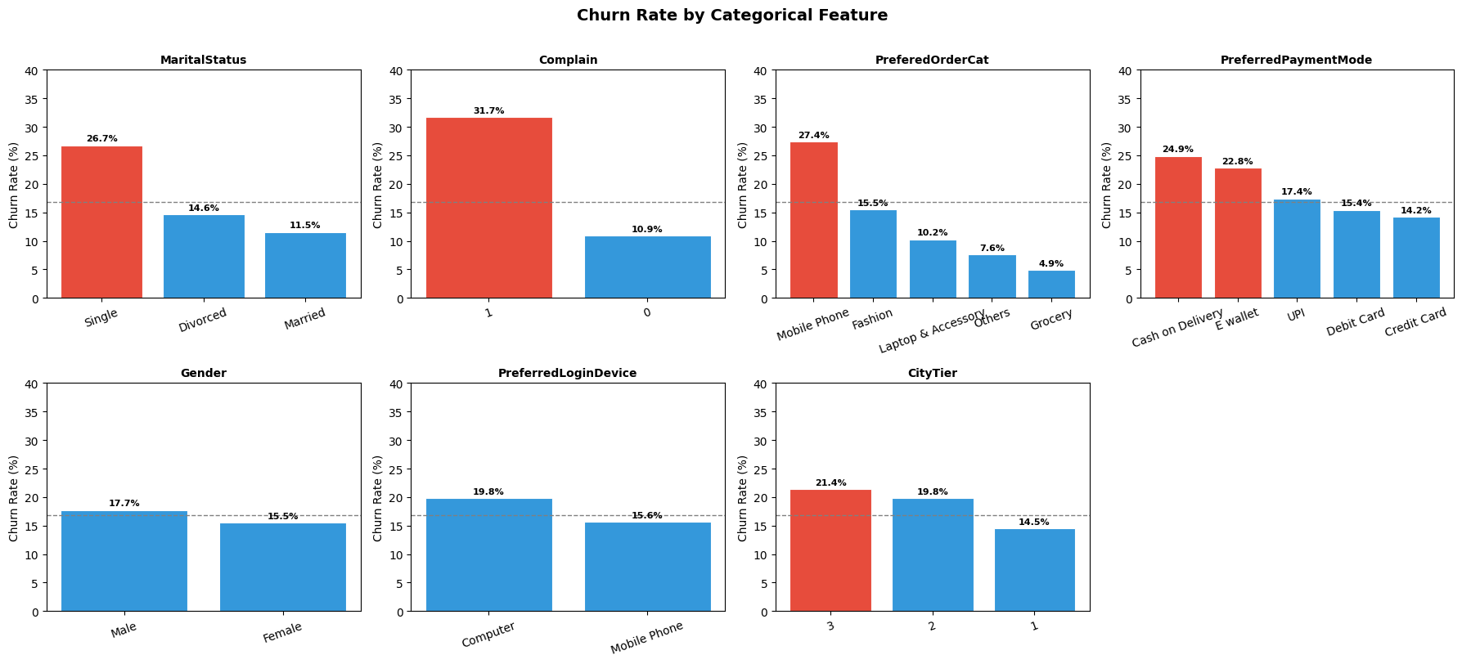
Exploratory data analysis was used to understand the distribution of churn and to identify potential drivers before training the models.
Figure 1 Churn Rate by Categorical Features
Figure 1 shows that churn varies noticeably across categorical customer groups. Higher churn rates are observed among single customers, customers with complaints, Mobile Phone category buyers, and Cash on Delivery users, all of which are above the overall churn average of 16.8%. In contrast, gender and preferred login devices display only minor differences, suggesting that these variables have relatively limited influence on churn behavior.

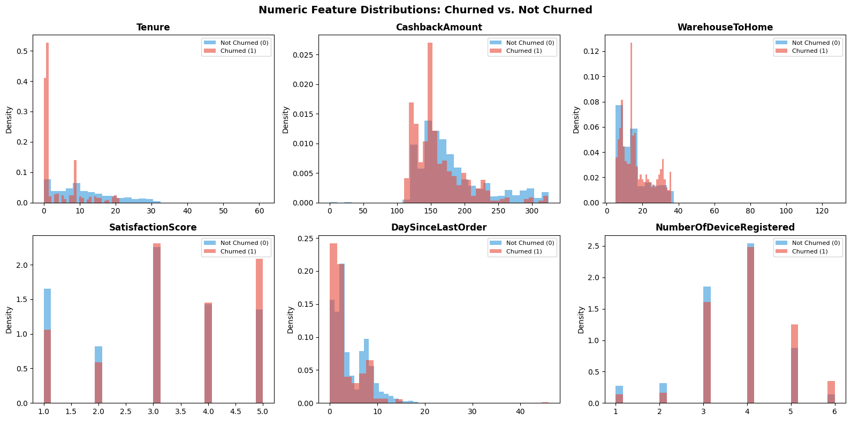
Figure 2 indicates that churned and non-churned customers differ across several numeric features. Churned customers generally have shorter tenure and lower cashback amounts, while SatisfactionScore, DaySinceLastOrder, and WarehouseToHome show moderate differences between the two groups. Overall, these patterns suggest that customer experience and engagement-related variables are associated with churn behavior.
Figure 2 Numeric Feature Distribution: Churned vs. Not Churned

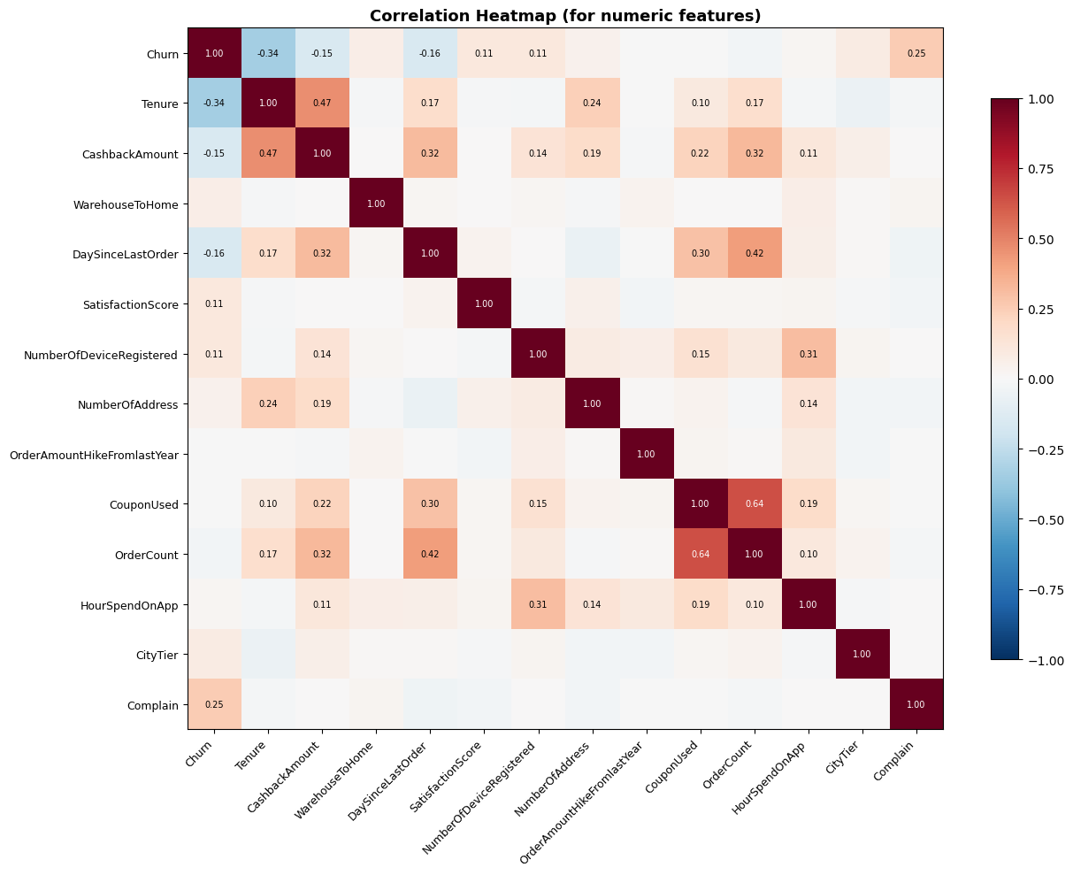
Figure 3 Correlation Heatmap
Figure 3 presents the correlation structure among the numeric variables and their relationship with churn. The heatmap suggests that churn is most strongly associated with Tenure, Complain, DaySinceLastOrder, and CashbackAmount, indicating that customer lifecycle, complaint behavior, recency of purchase, and reward-related factors are important signals of churn. In addition, some moderate correlations are observed among predictor variables themselves, such as between CouponUsed and OrderCount, and between Tenure and CashbackAmount. Overall, the results show that churn is influenced by several behavioral and engagement-related factors rather than by a single dominant variable.

- Model Preparation & Training
After cleaning the data, CustomerID was removed from the feature set because it is just an identifier and not a useful feature. Categorical variables were one-hot encoded into five categorical columns: PreferredLoginDevice, PreferredPaymentMode, Gender, PreferedOrderCat, MaritalStatus, and the dataset was split into 80% training and 20% test subsets with stratification to preserve the churn ratio. Standardization was applied for Logistic Regression. Four supervised classification models were then trained and compared. Table 1 summarizes the classification models used in the study and their main parameter settings.
Table 1 Models used and their configurations
Model | Configuration
Logistic Regression | class_weight='balanced', max_iter=1000
Decision Tree | max_depth=5, class_weight='balanced'
Random Forest | n_estimators=300, max_depth=10, class_weight='balanced'
Gradient Boosting | n_estimators=200, learning_rate=0.1, max_depth=4

- Model Evaluation
Given the class imbalance in the dataset, model performance was evaluated using ROC-AUC, precision, recall, and F1 score rather than accuracy alone. The comparative test results are presented in Table 2 and Figure 4, which indicate that Gradient Boosting delivered the best overall test performance, followed by Random Forest. While Logistic Regression and Decision Tree achieved high recall, their lower precision and F1 scores suggest weaker overall balance. Therefore, Gradient Boosting was selected as the strongest model for churn prediction.
Table 2 Test set performance of the classification models across evaluation metrics
Model | Accuracy | Precision | Recall | F1 | ROC-AUC
Logistic Regression | 79.2% | 0.4399 | 0.8474 | 0.5791 | 0.8856
Decision Tree | 78.6% | 0.4309 | 0.8368 | 0.5689 | 0.8769
Random Forest | 94.6% | 0.8274 | 0.8579 | 0.8424 | 0.9851
Gradient Boosting | 95.8% | 0.9333 | 0.8105 | 0.8676 | 0.9877
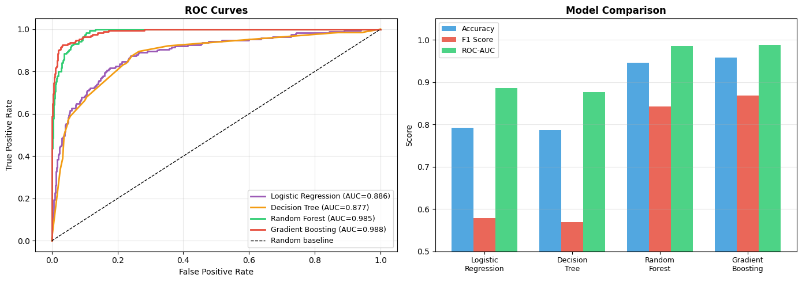
Figure 4 ROC curves and metric comparison across the models.
Table 3 provides a comparison of the models in terms of correctly identified churners and prediction errors. Random Forest captured the highest number of churners while keeping missed churners relatively low, but it produced more false alarms than Gradient Boosting. Gradient Boosting generated the fewest false positives by a large margin, although it missed slightly more churners. In contrast, Logistic Regression and Decision Tree identified a similar number of churners but at the cost of a much higher number of false alarms. Overall, the table shows that Gradient Boosting offers the most efficient balance when minimizing unnecessary interventions is important, whereas Random Forest is slightly stronger at catching churners
Table 3 Confusion-Matrix Summary
Model | Caught Churners (TP) | Missed Churners (FN) | False Alarms (FP)
Logistic Regression | 161 | 29 | 205
Decision Tree | 159 | 31 | 210
Random Forest | 163 | 27 | 34
Gradient Boosting | 154 | 36 | 11

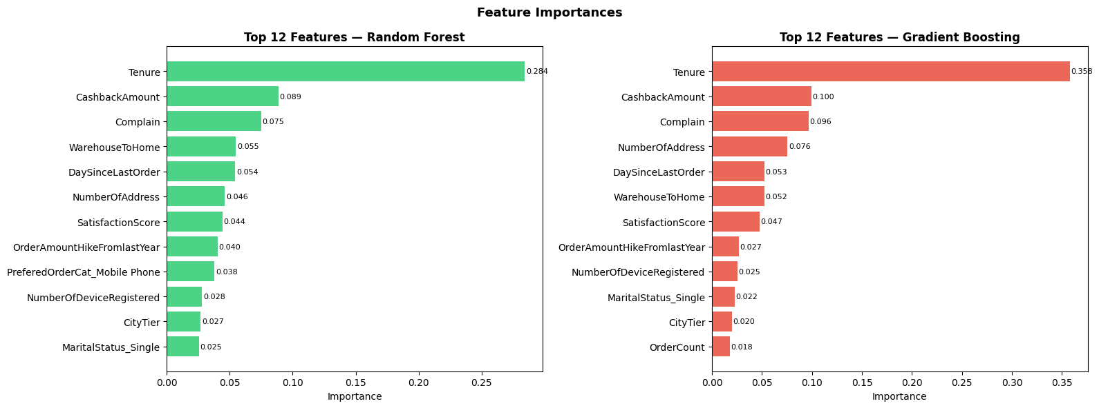
- Feature Importance
Figure 5 Feature importance comparison for Random Forest and Gradient Boosting
Figure 5 shows that both Random Forest and Gradient Boosting point to a very similar story. In both models, Tenure stands out as the most important factor by far, which suggests that how long a customer has been with the company plays the biggest role in churn prediction. CashbackAmount and Complain also appear near the top in both models, indicating that rewards and complaint history are closely linked to whether a customer leaves. Other factors such as DaySinceLastOrder, WarehouseToHome, SatisfactionScore, and NumberOfAddress also matter, but their effect is smaller. Overall, the two models are consistent with each other, which makes the identified churn drivers more convincing and easier to trust.

- Business Insights

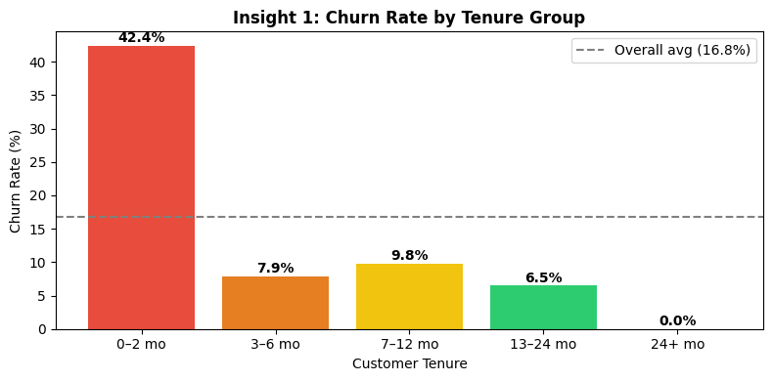
Figure 6 Churn rate by Tenure Group
Figure 6 shows that churn is mostly an early-stage problem. Customers in their first 0–2 months have the highest churn rate by a wide margin (42.4%), far above the overall average of 16.8%. After that, the churn rate drops a lot and stays relatively low as customer tenure increases. This suggests that the first few months are the most important period for keeping customers engaged, so stronger onboarding and early follow-up efforts could make a big difference.
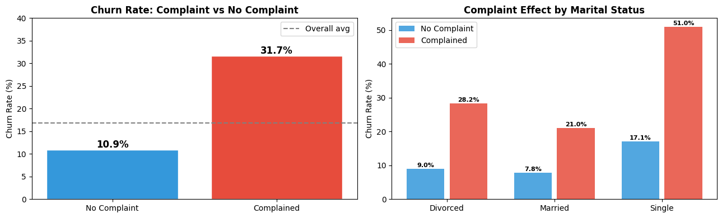
Recommended action: The company should prioritize early-stage retention strategies, particularly within the first three months, through structured onboarding, proactive communication, and targeted promotional support for newly acquired customers.
Figure 7 Churn rate by complaint status and complaint effect within marital status segments
As shown in Figure 7, complaints are one of the clearest warning signs of churn. Customers who submitted a complaint have a much higher churn rate (31.7%) than those who did not (10.9%). This pattern also remains consistent across marital-status groups, with especially high churn among single customers who complained. Overall, the figure suggests that complaints are not just service issues, but strong signals of retention risk.
Recommended action: The company should treat every complaint as a potential churn alert. Fast follow-up, service recovery within 24 hours, and targeted retention offers for complaining customers could help reduce the likelihood of churn.

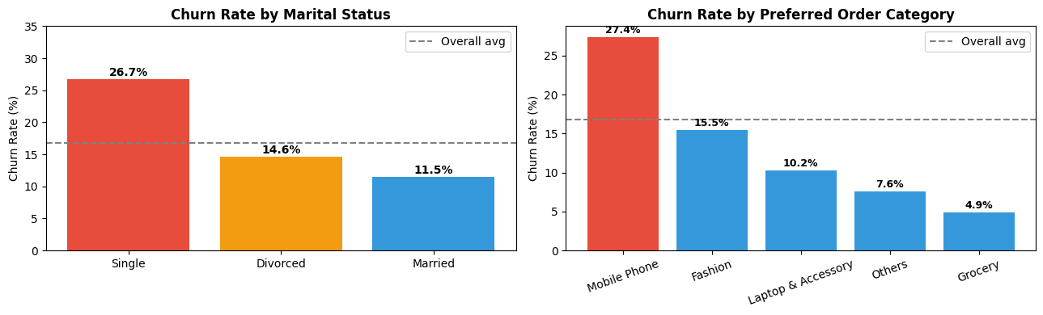
Figure 8 shows that churn is noticeably higher among single customers and customers who mainly buy from the Mobile Phone category. Single customers have the highest churn rate among marital-status groups, while Mobile Phone buyers stand out clearly among product categories. This suggests that these two segments may be more price-sensitive, less loyal, or more likely to switch when they find a better option. In other words, not all customers are leaving for the same reason, so a single retention strategy may not be enough.
Figure 8 Churn rate by marital status and preferred order category
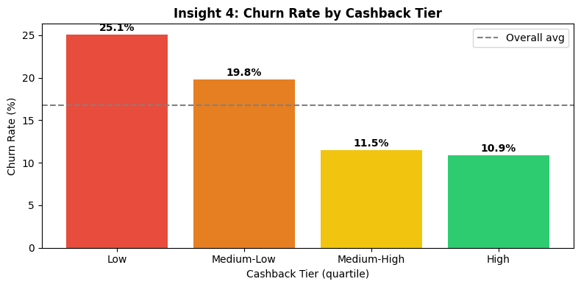
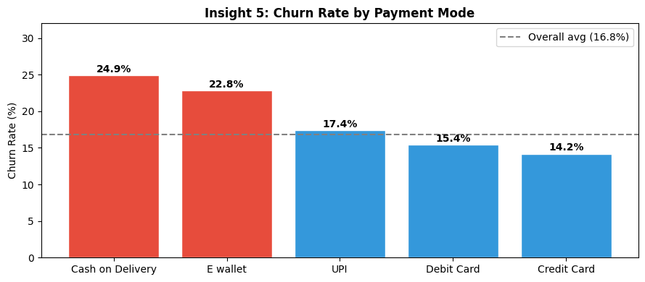
Recommended action: The company should design separate retention campaigns for these high-risk groups. For single customers, loyalty perks, referral rewards, or personalized engagement offers may help strengthen retention. For Mobile Phone buyers, price-match deals, warranty extensions, or post-purchase offers could reduce switching risk and improve customer loyalty.
Figure 9 Churn rate by cashback tier (left) and preferred payment mode (right)
Figure 9 shows that both cashback level and preferred payment mode are linked to churn. On the left, customers in the low cashback tier have the highest churn rate, and this rate steadily decreases as cashback benefits increase. On the right, customers using Cash on Delivery and E-wallet have higher churn rates than those using UPI, Debit Card, or Credit Card. Together, these patterns suggest that customers receiving weaker rewards and those relying on less committed payment methods are more likely to leave.

Recommended action: The company should strengthen retention efforts for customers in the low cashback tier and for high-risk payment groups, especially Cash on Delivery users. This can be done through targeted bonus cashback, personalized reward offers, and incentives that encourage customers to switch to more stable digital payment methods.

- Conclusion
This study showed that customer churn can be predicted effectively using machine learning, while also providing useful business insights. Among the four models tested, Gradient Boosting performed the best overall, with the highest ROC-AUC, F1 score, and accuracy.
The analysis shows that customer churn is driven by a small number of clear and actionable factors.
- Tenure is the most important churn driver. Customers in their first 0–2 months show the highest churn rate. After around 6 months, churn decreases substantially. This suggests that the first 90 days are the most critical retention period, and stronger onboarding with early incentives could help reduce customer loss.
- Complaints are one of the strongest warning signs of churn. Customers who submitted a complaint churn at nearly three times the rate of those who did not. This pattern is also consistent across marital-status groups. Therefore, fast complaint resolution is likely to be one of the most effective actions the company can take.
- Single customers represent a higher-risk segment. Single customers churn at more than twice the rate of married customers. This suggests that they may require different retention strategies, such as personalized offers, referral rewards, or loyalty-based incentives.
- Mobile Phone buyers are the most vulnerable product segment. Among all product categories, customers purchasing Mobile Phone products have the highest churn rate. This may indicate stronger price sensitivity or higher comparison shopping behavior. Price-match offers, warranty extensions, or post-purchase campaigns may improve retention in this segment.
- Low cashback and Cash on Delivery usage both signal higher churn risk. Customers receiving lower cashback rewards are more likely to churn, and Cash on Delivery users also show higher churn than customers using card-based payment methods. This suggests that both reward value and payment behavior are linked to customer loyalty. Improving cashback incentives and encouraging more stable digital payment methods may help lower churn.
Overall, the findings suggest that the company should move from a general retention approach to a more targeted strategy focused on early-stage customers, complainers, single customers, Mobile Phone buyers, and low-reward or COD users.

