24.12.2026
EEE412 Microwave Electronics- Lab 2 Experimental Report
Ezgi Demir, 22103304
“I completed this homework assignment independently.”

Part 1
1.a)
Network analyzer measurement are as below, at my voltage as in preliminary work (5V selected).

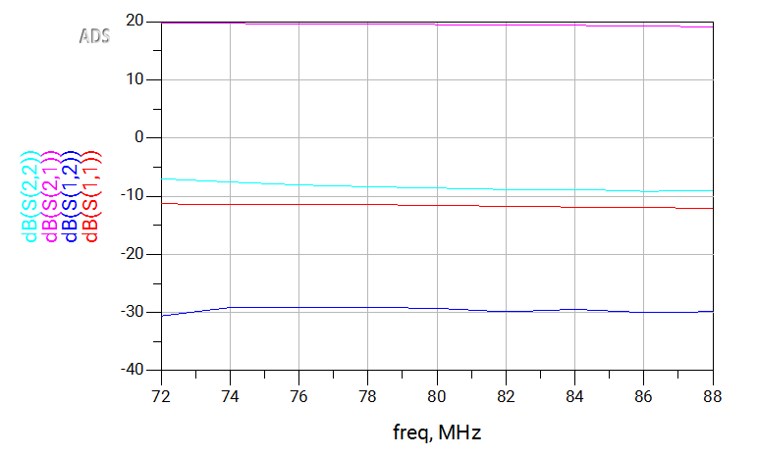
Fig.1: S parameters at Vcc= 5V

The S parameters of the BFU520-based amplifier was measured using a network analyzer at the selected center frequency of 80 MHz with a ±10% frequency span. The supply voltage was set to VCC = 5V.

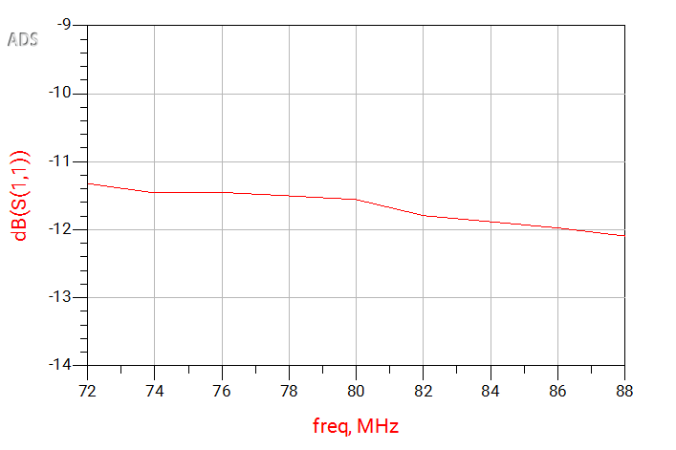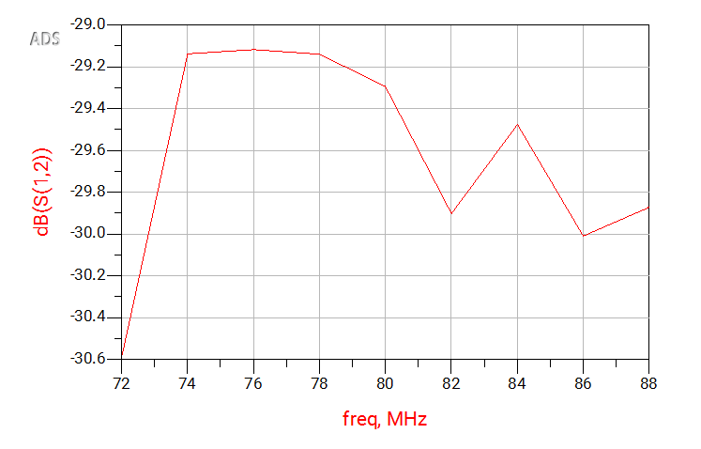
Fig.2: S11 at 5V, 80MHz Fig.3: S12 at 5V, 80MHz

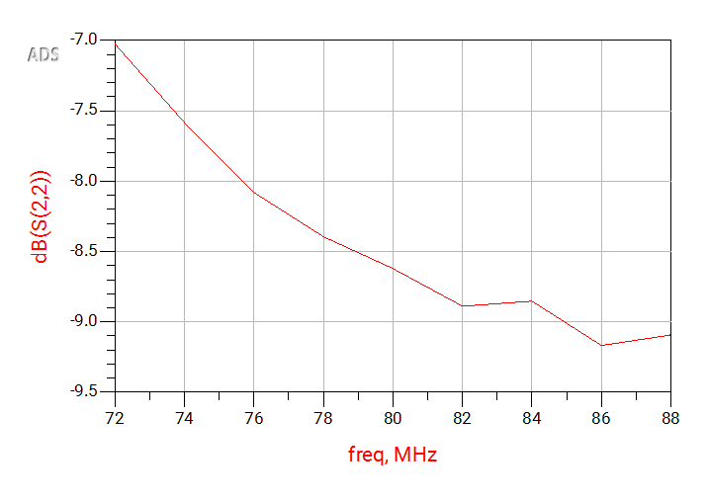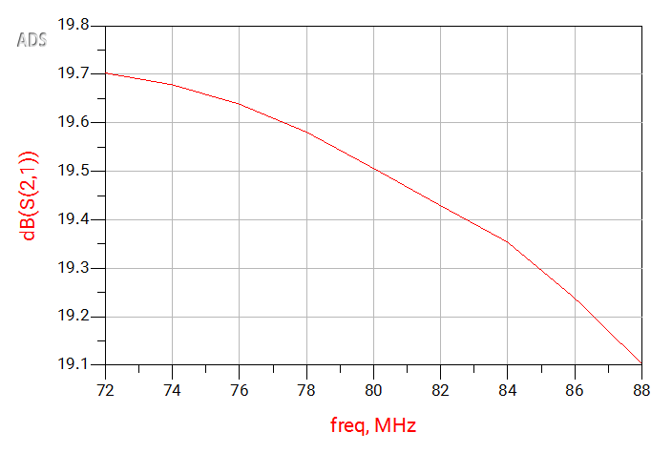
Fig.4: S22 at 5V, 80MHz Fig.5: S21 at 5V, 80MHz

1.b) In this part, another voltage value selected and ADS measurements are as below,

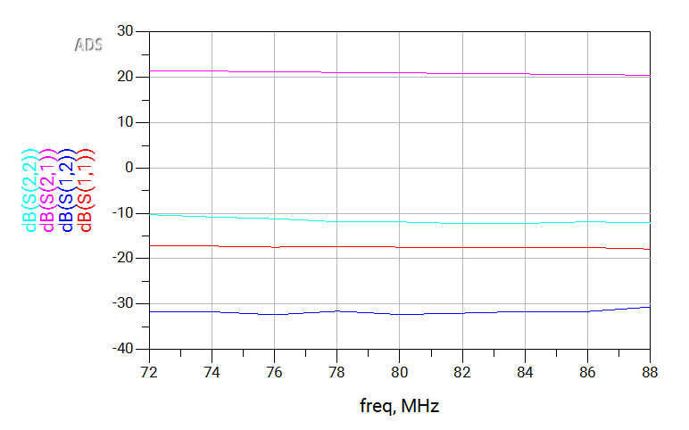
Fig.6: S parameters at Vcc= 9V

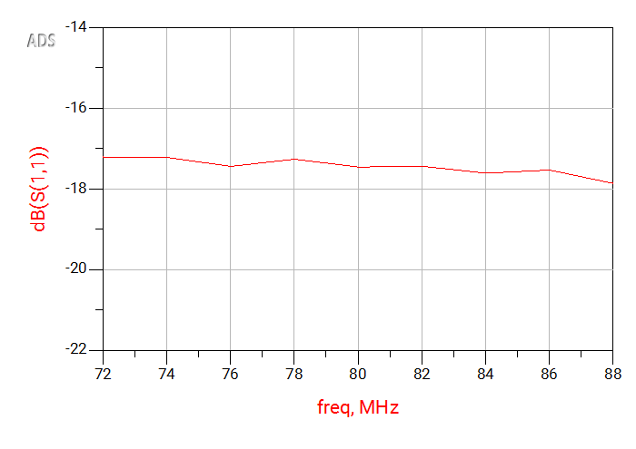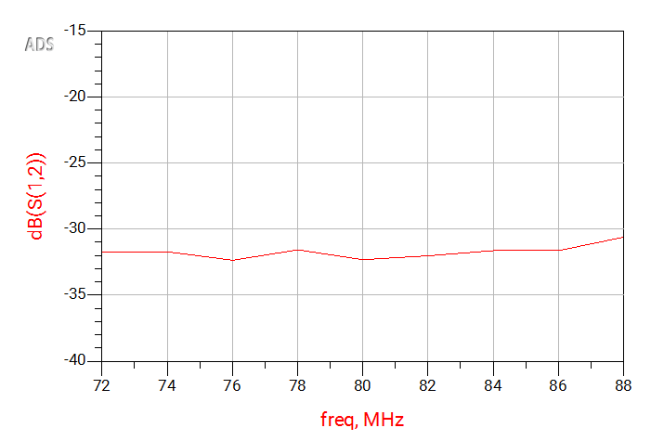
Fig.7: S11 at 5V, 80MHz Fig.8: S12 at 5V, 80MHz
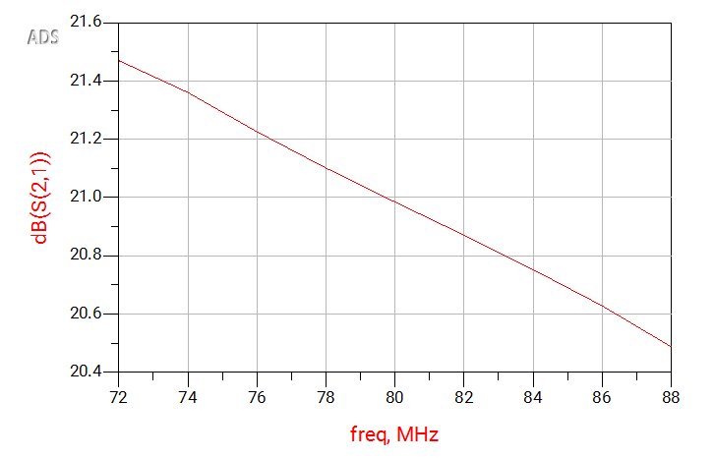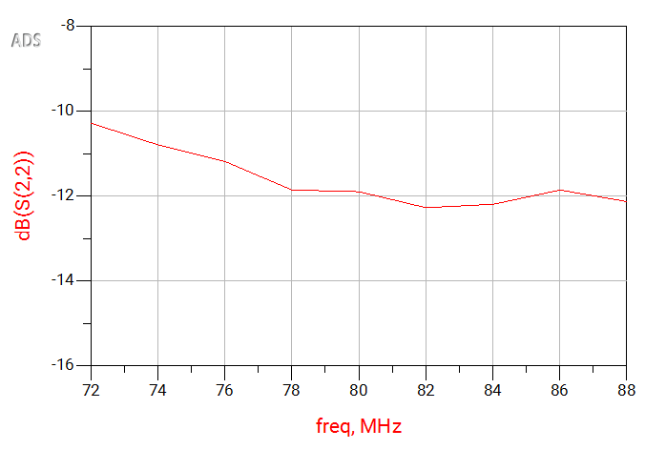
Fig.9: S21 at 9V, 80MHz Fig.10: S12 at 9V, 80MHz

1.d) In this part 1-dB compression point measurements are made, see below for results. Starting from 5V, increasing with 1step V. Results and plots are as below. Figure 11 is the result of part c (5V).

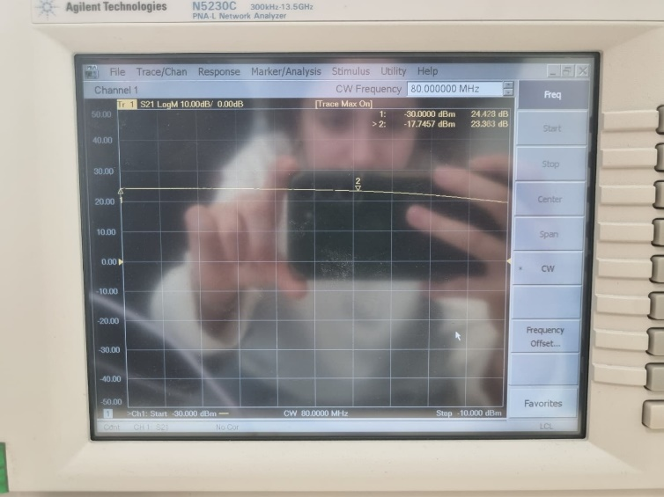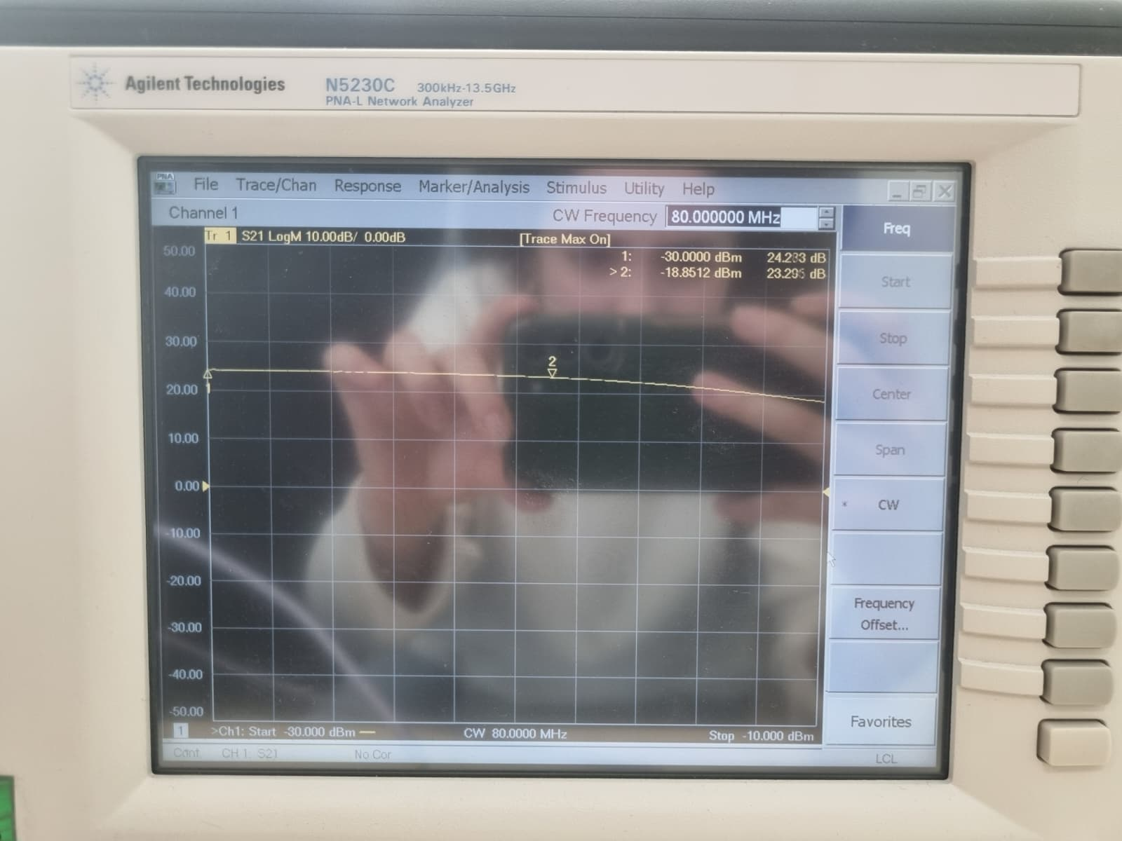
Fig.11: Vcc=5V, 80MHz Fig.12: Vcc=6V, 80MHz

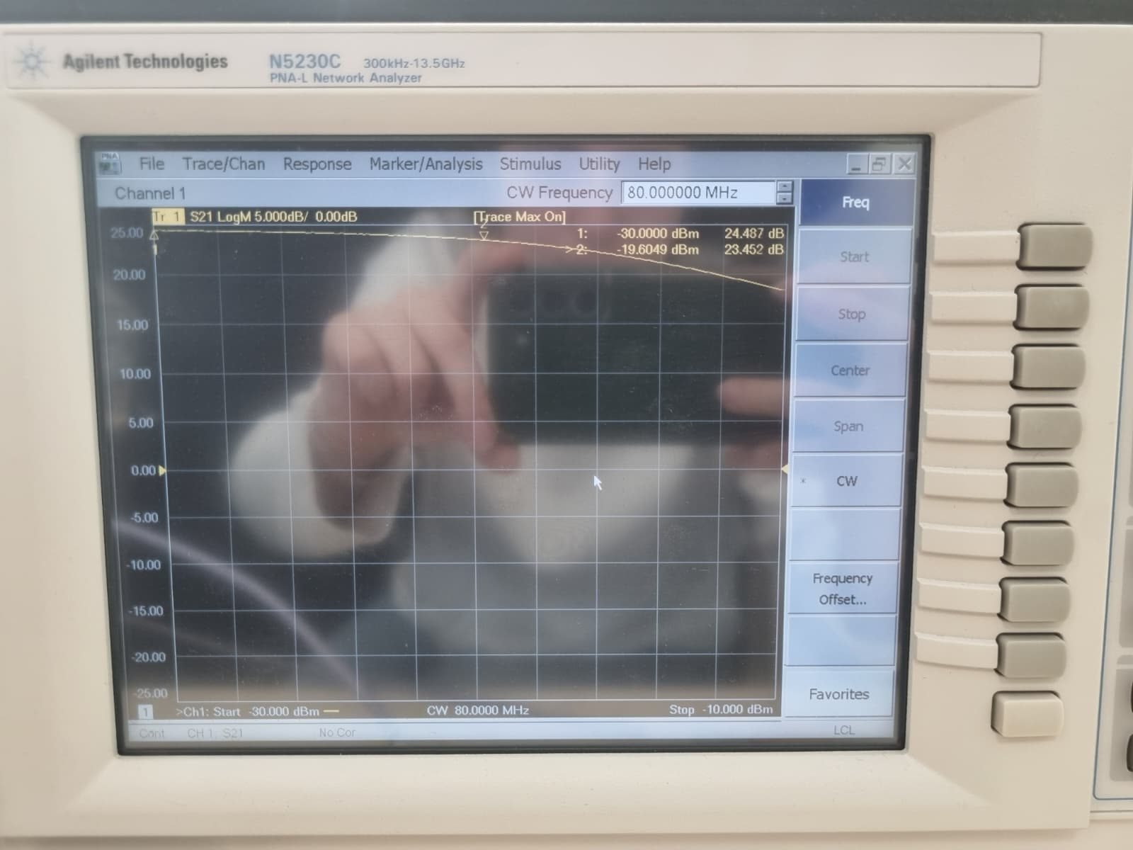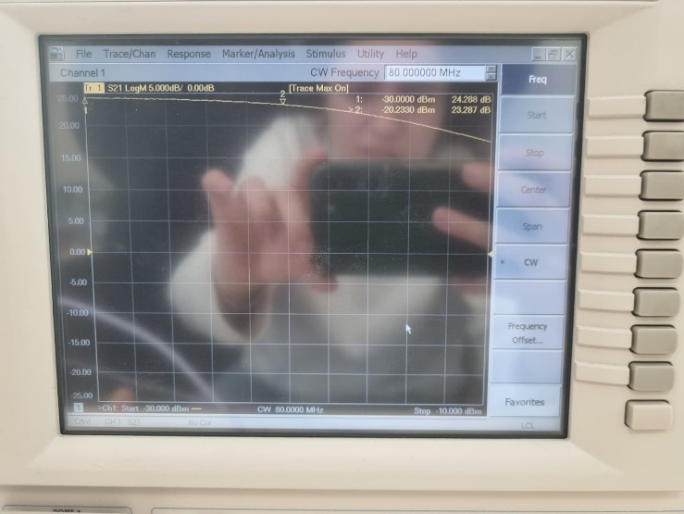
Fig.13: Vcc=7V, 80MHz Fig.14: Vcc=8V, 80MHz
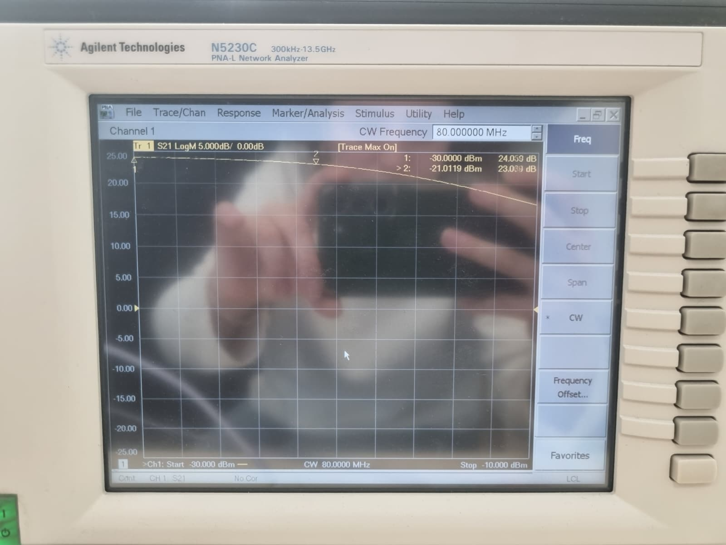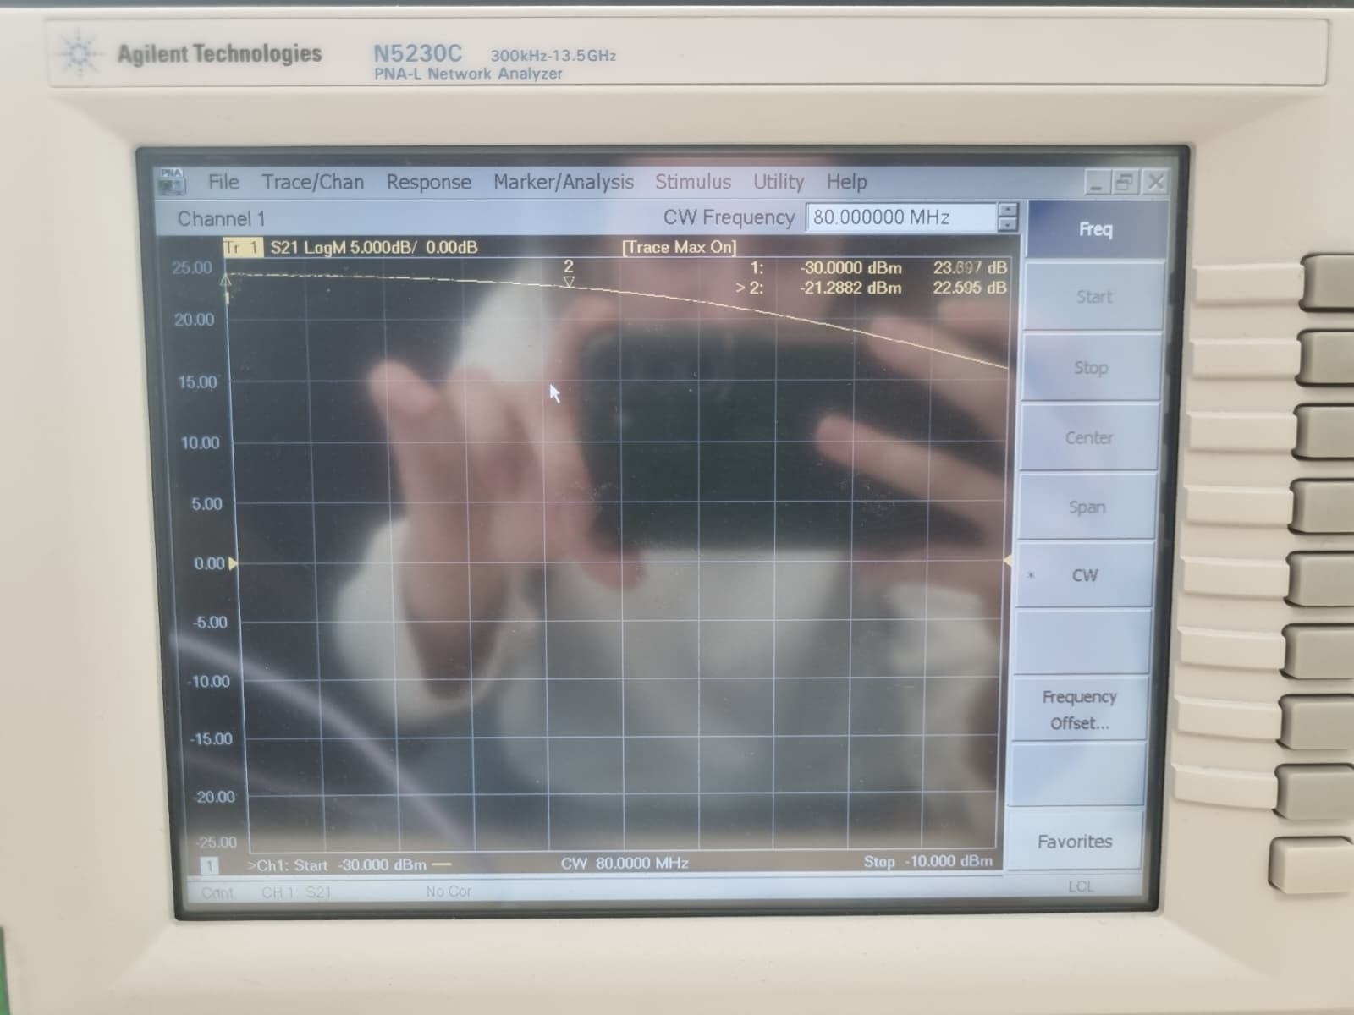
Fig.15: Vcc=9V, 80MHz Fig.16: Vcc=10V, 80MHz

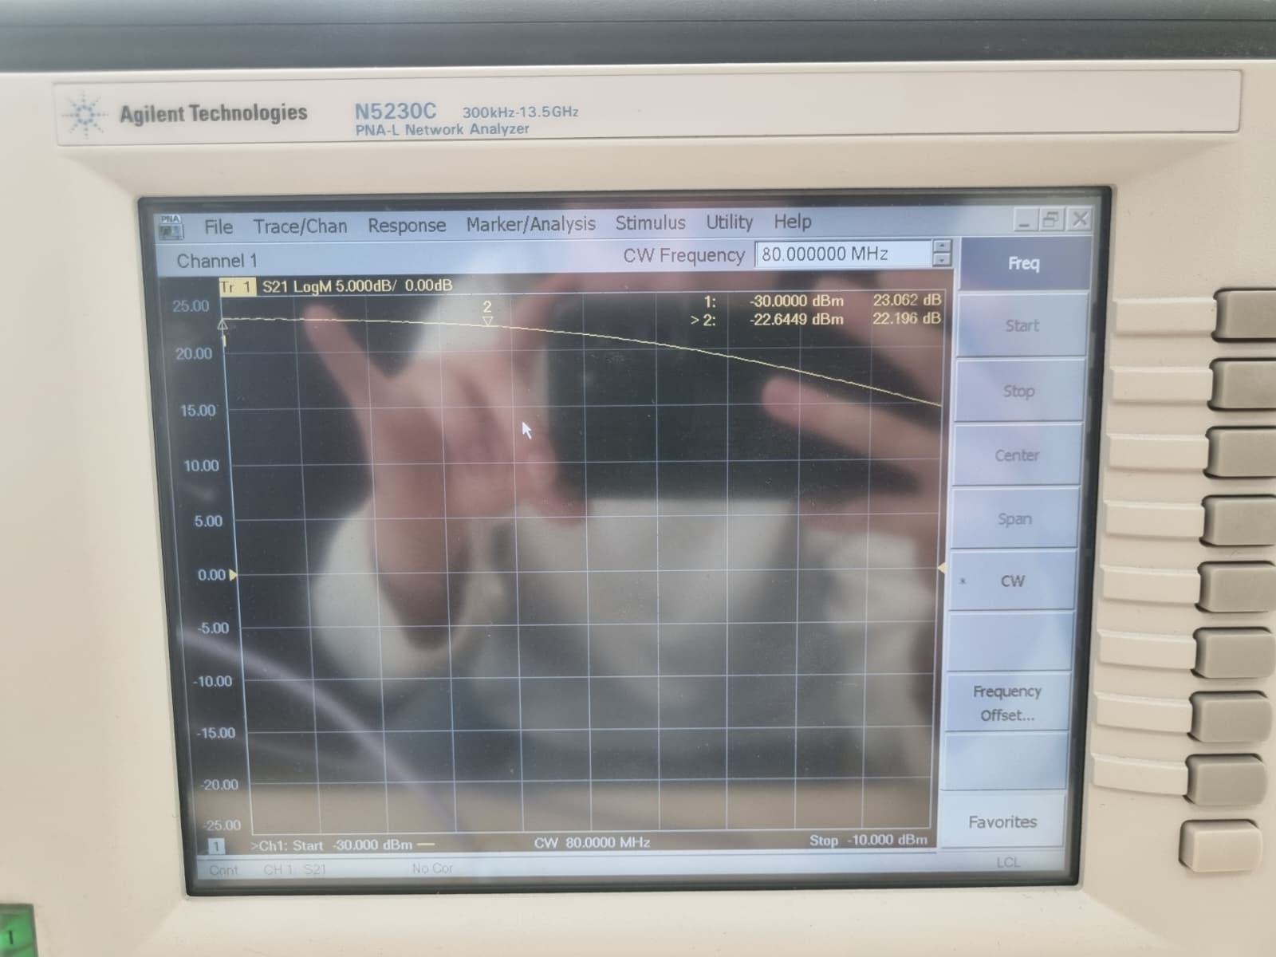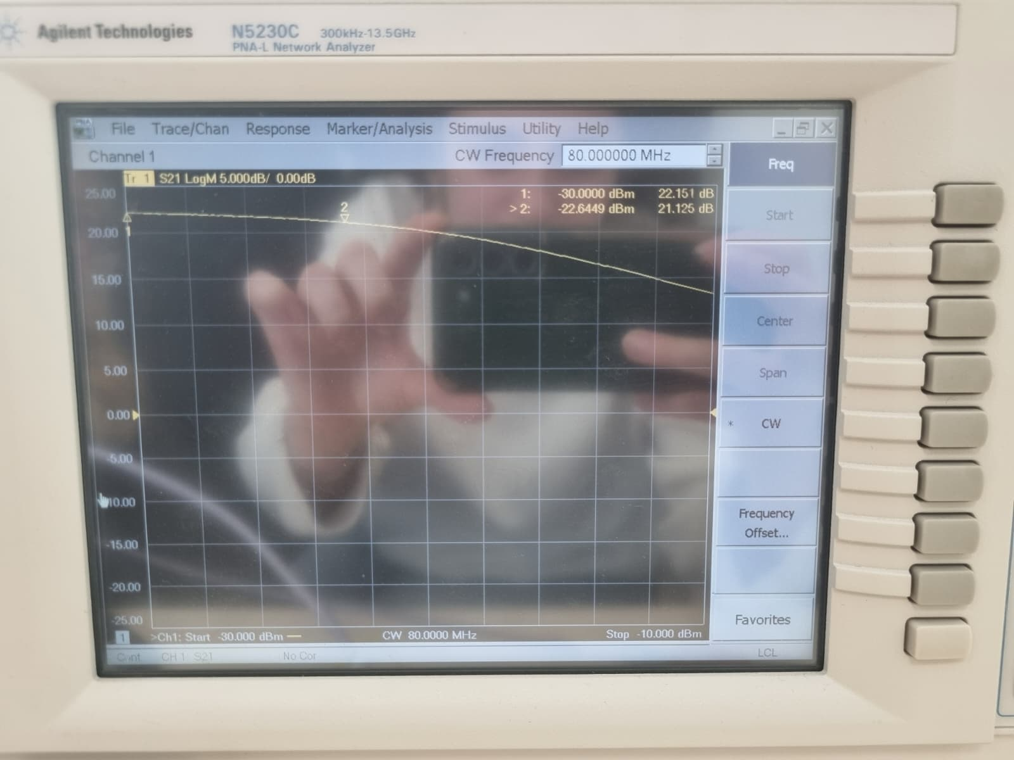
Fig.17: Vcc=11V, 80MHz Fig.18: Vcc=12V, 80MHz

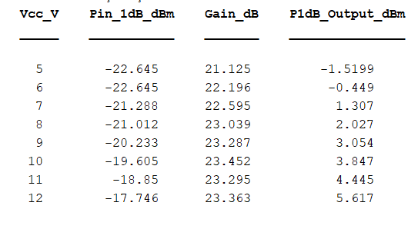
Table 1: 1dBCompression Points From Figures Above

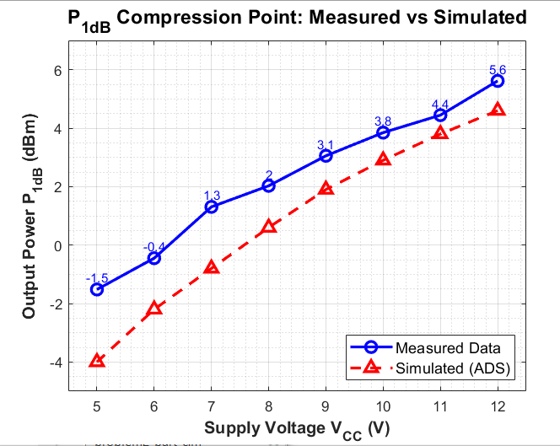
Fig.19: Simulation and Measured Value Comparison for P1dB

Part 2
2.a) Two signal generators were used to apply a two-tone input at (f_1 = 80) MHz and (f_2 = 81) MHz. In the experiment, both sources were set to an output power of 37 dBm. This level was chosen instead of 40 dBm to avoid overdriving the setup and to better capture the influence of other noise contributions.

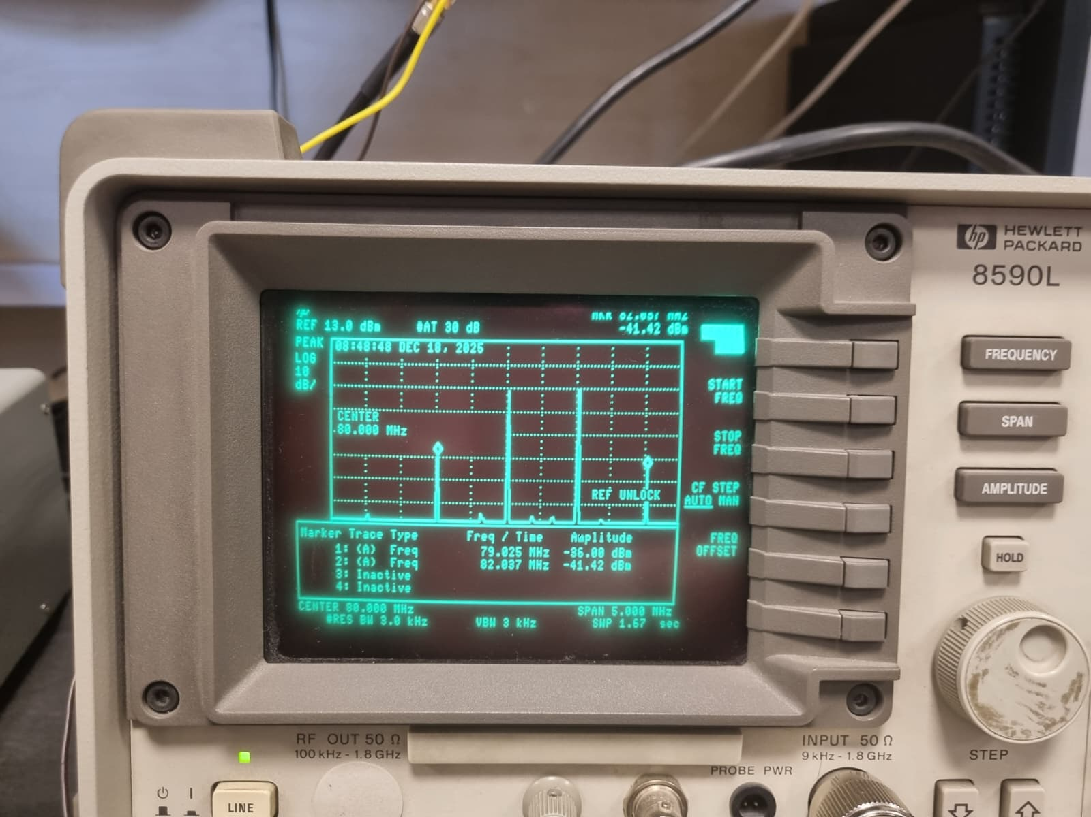
Fig.20: Fundamental and Third-order Components for -30dBm
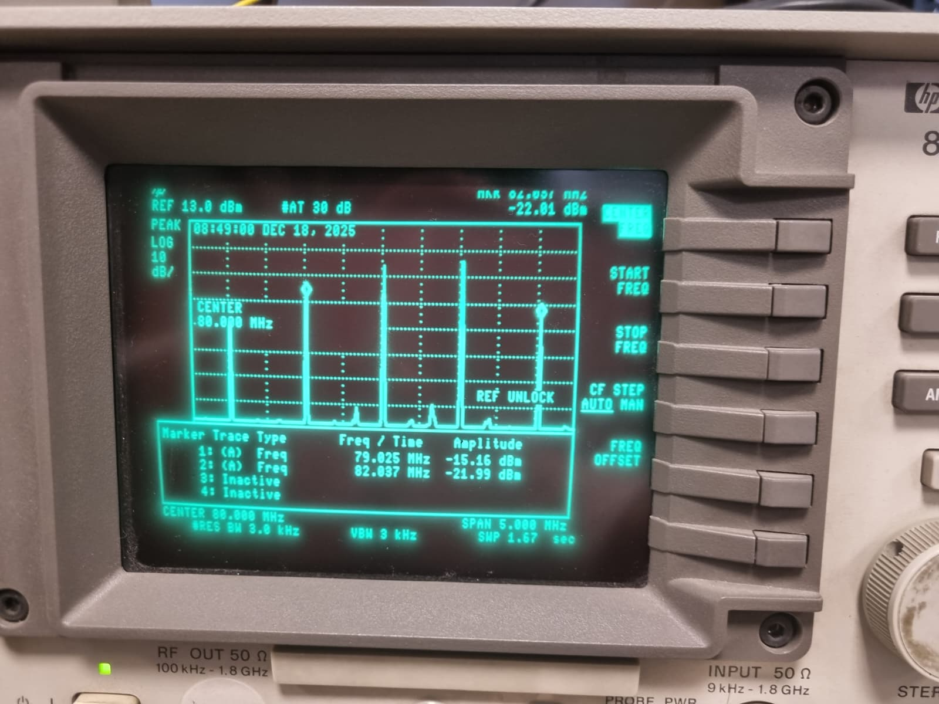
Fig.21: Fundamental and Third-order Components for -20dBm

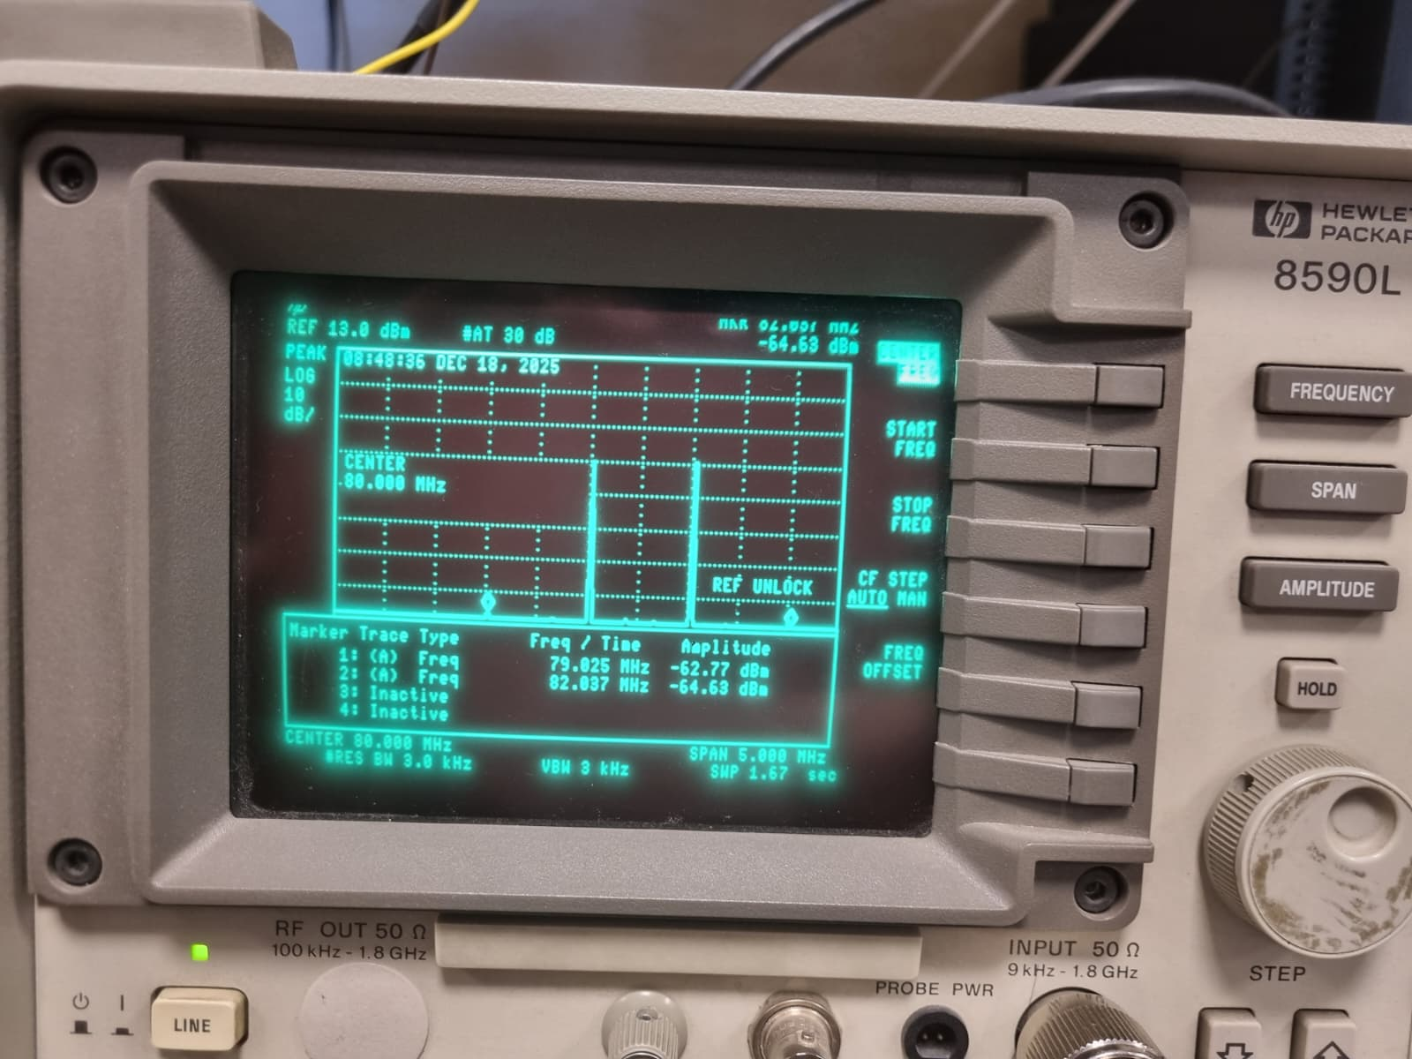
Fig.22: Fundamental and Third-order Components for -40dBm

