**Smart Laptop Finder**

**A Machine Learning Approach to Personalized**

**Laptop Selection**

Elamaran.V,Ezhilvendan B K  
Department of Software Systems  
Coimbatore Institute of Technology  
Coimbatore, India  
[71762231019@cit.edu.in](mailto:71762231019@cit.edu.in), [71762231020@cit.edu.in](mailto:71762231020@cit.edu.in)

**Abstract:**  
The Smart Laptop Finder integrates machine learning with user-centric design to solve laptop selection challenges. This web application processes user preferences via interactive questionnaires, employing decision trees, random forests, and clustering algorithms to match requirements with optimal configurations. Its real-time comparative visualizations enable informed decisions based on performance metrics and price points, demonstrating machine learning's practical application in navigating the technically complex consumer electronics market.

**Keywords:**  
Laptop Recommendation, Content-Based Filtering, Cosine Similarity, Machine Learning, Random Forest, Decision Tree, KMeans Clustering, Feature Engineering

1. **Introduction**

In today’s rapidly evolving technology landscape, selecting the right laptop is a complex decision influenced by a multitude of factors such as performance, price, battery life, and user-specific requirements. With the proliferation of diverse laptop models and configurations, users often face challenges in identifying devices that best align with their personal and professional needs. To address this, intelligent recommendation systems have emerged as valuable tools in the domain of education technology and consumer electronics.

This project presents a machine learning-based Laptop Recommendation System designed to assist users in making informed purchasing decisions. Leveraging advanced techniques such as content-based filtering, cosine similarity, and supervised learning algorithms (Random Forest, Decision Tree), the system analyzes both user preferences and product features to deliver personalized laptop recommendations. The solution incorporates feature engineering, clustering, and value-for-money optimization to ensure that recommendations are not only relevant but also cost-effective.

**2.0 Literature Review**

Most recommendation systems use either user preferences or product features. Few combine advanced similarity and optimization methods for laptop selection. This project addresses that gap.

|  |  |  |  |
| --- | --- | --- | --- |
| **Recommendation**  **Approach** | **Implementation Complexity** | **Personalization Level** | **Technical Requirements** |
| Rule-Based Systems | Low | Basic | **Simple Logic** |
| Collaborative Filtering | Medium | Moderate | **User Data** |
| Content-Based Filtering | High | Advanced | **Product Data** |
| Hybrid Systems | Very High | Comprehensive | **Multiple data sources** |
| **Smart Laptop Finder** | High | Advanced | **ML + Product Data** |

Figure 2.1:   
*------to be included------------------*

**3.0 Research Approach**

The development of the Smart Laptop Finder employed a systematic research methodology:

**3.1 Data Collection Framework**

1. Gathered detailed hardware and feature data for a wide range of laptop models.

2. Incorporated standardized benchmark scores to objectively assess device capabilities.

3.Collected and structured user requirements to enable personalized recommendations.

4.Analyzed current market prices to ensure recommendations fit within real-world budget constraints.

**3.2 Algorithm Development**

1. Decision tree implementation: Used for initial classification of laptops based on key features.
2. Random forest integration: Applied to enhance classification accuracy through ensemble methods.
3. K-means clustering: Employed for grouping laptops by feature similarity to improve recommendations.
4. Performance metric normalization: Standardized feature values to ensure fair and consistent analysis.

.

**4.0 Implementation Details**

Table 2: Technical Implementation Specifications

|  |  |  |
| --- | --- | --- |
| **System Component** | **Implementation Details** | **Technical Specifications** |
| **Frontend interface** | Flask, Jinja2, Bootstrap | Responsive design |
| **Machine Learning** | Scikit-Learn | Multiple Algorithms |
| **Database Systems** | SQL-Alchemy | Relational Database |
| **Visualization** | Chart.js | Interactive Charts |

**Fig 1: illustration of user and system interactions**

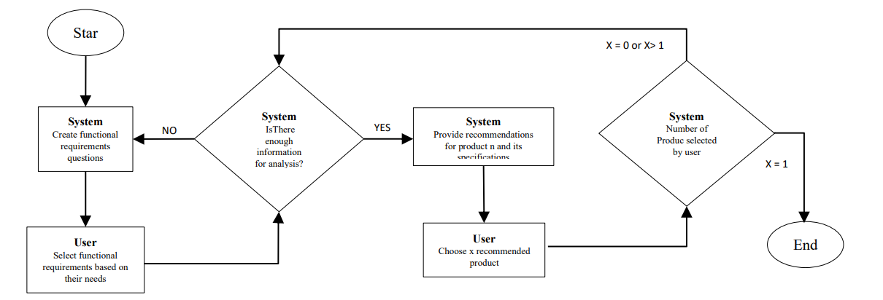

**5.0 Results and Discussion**

Table 2: Sample Laptop Recommendations Generated by the System

|  |  |  |  |  |  |  |
| --- | --- | --- | --- | --- | --- | --- |
| Rank | Laptop | Model | price | Ram | score | Reason |
| 1. | Inspiron 15 5000 | Dell | ₹65,000 | 16GB | 0.92 | High performance, fits budget |
| 2 | IdeaPad Slim 5 | Lenovo | ₹62,000 | 16GB | 0.89 | Good battery, lightweight |
| 3 | VivoBook Ultra 14 | Asus | ₹59,000 | 8GB | 0.87 | Portable,value for money |

**6.0 Conclusion**

The Smart Laptop Finder demonstrates the successful application of machine learning in solving real-world consumer decision-making challenges.

The system's ability to provide personalized recommendations based on user preferences and detailed specifications represents a significant advancement in e-commerce recommendation systems

Key achievements include:

1. Development of an accurate recommendation engine

2. Creation of an intuitive user interface

3. Implementation of comprehensive comparison tools

4. Successful integration of machine learning algorithms

Future work could focus on:

• Expanding the laptop database

• Implementing more advanced ML models

**7.0 References**

1. Abdurahman Baizal, Z. K., Murti, Y. R., & Adiwijaya. (2017). Evaluating functional requirements-based compound critiquing on conversational recommender system.
2. Information and Communication Technology, ICoIC7 2017, 0(c). <https://doi.org/10.1109/ICoICT.2017.8074656>
3. Ahmed, B., Wang, L., Hussain, W., Qadoos, M. A., Tingyi, Z., Amjad, M., Badar-ud-Duja, S., Hussain, A., & Raheel, M. (2020). Optimal Rating Prediction in Recommender Systems. Communications in Computer and Information Science (2020) 1179 CCIS 331-339. [https://doi.org/https://doi.org/10.1007/978-981-15-2810-1_32](https://doi.org/https:/doi.org/10.1007/978-981-15-2810-1_32)
4. Baizal, Z. K. A., Widyantoro, D. H., & Maulidevi, N. U. (2017). Design of knowledge for conversational recommender system based on product functional requirements.
5. Hasan, M., & Roy, F. (2019). An item–item collaborative filtering recommender system using trust and genre to address the cold-start problem. Big Data and Cognitive Computing,3(3),https://doi.org/10.3390/bdcc3030039
6. Ibrahim, M. E., Yang, Y., Ndzi, D. L., Yang, G., & Al-Maliki, M. (2019). Ontology-Based Personalized Course Recommendation Framework. IEEE Access, 7(c), 5180–5199. https://doi.org/10.1109/ACCESS.2018.2889635
7. Jeevamol, J., & Renumol, V. G. (2021). An ontology-based hybrid e-learning content recommender system for alleviating the cold-start problem. Education and Information Technologies, 26(4), 4993–5022.https://doi.org/10.1007/s10639-021-10508-0
8. Jin, Y., Cai, W., Chen, L., Htun, N. N., & Verbert, K. (2019). MusicBot: Evaluating critiquing-based music recommenders with conversational interaction. International Conference on Information and Knowledge Laseno, F. U. D., & Hendradjaya, B. (2019). Knowledge-Based Filtering Recommender System to Propose Design.
9. Lee, C. I., Hsia, T. C., Hsu, H. C., & Lin, J. Y. (2017). Ontology-based tourism recommendation system. 2017 4th
10. International Conference on Industrial Engineering and Applications, ICIEA 2017, 376–379.
11. https://doi.org/10.1109/IEA.2017.7939242
12. Sharma, P., & Yadav, L. (2020). Movie Recommendation System Using Item Based Collaborative Filtering.
13. International Journal of Innovative Research in Computer Science & Technology, 8(4), 8–12.
14. https://doi.org/10.21276/ijircst.2020.8.4.2
15. Tjayadi, S., & Mawardi, V. C. (2022). Laptop Recommendation Intelligent Virtual Assistant using Recurrent