Jenkins Failure Auto-Remediation — Solution Architecture
Status: Draft for review · Version 0.1 · 2026-10-31
Companion to: Design & Phased Plan (docs/superpowers/specs/2026-10-30-jenkins-auto-remediation-design.md)

1. Summary
Recommendation: Extend the existing Jenkins AI Analyzer into an event-driven remediation service. It receives Jenkins failures, classifies them with deterministic rules plus the existing LangGraph pipeline, and runs one of three bounded remediation workflows. Infra and DevOps remediation starts in shadow mode, where the service only records the action it would take, and moves to automatic execution once accuracy is proven. Compilation remediation (finding and excluding the culprit Gerrit change) runs automatically from go-live, with no human approval, behind an offline backtest and deterministic safeguards.
Business impact:
- Fewer manual touches per failed build.
- Faster recovery from transient infrastructure failures.
- Faster feedback to change authors.
- A complete audit trail for every automated decision.
Architectural stance: Validate before acting.
- Every action passes a policy gate.
- Every action target comes from system-of-record APIs, never from LLM output.
- Every step is persisted.

2. Scope
In scope
- Webhook intake from Jenkins.
- Enrichment from the Jenkins and Gerrit APIs.
- Classification into infra, devops, compilation or needs_triage.
- Three remediation workflows, the policy gate, the audit store and the review UI.
Out of scope (v1)
- Automated code or config fixes.
- Test-failure remediation.
- Changes to Jenkins or Gerrit beyond a shared-library failure hook and service-account permissions.

3. Architecture principles
Principle | How it is applied
Validate before act | Policy gate requires validator pass, high confidence, rule agreement, eligibility and budget before any action
Deterministic targets | Change numbers, emails and job names come from Jenkins/Gerrit APIs; the LLM only proposes a category and evidence
Fail safe | Any uncertainty routes to needs_triage; no partial actions without read-back verification
Least privilege | Separate service accounts per system; shadow mode needs read-only credentials
Idempotent and bounded | Dedupe on (controller_id, job, build#); re-run and re-trigger budgets enforced via lineage
Auditable | Every enrichment, analysis, gate decision, API request and response persisted with actor and timestamp
Reversible | Every Gerrit action is explained in a comment with restore instructions; re-runs never alter source

4. System context
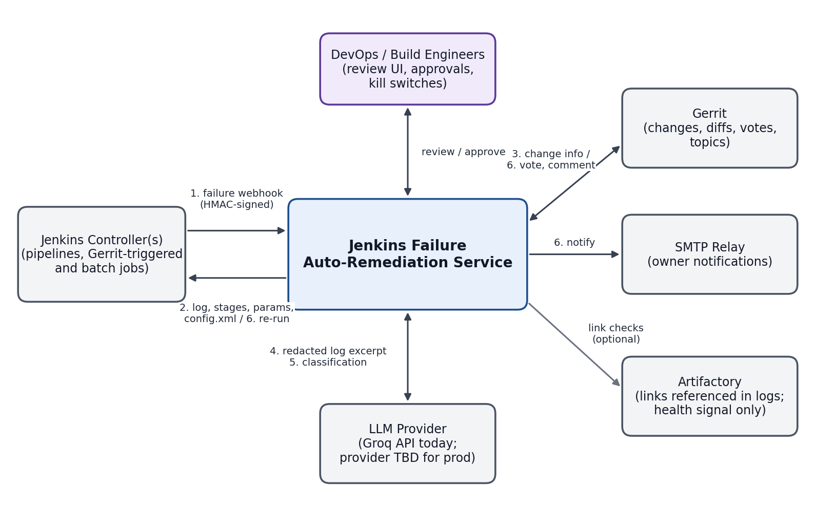
System context: external systems and interactions
External system | Interaction | Direction | Credential
Jenkins controller(s) | Failure webhook; console log, stage data, parameters, config.xml; re-run | In (webhook), Out (REST) | Jenkins user + API token (Read; Build on allowlisted jobs)
Gerrit | Change detail, files/diff, topic query; remove +2, post -1 and comment | Out (REST) | HTTP credentials; Code-Review -1..+1 and Remove Reviewer on target projects
SMTP relay | Owner notification and triage emails | Out | Send-only relay account
LLM provider | Redacted log excerpt in, structured classification out | Out | API key; egress allowlisted
Artifactory | Links extracted from logs; optional reachability check as infra signal | Out (optional) | Read-only or none
DevOps / build engineers | Review events, label shadow actions, operate kill switches | In (UI) | Identity provider TBD; interim local accounts

5. Logical architecture
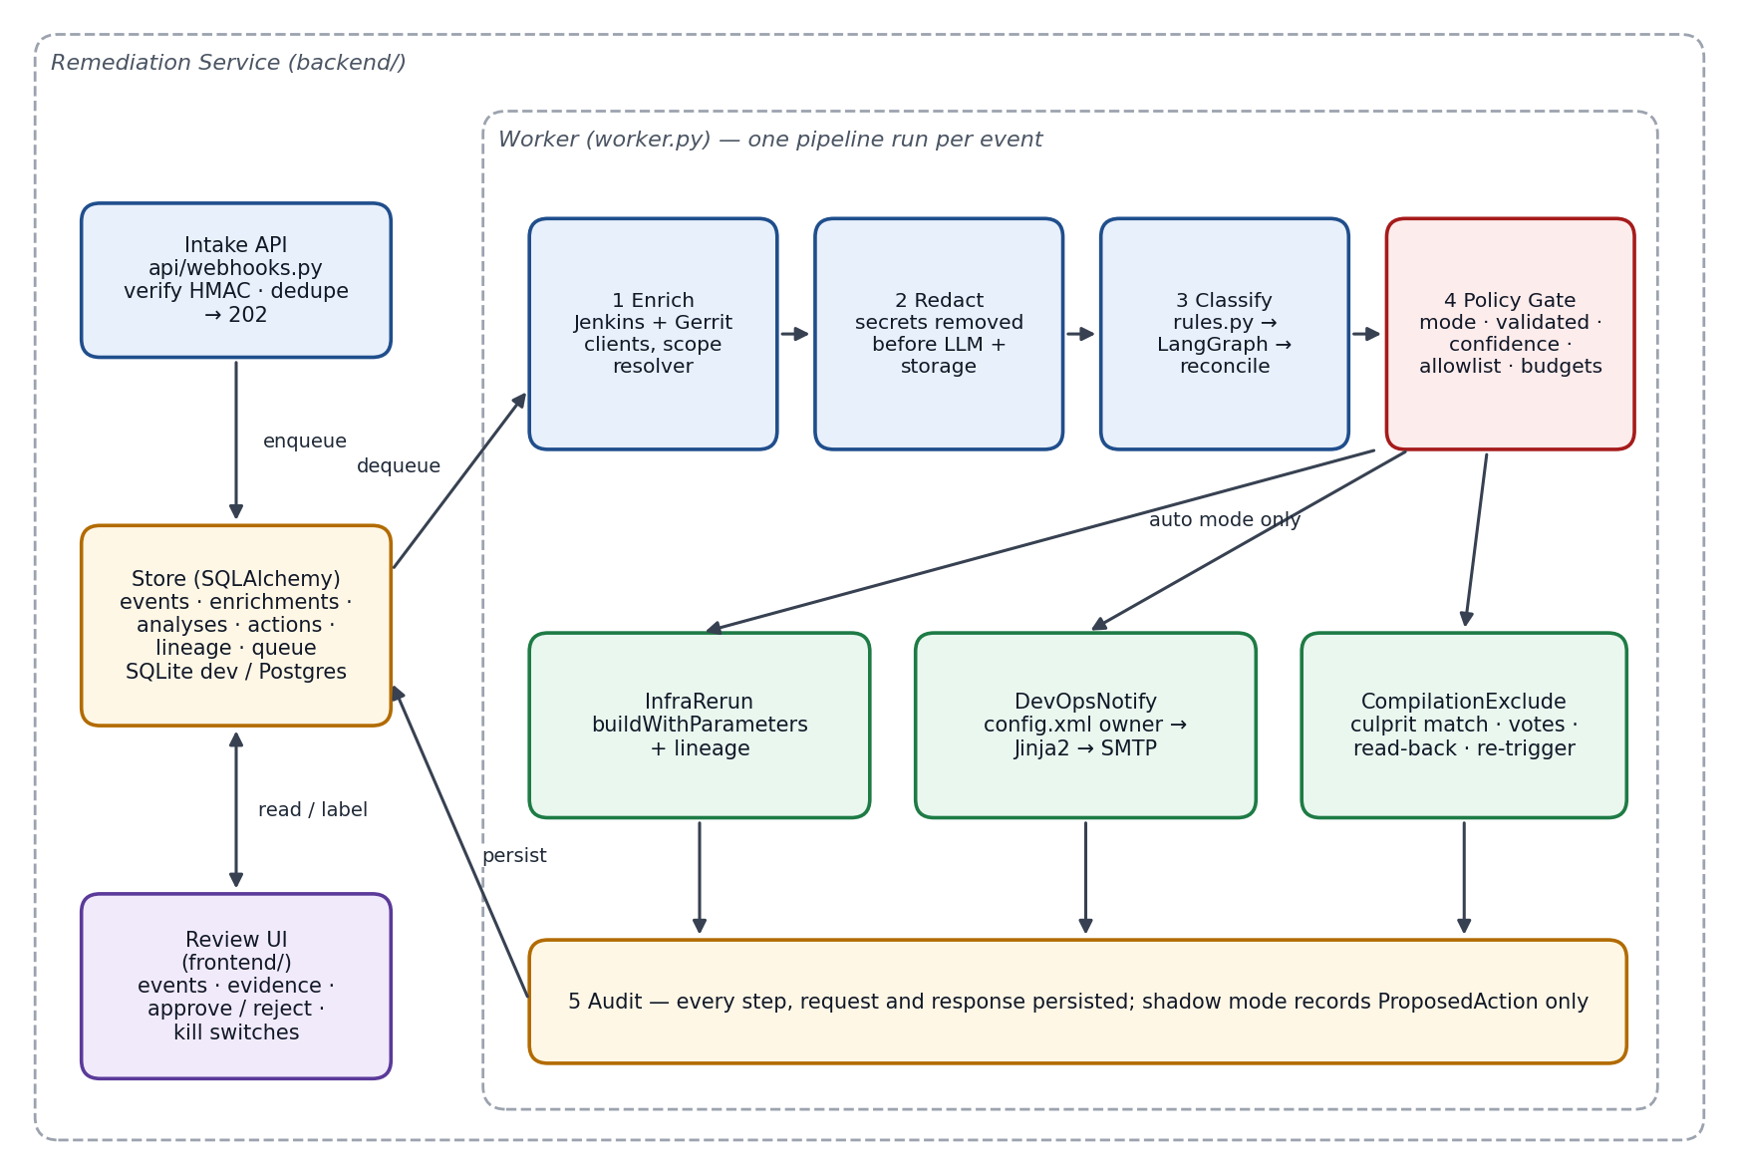
Component view of the remediation service
Component | Responsibility | Notes
Intake API | Verify HMAC, dedupe, persist event, enqueue, return 202 | Stateless; no outbound calls on request path
Store | Events, enrichments, analyses, actions, lineage, queue | SQLAlchemy 2 + Alembic; SQLite (dev), PostgreSQL (prod)
Worker | Runs the pipeline per event: enrich → redact → classify → gate → execute → audit | DB-backed queue with row locking; 1..n replicas
Jenkins client | consoleText, wfapi/describe, api/json (params, causes), config.xml, buildWithParameters, queue-item resolution | Bounded log fetch (tail N MB)
Gerrit client | Change detail, files/diff, topic query, delete vote, post review | Strips )]}' XSSI prefix; uses /a/ authenticated endpoints
Build-scope resolver | Determines change(s) in a build: Gerrit Trigger params → batch param/manifest → configured query | Unresolved → needs_triage
Rules engine | Deterministic signatures + failing stage → category hint | Versioned rule set; seeded from known infra/devops/compiler patterns
LangGraph classifier | Existing parser → error detector → root cause → validator loop, hardened | Schema-validated JSON, 4-class taxonomy, exposes validated
Policy gate | Mode, validation, confidence, agreement, allowlist, budgets, kill switch | Single decision point; emits reason codes
Executors | InfraRerun, DevOpsNotify, CompilationExclude | Idempotent; staleness re-check before acting
Review UI | Event list, evidence, proposed/executed actions, approve/reject labels, kill switches | Extends current static frontend

6. Processing pipeline
Stage | Input | Output | Failure handling
1. Intake | Webhook payload + signature | event row, queue entry | Bad signature → 401; duplicate → 200 with existing id
2. Enrich | Event | Log tail, failing stage, params, causes, Artifactory links, Gerrit change set | Retry with backoff; persistent failure → needs_triage (reason: enrichment_failed)
3. Redact | Raw log excerpt | Redacted excerpt | Redaction is mandatory; on error the event stops (no LLM call)
4. Classify | Redacted excerpt, stage, rule hints | Category, confidence, validated, evidence | LLM error/timeout → rules-only result, forced to needs_triage unless rules are decisive and category mode allows
5. Gate | Analysis + context | Allow / deny + reason codes | Deny → needs_triage
6. Execute | Gate allow | Action record with request/response | Executor error → action failed; no automatic retry of write calls without idempotency check
7. Audit | All of the above | Immutable records; UI visibility | —

7. Classification and decision flow
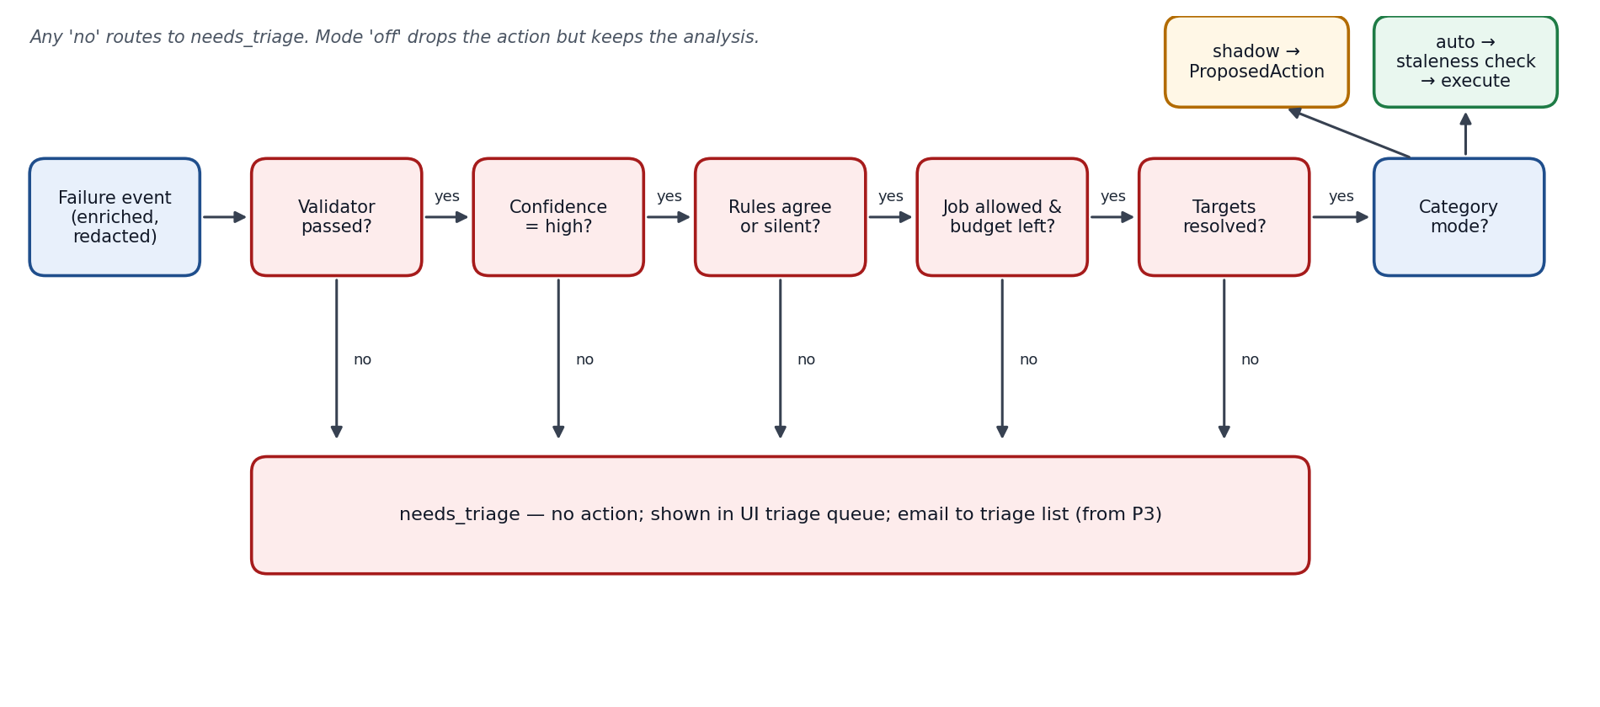
Policy gate decision flow
Gate check | Pass condition | Reason code on fail
Validator | LangGraph validator returned valid = true within retry budget | unvalidated
Confidence | Confidence = high | low_confidence
Agreement | Rule hint equals LLM category, or no rule matched | rule_llm_conflict
Eligibility | Job matches controller allowlist; budget for lineage not exhausted | job_not_allowed / budget_exhausted
Targets | Owner email found and on allowed domain; culprit change resolved uniquely | target_unresolved / culprit_ambiguous
Mode | Category mode is shadow (record) or auto (execute); off records analysis only | mode_off
Kill switch | Global and category switches off | kill_switch

8. Remediation workflows

8.1 Infra — re-run
Step | Operation | Guardrail
1 | GET {build_url}api/json?tree=actions[parameters[name,value],causes[*]] | —
2 | Check lineage budget (default ≤1 automatic re-run per original build) | Exhausted → needs_triage
3 | Staleness check: failed build is still the latest for its job | Newer build exists → skip
4 | POST {job_url}buildWithParameters with original parameters | Allowlisted jobs only
5 | Follow Location queue item → executable.number; write lineage | Unresolved after timeout → action failed, alert

8.2 DevOps — notify owner
Step | Operation | Guardrail
1 | GET {job_url}config.xml; extract owner via configured XPath | XML parsed with a hardened parser (no external entities)
2 | Validate email format and allowed domain | Invalid/missing → needs_triage
3 | Rate-limit per (job, failure signature) per N hours | Suppressed sends recorded
4 | Render Jinja2 template (job, build link, failing stage, evidence, analysis) | Template autoescaping on
5 | Send via SMTP relay; record message id | Send failure → action failed

8.3 Compilation — exclude culprit and re-trigger
Step | Operation | Guardrail
1 | Resolve change set via build-scope resolver | Unresolved → needs_triage
2 | For each change: GET /a/changes/{id}?o=CURRENT_REVISION&o=DETAILED_LABELS&o=DETAILED_ACCOUNTS, GET .../revisions/current/files | Patchset must equal the one built
3 | Culprit match: compiler-error file paths ∩ files modified by each change | Zero or multiple matches → needs_triage
4 | Topic expansion: GET /a/changes/?q=topic:{topic}+status:open | Whole topic leaves the batch together
5 | Culprit: DELETE /a/changes/{id}/reviewers/{account}/votes/Code-Review per +2; POST .../revisions/current/review with Code-Review: -1 and evidence comment | Comment includes build link and restore steps
6 | Topic siblings: remove +2 only (no -1); comment "held back: topic sibling failed" | No negative vote on non-culprits
7 | Read-back: no +2 remains on any change in the unit | Mismatch → stop, alert
8 | Re-trigger only for query-defined batch builds; budget ≤2 cycles per pipeline run | Single-change and parameter/manifest batches: vote + comment only
9 | Post-action: sampled exclusions queued for DevOps audit review (after the fact, not an approval); one-click restore removes bot -1 and asks reviewers to re-apply +2 | Confirmed wrong-culprit vote trips the compilation kill switch

All steps run automatically with no human approval. Execution is limited to an allowlist of Gerrit projects at go-live.

9. Data architecture
Entity | Key fields | Purpose
events | id, controller_id, job, build_number, build_url, received_at, status | One per failed build; unique on (controller_id, job, build_number)
enrichments | event_id, failing_stage, params, causes, artifactory_links, gerrit_changes, log_excerpt (redacted) | Inputs used for classification
analyses | event_id, rule_hint, llm_output, category, confidence, validated, evidence, model, prompt_version, rules_version | Reproducible classification record
gate_decisions | analysis_id, allowed, reason_codes, mode | Why an action was or was not taken
actions | id, event_id, type, mode, status, target, request, response, actor, created_at, executed_at | Proposed and executed actions
labels | action_id, reviewer, verdict, note | Shadow-mode ground truth for promotion
lineage | parent_event_id, child_build_url, kind (rerun/retrigger) | Budget enforcement and loop prevention

Action states
- Shadow: proposed → approved / rejected. These are labels only; nothing executes.
- Auto: pending → executed / failed / skipped (stale, budget exhausted or kill switch).
Retention (proposed)
- Redacted log excerpts: 90 days.
- Analyses, decisions, actions and labels: 1 year.
- Raw logs are never stored.

10. Integration contracts

10.1 Webhook (Jenkins → service)
POST /webhooks/jenkins
X-Remediation-Timestamp: 2026-10-30T14:02:11Z
X-Remediation-Signature: sha256=<hex HMAC of timestamp + "." + body>

{
"controller_id": "jenkins-prod-1",
"job": "folder/app-build",
"build_number": 1234,
"build_url": "https://jenkins.example.internal/job/folder/job/app-build/1234/",
"result": "FAILURE"
}
Responses:
- 202 with event_id when accepted.
- 200 with the existing event_id for a duplicate.
- 401 for a bad signature or a timestamp more than 5 minutes off.

10.2 Service internal API (UI)
Endpoint | Purpose
GET /events?status=&category= | Event list
GET /events/{id} | Event detail: enrichment, analysis, gate decision, actions
POST /actions/{id}/label | Approve/reject a shadow action
GET/PUT /settings/modes | Per-category mode and kill switches (privileged role)
POST /analyze-log | Existing manual upload path, retained

11. Security architecture
Concern | Control
Webhook spoofing | HMAC-SHA256 with per-controller secret; timestamp window; TLS
Prompt injection via logs | LLM output limited to category/evidence/explanation; targets from APIs; evidence must be verbatim substrings; policy gate independent of LLM text
Secret leakage | Redaction before LLM and storage; structured logging replaces print; no raw log persistence
Data sent to third-party LLM | Redacted excerpts only; provider approval pending (open decision)
Credential scope | Separate service accounts; infra/devops shadow phases run with read-only Jenkins credentials; Gerrit write (Code-Review -1..+1, Remove Reviewer) needed from compilation go-live, limited to allowlisted projects
UI access | Pluggable auth; role split: viewer, labeler, operator (modes and kill switches)
XML parsing | Hardened parser for config.xml (no external entities)
Email injection | Recipients only from validated config field and allowed domains; template autoescaping

12. Deployment view
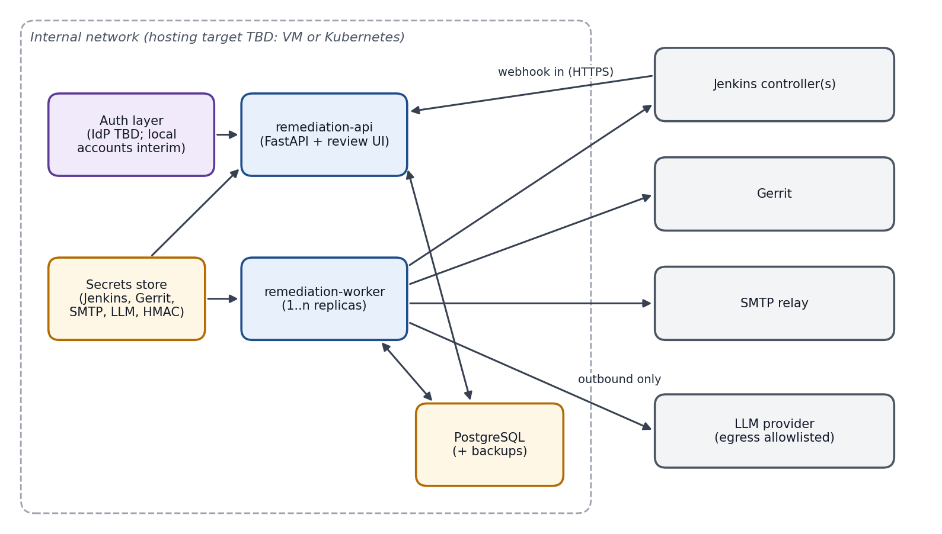
Deployment view
Containers
- remediation-api: FastAPI, which also serves the review UI.
- remediation-worker: 1..n replicas.
- PostgreSQL.
Networking
- Inbound: Jenkins → API (HTTPS).
- Outbound from the worker: Jenkins, Gerrit, SMTP and the LLM provider, all through egress allowlisting.
Configuration
- pydantic-settings reads from environment variables and a secrets store.
- Each controller has its own block: URL, credentials, HMAC secret and allowlist.
Hosting target: VM or Kubernetes, still to be decided. The containers are the same either way.

13. Reliability and failure modes
Failure | Effect | Mitigation
Duplicate or replayed webhook | Double processing | Unique dedupe key; timestamp window
Worker crash mid-pipeline | Event stuck | Lease with timeout; event re-queued; executors idempotent (check lineage/votes before write)
Jenkins API unavailable | No enrichment / re-run | Retry with backoff; then needs_triage
Gerrit partial update (some votes removed) | Inconsistent exclusion | Read-back step; stop and alert; no re-trigger until consistent
LLM timeout or malformed output | No LLM classification | Schema validation + retry; fallback to rules-only → needs_triage
Re-run fails again | Loop risk | Lineage budget; second infra failure → needs_triage + notify
New patchset uploaded before action | Acting on stale change | Patchset staleness check before every Gerrit write
Wrong culprit voted automatically | Developer change blocked incorrectly | Unique-match rule; backtest go-live bar; one-click restore; audit sampling; confirmed wrong vote trips compilation kill switch
Failure storm (agent pool outage) | Mass re-runs | Global rate limit on re-runs; circuit breaker trips kill switch above threshold

14. Observability
Metrics
- Events received and processed.
- Category mix.
- Gate denials, broken down by reason code.
- Actions proposed, executed and failed.
- Label agreement rate per category.
- Queue depth.
- Time from webhook to decision.
Logs: structured JSON with event_id correlation and secrets redacted.
Alerts
- Worker backlog above threshold.
- Executor failure rate.
- Read-back mismatch.
- Circuit breaker trip.
- LLM error rate.

15. Rollout and operating modes
Mode | Behavior | Credentials needed
off | Analysis recorded; no action proposed | Read-only
shadow | Proposed action recorded; reviewers label it | Read-only
auto | Gate-approved actions execute | Write (scoped)

Default modes at go-live: infra and devops start in shadow; compilation starts in auto (no human approval).
Compilation go-live bar (replaces the shadow period):
- Offline backtest of classifier + culprit matcher on historical failed builds with a known culprit, labeled by DevOps.
- Zero wrong-culprit identifications in the backtest.
- Gerrit write permissions granted; initial project allowlist agreed.
Promotion for infra and devops (proposed thresholds):
- At least 50 labeled shadow events.
- At least 95% approved by reviewers.
- Zero wrong-target incidents.
Rollout order: infra → devops → compilation. Compilation goes live directly in auto once its backtest passes, starting with allowlisted Gerrit projects.

16. Changes to the existing codebase
Area | Current | Target
graph.py | 3-category taxonomy; unvalidated output returned; bare json.loads | 4-class taxonomy; validated exposed; schema-validated output with retry
main.py | Upload endpoints only; sync LLM call in async route; duplicate Groq client | Webhook + UI API routers; LLM work in worker; single configured client
models.py | Response Literal of 3 categories | Shared enums for category, action type, status
Logging | print of full logs | Structured, redacted logging
Config | GROQ_API_KEY only; hardcoded model and URLs | settings.py (controllers, Gerrit, SMTP, LLM, modes, thresholds)
Persistence | None | SQLAlchemy store + migrations
Frontend | Single upload page | Upload page + event list/detail + labeling + settings

17. Open architectural decisions
# | Decision | Owner | Needed by
1 | Build-scope mechanism actually used by the pipelines | Jenkins admin | P4
2 | Owner field location in job config.xml | DevOps | P3
3 | Gerrit service-account permissions | Gerrit admin | P4
4 | LLM provider approval for build-log content | Security / data governance | P1 production use
5 | Hosting target and identity provider | Platform team | Before production
6 | SMTP relay, sender identity, template wording | DevOps | P3
7 | Re-run allowlist contents | DevOps | P2
8 | Promotion thresholds | DevOps lead | P2
9 | Compilation go-live scope: initial Gerrit project allowlist, backtest sample size, audit sampling rate | DevOps lead + Gerrit admin | P4

