Task 2

|  |
| --- |
| Design database for Zen class programme |
|  | users |
|  | codekata |
|  | attendance |
|  | topics |
|  | tasks |
|  | company_drives |
|  | mentors |

JSON DATA:

[

  {

    "username": "user1",

    "Attendance": "P",

    "Task_Submission": "true",

    "No_Of_Problems_Solved": 50

  },

  {

    "username": "user2",

    "Attendance": "A",

    "Task_Submission": "true",

    "No_Of_Problems_Solved": 50

  },

  {

    "username": "user3",

    "Attendance": "P",

    "Task_Submission": "false",

    "No_Of_Problems_Solved": 0

  },

  {

    "username": "user4",

    "Attendance": "P",

    "Task_Submission": "true",

    "No_Of_Problems_Solved": 50

  },

  {

    "username": "user5",

    "Attendance": "P",

    "Task_Submission": "true",

    "No_Of_Problems_Solved": 50

  },

  {

    "username": "user6",

    "Attendance": "P",

    "Task_Submission": "false",

    "No_Of_Problems_Solved": 0

  },

  {

    "username": "user7",

    "Attendance": "P",

    "Task_Submission": "true",

    "No_Of_Problems_Solved": 50

  },

  {

    "username": "user8",

    "Attendance": "P",

    "Task_Submission": "true",

    "No_Of_Problems_Solved": 50

  },

  {

    "username": "user9",

    "Attendance": "P",

    "Task_Submission": "true",

    "No_Of_Problems_Solved": 50

  },

  {

    "username": "user10",

    "Attendance": "P",

    "Task_Submission": "false",

    "No_Of_Problems_Solved": 0

  },

  {

    "username": "user11",

    "Attendance": "A",

    "Task_Submission": "true",

    "No_Of_Problems_Solved": 50

  },

  {

    "mentor_details": [

      {

        "name": "ab",

        "count": "12"

      },

      {

        "name": "cd",

        "count": "16"

      },

      {

        "name": "ef",

        "count": "16"

      },

      {

        "name": "gh",

        "count": "16"

      },

      {

        "name": "ij",

        "count": "16"

      }

    ]

  },

  {

    "task_details": [

      {

        "topic": "HTML",

        "task": "pancard",

        "Month": "October"

      },

      {

        "topic": "Css",

        "task": "flecbox",

        "Month": "March"

      },

      {

        "topic": "React",

        "task": "Component",

        "Month": "July"

      },

      {

        "topic": "Javascript",

        "task": "CrUD",

        "Month": "October"

      },

      {

        "topic": "MongoDb",

        "task": "Db creation",

        "Month": "October"

      },

      {

        "topic": "Node js",

        "task": "search operation",

        "Month": "October"

      },

      {

        "topic": "SQL",

        "task": "Query fetching",

        "Month": "October"

      }

    ]

  },

  {

    "Companydrivedetails": [

      {

        "company_name": "apple",

        "Student": [

          "user1",

          "user4"

        ],

        "Drive_date": "15-oct-2020"

      },

      {

        "company_name": "apple",

        "Student": [

          "user7",

          "user6"

        ],

        "Drive_date": "16-oct-2020"

      },

      {

        "company_name": "zoho",

        "Student": [

          "user8",

          "user9"

        ],

        "Drive_date": "17-oct-2020"

      },

      {

        "company_name": "chargebee",

        "Student": [

          "user5",

          "user7"

        ],

        "Drive_date": "15-sep-2020"

      },

      {

        "company_name": "paypal",

        "Student": [

          "user1",

          "user11"

        ],

        "Drive_date": "31-oct-2020"

      },

      {

        "company_name": "tcs",

        "Student": [

          "user10",

          "user2",

          "user5"

        ],

        "Drive_date": "15-oct-2020"

      }

    ]

  }

]

Find all the topics and tasks which are thought in the month of October

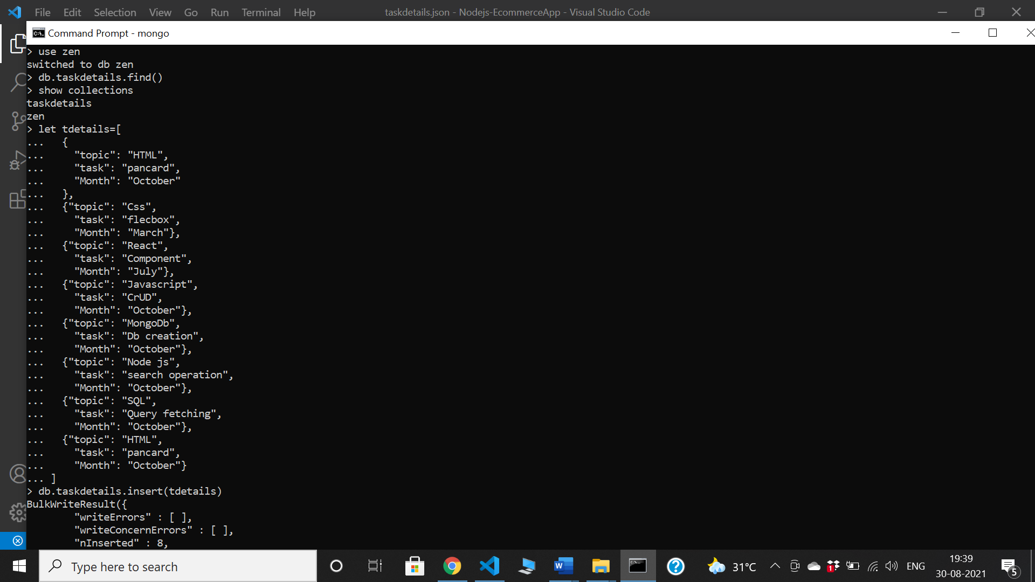

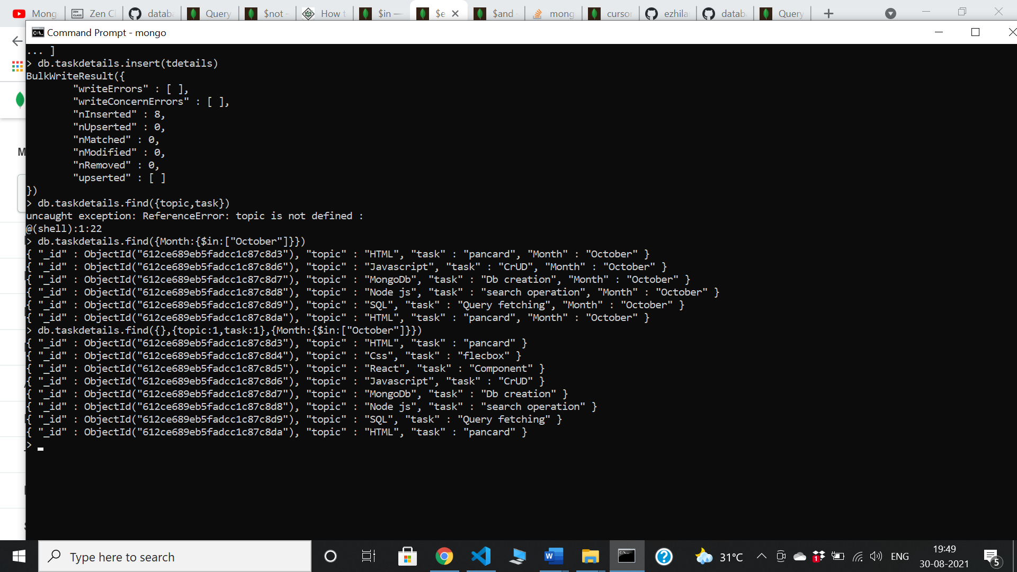

|  |
| --- |
| Find all the company drives which appeared between 15 oct-2020 and 31-oct-2020 |
| Find all the company drives and students who are appeared for the placement. |
| Find the number of problems solved by the user in codekata |
| Find all the mentors with who has the mentee's count more than 15 |
|  |

Find the number of users who are absent and task is not submitted between 15 oct-2020 and 31-oct-2020