Find all the information about each products





Find all the information about each products

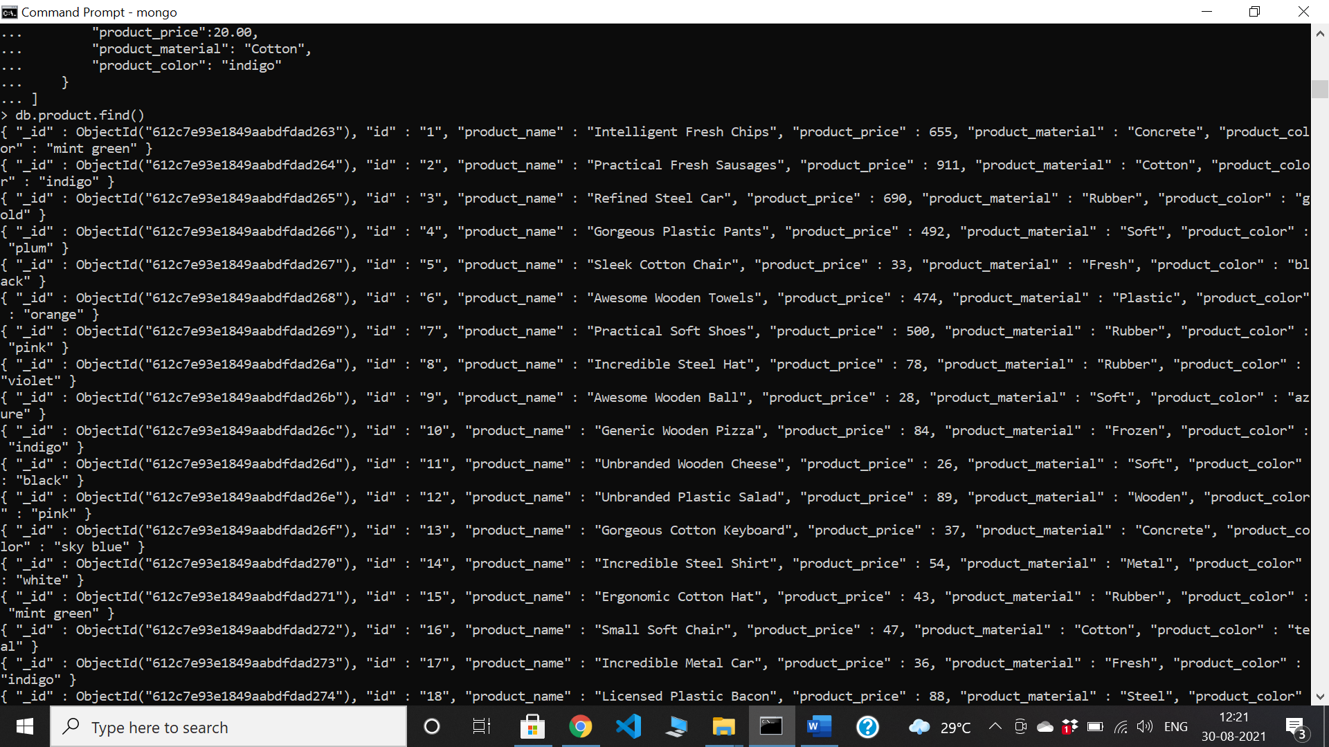

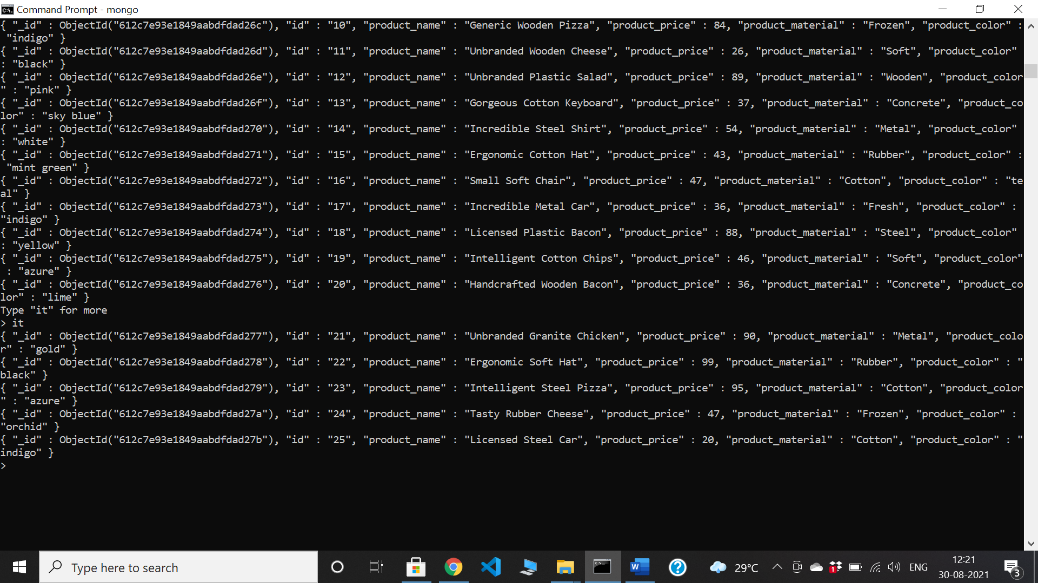

Find the product price which are between 400 to 800

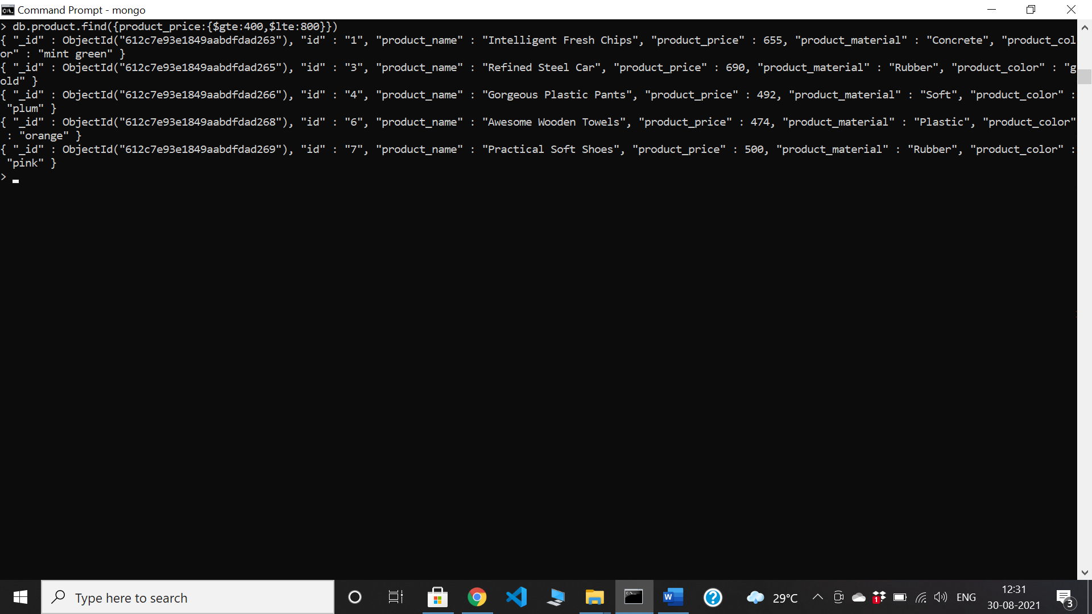

Find the product price which are not between 400 to 600

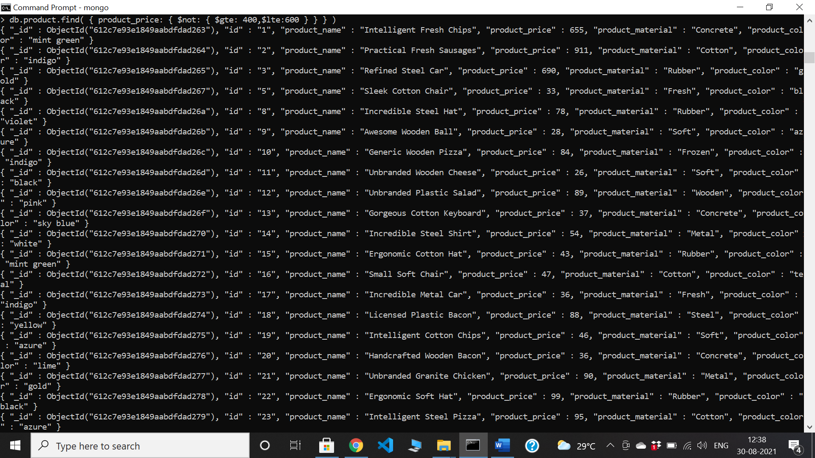

List the four product which are greater than 500 in price

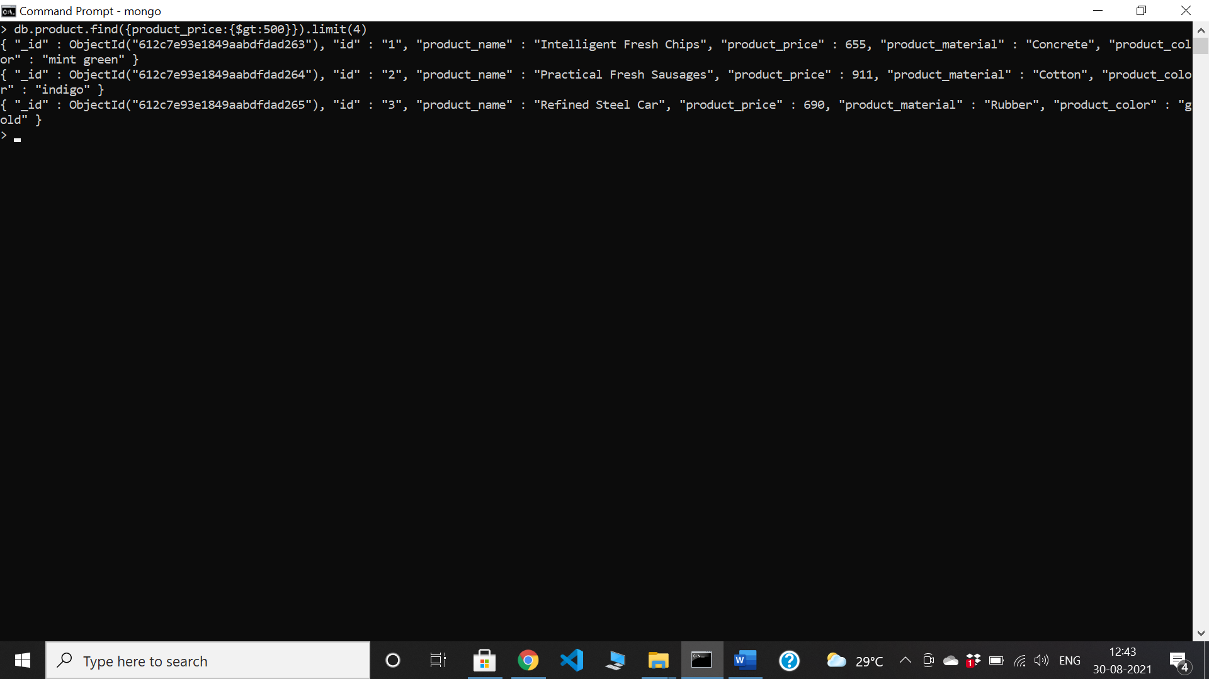

Find the product name and product material of each products

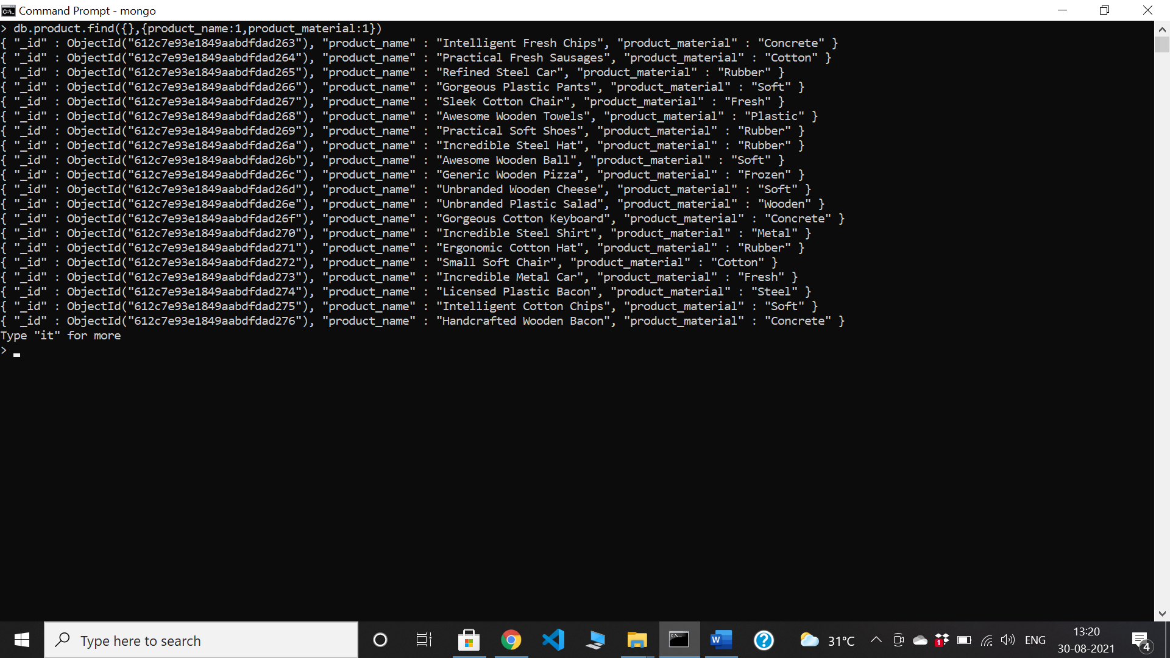

Find the product with a row id of 10

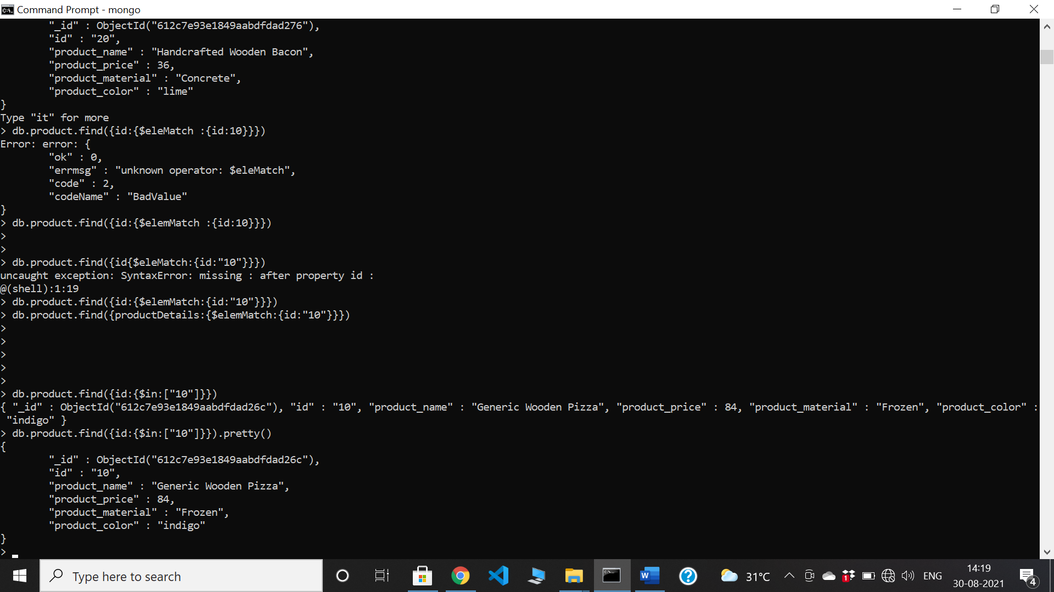

Find only the product name and product material

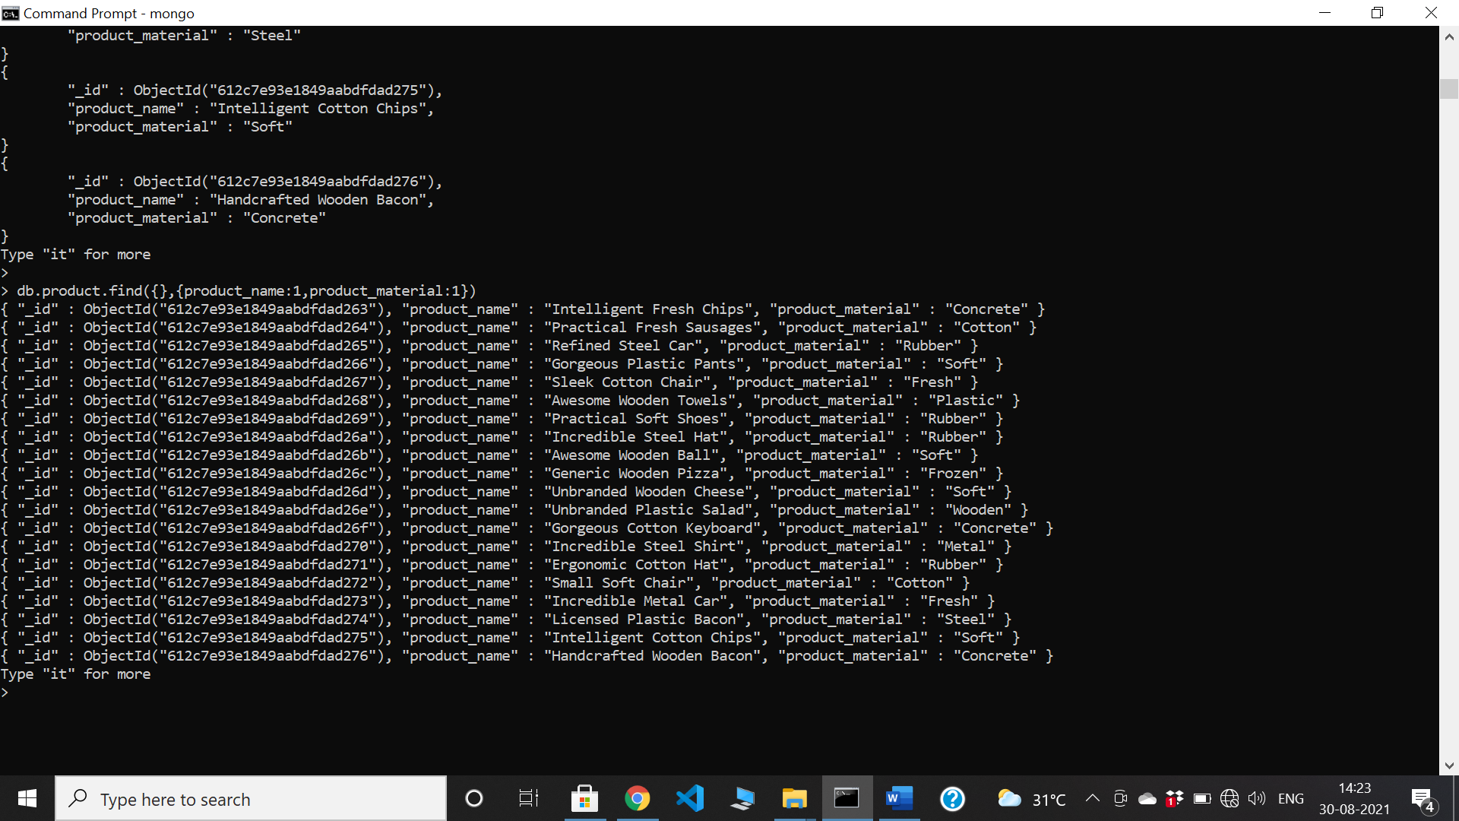

Find all products which contain the value of soft in product material

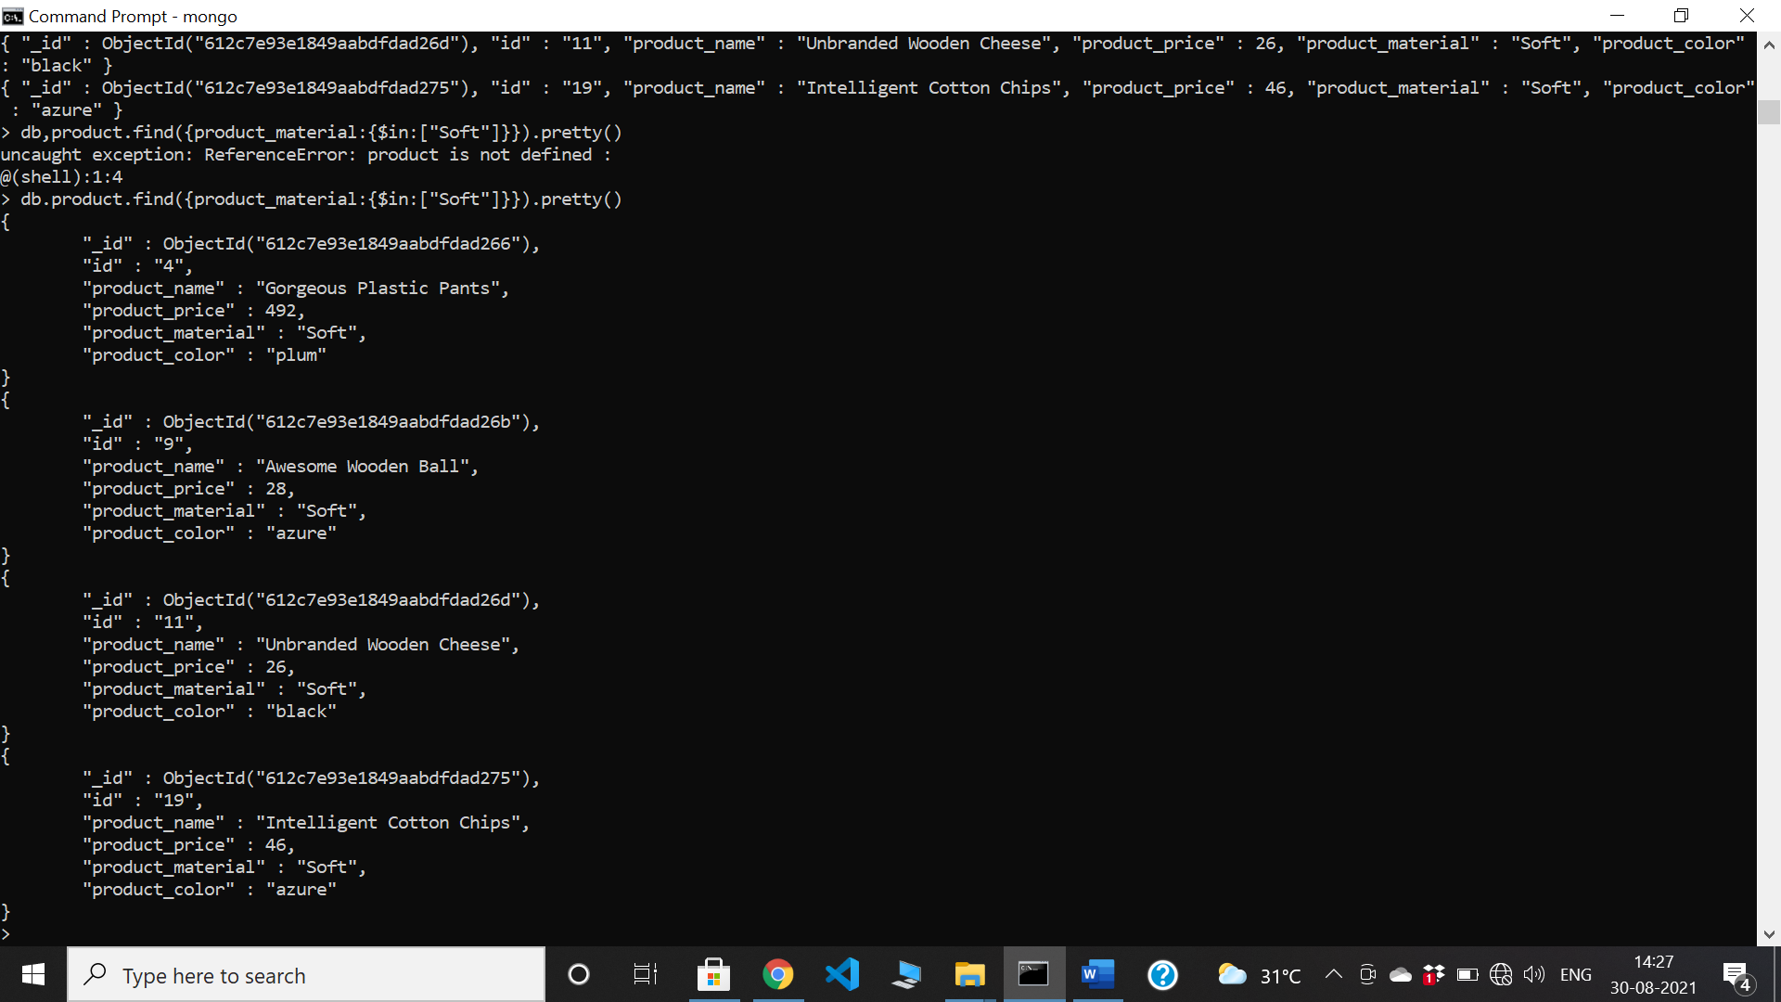

Find products which contain product color indigo and product price 492.00

db.product.aggregate([

{

"$match": {

"product_color" : { "$in": [“indigo”] },

"product_price" : { "$in": [492.00] }

}

}

])ANS:

No data

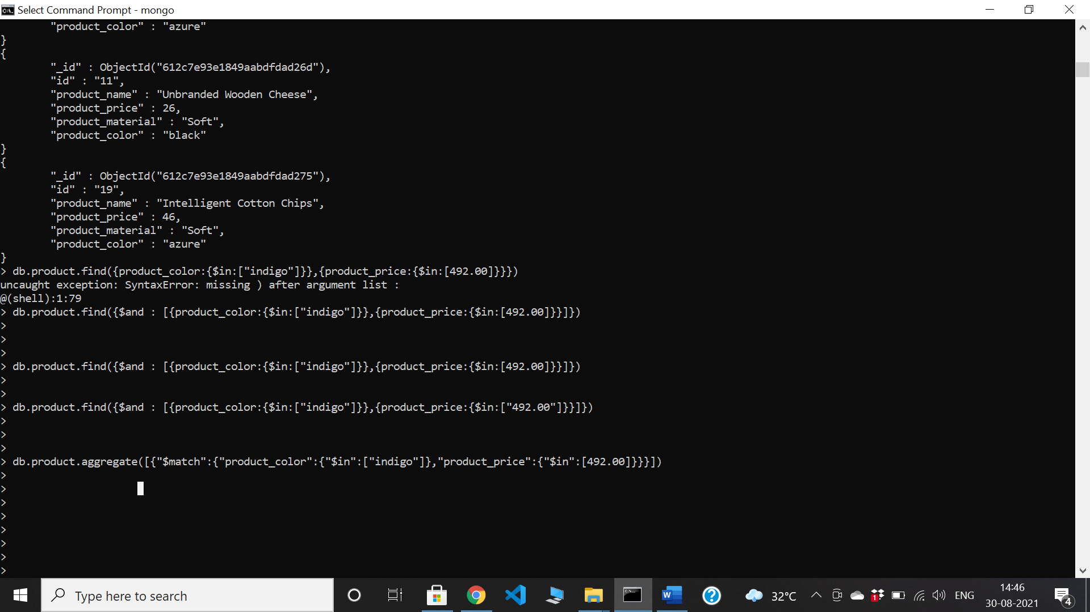

Delete the products which product price value are same

