**EXPLORATORY DATA ANALYSIS:**

Index that are present in the dataset

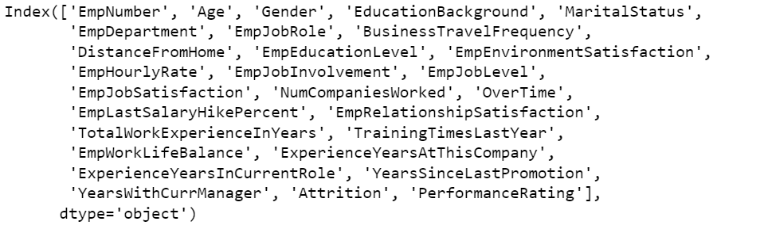

Finding out the mean performance of all the departments and plotting its bar graph using seaborn.

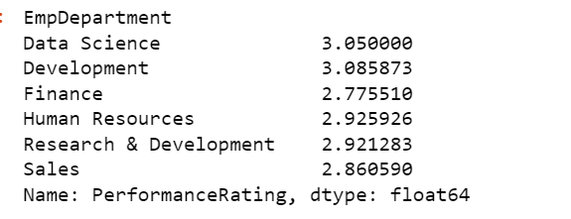

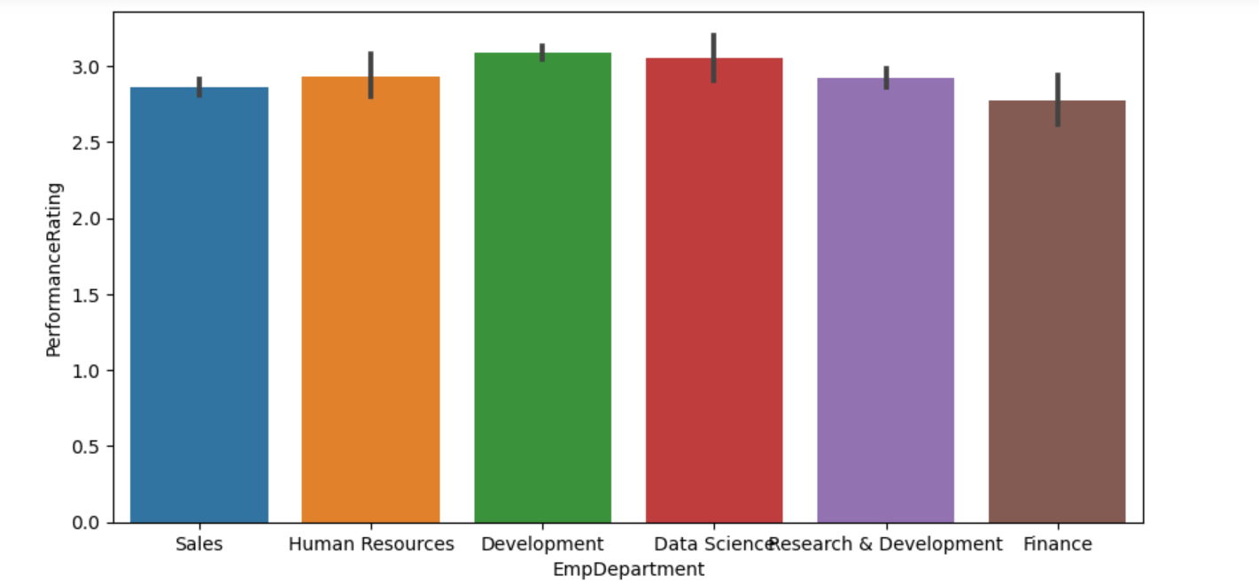

Analyze each department separately

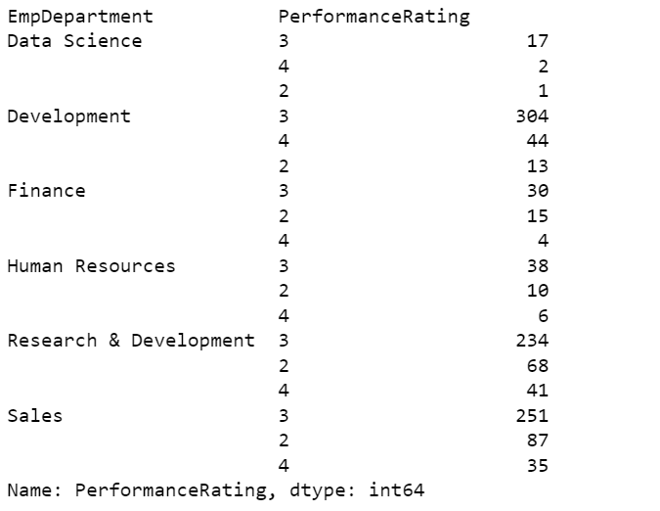

Plotting a separate bar graph for performance of each department using seaborn

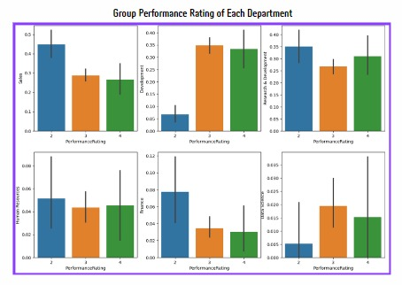

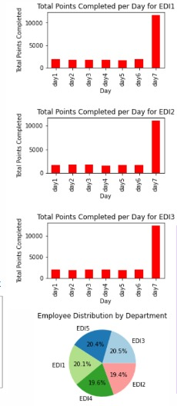

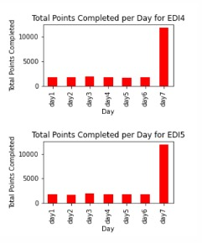

**FEATURE SELECTION:**

Feature selection involves picking the most relevant attributes or variables from a dataset. In employee performance assessment, "expected work" and "performance rating" are vital features. This process streamlines analysis, focusing on essential factors for data-driven decision-making and performance improvement. It ensures a more efficient and effective evaluation of employee productivity.

**MODEL BUILDING:**

Model 1 - Logistic regression

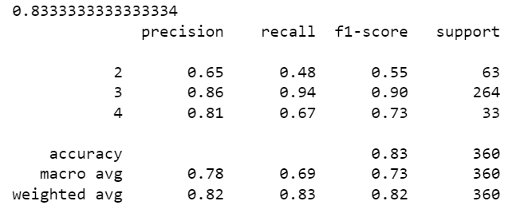

The accuracy of the model is 83%

Model 2 - Support Vector Machine

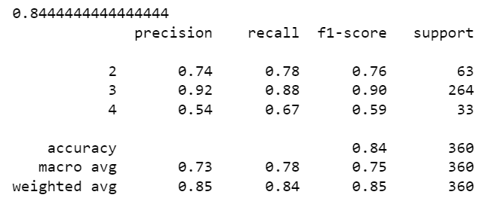

The accuracy of the model is 84%

Model 3 – K-Nearest Neighbor

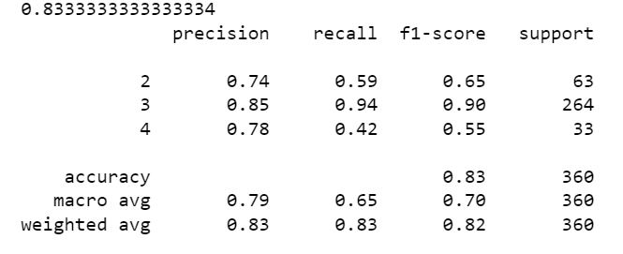

The accuracy of the model is 83%

Model 4 – Decision tree

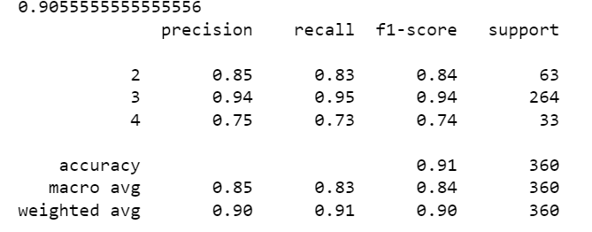

The accuracy of the model is 90%

Model 5 – Random Forest

