**Abstract**

‘Automation’ is a way to have things around happen automatically, the first thing comes to our mind when we think of automation are robots, flashing lights, complicated electronics, complex programming, computer hardware and software, machine visions, raw things turning into some extraordinary and efficient solutions on critical things to make it simpler and easier to handle.

Our project called ‘My Home’, is an automated system which makes the regular homes smart and interactive. This is multi-disciplinary strategy to develop, optimize and capitalize on appliances in our homes that enable new and improved processes. This is the system that is supposed to be implemented in people's homes, without any changes to be made to the infrastructure. It is new way to interact and make use of our homes to make them smarter to work. . This will surely help many people all around the world of different age groups to interact with their homes like never before.

**Introduction**

The concept of home automation has been around since the late 1970s. But with the advancement of technology and services, people’s expectations of what a home should do or how the services should be provided and accessed at home has changed a lot during the course of time, and so has the idea of home automation systems.[1] If we look at different home automation systems over time, they have always tried to provide efficient, convenient, and safe ways for home inhabitants to access their homes. Irrespective of the change in user expectations, advancement of technology, or change of time, the role of a home automation system has remained the same. From an engineering point of view, a home can be broken down into the “Six S’s”. Home automation systems mainly deal with the last “S’s,” namely Service, Space Plan, and Stuff. A study showed that in addition to home automation technology and devices, a modern home relies on three to seven services or companies to provide them with infrastructure support like Internet, telephone, electricity, gas, etc. Another study done on different homes showed that people choose the “Site” of the home based on factors like the availability of uninterrupted power, high speed Internet, etc., excluding other factors like property prices and neighbours, which are beyond the scope of this work. The study also showed that a typical home environment handles a plethora of “Services,” so many of these services will have to share the resources of the home. The availability of wireless communication nowadays has helped with the “Space Plan” and improved the aesthetics of the modern home. Moreover, home inhabitants add, remove, and move equipment in their home as they please, so “Stuff” always changes in a home.

Home automation is “The Internet of Things"...The way that all of our devices and appliances will be networked together to provide us with a seamless control over all aspects of our home and more. [2]Home automation has been around from many decades in terms of lighting and simple appliance control, and only recently has technology caught up for the idea of the interconnected world, allowing full control of your home from anywhere, to become a reality. With home automation, you dictate how a device should react, when it should react, and why it should react. You set the schedule and the rest is automated and based off of your personal preferences thus providing convenience, control, money savings, and an overall smarter home. Home automation can also alert you to events that you might want to know about right-away while you are gone like water leaks and unexpected access to your home, or any part of it. At any time, you can grab your iPhone, Android device or other remote control and change the settings in your house as desired.

"My Home" is a project based on Internet of Things. It is a home automation system but unlike other systems, it is far more responsive, interactive and easy to use than any other systems present in market today.

It is designed to be "Smart"...to work like a machine but with a brain of its own.

**Problem Definition and SRS**

Problem Definition:

Automation was initially used in Industries to reduce the human exposure to hazardous situations and to work done more effectively and efficiently. Its use reduced the man power required, and also helped in handling complex systems more effectively. In this project, we have tried to bring a model for Home Automation which is simple to use, reliable and cost- effective. By making use of the fact that mobile phones have become an inseparable part of our lives, in this model we have kept the mobile phone at the centre of the system i.e. we have tried to automate entire home with the help of a mobile phone. This Automation model is hugely expandable and is capable to handle several complex tasks in parallel. The idea behind making of this project is to get a feeling of how a home can be automated completely with the help of a mobile phone(Android phone in our project).

Objectives:

1. To create a home automation system that is fast, interactive and reliable.

2. To make improvements in the present systems available in the market.

3. To significantly reduce the human efforts required in everyday tasks.

4. To help physically challenged people and make their lives easier with its use.

5. To make human-thing interaction possible too.

6. To make a person feel good positive vibes with its use.

Major Inputs and Outputs:

Inputs:

Commands to the android app are the input.

The two major inputs are-

1. Touch by the user.

2. Voice as a command to the app.

Outputs:

- Appliances get switched On or Off.

- Any other appliances with intensity control can also be controlled.

**Requirements: Hardware**

**Resources:**

1.Raspberry Pi 3 Model B

2.8 channel Relay board

3.Android smart phone(with ver. JellyBean or higher)

4.Wi-fi router(optional)

5.Electrical appliances(lights,fan,tv,etc)

**Software Resources:**

Android Studio- to develop the android app with google voice api implementation.

**Software Requirement Specification**

**Introduction:**

**Purpose:**

This project will be built solely with the purpose of reducing human efforts to perform day to day tasks and make them more fun and easy to use.

**Intended Audience:**

This document is to be read by the development team, the project guide, HOD Ma'am, testers and other teaching staff of CSE department. The SRS has been organized approximately in order of increasing specificity.

**Function ID Name of Function**

|  |  |  |
| --- | --- | --- |
| **SR**  **No.** | **Function ID** | **Name of Function** |
| 1. | FT | Touch |
| 2. | FV | Voice |
| 3. | FS | Switching |
| 4. | FSS | Switch State |

**FT Touch: Description:**

User will be providing input as touch on the android app UI.

**FV Voice: Description:**

User can give commands in his/her own voice to make things done.

**FS Switching: Description:**

Appliances can be switched on or off as required by the user.

**FS Switching: Description:**

User can know the present condition of an electrical appliance.

**System Design and Implementation**

**Proposed System Architecture:**

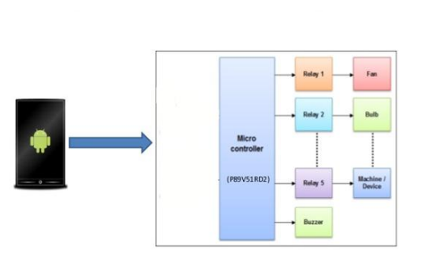

System Architecture

**Data Flow Diagram:**

A graphic tool used to describe and analyze the moment of data through a system – manual or automated – including the processes, stores of data, and delays in the system. Data flow diagrams are the central tools and the basis from which other components are developed. The transformation of data from input to output, through processes, may be described logically and independently of the physical components associated with the system.

Data Flow Diagram is a means of representing a system at any level of detail with a graphic network of symbols showing data flows, data stores, data processes and data sources. The purpose of data flow diagram is to provide a semantic bridge between users and system developers. The diagram is the basis of structured system analysis. A DFD describes what data flows rather than how they are processed, so it does not depend on hardware, software, data structure or file organization.

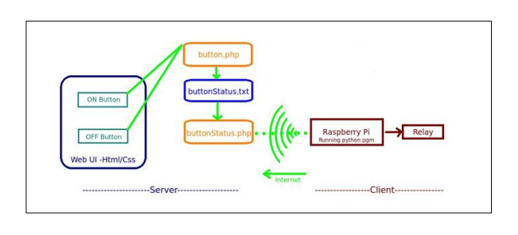

Data Flow Diagram

**Implementation Details:**

Android app code & PHP Scripts:

**1. Speech Recognition:-**

public void promptSpeechInput()

{

Intent i = new Intent(RecognizerIntent.ACTION_RECOGNIZE_SPEECH);

i.putExtra(RecognizerIntent.EXTRA_LANGUAGE_MODEL,RecognizerIntent.LANGUAGE

_MODEL_FREE_FORM);

i.putExtra(RecognizerIntent.EXTRA_LANGUAGE, Locale.getDefault());

i.putExtra(RecognizerIntent.EXTRA_PROMPT,"How may I help you");

try{

startActivityForResult(i,100);

}

catch(ActivityNotFoundException a)

{

Toast.makeText(MainActivity.this,"Sorry your device doesn't support Speech

recognition!",Toast.LENGTH_LONG).show();

}

}

public void onActivityResult(int request_code, int result_code, Intent i)

{

super.onActivityResult(request_code,result_code,i);

switch(request_code)

{

case 100: if(result_code == RESULT_OK && i!=null)

{

ArrayList<String> result =

i.getStringArrayListExtra(RecognizerIntent.EXTRA_RESULTS);

String m=result.get(0);

resultTEXT.setText(result.get(0));

**2.Switching ON/OFF on Voice Recognition :-**

if(m.equals("lights on"))

{

text="Lights are turned on";

toSpeech.speak(text,TextToSpeech.QUEUE_FLUSH,null);

web.loadUrl(s+"gpio17lights.php?on=ON");

l.setChecked(true);

}

OR

if(m.equals("light up the room"))

{

text="Lights are turned on";

toSpeech.speak(text,TextToSpeech.QUEUE_FLUSH,null);

web.loadUrl(s+"gpio17lights.php?on=ON");

l.setChecked(true);

}

**3.Switching ON/OFF using Toggle Buttons :-**

public class myWebClient extends WebViewClient

{

@Override

public void onPageStarted(WebView view, String url, Bitmap favicon)

{

super.onPageStarted(view, url, favicon);

}

@Override

public boolean shouldOverrideUrlLoading(WebView view, String url)

{

view.loadUrl(url);

return true;

}

}

public void toggleLights (View view)

{

boolean on = ((ToggleButton) view).isChecked();

if(on)

{

web.loadUrl(s+"gpio17lights.php?on=ON");

}

else

{

web.loadUrl(s+"gpio17lights.php?off=OFF");

}

}

**PHP Script:-**

**gpio17lights.php:-**

<?php

$setmode17 = shell_exec("/usr/local/bin/gpio -g mode 17 out");

if(isset($_GET['on']))

{

$gpio_on= shell_exec("/usr/local/bin/gpio -g write 17 1");

}

else if(isset($_GET['off']))

{

$gpio_off= shell_exec("/usr/local/bin/gpio -g write 17 0");

}

?>

**Conclusion:**

Our "My Home" smart home automation system was built keeping in mind the two aspects

1. Dependency on the Internet connection, and

2. Easy to use UI for the users.

This project makes use of the best possible technologies with least cost implementation.

It focused on making people's lives easier by automating the simple day-to-day tasks.

Many people of different age groups and also the physically challenged people could make a

good use of this. The additional voice recognition and action feature took it to the nest level,

making it easy and fun to use.

The best advantage of this project was that it does not require Internet for functioning at all.

Everything works offline while still maintaining the ease of use and speed of performance to

its possible maximum.

The present available home automation systems were good enough. However, they had some

drawbacks. These were all fixed in our project successfully.