SEVERLESS IoT DATA PROCESSING

**Abstract**

The "Serverless IoT Data Processing" project seeks to convert a conventional home into an intelligent living environment using IBM Cloud Functions for IoT data processing. The primary objective is to aggregate data from diverse smart devices, process it in real-time, and facilitate automated routines that optimize energy efficiency and enhance home security. This comprehensive project involves the design and installation of a smart home infrastructure, the establishment of data collection and real-time processing, and the utilization of IBM Cloud for data storage and analysis. By leveraging the capabilities of serverless computing and the Internet of Things, this project aspires to bring about a transformative shift in domestic living, making homes smarter, more efficient, and more secure

**Introduction**

The concept of home automation has been around since the late 1970s. But with the advancement of technology and services, people’s expectations of what a home should do or how the services should be provided and accessed at home has changed a lot during the course of time, and so has the idea of home automation systems.[1] If we look at different home automation systems over time, they have always tried to provide efficient, convenient, and safe ways for home inhabitants to access their homes. Irrespective of the change in user expectations, advancement of technology, or change of time, the role of a home automation system has remained the same. From an engineering point of view, a home can be broken down into the “Six S’s”. Home automation systems mainly deal with the last “S’s,” namely Service, Space Plan, and Stuff. A study showed that in addition to home automation technology and devices, a modern home relies on three to seven services or companies to provide them with infrastructure support like Internet, telephone, electricity, gas, etc. Another study done on different homes showed that people choose the “Site” of the home based on factors like the availability of uninterrupted power, high speed Internet, etc., excluding other factors like property prices and neighbours, which are beyond the scope of this work. The study also showed that a typical home environment handles a plethora of “Services,” so many of these services will have to share the resources of the home. The availability of wireless communication nowadays has helped with the “Space Plan” and improved the aesthetics of the modern home. Moreover, home inhabitants add, remove, and move equipment in their home as they please, so “Stuff” always changes in a home.

Home automation is “The Internet of Things"...The way that all of our devices and appliances will be networked together to provide us with a seamless control over all aspects of our home and more. [2]Home automation has been around from many decades in terms of lighting and simple appliance control, and only recently has technology caught up for the idea of the interconnected world, allowing full control of your home from anywhere, to become a reality. With home automation, you dictate how a device should react, when it should react, and why it should react. You set the schedule and the rest is automated and based off of your personal preferences thus providing convenience, control, money savings, and an overall smarter home. Home automation can also alert you to events that you might want to know about right-away while you are gone like water leaks and unexpected access to your home, or any part of it. At any time, you can grab your iPhone, Android device or other remote control and change the settings in your house as desired.

"My Home" is a project based on Internet of Things. It is a home automation system but unlike other systems, it is far more responsive, interactive and easy to use than any other systems present in market today.

It is designed to be "Smart"...to work like a machine but with a brain of its own.

**Problem Definition and SRS**

Problem Definition:

Automation was initially used in Industries to reduce the human exposure to hazardous situations and to work done more effectively and efficiently. Its use reduced the man power required, and also helped in handling complex systems more effectively. In this project, we have tried to bring a model for Home Automation which is simple to use, reliable and cost- effective. By making use of the fact that mobile phones have become an inseparable part of our lives, in this model we have kept the mobile phone at the centre of the system i.e. we have tried to automate entire home with the help of a mobile phone. This Automation model is hugely expandable and is capable to handle several complex tasks in parallel. The idea behind making of this project is to get a feeling of how a home can be automated completely with the help of a mobile phone(Android phone in our project).

Objectives:

1. To create a home automation system that is fast, interactive and reliable.

2. To make improvements in the present systems available in the market.

3. To significantly reduce the human efforts required in everyday tasks.

4. To help physically challenged people and make their lives easier with its use.

5. To make human-thing interaction possible too.

6. To make a person feel good positive vibes with its use.

Major Inputs and Outputs:

Inputs:

Commands to the android app are the input.

The two major inputs are-

1. Touch by the user.

2. Voice as a command to the app.

Outputs:

- Appliances get switched On or Off.

- Any other appliances with intensity control can also be controlled.

**Requirements: Hardware**

**Resources:**

1.Raspberry Pi Model B

2.8 channel Relay board

3.Android smart phone(with ver. JellyBean or higher)

4.Wi-fi router(optional)

5.Electrical appliances(lights,fan,tv,etc)

**Software Resources:**

Android Studio- to develop the android app with google voice api implementation.

**Software Requirement Specification**

**Introduction:**

**Purpose:**

This project will be built solely with the purpose of reducing human efforts to perform day to day tasks and make them more fun and easy to use.

**Intended Audience:**

This document is to be read by the development team, the project guide, HOD Ma'am, testers and other teaching staff of CSE department. The SRS has been organized approximately in order of increasing specificity.

**Function ID Name of Function**

|  |  |  |
| --- | --- | --- |
| **SR**  **No.** | **Function ID** | **Name of Function** |
| 1. | FT | Touch |
| 2. | FV | Voice |
| 3. | FS | Switching |
| 4. | FSS | Switch State |

**FT Touch: Description:**

User will be providing input as touch on the android app UI.

**FV Voice: Description:**

User can give commands in his/her own voice to make things done.

**FS Switching: Description:**

Appliances can be switched on or off as required by the user.

**FS Switching: Description:**

User can know the present condition of an electrical appliance.

**System Design and Implementation**

**Proposed System Architecture:**

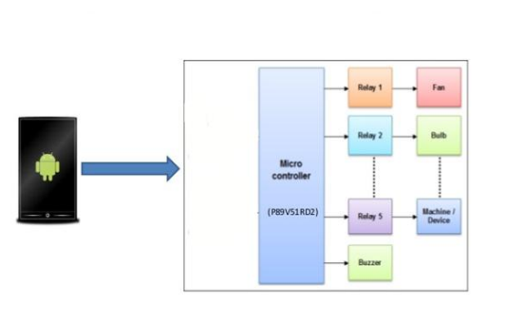

System Architecture

**Data Flow Diagram:**

A graphic tool used to describe and analyze the moment of data through a system – manual or automated – including the processes, stores of data, and delays in the system. Data flow diagrams are the central tools and the basis from which other components are developed. The transformation of data from input to output, through processes, may be described logically and independently of the physical components associated with the system.

Data Flow Diagram is a means of representing a system at any level of detail with a graphic network of symbols showing data flows, data stores, data processes and data sources. The purpose of data flow diagram is to provide a semantic bridge between users and system developers. The diagram is the basis of structured system analysis. A DFD describes what data flows rather than how they are processed, so it does not depend on hardware, software, data structure or file organization.

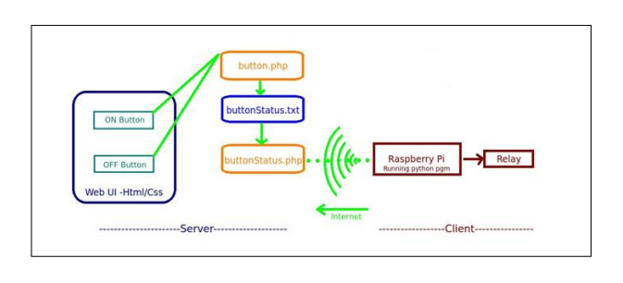Data Flow Diagram

**Design:**

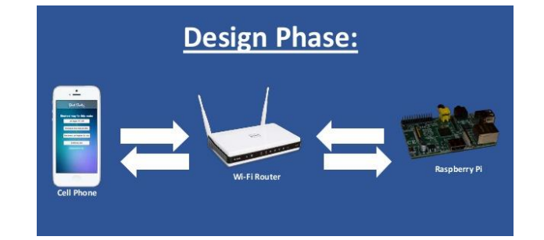

Design Phase with Wi-fi router as Gateway.

The connection between mobile phone(Android smart phone) and the Raspberry Pi is made

possible using Wi-fi router as the Gateway for sending data(http request) to the Raspberry Pi.

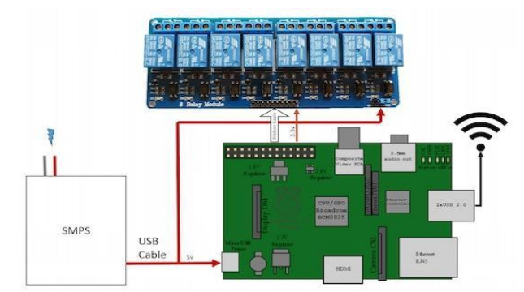

Raspberry Pi to Relay connection diagram.

how a Relay(here: 8 channel Relay) is connected to the Raspberry Pi(here: Raspberry Pi 3 Model B) with SMPS being the power source for the Pi. The connection is made possible using jumper cables. The Relay is further connected to the Electrical appliances via the switchboard or the Fuse box.

**Implementation Details:**

Android app code & PHP Scripts:

**1. Speech Recognition:-**

public void promptSpeechInput()

{

Intent i = new Intent(RecognizerIntent.ACTION_RECOGNIZE_SPEECH);

i.putExtra(RecognizerIntent.EXTRA_LANGUAGE_MODEL,RecognizerIntent.LANGUAGE

_MODEL_FREE_FORM);

i.putExtra(RecognizerIntent.EXTRA_LANGUAGE, Locale.getDefault());

i.putExtra(RecognizerIntent.EXTRA_PROMPT,"How may I help you");

try{

startActivityForResult(i,100);

}

catch(ActivityNotFoundException a)

{

Toast.makeText(MainActivity.this,"Sorry your device doesn't support Speech

recognition!",Toast.LENGTH_LONG).show();

}

}

public void onActivityResult(int request_code, int result_code, Intent i)

{

super.onActivityResult(request_code,result_code,i);

switch(request_code)

{

case 100: if(result_code == RESULT_OK && i!=null)

{

ArrayList<String> result =

i.getStringArrayListExtra(RecognizerIntent.EXTRA_RESULTS);

String m=result.get(0);

resultTEXT.setText(result.get(0));

**2.Switching ON/OFF on Voice Recognition :-**

if(m.equals("lights on"))

{

text="Lights are turned on";

toSpeech.speak(text,TextToSpeech.QUEUE_FLUSH,null);

web.loadUrl(s+"gpio17lights.php?on=ON");

l.setChecked(true);

}

OR

if(m.equals("light up the room"))

{

text="Lights are turned on";

toSpeech.speak(text,TextToSpeech.QUEUE_FLUSH,null);

web.loadUrl(s+"gpio17lights.php?on=ON");

l.setChecked(true);

}

**3.Switching ON/OFF using Toggle Buttons :-**

public class myWebClient extends WebViewClient

{

@Override

public void onPageStarted(WebView view, String url, Bitmap favicon)

{

super.onPageStarted(view, url, favicon);

}

@Override

public boolean shouldOverrideUrlLoading(WebView view, String url)

{

view.loadUrl(url);

return true;

}

}

public void toggleLights (View view)

{

boolean on = ((ToggleButton) view).isChecked();

if(on)

{

web.loadUrl(s+"gpio17lights.php?on=ON");

}

else

{

web.loadUrl(s+"gpio17lights.php?off=OFF");

}

}

**PHP Script:-**

**gpio17lights.php:-**

<?php

$setmode17 = shell_exec("/usr/local/bin/gpio -g mode 17 out");

if(isset($_GET['on']))

{

$gpio_on= shell_exec("/usr/local/bin/gpio -g write 17 1");

}

else if(isset($_GET['off']))

{

$gpio_off= shell_exec("/usr/local/bin/gpio -g write 17 0");

}

?>

**Performance Analysis**

Sometimes referred to as profiling, performance analysis as it relates to software engineering is simply the process of evaluating how a particular software program is functioning. This process normally begins with how the program loads and what happens when each step in using the program is executed. The object of performance analysis is to ensure the software program is working at optimum efficiency and to identify and correct any issues that may negatively impact that efficiency. Performance analysis also helps the engineer to adjust components in a manner that helps the program make the best use of available resources. By evaluating real time executions, it is possible to determine if something could be done to speed up a task, or change the amount of memory required to run the task without negatively impacting the overall function of the software. The final goal is a program that runs smoothly, quickly, and works each time any task is initiated.

Performance analysis is one type of dynamic program analysis, or DPA. DPA focuses on what happens when a program is actively running, including how resources are used and in what order. This is different from static code analysis, which tends to focus more on how the code is written and how logical the succession of commands happens to be. However, both types of analysis are common elements of evaluating and refining software and software functionality.

**Modules:**

**Touch Interface:**

This module is all about the android app UI. Any user can use his/her mobile phone to control the home appliances using this touch panel of the mobile screen.

**Voice:**

This module is an added feature for the user to make use of his/her voice. Voice commands can be given to the app to perform a specific task. The app uses "Google now" voice recognition service to control home appliances without using the Internet.

**Output Screens:**

**Touch Module:**

**1. The UI:**

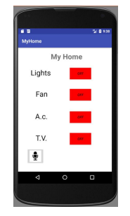

This is the app User Interface that a person will first look at as soon as he/she launches the application.

**2. Switched ON state:**

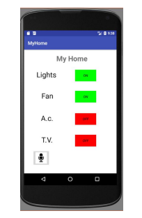

App will look like the image below, whenever someone switches ON an appliance, in this case Lights and Fan were turned ON.

**Voice Module:**

**1. The UI:**

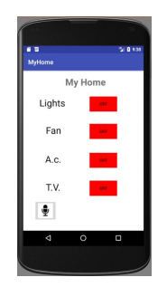

This is the app User Interface that a person will first look at as soon as he/she launches the application.

**2. Voice Recognizer:**

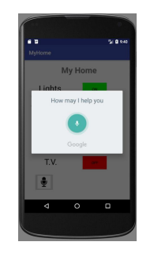

As the user touches the Mic button (on the bottom left), a screen will appear as shown below. This activates the voice recognition module of the app(Google Now).

**Major Constraints:**

**Equipment and installation costs:**

Automation of the home is widely related to the financial costs. The total cost depends on the equipments you install in your house and on how much it takes to install. The more advanced the system; the cost of the system will be very high as it has the more advantages and more new features. As there is a gradual growth in developing the home automated devices price the cost is going to reduce. But as of now, because of the unpopularity of the home automated devices the cost is very high. Current technology is unable to reach the desired task.

**System crashes due to any damage in the interconnection:**

If there is any damage due to rupturing of cables or the fibers the entire system gets crashed. This will not be the case of radio signals or the other signals. Here there will be a problem of signal receiving. The wiring of the system results in crash in most of the systems.

**Human errors:**

If the human does not handle the kit safely or if he/she does not use the correct keys to perform the operations, human errors may occur. Human errors also lead to destructions of the machine. Then there will be a huge system crash.

**Reliability:**

In very rare cases, the reliability of the home automated devices varies(decreases). It depends mostly on the technology used and the advancements being done.

**Screenshots of the Output:**

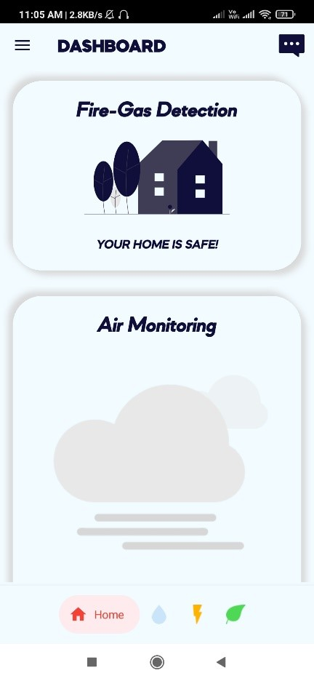

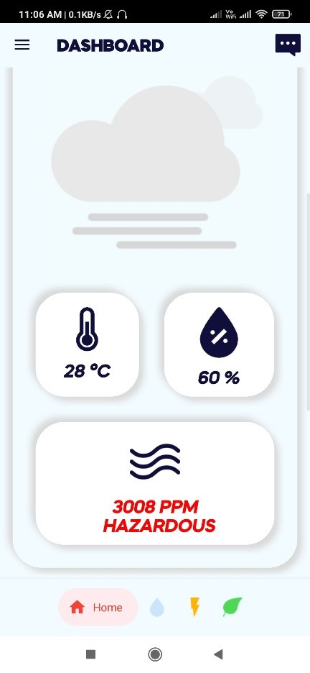

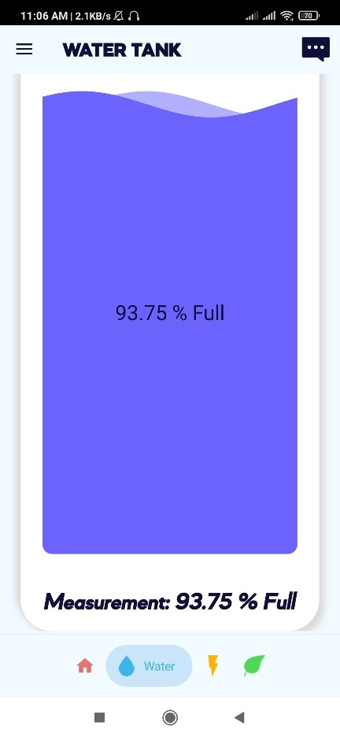

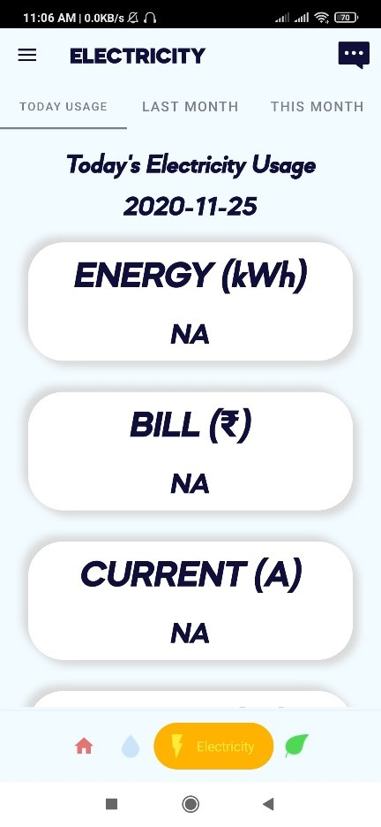

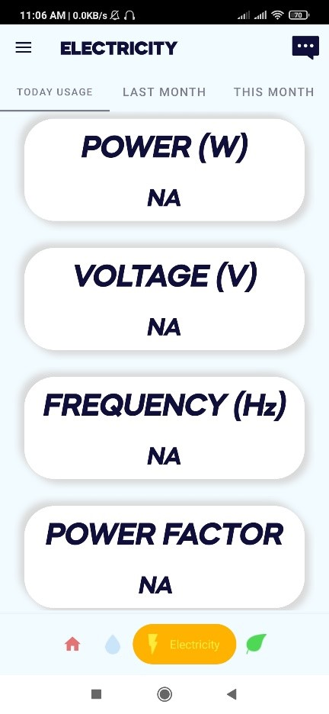

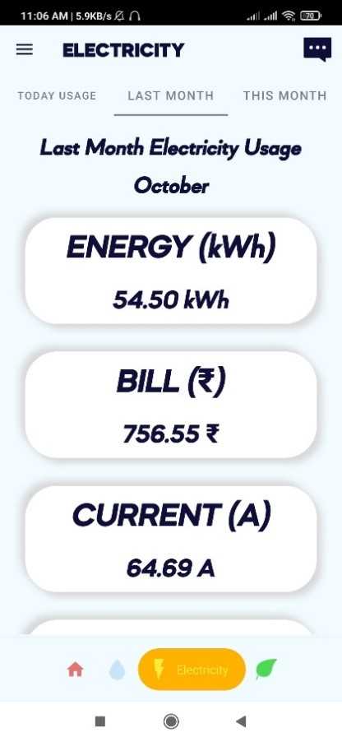

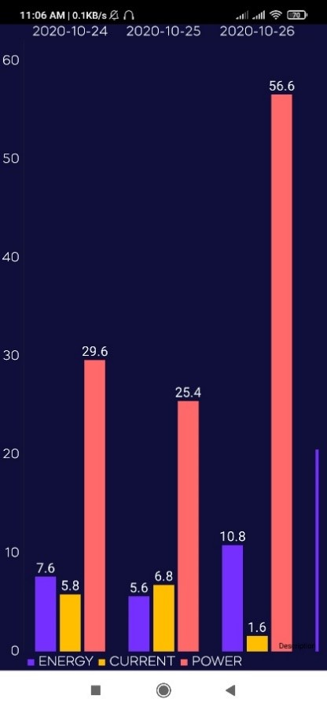

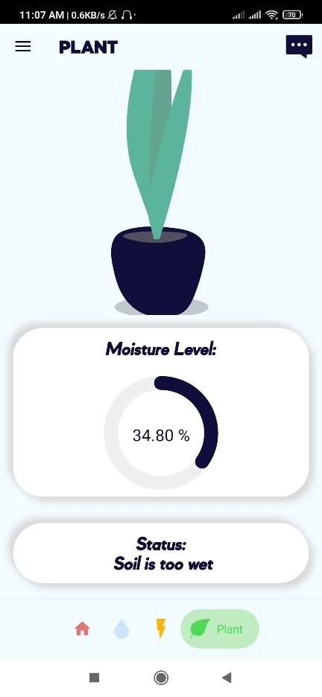

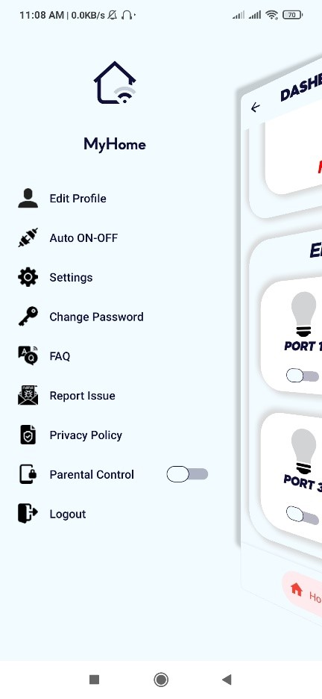

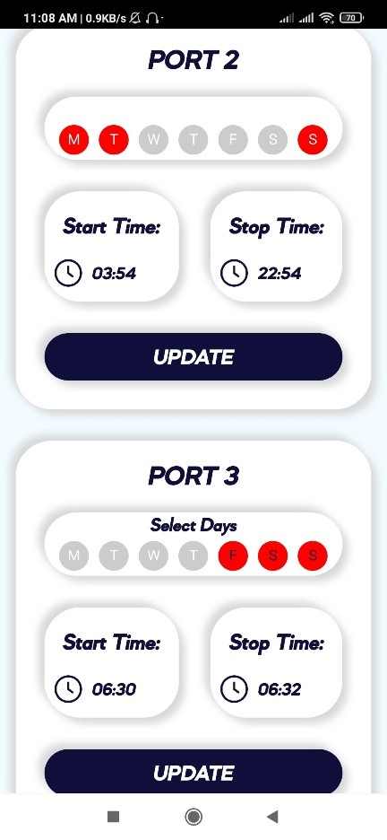

**Conclusion:**

In conclusion, the "Serverless IoT Data Processing" project represents an ambitious and forward-thinking endeavor to harness the power of technology and data to enhance the way we live in our homes. By integrating IoT devices, cloud-based data processing, and automation, this project holds the potential to make our living spaces more intelligent, energy-efficient, and secure.

Throughout the project, we have embarked on a journey that started with project initiation, requirements gathering, and technology selection in Phase 1. We defined our objectives, selected the right IoT devices, and laid the groundwork for the smart home of the future.

As we move forward with the implementation, our focus shifts to bringing the smart home to life. We acquire the necessary hardware and software, configure the devices, and set up cloud functions for data processing. The data collected from these devices is analyzed and used to create automation rules that enhance the quality of life for homeowners.

Security and privacy have been key considerations throughout, ensuring that the technology works seamlessly while maintaining the utmost protection of data and privacy.

The benefits of this project are far-reaching, offering convenience, energy savings, and peace of mind. Homeowners will have the ability to control and monitor their living spaces in ways never before possible, providing insights and control at their fingertips.

As we look ahead, this project is not only a reflection of the power of technology but also an indication of the exciting potential for further innovations in the world of IoT and serverless computing. We hope that this project inspires more developments that continue to transform our daily lives for the better. The journey has begun, and the possibilities are limitless in our quest to create smarter, more efficient, and more secure living spaces.

**Future Scope:**

"My Home" specifically has the following aspects that can be looked at for future development:

**Reduction of hardware resources required:**

The project was built with the use of a Wi-fi router at present. This can be avoided with the use of Mobile personal hotspot for establishing the connection between Raspberry Pi and the Mobile phone.

**Cost Reduction:**

Raspberry Pi costs a little more than other Microprocessors and Microcontrollers available today that can facilitate the functioning of "My Home". Arduino canbe used instead of it. Arduino is cheaper compared to Raspberry Pi, thus reducing the costinvolved.

**Faster operation:**

With the use of Internet connectivity, the voice recognition by "Google Now" can work faster and reduce the response time taken by the app to switch ON/OFF the appliances.