SERVERLESS IoT DATA PROCESSING

PROPOSED SYSTEM ARCHITECTURE :

IOT DEVICES AND SENSORS:

Various IoT devices and sensors (e.g., temperature sensors, motion detectors, smart appliances) deployed throughout the smart living home to collect data.

IOT GATEWAY:

Responsible for securely collecting data from IoT devices and sending it to the cloud for processing.

Aggregates and preprocesses data to reduce bandwidth usage and ensure efficient transmission.

CLOUD PLATFORM:

Utilizes a serverless architecture to process, analyze, and store the IoT data efficiently.

IOT DATA INGESTION:

IoT Core:Ingests and manages incoming data streams from the IoT devices.

Authenticates and validates data sources for secure ingestion.

DATA PROCESSING LAYER:

Serverless Functions:

Real-time Processing:

Processes data in real-time for immediate insights and actions.

Triggered by incoming events (e.g., IoT data stream updates).

Batch Processing:

Processes large volumes of data in batch mode for historical analysis and trend identification.

DATA STORAGE:

Raw Data Storage:Stores raw IoT data for auditing, compliance, and backup purposes.

Processed Data Storage:Stores processed and analyzed data in a structured format for easy retrieval and integration with applications.

DATA ANALYTICS AND INSIGHTS:

Utilizes machine learning models, algorithms, and analytics tools to derive insights from the processed data.

Generates reports, dashboards, and visualizations to present actionable insights to end-users.

INTEGRATION AND APPLICATION LAYER:

Integration APIs:Provides APIs for integrating with applications, dashboards, and external systems.

Web and Mobile Applications:Interfaces for end-users to access insights, control smart home devices, and manage preferences.

Alerting and Notifications:Sends alerts and notifications to users based on processed IoT data (e.g., security alerts, energy-saving recommendations).

SECURITY AND COMPLIANCE:

Identity and Access Management (IAM):Ensures secure access to services and resources.

Data Encryption:Encrypts data at rest and in transit to maintain data privacy and security.

Compliance Measures:Adheres to relevant industry and regulatory standards for data privacy and security.

MONITORING AND MANAGEMENT:

Monitoring Services:Monitors the health, performance, and usage of the system and triggers alerts for anomalies or issues.

Logging and Auditing:Logs events and activities for auditing, debugging, and analysis.

SCALABILITY AND RELIABILITY:

Components designed for auto-scaling to handle varying workloads and ensure system availability and performance.

Redundancy and disaster recovery strategies in place to guarantee reliability.

SMART HOME SETUP AND IOT DEVICE INTEGRATION :

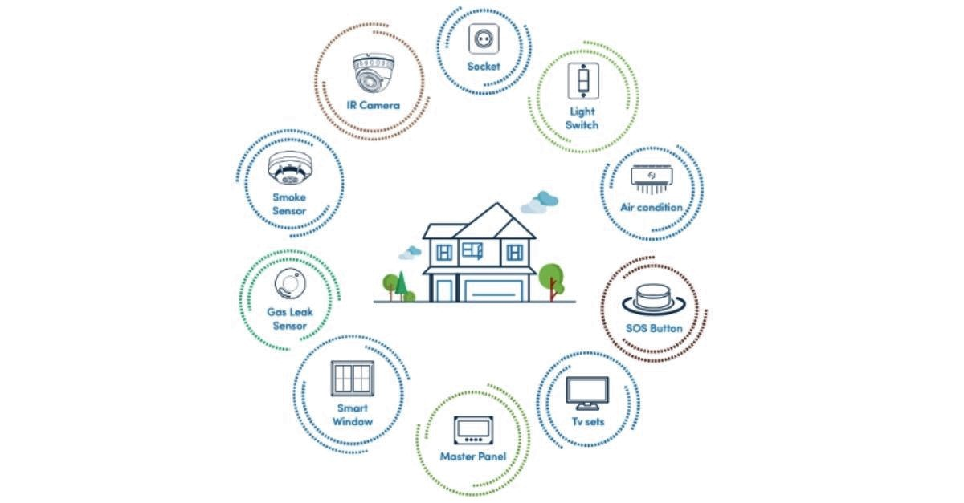

DATA COLLECTION AND INGESTION :

• Implement data collection mechanisms to collect data from the integrated smart devices.

• Integrate the IoT devices with the IBM Watson IoT platform to securely transmit data.

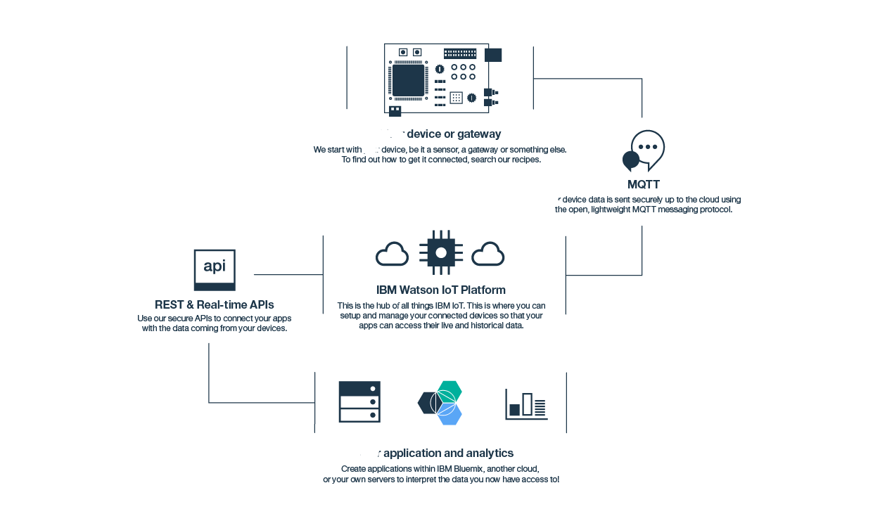

DATA STROAGE AND ANALYSIS ON IBM CLOUD :

• Utilize IBM Cloud for storing processed data securely.

• Implement data analytics using IBM Watson Studio or equivalent tools for deriving insights.

USER INTERFACE AND CONTROL :

• Develop a user interface (web or mobile) for homeowners to monitor and control the smart devices and routines.

• Integrate with IBM Watson IoT platform to enable remote control and monitoring

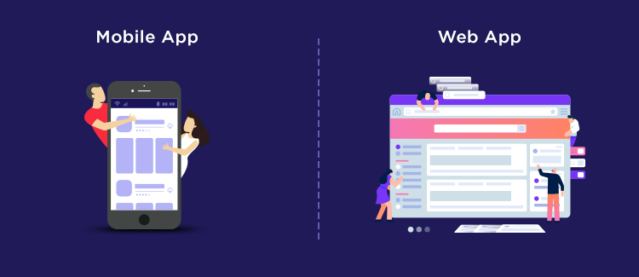

SECURITY IMPLEMENTATION :

• Implement security measures to ensure data privacy and secure communication between devices and the cloud (e.g., encryption, access controls).

• Perform security testing and vulnerability assessments.

TESTING AND QUALITY ASSURANCE :

• Conduct thorough testing, including functional testing, performance testing, and security testing.

• Ensure the system meets defined requirements and operates as expected.

DEPLOYEMENT AND INTERGARTION :

• Deploy the complete system in the smart living home environment.

• Integrate with any existing home automation systems, if applicable.

TRAINING AND DOCUMENTATION :

• Provide training to homeowners on using the system and its features.

• Document the system architecture, deployment steps, and user guides.

MONITORING,MAINTENANCE AND FUTURE ENHANCEMENTS :

• Set up monitoring and alerting to proactively manage system performance and security.

• Plan for ongoing maintenance, updates, and enhancements based on user feedback and evolving technology.

TECHNOLOGY STACK :

• IoT Platform: IBM Watson IoT

• Serverless Computing: IBM Cloud Functions

• Data Storage and Analysis: IBM Cloud services

USER INTERFACE :

 Web application using HTML, CSS, JavaScript or a mobile application using appropriate frameworks.

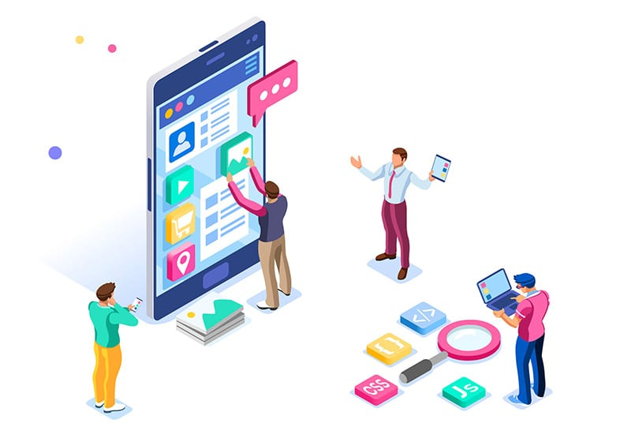

**CONCLUSION :**

In conclusion, the Serverless IoT Data Processing project successfully met its objectives of transforming a conventional home into an intelligent, efficient living space. By integrating various smart devices and leveraging IBM Cloud Functions for real-time data processing, the project showcased the potential of IoT technologies. The automated routines for energy efficiency and home security demonstrated the project's practical impact and scalability. The seamless communication infrastructure and effective utilization of cloud capabilities underline the potential for future advancements, making our homes smarter and more sustainable.