**FIT3179 Week 9 Homework Assignment**

**Create a Map with Vega-Lite**

Edwin Zhu (33115966) Studio: Monday 10AM (Ria)

Vega-Lite Map GitHub URL:

<https://ezhu0009.github.io/FIT3179/W9_HW_clor/index.html>

or access [here](https://ezhu0009.github.io/FIT3179/W9_HW_clor/index.html).

Screenshot:

Discussion

The domain of your visualisation

* The visualisation involves shark attack incidents and details of each shark attack, that have been recorded between 1971 and 2018. These incidents have occurred along the coastal borders of Australia and include both non-fatal (victim is alive as outcome), and fatal incidents.

The visualised dataset (attribute types, source and author, etc.)

* The dataset was obtained from the *Australian Shark-Incident Database*, which can be found at: <https://zenodo.org/records/11334212>
* The database is managed by Phoebe Meagher (Taronga Conservation Society Australia). The project is lead by Madeline Thiele (Flinders University), with members Corey Bradshaw (Flinders University), Charlie Huveneers (Flinders University), Victor Peddemors (NSW PDI) and David Slip (Taronga Conservation Society Australia).
* For each incident, the dataset originally contains information of the incident time and location (including longitude and latitude), injury type (ordinal), location category (nominal), shark type (nominal), victim activity (nominal), victim age (ordinal) and more.
* This raw dataset has also been tidied using R to wrangle, and tidy the main attributes for visualisation, namely State, victim outcome and injury type.

Data transformation that you applied (if any), such as normalisation by area or population.

* The resulting calculated field of total incidents in each State, was sorted in bins. As transformations such as a linear scale would result in states being almost too contrasting, rather than a sequential gradient (left):

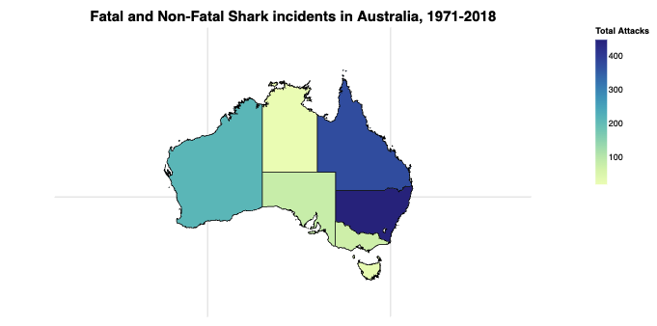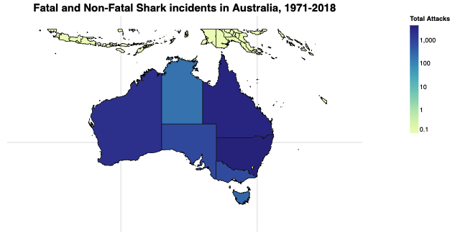

* Whilst using a log scale transformation would result in struggle to differentiate states with greater but differing number of attacks (right).
* Another option was to normalise fatal attacks in respect to total attacks, however the purpose and intent of the visualisation was to include data on injury type. Alternative idioms could be used to visualise the varying rates of fatal attacks vs total attacks such as proportional symbol map.

A justification for the type of map idiom used. For example, explain why you chose to create a proportional symbol map instead of a choropleth map or a dot map

* The previous dot point states the use of a choropleth map over a proportional symbol map.
* Another option was to use a dot-map, to point out every incident that happened over the period 1791 – 2018, which would’ve been possible as the dataset records exact beach locations of each incident. However, this would result in many, many congested dot marks at locations which are common for shark incidents. Imagine Bondi beach having hundreds of dots and the user unable to select a certain mark.
* There are other options like bin maps, or non-viable maps such as flow maps, but ultimately, the choice of a choropleth map summarises all recorded incidents into a neat map visualisation with the purpose of illustrating which state has the most incidents, with some more detailed interactions shown to the user if they are interested.