OBJECTIVE: To determine, analytically, the reaction forces *F1*, *F2*, …,*Fn* of a continuous beam of length *L* with *n* equidistant supports subjected to a transversal uniform load *w*.

1. Three Supports

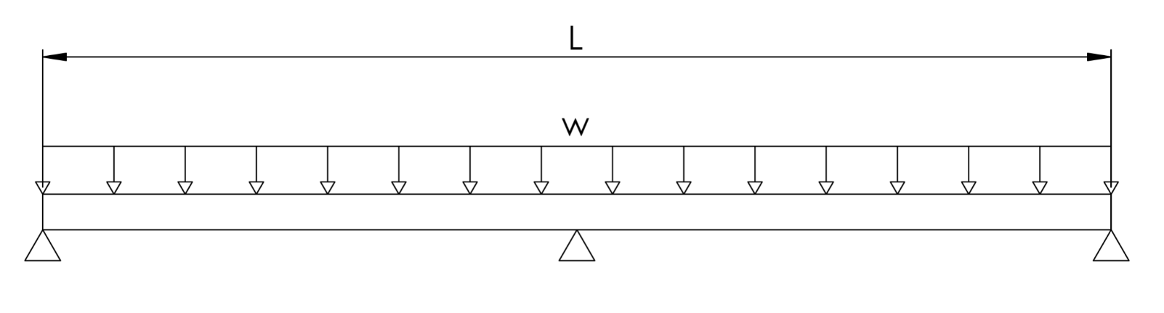

Three unknown variables ($F_{1}, F_{2}, F_{3}$), two equilibrium equations:

$\sum{F}=F_{1}+F_{2}+F_{3}-wL=0$

|  |  |
| --- | --- |
| $$F_{1}+F_{2}+F_{3}=wL$$ | (01) |

|  |  |
| --- | --- |
|  | (02) |

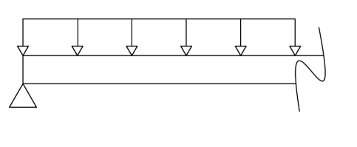

Bending moment (section 01):

$M_{1}\left(x\right)=F_{1}x_{1}-\frac{w{x_{1}}^{2}}{2}$

Elastic line equation (section 01):

$EI{\frac{d^{2}v_{1}}{d{x_{1}}^{2}}=M}_{1}\left(x\right)$

${\frac{dv_{1}}{dx_{1}}=F}_{1}\frac{{x_{1}}^{2}}{2}-\frac{w{x_{1}}^{3}}{6}+c_{1}$

${v_{1}=F}_{1}\frac{{x_{1}}^{3}}{6}-\frac{w{x_{1}}^{4}}{24}+c_{1}x_{1}+c_{2}$

Boundary conditions (section 01):

|  |  |
| --- | --- |
|  | (03) |
|  | (04) |

Five unknown variables () and four equations (2 equilibrium equations and 2 boundary condition equations).

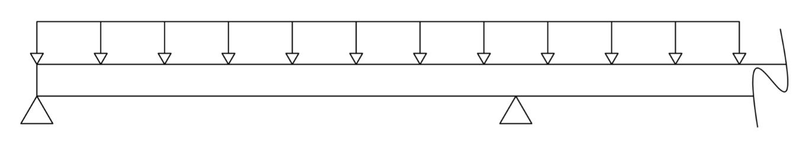

Bending moment (section 02):

$M_{2}\left(x\right)=F_{1}x_{2}+F_{2}\left(x_{2}-\frac{L}{2}\right)-\frac{w{x_{2}}^{2}}{2}$

Elastic line equation (section 02):

$EI{\frac{d^{2}v_{2}}{d{x_{2}}^{2}}=M}_{2}\left(x\right)$

${\frac{dv_{2}}{dx_{2}}=F}_{1}\frac{{x_{2}}^{2}}{2}+F_{2}\left(\frac{{x_{2}}^{2}}{2}-\frac{x_{2}L}{2}\right)-\frac{w{x_{2}}^{3}}{6}+c_{3}$

${v_{2}=F}_{1}\frac{{x_{2}}^{3}}{6}+F_{2}\left(\frac{{x_{2}}^{3}}{6}-\frac{{x_{2}}^{2}L}{4}\right)-\frac{w{x_{2}}^{4}}{24}+c_{3}x_{2}+c_{4}$

Bounday conditions (section 02):

$$x_{2}=L || v_{2}=0$$

$F_{1}\frac{{x_{2}}^{3}}{6}+F_{2}\left(\frac{{x_{2}}^{3}}{6}-\frac{{x_{2}}^{2}L}{4}\right)+c_{3}x_{2}+c_{4}=\frac{w{x_{2}}^{4}}{24}$

|  |  |
| --- | --- |
| $F_{1}\frac{L^{3}}{6}-F_{2}\frac{L^{3}}{12}+c_{3}L+c_{4}=\frac{wL^{4}}{24}$ | (05) |

Continuity equations (section 01 and 02):

$$x=\frac{L}{2} || \frac{dv}{dx_{1}}=\frac{dv}{dx_{2}}$$

$$x=\frac{L}{2} || v_{1}=v_{2}$$

$F_{1}\frac{{x_{2}}^{2}}{2}+F_{2}\left(\frac{{x_{2}}^{2}}{2}-\frac{x_{2}L}{2}\right)-\frac{w{x_{2}}^{3}}{6}+c_{3}{=F}_{1}\frac{{x_{1}}^{2}}{2}-\frac{w{x_{1}}^{3}}{6}+c_{1}$

$F_{2}\left(\frac{{x_{2}}^{2}}{2}-\frac{x_{2}L}{2}\right)-c_{1}+c_{3}=0$

$F_{2}\left(\frac{L^{2}}{8}-\frac{L^{2}}{4}\right)-c_{1}+c_{3}=0$

|  |  |
| --- | --- |
| $-F_{2}\frac{L^{2}}{8}-c_{1}+c_{3}=0$ | (06) |

|  |  |
| --- | --- |
|  | (07) |

Seven unknown variables ($F_{1}, F_{2}, F_{3}, c_{1},c_{2}, c_{3}, c_{4}$) e seven equations (2 equilibrium equations, 3 boundary condition equations and 2 continuity equations).

The linear system can be represented by the following matrices $\left(A∙x=b\right)$:

A =

|  |  |  |  |  |  |  |
| --- | --- | --- | --- | --- | --- | --- |
| $$F_{1}$$ | $$F_{2}$$ | $$F_{3}$$ | $$c_{1}$$ | $$c_{2}$$ | $$c_{3}$$ | $$c_{4}$$ |
| $$1$$ | $$1$$ | $$1$$ | $$0$$ | $$0$$ | $$0$$ | $$0$$ |
| $$0$$ | $$L/2$$ | $$L$$ | $$0$$ | $$0$$ | $$0$$ | $$0$$ |
| $$0$$ | $$0$$ | $$0$$ | $$0$$ | $$1$$ | $$0$$ | $$0$$ |
| $\frac{{x_{1}}^{3}}{6} (x_{1}=L/2)$ | $$0$$ | $$0$$ | $x_{1}$ $(x_{1}=L/2)$ | $$1$$ | $$0$$ | $$0$$ |
| $$\frac{{x_{2}}^{3}}{6} (x_{2}=L)$$ | $$\frac{{x_{2}}^{3}}{6}-\frac{{x_{2}}^{2}L}{4} (x_{2}=L)$$ | $$0$$ | $$0$$ | $$0$$ | $$x_{2} (x_{2}=L)$$ | $$1$$ |
| $$0$$ | $$\frac{{x_{2}}^{2}}{2}-\frac{x_{2}L}{2} (x_{2}=L/2)$$ | $$0$$ | $$-1$$ | $$0$$ | $$1$$ | $$0$$ |
| $$0$$ | $$\frac{{x_{2}}^{3}}{6}-\frac{{x_{2}}^{2}L}{4} (x_{2}=L/2)$$ | $$0$$ | $$-x_{1} (x_{1}=L/2)$$ | $$-1$$ | $$x_{2} (x_{2}=L/2)$$ | $$1$$ |

b =

|  |
| --- |
| $$wL$$ |
| $$wL²/2$$ |
| $$0$$ |
| $\frac{w{x_{1}}^{4}}{24} (x_{1}=L/2)$ |
| $\frac{w{x_{2}}^{4}}{24} (x_{2}=L)$ |
| 0 |
| 0 |

1. Four supports

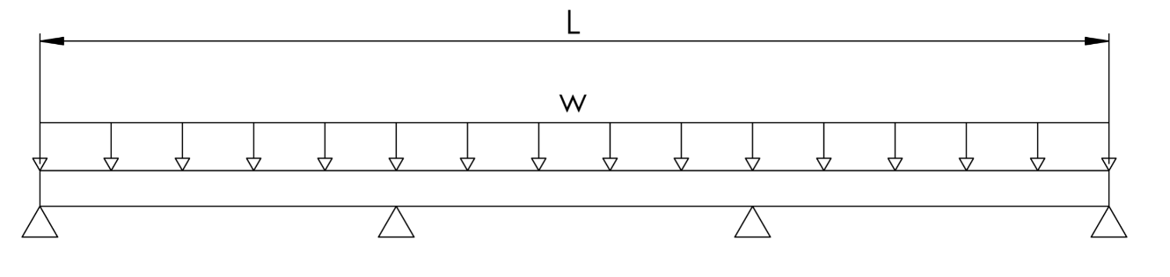

Four unknown variables ($F_{1}, F_{2}, F_{3}, F_{4}$), two equilibrium equations:

$\sum{F}=F_{1}+F_{2}+F_{3}+F_{4}-wL=0$

|  |  |
| --- | --- |
| $$F_{1}+F_{2}+F_{3}+F_{4}=wL$$ | (01) |

|  |  |
| --- | --- |
|  | (02) |

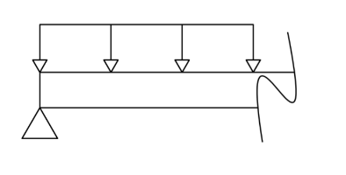

Bending moment (section 01):

$M_{1}\left(x\right)=F_{1}x_{1}-\frac{w{x_{1}}^{2}}{2}$

Elastic line equation (section 01):

${EI\frac{d^{2}v_{1}}{d{x_{1}}^{2}}=M}_{1}\left(x\right)$

${\frac{dv_{1}}{dx_{1}}=F}_{1}\frac{{x_{1}}^{2}}{2}-\frac{w{x_{1}}^{3}}{6}+c_{1}$

${v_{1}=F}_{1}\frac{{x_{1}}^{3}}{6}-\frac{w{x_{1}}^{4}}{24}+c_{1}x_{1}+c_{2}$

Boundary conditions (section 01):

|  |  |
| --- | --- |
|  | (03) |
|  | (04) |

Five unknown variables () and four equations (2 equilibrium equations and 2 boundary condition equations).

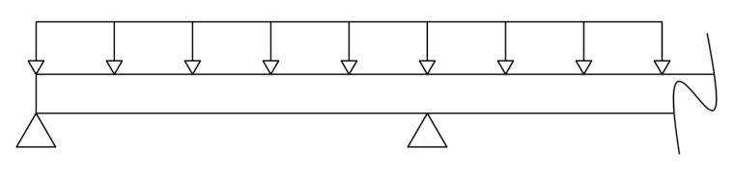

Bending moment (section 02):

$M_{2}\left(x\right)=F_{1}x_{2}+F_{2}\left(x_{2}-\frac{L}{3}\right)-\frac{w{x_{2}}^{2}}{2}$

Elastic line equation (section 02):

${EI\frac{d^{2}v_{2}}{d{x_{2}}^{2}}=M}_{2}\left(x\right)$

${\frac{dv_{2}}{dx_{2}}=F}_{1}\frac{{x_{2}}^{2}}{2}+F_{2}\left(\frac{{x_{2}}^{2}}{2}-\frac{x_{2}L}{3}\right)-\frac{w{x_{2}}^{3}}{6}+c_{3}$

${v_{2}=F}_{1}\frac{{x_{2}}^{3}}{6}+F_{2}\left(\frac{{x_{2}}^{3}}{6}-\frac{{x_{2}}^{2}L}{6}\right)-\frac{w{x_{2}}^{4}}{24}+c_{3}x_{2}+c_{4}$

Boundary conditions (section 02):

$$x_{2}=2L/3 || v_{2}=0$$

$$F_{1}\frac{{x_{2}}^{3}}{6}+F_{2}\left(\frac{{x_{2}}^{3}}{6}-\frac{{x_{2}}^{2}L}{6}\right)+c_{3}x_{2}+c_{4}=\frac{w{x_{2}}^{4}}{24}$$

$F_{1}\frac{{\left(\frac{2L}{3}\right)}^{3}}{6}+F_{2}\left(\frac{{\left(\frac{2L}{3}\right)}^{3}}{6}-\frac{{\left(\frac{2L}{3}\right)}^{2}L}{6}\right)+c_{3}\frac{2L}{3}+c_{4}=\frac{w{\left(\frac{2L}{3}\right)}^{4}}{24}$

$$F_{1}\frac{{32L}^{3}}{81}+F_{2}\left(\frac{32L^{3}}{81}-\frac{2L^{3}}{27}\right)+c_{3}\frac{2L}{3}+c_{4}=\frac{2wL^{4}}{243}$$

|  |  |
| --- | --- |
| $F_{1}\frac{{32L}^{3}}{81}+F_{2}\frac{26L^{3}}{81}+c_{3}\frac{2L}{3}+c_{4}=\frac{2wL^{4}}{243}$ | (05) |

Continuity equations (sections 01 and 02):

$$x=\frac{L}{3} || \frac{dv}{dx_{1}}=\frac{dv}{dx_{2}}$$

$$x=\frac{L}{3} || v_{1}=v_{2}$$

$F_{1}\frac{{x_{2}}^{2}}{2}+F_{2}\left(\frac{{x_{2}}^{2}}{2}-\frac{x_{2}L}{3}\right)-\frac{w{x_{2}}^{3}}{6}+c_{3}{=F}_{1}\frac{{x_{1}}^{2}}{2}-\frac{w{x_{1}}^{3}}{6}+c_{1}$

$F_{2}\left(\frac{{x_{2}}^{2}}{2}-\frac{x_{2}L}{3}\right)-c_{1}+c_{3}=0$

$F_{2}\left(\frac{L^{2}}{18}-\frac{L^{2}}{9}\right)-c_{1}+c_{3}=0$

|  |  |
| --- | --- |
| $-F_{2}\frac{L^{2}}{18}-c_{1}+c_{3}=0$ | (06) |

|  |  |
| --- | --- |
|  | (07) |

Eight unknown variables ($F_{1}, F_{2}, F_{3},F_{4}, c_{1},c_{2}, c_{3}, c_{4}$) and seven equations (2 equilibrium equations, 3 boundary condition equations and 2 continuity equations).

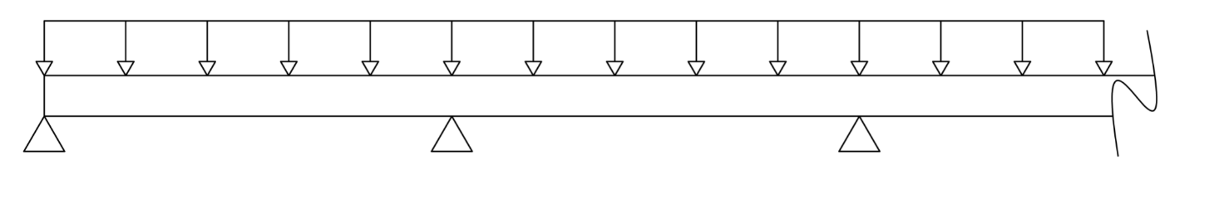

Bending moment (section 03):

$M_{3}\left(x\right)=F_{1}x_{3}+F_{2}\left(x_{3}-\frac{L}{3}\right)+F_{3}\left(x_{3}-\frac{2L}{3}\right)-\frac{w{x_{3}}^{2}}{2}$

Elastic line equation (section 03):

$EI{\frac{d^{2}v_{3}}{d{x_{3}}^{2}}=M}_{3}\left(x\right)$

${\frac{dv_{3}}{dx_{3}}=F}_{1}\frac{{x_{3}}^{2}}{2}+F_{2}\left(\frac{{x_{3}}^{2}}{2}-\frac{x_{3}L}{3}\right)+F_{3}\left(\frac{{x_{3}}^{2}}{2}-\frac{2x_{3}L}{3}\right)-\frac{w{x_{3}}^{3}}{6}+c_{5}$

${v_{2}=F}_{1}\frac{{x_{3}}^{3}}{6}+F_{2}\left(\frac{{x_{3}}^{3}}{6}-\frac{{x_{3}}^{2}L}{6}\right)+F_{3}\left(\frac{{x_{3}}^{3}}{6}-\frac{{x_{3}}^{2}L}{3}\right)-\frac{w{x_{3}}^{4}}{24}+c_{5}x_{3}+c_{6}$

Boundary conditions (section 03):

$$x_{3}=L || v_{3}=0$$

$F_{1}\frac{L^{3}}{6}+F_{2}\left(\frac{L^{3}}{6}-\frac{L^{2}L}{6}\right)+F_{3}\left(\frac{L^{3}}{6}-\frac{L^{2}L}{3}\right)+c_{5}L+c_{6}=\frac{wL^{4}}{24}$

$$F_{1}\frac{L^{3}}{6}+F_{2}\left(\frac{L^{3}}{6}-\frac{L^{3}}{6}\right)+F_{3}\left(\frac{L^{3}}{6}-\frac{L^{3}}{3}\right)+c_{5}L+c_{6}=\frac{wL^{4}}{24}$$

|  |  |
| --- | --- |
| $F_{1}\frac{L^{3}}{6}+c_{5}L+c_{6}=\frac{wL^{4}}{24}$ | (08) |

Continuity equations (sections 02 and 03):

$$x=\frac{2L}{3} || \frac{dv}{dx_{2}}=\frac{dv}{dx_{3}}$$

$$x=\frac{2L}{3} || v_{1}=v_{2}$$

$F_{1}\frac{{x_{3}}^{2}}{2}+F_{2}\left(\frac{{x_{3}}^{2}}{2}-\frac{x_{3}L}{3}\right)+F_{3}\left(\frac{{x_{3}}^{2}}{2}-\frac{2x_{3}L}{3}\right)-\frac{w{x_{3}}^{3}}{6}+c_{5}{=F}_{1}\frac{{x_{2}}^{2}}{2}+F_{2}\left(\frac{{x_{2}}^{2}}{2}-\frac{x_{2}L}{3}\right)-\frac{w{x_{2}}^{3}}{6}+c_{3}$

$$F_{3}\left(\frac{{x_{3}}^{2}}{2}-\frac{2x_{3}L}{3}\right)+c_{5}=c_{3}$$

$F_{3}\left(\frac{{\left(\frac{2L}{3}\right)}^{2}}{2}-\frac{2\left(\frac{2L}{3}\right)L}{3}\right)+c_{5}-c_{3}=0$

$F_{3}\left(\frac{{4L}^{2}}{18}-\frac{4L^{2}}{9}\right)+c_{5}-c_{3}=0$

|  |  |
| --- | --- |
| $-\frac{2L^{2}}{9}F_{3}-c_{3}+c_{5}=0$ | (09) |

|  |  |
| --- | --- |
|  | (10) |

Ten unknown variables ($F_{1}, F_{2}, F_{3},F_{4}, c_{1},c_{2}, c_{3}, c_{4},c_{5},c_{6}$) and ten equations (2 equilibrium equations, 4 boundary condition equations and 4 continuity equations).

Representing the linear equations through matrices:

A =

|  |  |  |  |  |  |  |  |  |  |
| --- | --- | --- | --- | --- | --- | --- | --- | --- | --- |
| $$F_{1}$$ | $$F_{2}$$ | $$F_{3}$$ | $$F_{4}$$ | $$c_{1}$$ | $$c_{2}$$ | $$c_{3}$$ | $$c_{4}$$ | $$c_{5}$$ | $$c_{6}$$ |
| $$1$$ | $$1$$ | $$1$$ | 1 | $$0$$ | $$0$$ | $$0$$ | $$0$$ | 0 | 0 |
| $$0$$ | $$L/3$$ | $$2L/3$$ | L | $$0$$ | $$0$$ | $$0$$ | $$0$$ | 0 | 0 |
| $$0$$ | $$0$$ | $$0$$ | 0 | $$0$$ | $$1$$ | $$0$$ | $$0$$ | 0 | 0 |
| $$\frac{{x_{1}}^{3}}{6}$$ $(x_{1}=L/3)$ | $$0$$ | $$0$$ | 0 | $$x_{1}$$ $$(x_{1}=L/3)$$ | $$1$$ | $$0$$ | $$0$$ | 0 | 0 |
| $\frac{{x_{2}}^{3}}{6}$ $$(x_{2}=2L/3)$$ | $\frac{{x_{2}}^{3}}{6}-\frac{{x_{2}}^{2}L}{6}$ $(x_{2}=2L/3)$ | $$0$$ | $$0$$ | $$0$$ | $$0$$ | $$x_{2}$$ $$(x_{2}=2L/3)$$ | $$1$$ | $$0$$ | $$0$$ |
| $$0$$ | $\frac{{x_{2}}^{2}}{2}-\frac{x_{2}L}{3}$ $$(x_{2}=L/3)$$ | $$0$$ | 0 | $$-1$$ | $$0$$ | $$1$$ | $$0$$ | $$0$$ | 0 |
| $$0$$ | $\frac{{x_{2}}^{3}}{6}-\frac{{x_{2}}^{2}L}{6}$ $$(x_{2}=L/3)$$ | $$0$$ | 0 | $${-x}_{1 }$$ $$(x_{1}=L/3)$$ | $$-1$$ | $$x_{2}$$ $$(x_{2}=L/3)$$ | $$1$$ | $$0$$ | $$0$$ |
| $\frac{{x_{3}}^{3}}{6}$ $$(x_{3}=L)$$ | $\frac{{x_{3}}^{3}}{6}-\frac{{x_{3}}^{2}L}{6}$ $$(x_{3}=L)$$ | $\frac{{x_{3}}^{3}}{6}-\frac{{x_{3}}^{2}L}{3}$ $$(x_{3}=L)$$ | $$0$$ | $$0$$ | $$0$$ | $$0$$ | $$0$$ | $x_{3}$ $$(x_{3}=L)$$ | $$1$$ |
| $$0$$ | $$0$$ | $\frac{{x_{3}}^{2}}{2}-\frac{2x_{3}L}{3}$ $$(x_{3}=2L/3)$$ | $$0$$ | $$0$$ | $$0$$ | $$-1$$ | $$0$$ | 1 | 0 |
| $$0$$ | $$0$$ | $\frac{{x_{3}}^{3}}{6}-\frac{{x_{3}}^{2}L}{3}$ $$(x_{3}=2L/3)$$ | $$0$$ | $$0$$ | $$0$$ | $-x_{2}$ $$(x_{2}=2L/3)$$ | $$-1$$ | $$x_{3}$$ $$(x_{3}=2L/3)$$ | $$1$$ |

b =

|  |
| --- |
| $$wL$$ |
| $$wL²/2$$ |
| $$0$$ |
| $\frac{w{x_{1}}^{4}}{24} (x_{1}=L/3)$ |
| $\frac{w{x_{2}}^{4}}{24} (x_{2}=2L/3)$ |
| 0 |
| 0 |
| $$\frac{w{x_{3}}^{4}}{24} (x_{3}=L)$$ |
| 0 |
| 0 |

1. N supports (general solution)

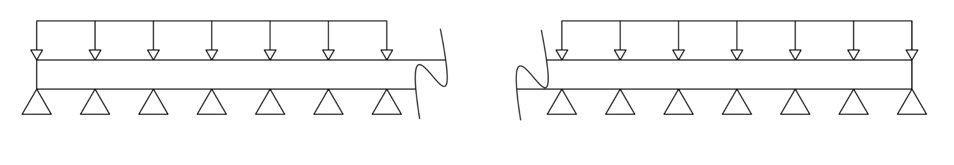

Bending moment for three supports:

* Section 01
$$M_{1}\left(x\right)=F_{1}x_{1}-\frac{w{x_{1}}^{2}}{2}$$

* Section 02

$$M_{2}\left(x\right)=F_{1}x_{2}+F_{2}\left(x_{2}-\frac{L}{2}\right)-\frac{w{x_{2}}^{2}}{2}$$

Bending moment for four supports:

* Section 01
$$M_{1}\left(x\right)=F_{1}x_{1}-\frac{w{x_{1}}^{2}}{2}$$

* Section 02
$$M_{2}\left(x\right)=F_{1}x_{2}+F_{2}\left(x_{2}-\frac{L}{2}\right)-\frac{w{x_{2}}^{2}}{2}$$

* Section 03

$$M_{3}\left(x\right)=F_{1}x_{3}+F_{2}\left(x_{3}-\frac{L}{3}\right)+F_{3}\left(x_{3}-\frac{2L}{3}\right)-\frac{w{x_{3}}^{2}}{2}$$

General solution

Bending moment for *n* supports:

* Section j

$M_{j}=\sum_{i=1}^{j}{F_{i}}\left(x_{j}-L\frac{\left(i-1\right)}{\left(n-1\right)}\right)-\frac{wx_{j}^{2}}{2}$

Integrating the expression to arrive at the elastic line equation yields:

${EI\frac{d^{2}v_{j}}{d{x_{j}}^{2}}=M}_{j}\left(x\right)$

$EI\frac{dv_{j}}{dx_{j}}=\sum_{i=1}^{j}{F_{i}}x_{j}\left(\frac{x_{j}}{2}-L\frac{\left(i-1\right)}{\left(n-1\right)}\right)-\frac{wx_{j}^{3}}{6}+c_{2j-1}$

$$EIv_{j}=\sum_{i=1}^{j}{F_{i}}x_{j}^{2}\left(\frac{x_{j}}{6}-L\frac{\left(i-1\right)}{2\left(n-1\right)}\right)-\frac{wx_{j}^{4}}{24}+{x_{j}c}_{2j-1}+c_{2j}$$

Matrix for three supports:

A =

|  |  |  |  |  |  |  |
| --- | --- | --- | --- | --- | --- | --- |
| $$F_{1}$$ | $$F_{2}$$ | $$F_{3}$$ | $$c_{1}$$ | $$c_{2}$$ | $$c_{3}$$ | $$c_{4}$$ |
| $$1$$ | $$1$$ | $$1$$ | $$0$$ | $$0$$ | $$0$$ | $$0$$ |
| $$0$$ | $$L/2$$ | $$L$$ | $$0$$ | $$0$$ | $$0$$ | $$0$$ |
| $$0$$ | $$0$$ | $$0$$ | $$0$$ | $$1$$ | $$0$$ | $$0$$ |
| $\frac{{x_{1}}^{3}}{6} (x_{1}=L/2)$ | $$0$$ | $$0$$ | $x_{1}$ $(x_{1}=L/2)$ | $$1$$ | $$0$$ | $$0$$ |
| $$\frac{{x_{2}}^{3}}{6} (x_{2}=L)$$ | $$\frac{{x_{2}}^{3}}{6}-\frac{{x_{2}}^{2}L}{4} (x_{2}=L)$$ | $$0$$ | $$0$$ | $$0$$ | $$x_{2} (x_{2}=L)$$ | $$1$$ |
| $$0$$ | $$\frac{{x_{2}}^{2}}{2}-\frac{x_{2}L}{2} (x_{2}=L/2)$$ | $$0$$ | $$-1$$ | $$0$$ | $$1$$ | $$0$$ |
| $$0$$ | $$\frac{{x_{2}}^{3}}{6}-\frac{{x_{2}}^{2}L}{4} (x_{2}=L/2)$$ | $$0$$ | $$-x_{1} (x_{1}=L/2)$$ | $$-1$$ | $$x_{2} (x_{2}=L/2)$$ | $$1$$ |

b =

|  |
| --- |
| $$wL$$ |
| $$wL²/2$$ |
| $$0$$ |
| $\frac{w{x_{1}}^{4}}{24} (x_{1}=L/2)$ |
| $\frac{w{x_{2}}^{4}}{24} (x_{2}=L)$ |
| 0 |
| 0 |

Matrix for four supports:

A =

|  |  |  |  |  |  |  |  |  |  |
| --- | --- | --- | --- | --- | --- | --- | --- | --- | --- |
| $$F_{1}$$ | $$F_{2}$$ | $$F_{3}$$ | $$F_{4}$$ | $$c_{1}$$ | $$c_{2}$$ | $$c_{3}$$ | $$c_{4}$$ | $$c_{5}$$ | $$c_{6}$$ |
| $$1$$ | $$1$$ | $$1$$ | 1 | $$0$$ | $$0$$ | $$0$$ | $$0$$ | 0 | 0 |
| $$0$$ | $$L/3$$ | $$2L/3$$ | L | $$0$$ | $$0$$ | $$0$$ | $$0$$ | 0 | 0 |
| $$0$$ | $$0$$ | $$0$$ | 0 | $$0$$ | $$1$$ | $$0$$ | $$0$$ | 0 | 0 |
| $$\frac{{x_{1}}^{3}}{6}$$ $(x_{1}=L/3)$ | $$0$$ | $$0$$ | 0 | $$x_{1}$$ $$(x_{1}=L/3)$$ | $$1$$ | $$0$$ | $$0$$ | 0 | 0 |
| $\frac{{x_{2}}^{3}}{6}$ $$(x_{2}=2L/3)$$ | $\frac{{x_{2}}^{3}}{6}-\frac{{x_{2}}^{2}L}{6}$ $(x_{2}=2L/3)$ | $$0$$ | $$0$$ | $$0$$ | $$0$$ | $$x_{2}$$ $$(x_{2}=2L/3)$$ | $$1$$ | $$0$$ | $$0$$ |
| $\frac{{x_{3}}^{3}}{6}$ $$(x_{3}=L)$$ | $\frac{{x_{3}}^{3}}{6}-\frac{{x_{3}}^{2}L}{6}$ $$(x_{3}=L)$$ | $\frac{{x_{3}}^{3}}{6}-\frac{{x_{3}}^{2}L}{3}$ $$(x_{3}=L)$$ | $$0$$ | $$0$$ | $$0$$ | $$0$$ | $$0$$ | $x_{3}$ $$(x_{3}=L)$$ | $$1$$ |
| $$0$$ | $\frac{{x_{2}}^{2}}{2}-\frac{x_{2}L}{3}$ $$(x_{2}=L/3)$$ | $$0$$ | 0 | $$-1$$ | $$0$$ | $$1$$ | $$0$$ | $$0$$ | 0 |
| $$0$$ | $\frac{{x_{2}}^{3}}{6}-\frac{{x_{2}}^{2}L}{6}$ $$(x_{2}=L/3)$$ | $$0$$ | 0 | $${-x}_{1 }$$ $$(x_{1}=L/3)$$ | $$-1$$ | $$x_{2}$$ $$(x_{2}=L/3)$$ | $$1$$ | $$0$$ | $$0$$ |
| $$0$$ | $$0$$ | $\frac{{x_{3}}^{2}}{2}-\frac{2x_{3}L}{3}$ $$(x_{3}=2L/3)$$ | $$0$$ | $$0$$ | $$0$$ | $$-1$$ | $$0$$ | 1 | 0 |
| $$0$$ | $$0$$ | $\frac{{x_{3}}^{3}}{6}-\frac{{x_{3}}^{2}L}{3}$ $$(x_{3}=2L/3)$$ | $$0$$ | $$0$$ | $$0$$ | $-x_{2}$ $$(x_{2}=2L/3)$$ | $$-1$$ | $$x_{3}$$ $$(x_{3}=2L/3)$$ | $$1$$ |

b =

|  |
| --- |
| $$wL$$ |
| $$wL²/2$$ |
| $$0$$ |
| $\frac{w{x_{1}}^{4}}{24} (x_{1}=L/3)$ |
| $\frac{w{x_{2}}^{4}}{24} (x_{2}=2L/3)$ |
| $\frac{w{x_{3}}^{4}}{24} (x_{3}=L)$ |
| 0 |
| 0 |
| 0 |
| 0 |

Matrix for n supports:

|  |  |  |  |  |  |  |  |  |  |  |  |  |  |
| --- | --- | --- | --- | --- | --- | --- | --- | --- | --- | --- | --- | --- | --- |
| -- | $$F_{1}$$ | $$F_{2}$$ | $$F_{3}$$ | ... | $$F_{n-1}$$ | $$F_{n}$$ | $$c_{1}$$ | $$c_{2}$$ | $$c_{3}$$ | $$c_{4}$$ | ... | $$c_{2\left(n-1\right)-1}$$ | $$c_{2\left(n-1\right)}$$ |
| -- | $$1$$ | $$1$$ | $$1$$ | ... | 1 | 1 | $$0$$ | $$0$$ | $$0$$ | $$0$$ | ... | 0 | 0 |
| -- | $$0$$ | $\frac{L}{n-1}$ | $\frac{2L}{n-1}$ | ... | $\frac{(n-2)L}{n-1}$ | $L$ | $$0$$ | $$0$$ | $$0$$ | $$0$$ | ... | 0 | 0 |
| -- | $0$ | $$0$$ | $$0$$ | ... | 0 | 0 | $$0$$ | $$1$$ | $$0$$ | $$0$$ | ... | 0 | 0 |
| $x_{1}=L/(n-1)$ | $$\frac{{x_{1}}^{3}}{6}$$ | $$0$$ | $$0$$ | ... | 0 | 0 | $$x_{1}$$ | $$1$$ | $$0$$ | $$0$$ | ... | 0 | 0 |
| $x_{2}=2L/(n-1)$ | $$\frac{{x_{2}}^{3}}{6}$$ | $\frac{{x_{2}}^{3}}{6}-\frac{{x_{2}}^{2}L}{2(n-1)}$ | $$0$$ | ... | 0 | $$0$$ | $$0$$ | $$0$$ | $$x_{2}$$ | $$1$$ | ... | $$0$$ | $$0$$ |
| ⁞ | ⁞ | ⁞ | ⁞ | ... | ⁞ | ⁞ | ⁞ | ⁞ | ⁞ | ⁞ | ... | ⁞ | ⁞ |
| $$x_{n-1}=L$$ | $\frac{{x_{n-1}}^{3}}{6}$ | $\frac{{x_{n-1}}^{3}}{6}-\frac{{x_{n-1}}^{2}L}{2(n-1)}$ | $\frac{{x_{n-1}}^{3}}{6}-\frac{2{x_{n-1}}^{2}L}{2(n-1)}$ | ... | $\frac{{x_{n-1}}^{3}}{6}-\frac{(n-2){x_{n-1}}^{2}L}{2(n-1)}$ | 0 | $$0$$ | $$0$$ | $$0$$ | $$0$$ | ... | $$x_{n-1}$$ | $$1$$ |
| $x_{2}=L/(n-1)$ | $$0$$ | $\frac{{x_{2}}^{2}}{2}-\frac{x_{2}L}{(n-1)}$ | $$0$$ | ... | 0 | $$0$$ | $$-1$$ | $$0$$ | $$1$$ | $$0$$ | ... | $$0$$ | $$1$$ |
| $x_{2}=L/(n-1)$ | $$0$$ | $\frac{{x_{2}}^{3}}{6}-\frac{{x_{2}}^{2}L}{2(n-1)}$ | $$0$$ | ... | 0 | $$0$$ | $$-x_{2}$$ | $$-1$$ | $$x_{2}$$ | $$1$$ | ... | $$0$$ | 0 |
| ⁞ | ⁞ | ⁞ | ⁞ | ... | ⁞ | ⁞ | ⁞ | ⁞ | ⁞ | ⁞ | ... | ⁞ | ⁞ |
| $$x_{n-1}=L(n-2)/(n-1)$$ | $$0$$ | $$0$$ | $$0$$ | ... | $\frac{{x_{n-1}}^{2}}{2}-\frac{(n-2)x_{n-1}L}{(n-1)}$ | $$0$$ | $$0$$ | $$0$$ | $$0$$ | $$0$$ | ... | $$1$$ | $$0$$ |
| $$x_{n-1}=L(n-2)/(n-1)$$ | $$0$$ | $$0$$ | $$0$$ | ... | $\frac{{x_{n-1}}^{3}}{6}-\frac{(n-2){x_{n-1}}^{2}L}{2(n-1)}$ | $$0$$ | $$0$$ | $$0$$ | $$0$$ | $$0$$ | ... | $$x_{n-1}$$ | $$1$$ |

b =

|  |
| --- |
| $$wL$$ |
| $$wL²/2$$ |
| $$0$$ |
| $\frac{w{x_{1}}^{4}}{24} (x_{1}=L/3)$ |
| $\frac{w{x_{2}}^{4}}{24} (x_{2}=2L/3)$ |
| ⁞ |
| $$\frac{w{x_{3}}^{4}}{24} (x_{n-1}=L)$$ |
| 0 |
| ⁞ |
| 0 |
| 0 |

The linear system for the general solution is represented by a matrix A of size $\left(3n-2×3n-2\right)$ and a vector *b* of size $\left(3n-2\right)$. The system can be solved through Gauss’s elimination method in order to be as close as possible to an analytical solution.