Software Requirements Specification

for

Kalasangam

Group Project Prepared by

|  |  |
| --- | --- |
| NAME | ROLL NUMBER |
| ARCHISHA VERMA | 2105700 |
| ANUROOP ROY | 21051543 |
| BODHISATTA BHATTACHARJEE | 22057025 |
| MUSKAN PRITAM | 2105974 |
| PRADYUNNA PODDAR | 2105216 |
| PRATYUSH ADHIKARI | 2105810 |
| SANDALI DEV SINHA | 21052448 |
| SYAMANTAK MANDAL | 21052800 |

Date : 10th October, 2023

Table of Contents

Table of Contents ii

Revision History ii

1. Introduction 1

1.1 Purpose 1

1.2 Project Overview 1

1.3 Project Scope 1

1.4 References 2

2. Overall Description 3

2.1 Product Perspective 3

2.2 Database Schema - ER Diagram 3

2.3 User Case Diagram 4

3. System Features 6

3.1 User Management……………………………………………………….……………………...6

3.2 Product Management……………………………………………………………………………6

3.3 Shopping Cart and checkout…………………………………………………………………….6

Revision History

|  |  |  |  |
| --- | --- | --- | --- |
| **Name** | **Date (DD/MM/YY)** | **Reason For Changes** | **Version** |
| Initial | 05/09/2023 | - | 1.0.0 |
| After Mid Sem - 1 | 10/10/2023 | Making the SRS more relevant | 1.1.0 |

# Introduction

## Purpose

## *The purpose of this Software Requirements Specification (SRS) document is to provide a comprehensive overview of “Kalasangam”, a MERN (MongoDB, Express.js, React, Node.js) Stack web application, and to establish a clear understanding of its goals, functionalities, and constraints. This document serves as a reference guide to describe functionality, external interfaces, performance, attributes and the design constraints of the system which is going to be developed. Therefore, intended reader groups for this software requirement specification are customers, suppliers and users.*

## Project Overview

“Kalasangam” is a web application designed to create a platform between the different artisans and the buyers (users). It aims to fill the void of a marketplace for indigenous artists / artisans / small crafts… and provide users with the opportunity to know them and connect with them to buy their products.

## Project Scope

The following features, functionalities, and components are included within the scope of Kalasangam:

1. **User Authentication and Authorization:**
   * User registration and login with email/password / social media accounts.
   * Role-based access control for administrators(moderators) and regular users.
2. **Listing Products and Management:**
   * Users can create, edit, and delete product listings and add social media links.
   * Ability to upload and manage images and multimedia content.
3. **Category of Products:**
   * Users can search for different types of products from categories section.
   * Sorting and categorizing content by category type.
4. **Admin Dashboard:**
   * Administrative panel for managing user accounts, managing different categories, content moderation, and analytics.
5. **Responsive Design:**
   * Ensuring the application is accessible and responsive on various devices, including desktops, tablets, and mobile phones.
6. **User Profile Management:**
   * Users can create and edit their profiles, including adding profile pictures and personal information.

The following features and functionalities are explicitly excluded from the scope of this project:

1. **Payment Processing:**

Integration with payment gateways for e-commerce functionality is not within the scope of this project.

1. **Advanced Data Analytics:**

Complex data analysis and reporting beyond basic user analytics are considered out of scope.

1. **Localization:**

Translating the application into multiple languages is not part of this project's scope.

1. **Third-Party Integrations:**

Any additional third-party integrations beyond those specified in the architecture are not included in the scope.

## References

1. React.js : [Documentation](https://react.dev/blog/2023/03/16/introducing-react-dev)
2. Node.js : [Documentation](https://nodejs.org/dist/latest-v20.x/docs/api/)
3. MongoDB : [Documentation](https://www.mongodb.com/docs/manual/)
4. Udemy MERN Course by “Academind” : [Course link](https://www.udemy.com/course/react-nodejs-express-mongodb-the-mern-fullstack-guide/)
5. Udemy MERN Course by “Brad Traversy” : [Course Link](https://www.udemy.com/course/mern-ecommerce/)
6. Udemy WEB DEV Course by “Angela Yu” : [Course Link](https://www.udemy.com/course/the-complete-web-development-bootcamp/)
7. YouTube Playlist of MERN course by “CodeWithHarry”: [Course Link](https://www.youtube.com/watch?v=YhJ-lPiCfyc&list=PLTtZ8XLMT18H7aPMXMgGCSutVk_m2fgLC) , and other courses
8. Help from [StackOverFlow](https://stackoverflow.com/) , [w3school](https://www.w3schools.com/) , [Quora](https://www.quora.com/) , [GeeksForGeeks](https://www.geeksforgeeks.org/) , [TutorialPoint](https://www.tutorialspoint.com/index.htm), … as and when required

# Overall Description

## Product Perspective

Through our online platform, "Kalasangam", we aim to bridge the gap between local artisans, employers, and potential buyers within a digital ecosystem, in an effort to bring India's forgotten culture and many talented but unrecognized individuals who struggle every day to ensure the survival of our country's creative identity and integrity to the forefront. The main purpose of 'Kalasangam' is to serve as an innovative and user-centric platform, build a support system to empower artisans to showcase their skills, connect with job opportunities, and gain visibility within their local communities, as well as among fellow artists. Simultaneously, it will offer employers and buyers a convenient and straight-forward way to discover, collaborate with, and engage with artisans of their locality on the basis of their preferences and needs. Kalasangam will function as a standalone and independent web application, offering accessibility via web browsers and potentially extending its reach through mobile applications, as well as by maintaining an online presence through various social media platforms. With an emphasis on security, reliability and serviceability, 'Kalasangam' aspires to create a safe and vibrant online marketplace that nurtures creativity, encourages financial growth of talented but struggling artists, and facilitates valuable connections within the artisanal community and beyond, so that India's youth may rediscover the beauty of it's forgotten culture.

## Database Schema - ER Diagram

An Entity-Relationship (ER) diagram is a visual representation of the data model that defines the relationships between entities within a database. ER diagrams are widely used in database design and serve as a valuable tool for understanding the structure and organization of data.

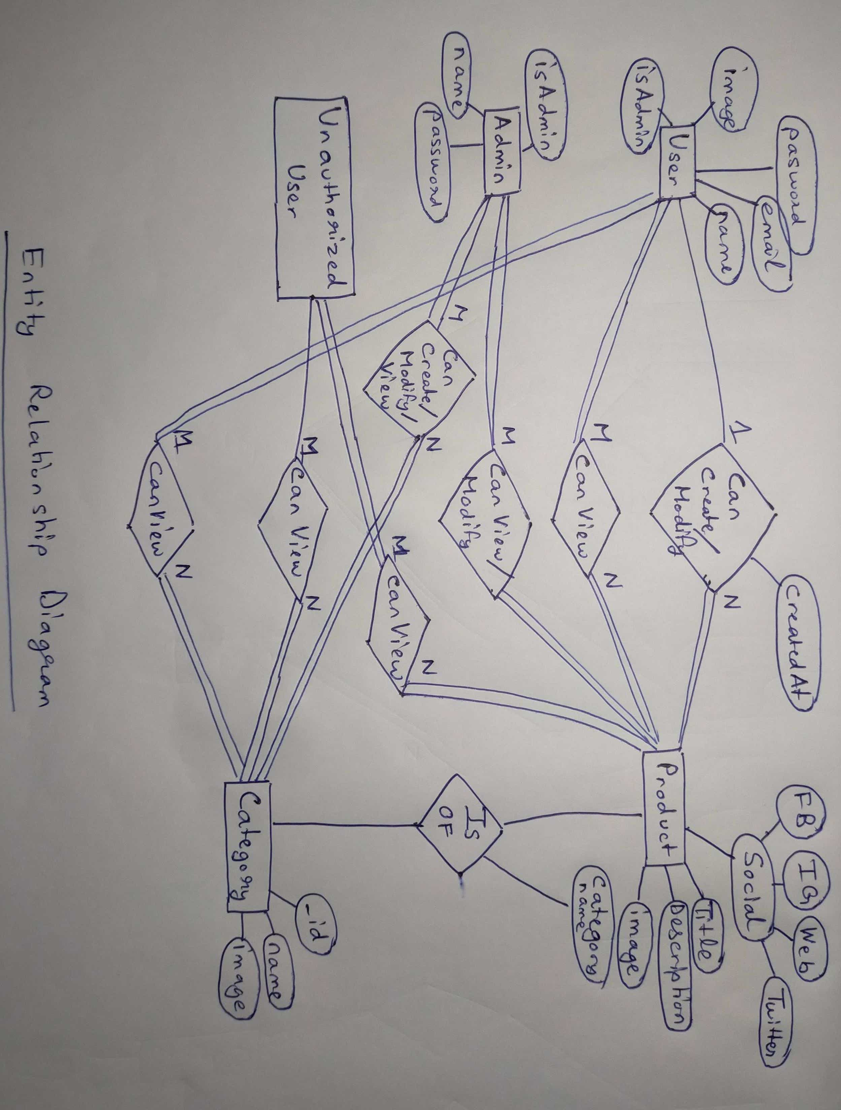

**NOTE**: NoSQL MongoDB is used for the implementation of the database. ER diagram is drawn considering if it was an SQL based Database.

## Use Case Diagram

A Use Case Diagram is a visual representation of the functional requirements of a system from the perspective of its users. It helps to illustrate the different ways users can interact with a system or website. For our website, it is a valuable tool in understanding and documenting how various users, both external and internal, interact with your website. It provides a high-level overview of the functionalities and features of your website, emphasizing the user's perspective.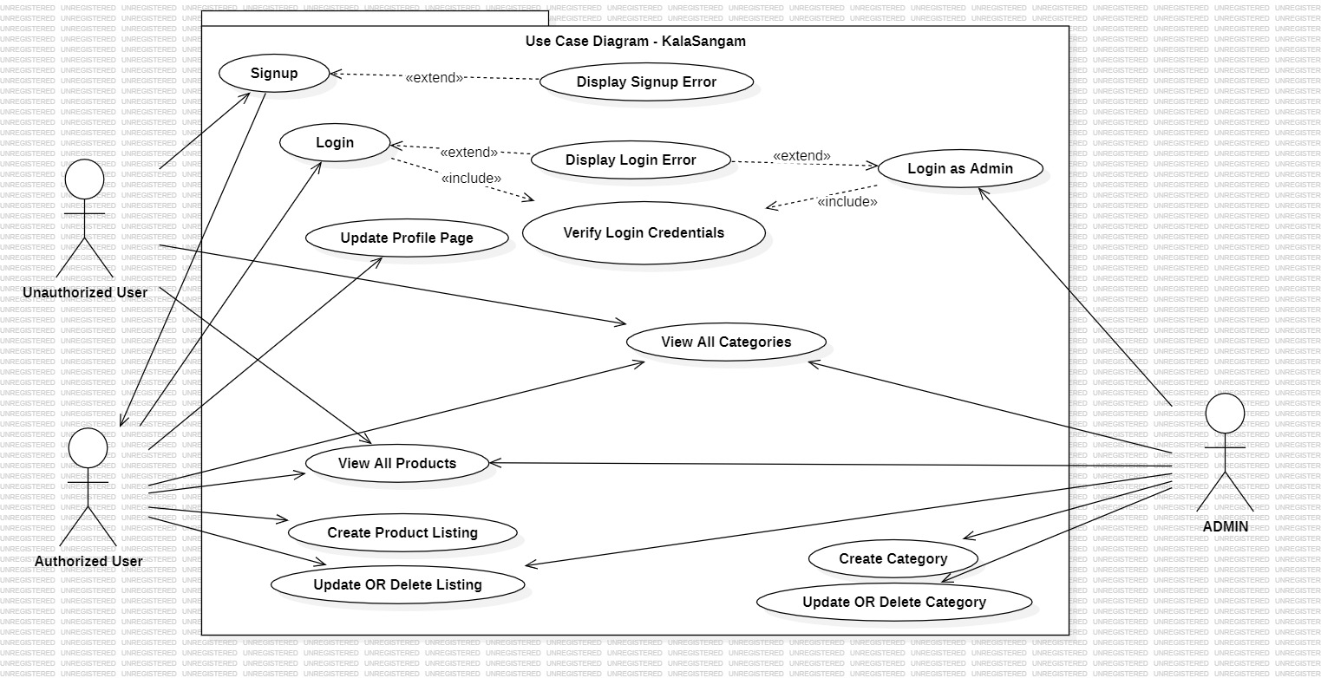

## Design and Implementation Constraints

**2.4.1**. The information of all **USER**s, **PRODUCT**s, **CATEGORIES**, **ADMIN**s must be stored in **MONGODB** database that is accessible by the website ‘KalaSangam’.

**2.4.2**. NoSQL Server by Mongo DB will be used to serve the purpose.

**2.4.3**. The Website to run on a system which will be hosted for 24 hours a day.

**2.4.4**. Users may access from any computer that has Internet browsing capabilities and an Internet connection.

**2.4.5**. Users must have their correct usernames and passwords to enter into their online accounts and do actions

# System Features

In this section, we will briefly describe the major services provided by the product. Basically, we will illustrate organizing the functional requirements for the product by system features. Each feature will be briefed independently comprising of the sub-features along with their description.

* 1. **User Management**

User management mainly involves handling user registration, authentication, and profile management, ensuring security in addition to providing personalized user experiences.

**3.1.1 User Registration**

This feature deals with collecting user information including name, email and password along with which it implements email verification for registration.

**3.1.2 User Authentication**

Here we ensure secure login using passwords and authentication tokens. Passwords are saved as hashed values so that no one can access the exact password even if looking in the database

**3.1.3 User Profiles**

Allows users to create and edit their profiles which includes options for profile pictures, contact information and personal preferences.

* 1. **Product Management**

Product management encompasses the creation and management of product listings, including details like descriptions, images ensuring a seamless product viewing experience for customers.

**3.3.1 Product Listings**

Allows users to create product listings for their products including fields for product name, description, social media links for engaging customers for that product and many more features provided by the user.

**3.3.2 Product Details**

Enables users to upload images for each product. For making it more appealing it supports rich text descriptions

* 1. **Category Management**

Categorymanagement encompasses the creation and management of categories by the administrator, including details like category name, images.

**3.4.1 Category creation / modification**

The Admin can create / update / delete details of a category like name, image, which id displayed in the categories section

**3.4.2 Selection of category when listing product**

When a user is listing a product, they can select which category their product belongs to

**3.4.3 Searching Products Based on category**

Any user can view all the products belonging to a specific category from the categories section.