Software Requirements Specification

for

Kalasangam

Group Project Prepared by

|  |  |
| --- | --- |
| NAME | ROLL NUMBER |
| ARCHISHA VERMA | 2105700 |
| ANUROOP ROY | 21051543 |
| BODHISATTA BHATTACHARJEE | 22057025 |
| MUSKAN PRITAM | 2105974 |
| PRADYUNNA PODDAR | 2105216 |
| PRATYUSH ADHIKARI | 2105810 |
| SANDALI DEV SINHA | 21052448 |
| SYAMANTAK MANDAL | 21052800 |

Date : 4th September, 2023

Table of Contents

Table of Contents ii

Revision History ii

1. Introduction 1

1.1 Purpose 1

1.2 Project Overview 1

1.3 Project Scope 1

1.4 References 2

2. Overall Description 2

2.1 Product Perspective 2

2.2 Database Schema - ER Diagram 3

2.3 User Case Diagram 3

2.4 Design and Implementation Constraints 4

2.5 User Documentation 4

3. System Features 5

3.1 User Management……………………………………………………….……………………...5

3.2 Product Management……………………………………………………………………………5

3.3 Shopping Cart and checkout…………………………………………………………………….5

3.4 Reviews and Ratings……………………………………………………………………………6

3.5 Messaging and Notifications……………………………………………………………………6

3.6 Search and Recommendation…………………………………………………………………...6

3.7 Reporting and Analytics………………………………………………………………………...6

4. Other Nonfunctional Requirements 7

4.1 Performance Requirements 7

4.2 Safety Requirements 7

4.3 Security Requirements 8

Revision History

|  |  |  |  |
| --- | --- | --- | --- |
| **Name** | **Date (DD/MM/YY)** | **Reason For Changes** | **Version** |
| Initial | 05/09/23 | - | 1.0.0 |
|  |  |  |  |

# Introduction

## Purpose

## *The purpose of this Software Requirements Specification (SRS) document is to provide a comprehensive overview of “Kalasangam”, a MERN (MongoDB, Express.js, React, Node.js) Stack web application, and to establish a clear understanding of its goals, functionalities, and constraints. This document serves as a reference guide to describe functionality, external interfaces, performance, attributes and the design constraints of the system which is going to be developed. Therefore, intended reader groups for this software requirement specification are customers, suppliers and users.*

## Project Overview

“Kalasangam” is a web application designed to create a platform between the different artisans and the buyers (users). It aims to fill the void of a marketplace for indigenous artists / artisans / small crafts… and provide users with the opportunity to know them and connect with them to buy their products.

## Project Scope

The following features, functionalities, and components are included within the scope of Kalasangam:

1. **User Authentication and Authorization:**
   * User registration and login with email/password or social media accounts.
   * Role-based access control for administrators, moderators, and regular users.
2. **User Profile Management:**
   * Users can create and edit their profiles, including adding profile pictures and personal information.
3. **Listing Products and Management:**
   * Users can create, edit, and delete products.
   * Ability to upload and manage images and multimedia content.
4. **Search and Filtering:**
   * Users can search for different types of products using keywords.
   * Filters for sorting and categorizing content by tags, popularity, and categories.
5. **Admin Dashboard:**
   * Administrative panel for managing user accounts, content moderation, and analytics.
6. **Responsive Design:**
   * Ensuring the application is accessible and responsive on various devices, including desktops, tablets, and mobile phones.

The following features and functionalities are explicitly excluded from the scope of this project:

1. **Payment Processing:**

Integration with payment gateways for e-commerce functionality is not within the scope of this project.

1. **Advanced Data Analytics:**

Complex data analysis and reporting beyond basic user analytics are considered out of scope.

1. **Localization:**

Translating the application into multiple languages is not part of this project's scope.

1. **Third-Party Integrations:**

Any additional third-party integrations beyond those specified in the architecture are not included in the scope.

## References

1. React.js : [Documentation](https://react.dev/blog/2023/03/16/introducing-react-dev)
2. Node.js : [Documentation](https://nodejs.org/dist/latest-v20.x/docs/api/)
3. MongoDB : [Documentation](https://www.mongodb.com/docs/manual/)
4. Udemy MERN Course by “Academind” : [Course link](https://www.udemy.com/course/react-nodejs-express-mongodb-the-mern-fullstack-guide/)
5. Udemy MERN Course by “Brad Traversy” : [Course Link](https://www.udemy.com/course/mern-ecommerce/)
6. Udemy WEB DEV Course by “Angela Yu” : [Course Link](https://www.udemy.com/course/the-complete-web-development-bootcamp/)
7. YouTube Playlist of MERN course by “CodeWithHarry”: Course Link

# Overall Description

## Product Perspective

Through our online platform, "Kalasangam", we aim to bridge the gap between local artisans, employers, and potential buyers within a digital ecosystem, in an effort to bring India's forgotten culture and many talented but unrecognized individuals who struggle every day to ensure the survival of our country's creative identity and integrity to the forefront. The main purpose of 'Kalasangam' is to serve as an innovative and user-centric platform, build a support system to empower artisans to showcase their skills, connect with job opportunities, and gain visibility within their local communities, as well as among fellow artists. Simultaneously, it will offer employers and buyers a convenient and straight-forward way to discover, collaborate with, and engage with artisans of their locality on the basis of their preferences and needs. Kalasangam will function as a standalone and independent web application, offering accessibility via web browsers and potentially extending its reach through mobile applications, as well as by maintaining an online presence through various social media platforms. With an emphasis on security, reliability and serviceability, 'Kalasangam' aspires to create a safe and vibrant online marketplace that nurtures creativity, encourages financial growth of talented but struggling artists, and facilitates valuable connections within the artisanal community and beyond, so that India's youth may rediscover the beauty of it's forgotten culture.

## Database Schema - ER Diagram

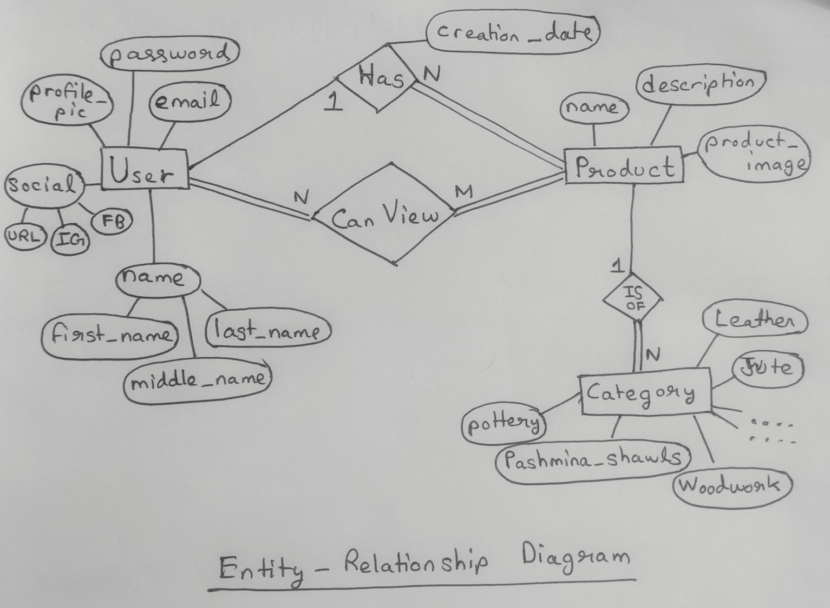 An Entity-Relationship (ER) diagram is a visual representation of the data model that defines the relationships between entities within a database. ER diagrams are widely used in database design and serve as a valuable tool for understanding the structure and organization of data.

## 

## User Case Diagram

A User Case Diagram is a visual representation of the functional requirements of a system from the perspective of its users. It helps to illustrate the different ways users can interact with a system or website. For our website, it is a valuable tool in understanding and documenting how various users, both external and internal, interact with your website. It provides a high-level overview of the functionalities and features of your website, emphasizing the user's perspective.

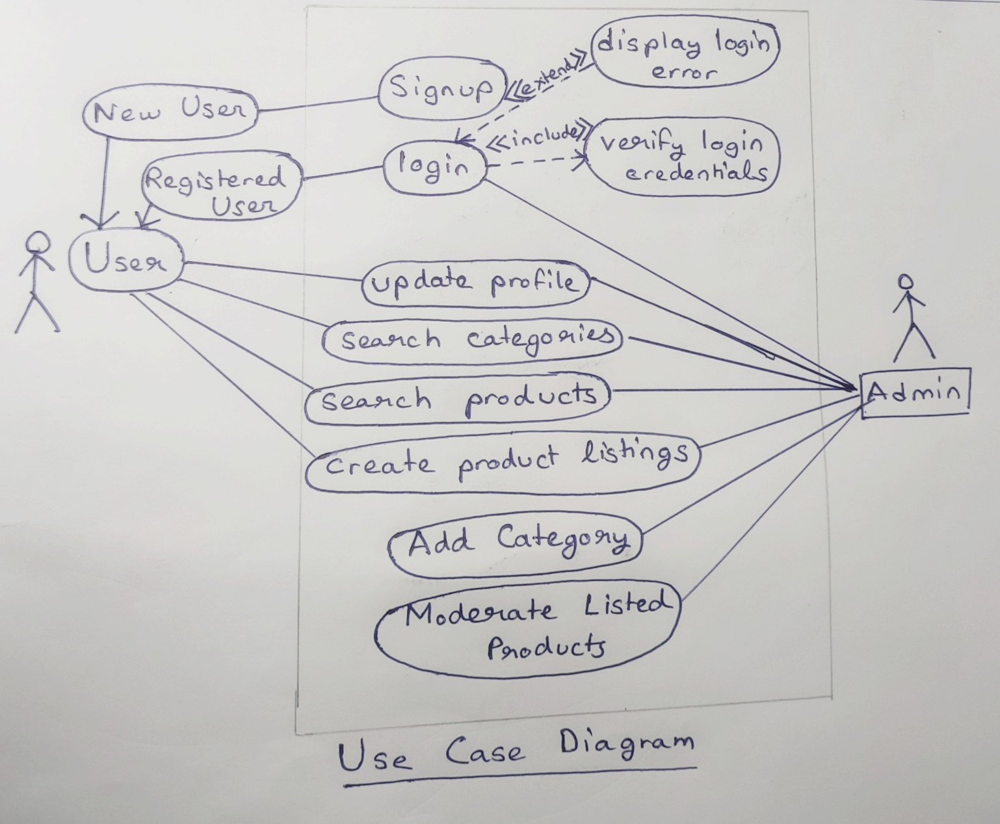

## Design and Implementation Constraints

**2.4.1**. The information of all users, products and artisans must be stored in a database that is accessible by the website.

**2.4.2**. MS SQL Server will be used as SQL engine and database.

**2.4.3**. The Website to run on a system which will be running 24 hours a day.

**2.4.4**. Users may access from any computer that has Internet browsing capabilities and an Internet connection.

**2.4.5**. Users must have their correct usernames and passwords to enter into their online accounts and do actions

## User Documentation

This software product will include a quick start guideline user manual covering complete overview of the product in the form of Email and Manual Page embedded in the website with technical supports. Also they would have the access to online tutorials. The tutorials and manual covering step by step guidance about how to add items to the cart, delivery, login-register and so on. Updated FAQs section in the website to provide ease to the user.

# System Features

In this section, we will briefly describe the major services provided by the product. Basically, we will illustrate organizing the functional requirements for the product by system features. Each feature will be briefed independently comprising of the sub-features along with their description.

* 1. **User Management**

User management mainly involves handling user registration, authentication, and profile management, ensuring security in addition to providing personalized user experiences.

**3.1.1 User Registration**

This feature deals with collecting user information including name, email and password along with which it implements email verification for registration.

**3.1.2 User Authentication**

Here we ensure secure login using passwords and authentication tokens

**3.1.3 User Profiles**

Allows users to create and edit their profiles which includes options for profile pictures, contact information and personal preferences.

* 1. **Product Management**

Product management encompasses the creation and management of product listings, including details like descriptions, images, pricing and inventory tracking ensuring a seamless shopping experience for users.

**3.3.1 Product Listings**

Allows artisans to create listings for their handmade products including fields for product name, description and many more features provided by the artisan.

**3.3.2 Product Details**

Enables artisans to upload multiple images for each product. For making it more appealing it supports rich text descriptions with formatting options and provides product variants such as size, color etc.

**3.3.3 Inventory Management**

Helps artisans track stock levels and automatically updates listings when products are sold.

* 1. **Shopping Cart and Checkout**

Shopping and checkout enables users to add items of choice to cart and securely complete their purchase, streamlining the buying process on the website.

**3.4.1 Shopping Cart**

Implements a responsive cart system providing options of adding, removing and viewing selected items from the cart.

**3.4.2 Secure Checkout and Payment Integration**

Ensures secure, HTTPS-enabled checkout along with displaying the bill and shipping information. Integrates with payment gateways like various UPIs for secure transactions. For ease of transactions it also handles multiple currencies and imposes taxes if applicable.

* 1. **Reviews and Ratings**

This feature allows customers to share their feedback and experiences with products, helping others to review their work accordingly. They also serve as valuable insights for artisans to improve their offerings and build trust among potential buyers.

**3.5.1 Customer Feedback**

Allows registered customers to leave reviews and rating for products in the format of text reviews and star ratings.

**3.5.2 Artisan Ratings**

Calculates the average ratings for artisans based on product reviews and display the ratings on their portfolio or artisan profiles.

* 1. **Messaging and Notifications**

Messaging and notifications facilitate real-time communication between users and artisans, fostering engagement and addressing inquires efficiently. Notifications helps inform users about important updates, enhancing their overall experience on the platform.

**3.6.1 In-App Messaging**

Focuses on implementing a real time messaging system for communication between users and artisans along with providing notifications for new messages and messages read status.

**3.6.2 Notifications**

Sends email or in-app notifications for order updates, product recommendations and important announcements for the convenience of the users.

* 1. **Search and Recommendation**

Search and recommendations empower users to find specific products or artisans. Easily through advanced search filters. Recommendations leverage user behavior and preferences to suggest relevant products, enhancing the personalized shopping experience and increasing user engagement on the platform.

**3.7.1 Advanced Search**

Implements a powerful search engine with filters for customizing the products and artisans accordingly.

**3.7.2 Product Recommendations**

Uses recommendation algorithms to personalize the display page based on user’s behavior and preferences.

* 1. **Reporting and Analytics**

Reporting and analytics provide valuable insights by tracking website performance, user behavior and sales data, aiding decision making and optimizing the platform for better user experiences and business growth.

**3.8.1 Generates Reports and Analytics**

Provides necessary tools to generate reports on sales, popular products and user activity. In addition to this it integrates analytic tools like Google Analytics to track website traffic and user engagement.

# Other Nonfunctional Requirements

## Performance Requirements

1. **Page load time**: The website should load quickly to ensure a smooth user experience.
2. **Scalability**: The website should be able to handle a large number of users and transactions without slowing down or crashing.
3. **Security**: The website should be secure to protect user data and prevent unauthorized access.
4. **Availability**: The website should be available 24/7 with minimal downtime. This can be achieved by using a reliable hosting provider and implementing redundancy measures such as load balancing and failover.
5. **Mobile responsiveness**: The website should be optimized for mobile devices to ensure a seamless user experience on smartphones and tablets.
6. **Search functionality**: The website should have a robust search functionality that allows users to easily find the products they are looking for.
7. **Payment gateway integration**: The website should integrate with popular payment gateways such as PayPal, Stripe, and Square to provide users with a variety of payment options.
8. **Inventory management**: The website should have an inventory management system that allows artisans to manage their products and stock levels.
9. **Customer service**: The website should have a customer service system in place to handle inquiries, complaints, and returns.
10. **Analytics**: The website should have an analytics system in place to track user behavior and identify areas for improvement.

## Safety Requirements

1. **Secure payment gateway:** The website should integrate with popular payment gateways such as PayPal, Stripe, and Square to provide users with a variety of payment options.
2. **Data protection**: The website should be designed to protect user data and prevent unauthorized access.
3. **Seller verification**: The website should have a seller verification process in place to ensure that only legitimate artisans are allowed to sell their products on the platform.
4. **Product quality control**: The website should have a system in place to ensure that the products sold on the platform meet certain quality standards. This can include reviewing product descriptions, images, and customer feedback.
5. **Dispute resolution**: The website should have a dispute resolution system in place to handle conflicts between buyers and sellers. This can include mediation services or an arbitration process.
6. **Customer service**: The website should have a customer service system in place to handle inquiries, complaints, and returns. This can include providing users with a dedicated support team or a self-service portal.
7. **Legal compliance**: The website should comply with all relevant laws and regulations related to e-commerce and online marketplaces. This can include tax laws, consumer protection laws, and data protection laws.

## Security Requirements

1. **Secure Payment Processing**: The website should use a secure payment gateway to process transactions and protect customers’ payment information. This can be achieved by using encryption technologies such as SSL (Secure Sockets Layer) or TLS (Transport Layer Security) to encrypt sensitive information during transmission.
2. **Data Protection**: The website should have measures in place to protect customers’ personal information, such as encryption and secure storage. This can be achieved by using encryption technologies to encrypt data at rest, as well as implementing access controls to restrict access to sensitive data.
3. **Access Control**: The website should have a system in place to control access to sensitive information, such as customer data and order details. This can be achieved by implementing role-based access controls, where different users have different levels of access based on their roles and responsibilities.
4. **Regular Security Updates**: The website should be regularly updated with the latest security patches to protect against vulnerabilities. This can be achieved by regularly updating the software and systems used by the website, as well as implementing a vulnerability management program to identify and remediate vulnerabilities.
5. **Fraud Prevention**: The website should have measures in place to prevent fraudulent activities, such as fake orders or fake reviews. This can be achieved by implementing fraud detection and prevention technologies, as well as monitoring user activity for suspicious behavior.