FLOWCHART

A flowchart is a picture of the separate steps of a process in sequential order. It is a generic tool that can be adapted for a wide variety of purposes, and can be used to describe various processes, such as a manufacturing process, an administrative or service process, or a project plan.

It is also a type of [diagram](https://en.wikipedia.org/wiki/Diagram) that represents a [workflow](https://en.wikipedia.org/wiki/Workflow) or [process](https://en.wikipedia.org/wiki/Process). A flowchart can also be defined as a diagrammatic representation of an [algorithm](https://en.wikipedia.org/wiki/Algorithm), a step-by-step approach to solving a task.

The flowchart shows the steps as boxes of various kinds, and their order by connecting the boxes with arrows. This diagrammatic representation illustrates a solution model to a given [problem](https://en.wikipedia.org/wiki/Problem_solving). Flowcharts are used in analyzing, designing, documenting or managing a process or program in various fields.

Examples of flowchart are below:

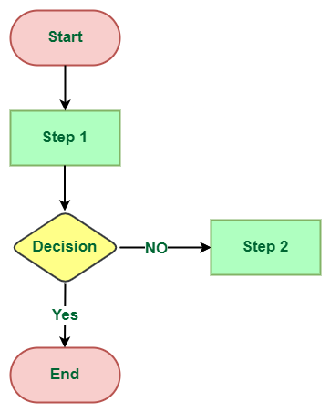

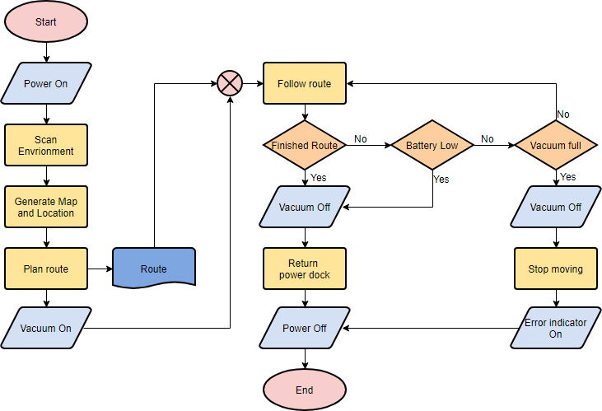

Flowcharts can be simple or complex