Accenture Operations Twin

Intelligent Advisor
UI GUIDE
Release Version: 2.5
Metadata Table:
Field | Value
Asset / Solution Name | Accenture Operations Twin / Intelligent Advisor
Domain / Area | Advisory / Decision Automation
Owner (Team/Person) | Tournier, Florian
Reviewers | Zoltani, Judit-Kinga
Status | Published / Approved
Confidentiality | Internal / Confidential
Source of Truth | Summary - Overview
Related Assets / Alternatives | Intelligent Advisor Delivery Guide

Contents
Introduction 3
Target Audience 3
Purpose 3
Contacts 3
Related Links 3
Prerequisites 3
Glossary 4
Intelligent Advisor Applications 5
Main Application 6
Intelligent Advisor Panel 6
Operations Hierarchy Panel 7
Digital Twin Assistant Panel 7
Insights 8
Actions 17
Template Viewer 26
Insight Details 27
Recommendations 28
Related Actions 28
More Details 29

Introduction

Accenture Operations Twin (AOT) is a collection of software accelerators and tools, including Intelligent Advisor, which can be assembled to deliver client solutions. AOT accelerates the integration of product, process, and live data from disparate IT and OT systems, creating a comprehensive and contextualized view of operations to enable better decisions and optimized processes.
Intelligent Advisor (IA) is an AOT component and an AI-based solution that enables distinct types of workers to focus on critical issues with real-time-generated, prioritized, and contextualized insights and recommendations. It combines the following functional components: Insight generation engine, collaboration via MS Teams, Actions, Advisor panel, Insight Viewer template, and Insight lifecycle management.
The user interface for IA is made up of two distinct parts – the IA side panel and the Template Viewer.

Target Audience
End users of the AOT UI

Purpose
This guide explains how to use AOT’s Intelligent Advisor UI with Template Viewer.

Contacts
- florian.tournier@accenture.com
- judit-kinga.zoltani@accenture.com

Related Links
- AOT on CDF
- AOT on Azure
- Release Notes
- Deployment Guide
- IA Delivery Guide
- Administration Guide

Prerequisites
- AOT has been deployed.
- Insights have been configured and generated.
- Google Chrome browser is installed.

Glossary
Term | Definition
AOT (Accenture Operations Twin) | A suite of software accelerators and tools that integrate product, process, and live data from IT and OT systems, providing a contextualized view of operations for improved decision-making and process optimization.
Intelligent Advisor (IA) | An AI-based component of AOT that generates prioritized, contextual insights and recommendations, enabling users to focus on critical issues and collaborate via MS Teams.
Insight | An event or alert generated by business logic, contextualized by user role, providing understanding of operational events. Insights support root-cause analysis, action creation, and team collaboration.
Insight Card | A UI element displaying details of a single insight, including priority, title, creation timestamp, role, status, description, actions, and ID.
Insight Priority | High (Red Diamond), Medium (Yellow Diamond), Low (Blue Diamond). Indicates the urgency or importance of an insight.
Insight Status | New, Converted to Action, In Action, Resolved, Closed, Auto-Closed. Describes the lifecycle stage of an insight.
Action | A task or work activity assigned to address an issue highlighted by an insight. Actions can be manually created or, in future releases, automatically generated by the recommendation engine.
Action Card | A UI element showing details of an action, such as title, creation timestamp, role, status, due date, action count, work order status, and ID.
Action Status | New, In Progress, Closed. Describes the lifecycle stage of an action.
Work Order | A formal task created in SAP PM (Plant Maintenance) system, linked to an action for operational follow-up. Status indicated by icon color (green: success, red: failed, gray: none).
Advisor Panel | Main UI panel for Intelligent Advisor, available in collapsed and expanded views. Displays insights and actions, with filtering and hierarchy navigation options.
Operations Hierarchy Panel | Tree view of operational hierarchy, allowing users to filter insights by plant or operational level.
Digital Twin Assistant Panel | AI-powered assistant (in Azure deployments) for interacting with real-time and historical operational data using natural language queries.
Template Viewer | UI component for viewing templates that define how insight details are displayed and organized. Accessed via the Details button on the Insight Summary.
Recommendations | Automatically generated proposed actions to resolve insights, based on previous insight-to-action processes and machine learning.
Related Actions | List of actions linked to a specific insight, shown in the Template Viewer.
KPI Breach | A type of insight indicating that a Key Performance Indicator (KPI) has exceeded its threshold, with drill-down options for further analysis.
Asset Optimization | A type of insight focused on predictive failure analysis for equipment, visualized with historical probability graphs.
Filtering | Functionality for narrowing down insights or actions by criteria such as count, sort order, source, status, priority, sub-type, and more.
Collaborate | Feature allowing users to work together on resolving insights or actions, accessible via dedicated buttons in the UI.
Create Insight / Create Action | UI options for manually adding new insights or actions, requiring completion of mandatory fields.
Edit Insight / Edit Action | Pop-up windows for modifying existing insights or actions, with editable fields depending on how the item was generated.
Closed Insights / Actions | Items that have been resolved and are no longer active, viewable via filter options.
Archived Insights | Insights automatically closed due to expiration, with system-generated reasoning.

Intelligent Advisor Applications
AOT’s Intelligent Advisor feature is divided into two distinct applications. The left-side main application panel is loaded along with the Smart KPIs Dashboard application. Clicking Details on the main application’s Insight summary loads the right-side template viewer panel. The collaboration option launches the collaborate functionality.

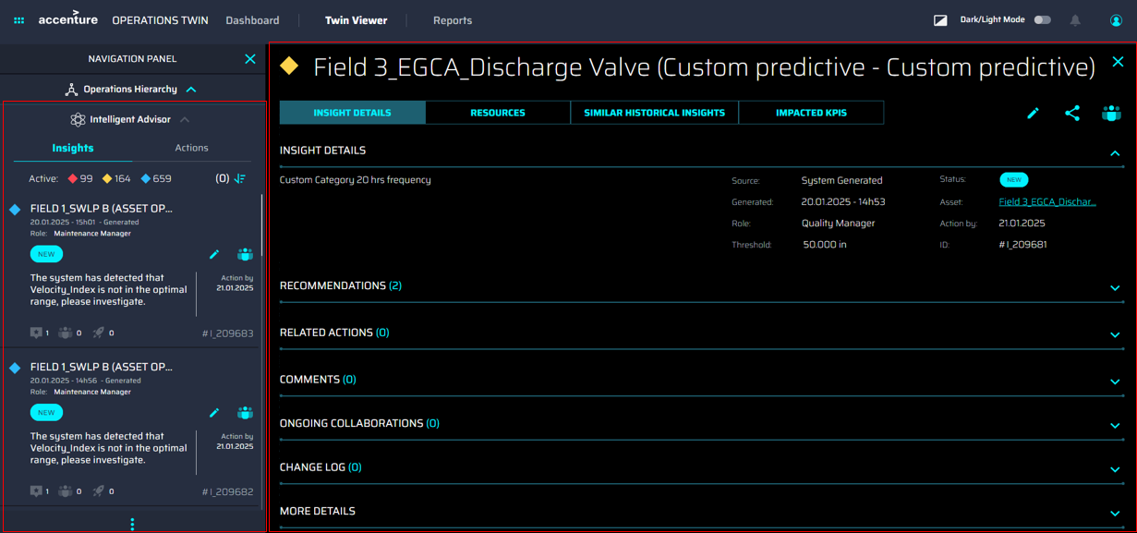

Main Application

Intelligent Advisor Panel
There are two ways to view the Intelligent Advisor panel – collapsed and expanded.
When AOT is launched, the IA panel is displayed in a collapsed view, which displays basic information about insights and actions in a narrow space.

Icon | Purpose
 | Clicking this expands panel with unfiltered insights
Number of unread high-priority insights.
Clicking this expands panel with filtered high-priority insights.
Number of unread medium-priority insights.
Clicking this expands panel with filtered medium-priority insights.
 | Number of unread low-priority insights. Clicking this expands panel with filtered low-priority insights.
 | Clicking this expands panel redirecting to either insights or actions filter
Number of unclosed actions that are past-due.
Clicking this expands panel with filtered past-due actions.
 | Number of unclosed actions not past-due.  Clicking this expands panel with filtered not past-due actions.
 | Clicking this opens the Operations Hierarchy panel

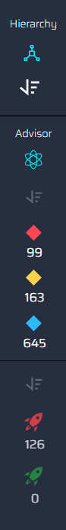
The expanded view of the Advisor Panel displays more information about insights and actions in separate tabs. Clicking the tabs at the top toggles between insights and actions.
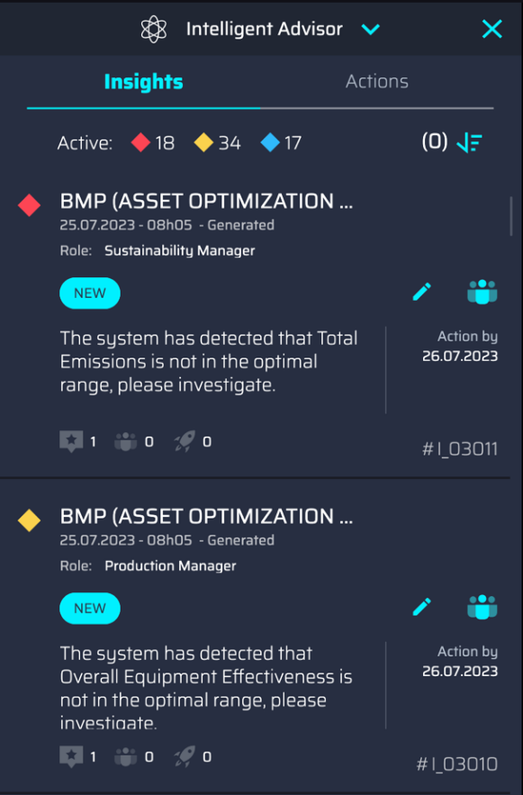

Operations Hierarchy Panel
Clicking on the Operations hierarchy icon in the Intelligent Advisor panel reveals the Operations hierarchy panel that shows the tree view of the Operations hierarchy.
Selecting a plant or level in the Operations Hierarchy causes the Insights in the Intelligent Advisor Panel to be filtered according to the selected item.
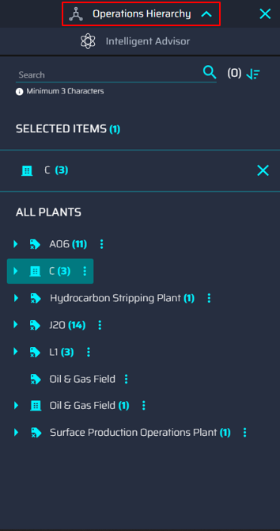

Digital Twin Assistant Panel
In Azure deployments, clicking the robot icon in the ribbon launches an AI-powered assistant within AOT that enables interaction with real-time and historical operational data using natural language. It simplifies access to structured and unstructured data, providing contextual insights, KPIs, actions, and root-cause analysis to support faster and smarter decision-making across assets, roles, and plants.
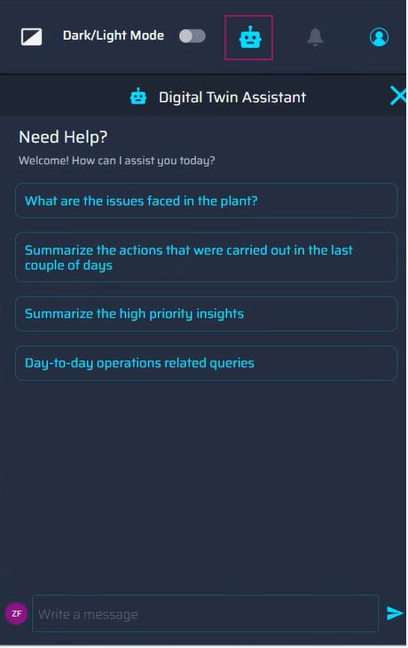

Insights
An Insight is an event/alert generated through certain business logic, contextualized by role – that helps AOT users gain a relevant understanding of that event, with the ability to drill down into the root-cause analysis of that event, create an action against that Insight, or collaborate with team members to resolve the issue.

Intelligent Advisor Panel
The following metrics are displayed on the IA panel:

- Active insights – the number of Insights per priority that have not been read or viewed.
- Insights Filter Button – Clicking opens the Filter panel with all the available options.
- Insight Card – details for one Insight.
- Load More button – loads more insight cards to be displayed.
- More Options – reveals the buttons for Create Insight and Historical Insight.

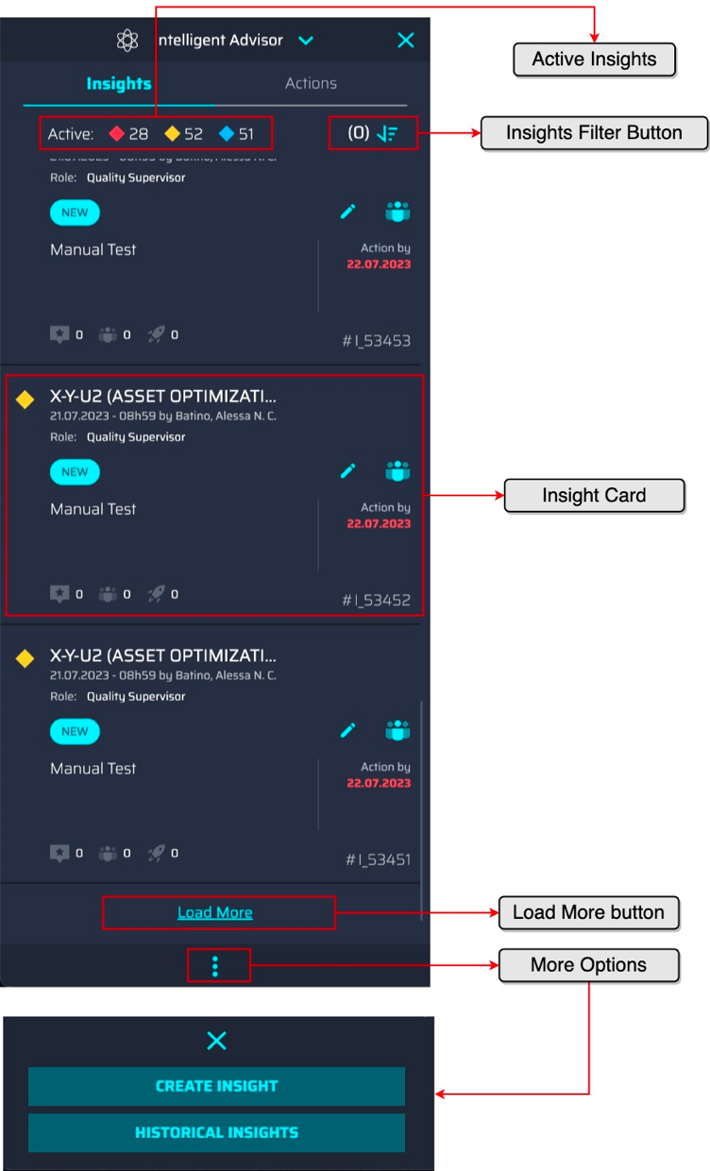

Insight Card
The Insight card shows the following information related to an Insight:
- Diamond – indicates the priority of the Insight. The color of the diamond indicates the priority level:
  - Red – High
  - Yellow – Medium
  - Blue – Low
- Title – Asset Name (Theme + Subtype)
- Creation Timestamp and Created by – Displays date when the Insight was created and by whom. If the Insight was system-generated, then the Generated timestamp is displayed.
- Role – The role to which the Insight is assigned.
- Status – Insight table status mapping:
  - New – Insight was just created.
  - Converted to Action – an action related to the Insight has been created.
  - In Action – one action related to Insight has a status of In Progress
  - Resolved – actions related to the Insight have the status of Closed.
- Edit and Collaborate buttons – launches appropriate pop-up menu. The Edit icon will launch the Edit Action window; Collaboration will open the Collaborate pop-up window.
- Description – An explanation of the Insight – a textual description of the Insight.
- Action By – the date by which the insights need to be addressed
- Future Use
- Future Use
- Actions – the count of created actions related to the Insight.
- Insight ID – the ID of an Insight made up of the #I_+ the count of the Insight.

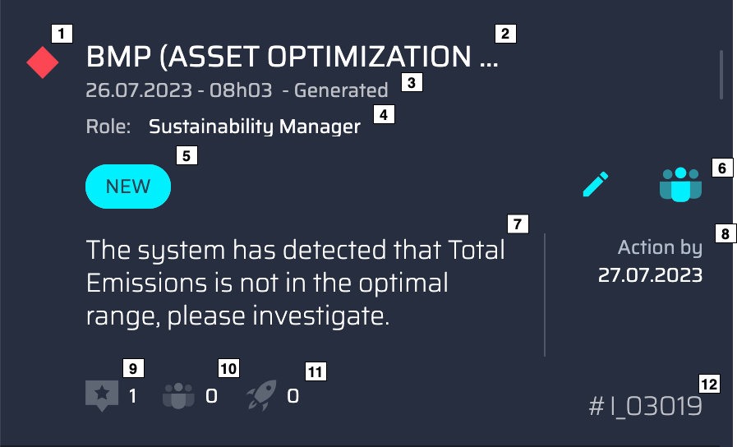

Insight Summary
The Insight summary can be accessed by clicking anywhere on the Insight card. This summary provides more information than what is shown on the Insight card.

- Back – Return to the Insight List – to the Intelligent Advisor main panel.
- Details – For system-generated insights, this option opens the Template Viewer on the right side.
- Tags – tags related to the Insight.
- Recommendations – list of recommended actions for an Insight, static list for this release
- Related Actions – list of existing actions for an Insight
- Future Use
- Future Use
- Create Action – Launch the create action popup.
- Collaborate – Launch the collaboration popup.

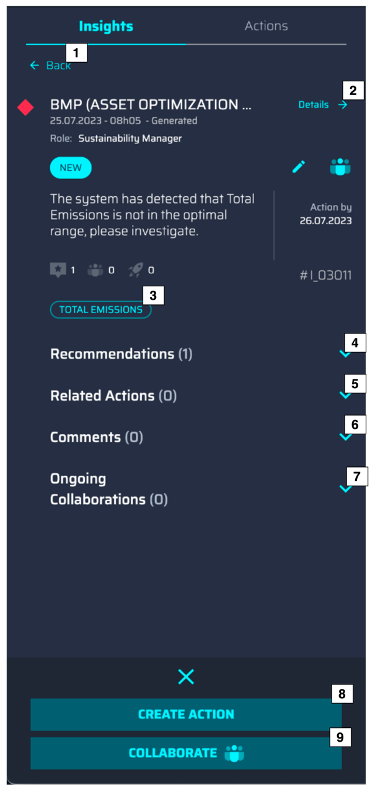

Create Insight
…
AOT users can raise awareness about issues or potential problems by manually creating insights. The Create Insight and Historical Insights buttons are revealed by clicking the vertical ellipsis (three dots) icon at the bottom.

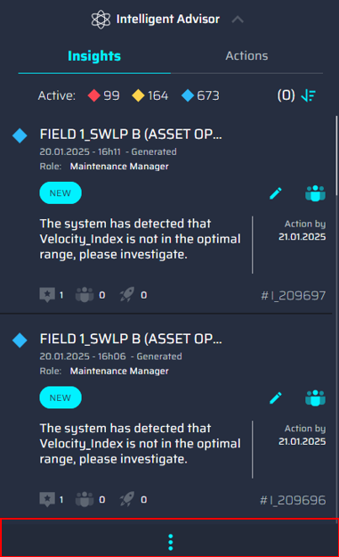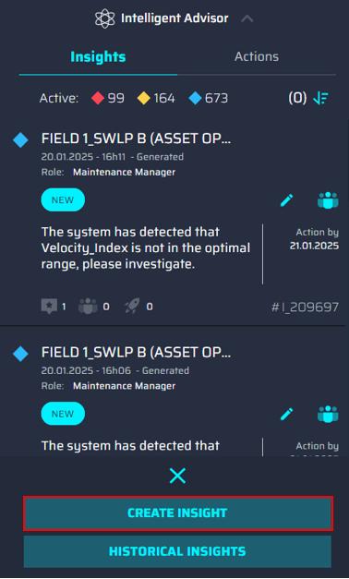

Clicking the Create Insight button in the More Options section of the Insight List launches the Create Insight screen. Mandatory fields are indicated by a red asterisk (*).

- Plant – A drop-down list of available plants. Other fields remain disabled until a Plant is selected.
- Department – A drop-down list of available departments
- Role – A selection drop-down list of respective roles used to define which roles of the previously chosen department have visibility into this Insight.
- Status – A read-only status equals New.
- Priority – A drop-down list for priority: High, Medium, Low
- Asset Hierarchy – A selection drop-down list of assets to which the generated Insight must be linked.
- Impacted KPIs – A selection drop-down used to select the KPIs that are thought to be impacted by this Insight.
- Theme – A selection drop-down list for choosing a theme with which to categorize the Insights.
- Sub-type – A selection drop-down used to choose a sub-type with which to categorize the Insight.
- Action By – A selection calendar used to select a future due date for the Insight.
- Insight Details – A free-text field of ten or more alphanumeric characters.
- Create Insight – A submission button after all fields have been filled for Insight creation.
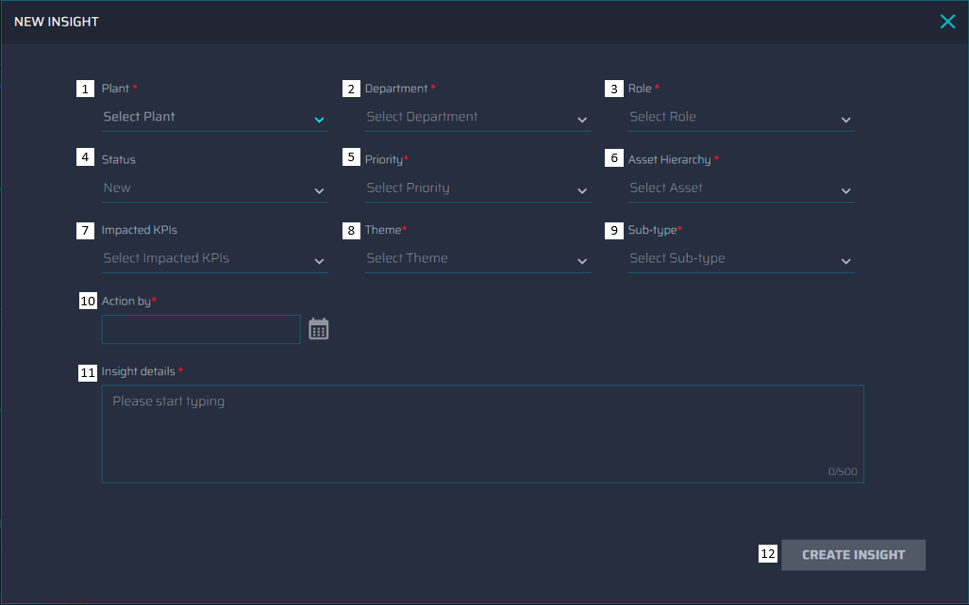

Edit Insight
The edit Insight pop-up can be accessed by clicking the button in the Insight card. The editable fields will depend on how an Insight was generated.

System-Generated Insights have seven editable fields:
- Plant
- Department
- Role
- Status
- Priority
- Impacted KPIs
- Estimated Impact
- Action By
Manually generated Insights have three additional editable fields:
- Asset Hierarchy
- Theme
- Sub-type
For both types of Insights, the Insight details field is not editable, and the Status field will only be enabled if all related actions of the Insight are closed. Therefore, the Status field is activated only when the Insight state equals Resolved.
Note that two AOT users cannot edit the same Insight simultaneously. Trying to do so results in a pop-up notification from the application.
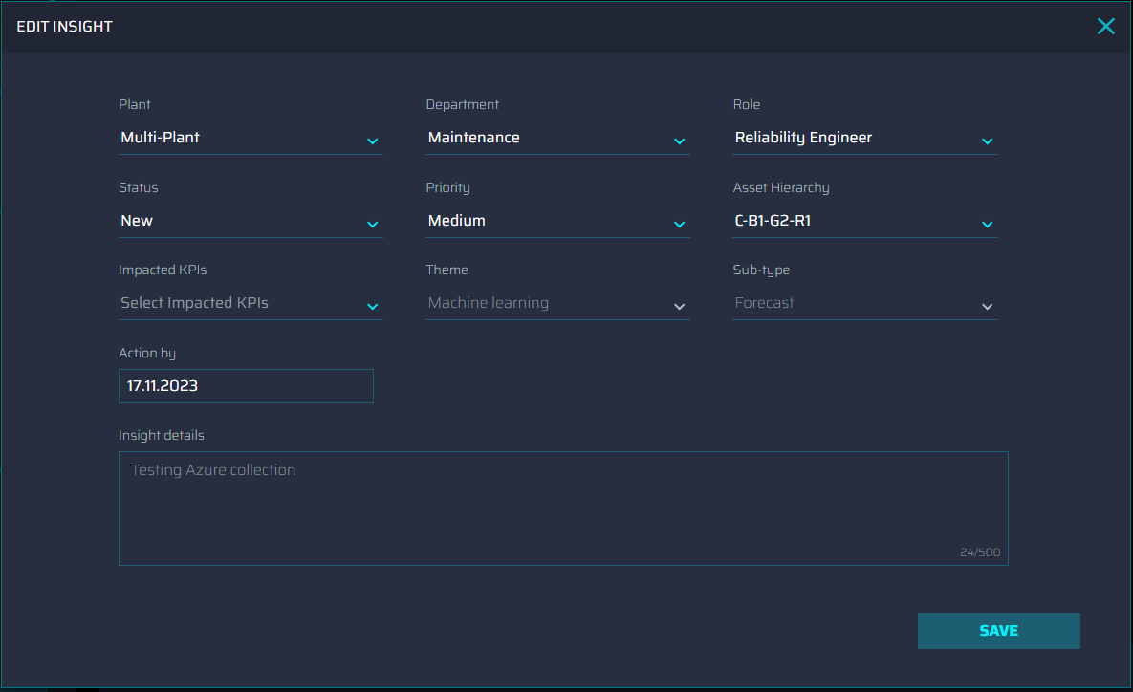

Close Insight
When all the Related Actions of the Insight are closed, the status of the Insight will change to Resolved. The status field will then be enabled. After choosing the Closed option, a new field is present for adding the reason for closing the Insight. The reason must be entered to enable the save button.
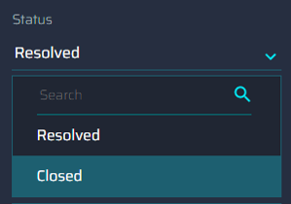

View Closed Insights

Once an Insight is closed, it will no longer be visible in the Intelligent Advisor panel along with the other active Insights.
To see the closed Insights, the AOT user must use the filter function as shown below:
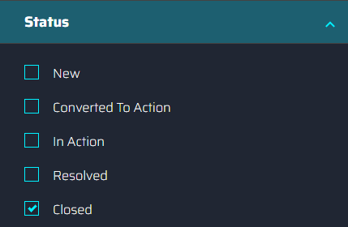
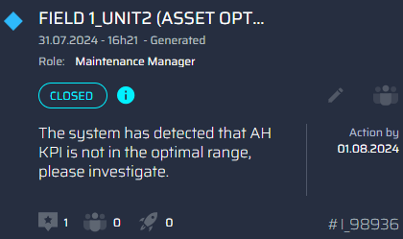
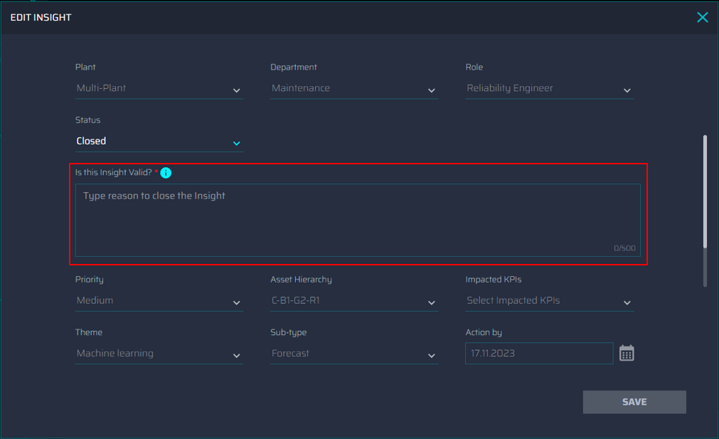

Archived Insights

Insights will automatically be closed regardless of the source, status, or priority if it exceeds the set expiration time. The Insight will also have an automatic reasoning message attached to it: "The expiration date of this insight has exceeded the maximum allowed period and, therefore, has been closed automatically with all its related actions by the system”
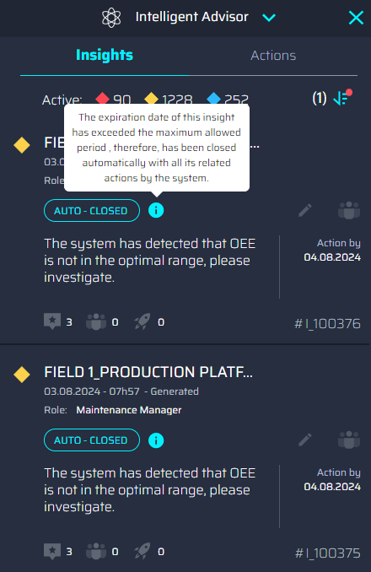

Filtering Insights
Filtering allows the return of fewer results for a simplified view. Filtering selections are shown below.

Filtering groups:

- Filter Count
- Sort By
- Source
- Status
- Priority
- Sub-Type – Values will vary, depending on insights visible to the AOT user.
- Close / Clear – If a filter is applied, the “Close” button will change to “Clear” so that filtering can be undone.
- Apply – The selected filters will only be applied after clicking the “Apply” button.
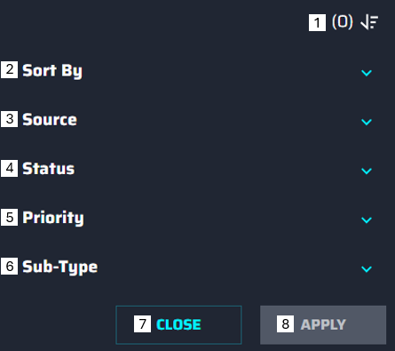
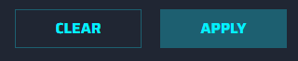
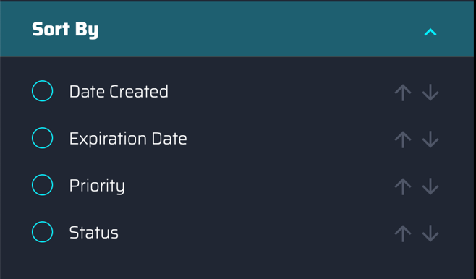
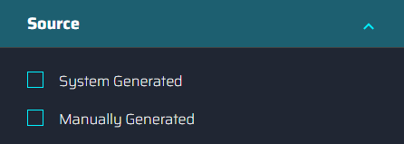
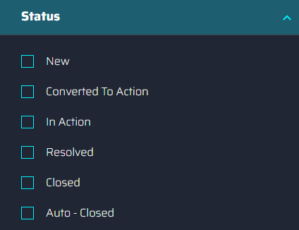
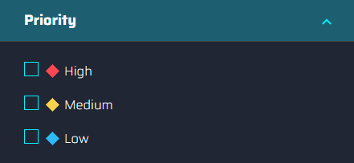
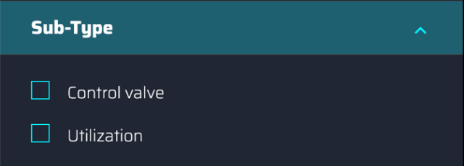

Actions
An action is a work activity or a task that is being attributed to a certain person to address the specific issue derived from an Insight.

Create New Action
Actions are created manually against the insights. Creating actions manually enables AOT users to resolve the issues highlighted through the insights. In the future, some of the Actions are planned to be generated automatically through our recommendation engine. There are two kinds of Actions. An Action that has a Work Order and an Action without one. The Create New Action pop-up screen can be accessed using buttons in either the Insight Summary or the Recommended Action items. To create an Action, the user must complete the fields in the “Action Details” tab and then click the “Create Action” button.
- Title – free-text field of ten to fifty alphanumeric characters
- Plant – selection drop-down used to choose a plant.
- Department – selection drop-down used to choose a responsible team.
- Assigned to – selection drop-down used to choose which role in the previously selected department will have visibility into these Actions in the Action panel.
- Asset Hierarchy – selection drop-down used to choose the asset to be linked to the action.
- Topic – selection drop-down used to choose the subject.
- Status – read-only status of New
- Action by – selection calendar used to select a future due date for the Action.
- Action Details – free text field of 10-500 alphanumeric characters.
- Create Action – Submission button enabled once the required fields are filled.
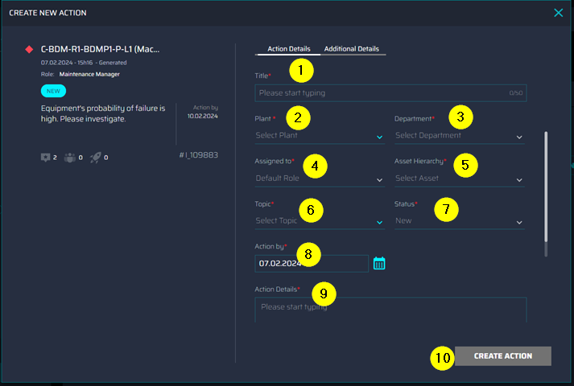

If a Work Order is involved, then all the fields in the “Additional Details” tab must also be completed, and the “Create Work Order in SAP PM” option must be selected to display the mandatory dropdowns for creating a Work Order.

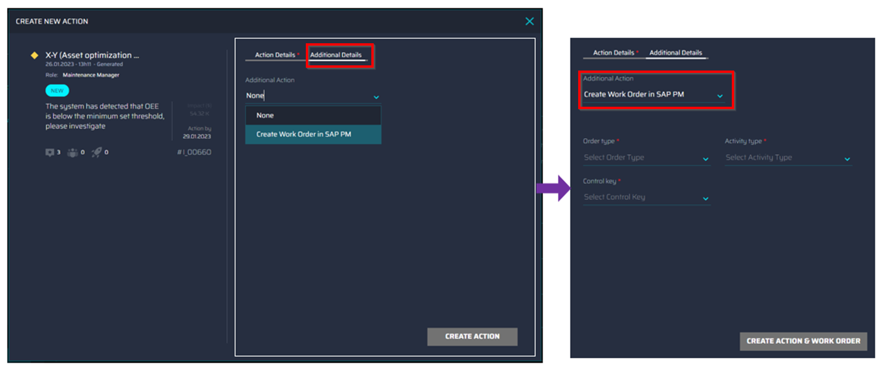

Actions List
The actions list contains the following:
- Actions Indication –The color of the rocket indicates the expiry status:
- Red – Action, with action by date beyond the current date
- Green – action with action by date not beyond the current date
- Gray – action with closed status
- Actions Filter Button – button for filtering the actions list.
- Action Card – view the details of an action.
- Load More button – loads more action cards to be displayed.
- More Options – Reveal the Collaborate button that will open the Collaboration pop-up window.
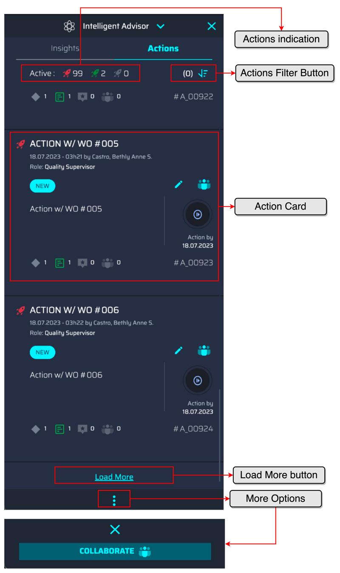

Action Card

- Due Date Icon – view the custom title of the Action.
  - Green – Not yet passed the due date.
  - Red – Passed the due date.
- Title – View the custom title of the Action.
- Creation Timestamp/Created by – Learn when the Action was created and the name of the person who created the Action.
- Role – view the role of the assignee, to whom this Action was assigned.
- Status – one of three possible statuses of the action:
  - New
  - In Progress
  - Closed
- Edit / Collaborate – Click to launch the related Edit Action screen. The edit button is disabled if Action has a Work Order
- Action Details – text description of the action
- Status – a graphical icon that shows the status of the Action.
- Due Date – the date by which the action must be resolved in day.month.year format.
- Action Count – numeric count of Action
- Work Order Status and Count – numeric count of Work Order. The color of the icon will depend on the Work Order Status:
  - Green – Successfully created a Work Order
  - Red – Work Order creation failed.
  - Gray – Action has no Work Order
- Placeholder for Comment Count
- Placeholder for Historical Collaboration Count
- Action ID – the ID of the Action made up of the #A_+ the count of the Action.
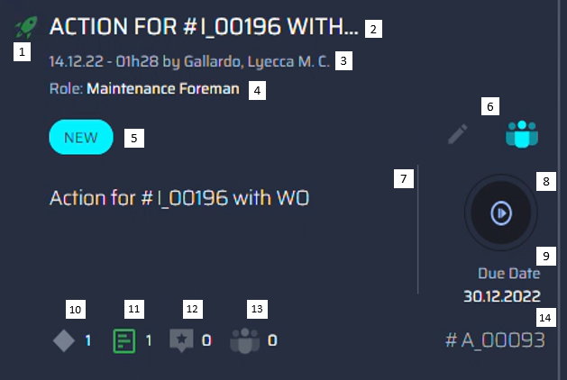

Action Summary
The Action summary is accessed by clicking the Action card. The summary contains all the information on the Action card, plus:
- Related Insight – View the related Insight of the Action
- Details – redirect to the summary of the related Insight.
- Work Orders - View the work order of the Action.
- Existing Collaborations – The Collaborations initiated on this action; the count is a placeholder.
- Expanded Option – contains the collaborate button that will open the collaboration pop-up window.
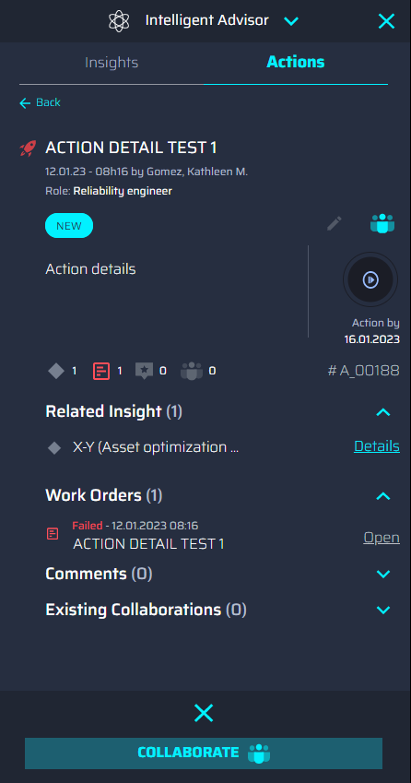

Edit Action

View and update the Action. Only Actions without a Work Order can be edited.
- Title – read-only title.
- Plant – selection drop-down for Plant.
- Department – selection responsible team.
- Topic – a selection subject of the action
- Assigned to – selection assignee role.
- Status – selection state of the action
- Asset Hierarchy – selection asset related to the action.
- Action by – selection due date
- Action Details – read-only context about the action
- Save – finishes editing, submits, and saves the changes.
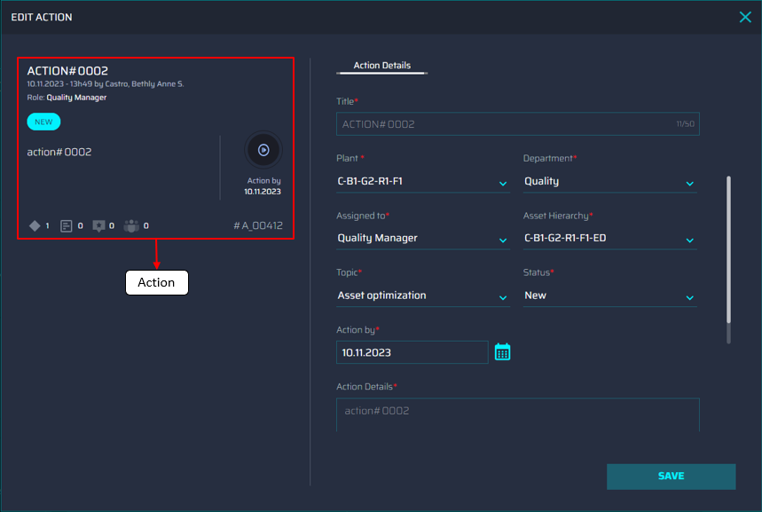

If an Action has a Work Order, the AOT user can navigate to the work order details by clicking the “Additional Details” tab. The “Additional Details” will only be available if the action has a Work Order.

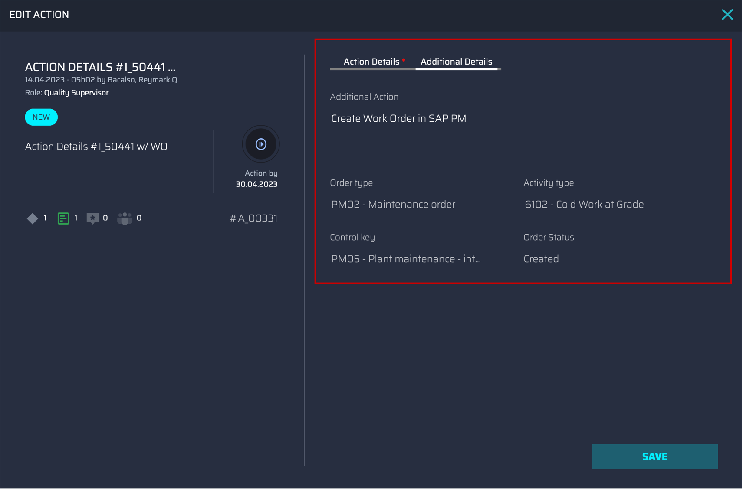

Close Action

Selecting the Closed option in the status drop-down list disables the other fields and reveals a mandatory text field with which to validate the closure.
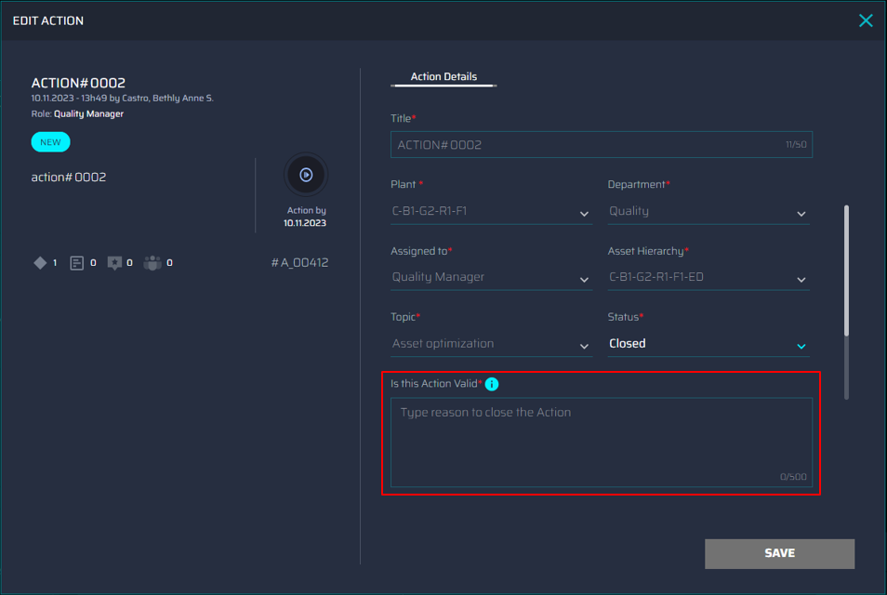

Filtering Actions
Filtering allows the return of fewer results for a simplified view. The filtering selections are shown below.

Filtering Groups are as follows. The points correspond to the numbered callouts in the image.
- Filter Count
- Sort By
- Status
- Close/Clear – If a filter is applied, the “Close” button will change to “Clear” so that filtering can be cleared.
- Apply – The selected filters are only applied after clicking the “Apply” button.
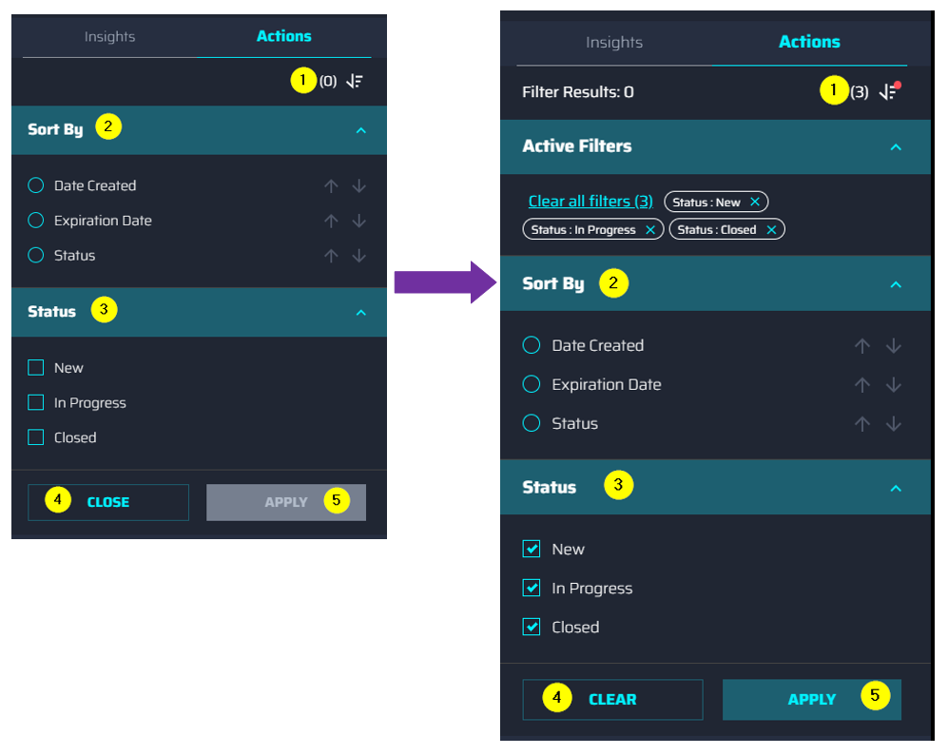

Template Viewer
Templates are used to define the details that are shared about a category of Insights. Templates also define the way the information is organized in the display. Intelligent Advisor’s Template Viewer allows viewing of the template for an Insight.
Clicking the Details button on the Insight Summary loads the Template Viewer that includes viewable fields for:

- Insight Title – Asset name (Theme + Sub-type)
- Insight Details – contains the main page for Insight details, toggle info displayed.
- Future Use
- Future Use
- Future Use
- Future Use
- Future Use
- Collaborate - opens the Collaborate pop-up window.
- Insight Details – contains all the details of the insights.

The collapsible sections of the Template Viewer are described in the sections that follow.
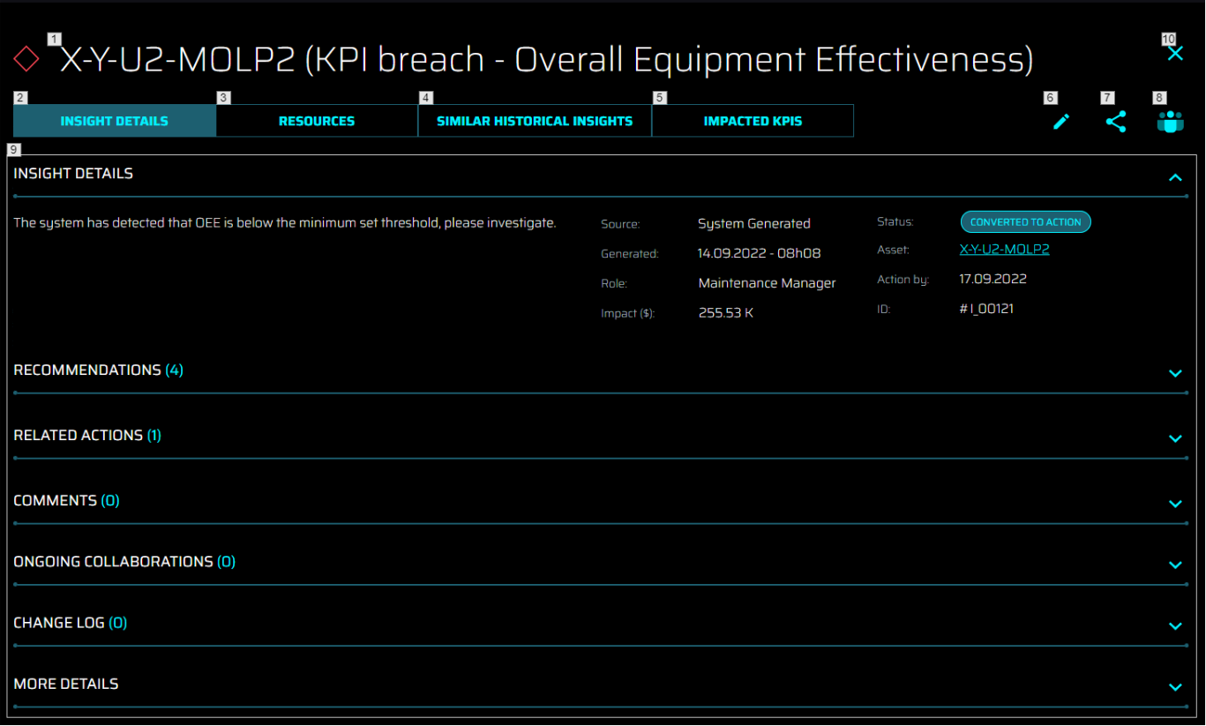

Insight Details

- Description – The full text of the Insight description
- Source – The source of the (system-generated) Insight.
- Generated - The date and time when the Insight is generated.
- Role – The role to which the Insight is assigned.
- Threshold – Only available for system-generated insights using the Custom configuration
- Status – The status of the Insight
- Asset – The asset that is linked to the Insight.
- Action By – The due date of the Insight
- Id – the ID of an Insight made up of the #I_+ the count of the Insight.

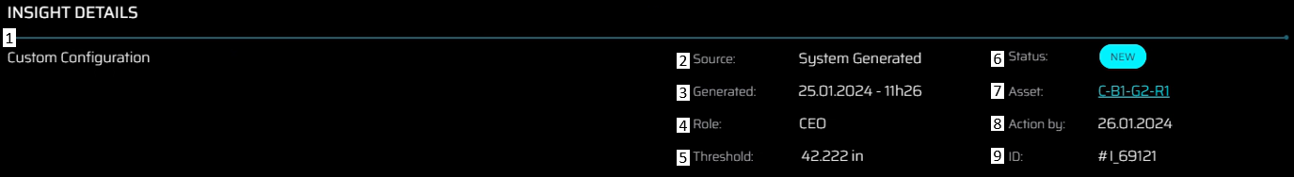

Recommendations
Recommendations represent a set of proposed Actions that can be selected to resolve the related insight. These are generated automatically by our recommendation engine by leveraging knowledge from previous Insight-to-action processes, using ML algorithms, and complex rule-based models. This section contains a list of recommended actions. The Action link is currently a placeholder for a future feature.
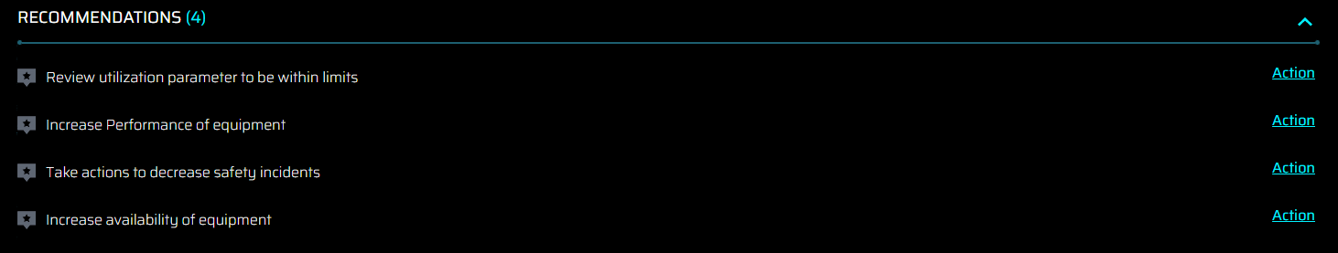

Related Actions
This section lists details about actions related to an Insight. The grid view is planned for the next release.
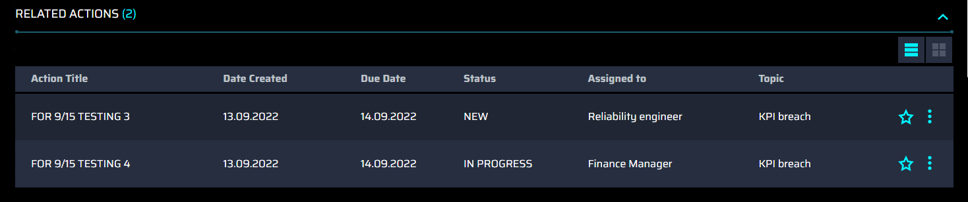

More Details
The content in this section varies by Insight category. If the Insights are KPI-based, this section will have KPI tiles and KPI drill-down possibilities. If the Insights are based on Asset Optimization, then it will show the chart with the historical probability of failure of that equipment. Examples of both scenarios are shown below.

KPI Breach – This view shows the following tiles:
- KPI Tile – clicking the tile redirects to the KPI drill-down page of the Smart KPI Application
- KPI Description – Overview and formula
- Trendline Timeline

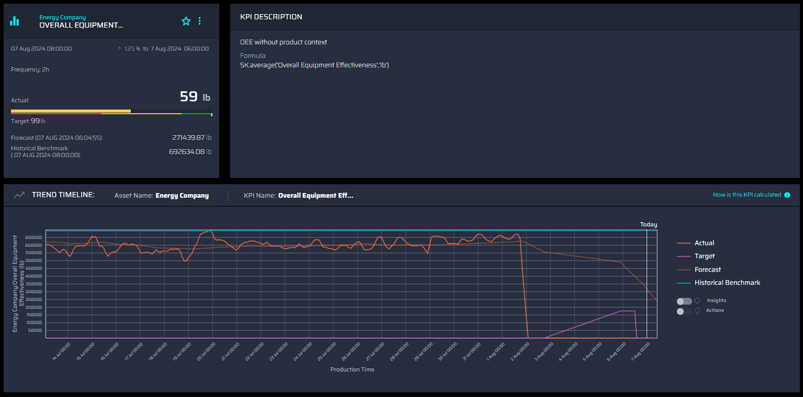

Asset Optimization – This view shows the predictive failure graph.
