Accenture Operations Twin
ML OPS Toolchain Blueprint
ARCHITECTURE AND INTEGRATION
  - Release Version: 2.5
Metadata Table
Field | Value
Asset / Solution Name | Accenture Operations Twin / Intelligent Advisor
Domain / Area | Advisory / Decision Automation
Owner (Team/Person) | Tournier, Florian
Reviewers | Zoltani, Judit-Kinga, Kumar Singh, Rajnish
Status | Published / Approved
Confidentiality | Internal / Confidential
Source of Truth | Summary - Overview
Related Assets / Alternatives | Intelligent Advisor UI Guide, Intelligent Advisor Delivery Guide

Contents
Introduction 3
Target Audience 3
Purpose 3
Prerequisites 3
Contact 3
Related Links 3
Glossary 3
Background 4
MLOps Design Patterns 4
What is MLOps Azure 4
MLOps Versus DevOps 4
DevOps 4
MLOps 4
Architecture 5
Methods to Consume ML Model 6
MLOps Workflow Pipeline 7
Operationalization of the MLOps Model 8

Introduction

Accenture Operations Twin (AOT) is a collection of software accelerators and tools, including Intelligent Advisor, which can be assembled to deliver client solutions. AOT accelerates the integration of product, process, and live data from disparate IT and OT systems, creating a comprehensive and contextualized view of operations to enable better decisions and optimized processes.
AOT Intelligent Advisor can be integrated with Azure MLOps to unlock AI use cases such as predictive maintenance. AOT can run machine learning models that have been deployed on Azure ML Studio. AOT can include the flow of data preparation, model training, evaluation, registration, and deployment of the ML model in Azure MLOps. Additionally, AOT can include the flow for vendor-trained ML Models and deploy them in Azure MLOps.

Target Audience
- Client Delivery Teams Leveraging AOT Intelligent Advisor
- Asset Delivery Teams
- Solution Architects, Technical Architects, Data Scientists, Data Engineers

Purpose
This document provides an overview of the Azure machine learning infrastructure and describes how to integrate it with AOT’s Intelligent Advisor framework.

Prerequisites
- A Business Analyst (BA) must be engaged by the AOT team to define the requirements.
- A customized spreadsheet must be provided by the BA for creation of the hierarchies described later in this document.
- Access to code is required.

Contact
- rajnish.kumar.singh@accenture.com
- florin.horodinca@accenture.com
- judit-kinga.zoltani@accenture.com

Related Links
- Cognite Documentation
- Release Notes
- AOT Architecture Documents

Glossary
Term | Definition
AOT (Accenture Operations Twin) | A suite of software accelerators and tools designed to integrate product, process, and live data from diverse IT and OT systems, providing a contextualized view of operations to enhance decision-making and optimize processes.
Intelligent Advisor | An accelerator within AOT that can be integrated with Azure MLOps to enable advanced AI use cases, such as predictive maintenance.
Azure MLOps | A set of practices and tools on Microsoft Azure that streamline the lifecycle of machine learning models, including data preparation, training, evaluation, registration, and deployment.
Azure ML Studio | A cloud-based environment in Azure for building, training, and deploying machine learning models.
MLOps | The discipline combining machine learning, DevOps, and data engineering to automate and monitor the entire ML lifecycle.
DevOps | A set of practices that combines software development and IT operations to shorten the development lifecycle and deliver high-quality software continuously.
Workflow Pipeline | The sequence of processes involved in preparing data, training, evaluating, registering, and deploying machine learning models.
Vendor-trained ML Models | Machine learning models developed and trained by external vendors, which can be integrated and deployed within Azure MLOps.
Client Delivery Teams | Teams responsible for delivering solutions to clients using AOT Intelligent Advisor.
Asset Delivery Teams | Teams focused on delivering and managing assets, potentially leveraging AOT and machine learning solutions.
Solution Architect | A professional who designs comprehensive technical solutions, including integrating AOT Intelligent Advisor with Azure MLOps.
Technical Architect | A specialist who determines the technical requirements and architecture for implementing solutions using AOT and Azure MLOps.
Data Scientist | A practitioner who builds machine learning models and leverages data analytics within the AOT and Azure ML framework.
Data Engineer | An expert responsible for preparing and managing data flows, supporting machine learning processes in AOT and Azure MLOps.
Predictive Maintenance | An AI-driven use case enabled by integrating AOT Intelligent Advisor with Azure MLOps, focusing on forecasting asset failures to optimize maintenance schedules.
IT and OT Systems | Information Technology (IT) and Operational Technology (OT) systems, whose data integration is a central feature of AOT.

Background

MLOps Design Patterns
Design patterns are a set of best practices and reusable solutions used to combat several common problems that occur in data science and software development. Azure MLOps Design patterns categorize the most commonly occurring problems and provide various blueprints to easily recognize and solve them.

What is MLOps Azure
MLOps Azure is a machine learning engineering culture and practice that aims at unifying ML system development (Dev) and ML system operation (Ops). It applies DevOps principles and practices such as continuous integration, delivery, and deployment to the machine learning process, with an aim for faster experimentation, development, and deployment of Azure ML models into production and test environments. MLOps is a set of processes designed to transform experimental Machine Learning models into production services ready to make decisions in the real world. MLOps can:
- Create reproducible ML pipelines.
- Improve time to market via faster deployments.
- Increase model robustness.
- Provide more flexibility to train and compare different ML models.
- Create reusable software environments.
- Register, package, and deploy models from anywhere.
- Automate the end-to-end ML lifecycle with Azure Machine Learning and Azure Pipelines.

MLOps Versus DevOps
MLOps is based on the same principles as DevOps, but with an additional focus on data validation and continuous training and evaluation. The differences between the two are outlined below.

DevOps
- Code components are tested and validated.
- The focus is on specific software.
- The model is not monitored.
- Handles code versioning.
- Allows software reuse only.

MLOps
- Data and models are tested along with code components.
- The focus includes the entire ML pipeline and system.
- The deployed model is constantly monitored with Azure Monitor.
- Handles data/model versioning.
- Allows model reuse by retraining models.

Architecture
The diagram below illustrates how AOT Intelligent Advisor is integrated with MLOps for an AI application using Azure DevOps and Azure Machine Learning. The orange block provides the context for ML Ops in the diagram.
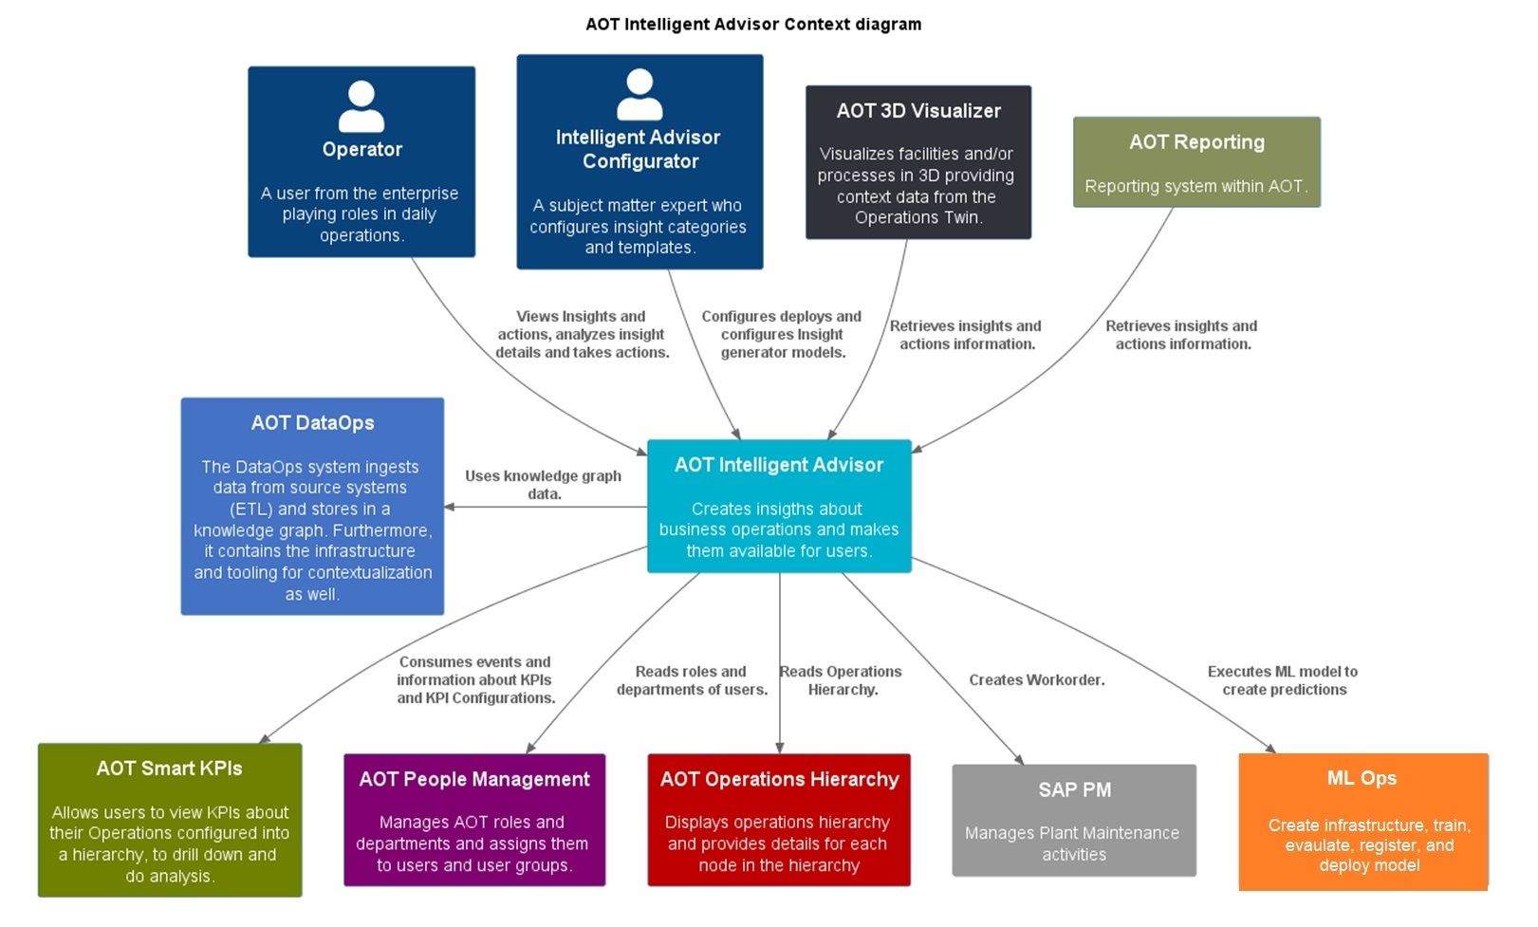
The following points describe how the ML Ops functions in executing the ML model:
- The user saves the configuration for the model from the AOT Intelligent Advisor UI. The configuration defines necessary parameters such as data source identifier, equipment, frequency of trigger, etc.
- ML Model execution can be triggered in AOT with Scheduler or from an external system. The scheduler creates the process to trigger and run the model (the deployed ML algorithm) at the configured frequency.
- The input data to run the ML Model is taken from Azure (blob, data lake, DB, etc.) or the CDF time series.
- The model microservice from AOT Intelligent Advisor utilizes the deployed ML Model endpoint from Azure MLOps.
- ML Model output is processed and saved according to the business requirements.

Methods to Consume ML Model

AOT provides the UI to configure model parameters such as frequency to trigger, equipment, and data input identifiers. ML models can be scheduled to run with a configured frequency. Output from the deployed ML model is processed and used according to the business logic. The following table describes the model types that can be deployed.
Model Type 1 | Model Type 2 | Model Type 3
- AOT can already deploy the vendor model directly into IA.  - The model microservice from IA invokes the handler for the model when the configuration is saved from the AOT UI.  - The handler checks the model configuration, retrieves the data from the AOT knowledge graph, and pre-processes it.  - The pre-processed data is sent as input to the in-memory model engine, which is the ML model (pkl) file directly deployed in Kubernetes with the docker in the AOT IA framework. | - The model is deployed in Azure ML Studio.  - The model microservice deployed in the AOT framework invokes the handler for Model type 2 when the configuration is saved from the AOT UI.  - The handler checks the model configuration, retrieves the data from the AOT knowledge graph, and pre-processes it.  - The pre-processed data is sent to the ML Model deployed on Azure MLOps. | - The model is deployed in Azure ML Studio.  - The model microservice deployed in the AOT framework invokes the handler for Model type 3 when the configuration is saved from the AOT UI.  - The handler checks the data identifier from the model configuration and sends it to the ML Model engine deployed in Azure MLops.  - The ML Model engine fetches the data from the AOT Knowledge graph and uses it as input.
The figure below depicts the ML model execution scenarios. Click on the image for an enlarged view.
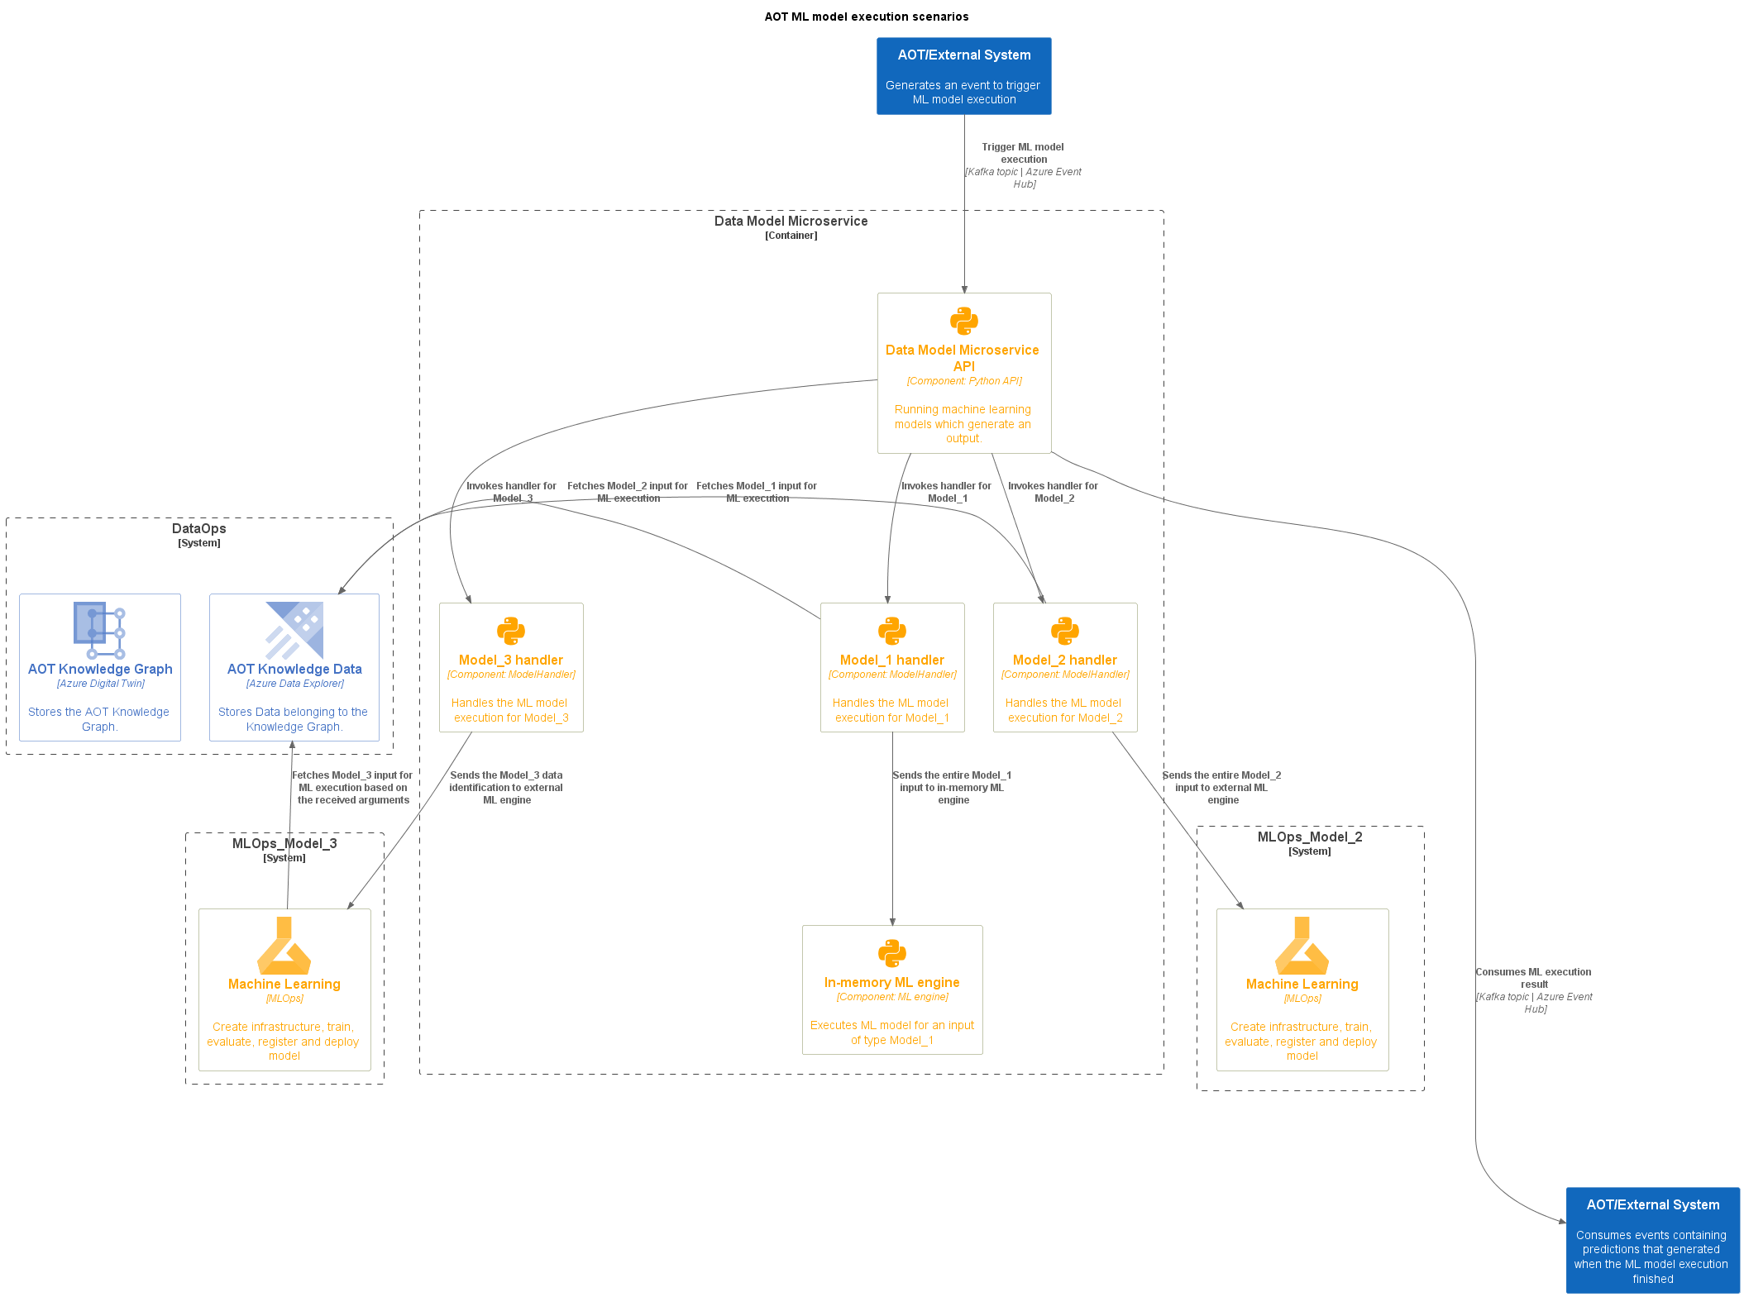

MLOps Workflow Pipeline
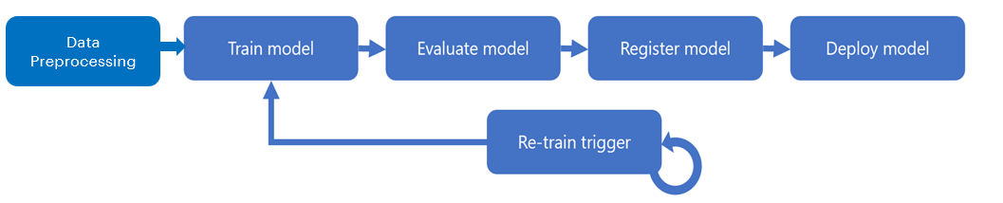
As diagrammed above, Machine Learning (ML) projects are constructed by several different steps. They are described in the following table:
Step | Description
Data Pre-processing | Data preparation (cleaning, transformation, etc.), data versioning, and data registration to Azure MLOps.
Train Model | Run training code/algorithm and output a model file.
Evaluate Model | Compare the performance of the newly trained model with the model in production. If the new model performs better than the production model, the following steps are executed. If not, they will be skipped.
Register Model | Take the best model and register it with the Azure ML Model registry, which allows version-control.
Deploy Model | Deploy the registered model on Azure MLOps as an endpoint.

Operationalization of the MLOps Model
This architecture describes how continuous integration (CI), continuous delivery (CD), and retraining pipelines are implemented for an AI application using Azure DevOps and Azure Machine Learning.
- The ML model is packaged and validated using the Azure ML CLI.
- Once the ML model is registered, Azure ML + Azure DevOps is used to deploy it.
- A release definition can be defined in Azure Pipelines to help coordinate a release. Using the DevOps extension for Machine Learning as well as artifacts from Azure ML, Azure Repos, and GitHub can be included as part of the Release Pipeline.
- In the release definition, we can leverage the Azure ML CLI's model deploy command to deploy the Azure ML model to the cloud (ACI or AKS).
