Accenture Operations Twin
PI AF EXTRACTOR
DEPLOYMENT GUIDE
Release Version: 2.5

Metadata Table
Field | Value
Asset / Solution Name | Accenture Operations Twin / Data Integration Accelerators
Domain / Area | Extractors / Data Processing
Owner (Team/Person) | Tournier, Florian
Reviewers | Joshi, Rishabh
Status | Published / Complete
Confidentiality | Internal / Confidential
Source of Truth | Summary - Overview
Related Assets / Alternatives | AOT Extractors Architecture Blueprint, AOT Extractors Getting Started


Contents
Introduction 3
Purpose 3
Target Audience 3
Prerequisites 3
Contacts 3
Related Links 3
Glossary 4
Features 4
Cloud Deployment 5
Prerequisites 5
Configure the Environment 6
Create a Build Pipeline 11
Create a Release Pipeline 13
On-Prem Deployment 17
Prerequisites 17
Install the Extractor 17
Start the Extractor 20
Stop the Extractor 22

Introduction

Accenture Operations Twin (AOT) is a collection of software accelerators and tools, including extractors, that can be assembled to deliver client solutions. AOT accelerates the integration of product, process, and live data from disparate IT and OT systems, creating a comprehensive and contextualized view of operations to enable better decisions and optimized processes.
AOT extractors, also known as data integration accelerators, are developed to automate and simplify the process of extracting data from enterprise source systems and moving it to CDF RAW. AOT’s PI AF Extractor establishes a connection with the OSI PI system and reads asset hierarchy data from the OSI PI system. It processes and transforms the extracted data to a format that Cognite recognizes before pushing that data to CDF RAW.

Purpose
This document explains how to extract data from the source system and load it into CDF RAW using the PI AF extractor. It covers the prerequisites for deploying the Extractor, provides instructions for configuring and deploying it in the cloud, and enables the reader to verify the data flow from the source system to CDF.

Target Audience
Developers with the following skills:
- Cognite Data Fusion
- Azure Pipeline creation
- SonarQube
- OSI PI

Prerequisites
- Cognite Data Fusion
- Azure DevOps
- SonarQube
- OSI PI
- Lens app
- Additional prerequisites for deployment are mentioned in respective sections.

Contacts
- hanuman.prasad.gali@accenture.com
- rishabh.b.joshi@accenture.com

Related Links
- How to create an Azure Pipeline
- How to create a Release Pipeline
- AOT IX Developer Hub Resources
- Release Notes

Glossary
Term | Definition
Azure Pipeline | A set of automated processes in Azure DevOps used to build, test, and deploy code projects.
Release Pipeline | An Azure DevOps pipeline designed to automate the deployment of applications to various environments.
AKS Cluster | Azure Kubernetes Service cluster, a managed container orchestration service for deploying and managing containerised applications.
Containerising | The process of packaging software and its dependencies into a container, enabling consistent deployment across environments.
PI AF Extractor | A tool that extracts data from PI Asset Framework systems, allowing configuration for multiple sources and assets.
Root Asset | The primary asset within a source system from which data extraction begins.
On-Prem | Short for "on-premises", referring to systems and software deployed within an organisation's local infrastructure rather than in the cloud.
Exception Handling | Built-in methods for detecting and managing errors during the process, ensuring system stability.
Timer Option | A configurable feature that enables automatic operation at specified intervals.

Features

AOT’s PI AF Extractor provides users the flexibility to pre-configure multiple source systems, root assets, and other required details in a configuration file. A pipeline is used for both containerizing the extractor and running it on an Azure Kubernetes Cluster. It also includes an extraction pipeline for tracking both successful and failed pipeline runs on CDF UI. On every run, the extractor sends a Success/Failure message about the run and notifies the list of contacts about the same based on the configurations.
The major features of the PI AF Extractor include:
- User configurable based on business needs
- The Timer option allows automatic operation at a configurable interval
- Deployable On-Cloud and On-Prem with minimal user effort
- Built-in validation and exception handling simplify the configuration
- Supports multiple source systems and root assets, and respective CDF details

Cloud Deployment
Two pipelines are needed to deploy the extractor to an AKS Cluster.
This section includes step-by-step guidance for:
- Prerequisites that need to be fulfilled before Extractor can be deployed and used
- Setting up the Azure DevOps environment
- Creating a Build Pipeline for Dockerizing the Extractor Package
- Creating a Release Pipeline for Deploying the Docker Image to AKS Cluster
- Validating in CDF RAW if the RAW table has the right data

Prerequisites
- PI server username and password
- Web API URL for each PI AF asset hierarchy
- Azure license/subscription to create resources
- Azure DevOps repository for extractor code, and pipeline files
- Azure service connections for SonarQube and Container Registry
- Namespace in the AKS cluster for environments
- Kubernetes Service Connection for AKS Cluster
- Sonar project and key

Configure the Environment
A build pipeline and a release pipeline are used to deploy the PI AF Extractor to an AKS Cluster. Follow these steps before creating pipelines:
- Create an Azure Key Vault.
- Add the following secrets in the Azure Key Vault created in the previous step:
ClientID | Provide the Client ID for CDF
ClientSecret | Provide the Client Secret for CDF
PIUserName | Provide the username for OSI PI Server
PIPassword | Provide the password for OSI PI Server
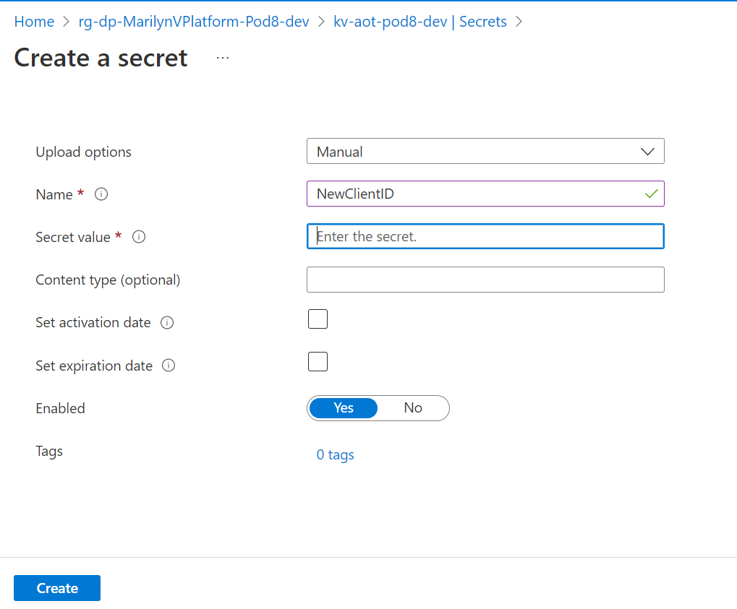
- Create a key vault library in Azure DevOps and add the secrets created in the previous step.
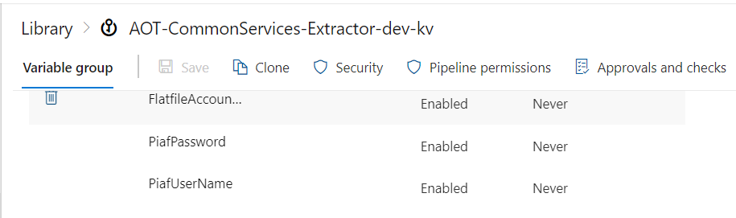

- Create a Library/Variable Group in Azure DevOps with the following parameters:
Variable | Description
COGNITE_HOST | Provide the host details for CDF.
COGNITE_PROJECT | Provide the project name for CDF.
SCOPES | Provide the scopes for CDF.
TENANT_ID | Provide the tenant ID for CDF.
PI_SERVER_WEBAPI_ENDPOINT | Provide the PI server WebAPI endpoint of the OSI PI server.
PI_KEY_COLUMN | Provide the key column for filtering data to upload into the CDF RAW table.
PI_CONFIG_FILENAME: | Provide the configuration filename that is used to run the extractor. The filenames are environment-specific e.g., pi_config_dev.yaml, pi_config_itest.yaml, and pi_config_prod.yaml
CONTAINER_REGISTRY_SERVICE_CONNECTION | Provide container registry service connection for build and release pipeline.
SONARQUBE_SERVICE_CONNECTION | Provide service connection for SonarQube.
PIAF_CLI_PROJECT_KEY | Provide SonarQube project key for PI AF extractor.
PIAF_CLI_PROJECT_NAME | Provide SonarQube project name for PI AF extractor.
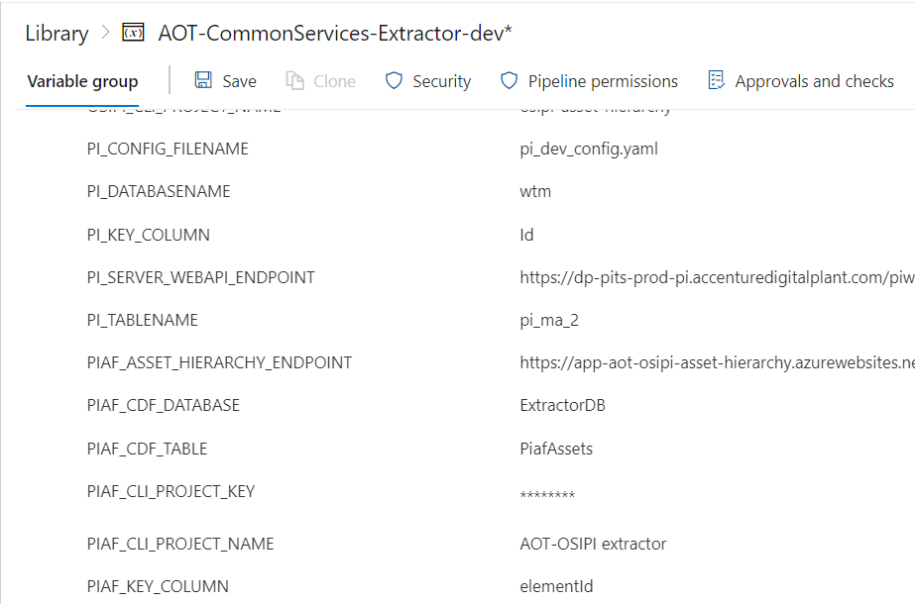

- Navigate to the pipeline file location “Source/Extractors/PIAF-extractor-2.0/pipeline/Dev/azure-pipelines.yml” and ensure that the pipeline is referring to the libraries created in the previous steps.
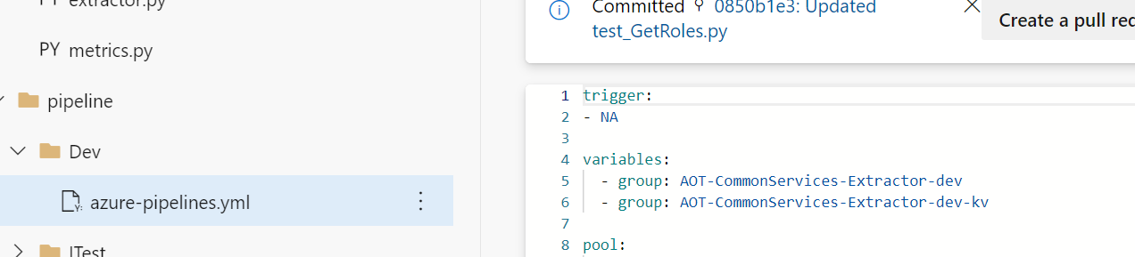
- Configure the following parameters in the configuration file for the PIAF Extractor:
  - Provide timer value in seconds to schedule the extractor.
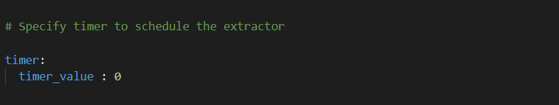
  - Mandatory Cognite-related config parameters:
Parameter | Description
host | Use the hostname for Cognite data fusion (CDF) added in the Azure DevOps library in earlier steps
project | Use the project name for CDF added in the Azure DevOps library in earlier steps
idp-authentication. client-id | Use the client Id for CDF added in the Azure DevOps key vault library in earlier steps
idp-authentication. secret | Use the client secret for CDF added in the Azure DevOps key vault library in earlier steps
idp-authentication. scopes | Use the scopes for CDF added in the Azure DevOps library in earlier steps
idp-authentication. tenant | Use the tenant Id for CDF added in the Azure DevOps library in earlier steps
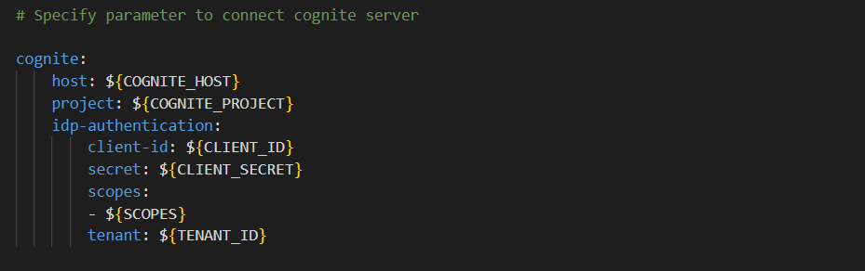
  - Mandatory OSI PI-related config parameters: PI AF Extractor allows the configuration of multiple OSI PI Systems. Also, multiple root asset details can be configured to fetch asset hierarchy data from the OSI PI systems.
Parameter | Description
pi_webapi_endpoint | Use the PI Server WebAPI endpoint of the OSI PI server added in the Azure DevOps library in earlier steps.
username | Use the username of the OSI PI system added in the Azure DevOps key vault library in earlier steps.
password | Use the password of the OSI PI system added in the Azure DevOps key vault library in earlier steps.
key-column | Use the key column for filtering data to upload into the CDF RAW table added in the Azure DevOps library in earlier steps.
assets.destination.database | Provide a database name in CDF where the table would be created.
assets.destination.table | Provide a table name where asset hierarchy data will be uploaded.
assets.path | Provide the root asset’s path from the OSI PI Server.
assets.category_name | OPTIONAL - Provide category name from OSI PI Server to filter child elements in the asset hierarchy.
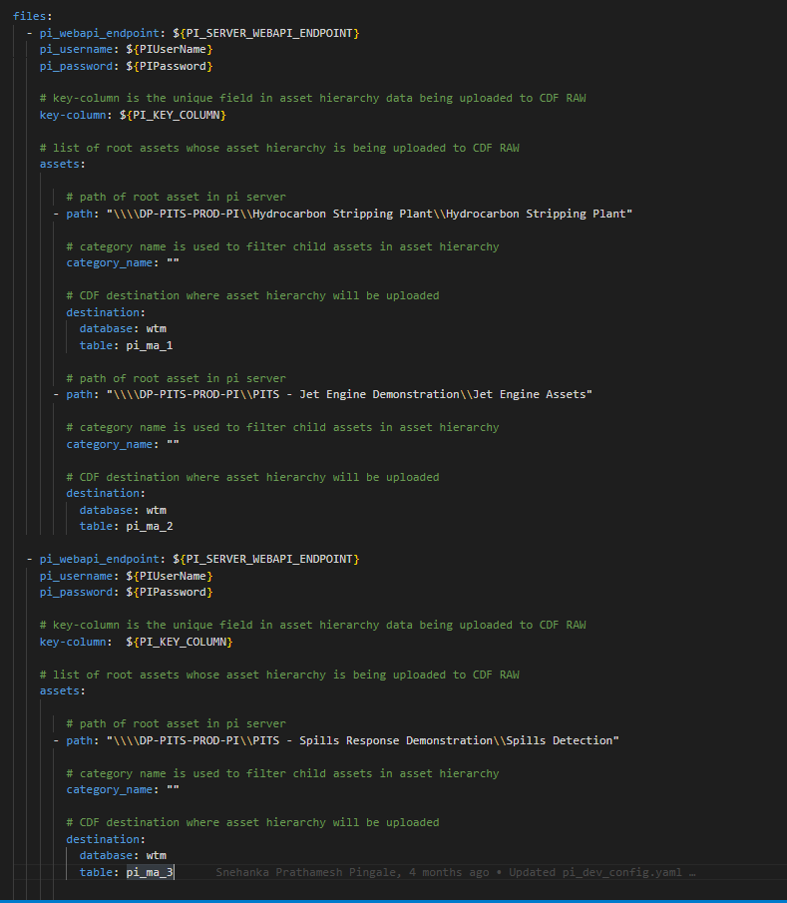

  - Extraction pipeline-related config parameters:
Parameter | Description
datasetexternal_id | Provide the External id of the Dataset in Cognite data fusion (CDF)
dataset_name | Provide the name of the Dataset in CDF
external_id | Provide external id of CDF extraction pipeline
ep_name | Provide the name of the CDF extraction pipeline
contacts.name | OPTIONAL - Provide the name of the contact to whom the extraction pipeline notification should be sent.
contacts.email | OPTIONAL - Provide the email of the contact to whom the extraction pipeline notification should be sent.
contacts.sendnotification | OPTIONAL - Provide notification value. If the send notification value is true, then mail is sent to the respective mail ID, otherwise, no mail is sent.

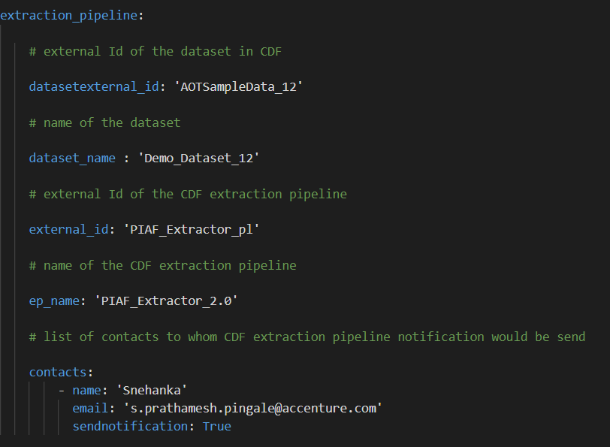

Create a Build Pipeline
The Build Pipeline is used to Dockerize the Extractor Package. The artifacts created here are used in the release pipeline for deployment.
To create a build pipeline, follow the steps below:
- Navigate to Azure DevOps, select Pipelines, and then select New Pipeline.
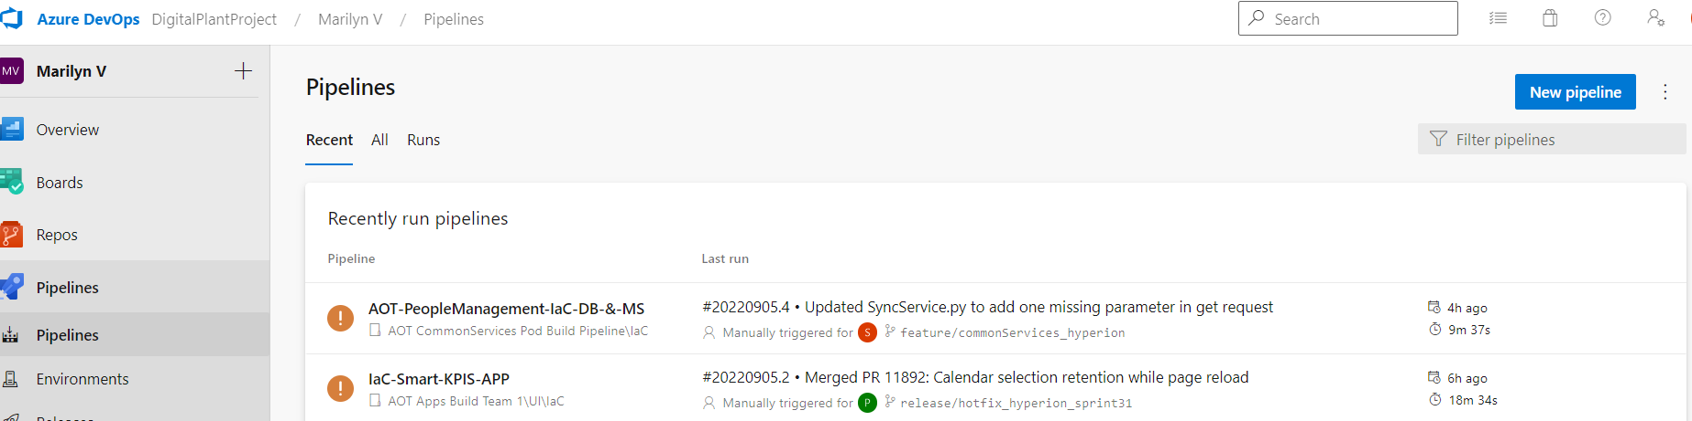
- Select Azure Repos Git. Then select the Repository Name that contains the PI AF Extractor code and pipeline files.
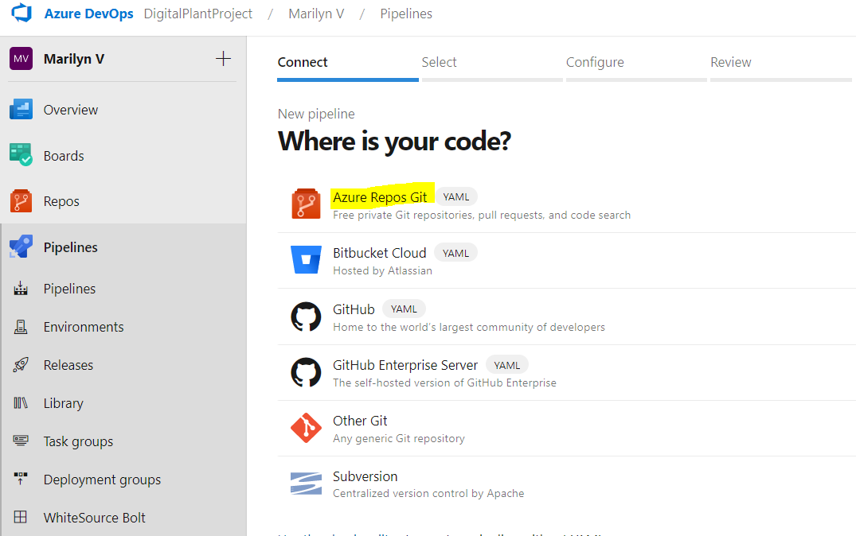

- Select ‘Existing Azure Pipelines YAML file’.
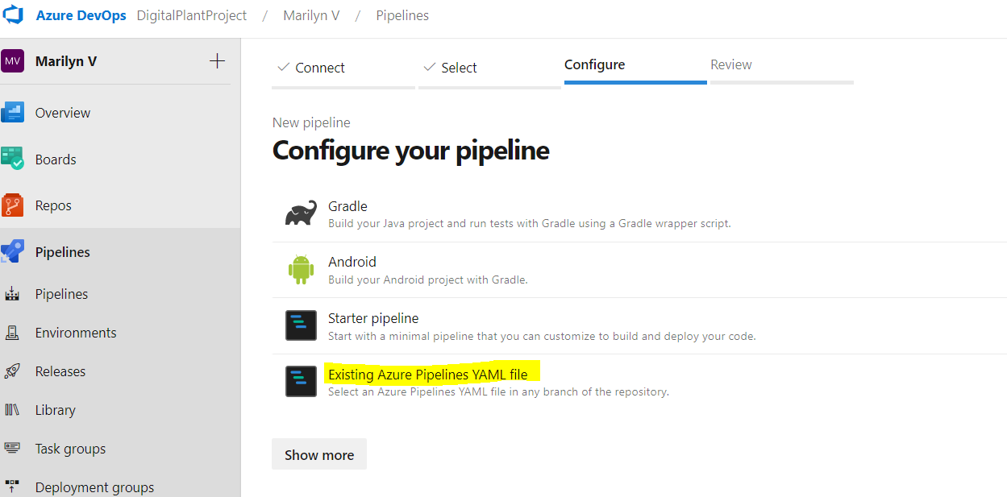
- Select the branch, provide the pipeline file path as “Source/Extractors/PIAF-extractor-2.0/pipeline/Dev/azure-pipelines.yml”, and then select Continue.
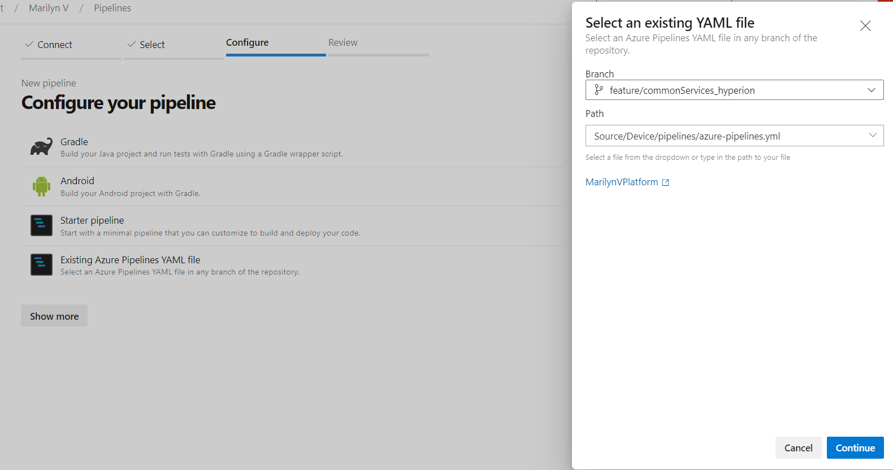
- Review and save.
- Run the pipeline and wait for its successful completion.

Create a Release Pipeline
The Release pipeline deploys the Docker Image of the PI AF Extractor created by the build pipeline to the AKS Cluster.
Follow the below steps to create the PI AF Extractor release pipeline:
- Create a release pipeline with two tasks for AKS Cluster.
  - task with delete command
  - task with create command
- Update the value of the service connection for the AKS cluster in the tasks.
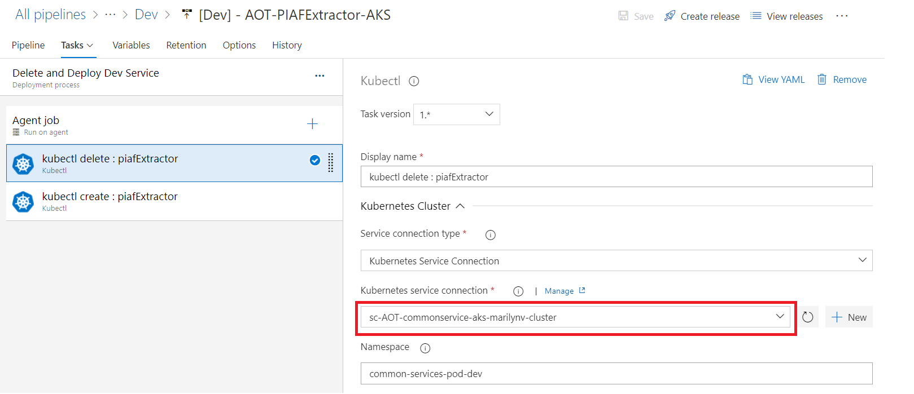
- Update the AKS file location in the tasks.
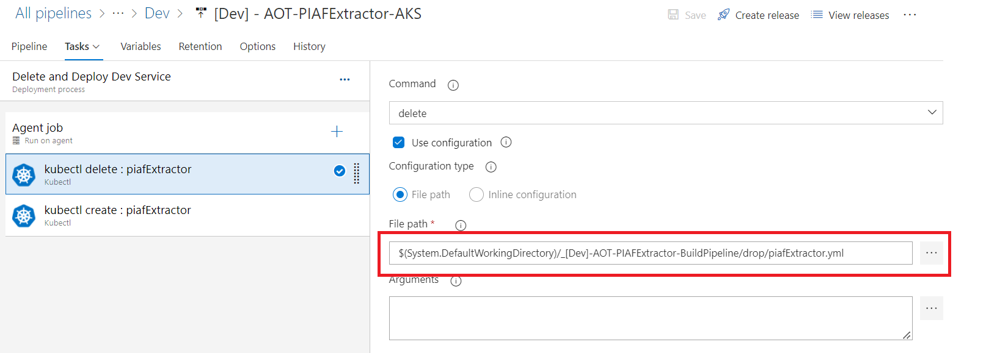

- If this is the first run, then disable the delete task from the pipeline.
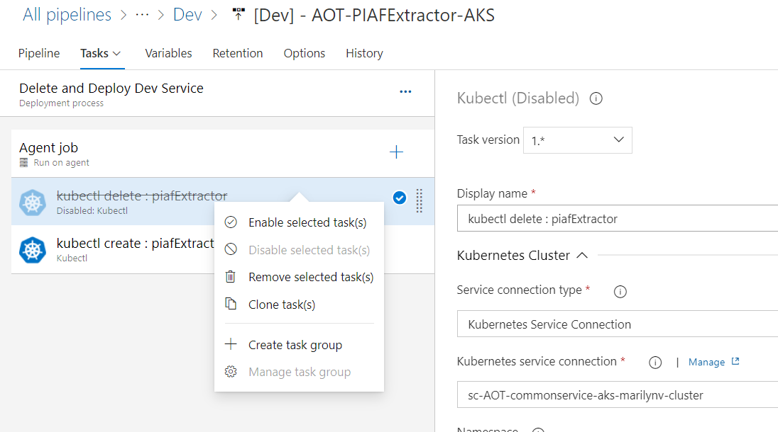
- Create a release from the release pipeline created in the previous step.
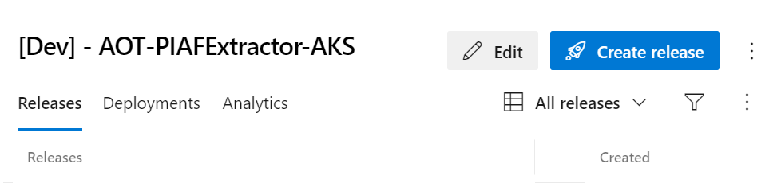
- Once the release is completed, confirm that the deployment is successful on Azure DevOps.
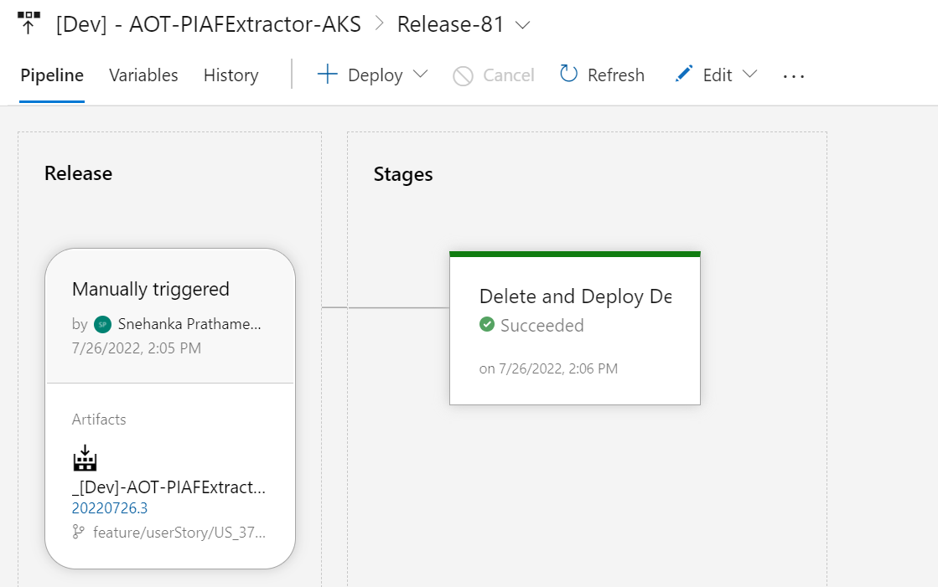
- After deployment is complete, check the Azure Portal to validate that the deployment to the AKS cluster was successful.
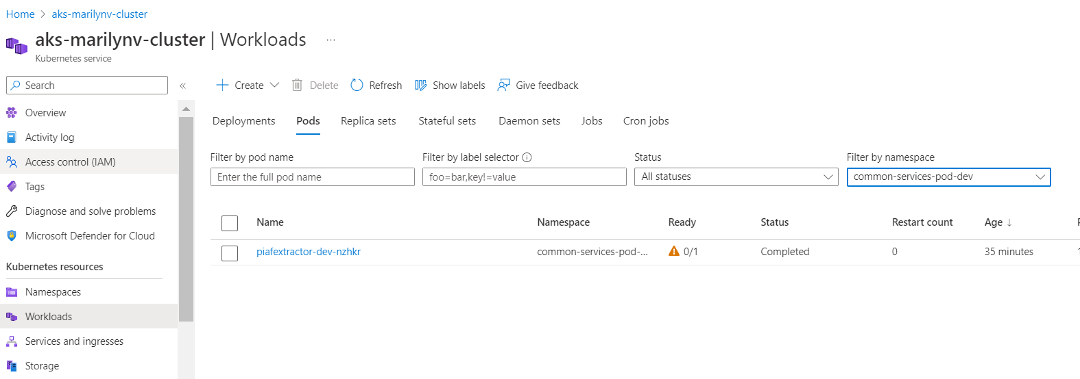
- Validate PI AF Extractor logs on the Lens app. Note that the Lens App is an external tool to check logs of the AKS Cluster.
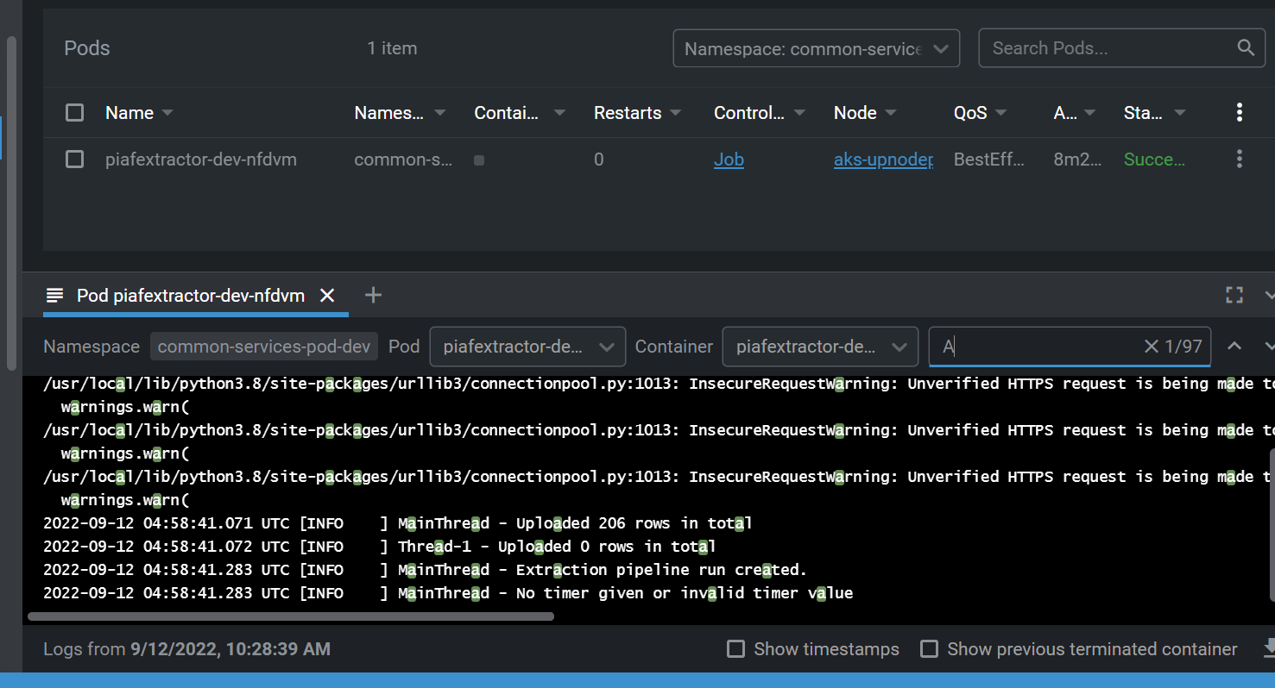

- If everything looks good and the AKS POD is created, enable the delete task that was previously disabled.
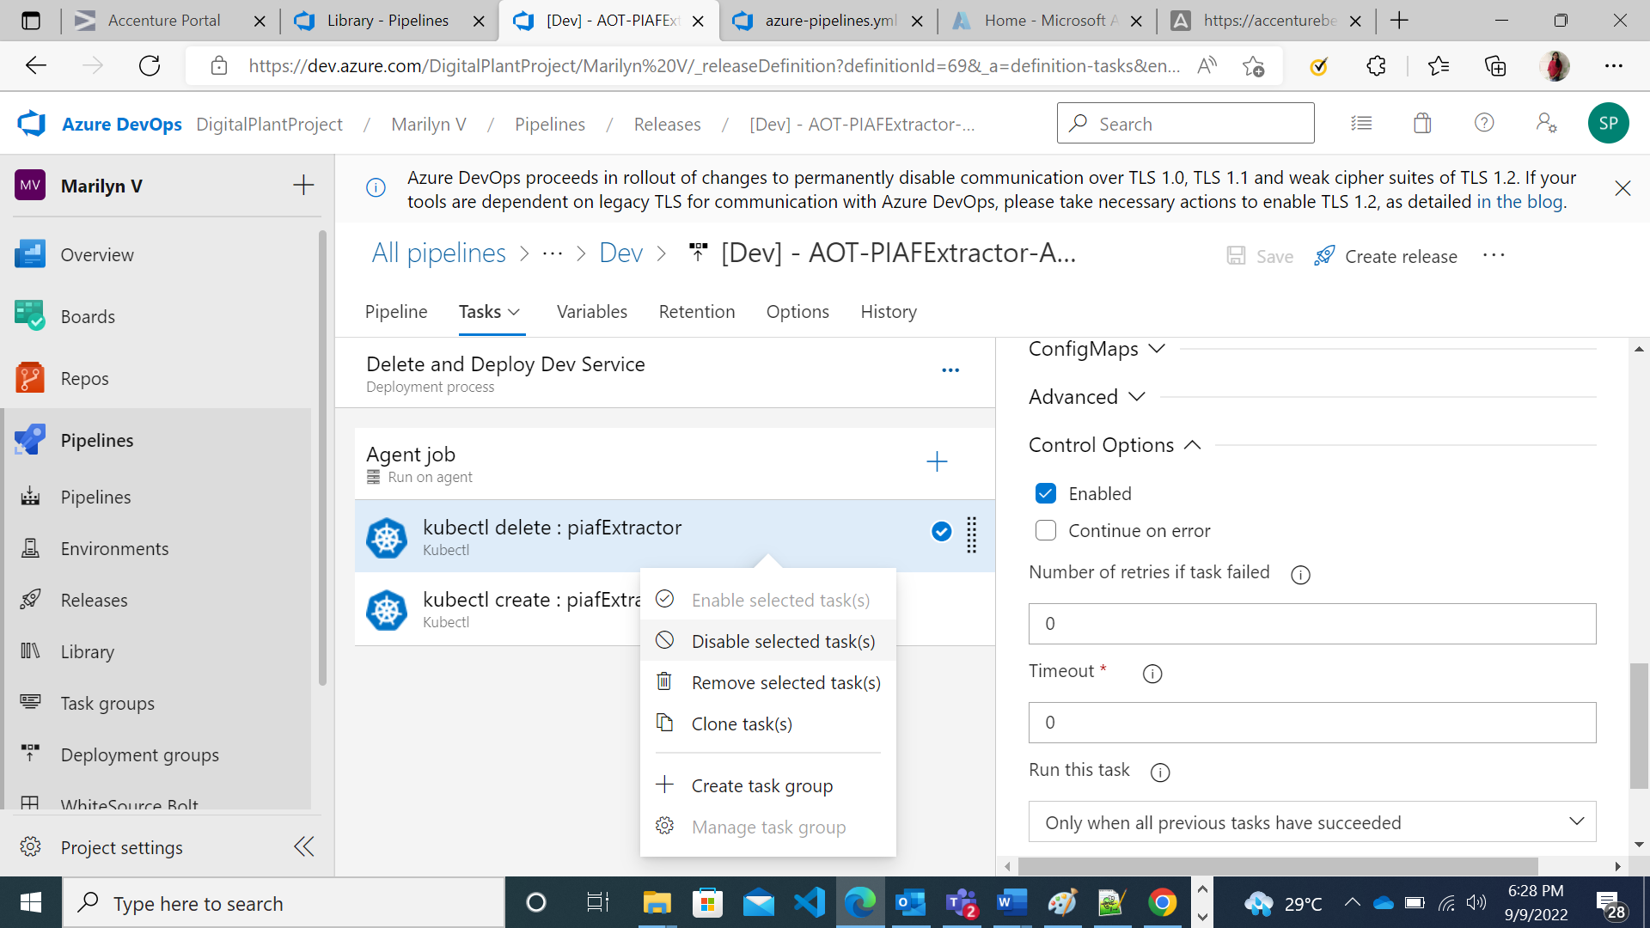

- Validate the creation of the database and table with asset hierarchy data on the CDF Portal.
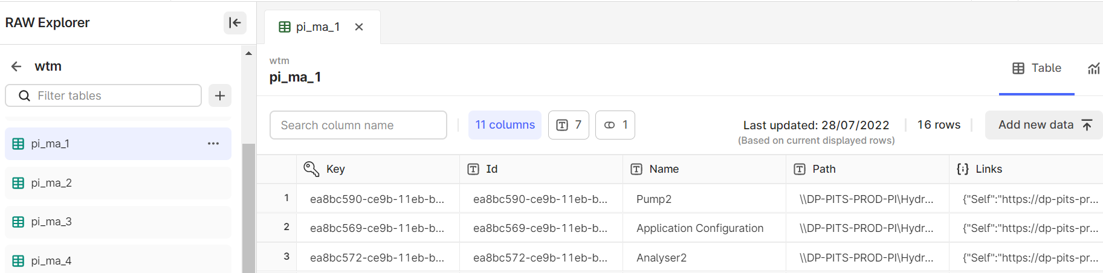

- When the deployment is complete, an extraction pipeline is created in CDF based on the details provided in the configuration file. A Success/Failure message can be visualized on the CDF portal. Also, a notification is sent to the respective email address.
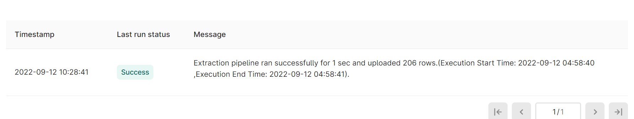

On-Prem Deployment
The PI AF Extractor Windows Service is created to give users the option of deploying the PI AF Extractor on-premises. The PI AF Extractor Windows service is installed through a batch script that runs all the necessary commands required for the installation. The PI AF Extractor extracts asset hierarchy data from one or more OSI PI systems and inserts it into CDF RAW.

Prerequisites
- PI server username and password
- Web API URL for each PI AF asset hierarchy
- Install Python

Install the Extractor
Follow the below steps to install PI AF Extractor on-premises:
- Edit pi_config.yaml file to update the following:
- Add the path of a log file to store extractor logs.
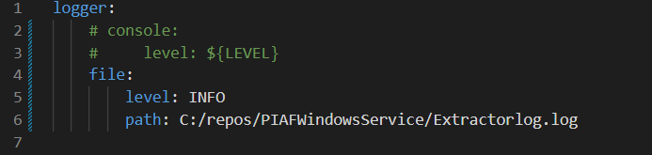
- Add timer value in seconds to schedule the extractor.

- Add mandatory Cognite-related details:
Parameter | Description
host | Provide the hostname for CDF
project | Provide the project name for CDF
idp-authentication. client-id | Provide the client Id for CDF
idp-authentication. secret | Provide the client secret for CDF
idp-authentication. scopes | Provide the scopes for CDF
idp-authentication. tenant | Provide the tenant Id for CDF

- Add extraction pipeline-related details:
Parameter | Description
datasetexternal_id | Provide the external Id of the dataset in CDF.
dataset_name | Provide the name of the dataset in CDF.
external_id | Provide external Id of CDF extraction pipeline.
ep_name | Provide the name of the CDF extraction pipeline.
contacts.name | OPTIONAL - Provide the name of the contact to whom the extraction pipeline notification should be sent.
contacts.email | OPTIONAL - Provide the email of the contact to whom the extraction pipeline notification should be sent.
contacts.sendnotification | OPTIONAL - Provide notification value. If the send notification value is true, then mail is sent to the respective mail Id else no mail is sent.
- Add OSI PI system configurations:
Parameter | Description
pi_webapi_endpoint | Provide the PI Server WebAPI endpoint of the OSI PI server.
username | Provide the username of the OSI PI system.
password | Provide the password of the OSI PI system.
key-column | Provide the key column for filtering data to upload into the CDF RAW table.
assets.destination.database | Provide a database name in CDF where the table would be created.
assets.destination.table | Provide a table name where asset hierarchy data will be uploaded.
assets.path | Provide assets path from OSI PI system.
assets.category_name | OPTIONAL - Provide the category name from the OSI PI system to filter child elements in the asset hierarchy.

- Edit WSInstallation.bat file to add the absolute path of the Python folder and PIAFWindowsService.py file as shown below.
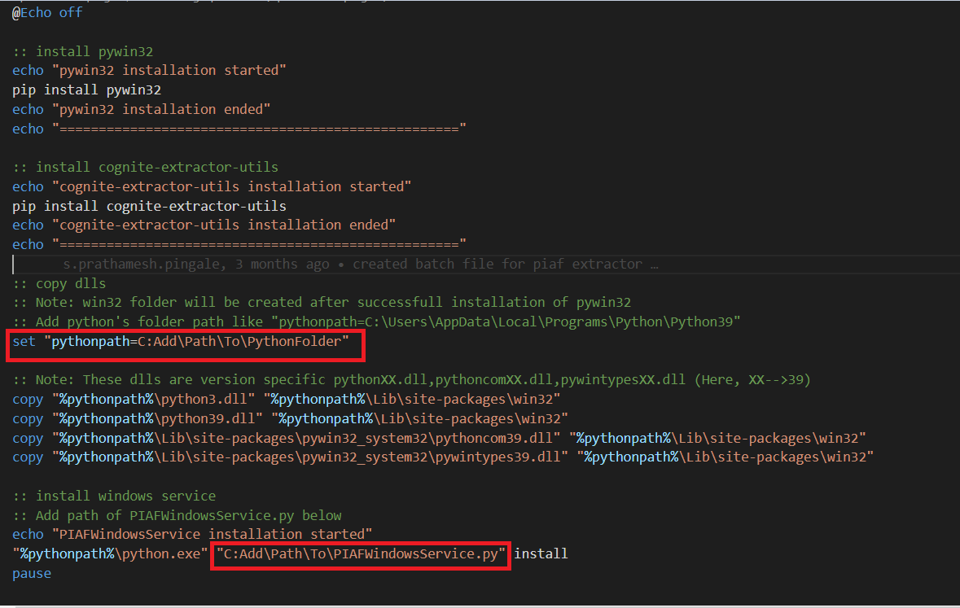
- For the on-premise installation of the PI AF Extractor, right-click on the WSInstallation.bat file and select Run as Administrator. The file installs all the required Python modules and PI AF extractor as a windows service.
- Verify the following libraries are installed correctly in the system.
  - pywin32 module
  - cognite-extractor-utils module
  - pythonX.dll
  - pythonXX.dll
  - pythoncomXX.dll
  - pywintypesXX.dll
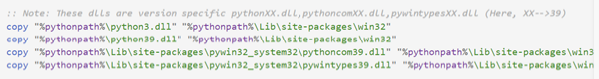

Start the Extractor
- Click the Start button, search for “Services”, and select Run as Administrator.
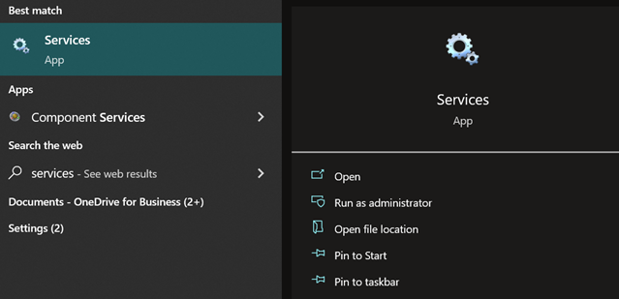

- Search for the “PIAFExtractor” service name, right-click on it, and select Start.
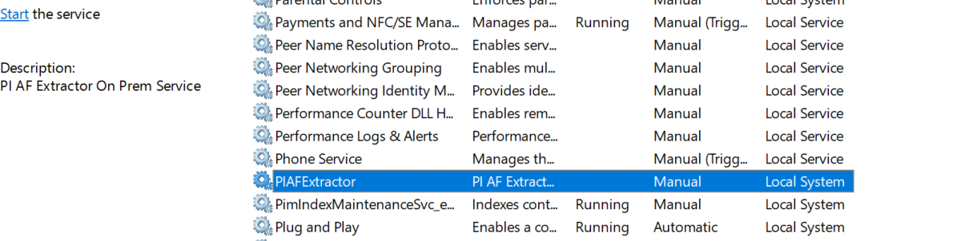

- Once the PI AF Extractor starts running, check the logs in the log file specified in the configuration file.
- Validate the creation of the database and tables with asset hierarchy data on the CDF portal.


- Validate the creation of the extraction pipeline with a success message on the CDF portal.


Stop the Extractor
- Click the Start button, search for “Services”, and select Run as Administrator.


- Search for the “PIAFExtractor” service name, right-click on it, and select Stop.
