Digital Thread Foundations
BOM Management Database
TECHNICAL OVERVIEW
Release Version: 1.2
Metadata Table
Field | Value
Asset / Solution Name | Digital Thread
Domain / Area | Engineering
Owner (Team/Person) | Karthik Ramachandra
Reviewers | Karthik Ramachandra
Status | Approved / Complete
Confidentiality | Internal / Confidential
Source of Truth | https://dev.azure.com/IXAssets/IXAssetsProject/_git/ixassets
Related Assets / Alternatives | AOT / Engineering Orch / Engineering Agents

Contents
Introduction 3
Purpose 3
Target Audience 3
Prerequisites 3
Related Links 3
Contacts 3
Background 4
Entity Relationship Diagram 4
Connectivity Details 5
Connection Procedure 5
Database Objects 7
Schema 7
Tables 7
bom.ix_templates 8
bom.ix_business_rules 9
bom.ix_mbom_conversions 10
bom.ix_part_replacement 11

Introduction
A digital thread refers to the continuous and consistent flow of information throughout the entire lifecycle of a product or system – from design and development to operation and maintenance. It enables the integration of data from different stages and sources, allowing effective traceability, seamless collaboration, and efficient decision-making by unleashing the power of sleeping data. The digital thread is considered a key aspect of Industry 4.0 and the digital transformation of the manufacturing industry.
It is the core of the Enterprise Operating System (EOS). Digital Thread is a communication framework that helps integrate various enterprise systems involved in the engineering and manufacturing product life cycle.
The EBOM to MBOM Conversion feature in BOM Management is designed to help users efficiently transform an Engineering Bill of Materials (EBOM) into a Manufacturing Bill of Materials (MBOM) within a structured workflow. This conversion process ensures that engineering data is accurately translated into a manufacturable format while maintaining traceability and version control.

Purpose
This document provides a detailed description of the Postgres database (ixts-dev-psqldb) utilized for EBOM to MBOM conversion by IX Digital Thread.

Target Audience
- Data Management and Governance Team
- Interface Developers
- Data Engineers
- Application Support Team

Prerequisites
- Get access to the ixts-dev-psqldb database in Azure. (provided by the IX-Thread Infra team)
- Download and Install any GUI to access the ixts-dev-psqldb database from a local machine i.e. PgAdmin.

Related Links
- IX Digital Thread Documentation
- BOM Management Documentation

Contacts
- karthik.ramachandra@accenture.com
- mohit.k.mishra@accenture.com

Background
IXAssetsProject currently uses the ixts-dev-psqldb database to store all the reference information regarding EBOM to MBOM conversion. This database is created using Azure Postgres SQL and stores the information about BOM templates, Conversion Rules, and other conversion details in various tables.

Entity Relationship Diagram
Below is the ERD (entity relationship diagram) for the database ixts-dev-psqldb and schema bom.
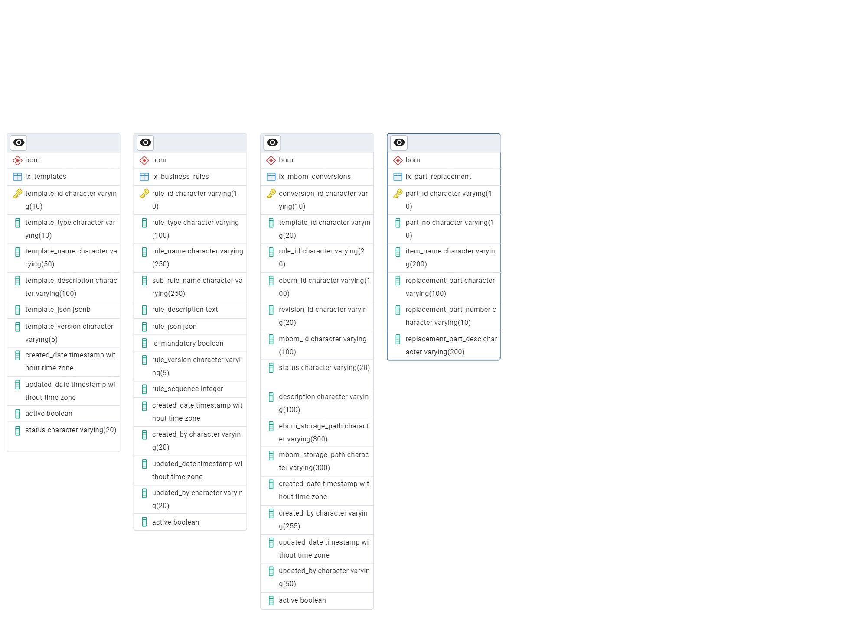

Connectivity Details
The following table outlines the details needed to connect with the database server.
Database Server name/Host name/address | ixts-dev-postgres-datafederation.postgres.database.azure.com
Database name | ixts-dev-psqldb
Database Owner name | ix_postgres_admin
Port | 5432
Username | ix_postgres_admin
Maintenance database | postgres

Connection Procedure
Below are the steps to connect to the ixts-dev-psqldb using PgAdmin,
- Open the PgAdmin application on the local machine and go to servers in Object Explorer. Now right-click on Object Explorer > Register > Server.
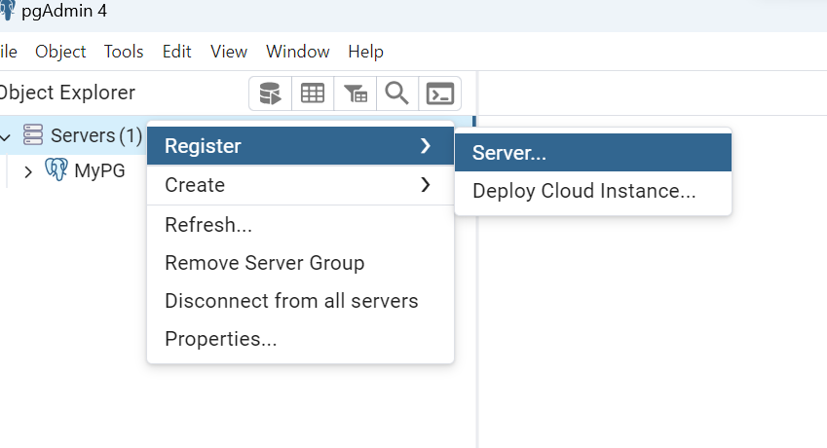
- In the popup window, provide details in the General tab as depicted in the image.
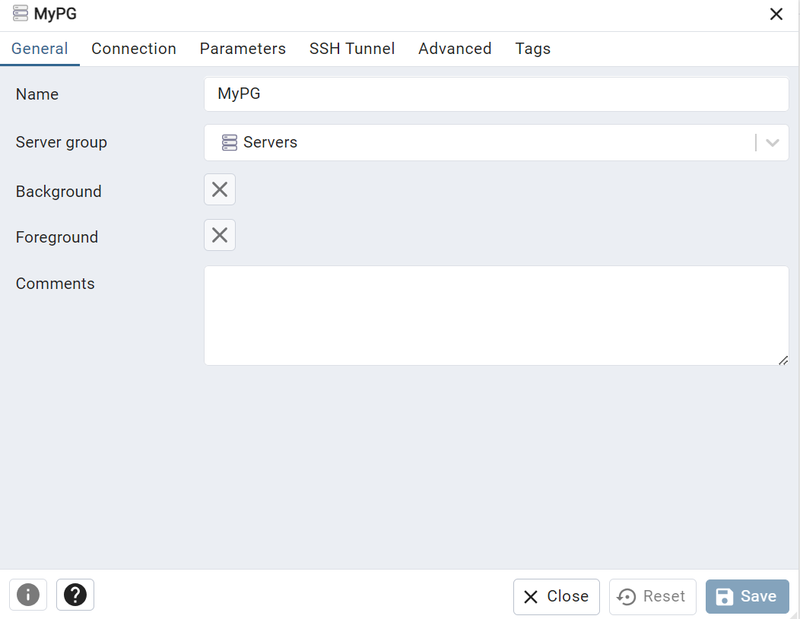
- Go to the Connection tab. Enter the Host name/address, port, username, etc., and click on the Save option to save the details.
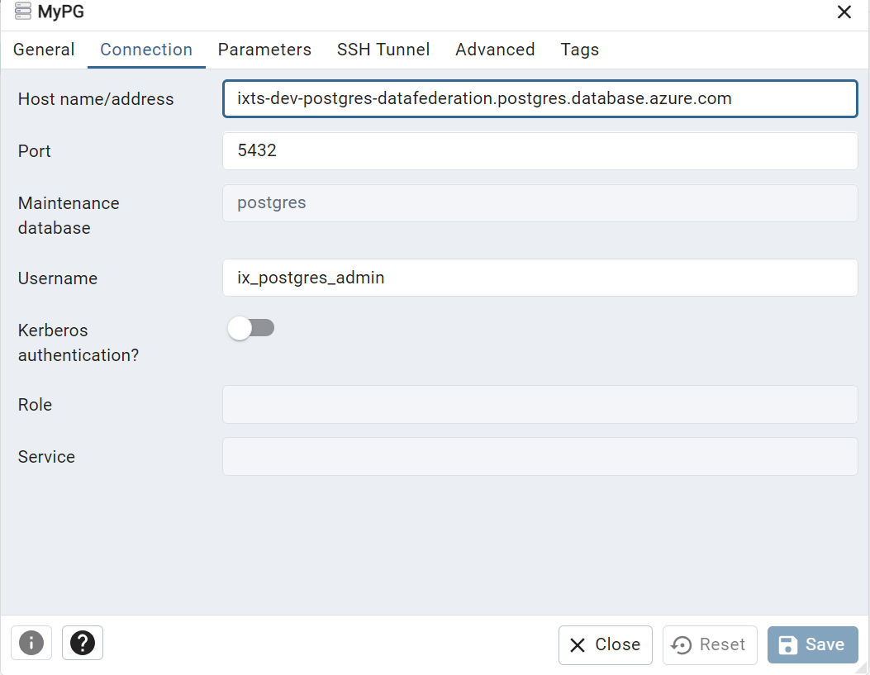
- After clicking on Save, the details will be shown in the Object Explorer,
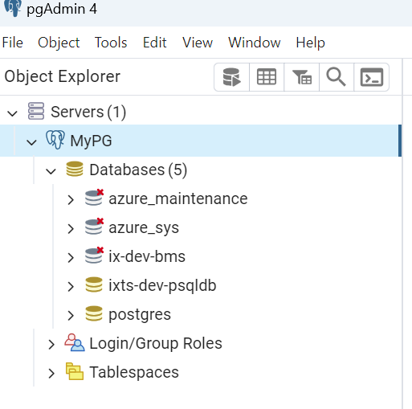

Database Objects
Below are the objects created in the database.

Schema
A new schema with the name BOM has been created and all the objects for release are created under the BOM schema.
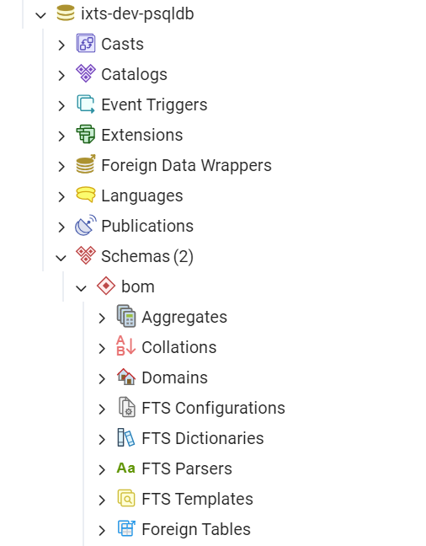

Tables
The tables mentioned in the tabular figure are created under the BOM schema.
The metadata and sample data are provided for each table in the subsequent sections.
# | Table
1 | bom.ix_templates
2 | bom.ix_business_rules
3 | bom.ix_mbom_conversions
4 | bom.ix_part_replacement

bom.ix_templates
Below is the metadata for the bom.ix_templates table,
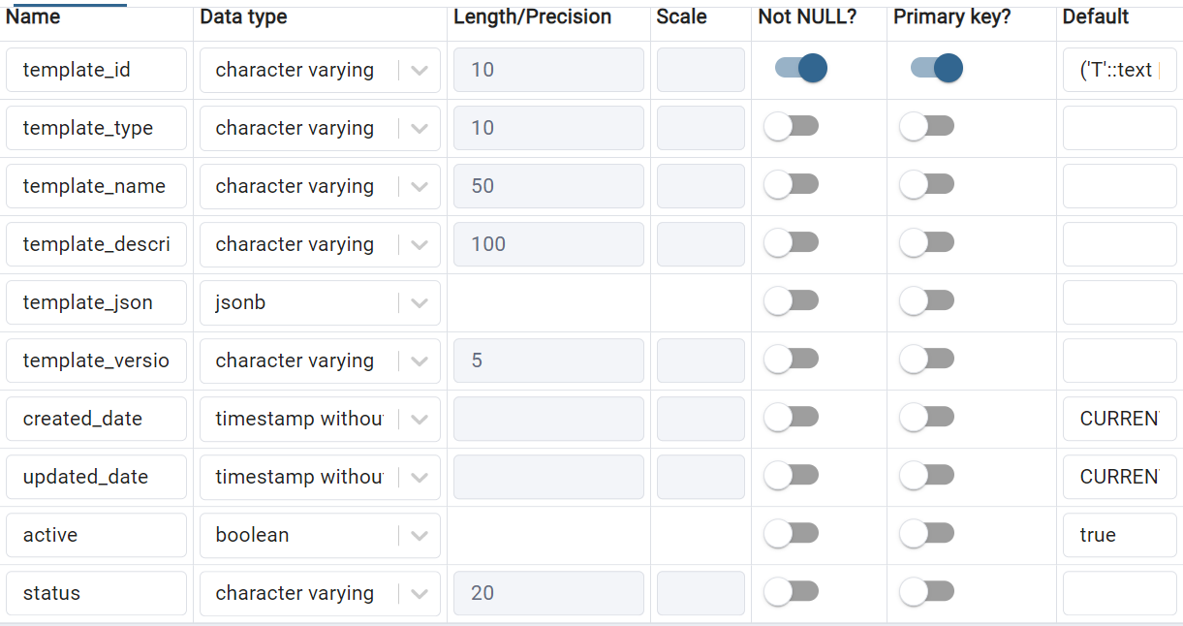
Below is the sample data in the above table.
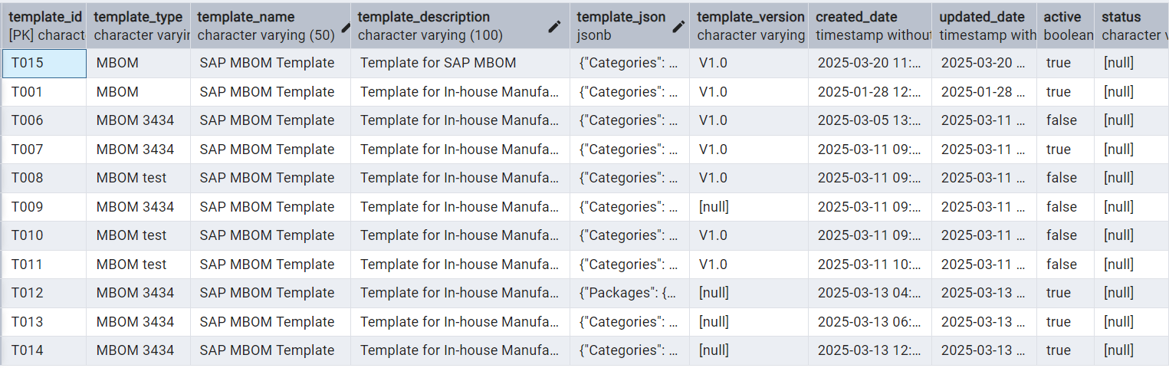

bom.ix_business_rules
Below is the metadata for the bom.ix_business_rules table,
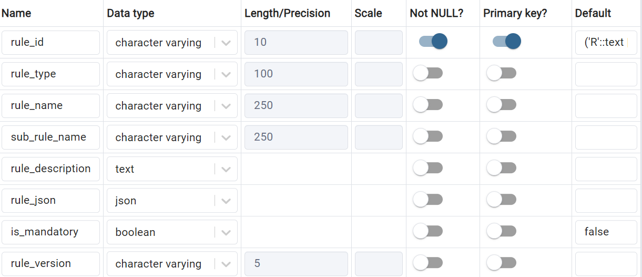
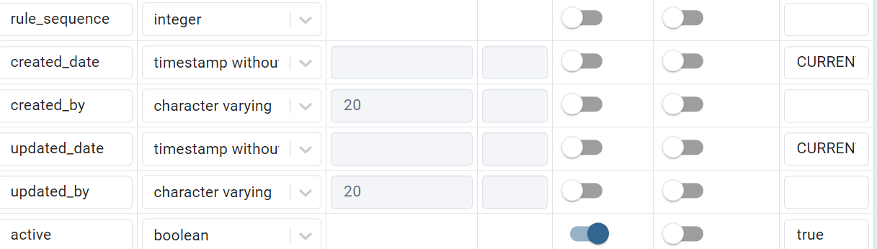
Below is the sample data for the above table.
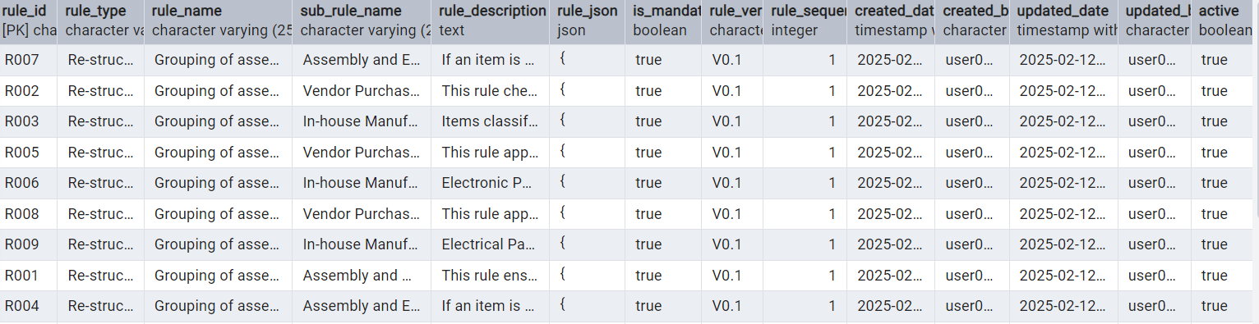

bom.ix_mbom_conversions
Below is the metadata for the bom.ix_mbom_conversions table,
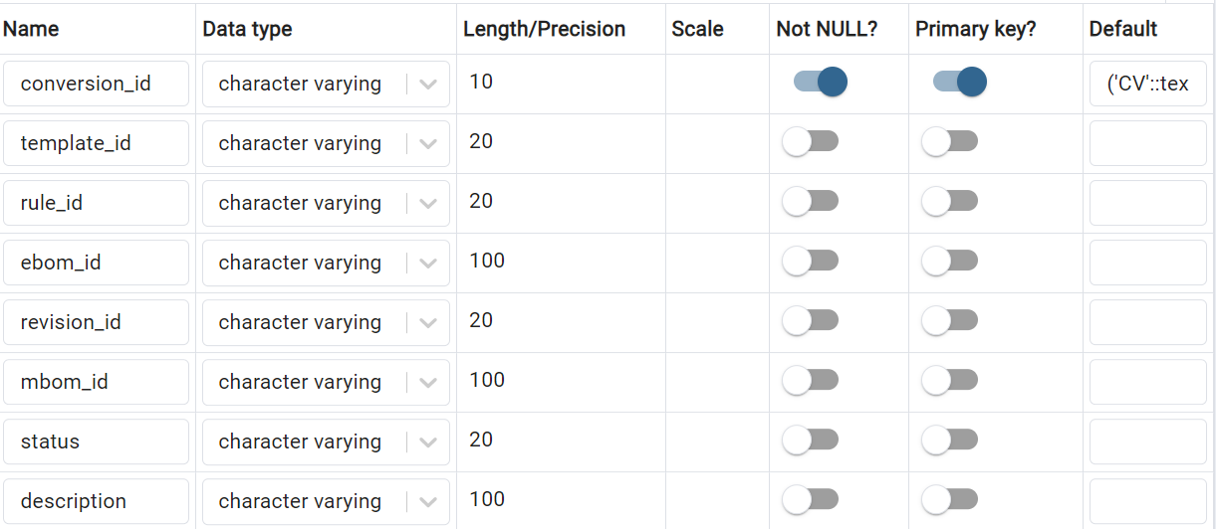
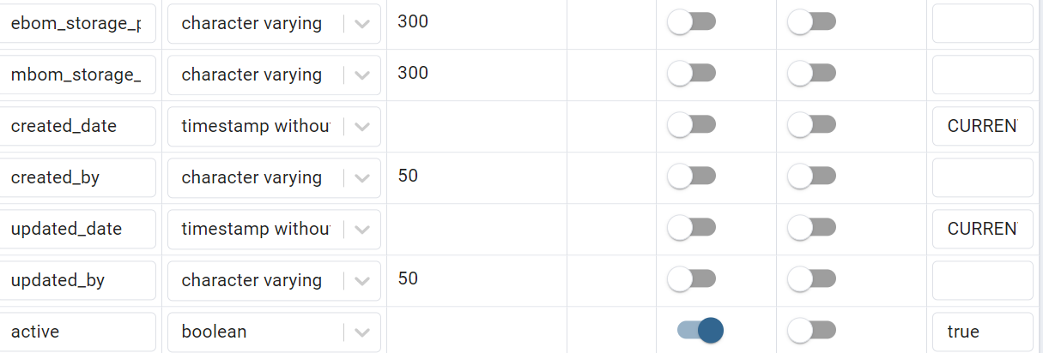
Below is the sample data for the above table.
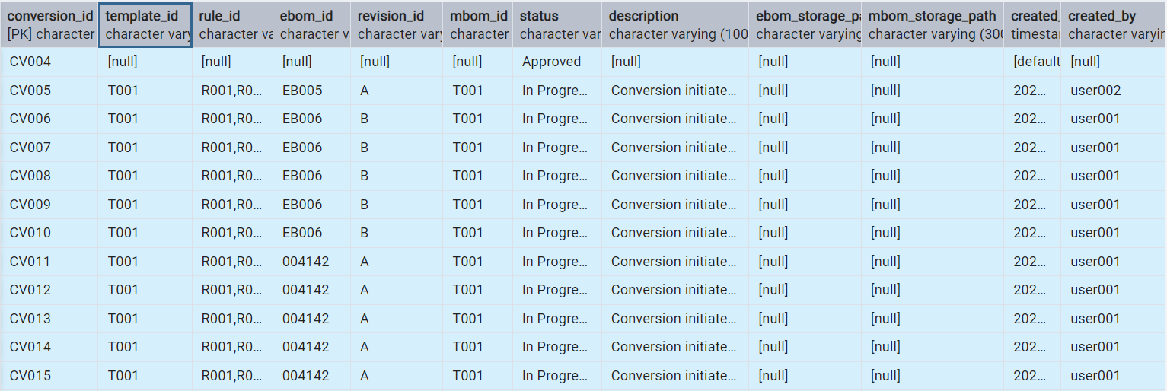

bom.ix_part_replacement
Below is the metadata for the bom.ix_mbom_conversions table,
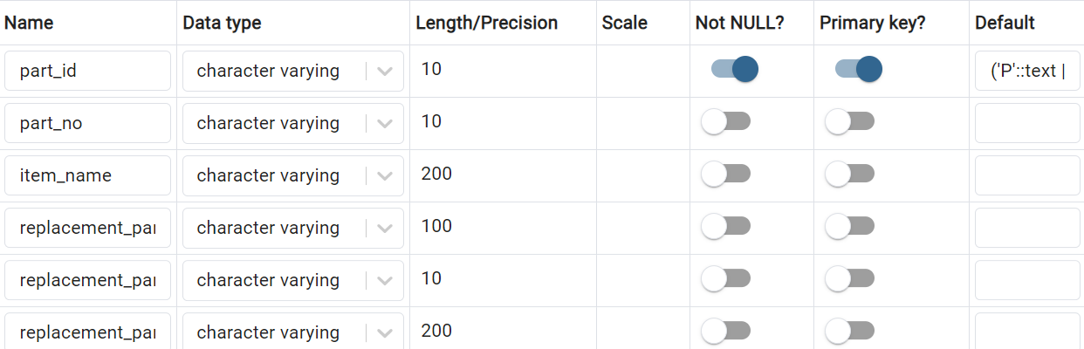
Below is the data for the above table.

