Digital Thread Foundations
SAP Connector
INTEGRATION GUIDE
Release Version: 1.2
Contents
Introduction 3
Purpose 3
Target Audience 3
Prerequisites 3
Business Contacts 3
Related Links 3
Access Management 4
CRUD API 4
RBAC Implementation 4
SAP Connector Blueprint 5
Data Catalog 5
BOM Management 5
SAP Olingo Library Details 6
Capabilities 7
Logging 7
Secure Secrets Management 8
Error Management 9
Role-based Access Control 9
Connector Filter 10
Download and Usage 11
APIs 12
Get Metadata 13
Get Data 14
Get Lineage 15
Create Data 16
Update Data 17
Delete Data 18

BOM Fetch 19

Introduction
A digital thread refers to the continuous and consistent flow of information throughout the entire lifecycle of a product or system – from design and development to operation and maintenance. It enables the integration of data from different stages and sources, allowing effective traceability, seamless collaboration, and efficient decision-making by unleashing the power of sleeping data. The digital thread is considered a key aspect of Industry 4.0 and the digital transformation of the manufacturing industry. It is the core of the Enterprise Operating System (EOS). Digital Thread is a communication framework that helps integrate various enterprise systems involved in the engineering and manufacturing product life cycle.
Digital Thread Foundations has implemented dedicated connectors to connect to various source systems. The SAP Connector is one such connection implemented. It leverages the Olingo library and serves as middleware, bridging SAP systems and external applications through JAVA REST APIs. This REST API can perform Create, Read, Update, and Delete (CRUD) operations using the HTTP gateway. Acting as a Java-based intermediary, it streamlines connectivity and data exchange. With Maven integration, developers can seamlessly access SAP resources. This document explores how this middleware simplifies SAP integration, empowering businesses to enhance connectivity and efficiency effortlessly.

Purpose
This document describes the SAP Connector integration and API details.

Target Audience
Software architects, developers, and integrators with IT backgrounds.

Prerequisites
- Download and install Java (version 17)
- Download and install IntelliJ IDEA (version: 2023.1.1)
- Download and install Apache Maven (version: 3.9.1)
- An API testing tool such as Postman.
- Access to the Azure repository provided by the DevOps team.

Business Contacts
- florian.tournier@accenture.com
- laura.mosconi@accenture.com
- karthik.ramachandra@accenture.com
- stefano.giacco@accenture.com
- srinath.k.murthy@accenture.com

Related Links
- DT_Role_Mapping_Config.txt
- Digital Thread documentation

Access Management

CRUD API
The Create/Read/Update/Delete (CRUD) API enables interaction with SAP to perform essential operations such as fetching issue details, updating existing issues, and creating new ones. This provides the flexibility needed to manage issues directly from external systems or custom applications, enhancing integration possibilities.

RBAC Implementation
Role Based Access Control (RBAC) in the SAP connector application is managed through Azure management services, following similar practices as other connector applications. RBAC policies are defined at the product level, dictating the access rights for various methods within the application. The below table shows the permissions granted to each role. Permissions for each role in the SAP connector application are structured as follows:
- Admin: Granted full permissions, including POST, PUT, and GET operations.
- Quality Engineer (QE): Granted full permissions, including POST, PUT, and GET operations.
- Tester: Granted limited permissions, restricted to GET operations only.
- Developer (Dev): Granted limited permissions, restricted to GET operations only.
- User: Granted limited permissions, restricted to GET operations only.

SAP Connector Blueprint

Data Catalog

The following diagram depicts the high-level design flow for the SAP Connector and how an SAP ERP system and a Data Catalog interact via OData services handled by Olingo and Java-based RESTful APIs.
- The SAP ERP system provides data which is handled through the Olingo Library.
- The Java REST APIs built on the Olingo Library allow data to be transferred from the SAP ERP system to the Data Catalog.
- The Data Catalog receives and stores the data for further use, analysis, or reporting.
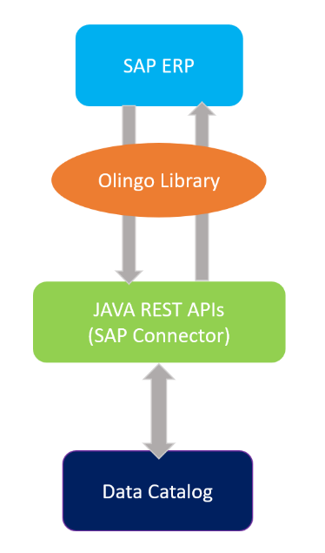

BOM Management
The following diagram depicts a high-level flow for SAP connector is used for BOM Management application.
The user provides a BOM ID as the input parameter to the API. The API communicates with the SAP ERP system and fetches all data related to the BOM ID. The data is stored within the internal storage of the SAP system as an Excel file. A scheduler script, developed by the SAP SME, is used to export the stored Excel file to Blob storage, ensuring secure and scalable access to the BOM data.
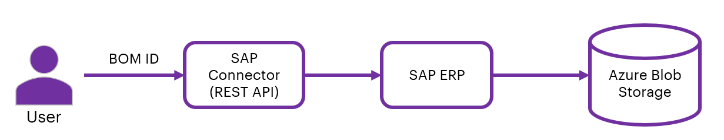

SAP Olingo Library Details
The dependency in the SAP connector is used to develop the functionality of CRED operations and access information present in SAP ERP. The dependency is as shown in the pom.xml file on the side.
Ensure to replace `<! -- Replace with the desired version -->`> with the actual version of the Apache Olingo library that was downloaded after including the Olingo library as a dependency.
<dependency>
<groupId>org.apache.olingo</groupId>
<artifactId>odata-client-core</artifactId>
<version><! -- Replace with the desired version --></version>
</dependency>
<dependency>
<groupId>org.apache.olingo</groupId>
<artifactId>olingo-odata2-api</artifactId>
<version><! -- Replace with the desired version --></version>
</dependency>
<dependency>

Capabilities
The SAP connector implemented has the following capabilities.
- Logging
- Secure Secrets Management
- Error management
- Role-based Access Control

Logging
SAP connector is built to log with logback and slf4j. The required format for the application logging is as follows:
<Timestamp ISO8601 with timezone>|<LOG LEVEL>|<THREAD IDENTIFIER>|<APPLICATION LABEL|<TRANSACTION ID>|<PLATFORM TRANSACTION ID>|<CLASS>|<METHOD>|<MESSAGE>
Refer logback-spring.xml Under directory “src/main/resources”
<?xml version="1.0" encoding="UTF-8"?>
<configuration>
<appender name="stdout" class="ch.qos.logback.core.ConsoleAppender">
<encoder>
<pattern>
%d{yyyy-MM-dd'T'HH:mm:ss.SSS'Z'}|%level|%thread|%X{APPLICATION-LABEL}|%X{TRANSACTION-ID}|%X{PLATFORM-TRANSACTION-ID}|%logger|%method|%msg%n
</pattern>
</encoder>
</appender>
<logger name="${package}" level="debug" additivity="false">
<appender-ref ref="stdout"/>
</logger>

<root level="info">
<appender-ref ref="stdout"/>
</root>
</configuration>

Secure Secrets Management
Secret management is a practice that allows developers to store sensitive data such as passwords, keys, and tokens, in a secure environment with strict access controls.
Azure Key Vault enables users to securely store and manage sensitive data like keys, passwords, certificates, and other sensitive information. These are kept in centralized storage that is protected by industry-standard algorithms and hardware security modules.
With this feature, the SAP Connector enables the user to store access information in the key vaults. This information is picked up by various APIs and based on the access level provided to the credential (user), the actions are performed.
Azure Key Vault Dependency
<dependency>
<groupId>com.azure.spring</groupId>
<artifactId>spring-cloud-azure-starter-keyvault-secrets</artifactId>
</dependency>

<dependencyManagement>
<dependencies>
<dependency>
<groupId>com.azure.spring</groupId>
<artifactId>spring-cloud-azure-dependencies</artifactId>
<version>5.3.0</version>
<type>pom</type>
<scope>import</scope>
</dependency>
</dependencies>
</dependencyManagement>
Key Vault Configuration in springboot application.properties
spring.cloud.azure.keyvault.secret.property-source-enabled=true
spring.cloud.azure.keyvault.secret.property-sources[0].credential.client-secret=<Client Secret Value>
spring.cloud.azure.keyvault.secret.property-sources[0].credential.client-id=<Client ID>
spring.cloud.azure.keyvault.secret.property-sources[0].profile.tenant-id=<Tenant ID>
spring.cloud.azure.keyvault.secret.property-sources[0].endpoint=<Vault URI>

Error Management
Whenever a certain operation encounters an error, the same structure should be returned by all the DigitalThread components.

Output Body
Parameter | Description | M/O | Type
errorManagement | Object identifying the error | O* | Object
errorCode | Code that identifies the error occurred | O* | String
errorDescription | Error description | O* | String
Example: error response message
{
"errorManagement": {
"errorCode": "CMPNT_02.100004",
"errorDescription": "db connection error"
}
}

Role-based Access Control
This sequence diagram represents the flow of user-role validation against a role mapping file in an SAP Connector.
The user role is extracted at the APIM level from the JWT token and is passed to the connector as a header. The user role is validated against the role mapping config file in the filter layer. The extract role service is part of the filter layer where the user role is extracted from the header and validated against the config file.
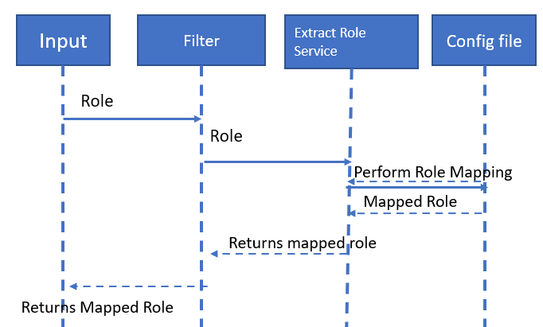

Connector Filter
The following image explains the skeleton of the connector filter service using three methods, each of which performs specific validation and filtering. These three methods are:
- doFliter: Uses a servlet filter to intercept requests.
- extractUserRole: Extracts the user from the header.
- loadRoleConfig(): Loads the RBAC config file.
- IsValidRole(): Validates the role extracted from the header against the RBAC config file.
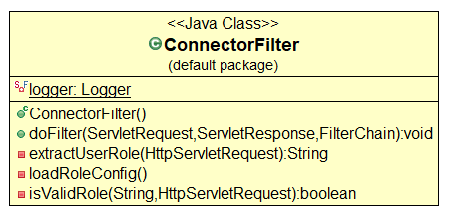

Download and Usage
The steps mentioned below describe how to access the SAP Connector code.
- Access the Azure repository at: https://dev.azure.com/IXDigitalThread/IXThreadComponents/_git/ix-thread-components
- Clone the project with the help of Git into local.
- Use this path to access SAP connector code in IntelliJ IDEA: IXDigitalThread\SAP-Dev\ix-thread-components\connector\ix-sap-api
- Import the project into IntelliJ from the project directory.
- After importing, the project structure should resemble the example depicted in the image on the side.
- After importing the project into local, Update the application.properties with server details.
- Run the application.
- Use Postman and add “user-role” in the header Trigger of the APIs described in the subsequent section.
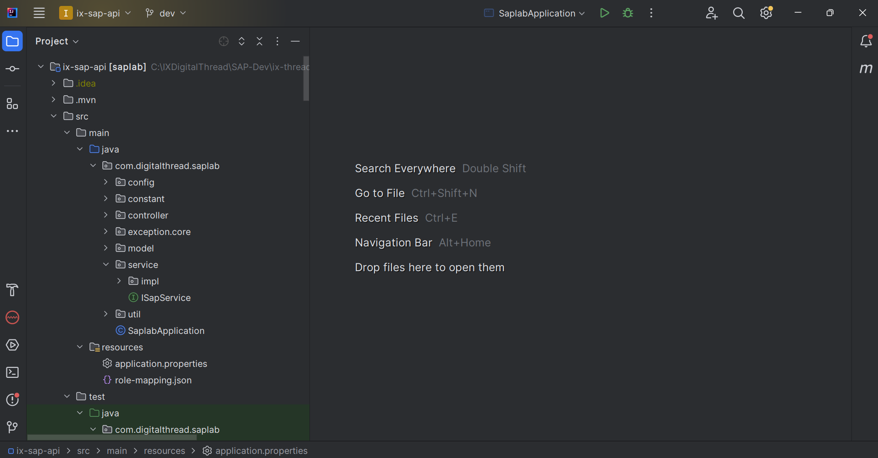

APIs
The SAP Connector offers a suite of APIs designed to streamline interactions with SAP, enabling a range of operations including creating, updating, reading, and deleting data. The primary APIs provided by the connector are listed in the table below.
The table below includes a short description of every Product Name API.
Product Name APIs
Name | Description
GET Metadata | This API serves as an endpoint to retrieve metadata.
GET Data | This API serves as an endpoint to fetch the data.
GET Lineage | This API serves as an endpoint to retrieve Lineage data.
CREATE Data | This API is for creating data.
UPDATE Data | This API is used to update details.
DELETE Data | This API serves as an endpoint to delete the data.
BOM Fetch | This API is used to fetch BOM data from SAP ERP system.
According to the environment, users will have to acquire proper access to generate a JWT token to be used for authentication. Additionally, users will require a product subscription key of the product created in Azure application management services for the SAP connector application and will have to pass a transaction-id. All this information needs to be passed in the request headers for authentication. The user can append specific endpoints after the base URL and utilize the API accordingly.

Get Metadata
This API retrieves details about metadata using the /edm endpoint.
PROTOCOL | HTTPS
DEV ENDPOINT | https://ix-dev-apimgmt.azure-api.net/sap-api/edm
QA ENDPOINT | https://ix-qa-apimgmt.azure-api.net/sap-api/edm
METHOD | GET
CONTENT TYPE | application / json

Pagination Parameters
Parameter | Description
type | Unique identifier and specifies the type of data to retrieve
metadata | Unique identifier of the metadata

Sample Response
"entityTypes": [{
"name": "Customer",
"properties": [{
"name": "Kunnr",
"type": "String",
"annotationAttributes": {
"filterable": "false",
"unicode": "false",
"updatable": "false",
"label": "Customer",
"creatable": "false",
"sortable": "false"
}
}

Result
HTTP Code | Result Description
200 | Metadata details fetched successfully

Error Management
HTTP Code | Error Code | Error Description
500 | 500 | Project Specific error
404 | 404 | Not Found
403 | 403 | Forbidden
401 | 401 | Invalid Subscription key / Invalid Token
400 | 400 | Bad request

Get Data
This API is used to fetch and retrieve the data present in SAP and can filter the response as per user request for attributes, material, and pagination.
PROTOCOL | HTTPS
DEV ENDPOINT | https://ix-dev-apimgmt.azure-api.net/sap-api/feed
QA ENDPOINT | https://ix-qa-apimgmt.azure-api.net/sap-api/feed
METHOD | GET
CONTENT TYPE | application / json

Path Parameters
Parameter | Description
type | Unique identifier and specifies the type of data to retrieve
entitySetName | Specifies the name of the entity set to query

Pagination Parameters
Parameter | Description
offset | Page number of the dataset to retrieve (greater than 0).
limits | Page size, the maximum value is 50 (greater than 0).
filter | Is used to fetch materials based on given criteria or conditions
attributes | Is used to fetch particular attributes in the response

Result
HTTP Code | Result Description
200 | Data details fetched successfully

Error Management
HTTP Code | Error Code | Error Description
500 | 500 | Project Specific error
404 | 404 | Not Found
403 | 403 | Forbidden
401 | 401 | Invalid Subscription key / Invalid Token
400 | 400 | Bad request
Sample Response
{
"dataInstances": [{
"entityType": "Item",
"instances": [{
"properties": {
"Maktg": "",
"Dispo": "",
"Gewei": "KT",
"Mtvep": "",
"Vpreh": 0,
"Lifnr": "",
"Eislo": 0,
},
"workflows": null,
"secondaryDatasets": null
}]
}],
"offset": 0,
"limits": 0,
"totalRecords": "356"
}

Get Lineage
This API retrieves details of the Lineage data/lineage endpoint.
PROTOCOL | HTTPS
DEV ENDPOINT | https://ix-dev-apimgmt.azure-api.net/sap-api/lineage
QA ENDPOINT | https://ix-qa-apimgmt.azure-api.net/sap-api/lineage
METHOD | GET
CONTENT TYPE | application / json

Pagination Parameters
Parameter | Description
type | Unique identifier and specifies the type of data to retrieve
entitySetName | Specifies the name of the entity set to query
filter | Is used to fetch materials based on given criteria or conditions

Result
HTTP Code | Result Description
200 | Lineage data details fetched successfully

Error Management
HTTP Code | Error Code | Error Description
500 | 500 | Project Specific error
404 | 404 | Not Found
403 | 403 | Forbidden
401 | 401 | Invalid Subscription key / Invalid Token
400 | 400 | Bad request

Sample Response
LINK

Create Data
This API retrieves details about the sprints associated with a specific board. Sprints are typically time-bound iterations within an Agile project framework.
PROTOCOL | HTTPS
DEV ENDPOINT | https://ix-dev-apimgmt.azure-api.net/sap-api/create
QA ENDPOINT | https://ix-qa-apimgmt.azure-api.net/sap-api/create
METHOD | POST
CONTENT TYPE | application / json

Path Parameters
Parameter | Description
type | Unique identifier and specifies the type of data to retrieve
entitySetName | Specifies the name of the entity set to query

Result
HTTP Code | Result Description
200 | Data created successfully

Error Management
HTTP Code | Error Code | Error Description
500 | 500 | Project Specific error
404 | 404 | Not Found
403 | 403 | Forbidden
401 | 401 | Invalid Subscription key / Invalid Token
400 | 400 | Bad request

Sample Request Body
{
"Item": "196",
"ItemType": "ITEM",
"BomLevel": "01",
"BomNumber": "00000019",
"UnitOfMeasure": "EA",
"BomType": "MBOM",
"Status":
}

Sample Response
{
"dataInstances": [{
"entityType": "Item",
"instances": [{
"properties": {
"Maktg": "",
"Dispo": "",
"Gewei": "KT",
"Mtvep": "",
"Vpreh": 0,
"Lifnr": "",
"Eislo": 0,
},
"workflows": null,
"secondaryDatasets": null
}]
}],
"offset": 0,
"limits": 0,
"totalRecords": "356"
}

Update Data
This API retrieves details about a board using the /board endpoint.
PROTOCOL | HTTPS
DEV ENDPOINT | https://ix-dev-apimgmt.azure-api.net/sap-api/odata
QA ENDPOINT | https://ix-qa-apimgmt.azure-api.net/sap-api/odata
METHOD | GET
CONTENT TYPE | application / json

Pagination Parameters
Parameter | Description
type | Unique identifier and specifies the type of data to retrieve
entitySetName | Specifies the name of the entity set to query
id | Specifies the Unique identifier.

Result
HTTP Code | Result Description
200 | Data update successful

Error Management
HTTP Code | Error Code | Error Description
500 | 500 | Project Specific error
404 | 404 | Not Found
403 | 403 | Forbidden
401 | 401 | Invalid Subscription key / Invalid Token
400 | 400 | Bad request

Request and Response
LINK

Delete Data
This API works for the Deletion of data, But in SAP, data will not be deleted for the ERP system it will be marked as deleted.
PROTOCOL | HTTPS
DEV ENDPOINT | https://ix-dev-apimgmt.azure-api.net/sap-api/feed
QA ENDPOINT | https://ix-qa-apimgmt.azure-api.net/sap-api/feed
METHOD | GET
CONTENT TYPE | application / json

Path Parameters
Parameter | Description
type | Unique identifier and specifies the type of data to retrieve
entitySetName | Specifies the name of the entity set to query
Id | Specifies the material Unique Identification

Result
HTTP Code | Result Description
200 | Entry deleted successfully.

Error Management
HTTP Code | Error Code | Error Description
500 | 500 | Project Specific error
404 | 404 | Not Found
403 | 403 | Forbidden
401 | 401 | Invalid Subscription key / Invalid Token
400 | 400 | Bad request

Sample Response
{
"statusCode": "204",
"statusMessage": "Entry deleted successfully."
}

BOM Fetch
This API is used to fetch BOM data from the SAP ERP system.
PROTOCOL | HTTPS
DEV ENDPOINT | https://ixts-dev-apim.azure-api.net/sap-api/v1/bom
QA ENDPOINT | https://ixts-qa-apim.azure-api.net/sap-api/v1/bom
METHOD | GET
CONTENT TYPE | application / json

Path Parameters
Parameter | Description
type | Unique identifier and specifies the type of data to retrieve
entitySetName | Specifies the name of the entity set to query

Pagination Parameters
Parameter | Description
filter | Is used to fetch materials based on given criteria or conditions

Result
HTTP Code | Result Description
200 | Data details fetched successfully

Error Management
HTTP Code | Error Code | Error Description
500 | 500 | Project Specific error
404 | 404 | Not Found
403 | 403 | Forbidden
401 | 401 | Invalid Subscription key / Invalid Token
400 | 400 | Bad request

Sample Response
200 Ok Success Response

