Accenture Operations Twin
Intelligent Advisor
AWS DELIVERY GUIDE
  - Release Version: 2.5
  - Metadata Table:
- Field | - Value
- Asset / Solution Name | - Accenture Operations Twin / Intelligent Advisor
- Domain / Area | - Advisory / Decision Automation
- Owner (Team/Person) | - Tournier, Florian
- Reviewers | - Tan, Francis U; Kumar Singh, Rajnish
- Status | - Published / Approved
- Confidentiality | - Internal / Confidential
- Source of Truth | - Summary - Overview
- Related Assets / Alternatives | - Intelligent Advisor UI Guide, Intelligent Advisor Delivery Guide

Contents
Introduction 3
Purpose 3
Target Audience 3
Preferred Skills 3
Prerequisites 3
Contacts 3
Related Links 3
Glossary 4
Generating Insights 5
Create Insight Category 5
Creation Process 5
Leveraging AWS and CDF 6
Microservices 7
IA-config microservice 7
Generic Scheduler Microservice 8
ML Model Microservice 9
Evaluatemodel Microservice (Insight Generation Engine) 10
Generic Scheduler Database Structure 14
Archive Insights 15
Use Cases (UC) 15
UC1 – Predicting Control Valve Failure 15
Flow 15
IA Configuration 16
UC2 – Smart KPI for OEE 16
Flow 16
IA Configuration for Smart KPI Model 16
Create a User Interface Template 17
KPI Data Permissions 19

Introduction
Accenture Operations Twin (AOT) is a collection of software accelerators and tools, including Intelligent Advisor, which can be assembled to deliver client solutions. AOT accelerates the integration of product, process, and live data from disparate IT and OT systems, creating a comprehensive and contextualized view of operations to enable better decisions and optimized processes.
Intelligent Advisor (IA) is an AOT component and an AI-based solution that enables different types of users to focus on critical issues with real-time generated, prioritized and contextualized Insights and recommendations. It combines the following functional components: Insight generation engine, collaboration, Actions, Advisor panel, Insight Viewer template, and Insight lifecycle management.

Purpose
This document describes the end-to-end process of creating and maintaining Insight categories, configuring Insights, and defining Insight viewer templates. The document should be valuable to anyone who needs to generate and configure tailored Insights for a client.

Target Audience
- Client Delivery Teams Leveraging AOT Intelligent Advisor
- Asset Delivery Teams
- Solution Architects, Technical Architects, Data Scientists, Data Engineers

Preferred Skills
- Cognite Data Fusion (CDF)
- AWS RDS
- Python
- Machine Learning

Prerequisites
- A business analyst (BA) from the AOT team must be engaged to define the requirements.
- Access to a customized spreadsheet from the BA, which is used to create the hierarchies described later in this guide.
- Access to code is needed.

Contacts
- rajnish.kumar.singh@accenture.com
- reymark.q.bacalso@accenture.com
- francis.u.tan@accenture.com

Related Links
- IA-on-AWS
- Cognite Documentation
- Micro Frontend Development Guide
- AOT Documentation
- Release Notes
- Intelligent Advisor API Reference
- Generic Scheduler Technical Overview

Glossary
Term / Acronym | Definition
AOT (Accenture Operations Twin) | A collection of software accelerators and tools, including Intelligent Advisor, designed to integrate product, process, and live data from disparate IT and OT systems for improved operational decision-making.
Intelligent Advisor (IA) | An AI-based solution within AOT that generates, prioritizes, and contextualizes insights and recommendations for users, supporting decision automation.
CDF (Cognite Data Fusion) | A platform used for data integration and contextualization, supporting the generation and management of insights and categories in the AOT solution.
AWS RDS | Amazon Web Services Relational Database Service, used to store configurations, scheduler data, and other operational information for the IA solution.
Insight | A data-driven recommendation or alert generated by the IA system, based on business logic or machine learning models, to highlight critical operational issues or opportunities.
Insight Category | A classification structure for organizing insights, such as KPI-based, Predictive Failure, or Custom configurations, managed within CDF.
Microservice | A modular service within the IA architecture, each responsible for a specific function such as configuration, scheduling, model execution, or insight evaluation.
KPI (Key Performance Indicator) | A measurable value used to evaluate the success of an organization or asset in meeting objectives, often used as a basis for generating insights.
Predictive Failure Configuration | A setup within IA for predicting asset failures using machine learning models, allowing proactive maintenance and risk mitigation.
Generic Scheduler Microservice | A service that manages the scheduling of tasks (such as model runs or insight evaluations) at defined intervals or times.
ML Model Microservice | The microservice responsible for running pre-trained machine learning models to generate predictions used in insights.
Evaluatemodel Microservice | The engine that evaluates model outputs and business logic to determine if an insight should be generated.
IA Middleware Microservice | The service that acts as an interface between evaluation logic and the insight generation engine, facilitating the creation of insights.
Template | A predefined structure for displaying insight details in the user interface, mapping specific data fields to UI elements.
Kafka | A distributed event streaming platform used for message brokering between microservices in the IA architecture.
ADX (Azure Data Explorer) | A data analytics service used to store and analyze time series data, such as model predictions, within the IA solution.
Archive Insight | A feature that automatically closes insights and associated actions upon reaching their expiry, based on business-defined limits.
OEE (Overall Equipment Effectiveness) | A metric used to assess the efficiency and effectiveness of manufacturing operations, often used as a KPI in IA use cases.

Generating Insights
Insights are generated by using either some simple business logic or a more complex machine learning model that must be deployed and executed in an analytical framework. Simple business logic might be just a breach of a monitored KPI threshold, while a more complex use case could be an ML model that predicts failure and generates Insights wherever a malfunction happens.
Configuration of Insights is handled in AWS, which is also used for the deployment and execution of analytical models and for triggering Insights. Insights are created using three distinct steps:
- Create Insight category.
- Leverage AWS and CDF to Generate Insights
- Create a user interface template for viewing the details of the Insights.
The resultant data is rendered using middleware. The three steps listed above are described in the sections that follow.

Create Insight Category
New Insight categories can be created through Insight category hierarchy generation in CDF. Insight categories will be created, updated, maintained, and customized by Accenture and consumed by clients. Insights within the Insight Factory are categorized into an object structure called Insight Categories. These categories are then organized into a Category Hierarchy. Currently, only KPI-based and Predictive failure categories have been defined .The AOT Insight Category Hierarchy consists of two child assets:
- Insights based on KPIs
- Predictive Failure Configuration
- Custom Insight Configuration
The sections that follow explain how these categories are created, updated, maintained, and customized by Accenture and then consumed by clients.
To create the Insight Category, the following must exist:
- Excel sheet to define Insight categories: Insight_Factory_Category.xlsx.
- Database table on AWS: Insight_Category.
- Blob storage container: ia-samples-workitems

Creation Process
- Work with an AOT Business Analyst (BA) to create an Excel file to define the insight categories that are going to be created. This file gets converted to JSON. Note that this conversion is performed by a microservice that converts the Excel file to JSON. The microservice used is called ia_func_ms (IA function microservice). It converts the data from Excel to a JSON file and uploads the JSON files to CDF. Insight category
- Upload the JSON file to the CDF portal, which is automatically done through the microservice code.
- Deploy code in the Git repository.
- Run the pipeline to make the function appear in the CDF portal under the CDF function tab: CDF portal > Explore > Cognite functions
- Run functions in either of two ways:
  - Manual: CDF Portal>Explore>Cognite functions->Run button or through Postman.
  - Schedulers: CDF Portal > Explore > Cognite functions > Required function > Schedules
- View the Insight category hierarchy details in the CDF Portal by navigating to Explore > Explore data > Assets > AOT Configuration > Intelligent Advisor > Insight category hierarchy.
Helpful links:
- Git folder link
- Function Python code link
- IA Function Pipeline: AOT-AWS-IA-Function-MS
Note that for all environments, the pipeline is the same but while running, the pipeline changes branch according to the environment hierarchy created.

Leveraging AWS and CDF
Five different microservices and the IA Configuration database are employed to leverage AWS for system-generated insights. The ML Model uses twenty-six timeseries parameters as the input. The ML Model Microservice runs the pre-trained ML model to generate the output, which is a prediction for failure probability. This output is stored as a timeseries in ADX. The Generic Scheduler Microservice triggers the insight evaluation microservice endpoints for both the control valve and the Smart KPI models at the scheduled frequency that is specified in the IA configuration database. The Evaluatemodel Microservice is an insight generation engine. It is responsible for validating the insight generation logic and then triggering the insight generation engine API (via the IA Middleware microservice) in the IA configuration Microservice to create a system-generated insight. The subsequent sections discuss the microservices and the IA Configuration database structure in detail. The container structure is diagrammed below. Click on the image for a full-size view.
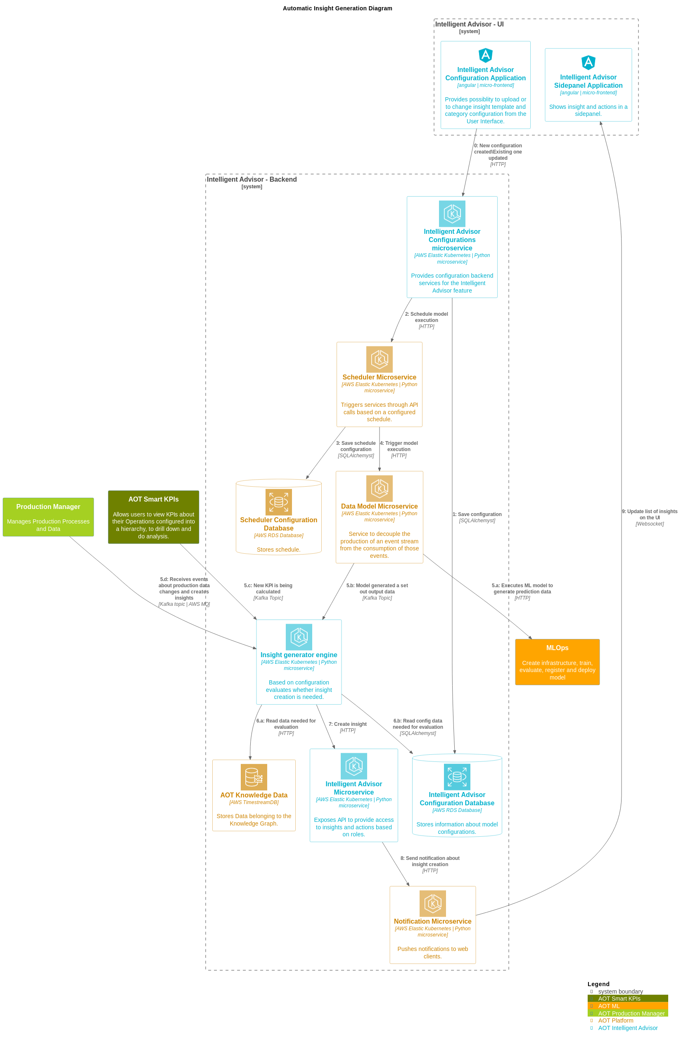

Microservices
This section describes these five microservices that are used to generate Insights:
- IA-config microservice
- Generic Scheduler Microservice
- ML-Model Microservice
- Evaluatemodel Microservice (Insight Generation Engine)
- IA Middleware microservice

IA-config microservice
The IA-config microservice is the first step depicted in the flow diagram in the previous section. It handles configuration based on the Plant/Multiplant for the insights listed in the table below. Insights get generated based on Plant/Multiplant.
Insight | Description
Insights based on KPIs | Create Configuration API stores the list of KPIs values in model_configurations and dedicated_model_configuration table under AWS RDS.
Predictive Failure Configuration | Create Configuration API stores the algorithm, asset, configuration, and Impacted KPIs values in model_configurations and dedicated_model_configuration table under AWS RDS. Here impacted KPIs are optional for user selection.
This microservice does not allow the creation of Insights based on the configuration of the KPI with existing KPIs in AWS RDS DB, as well as for Predictive configuration algorithms with existing assets.

Configuration APIs
API | Description
Create configuration | This API inserts the configurations as configured from UI into to model_configuration and dedicated_model_configuration table in the AWS RDS.
Update configuration | This API updates the model_configuration and dedicated_model_configuration tables based on the configuration ID in AWS RDS.  - For Insight based on KPIs configurations, only the ActionIn field may be updated.  - For Predictive configurations, the Theme, Sub-type, Priority, Department, Role, Action in, Description, Frequency, Threshold, and Impacted KPIs may be updated.
Delete configuration | This API deletes the configuration from model_configuration and dedicated_model_configuration tables based on the configuration ID in AWS RDS.
Generic scheduler Microservice will trigger only after create/update/delete of predictive failure configurations.
More information on APIs can be found here: AOT Intelligent Advisor API Reference.

Generic Scheduler Microservice
The Scheduler Microservice is a service designed to facilitate task scheduling, allowing users to schedule tasks to be executed at specific intervals or on specific dates.
Three types of scheduling expressions are supported:
Expression | Description
Cron | Triggers tasks according to a specified cron expression
Interval | Triggers tasks at regular time intervals
Date | Triggers a task only once at a specified date and time
When utilizing the Cron or Interval types without start and end dates, the tasks are triggered infinitely.
This microservice is triggered to perform the CRUD operations (Create, Read, Update, Delete) of the saved IA configurations. The scheduler details are stored in AWS RDS, and the process is scheduled to trigger the ML Model microservice with configured frequency and asset. This is represented in steps 2, 3, and 4 in the Automatic Insight Generation diagram.
- Configuration for generating insights is taken from the latest configuration saved for that asset.
- The created process keeps running with the scheduled frequency and asset for which it was created.
- Scheduler time for the frequency configured by the user:
- Hour: Insert a number from 1-24.
- Day: Insert a number from 1-15.
- Minute: Insert a number from 1-60.
The below diagram describes Generic Scheduler and CRUD operations (Create, Read, Update, Delete) performed on tasks.
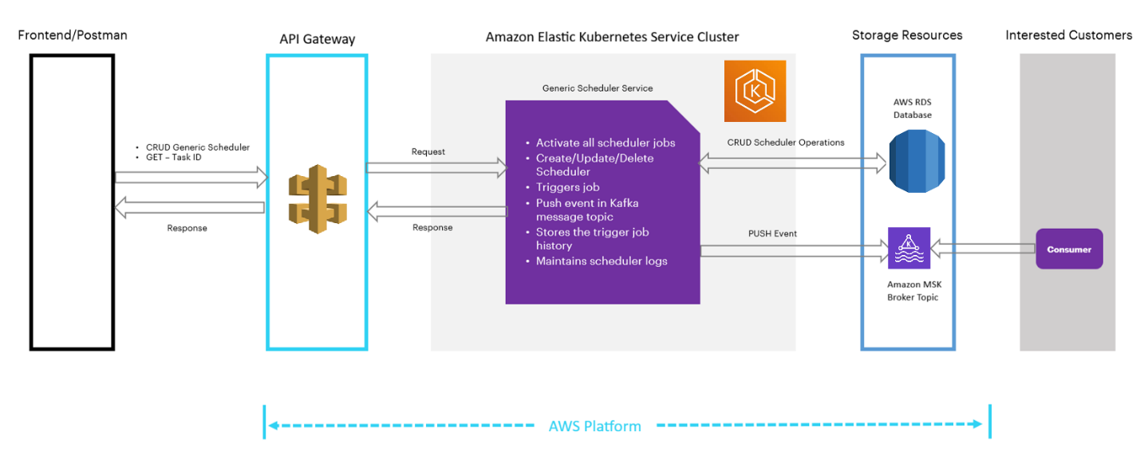
As shown in the previous diagram, both the AOT front end and the Postman client are used to interact with the scheduler. All the components in the diagram are briefly explained in the table that follows.
Component | Description
Frontend/Postman | Provides a user interface to interact with the Generic Scheduler. Users can perform CRUD operations on tasks through this interface.
Generic Scheduler | Handles the management of tasks and exposes APIs for CRUD operations
API Gateway (Amazon API Gateway) | Controls access to the Generic Scheduler's APIs and managing authentication and authorization.
EKS Cluster (Amazon Elastic Kubernetes Service) | Hosts the Generic Scheduler and related services. It activates all scheduler jobs and maintains scheduler logs.
Kafka Message Topic | A Kafka message topic is utilized to publish events (PUSH events) triggered by the Generic Scheduler. Consumers can subscribe to these events and process them.
Storage Resources | This component contains two main parts. First, Amazon RDS stores and manages information related to scheduler operations. This includes CRUD scheduler operations and triggers job history. Second, Amazon MSK Topic Broker (Consumers) acts as a message broker for Kafka topics. It allows consumers to subscribe and receive events pushed by the Generic Scheduler.

Generic Scheduler APIs
The generic scheduler APIs are described in the following table.
API | Description
RegisterTask API | This API inserts task details into the AWS RDS DB.
UpdateTask API | This API updates existing task details in AWS RDS DB based on the task ID.
DeleteTask API | This API deletes tasks from scheduled tasks. The deleted tasks are added to the table scheduled_tasks_log based on their task ID.
The APIs perform the following actions:
- Create/Update configuration: Once configurations are created or updated, Generic Scheduler APIs are called. Then, the schedule details are stored in the database 'sql-scheduler-db' and the process is scheduled. A message is triggered instantly. Then at the scheduled time, a message is produced to the Kafka topic. The produced message is consumed by the Model microservice's consumer file and the Evaluate Model microservice is run, which generates Insights.
- Delete configuration: After the delete configuration request is passed from the UI, the delete configuration API is called. The delete API deletes the data from the configuration database table and calls the Delete Scheduler API, which deletes data from the scheduler database table as well as the scheduler process.
Refer to AOT Generic Scheduler Technical Overview for more information about the Generic Scheduler Microservice APIs.

ML Model Microservice
The AOT Simulator in the IoT hub generates seven timeseries data: pressure1, pressure2, pressure3, temp1, temp2, vibration1, and vibration2. These are generated in real-time with a 1-minute frequency and are used as input for the ML model. The simulator is configured through a configuration file, where the data scientist specifies the limits and the details for the seven timeseries.
The ML model is trained outside of CDF, i.e., the client trains the model according to their requirements beforehand. Thus, the model is 'pre-trained'. The ML Model Microservice runs the pre-trained Model which is deployed in the same microservice as a pickle file. At a scheduled frequency, the ML Model microservice fetches seven timeseries from CDF for the selected asset, which is used as input to the pre-trained model to predict and calculate the failure probability. Once predictions are generated, it is stored in CDF as a timeseries, and the Message Broker will generate a message and produce the message to EventHub by subscribing to the topic (ia_evaluate_cv). Steps 4, 5, and 6 in the flow diagram describe this process.
Note that for the ML Model Microservice to perform CRUD operations, the middleware microservice, which consists of the CRUD APIs, must be deployed along with the ML Model Microservice. For more information on the middleware microservice, refer to section IA Middleware Microservice.

Evaluatemodel Microservice (Insight Generation Engine)
Evaluatemodel microservice evaluates whether insights need to be generated or not. This Microservice subscribes to two different Kafka topics. Evaluation for ML Model prediction and Smart KPI is event-driven now. Refer to steps 1, 2 (yellow), and 7 (purple) in the flow diagram.
Evaluation for the predictive failure ML model consumes messages from the topic (ia_evaluate_cv) and Smart KPI messages will be consumed from the topic (smart_kpi_schedule_sequencing)

ML Model Consumer
The predictive failure model consumer consumes message from ML model by subscribing to MSK topic (ia_evaluate_cv) and triggering Predictive Failure Evaluation Model.
Kafka Message Structure:
msg={
"Type": "Create",
"Scopes": ["Predictive Instance Value"],
"Timestamp": datetime.now().strftime("%Y-%m-%d %H:%M:%S"),
"Payload": [{"res_df":res_df.to_json(),"asset":asset_hierarchy}]
}

ML Model Evaluation
Messages sent by Model MS are consumed by the Evaluator MS and predicted values, timestamps, and assets are picked. Evaluation MS checks the latest configurations saved for the asset sent through the message broker and evaluates if the Insight needs to be generated by comparing predictions against the threshold from Configuration.
event_breach=EventBreachCount.ZERO.value
insight_type=InsightType.PARENT.value
for i in range(len(dataframePoints)):
if eval(str(dataframePoints['Pred_val'][i]) + condition + str(threshold)):
if insight_type==InsightType.PARENT.value:
print("Generate Insight")
else:
print("Check if sequence exists for insight, if not create and Log child
breach in sequence")
event_breach+=EventBreachCount.ONE.value
insight_type=InsightType.CHILD.value

Smart KPI Consumer
Evaluate microservice KPI messages from the MSK topic (smart_kpi_schedule_sequencing), and trigger the Smartkpi Evaluation model only when Scope is "SmartKPI Instance Value", Type is "Actual", and Status is "Success". Kafka message structure:
msg={
"Type": "Create",
"Scopes": ["SmartKPI Instance Value"],
"Timestamp": datetime.now().strftime("%Y-%m-%d %H:%M:%S"),
"Version": "1",
"Payload":[{
"KPIUID": kpidetails.external_id.split('_')[1],
"KPIName": kpidetails.metadata['Name'],
"AssetHierarchyLevel": kpidetails.external_id.split('_')[2],
"Asset": asset,
'actual_starttime': start_time.strftime("%Y-%m-%d %H:%M:%S"),
'actual_endtime': end_time.strftime("%Y-%m-%d %H:%M:%S"),
"Type": "Actual",
"Status":"Success",
"Reason":str(ex)
}]
}

Smart KPI Evaluation
Whenever a Message is generated by the Smart KPI engine, this microservice checks if configuration exists in the database for the calculated KPI and evaluates smartkpi insights. It checks the RAG status and generates insight by comparing the actual and target values.

status=[RagStatusEnum.RED.value,RagStatusEnum.AMBER.value,RagStatusEnum.GREEN.value]
actual_value=RAG_status["Actual"]['value']
limit = {}
for i in status:
j='{}-Mandatory'.format(i)
max = f"{i}_max"
min = f"{i}_min"
limit[max] = RAG_status['RAGStatus'][i][j]['max']
limit[min] = RAG_status['RAGStatus'][i][j]['min']

if RAG_status['kpiDirection']==KpiDirection.UP.value:
if i==RagStatusEnum.RED.value and actual_value<=limit[max]:
priority=PriorityStatusEnum.HIGH.value
break
elif i==RagStatusEnum.AMBER.value and limit[min] <actual_value<=limit[max]:
priority=PriorityStatusEnum.MEDIUM.value
break
elif i==RagStatusEnum.GREEN.value:
priority=PriorityStatusEnum.LOW.value
break
elif RAG_status['kpiDirection']==KpiDirection.DOWN.value:
if i==RagStatusEnum.RED.value and limit[min]<=actual_value:
priority=PriorityStatusEnum.HIGH.value
break
elif i==RagStatusEnum.AMBER.value and limit[min] <= actual_value < limit[max]:
priority=PriorityStatusEnum.MEDIUM.value
break
elif i==RagStatusEnum.GREEN.value:
priority=PriorityStatusEnum.LOW.value
break
if (actual_value<target_value and RAG_status['kpiDirection']==KPIDirection.UP.value) or (actual_value>target_value and RAG_status['kpiDirection']==KPIDirection.DOWN.value)

Print("Generate Insight")

IA Middleware Microservice
The IA Middleware Microservice's Insight Generation Engine API is triggered by the EvaluationModel Microservice (refer to step 7 in the flow diagram). This API is responsible for generating an insight.
Request Body of Insight Generation Engine
event_data={
"type":"Insight",
"subType":subtype,
"start_time":start_time,
"end_time":end_time,
"data_set_id":ts_dataset_id,
"asset_ids":ts_asset_id,
"metadata":meta_data
}
IA Configuration Database Structure
The following diagram describes the IA configuration database structure and how the microservices store and retrieve insights from the database.
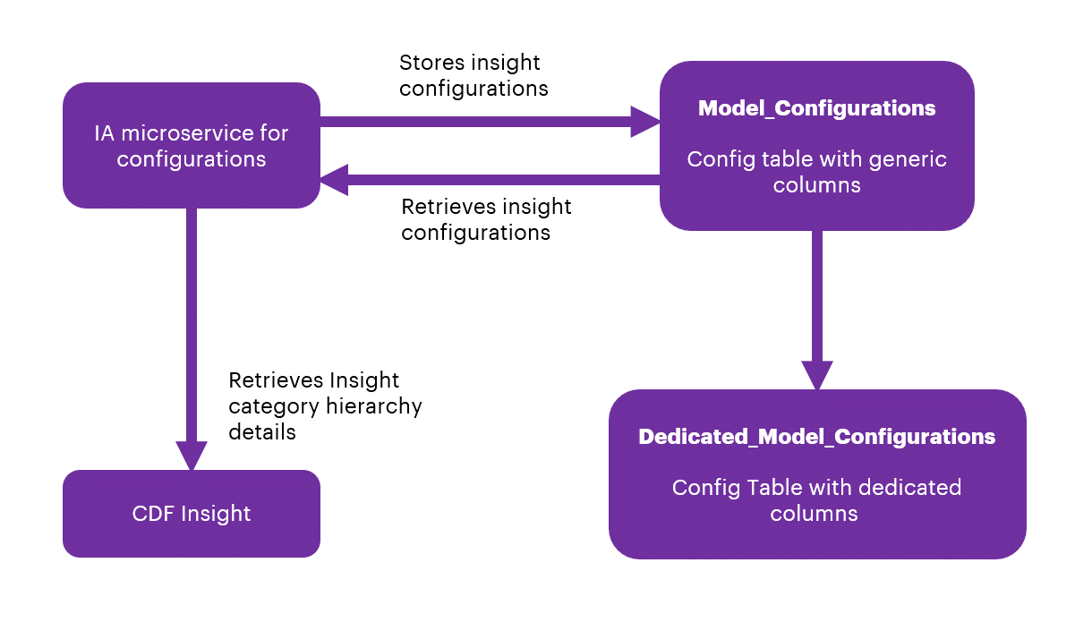
From the backend, through SQL Post query, the data from the UI will be stored in the AWS RDS database.
There are two tables in sql-ia-config-db-dev from AIR Replacement, which are:
- InsightCategoryConfigurationsParameters
- InsightCategoryConfigurations
Note that the first table (alembic_version) is the version of the SQL alchemy upgrade and not part of the database structure.
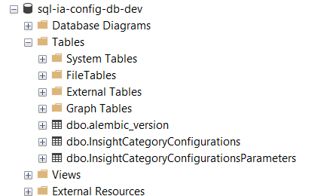

InsightCategoryConfigurations will have common fields listed below for both KPI and Predictive configurations:
- id
- category
- type
- theme
- subType
- template
- role
- department
- ActionIn
- createdBy
- createdDate
- configurationCategory
- trigger
- plant
- taskId
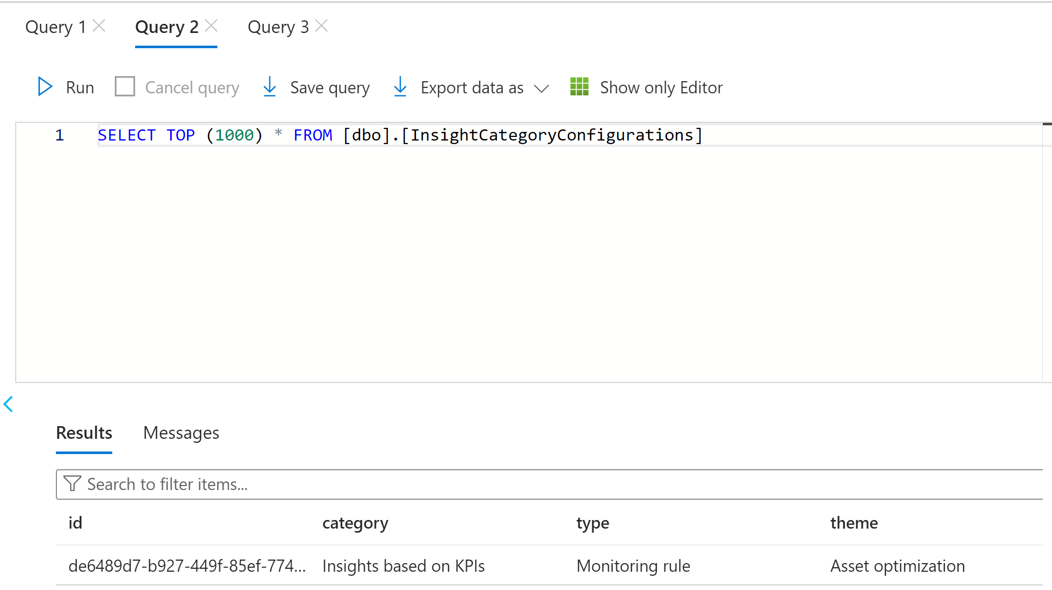
InsightCategoryConfigurationsParameters will have dedicated fields listed below for both KPI and Predictive configurations.

KPI configurations
- assetHierarchyLevel
- configId
- name
- uid

Predictive failure configurations
- priority
- algorithm
- assetList
- impactedKpis
- conditions
- frequency
- modelExecutionParametersId
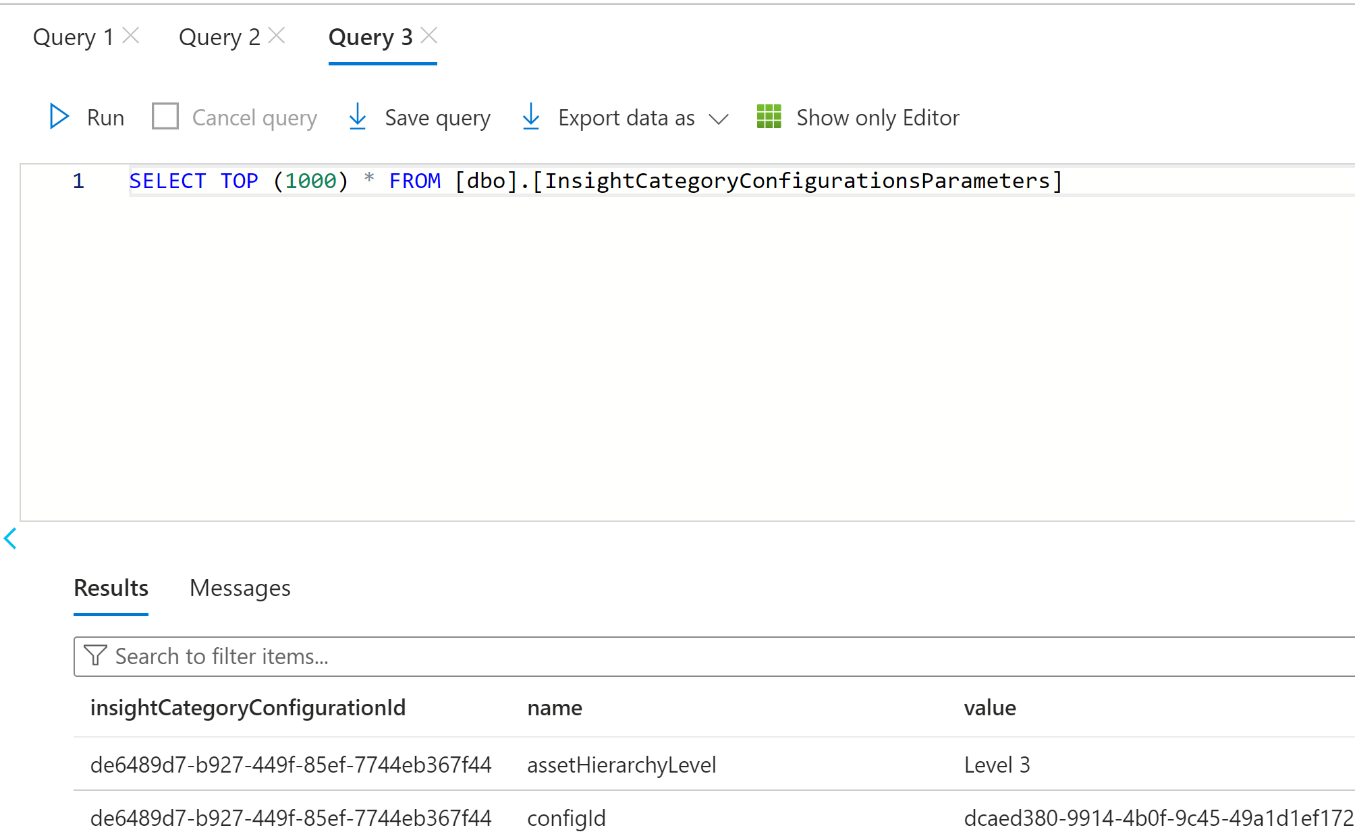

Generic Scheduler Database Structure
There are three tables in sql-scheduler-db: scheduled_tasks, scheduled_tasks_history, and scheduled_tasks_log.
- The scheduled_tasks table stores information about the active scheduled tasks. The string type parameters are creation_date, mod_date, Name, Parameters, scheduling_exp, Scope, and task_id.
- The scheduled_tasks_history table stores a history of events corresponding to the task triggers.
- The scheduled_tasks_log table stores information about the deleted scheduled tasks.
The following image shows the DB structure in AWS RDS.
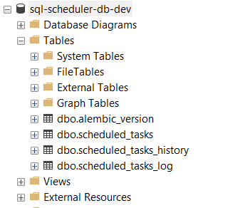

Archive Insights
The Archive Insight feature is a Python-based feature that serves as a mechanism for the automatic closure of insights and their associated actions upon reaching their expiry. The duration for expiration, termed the Expire Limit, is provided by the Business Analyst (BA) as per business requirements.
The key components of the Archive Insight feature are as follows:
- Scheduler: A task scheduler is implemented utilizing the existing generic scheduler API, configured to operate at hourly intervals. This scheduler orchestrates the periodic execution of subsequent tasks within the middleware microservice environment.
- Consumer: The consumer component is triggered on an hourly basis, initiating the invocation of the pertinent business logic code contained in the middleware microservice.
- Business Logic Code: Developed in Python, the business logic code encapsulates the functionality responsible for assessing the actionBy attribute of insights against the predefined expiration limit set by the BA. When the actionBy value surpasses the Expire Limit, the logic triggers the closure of the associated insight and its related action.

Use Cases (UC)

UC1 – Predicting Control Valve Failure
The diagram below shows the insight generation process for the control valve failure use case. The configuration of the model is saved in the IA Configuration DB. Configurable fields are listed in the adjacent table.

Flow
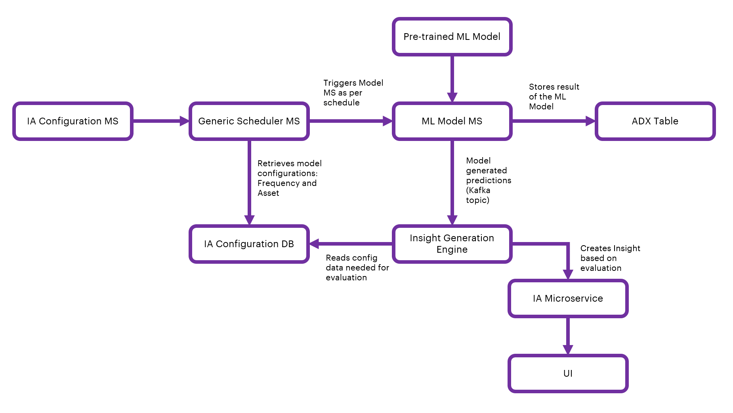

IA Configuration
Field | Description
Algorithm | Selection field (Predictive Failure Configuration category type)
Asset | Selection field to select Asset/Assets
Theme | Selection field (Predictive Failure Configuration Category theme)
Sub-type | Selection field (Predictive Failure Configuration Category Sub-type)
Priority | Selection field (High, Low, or Medium)
Department | Selection field to select Department from people management.
Role | Selection field from people management
Action in | Selection field when users should act upon the generated insight
Description | Text field for describing the insight
Frequency | Selection field to schedule predictive failure model
Threshold | Selection field to select a condition (equal, less than/greater than) for numeric threshold input(any number between 1 to 99)
Impacted KPI | Optional Selection field to select impacted KPI/KPIs

UC2 – Smart KPI for OEE

Flow
The flow diagram below shows the insight generation process for the OEE Smart KPI use case.
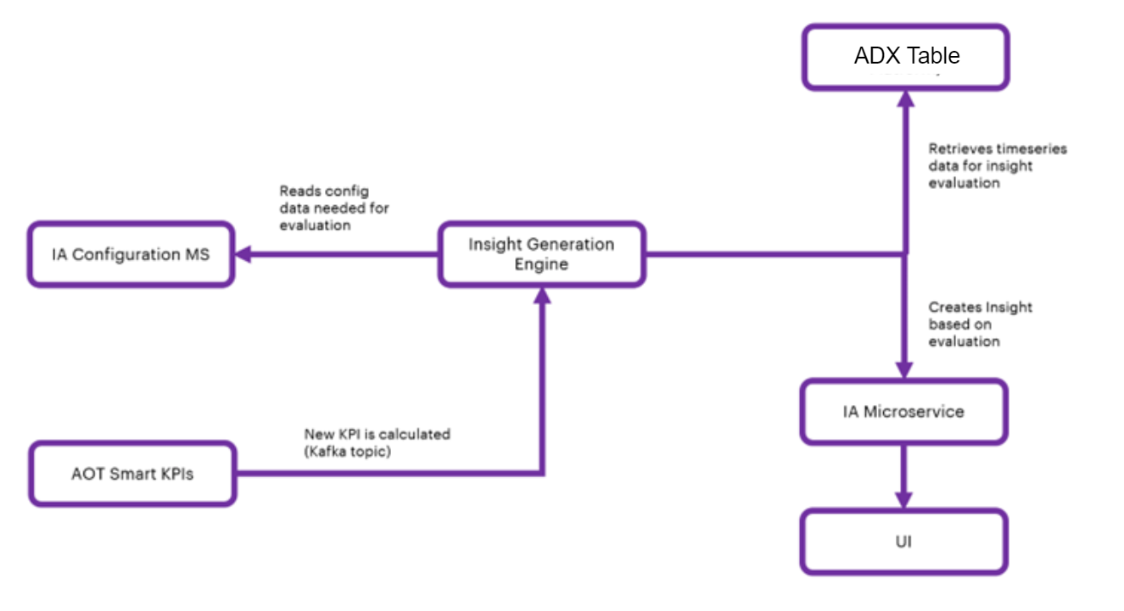

IA Configuration for Smart KPI Model
The configuration of the model is saved in IA Configuration DB. Configurable fields are listed in the table below.
Field | Description
KPI | selection field to select KPI/KPIs
Action in | selection field when users should act upon

Create a User Interface Template
To display the details of the Insight from Intelligent Advisor, a User Interface (UI) is needed. The specific information conveyed through the UI is controlled using templates. Each category of Insight will have its own template with both configurable and non-configurable elements.
A template is a way to roll out the information displayed about Insights. The details presented in the UI are based on the corresponding specific template. The UI will access data through predefined templates. The template will define the structure of the information that will be used in the UI, and it will define the way the information is organized in the display.
As shown in the diagram, each template will have a one-to-one mapping to the Insight categories. Templates are used to structure and organize data to your needs. The user can assign fields to the template and then assign values, or reference other data such as time series or assets. For the front end, the data can be taken from the back-end template and then passed to the application. The sections below explain how these template structures are created, updated, maintained, and customized by Accenture and then consumed by clients.
New Template categories can be created in the AWS RDS database with a table named Template_Category. To develop the viewer template, the following must exist:
- Template Excel sheet
- Function code
Follow the steps below to create the Template categories.
- Work with an AOT Business Analyst (BA) to create a properly formatted Excel template (example) containing the necessary details. The Excel file eventually gets converted to JSON format in the microservice code.
- Upload the JSON file to the CDF portal, which is automatically done through the microservice code.
- Deploy the function code in the Git repository.
- Run the pipeline to make the function appear in the CDF portal under the CDF function tab: CDF portal -> Explore -> Cognite functions.
- Run functions manually using Postman or visit either:
  - CDF Portal > Explore > Cognite functions to run.
  - CDF Portal>Explore>Cognite functions>Required function>Schedules to schedule.
- View the result in the CDF Portal (Explore>Explore data>Assets) by selecting AOT Configuration>Intelligent Advisor>Insight template hierarchy. The template hierarchy and relationship details are displayed on the right side and child nodes are displayed beneath the root.
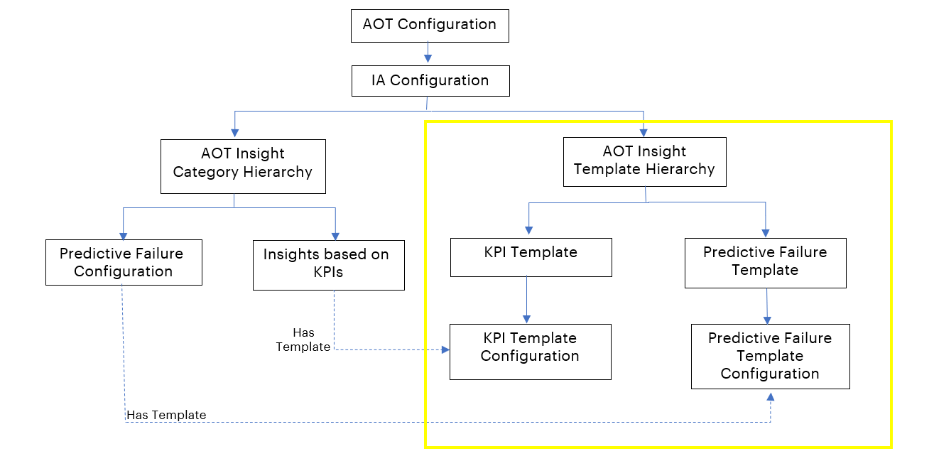
The screenshot below shows the IA configuration of the insight template heirarchy.

The template is used by the UI and has details about the insights.

KPI Data Permissions
- When the KPI role is updated, the KPI data permission microservice receives messages for updating the KPI role in the insight.
- KPI data permission microservice consumes the message (using Kafka topic), checks insights with similar KPI IDs, and updates the KPI role in insight role and role permissions fields.
{
'Timestamp': '2023-08-02 13:57:20',
'Scopes': ['Data Permission'],
'Version': '1',
'Type': 'Update',
'Payload':
[{
'Data Permission': {
'asset_hierarchy_level': 'System',
'config_id': '579aac71-08ac-4c19-92e5-f87464cacb0e'
'uid': 'f7c66e19-03a3-44b2-af5a-5bd4de87af2d',
'accessType': 'Owner',
'previous_value': 'Maintenance Manager',
'current_value': 'Reliability Engineer',
'plant_name': 'C-B1-G1-R1-F1',
'old_role_id': 'F93C62C1-9F1D-46E9-8497-C6D79E076961',
'new_role_id': '3BF3AFE6-8DE4-403A-932F-D84C24D4BCE9'}}
]
}

