
BUSINESS PROPOSAL
A complete booking & facility system for [Facility Name]
Live court availability, GCash / Maya payments, QR check-in, self-organizing Open Play and a full back office, in one platform built for pickleball in the Philippines.
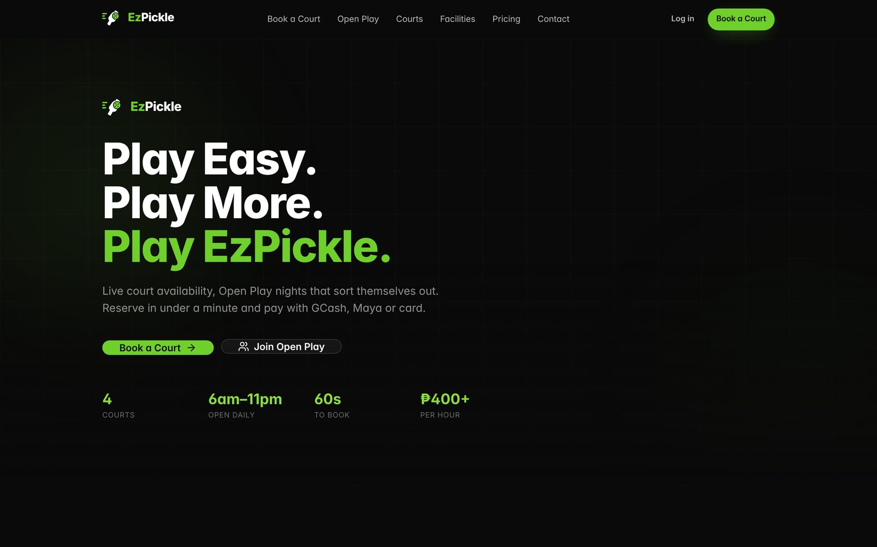

PREPARED FOR  [Client name, position] |  | PREPARED BY  [Your name], EzPickle |  | DATE · REF  [11 Nov 2026] · [EZP-2026-001]

EXECUTIVE SUMMARY

Fewer Messenger replies. Fuller courts. Cleaner books.
Thank you for the opportunity to work with [Facility Name]. This proposal outlines how EzPickle will run your court bookings, payments, Open Play and front desk from one system, starting [target go-live date].

What we heard  - Bookings come in through Messenger, calls and walk-ins, and staff confirm each slot by hand.  - Double-bookings and “available pa po ba?” back-and-forth cost time and customers.  - Payments are checked manually against screenshots.  - Open Play groups are sorted on paper and some players wait too long.  - [Add a pain point specific to this client, or delete] |  | What EzPickle changes  - Customers see live availability and book in under 60 seconds, 24/7.  - Double-booking is blocked at the database level, not just on screen.  - Payment is collected up front via PayMongo: GCash, Maya, GrabPay, QR Ph and cards.  - The auto-stacker builds skill-balanced Open Play courts in one click.  - You see revenue, bookings, utilization and stock on one dashboard.

< 60s  to book and pay for a court |  | 0  double-bookings, enforced by the database |  | 5  payment methods via PayMongo |  | 24/7  online booking, no staff needed

Scope for [Facility Name]
ITEM | DETAILS
Courts | [4] courts · [indoor / outdoor]
Operating hours | [6:00 AM – 11:00 PM daily]
Court rates | [₱500–₱700/hr, peak and off-peak]
Staff accounts | [1 owner, 2 managers, 4 front desk]
Domain | [book.yourfacility.ph]
FEATURE HIGHLIGHTS

What your players get
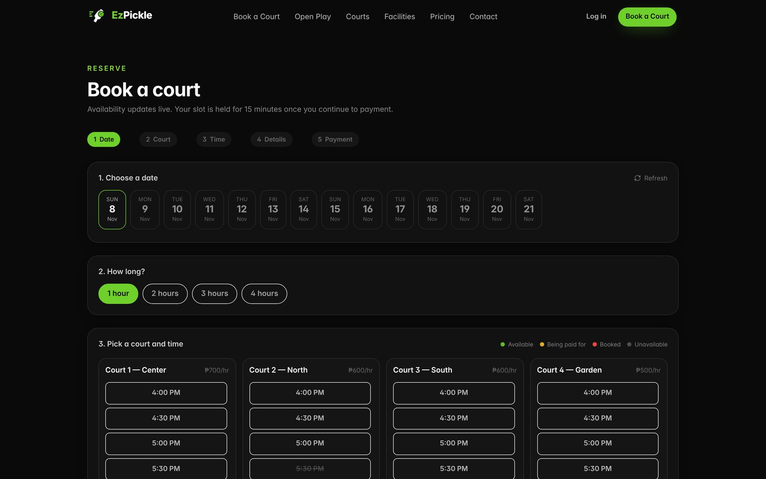
BOOKING PAYMENTS

Live availability and a 5-step booking flow
Players pick a date, court and time on a grid that updates in real time as others book. Their slot is held for 15 minutes while they pay with GCash, Maya, GrabPay, QR Ph or card through PayMongo’s secure checkout. Peak and off-peak rates are priced automatically, even across a booking that spans both.

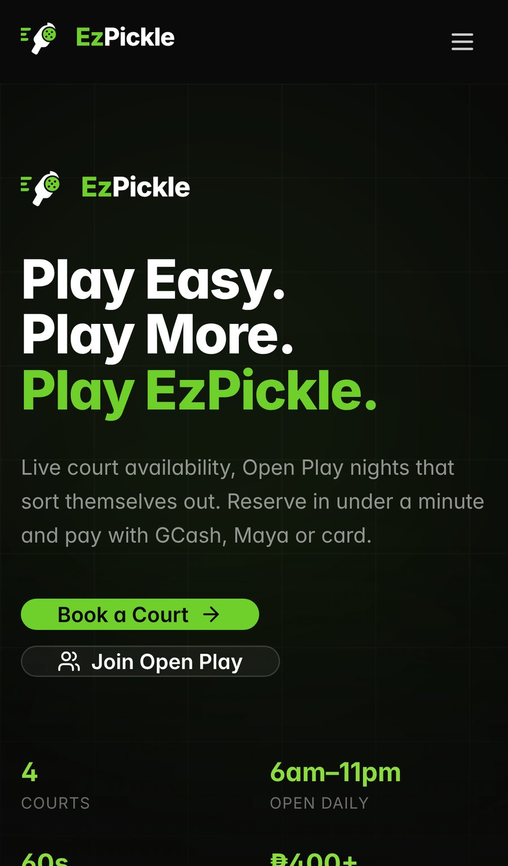 |  | MOBILE QR CHECK-IN  Made for phones, with QR check-in  Most bookings happen on a phone, so every screen is designed mobile-first. No app to download.  - Booking confirmation by email with a signed QR code.  - Front desk scans it with a phone camera or handheld scanner.  - Customer dashboard with upcoming bookings, payment history and profile.  - Promo codes for launches, loyal players and partners.
FEATURE HIGHLIGHTS

Open Play that sorts itself out
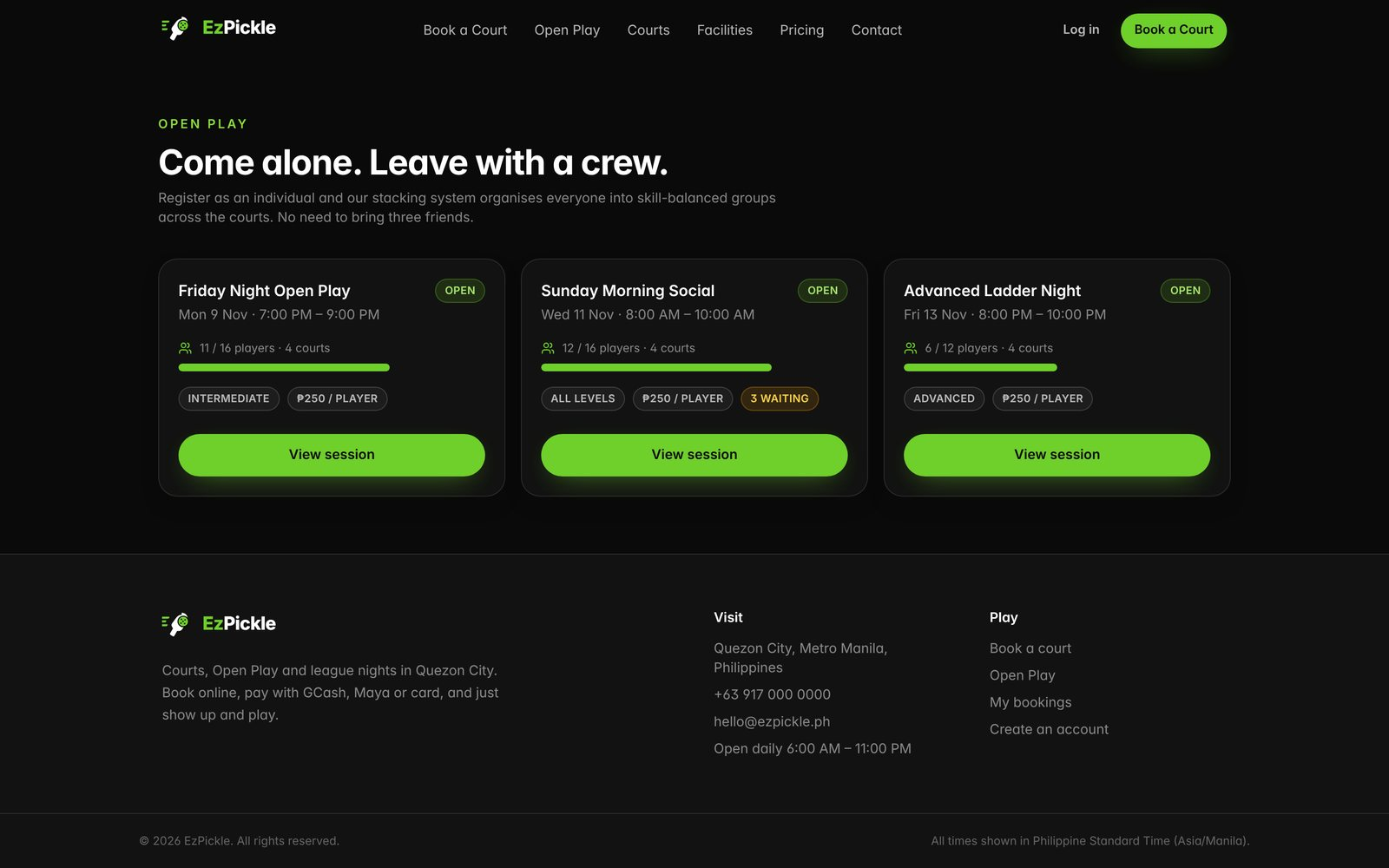
OPEN PLAY

Join solo, with a waitlist when it’s full
Players browse sessions by skill level, join and pay as individuals, and are added to a waitlist automatically when the session fills. When someone drops out, the next player is promoted.

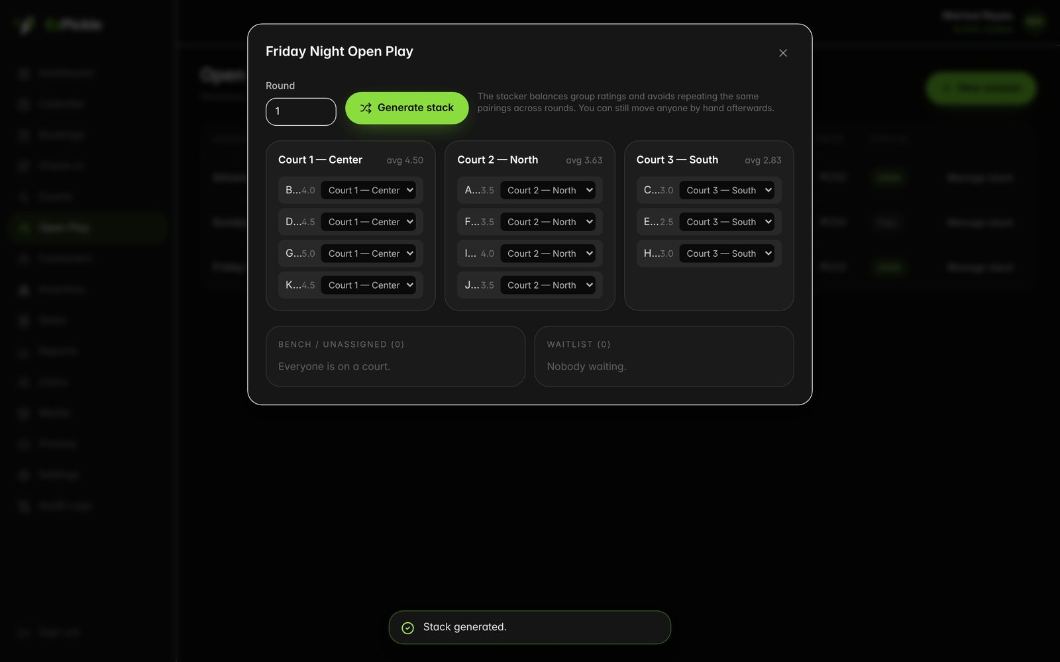
STAFF TOOL

One-click, skill-balanced court stacking
The auto-stacker groups players by rating and avoids repeating the same pairings across rounds. Courts never go over capacity, leftovers go to a clearly marked bench, and staff can move anyone by hand afterwards.
FEATURE HIGHLIGHTS

Run the whole facility from one place
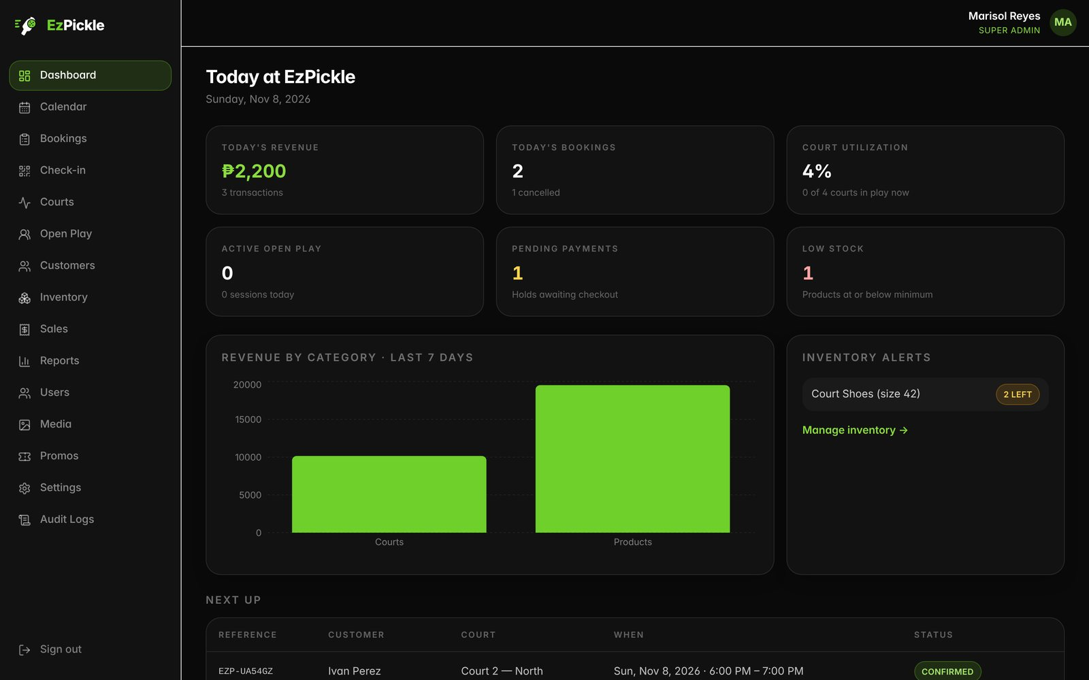
DASHBOARD

Today at a glance
Revenue, bookings, court utilization, active Open Play, pending payments and low-stock alerts the moment you sign in, plus the next bookings coming up.

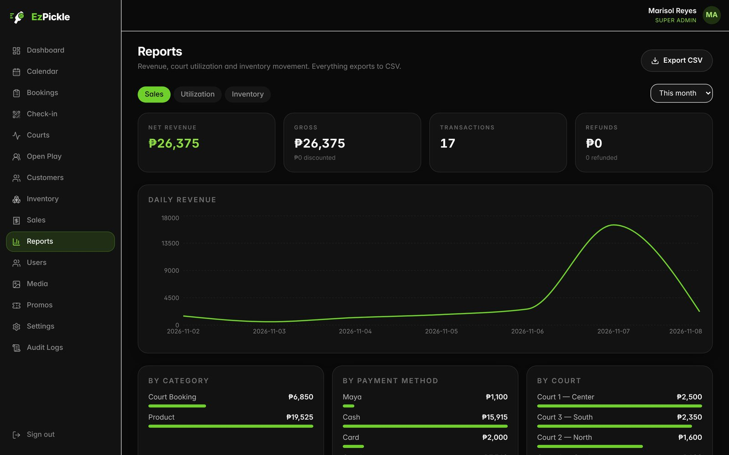
REPORTS CSV EXPORT

Sales, utilization and inventory reports
Break revenue down by category, payment method and court. Every report exports to CSV for your accountant.
EVERYTHING INCLUDED

Full feature list
Customer side  - Homepage with facility slideshow, court cards, pricing and Open Play preview  - Live availability grid, updating as other people book  - Five-step booking: date → court → time → details → payment  - PayMongo checkout: GCash, Maya, GrabPay, QR Ph, cards  - Booking confirmation email with a signed QR code  - Customer dashboard: bookings, payment history, profile  - Open Play: join solo, waitlist, see your stack |  | Staff & owner side  - Dashboard: revenue, bookings, utilization, pending payments, low stock  - Calendar: day grid, week and month views  - Walk-ins, rescheduling, cancellations and refunds  - QR check-in by camera or handheld scanner  - Courts, peak/off-peak pricing rules, maintenance blocks  - Open Play sessions with auto-stacker and manual overrides  - Inventory with movement ledger and counter sales  - Sales, utilization and inventory reports (CSV)  - Staff roles, promo codes, media manager, audit log

Built to be trusted with your money
No double-bookings, ever  Overlaps are blocked in three layers, ending with a database rule that no bug, second device or staff mistake can get around.  Accurate to the centavo  All amounts are stored as whole centavos and all times in Asia/Manila, so totals and reports always match. |  | Secure payments  Card and e-wallet details never touch our servers. PayMongo handles them, and every payment notification is signature-verified.  Role-based access and audit log  Front desk, managers and owners each see only what they need, and every sensitive change is recorded.
INVESTMENT

Packages
Edit or remove packages to suit this client. Prices exclude PayMongo transaction fees, which are charged by PayMongo directly.

Starter  ₱[0,000]  per month · up to [2] courts  - Online booking & payments  - QR check-in  - Dashboard & calendar  - Email support |  | RECOMMENDED  Club  ₱[0,000]  per month · up to [6] courts  - Everything in Starter  - Open Play & auto-stacker  - Inventory & counter sales  - Reports & promo codes  - Priority support |  | Pro  ₱[0,000]  per month · unlimited courts  - Everything in Club  - Custom domain & branding  - Multi-location ready  - On-site staff training

Quotation
ITEM | QTY | AMOUNT
One-time setup & data migration | 1 | ₱[0,000]
[Club] plan, first [12] months | [12] | ₱[0,000]
Staff training ([2] sessions) | [2] | ₱[0,000]
Discount [launch partner, remove if none] |  | −₱[0,000]
Total |  | ₱[00,000]

TIMELINE
WHEN | MILESTONE
Week 1 | Kick-off & setup. Courts, rates, hours, branding and staff accounts configured. PayMongo account connected.
Week 2 | Data & testing. Existing bookings and products imported. Test bookings and payments run end to end.
Week 3 | Training & soft launch. Front desk trained on check-in, walk-ins and Open Play. Regulars invited first.
[Go-live date] | Public launch. Booking link shared on your Facebook page and Messenger auto-reply.
NEXT STEPS

What we need from you
- Court names, rates (peak / off-peak) and operating hours
- A PayMongo business account (we’ll help you apply if you don’t have one)
- Logo, facility photos and your preferred domain
- Names and emails of staff who need access
- Products you sell at the counter, with prices and current stock

Terms  - This proposal is valid until [11 Dec 2026].  - Payment terms: [50% on signing, 50% on go-live; monthly plan billed in advance].  - Minimum term: [12 months].  - Your customer data stays yours and can be exported at any time.  - [Any other terms] |  | See it live  Book a walkthrough and we’ll show you EzPickle running with your own courts and rates.  [Your name]  [mobile number]  [email address]  [facebook.com/yourpage]

Acceptance
By signing below, [Facility Name] accepts this proposal and the [Club] package as quoted.

[Client name], [Position], [Facility Name]  Date: ____________________ |  | [Your name], EzPickle  Date: ____________________

Screenshots show EzPickle with sample demo data, not real customer information.

