Membership Extension for EZ Publish, version 0.1
Module by: Kristof Coomans
DRAFT Notes by: Paul Wilson, 20th February 2007

Document Purpose
The purpose of this document to help people interested in testing, using, and developing this extension.

At this stage, this document is made up of personal notes, general information about the Membership extension, and notes on a walkthrough of using the extension and its functions.

Screenshot images are taken in debug mode to indicate templates being used.

Contents

1 Extension Information 2
1.1 Related Information 2
1.2 Installation Overview 2
2 Functions & Dependencies Roadmap 3
3 Project / Group Extension(s) – An Overview 6
4 Walkthrough - Membership Functions 8
4.1 Joining a Group using Membership extension 8
4.2 Creating Permission for Membership Extension 9
4.3 Membership Workflows 11
4.4 Workflow Approve Membership - E-mail Notification 13
4.4.1 Cronjobs 14
4.4.2 Configuring Notification for Membership Approval 14
4.4.3 Membership approval e-mail 15
5 Notes / Comments / To Do / Ideas 16
5.1 Approving a Deleted Object? 16
5.2 Linking Content Area objects with Group Members? 16
5.3 Leave Group 16
5.4 Assigning: Event/Approve Membership 17
6 Appendices 18
6.1 Extension Settings 18
6.2 Document History 19

Extension Information
Last updated: Thursday 15 February 2007 7:46:35 pm
Author | Version | Compatible with
Kristof Coomans | 0.1 | 3.8+

Available from: http://ez.no/community/contribs/applications/membership

- Overall status – Alpha, a work-in-progress version.
- Some required functions missing but planned.

Related Information
- Forum Discussion - EZ Publish Projects Section (in development, K Coomans)
http://ez.no/community/forum/general/projects_section_on_ez_no
- Project: EZ Projects
http://pubsvn.ez.no/projects/plain_site_user/ezprojects
- Project Status, 17th Feb 2007
http://blog.coomanskristof.be/2007/02/17/ez-projects-status/

Installation Overview
The following steps were taken in order to have the extension working the way shown in this document.

- Upload Membership extension to extension directory of EZ Publish
- Activate extension via the Admin interface (setup/extensions).
- Patch as per Kristof’s notes – replace cronjobs/workflow.php with the file provided in the extension/patches directory.
- Add permission for registered users to access Membership module (see below).

Other notes:
- Using EZ Publish 3.9.0, with ezwebin package.
- Cronjob established to run EZ Publish workflows and notifications.

(A further explanation is provided in section 2, below).

Functions & Dependencies Roadmap

The following pages provide an overview of the functions of the module. This overview is presented as a table showing:

- Function – the function available to the site user/admin using the extension;
- Dependencies – the extension and EZ publish settings required for the function to work properly;
- Tests – ways to use the extension and the expected behaviour of the extension when it is being used;
- Evidence/Outcomes – the final outcomes of the function, and ways to check for evidence that it has worked.

Function | Dependencies | Tests | Evidence / Outcomes
0. (Basic Installation & Configuration)
Extension Installation | - EZ Publish 3.8+, note all testing for this document done on EZ 3.9.0  - Upload Membership extension to extension directory of EZ Publish site.  - Activate extension via the Admin interface (setup/extensions).
Configuration | - Establish role/policy for selected users to access membership/register function (see section 3.2 below).
1. Join Group (no approval workflow)
Join Group via Admin Interface | - (Basic installation and configuration) | - In administration interface, a single left click on an icon in the “content structure” navigation area will reveal the “context sensitive menu”. This will include a “Membership” menu item.  - Selecting this menu item will initiate the membership/register function for the currently-logged-in Admin user. (see section 3.1 below) | - Template/ message displayed that user is now a member.  - An extra location is created for the administrator user in the container object selected using the context sensitive menu. This can be verified by examining the administrator user object, and its listed locations.  - A further test is that the user object is also listed in the folder/user group where the “membership” was initiated.
Join via User Interface | - (Basic installation and configuration) | - Navigate to: (site)/membership/register/objectid  where objected is an existing object. (see section 3.1 below) | - (as above)
2. Join Group (with approval workflow)
(Using either of the join methods above) | - (basic installation and configuration)  - Cronjobs configured to run workflows/notifications for EZ publish site.  - Email Notification (optional):  Approving User (at the moment only Admin?) can edit their settings (my account / my notification settings) in the admin interface and tick the box for “collaboration notification – membership approval” (see section 3.4 below)  - Workflow must be configured for membership approval (see section 3.3 below) | - When the “join the club” button is pressed, a message is displayed to indicate that the membership is awaiting approval. (see explanation in section 3.3 below). | - Template/ message displayed that (i) membership is awaiting approval , and then when approved, (ii) same URL displays user is now a member.  - An extra location is created for the administrator user in the container object selected using the context sensitive menu. This can be verified by examining the administrator user object, and its listed locations. (see points above).

Project / Group Extension(s) – An Overview

According to Kristof C and related information links included above, the Membership extension is part of work towards creating a Projects area for EZ Publish.

Based on a brief review of these materials and some thinking about design, the following cross function diagram shows an overall process and comments that may be relevant to understanding/advancing this work.

If this appears too small to read, try zooming page or copying out to another application to zoom in on the jpeg diagram.

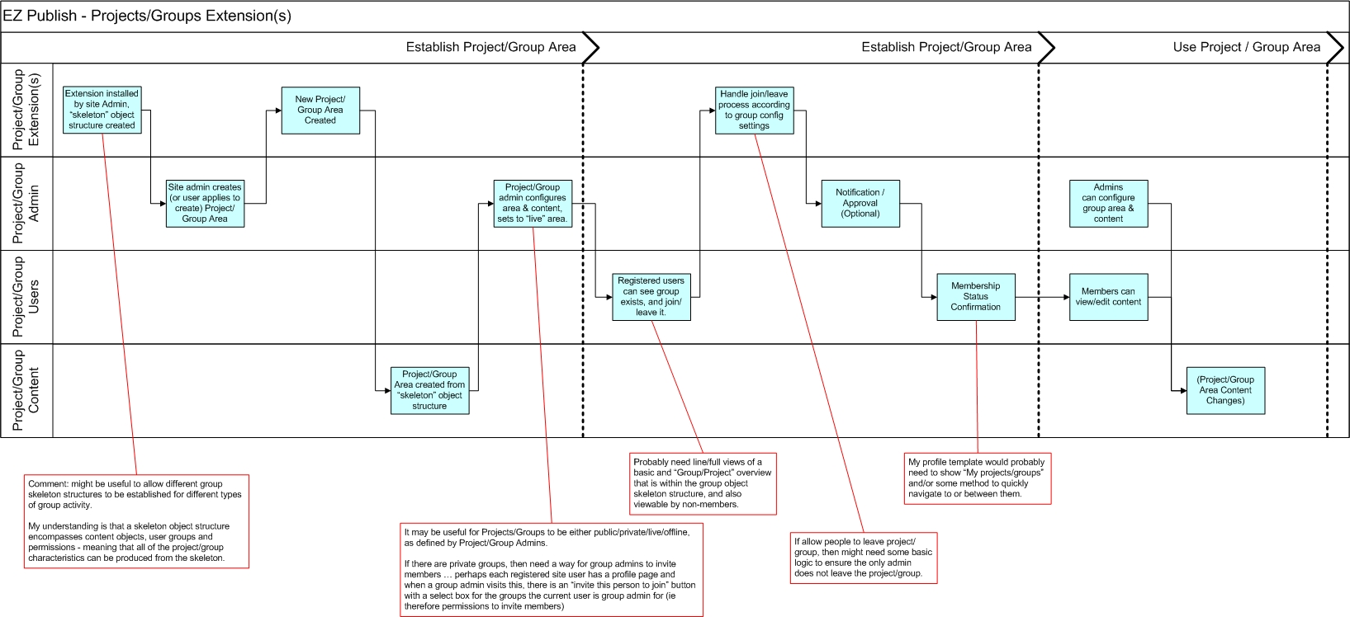

Walkthrough - Membership Functions

The following pages provide an overview/walkthrough of the Membership extension functions.

Joining a Group using Membership extension

The extension adds a “Membership” item to the EZ admin system’s context menu (see below).

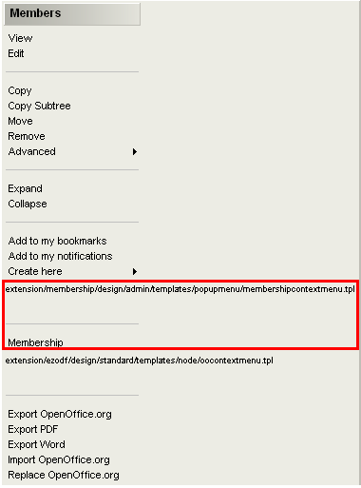

Clicking on this Membership menu item brings up a page with a URL like the following example:

www.ezpublishsitedomain.com/index.php/admin/membership/register/239

or accessing directly via the user siteaccess, as follows:
www.ezpublishsitedomain.com/index.php/eng/membership/register/239
The number at the end of the URL is an object id. Note that permissions need to be set to allow users to access the module, see Permissions section below.

In both cases the following template is loaded.



Clicking on the button adds an extra location for the currently-logged-in user, underneath the selected object. This applies whether the object is in the content structure or the user section.

The URL loaded is, for example:

www.ezpublishsitedomain.com/index.php/admin/membership/register/239

…and the following template is displayed.

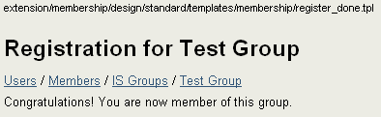

(There is not an unregister method in the current version of the Membership extension, version 0.1)

See below for workflow function information.

Creating Permission for Membership Extension
A permission needs to be added to allow (registered) users to have access to the Membership module. See below.
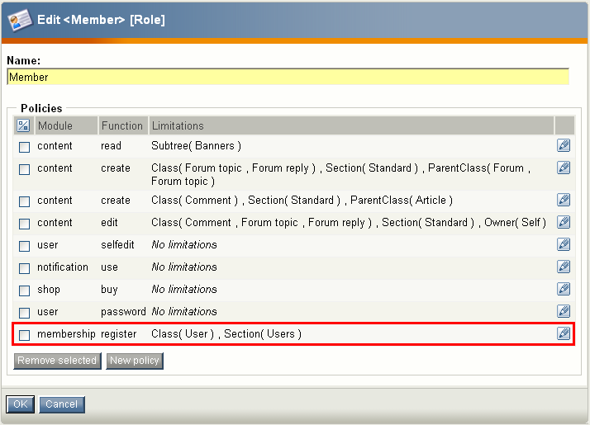

Note: Unresolved. It is possible to create policy “membership/register/no limitations”. Most of the work outlined in this document uses this setting. However it seems useful to limit this to the user class / user section as indicated above. I’ve not yet resolved how to have this operate for a basic registered (ie non-admin) user. They probably need some permission to the users section that is not dealt with using the method above.

Membership Workflows
The Membership extension adds an approve membership workflow (see below).
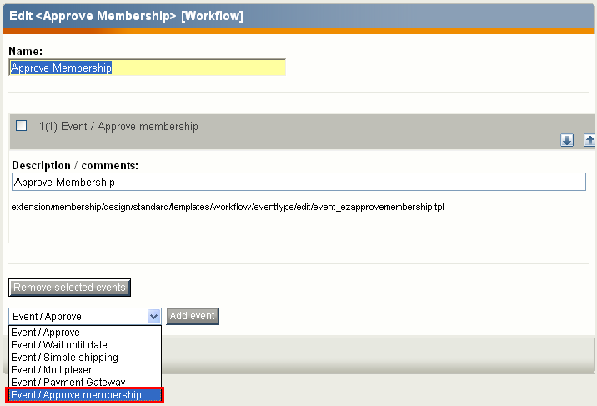

Further:
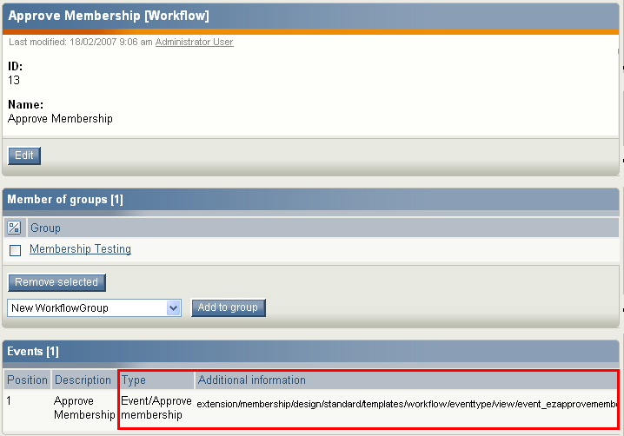
A trigger also needs to be established for the workflow:
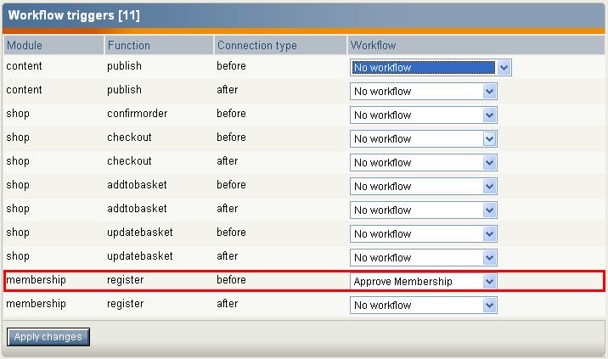

With this trigger and workflow established, it is possible to test this functionality by logging into the user siteaccess as a registered user (ie Member) and then going directly to a URL that uses the module. For example:

www.ezpublishsitedomain.com/index.php/eng/membership/register/239
(The “239” is an object id for an object representing the group/project for which the user is asking to become a member).

The following will be displayed:

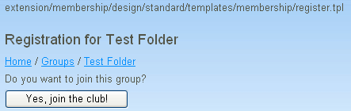

Clicking the join button will trigger the workflow, and the following page is displayed.

(Note that I only got this working for objects in the content structure. Adding to user groups is probably influenced by permissions).

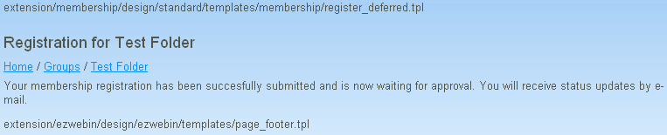

Looking in the collaboration/group/inbox as Admin user in admin site, the approval request is displayed.

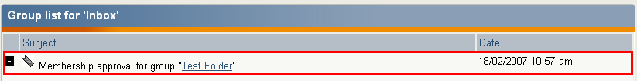

…and this can be approved in the normal manner.

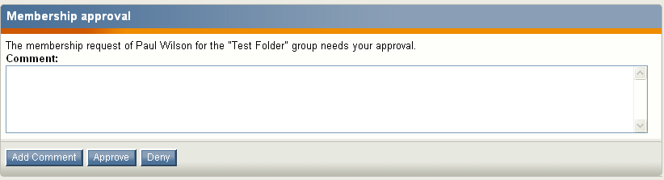

With this approval, the page now reports that the user is a member when refreshed/revisited, as shown below. (The URL remains www.ezpublishsitedomain.com/index.php/eng/membership/register/239).
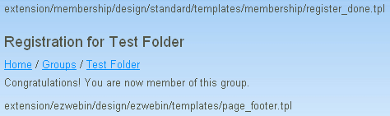

Workflow Approve Membership - E-mail Notification
An addition to the processes outlined in 3.3 above is to configure EZ Publish to send e-mail notification that a membership registration is awaiting approval. This section describes steps to configure this notification and a description of outcomes.

Cronjobs
E-mail notifications depend on an EZ Publish site having cronjobs enabled. This involves a server-level “cronjob” that periodically runs an EZ Publish php script. For example, in a Cpanel administers hosting environment, a cronjob like the following:

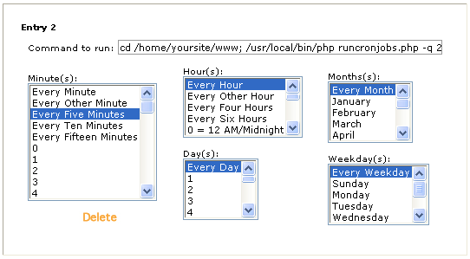

The full text of the “Command to run” used here is:

“cd /home/yoursite/www; /usr/local/bin/php runcronjobs.php -q 2>&1”

However this will change with hosting, server and installation arrangements. Refer to EZ Publish documentation/forums for more information.

Configuring Notification for Membership Approval

Log in to the EZ Publish as an administrator to the Admin Interface. Navigate to “My Account / My Notification Settings” and a page like the following will be displayed.

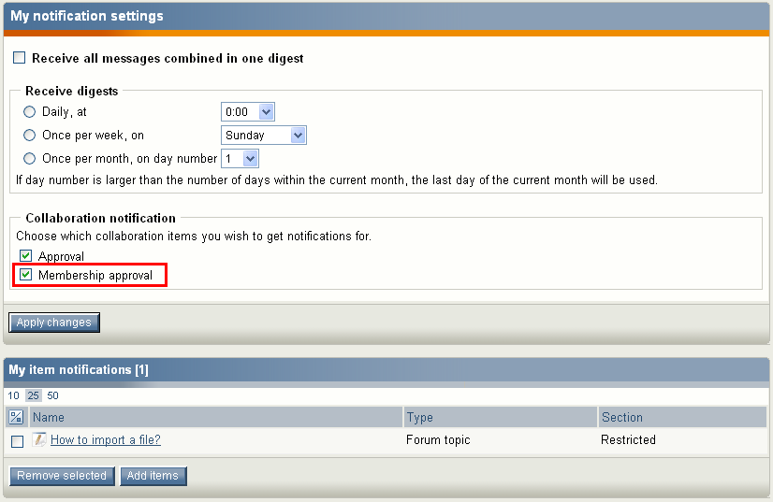

Tick the “membership approval” item indicated above to receive membership approval notifications. Note that these collaboration notification options are not available when editing settings via the user interface.

Membership approval e-mail

With the above steps completed, a membership/register action triggers an approval email being sent. The steps described in section 3.3 above can then be completed to approve/deny the membership registration.

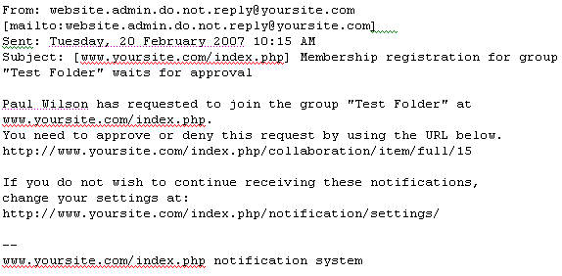

Notes / Comments / To Do / Ideas

Approving a Deleted Object?
I haven’t used workflow much, and this behaviour is probably expected in EZ. It doesn’t seem quite right though … not quite idiot-proofed enough for me.
- Login to the user site as a registered member, then go to the membership/register/(node) URL and click the button to register membership.
- (Approval workflow operating, so awaiting approval message)
- Login as admin to admin system.
- Delete the user-location object created by the Membership module (ie before it is approved/denied)
- This seems to create a weird loop where (1) if the membership is approved, then the deleted object is re-created in its original location, and (2) if that approved object is deleted, then the status goes back to awaiting approval, which leads back to (1).

Linking Content Area objects with Group Members?

- To get a group area working, I wrote simple (template) code that associates a content folder and a user group according to their common name. This is primitive and faulty in some circumstances, though it seems important to create this link. I haven’t spotted how this will be done in this extension. At the moment, users can’t be added to user groups from the public site without changing permissions – and adding user locations to a content area folder may be undesirable.

Leave Group

- I guess this is planned … option to leave a group. Though there needs to be some regulation of this. For example, having the only group admin/project manager leaving would mean the group had nobody in that role and it would not be possible to add someone to that role because nobody, other than site admin, would have permission.

Assigning: Event/Approve Membership

Comment: it seems useful to include/implement the functions of the Event/Approve workflow to select who can approve a group membership. This would allow the approve membership workflow to be pointed towards project/group admins.

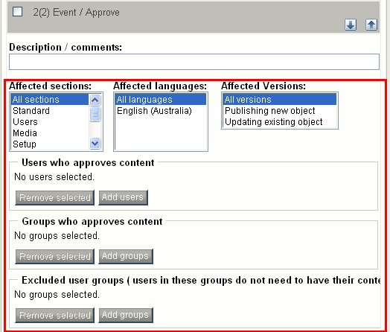

Appendices

Extension Settings
admininterface.ini.append.php
[AdditionalMenuSettings]
ContextMenuTemplateArray[]=popupmenu/membershipcontextmenu.tpl
SubitemsContextMenuTemplateArray[]=popupmenu/membershipsubitemscontextmenu.tpl

[Pop-up Menu Element – Admin Interface]

Content.ini.append.php
[ActionSettings]
ExtensionDirectories[]=membership

[Sets some basic nodes, custom tags, language/font and other settings]

Module.ini.append.php
[ModuleSettings]
ExtensionRepositories[]=membership
ModuleList[]=membership

[Basic module handling – recording existence for EZP]

Collaboration.ini.append.php
[HandlerSettings]
Extensions[]=membership
Active[]=ezapprovemembership

[Identifies collaboration-related modules to EZP]

Design.ini.append.php
[ExtensionSettings]
DesignExtensions[]=membership

[Identifies modules with design-related settings]

Workflow.ini.append.php
[OperationSettings]
AvailableOperationList[]=membership_register

[EventSettings]
ExtensionDirectories[]=membership
AvailableEventTypes[]=event_ezapprovemembership

[workflow triggers and event types set by extensions]

Document History

Version 0.05, 2007-02-18
- First draft version, 0.05.

Version 0.08, 2007-02-20
- Updated document with edits
- Added function & dependencies roadmap
- Added explanation of email notification
- Added cross-functional diagram / comments.

