 | xrow GbR  33449 Hannover  Germany  E-Mail: service@xrow.de


It is all about content sharing over websites
Table of contents

Requirements 1
Description 1
Concept 1
Installation Guide 3
Common extension setup 3
Database setup 3
Server Setup ( apply only to server installation ) 3
Client Setup ( apply to client installations ) 4
Approve Workflow Setup 4
User Guide 4
Client side 4
Server side 5
Trouble shooting 8
On commando line 8

Requirements
- eZ publish 3.6 and higher

Description

Concept
The content server enables multiple eZ publish instances to share a certain amount of content. Editors that provide content for a network of websites can mark any content object for export. Once marked for export an object is available to the client instances and an editor on client site can approve the import and move/publish the object to a desired location of satellite website. The content server also remembers the remote locations from the remote system and is able to map those locations to the appropriate locations on the client system.
The content server is the ideal solution for
- Portals and websites connected as a network
- Content sharing between different locations of a internet, intranet or extranet website
Your advantages
- Drastically cut costs by simplifying the work of your webmasters and content editors
- Content will auto update on satellite sites once a new version is out on the server side

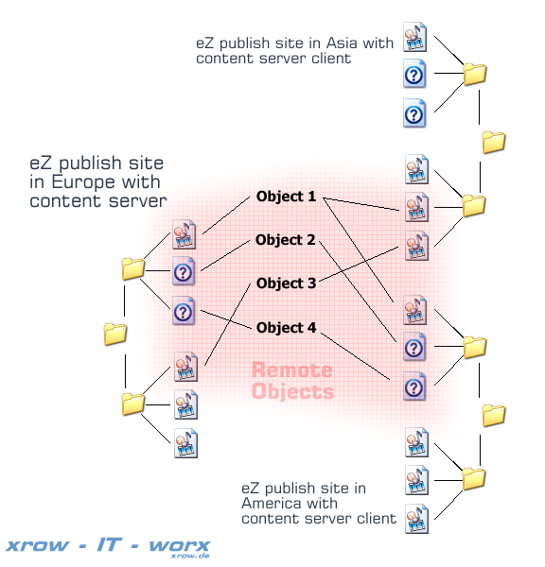
The content server is build as an extension to eZ publish. It does not modify any part of the kernel code. The extension provides
- A SOAP Interface
- Server side of the content server
- Client side of the content server
- Content server packagehandler
- An import approval workflow
  - Editors will get notified via email when new content is available
  - New content can be archived or directly published
- Automated placement of objects in the client system
  - Placement via Remote ID Path
  - Placement via Objectname Path
- A client side cronscript
- Additional webinterfaces
  - content approval
  - content export
  - content import ( incoming folder )
  - Interface to modify remote IDs

Installation Guide

Common extension setup
- Place the extracted folder named “contentserver” in the extension folder of your eZ installation.
- Login to your admin interface and activate this extension.

Database setup
php bin/php/ezsqlinsertschema.php --host=localhost --user=contentserver --password=123456 --insert-types=all --type=mysql --table-charset=utf-8 --schema-file=extension/contentserver/db_schema.dba extension/contentserver/db_schema.dba contentserver
Perform this step for the server and client database

Server Setup ( apply only to server installation )
- Enable the server
[ContentServer]
Client=enabled
- Define classes that should can be exported to a client system
[ContentServer]
NodeExportClassList[]=news
NodeExportClassList[]=article
NodeExportClassList[]=event
NodeExportClassList[]=glossary
NodeExportClassList[]=link
NodeExportClassList[]=file
SubtreeExportClassList[]=folder
- Create a new Role called “Content Exporter” with the ability to access the module content server and to read and edit certain content objects. Now apply this role to certain users or a group of users. Those users will later on permit that certain content can get exported.
- Create a new Role called “Content Importer” with the ability to read certain content objects. A Content Importer may import any content into his client installation that he can read and that was been marked for export before.

Client Setup ( apply to client installations )
- Enable the client in “contentserver.ini”
[ContentServer]
Client=enabled
- A new cronjob “contentserver.php” is available to the system. Implement this cron in your cronjob.ini.
- Override the content.ini and apply the content server’s hostname, you user name on the remote system and your password on the remote system to it.
[ContentServerSettings]
User=admin
Password=publish
Server=contentserver.example.com
Port=80
- Create a user that will be the owner of the imported objects
[ContentServerSettings]
LocalSystemUser=contentserver

Approve Workflow Setup
Optionally you can added the content server approve event to a workflow before publish to assure that nothing gets published on the client side without your permission. The event makes use of the collaboration system.
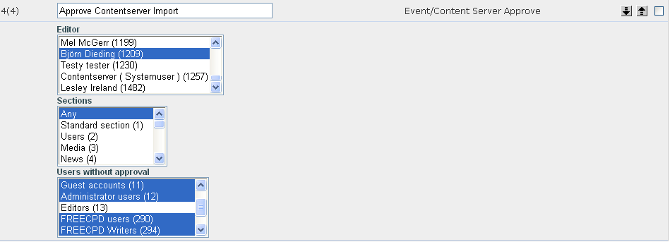

User Guide

Client side
To receive content from your global instance execute the commando line script by running:
php extension/contentserver/bin/contentserver.php –-user=admin –password=publish --remote-server=somehost.example.com
or by running the cron with preset values saved in the content.ini
php runcronjobs.php contentserver
Make sure you have the proper rights to read the content on the remote system. The connection can be secured over SSL.
View incoming content
http://admin.example.com/incoming
Do not edit your imported object, because any changes will be lost once the remote object has a newer version. You need to edit the global instance to apply changes to the content object. Locations/Nodes will not get updated so you can move your content to any place you want
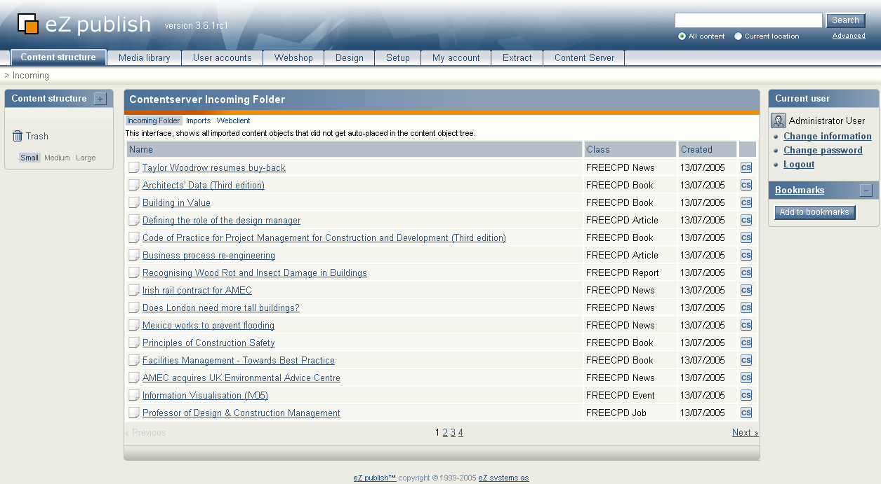
Force Update:
In order to update all content objects on a client please run the main executable for he content server with the option --force. Usually only objects get updated when there is a newer content object version available on the server-side.
php extension/contentserver/bin/contentserver.php --force
View all imported content
All imported and exported is identified by one Remote ID. You can use the Remote ID to lookup information on either the client or server side.
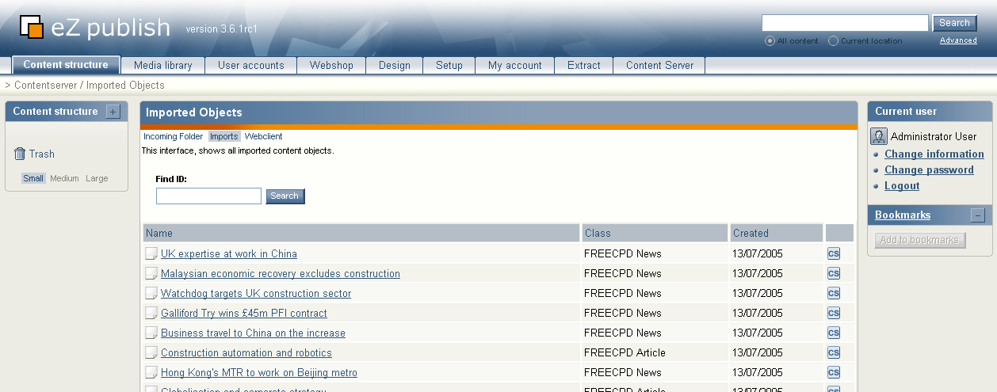
Server content webclient
If you don't have the option to run the content server via a cron you can also use it via a web interface. Additionally you have also the extra option to remove all imported content from a system.
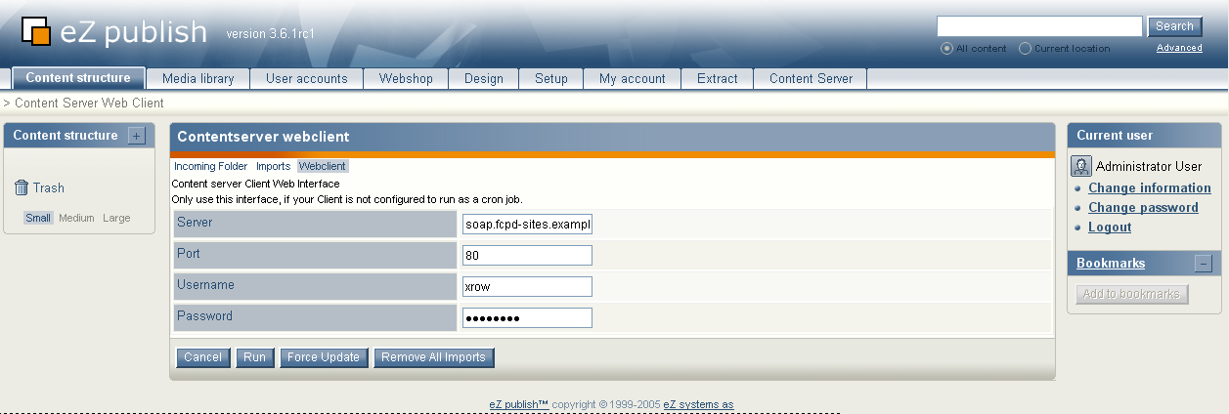

Server side
On server side you have the ability to mark Nodes export if you have the proper permissions. In the Content server export screen you have the option to define if the node should be exported as tree or as single Node. The Option “Expiry” can be used to expire content to the certain date on a remote system. In this case expired content will get completely removed from the remote system. The option “Update” defines if an object will get updated if a new version exists on server side else it will be just imported as the last published version. Once an object is exported you cannot remove it from the export though you can modify the export.
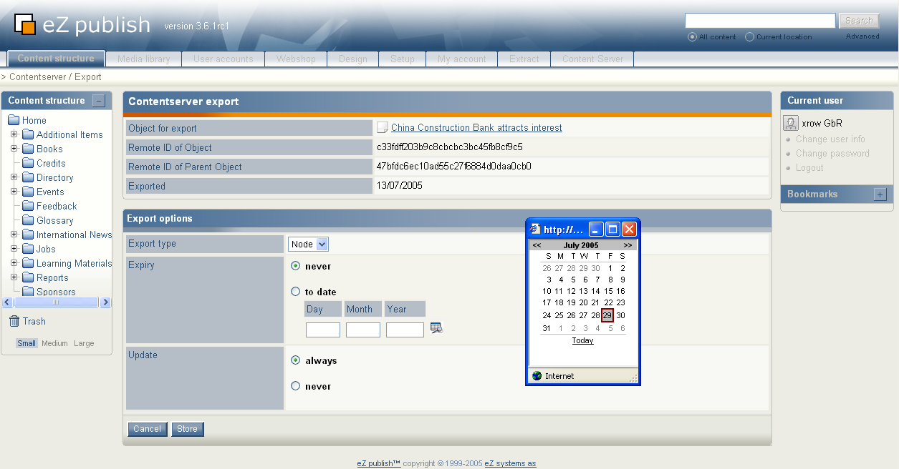
View all exported content
All imported and exported is identified by one Remote ID. You can use the Remote ID to lookup or edit information on server side.
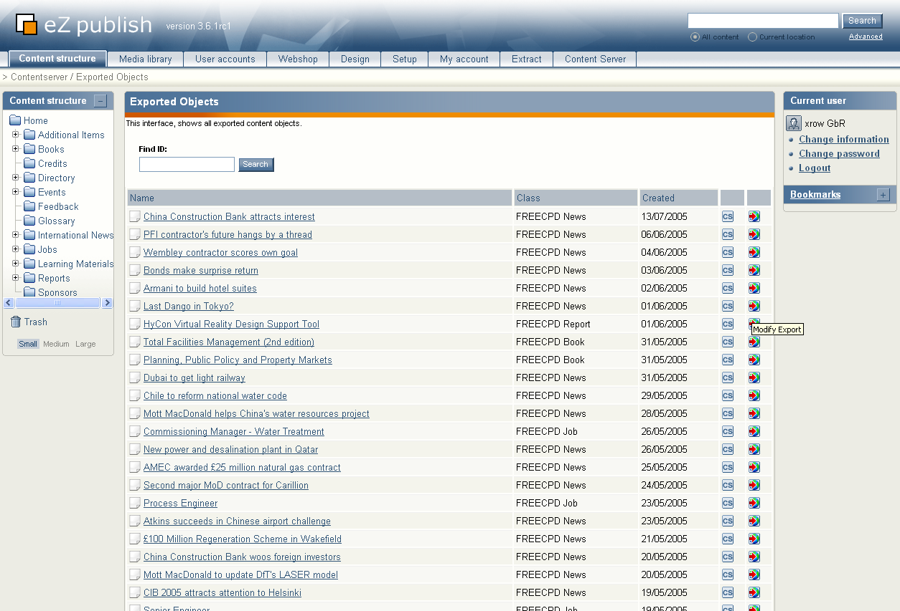
Viewing exported object information

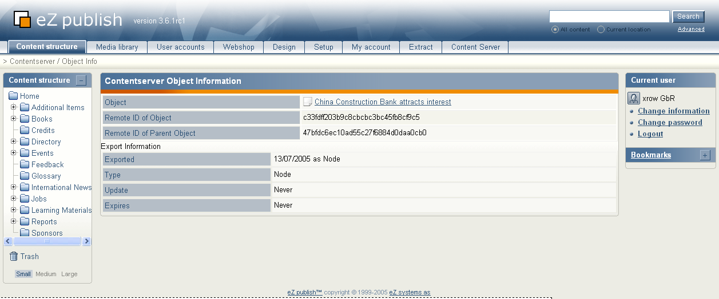

Reguirements for custom datatypes
All datatypes in eZ publish have the ability serialize and unserialize content object and content class info. The following functions have to be setup with each datatype ( file [mydatatypename] +"type.php" ) in your system.
- mydatatypenametype::serializeContentClassAttribute()
- mydatatypenametype::unserializeContentClassAttribute()
- mydatatypenametype::serializeContentObjectAttribute()
- mydatatypenametype::unserializeContentObjectAttribute()
Sample:
http://pubsvn.ez.no/doxygen/classeZXMLTextType.html

Trouble shooting

On commando line
-bash-3.00$ php -C extension/contentserver/bin/contentserver.php
Logged in as 'contentserver'
Using Siteaccess freecpdtv
Getting Content from "admin.fcpd-sites.co.uk"
Processing: 26209230fb46d03c1f8c89b6bd4eb914

Fatal error: Call to a member function on a non-object in /home/httpd/vhosts/freecpd.tv/httpdocs/kernel/classes/ezpackage.php on line 1474

Fatal error: eZ publish did not finish it's request
The execution of eZ publish was abruptly ended, the debug output is present below.
Please try to manually clear the package cache. Packages might have gotten locked in the cache.
rm –Rf var/storeagedirofsiteaccess/cache/package/
rm -Rf var/storeagedirofsiteaccess/storage/packages/object-*
Create a server from the imported object table
INSERT INTO ezcontentserver_export( id, created )
SELECT id, created
FROM ezcontentserver_import;

