

**2018 Judo Saskatchewan Winter Camp**

**Watrous Civic Centre**

**404 Main St, Watrous, SK S0K 4T0**

**December 21, 22 & 23, 2018**

Arrival time: Friday 5:30 - 6:00 PM

Pick up time: Sunday 12:30

Cost: $100 before December 10, 2018

$120 after December 10, 2018

Born in 2010 or earlier

Member of Provincial Judo Association

Must have slept overnight away from their parents.

**Register here:** [www.TrackieReg.com/2018JudoSaskWinterCamp](http://www.trackiereg.com/2018JudoSaskWinterCamp)

Guest Coach **Warren Seib**

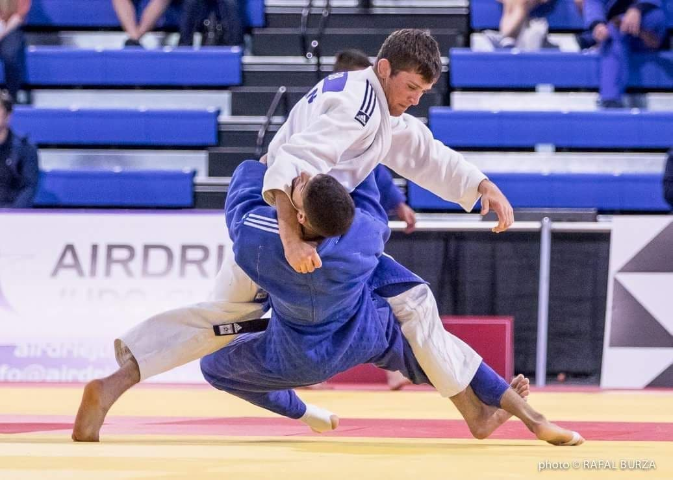

Important Things to Bring: Judo Gi’s Sleeping Bag & Pillow, Toiletries, Gym Cloths & Runners, Night clothing, change of clothing, Winter Clothing, Water bottle, Spending Money.