COLLEGE MUSIC STUDIES
MASTER SYLLABUS PACKAGE
Music Fundamentals • Music Theory I • Music Theory II • Sight Singing
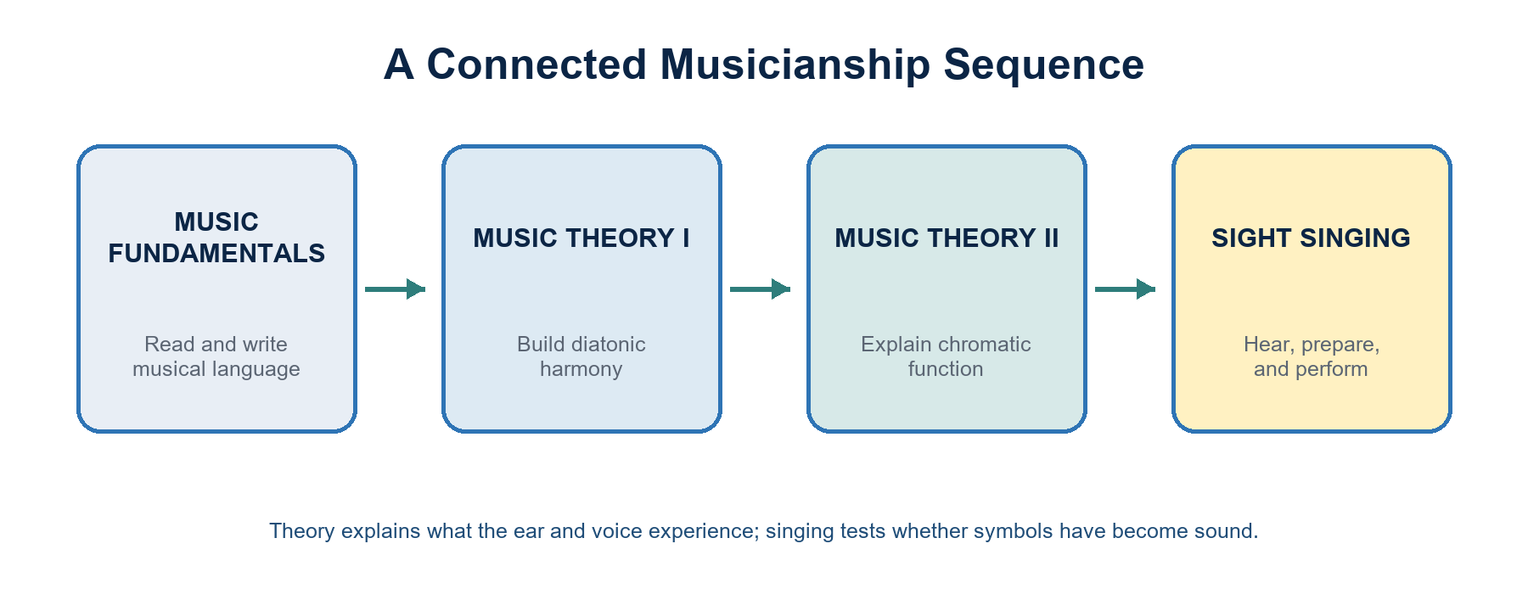
Designed for first- through fourth-year college students in the Philippines
18-week semester model | Outcomes-based | Mixed-experience friendly

EDITABLE FRONT MATTER
Course Setup Sheet
Complete once per course section before distributing to students.
Institution | [University / College] | College / Department | [Unit]
Academic year | [20__-20__] | Semester | [First / Second / Summer]
Course code | [Code] | Section | [Section]
Instructor | [Name and credentials] | Email | [Official email]
Class schedule | [Days / time] | Room / platform | [Room / LMS]
Consultation | [Schedule / booking process] | Units / contact hours | [Per institutional policy]

Recommended scheduling assumption: Music Fundamentals, Theory I, and Theory II are planned for three 60-minute meetings or equivalent each week. Sight Singing is planned for two 60-minute laboratory meetings. Adjust units and hours to institutional rules.

Primary learning resources
- Surmani, Andrew; Surmani, Karen Farnum; and Manus, Morton. Alfred's Essentials of Music Theory. Use the edition currently held by the instructor for Music Fundamentals.
- Benner. Theory for Piano Students. G. Schirmer (publisher). Use the instructor's volume/edition for Music Theory I and II.
- Snyder, Audrey. The Sight Singer, Volume 1. Use the instructor's edition for graded reading practice.
- Instructor-prepared keyboard examples, staff paper, recordings, and short excerpts that are public-domain, licensed, teacher-composed, or institutionally cleared.
Edition note: The weekly plans name topics instead of page numbers because editions and volumes differ. Enter the exact unit/page references before each term.

INSTRUCTOR GUIDE
How to Use This Package
A shared framework followed by four printable course sections and classroom appendices.
- Complete the Course Setup Sheet and copy the relevant details into each course section.
- Keep the sequence and outcomes; adjust repertoire, pacing, and textbook pages after the diagnostic.
- Use the activity toolkit for active practice. Each major concept should be heard, sung, played, written, and explained whenever possible.
- Project or print visual aids V1-V7. They are original summary graphics and do not reproduce textbook pages.
- Apply the included rubrics, then use the university's official grading conversion and attendance rules.

Shared teaching principles
- Sound before symbol: begin with listening, tapping, singing, or keyboard exploration before formal labeling.
- Spiral review: retrieve earlier skills in every meeting instead of isolating them in one unit.
- Multiple representations: connect staff notation, keyboard geography, solfège/scale degree, Roman numeral, and sound.
- Mixed-level access: offer a core task plus support and extension so first- and fourth-year students can work meaningfully together.
- Philippine musical context: include responsibly attributed examples from Filipino art, folk, sacred, popular, and contemporary traditions when suitable; discuss context rather than treating repertoire as decoration.
- Feedback cycle: attempt, diagnose, coach, retry. Improvement after feedback is part of the learning evidence.

Minimum materials
Students | Textbook access, pencil, eraser, staff paper, folder, headphones, phone/tablet when allowed | Room | Piano/keyboard, board, projector, speakers, metronome, moveable seating
Instructor | Prepared excerpts, answer keys, visual aids, LMS folders, accessible digital copies | Optional | MIDI keyboards, notation software, tuning app, document camera

STUDENT-FACING CORE
Shared Policies and Learning Support
Replace bracketed language with official institutional wording before release.

Attendance and participation
Regular attendance is essential because musicianship is cumulative and performance-based. Follow the institution's official absence and tardiness policy. Students should communicate documented or extended absences promptly and complete an agreed recovery plan.

Preparation
Bring assigned materials and complete short pre-class practice. Written work must be legible; performed work should show evidence of a deliberate preview and practice process.

Late work and make-up assessment
Use the institution's deadlines and make-up rules. Performance make-ups require comparable difficulty and may be scheduled individually or by recording when authorized.

Academic integrity
Submit your own analysis, notation, singing, and composition. Collaboration is allowed only when stated. Cite borrowed musical examples and acknowledge assistance.

Generative AI and digital tools
Notation, tuning, accompaniment, and AI tools may be used only when the task explicitly allows them. Students must disclose the tool and describe what it contributed. Tools may not replace a live skill check, closed assessment, or required personal analysis.

STUDENT-FACING CORE CONTINUED
Shared Policies and Learning Support
Accessibility, respectful participation, privacy, and institutional authority.

Accessibility and vocal care
Students may request reasonable access arrangements through the appropriate university process. Sight-singing can be transposed to a healthy range without changing difficulty. No student is required to sing through pain or illness.

Respectful learning environment
Use constructive language, honor names and identities, and discuss musical traditions with proper attribution and cultural care. Performance feedback addresses observable musical choices, not personal worth.

Privacy and recordings
Record classmates only with explicit permission and follow institutional policy and applicable privacy requirements. Assessment recordings are for instructional use unless additional consent is obtained.
Institutional authority: Official university, college, department, student handbook, accessibility, data privacy, safety, grading, and academic integrity policies supersede this adaptable template.

PROGRAM MAP
Curriculum Alignment at a Glance
The sequence develops literacy, analysis, creation, and independent musicianship.
Course | Core knowledge | Core practice | Culminating evidence
Music Fundamentals | Notation, rhythm, scales, keys, intervals, triads, basic form | Read • write • tap • play | Diagnostic portfolio + musicianship project
Music Theory I | Diatonic harmony, Roman numerals, SATB voice leading, cadences, phrase structure | Analyze • realize • compose • revise | Harmonization portfolio + analysis
Music Theory II | Seventh chords, tonicization, modulation, chromatic predominant harmony, mixture, form | Explain • transform • compose • defend | Chromatic analysis-composition project
Sight Singing | Pulse, rhythm, solfège/scale degree, interval and tonal reading, independent recovery | Preview • audiate • sing • reflect | Progress portfolio + final prepared/unprepared readings

Shared program-level outcomes
- PLO 1 - Decode and produce standard music notation accurately.
- PLO 2 - Hear, perform, and explain rhythmic, melodic, and harmonic relationships.
- PLO 3 - Analyze tonal music using appropriate terminology and notation.
- PLO 4 - Create short, stylistically coherent musical work and revise it from feedback.
- PLO 5 - Practice independently, collaborate respectfully, and communicate musical decisions clearly.

Recommended diagnostic in Week 1
Written (20 min) | Staff reading, rhythm, key signatures, intervals, triad spelling | Aural/performance (10 min) | Pulse echo, pitch matching, short tonal/rhythmic reading
Self-report (5 min) | Training history, instrument/voice, notation confidence, access needs | Use | Place supports, form mixed-level pairs, set practice targets; do not use as a punitive grade

COURSE 1 OF 4
Music Fundamentals
A foundation course in music literacy linking notation, rhythm, scales, keys, intervals, triads, listening, keyboard geography, and basic form. Designed for students with varied prior training.
Course code | [Insert code] | Units / hours | Recommended: 3 units / 54 contact hours
Prerequisite | None; placement or diagnostic information is used for support, not exclusion. | Primary text | Alfred's Essentials of Music Theory
Delivery | In-person / blended / online as approved | Class section | [Insert section]

Course learning outcomes
Code | By the end of the course, students can... | Primary evidence
MF1 | read treble and bass clefs and orient pitches on the grand staff and keyboard | notation checks; keyboard lab
MF2 | notate and perform common note/rest values in simple and compound meter | rhythm labs; quizzes
MF3 | construct major and minor scales and identify key signatures | scale/key portfolio
MF4 | identify and construct diatonic intervals and basic triads | written and aural checks
MF5 | recognize basic harmonic function, cadences, texture, phrase, and form | listening map; analysis
MF6 | apply vocabulary while listening, singing, playing, and discussing music | oral explanation; activities
MF7 | create and revise a short notated melody with coherent rhythm and phrase shape | capstone composition
MF8 | use a planned, reflective practice process | practice log and reflection

ASSESSMENT AND GRADING
Music Fundamentals: Assessment Plan
Weights, evidence, and the shared improvement cycle.

Assessment and grading
Assessment component | Weight | What it measures
Short quizzes and notation checks | 20% | Accurate retrieval of symbols, terms, and constructions
Workbook / problem sets | 20% | Guided application and correction habits
Active musicianship labs | 15% | Tapping, singing, keyboard, and collaborative work
Midterm written-practical assessment | 20% | Weeks 1-8 integration
Final musicianship project + exam | 20% | Creation, notation, performance, and explanation
Professional learning habits | 5% | Preparation, reflection, respectful participation

Grade calculation: Calculate the weighted raw score shown above, then apply the official university grading/transmutation system. Publish the approved equivalent table in the LMS or course handout.

Learning evidence cycle
- Prepare: short reading/practice before class.
- Attempt: low-stakes first try.
- Diagnose: label the specific musical issue.
- Coach and revise: apply one targeted strategy.
- Demonstrate: submit or perform independently.

COURSE SCHEDULE
Music Fundamentals: Weekly Plan
Weeks 1-6 | Assign exact textbook pages from the edition in use.
Wk | Focus / assigned reading | Learning target | Activity + visual aid | Evidence
1 | Orientation; diagnostic; sound/symbol pathway | Establish baseline and personal targets | Diagnostic stations; V1 pathway; name-the-sound game | Diagnostic profile
2 | Staff, clefs, note names, ledger lines | Read/write pitches in treble and bass | Human staff; whiteboard relay; keyboard mapping | Exit ticket
3 | Grand staff, octave registers, accidentals | Connect notation to pitch location | Pitch scavenger hunt; error detective | Notation check 1
4 | Beat, tempo, note/rest values | Maintain pulse and compare durations | Body percussion; V2 rhythm tree; rhythm dominoes | Rhythm lab 1
5 | Simple meter; barlines; ties; dots | Notate and perform simple-meter patterns | Measure builder; conductor circle | Quiz 1
6 | Compound meter; subdivision | Distinguish beat and subdivision | Meter switch; rhythm translation | Problem set

Instructor preparation: Select short examples that match student voices and instruments; use public-domain, licensed, teacher-composed, or institutionally cleared excerpts. Provide printed and projected versions.

COURSE SCHEDULE
Music Fundamentals: Weekly Plan
Weeks 7-12 | Assign exact textbook pages from the edition in use.
Wk | Focus / assigned reading | Learning target | Activity + visual aid | Evidence
7 | Major scale; whole/half-step pattern | Construct and perform major scales | Keyboard scale lab; floor-step pattern | Scale check
8 | Key signatures; circle of fifths | Name and write major keys | V3 circle; key-signature relay; flash retrieval | Quiz 2
9 | Midterm review and assessment | Integrate notation, rhythm, scales, keys | Team review circuit; individual written-practical | Midterm
10 | Minor scales and relative/parallel keys | Construct natural, harmonic, melodic minor | Minor makeover; compare sound and spelling | Scale portfolio
11 | Intervals: number, quality, inversion | Identify and construct intervals | V4 flow; interval ladder; partner checks | Notation check 2
12 | Triads: quality, root, inversion | Spell and identify four triad qualities | Triad factory; keyboard verification | Quiz 3

Instructor preparation: Select short examples that match student voices and instruments; use public-domain, licensed, teacher-composed, or institutionally cleared excerpts. Provide printed and projected versions.

COURSE SCHEDULE
Music Fundamentals: Weekly Plan
Weeks 13-18 | Assign exact textbook pages from the edition in use.
Wk | Focus / assigned reading | Learning target | Activity + visual aid | Evidence
13 | Diatonic triads and Roman numerals | Label triads within a key | Chord card sorting; V5 function preview | Problem set
14 | Cadences and phrase endings | Recognize basic cadence types | Cadence corners; listening vote | Listening map
15 | Melody: motive, sequence, contour, phrase | Describe and shape coherent melody | Melody surgery; contour drawing | Capstone draft
16 | Texture, dynamics, articulation, basic form | Use expressive and formal vocabulary | Listening gallery; form cards | Analysis paragraph
17 | Capstone workshop and peer feedback | Revise notation and musical logic | Gallery walk; perform-and-revise conference | Final project
18 | Final integration; reflection | Demonstrate cumulative literacy | Written-practical exam; portfolio conference | Final exam + reflection

Instructor preparation: Select short examples that match student voices and instruments; use public-domain, licensed, teacher-composed, or institutionally cleared excerpts. Provide printed and projected versions.

TEACHING TOOLKIT
Music Fundamentals: Activity Toolkit
Ready-to-run protocols; scale the examples for mixed year levels.

Human Grand Staff
Time: 20-30 minutes
Setup: Tape five-line staves on the floor; prepare pitch cards.
Process: Teams place themselves or cards on called pitches, then translate to the keyboard. Add accidentals and ledger lines for extension.
Evidence: Photo/diagram plus an individual five-item transfer check.

Rhythm Construction Lab
Time: 35 minutes
Setup: Prepare value cards, meter cards, and blank measures.
Process: Groups build measures, perform them, exchange with another group, and repair any meter violations. Advanced students add ties, dots, and syncopation.
Evidence: Correct measure set and performed reading.

Key-Signature Relay
Time: 20 minutes
Setup: Post a blank circle of fifths and prepare key cards.
Process: Students place keys, signatures, relative minors, and dominant relationships. Require each placement to be explained aloud.
Evidence: Timed accuracy plus one written explanation.

One-Phrase Composition Studio
Time: Two class meetings
Setup: Provide an eight-measure frame and clear constraints.
Process: Students draft, sing/play, peer-review, revise, and submit a clean score with a short rationale.
Evidence: Notated melody, performance, and revision note.

COURSE 2 OF 4
Music Theory I
A first course in tonal analysis and writing emphasizing diatonic harmony, Roman numeral analysis, SATB voice leading, cadences, non-chord tones, phrase structure, and basic form.
Course code | [Insert code] | Units / hours | Recommended: 3 units / 54 contact hours
Prerequisite | Music Fundamentals or equivalent placement; keyboard familiarity is helpful. | Primary text | Benner, Theory for Piano Students
Delivery | In-person / blended / online as approved | Class section | [Insert section]

Course learning outcomes
Code | By the end of the course, students can... | Primary evidence
T1.1 | spell, invert, and classify intervals, triads, and seventh chords used in diatonic contexts | construction quizzes
T1.2 | analyze diatonic harmony with key, Roman numeral, inversion figure, and cadence | analysis portfolio
T1.3 | write stylistically controlled SATB progressions with correct spacing and tendency-tone treatment | voice-leading labs
T1.4 | realize figured-bass or Roman-numeral prompts at keyboard or in notation | practical checks
T1.5 | harmonize a melody or bass using functional progression and cadential closure | harmonization project
T1.6 | identify phrase, motive, sequence, cadence, and basic formal units | annotated score
T1.7 | diagnose and revise harmonic or voice-leading errors | chorale repair tasks
T1.8 | explain an analytical choice in clear musical language | oral/written defense

ASSESSMENT AND GRADING
Music Theory I: Assessment Plan
Weights, evidence, and the shared improvement cycle.

Assessment and grading
Assessment component | Weight | What it measures
Quizzes and timed constructions | 15% | Fluent spelling, labeling, and recognition
Problem sets / workbook | 20% | Sustained practice and corrected reasoning
Analysis and keyboard labs | 15% | Transfer among score, sound, and instrument
Midterm examination | 20% | Diatonic analysis and foundational voice leading
Harmonization portfolio + final exam | 25% | Integrated analysis, writing, and revision
Professional learning habits | 5% | Preparation, collaboration, reflection

Grade calculation: Calculate the weighted raw score shown above, then apply the official university grading/transmutation system. Publish the approved equivalent table in the LMS or course handout.

Learning evidence cycle
- Prepare: short reading/practice before class.
- Attempt: low-stakes first try.
- Diagnose: label the specific musical issue.
- Coach and revise: apply one targeted strategy.
- Demonstrate: submit or perform independently.

COURSE SCHEDULE
Music Theory I: Weekly Plan
Weeks 1-6 | Assign exact textbook pages from the edition in use.
Wk | Focus / assigned reading | Learning target | Activity + visual aid | Evidence
1 | Diagnostic; tonal review; interval fluency | Repair prerequisite gaps | Retrieval grid; interval speed rounds; V4 | Diagnostic plan
2 | Triads, inversions, open/close position | Spell and arrange triads accurately | Triad voicing cards; keyboard check | Quiz 1
3 | Key, scale degree, Roman numeral analysis | Label diatonic triads in major/minor | Roman-numeral stations; V3 | Problem set
4 | SATB ranges, spacing, doubling | Write singable four-part textures | V6 checklist; voice-range audit | Voice-leading lab 1
5 | Melodic motion; parallels; tendency tones | Connect chords without prohibited motion | Chorale repair shop; sing each line | Quiz 2
6 | Root-position progressions; harmonic function | Build functional phrase models | V5 function map; progression tiles | Mini-composition

Instructor preparation: Select short examples that match student voices and instruments; use public-domain, licensed, teacher-composed, or institutionally cleared excerpts. Provide printed and projected versions.

COURSE SCHEDULE
Music Theory I: Weekly Plan
Weeks 7-12 | Assign exact textbook pages from the edition in use.
Wk | Focus / assigned reading | Learning target | Activity + visual aid | Evidence
7 | Cadences and phrase structure | Identify and write cadence types | Cadence hunt; phrase brackets | Analysis 1
8 | First-inversion triads and bass-line shaping | Use I6/IV6/ii6 appropriately | Bass-line makeover; keyboard compare | Voice-leading lab 2
9 | Midterm review and examination | Integrate analysis and voice leading | Peer teach-back; individual exam | Midterm
10 | Second-inversion triads: passing, pedal, cadential | Classify and control 6/4 functions | 6/4 sorting; error detective | Quiz 3
11 | Dominant seventh chord; preparation/resolution | Resolve chordal seventh and leading tone | Resolution arrows; sing inner voices | Problem set
12 | Diatonic seventh chords | Analyze and resolve common seventh chords | Chord-quality matrix; keyboard loop | Analysis 2

Instructor preparation: Select short examples that match student voices and instruments; use public-domain, licensed, teacher-composed, or institutionally cleared excerpts. Provide printed and projected versions.

COURSE SCHEDULE
Music Theory I: Weekly Plan
Weeks 13-18 | Assign exact textbook pages from the edition in use.
Wk | Focus / assigned reading | Learning target | Activity + visual aid | Evidence
13 | Non-chord tones I: passing, neighbor, suspension | Label and compose basic embellishments | NCT color-coding; suspension chain | Quiz 4
14 | Non-chord tones II: appoggiatura, escape, anticipation, pedal | Distinguish embellishments in context | Listening/score stations | Annotated score
15 | Melody harmonization planning | Choose bass, function, cadence, rhythm | Harmonization decision tree | Portfolio draft 1
16 | Figured bass / Roman-numeral realization | Realize a controlled progression | Keyboard-to-paper relay | Practical check
17 | Form: period, sentence, binary/ternary overview | Relate harmony to phrase design | Phrase map gallery; peer conference | Portfolio final
18 | Final examination and reflection | Demonstrate cumulative diatonic fluency | Written analysis/realization; oral defense | Final exam

Instructor preparation: Select short examples that match student voices and instruments; use public-domain, licensed, teacher-composed, or institutionally cleared excerpts. Provide printed and projected versions.

TEACHING TOOLKIT
Music Theory I: Activity Toolkit
Ready-to-run protocols; scale the examples for mixed year levels.

Chorale Repair Shop
Time: 35-45 minutes
Setup: Prepare a short teacher-composed SATB passage with 8-10 deliberate errors.
Process: Teams diagnose by category, propose a minimal repair, sing/play each line, and defend one revision. Extensions require two valid solutions.
Evidence: Annotated before/after score and defense.

Progression Tile Lab
Time: 30 minutes
Setup: Create cards for Roman numerals, inversions, bass notes, and functions.
Process: Students build a phrase from tonic through predominant and dominant, test at keyboard, then voice-lead the best solution.
Evidence: Progression map plus four-part realization.

Cadence Court
Time: 25 minutes
Setup: Prepare short cadence examples.
Process: One group argues for a cadence label using soprano/bass scale degrees and harmony; another group challenges the evidence.
Evidence: Individual cadence justification.

Harmonization Conference
Time: Two class meetings
Setup: Provide a melody with phrase marks and cadence goals.
Process: Students plan functions, draft bass, realize inner voices, peer-audit with V6, and revise after keyboard/singing feedback.
Evidence: Portfolio score, analysis, and revision memo.

COURSE 3 OF 4
Music Theory II
A continuation of tonal theory emphasizing seventh chords, tonicization, modulation, chromatic predominant harmony, mixture, altered harmony, formal function, analysis, and composition.
Course code | [Insert code] | Units / hours | Recommended: 3 units / 54 contact hours
Prerequisite | Music Theory I or equivalent. | Primary text | Benner, Theory for Piano Students
Delivery | In-person / blended / online as approved | Class section | [Insert section]

Course learning outcomes
Code | By the end of the course, students can... | Primary evidence
T2.1 | analyze and resolve diatonic and chromatic seventh chords | analysis and writing
T2.2 | identify and use secondary dominants and leading-tone chords | tonicization studies
T2.3 | distinguish tonicization from modulation and map pivot-chord processes | modulation analysis
T2.4 | analyze and write modal mixture, Neapolitan, and augmented-sixth sonorities | chromatic harmony labs
T2.5 | interpret altered chords through voice leading and harmonic function | oral/written defense
T2.6 | relate chromatic harmony to phrase, sequence, and larger form | formal analysis
T2.7 | compose and revise a short tonal passage using controlled chromaticism | capstone composition
T2.8 | compare multiple plausible analyses using evidence | analysis colloquium

ASSESSMENT AND GRADING
Music Theory II: Assessment Plan
Weights, evidence, and the shared improvement cycle.

Assessment and grading
Assessment component | Weight | What it measures
Quizzes and chord constructions | 15% | Fast, accurate chromatic spelling and labeling
Problem sets / analytical annotations | 20% | Consistent application and evidence
Keyboard, listening, and composition labs | 15% | Sound-symbol transfer
Midterm examination | 20% | Seventh chords, tonicization, modulation
Chromatic analysis-composition capstone + final | 25% | Integrated explanation, creation, and revision
Professional learning habits | 5% | Preparation, discussion, feedback practice

Grade calculation: Calculate the weighted raw score shown above, then apply the official university grading/transmutation system. Publish the approved equivalent table in the LMS or course handout.

Learning evidence cycle
- Prepare: short reading/practice before class.
- Attempt: low-stakes first try.
- Diagnose: label the specific musical issue.
- Coach and revise: apply one targeted strategy.
- Demonstrate: submit or perform independently.

COURSE SCHEDULE
Music Theory II: Weekly Plan
Weeks 1-6 | Assign exact textbook pages from the edition in use.
Wk | Focus / assigned reading | Learning target | Activity + visual aid | Evidence
1 | Diagnostic; review of diatonic function | Restore Theory I fluency | Function-map recall; chorale repair; V5/V6 | Diagnostic task
2 | Diatonic seventh chords in context | Analyze inversion and resolution | Resolution web; keyboard cycles | Quiz 1
3 | Sequences and expanded progression | Track pattern and function | Sequence strip puzzle; bass map | Analysis 1
4 | Secondary dominants | Spell and resolve V/x | Target-tonic game; arrow analysis | Problem set
5 | Secondary leading-tone chords | Spell and resolve vii°/x and vii°7/x | Chromatic spelling relay | Quiz 2
6 | Tonicization vs modulation | Use duration, cadence, and hierarchy as evidence | Evidence sort; listening timeline | Short response

Instructor preparation: Select short examples that match student voices and instruments; use public-domain, licensed, teacher-composed, or institutionally cleared excerpts. Provide printed and projected versions.

COURSE SCHEDULE
Music Theory II: Weekly Plan
Weeks 7-12 | Assign exact textbook pages from the edition in use.
Wk | Focus / assigned reading | Learning target | Activity + visual aid | Evidence
7 | Pivot-chord modulation | Identify common chord and new-key confirmation | V3 route map; pivot passport | Modulation lab
8 | Direct/common-tone modulation; phrase plan | Compare modulatory techniques | Before/after recomposition | Analysis 2
9 | Midterm review and examination | Integrate tonicization and modulation | Colloquium review; exam | Midterm
10 | Mode mixture / borrowed chords | Explain mixture by scale-degree alteration | Parallel-key overlay; color coding | Quiz 3
11 | Neapolitan chord | Spell, voice-lead, and contextualize N6 | Predominant comparison lab | Writing study
12 | Augmented-sixth chords | Distinguish It+6, Fr+6, Ger+6 | Interval-expansion model; resolution singing | Problem set

Instructor preparation: Select short examples that match student voices and instruments; use public-domain, licensed, teacher-composed, or institutionally cleared excerpts. Provide printed and projected versions.

COURSE SCHEDULE
Music Theory II: Weekly Plan
Weeks 13-18 | Assign exact textbook pages from the edition in use.
Wk | Focus / assigned reading | Learning target | Activity + visual aid | Evidence
13 | Altered dominants and enharmonic reinterpretation | Trace voice-leading purpose | Enharmonic pivot puzzle | Quiz 4
14 | Chromatic sequences and linear harmony | Separate local voice-leading from global function | Reduction workshop | Analysis 3
15 | Phrase/form with chromatic harmony | Relate harmonic events to formal function | Form-harmony timeline | Capstone proposal
16 | Capstone composition lab | Use chromaticism with structural purpose | Compose-play-sing-revise cycle | Draft + conference
17 | Analysis colloquium and portfolio revision | Defend an interpretation with evidence | Poster session; peer questions | Capstone final
18 | Final examination and reflection | Demonstrate cumulative analytical control | Analysis/writing exam; reflection | Final exam

Instructor preparation: Select short examples that match student voices and instruments; use public-domain, licensed, teacher-composed, or institutionally cleared excerpts. Provide printed and projected versions.

TEACHING TOOLKIT
Music Theory II: Activity Toolkit
Ready-to-run protocols; scale the examples for mixed year levels.

Tonicization Target Game
Time: 30 minutes
Setup: Prepare destination-chord cards and blank staff paper.
Process: Students draw a diatonic target, construct its applied dominant or leading-tone chord, resolve it, and explain altered tones. Advanced students create a two-link chain.
Evidence: Correct spelling, resolution, and functional explanation.

Modulation Route Map
Time: 45 minutes
Setup: Provide a short teacher-composed score that changes key.
Process: Students mark old key, pivot, reinterpretation, dominant preparation, cadence, and new key; then compare alternate readings.
Evidence: Annotated score and evidence statement.

Chromatic Predominant Laboratory
Time: 40 minutes
Setup: Prepare parallel phrase frames ending on V.
Process: Groups realize N6, It+6, Fr+6, and Ger+6 versions, sing critical voice-leading lines, and compare color and spacing.
Evidence: Four realizations plus comparison paragraph.

Analysis-Composition Colloquium
Time: Two class meetings
Setup: Students bring capstone score and one-page harmonic map.
Process: Presenters perform/play the passage, explain chromatic choices, answer evidence-based questions, and revise after feedback.
Evidence: Final score, analysis, presentation, revision memo.

COURSE 4 OF 4
Sight Singing
A progressive laboratory in rhythmic and melodic reading that develops audiation, tonal orientation, intonation, continuity, ensemble awareness, and reflective practice.
Course code | [Insert code] | Units / hours | Recommended: 1 unit / 36 contact hours
Prerequisite | Concurrent or prior Music Fundamentals recommended. Default system: movable-do with la-based minor; the instructor may substitute another consistent system. | Primary text | Snyder, The Sight Singer, Vol. 1
Delivery | In-person / blended / online as approved | Class section | [Insert section]

Course learning outcomes
Code | By the end of the course, students can... | Primary evidence
SS1 | establish tonic, pulse, meter, and starting pitch before reading | preview checks
SS2 | perform simple- and compound-meter rhythms with steady pulse | rhythm readings
SS3 | sing stepwise and triadic tonal patterns in major and minor | melodic readings
SS4 | read diatonic leaps through audiation and reference tones | individual checks
SS5 | maintain intonation, rhythmic continuity, and phrase direction | performance rubric
SS6 | recover musically after an error without stopping the pulse | one-take readings
SS7 | perform independently and in ensemble using solfège, scale degree, or assigned syllable | weekly portfolio
SS8 | diagnose a reading and plan the next practice step | reflection log

ASSESSMENT AND GRADING
Sight Singing: Assessment Plan
Weights, evidence, and the shared improvement cycle.

Assessment and grading
Assessment component | Weight | What it measures
Weekly individual sight-singing checks | 30% | First-read preparation, continuity, pitch, and rhythm
Rhythm reading and ensemble checks | 15% | Pulse, subdivision, meter, and coordination
Practice / reflection portfolio | 10% | Independent diagnosis and deliberate practice
Midterm prepared + unprepared readings | 20% | Cumulative Weeks 1-8 fluency
Final prepared + unprepared readings | 20% | Independent, musical reading at course level
Professional learning habits | 5% | Preparation, vocal care, supportive ensemble conduct

Grade calculation: Calculate the weighted raw score shown above, then apply the official university grading/transmutation system. Publish the approved equivalent table in the LMS or course handout.

Learning evidence cycle
- Prepare: short reading/practice before class.
- Attempt: low-stakes first try.
- Diagnose: label the specific musical issue.
- Coach and revise: apply one targeted strategy.
- Demonstrate: submit or perform independently.

COURSE SCHEDULE
Sight Singing: Weekly Plan
Weeks 1-6 | Assign exact textbook pages from the edition in use.
Wk | Focus / assigned reading | Learning target | Activity + visual aid | Evidence
1 | Diagnostic; healthy posture/breath; matching pitch | Establish starting skills and safe range | Call-and-response; V7 routine; range check | Diagnostic recording
2 | Pulse, beat division, simple meter | Read basic rhythms without pitch | Walk-tap-speak; conductor circle | Rhythm check 1
3 | Do-re-mi patterns; stepwise major | Read conjunct melodies | Tonal ladder; hand-sign echo | Melodic check 1
4 | Skips within tonic triad | Audiate do-mi-sol relationships | Triad arpeggio relay; anchor-tone map | Portfolio 1
5 | Simple-meter rests, ties, dotted values | Keep pulse through silence and sustain | Silent-beat circle; rhythm canon | Rhythm check 2
6 | Leaps of 3rd and 4th | Prepare and recover diatonic leaps | Interval frame; partner drone | Melodic check 2

Instructor preparation: Select short examples that match student voices and instruments; use public-domain, licensed, teacher-composed, or institutionally cleared excerpts. Provide printed and projected versions.

COURSE SCHEDULE
Sight Singing: Weekly Plan
Weeks 7-12 | Assign exact textbook pages from the edition in use.
Wk | Focus / assigned reading | Learning target | Activity + visual aid | Evidence
7 | Phrases, breath, dynamics, contour | Read musically beyond accuracy | Contour tracing; phrase relay | Expressive reading
8 | Compound meter and 6/8 patterns | Feel two-level beat structure | Macrobeat/microbeat movement | Rhythm check 3
9 | Midterm prepared and unprepared readings | Integrate preview, rhythm, pitch, recovery | Individual assessment and reflection | Midterm
10 | Minor mode and la-based minor default | Establish and read minor tonal patterns | Parallel-mode echo; minor anchor tones | Melodic check 3
11 | Leaps of 5th and 6th; inversion links | Use reference tones for wider leaps | Leap ladder; sing-fill-sing | Portfolio 2
12 | Anacrusis, syncopation, two-part rhythm | Maintain meter through displacement | Rhythm ensemble; role rotation | Rhythm check 4

Instructor preparation: Select short examples that match student voices and instruments; use public-domain, licensed, teacher-composed, or institutionally cleared excerpts. Provide printed and projected versions.

COURSE SCHEDULE
Sight Singing: Weekly Plan
Weeks 13-18 | Assign exact textbook pages from the edition in use.
Wk | Focus / assigned reading | Learning target | Activity + visual aid | Evidence
13 | Sequences and changed starting degrees | Track repeated patterns from new pitch levels | Sequence staircase; memory echo | Melodic check 4
14 | Chromatic inflections as introduced in text | Read altered tones from tonal context | Approach-resolve drill; keyboard drone | Individual check
15 | Two-part / partner sight singing | Maintain independent line and ensemble pulse | Duet carousel; listening partner rubric | Ensemble check
16 | Longer mixed reading; efficient preview | Prioritize hazards under time limit | 30-second scan challenge; coached retry | Mock final
17 | Final preparation and peer coaching | Apply personal practice plan | Sight-singing circuit; portfolio conference | Portfolio final
18 | Final prepared and unprepared readings | Demonstrate independent course-level reading | Individual assessment; reflection | Final performance

Instructor preparation: Select short examples that match student voices and instruments; use public-domain, licensed, teacher-composed, or institutionally cleared excerpts. Provide printed and projected versions.

TEACHING TOOLKIT
Sight Singing: Activity Toolkit
Ready-to-run protocols; scale the examples for mixed year levels.

Thirty-Second Scan
Time: 10-15 minutes daily
Setup: Project one short teacher-selected melody.
Process: Students silently identify key/tonic, meter, starting degree, rhythmic hazards, leaps, and phrase goal; then sing once without stopping and record one next step.
Evidence: Preview checklist and one-sentence reflection.

Recovery Drill
Time: 15 minutes
Setup: Use a melody with clear tonic/dominant anchors.
Process: The instructor deliberately signals an error point. Students keep pulse, aim for the next anchor, and rejoin. Debrief forward recovery rather than restarting.
Evidence: Continuity score and identified anchor.

Partner Drone and Leap Lab
Time: 20-25 minutes
Setup: Pairs, keyboard or tuning reference, interval cards.
Process: One student sustains tonic/dominant while the other sings target patterns; switch roles. Advanced students begin on non-tonic degrees.
Evidence: Accurate pattern set and peer feedback.

One-Take / Coached Retry Portfolio
Time: Weekly
Setup: Recording device when authorized; otherwise live conference.
Process: Perform a first take, annotate errors, choose one strategy, practice briefly, then record a second take without editing.
Evidence: Both attempts plus concise diagnosis.

APPENDIX A
Assessment Rubrics
Use the relevant rubric, add task-specific criteria if needed, and publish before assessment.

Written Analysis / Theory Work
Criterion | 4 - Exemplary | 3 - Proficient | 2 - Developing | 1 - Beginning
Accuracy | Labels, spelling, and notation are consistently correct. | Minor errors do not change the main interpretation. | Several errors weaken the interpretation. | Frequent errors prevent a valid reading.
Reasoning | Claims use precise, sufficient musical evidence. | Most claims have relevant evidence. | Evidence is partial or inconsistently linked. | Claims are unsupported or unclear.
Completeness | All required layers are addressed and connected. | Required layers are substantially complete. | Important layers are missing. | Response is fragmentary.
Communication | Notation and prose are clear, concise, and professional. | Meaning is clear with small presentation issues. | Presentation sometimes obscures meaning. | Presentation is difficult to follow.

Scoring note: Multiply criteria by the task weighting. For timed work, communicate any adjusted emphasis in advance.

APPENDIX A CONTINUED
Assessment Rubrics
Performance and composition criteria.

Composition / Harmonization
Criterion | 4 - Exemplary | 3 - Proficient | 2 - Developing | 1 - Beginning
Technical control | Harmony, notation, and voice leading are controlled throughout. | Mostly controlled with minor lapses. | Inconsistent control; revision is needed. | Technical issues obscure the musical plan.
Musical coherence | Phrase, function, and form create a convincing whole. | Plan is clear and mostly coherent. | Some sections lack connection or direction. | No sustained structural plan is evident.
Craft and purpose | Choices are intentional and audibly effective. | Most choices support the stated purpose. | Purpose is unevenly realized. | Choices seem arbitrary or copied without understanding.
Revision | Feedback is evaluated and revisions materially improve the work. | Relevant revisions are completed. | Revision is superficial or incomplete. | No meaningful revision is shown.

Scoring note: Require a draft, feedback record, and final version so revision is visible.

Sight-Singing Performance
Criterion | 4 - Exemplary | 3 - Proficient | 2 - Developing | 1 - Beginning
Preparation | Efficiently identifies tonic, meter, hazards, and phrase plan. | Identifies most essential features. | Preview is incomplete or unfocused. | Begins without an effective preview.
Rhythm | Pulse, subdivision, and durations remain secure. | Minor disruptions; pulse is recovered quickly. | Several disruptions affect continuity. | Pulse and meter are not sustained.
Pitch / intonation | Tonal center and intervals remain accurate. | Mostly accurate with quick recovery. | Frequent errors weaken tonal orientation. | Pitch relationships are largely inaccurate.
Continuity / expression | Performs forward with phrasing, breath, and musical shape. | Maintains continuity with basic expression. | Stops/restarts or gives limited phrase direction. | Cannot sustain the reading.

Scoring note: Suggested weighting: Preparation 15%, Rhythm 30%, Pitch/intonation 35%, Continuity/expression 20%. Transpose to a healthy range without penalty.

APPENDIX B • PRINTABLE VISUAL AID
V2. Rhythmic Value Tree
Use for duration equivalence, beat-unit changes, and subdivision drills.
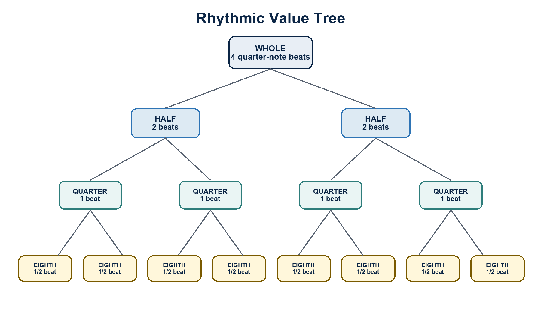

Three ways to use it
- Cover the lower levels and ask students to predict subdivisions.
- Change the beat unit and relabel the equivalences.
- Have groups build one measure using one path through the tree.
Accessibility: Provide the image digitally with the embedded description, read key relationships aloud, and allow students to recreate it in a tactile or high-contrast format as needed.

APPENDIX B • PRINTABLE VISUAL AID
V3. Circle of Fifths
Use for key signatures, relative keys, dominant relationships, and modulation planning.
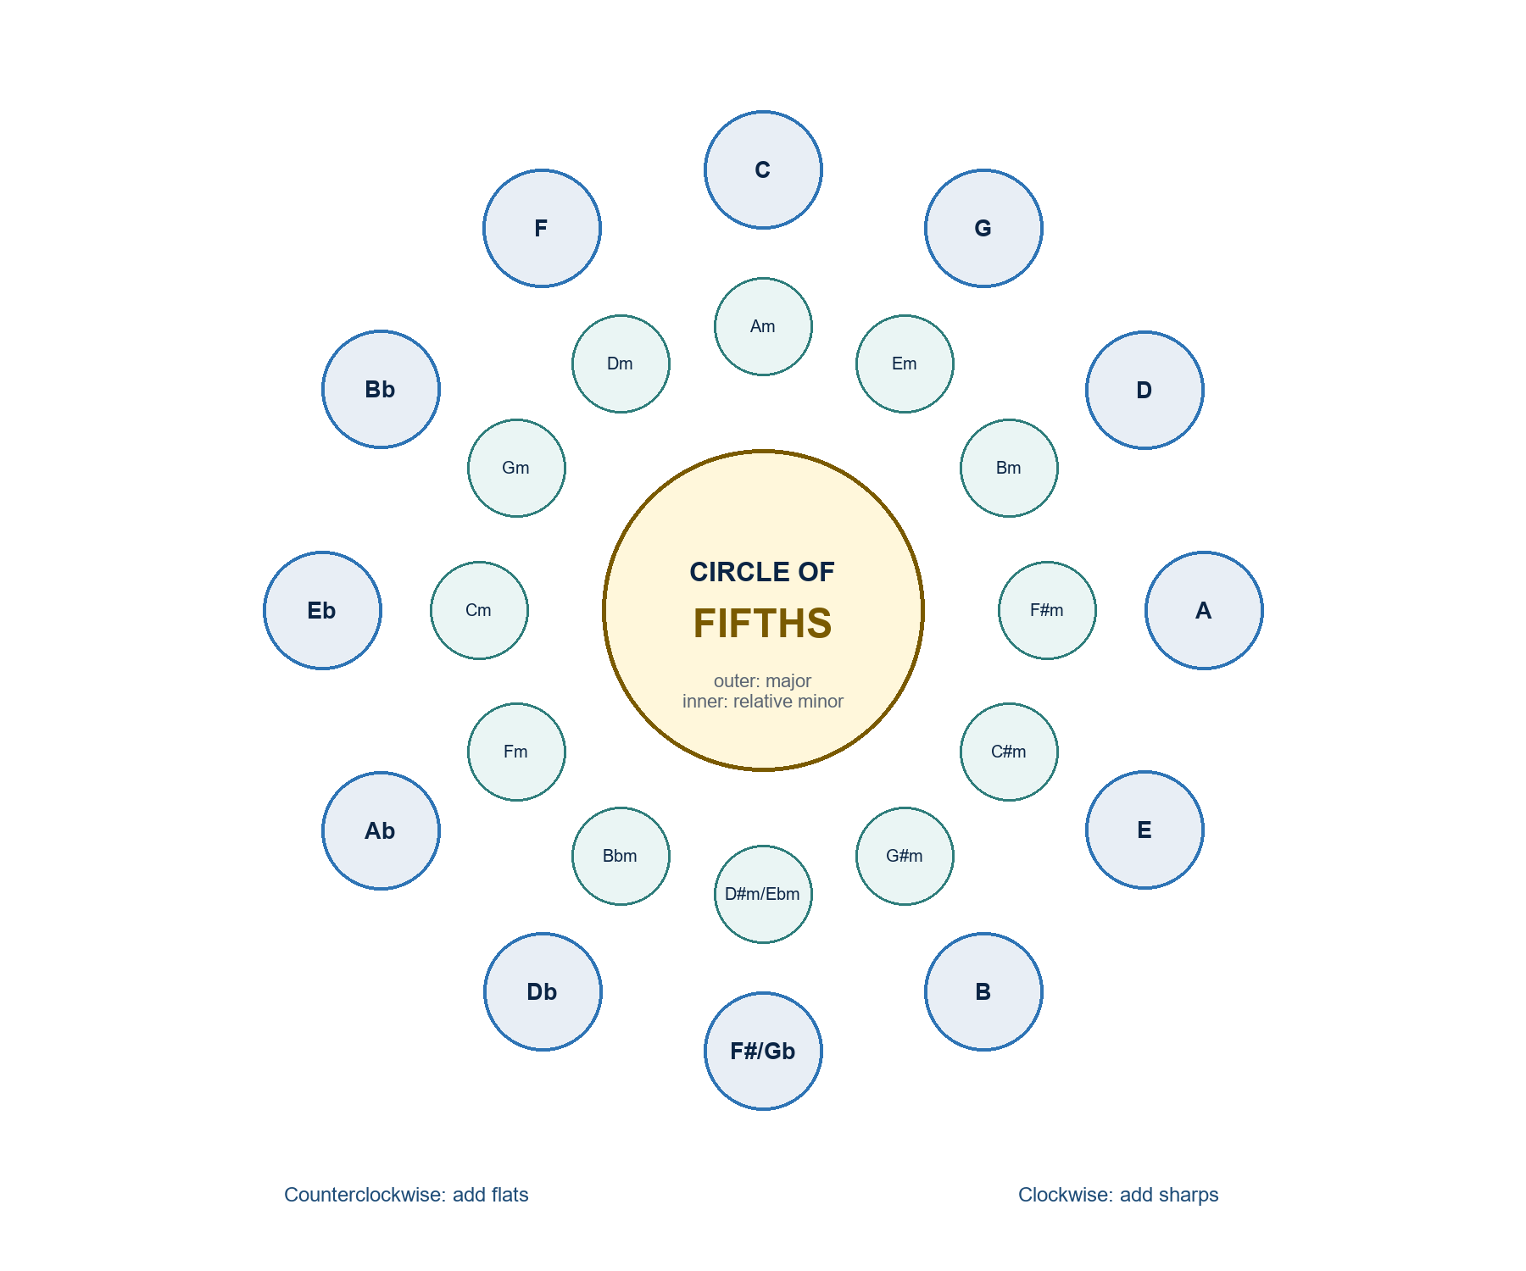

Three ways to use it
- Trace clockwise to add sharps and counterclockwise to add flats.
- Pair each major key with its relative minor.
- Draw a route from an original key to a possible destination key.
Accessibility: Provide the image digitally with the embedded description, read key relationships aloud, and allow students to recreate it in a tactile or high-contrast format as needed.

APPENDIX B • PRINTABLE VISUAL AID
V4. Interval Identification Flow
Use whenever students confuse interval number and quality.
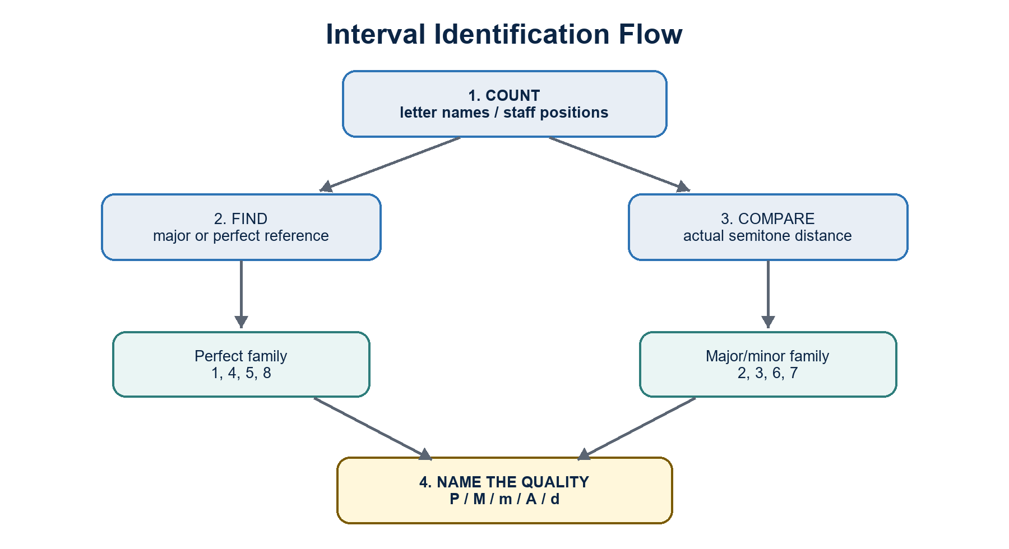

Three ways to use it
- Require the number before the quality.
- Use a keyboard only after students predict the reference interval.
- Invert the interval and explain how number and quality change.
Accessibility: Provide the image digitally with the embedded description, read key relationships aloud, and allow students to recreate it in a tactile or high-contrast format as needed.

APPENDIX B • PRINTABLE VISUAL AID
V5. Diatonic Harmonic Function Map
Use for phrase analysis, progression building, and cadence diagnosis.
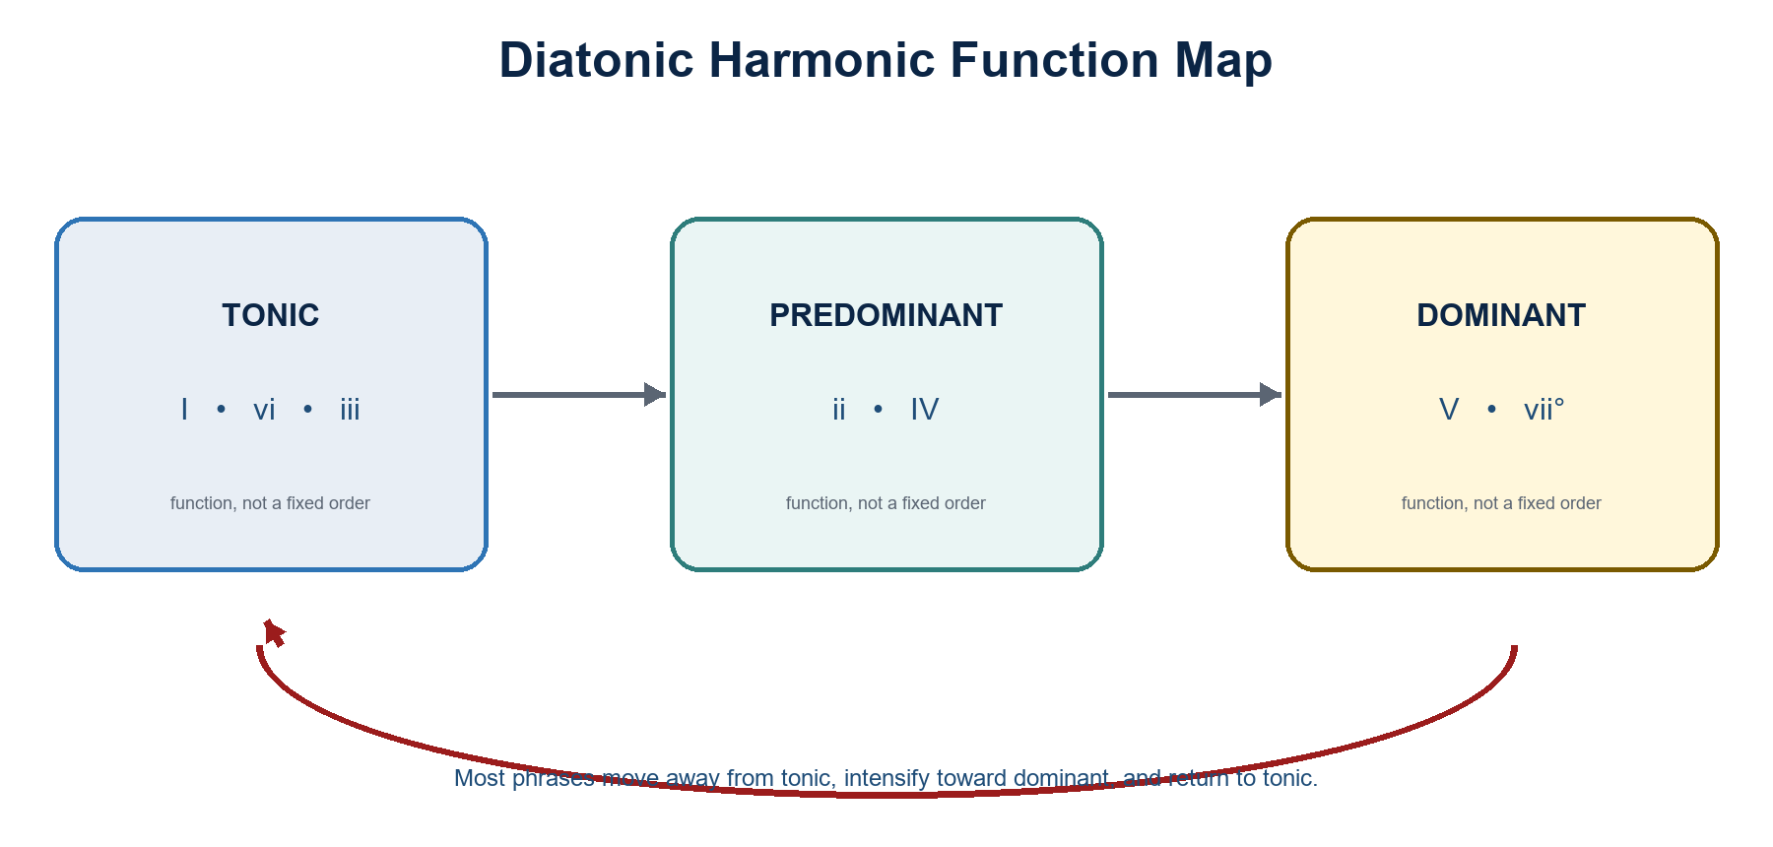

Three ways to use it
- Sort real chords by function before naming exact numerals.
- Build two different predominant paths to the same cadence.
- Mark where a phrase departs from and returns to tonic.
Accessibility: Provide the image digitally with the embedded description, read key relationships aloud, and allow students to recreate it in a tactile or high-contrast format as needed.

APPENDIX B • PRINTABLE VISUAL AID
V6. SATB Voice-Leading Checklist
Use as a desk reference during realization and correction labs.
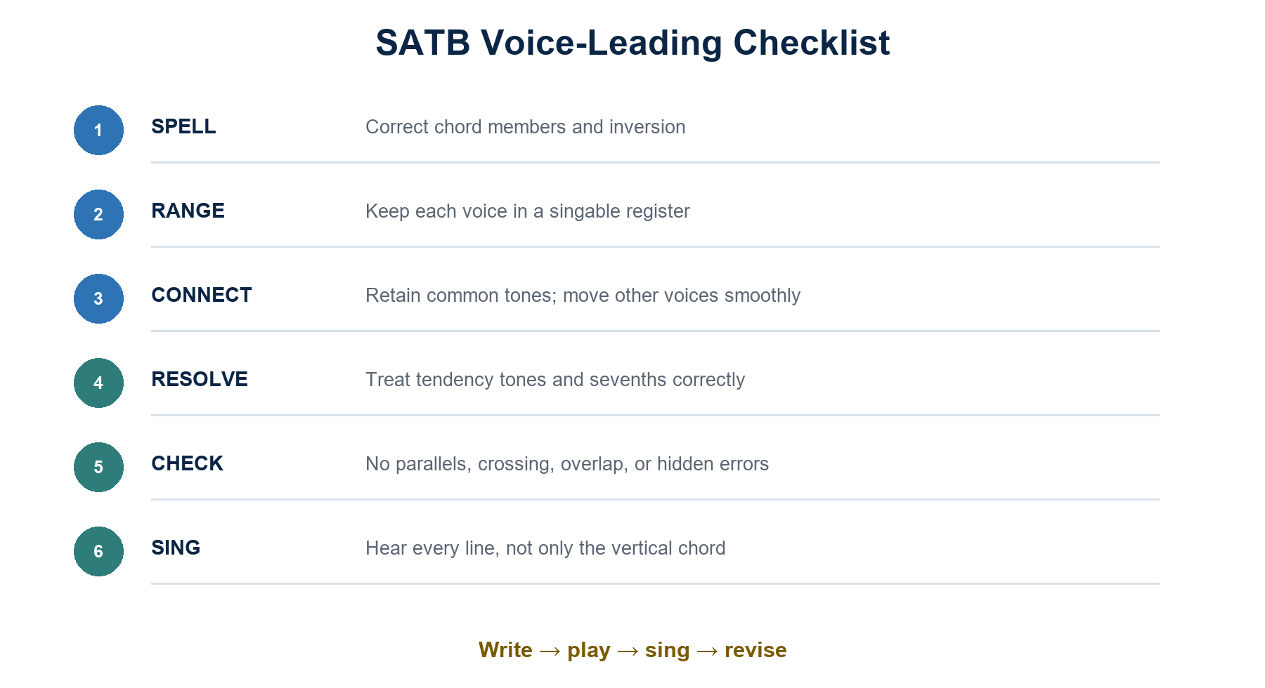

Three ways to use it
- Audit one category at a time instead of scanning randomly.
- Sing each line after vertical errors are corrected.
- Ask students to justify the smallest effective revision.
Accessibility: Provide the image digitally with the embedded description, read key relationships aloud, and allow students to recreate it in a tactile or high-contrast format as needed.

APPENDIX B • PRINTABLE VISUAL AID
V7. Sight-Singing Routine
Project before every individual or ensemble reading.
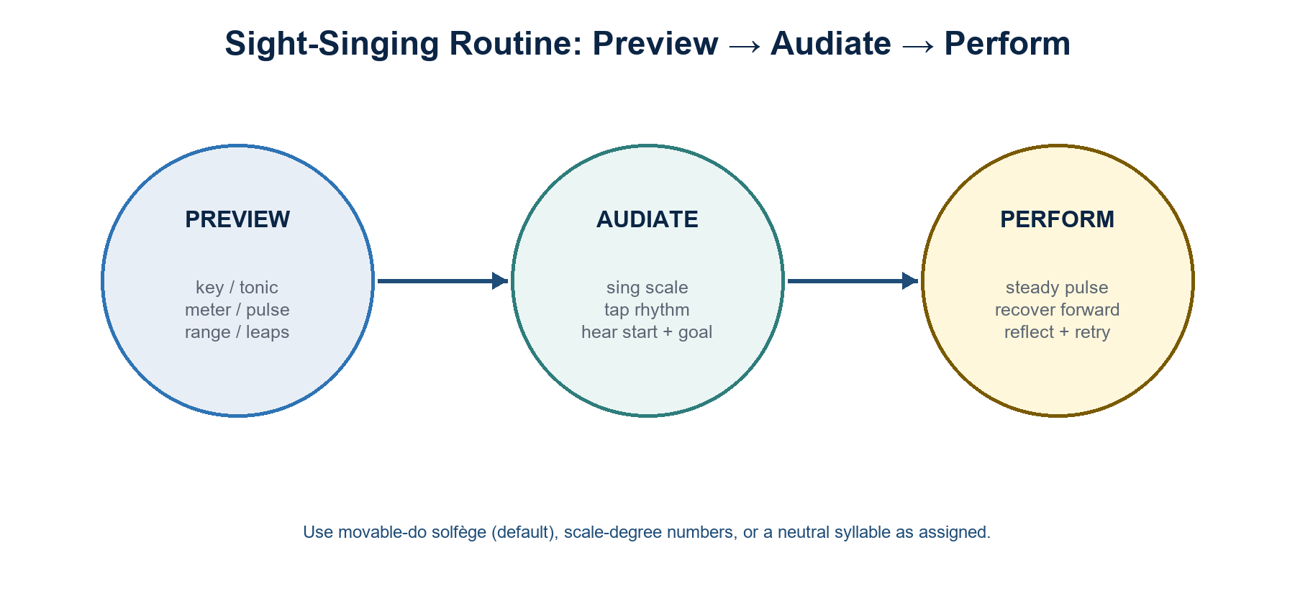

Three ways to use it
- Use the same routine before every graded reading.
- Limit preview time gradually as fluency improves.
- After singing, choose only one priority for the coached retry.
Accessibility: Provide the image digitally with the embedded description, read key relationships aloud, and allow students to recreate it in a tactile or high-contrast format as needed.

APPENDIX C
Reusable Activity Bank
Short routines that can be inserted into any of the four courses.

Five-minute retrieval grid
Individual recall, then pair correction; use yesterday/last week/last month items.

Error detective
Students explain why a prepared notation, analysis, or performance is wrong and repair it minimally.

Hear-sing-play-write
Present one concept in four representations; rotate the starting mode each week.

Whiteboard relay
Teams solve one step each; a final verifier checks the entire chain, not just the answer.

Gallery walk
Display analyses or scores; peers leave one evidence-based affirmation and one question.

Think-pair-perform
Silent preparation, partner rehearsal, then public performance or explanation.

Confidence traffic light
Students mark green/yellow/red privately; use results to form temporary support groups.

Exit ticket
One construction, one explanation, and one next practice step.

APPENDIX C CONTINUED
Mixed-Experience Differentiation
Core, support, and extension options for the same learning target.
Core task | Support option | Extension option
Read or analyze the assigned example | Color-coded guide tones, reduced length, paired preview, keyboard reference | Transpose, generate an alternate solution, or defend ambiguity
Write a progression or melody | Provide phrase frame, rhythm bank, or bass skeleton | Add controlled chromaticism, secondary line, or formal expansion
Sight-sing the assigned line | Slower tempo, tonic drone, chunked rehearsal, comfortable transposition | Reduced prep time, non-tonic start, partner line, or neutral syllable

APPENDIX D
Lesson Planning Template
A repeatable 60-minute structure; extend proportionally for longer meetings.
Time | Learning phase | Instructor / student action
0-5 min | Retrieval / pulse warm-up | One familiar skill, brisk feedback
5-12 min | Sound first | Listen, sing, tap, or play the new idea
12-25 min | Model and label | Connect sound to notation and vocabulary
25-42 min | Guided active task | Pairs/stations; instructor checks misconceptions
42-52 min | Independent transfer | Short written, keyboard, or performance problem
52-58 min | Feedback and retry | One targeted correction; immediate second attempt
58-60 min | Exit ticket | Evidence plus next practice step

Before class checklist
- Outcome and success criterion are visible.
- Examples fit the target skill and student range.
- Visual aid / board sequence is prepared.
- Support and extension versions are ready.
- Assessment evidence can be completed within the available time.
- Audio, keyboard, projector, and file access are tested.

After class reflection

- What could most students do independently?
- Which misconception needs retrieval next meeting?
- Who needs support or extension?
- Did students connect sound, symbol, and explanation?
- What should be shortened, repeated, or replaced?

APPENDIX E
Instructor Readiness Checklist
Finalize these items before releasing the syllabus.
- ☐ Insert official institution, department, course code, units, schedule, and faculty information.
- ☐ Confirm the academic calendar, holidays, examination week, and number of meetings.
- ☐ Insert exact textbook volume, edition, ISBN if required, and weekly page assignments.
- ☐ Replace template policy language with official institutional text and links.
- ☐ Confirm the official grading scale, transmutation, attendance, and make-up procedures.
- ☐ Choose the sight-singing tonal system and communicate it consistently.
- ☐ Choose assessment excerpts and verify copyright/licensing or institutional permission.
- ☐ Prepare accessible digital files and arrange accommodations through the proper process.
- ☐ Publish rubrics, due dates, submission formats, and recording/privacy expectations.
- ☐ Run the Week 1 diagnostic and revise pacing without lowering the stated outcomes.
Recommended first customization: Tell students exactly which textbook volume/pages correspond to each week. This package intentionally avoids edition-specific page references so it remains accurate across instructor copies.

Closing statement for students
Musicianship grows through frequent, focused attempts. Accuracy matters, but so do listening, recovery, explanation, revision, and respect for the people and traditions represented in the music. Come prepared to make sound, make decisions, and improve them.

