COLLEGE MUSIC TEACHING PACKAGE
Music Fundamentals
Course Syllabus, Weekly Learning Map, Activities, Rubric, Visual Aids, and Detailed Lesson Plans
Course purpose: A foundation course in music literacy linking notation, rhythm, scales, keys, intervals, triads, listening, keyboard geography, and basic form. Designed for students with varied prior training.

Course-at-a-glance
Recommended load: Recommended: 3 units / 54 contact hours
Primary text: Alfred's Essentials of Music Theory, Andrew Surmani, Karen Farnum Surmani, and Morton Manus
Planning model: Suggested model: three 60-minute meetings weekly; adjust to the approved institutional schedule.
Edition note: Insert exact chapter, unit, exercise, and page numbers from the edition owned by the class; page numbering varies by printing.

Before releasing to students
- Replace all bracketed institutional fields and publish the official course code and contact hours.
- Align grading equivalents, attendance rules, and make-up procedures with current university policy.
- Confirm room, piano/keyboard, projection, LMS, printing, and approved recording arrangements.
- Choose examples that are public-domain, licensed, teacher-composed, or institutionally cleared.

INSTRUCTOR SETUP
Music Fundamentals: Course Setup
Complete the fields below before circulation.

Institutional information
Institution: [Insert college/university]
College/Department: [Insert unit]
Instructor: [Insert name and credentials]
Academic term: [Insert term and AY]
Class schedule: [Insert days/time/room]
Consultation: [Insert office hours/contact]

Catalog and delivery profile
Course code: [Insert course code]
Units/contact hours: Recommended: 3 units / 54 contact hours
Prerequisite: None; placement or diagnostic information is used for support, not exclusion.
Primary text: Alfred's Essentials of Music Theory, Andrew Surmani, Karen Farnum Surmani, and Morton Manus
Delivery mode: In-person, blended, or online as approved by the institution.
Learning platforms: [Insert LMS, notation software, recording platform, or approved alternatives].

Required and recommended materials
- Assigned textbook and staff paper; pencil, eraser, and folder or digital portfolio.
- Access to a piano/keyboard or approved virtual keyboard for pitch and harmony checks.
- Headphones and an institution-approved recording method when an assessment requires audio.
- Instructor-provided excerpts, worksheets, and visual aids in accessible print/digital formats.

SYLLABUS CORE
Music Fundamentals: Outcomes and Assessment
Outcome-aligned evidence with a built-in cycle of attempt, feedback, correction, and demonstration.

Course learning outcomes
Code | By the end of the course, students can... | Primary evidence
MF1 | read treble and bass clefs and orient pitches on the grand staff and keyboard | notation checks; keyboard lab
MF2 | notate and perform common note/rest values in simple and compound meter | rhythm labs; quizzes
MF3 | construct major and minor scales and identify key signatures | scale/key portfolio
MF4 | identify and construct diatonic intervals and basic triads | written and aural checks
MF5 | recognize basic harmonic function, cadences, texture, phrase, and form | listening map; analysis
MF6 | apply vocabulary while listening, singing, playing, and discussing music | oral explanation; activities
MF7 | create and revise a short notated melody with coherent rhythm and phrase shape | capstone composition
MF8 | use a planned, reflective practice process | practice log and reflection

Assessment weights
Assessment component | Weight | What it measures
Short quizzes and notation checks | 20% | Accurate retrieval of symbols, terms, and constructions
Workbook / problem sets | 20% | Guided application and correction habits
Active musicianship labs | 15% | Tapping, singing, keyboard, and collaborative work
Midterm written-practical assessment | 20% | Weeks 1-8 integration
Final musicianship project + exam | 20% | Creation, notation, performance, and explanation
Professional learning habits | 5% | Preparation, reflection, respectful participation

Grade calculation: Calculate the weighted raw score above, then apply the official university grading or transmutation system. Publish the approved equivalent table in the LMS or course handout.

Evidence cycle
- Prepare through a short reading, listening, writing, keyboard, or vocal task.
- Attempt a low-stakes first try that reveals current understanding.
- Diagnose the specific musical issue using shared vocabulary.
- Coach and revise with one targeted strategy and timely feedback.
- Demonstrate independently, then archive the evidence in the course portfolio.

STUDENT GUIDE
Music Fundamentals: Learning and Course Policies
Adapt the bracketed items to official institutional policy; never let this section override university rules.

Attendance and participation
Policy: Music literacy develops through cumulative guided practice. Follow the institution's approved attendance policy. Students should notify the instructor through the official channel and complete the announced recovery task after an absence.

Late and make-up work
Policy: Insert the department-approved window, documentation requirements, and procedure for quizzes, examinations, performances, and technical disruptions. Equivalent make-up tasks may use different musical material.

Academic integrity
Policy: Submitted analysis, notation, composition, recordings, and reflections must represent the student's own work except where collaboration is explicitly assigned. Credit every borrowed score, recording, image, or idea in the format required by the instructor.

Generative AI and automated tools
Policy: AI, notation playback, tuners, analyzers, and answer-generating tools may be used only for the purposes explicitly permitted on an assignment. Students must disclose permitted assistance and remain able to perform, explain, and revise the work independently. Undisclosed or prohibited assistance is handled under institutional academic-integrity policy.

Accessibility and inclusive participation
Policy: Students may request reasonable accommodations through the authorized campus office. Provide accessible copies, clear notation, usable contrast, flexible demonstration modes when outcomes allow, and an appropriate vocal octave or range. Accommodation does not lower the stated musical outcome.

Recording and privacy
Policy: Record students only when institutionally authorized and educationally necessary. State the purpose, storage location, access, retention period, and non-recording alternative. Do not post class recordings publicly without valid consent and approval.

Copyright and repertoire
Policy: Use lawfully acquired textbooks and public-domain, licensed, teacher-composed, or institutionally cleared excerpts. Do not distribute scans or recordings beyond the permitted educational use.

Respectful musicianship
Policy: Critique the musical evidence, not the person. Use names and pronouns correctly, support developing voices and instruments, and maintain a rehearsal environment where students can attempt, recover, and improve safely.

COURSE SCHEDULE
Music Fundamentals: Weekly Plan
Weeks 1-6 | Assign exact textbook pages from the edition in use.
Wk | Focus / assigned reading | Learning target | Activity + visual aid | Evidence
1 | Orientation; diagnostic; sound/symbol pathway | Establish baseline and personal targets | Diagnostic stations; V1 pathway; name-the-sound game | Diagnostic profile
2 | Staff, clefs, note names, ledger lines | Read/write pitches in treble and bass | Human staff; whiteboard relay; keyboard mapping | Exit ticket
3 | Grand staff, octave registers, accidentals | Connect notation to pitch location | Pitch scavenger hunt; error detective | Notation check 1
4 | Beat, tempo, note/rest values | Maintain pulse and compare durations | Body percussion; V2 rhythm tree; rhythm dominoes | Rhythm lab 1
5 | Simple meter; barlines; ties; dots | Notate and perform simple-meter patterns | Measure builder; conductor circle | Quiz 1
6 | Compound meter; subdivision | Distinguish beat and subdivision | Meter switch; rhythm translation | Problem set

Instructor preparation: Select short examples that match student voices and instruments; use public-domain, licensed, teacher-composed, or institutionally cleared excerpts. Provide printed and projected versions.

COURSE SCHEDULE
Music Fundamentals: Weekly Plan
Weeks 7-12 | Assign exact textbook pages from the edition in use.
Wk | Focus / assigned reading | Learning target | Activity + visual aid | Evidence
7 | Major scale; whole/half-step pattern | Construct and perform major scales | Keyboard scale lab; floor-step pattern | Scale check
8 | Key signatures; circle of fifths | Name and write major keys | V3 circle; key-signature relay; flash retrieval | Quiz 2
9 | Midterm review and assessment | Integrate notation, rhythm, scales, keys | Team review circuit; individual written-practical | Midterm
10 | Minor scales and relative/parallel keys | Construct natural, harmonic, melodic minor | Minor makeover; compare sound and spelling | Scale portfolio
11 | Intervals: number, quality, inversion | Identify and construct intervals | V4 flow; interval ladder; partner checks | Notation check 2
12 | Triads: quality, root, inversion | Spell and identify four triad qualities | Triad factory; keyboard verification | Quiz 3

Instructor preparation: Select short examples that match student voices and instruments; use public-domain, licensed, teacher-composed, or institutionally cleared excerpts. Provide printed and projected versions.

COURSE SCHEDULE
Music Fundamentals: Weekly Plan
Weeks 13-18 | Assign exact textbook pages from the edition in use.
Wk | Focus / assigned reading | Learning target | Activity + visual aid | Evidence
13 | Diatonic triads and Roman numerals | Label triads within a key | Chord card sorting; V5 function preview | Problem set
14 | Cadences and phrase endings | Recognize basic cadence types | Cadence corners; listening vote | Listening map
15 | Melody: motive, sequence, contour, phrase | Describe and shape coherent melody | Melody surgery; contour drawing | Capstone draft
16 | Texture, dynamics, articulation, basic form | Use expressive and formal vocabulary | Listening gallery; form cards | Analysis paragraph
17 | Capstone workshop and peer feedback | Revise notation and musical logic | Gallery walk; perform-and-revise conference | Final project
18 | Final integration; reflection | Demonstrate cumulative literacy | Written-practical exam; portfolio conference | Final exam + reflection

Instructor preparation: Select short examples that match student voices and instruments; use public-domain, licensed, teacher-composed, or institutionally cleared excerpts. Provide printed and projected versions.

TEACHING TOOLKIT
Music Fundamentals: Activity Toolkit
Ready-to-run protocols; scale the examples for mixed year levels.

Human Grand Staff
Time: 20-30 minutes
Setup: Tape five-line staves on the floor; prepare pitch cards.
Process: Teams place themselves or cards on called pitches, then translate to the keyboard. Add accidentals and ledger lines for extension.
Evidence: Photo/diagram plus an individual five-item transfer check.

Rhythm Construction Lab
Time: 35 minutes
Setup: Prepare value cards, meter cards, and blank measures.
Process: Groups build measures, perform them, exchange with another group, and repair any meter violations. Advanced students add ties, dots, and syncopation.
Evidence: Correct measure set and performed reading.

Key-Signature Relay
Time: 20 minutes
Setup: Post a blank circle of fifths and prepare key cards.
Process: Students place keys, signatures, relative minors, and dominant relationships. Require each placement to be explained aloud.
Evidence: Timed accuracy plus one written explanation.

One-Phrase Composition Studio
Time: Two class meetings
Setup: Provide an eight-measure frame and clear constraints.
Process: Students draft, sing/play, peer-review, revise, and submit a clean score with a short rationale.
Evidence: Notated melody, performance, and revision note.

MUSIC FUNDAMENTALS
Week 1 Lesson Plan
Orientation; diagnostic; sound/symbol pathway
Weekly target: Establish baseline and personal targets
Textbook focus: Alfred's Essentials of Music Theory, Andrew Surmani, Karen Farnum Surmani, and Morton Manus - assign the matching unit, exercise, and page numbers from the class edition.
Materials / visual aids: Textbook, staff paper or score, board/projector, piano or keyboard, playback/recording only when approved; use the visual-aid appendix and the weekly visual code when named.

Measurable objectives
- Identify and explain the central features of orientation; diagnostic; sound/symbol pathway.
- Demonstrate this learning target: Establish baseline and personal targets.
- Produce, perform, or submit the announced evidence: Diagnostic profile.

Meeting A - Hear and discover
Focus activity: Diagnostic stations.
Flow: 5 min retrieval; 8 min aural/visual hook; 12 min concise model; 20 min guided practice; 10 min independent check; 5 min exit ticket.
Student evidence: Annotated example or accurately modeled first attempt.

Meeting B - Practice and apply
Focus activity: V1 pathway.
Flow: 5 min warm-up; 10 min error review; 20 min coached application; 15 min transfer task; 7 min peer feedback; 3 min reflection.
Student evidence: Completed application with peer/instructor feedback marked.

Meeting C - Demonstrate and reflect
Focus activity: name-the-sound game.
Flow: 5 min retrieval; 10 min misconception mini-lesson; 20 min synthesis or creation; 15 min assessed evidence; 7 min correction/retry; 3 min assignment briefing.
Student evidence: Independent evidence: Diagnostic profile.

Assessment, differentiation, and follow-through
Formative checks: Cold/warm response, one-minute construction or performance, error annotation, partner explanation, and exit ticket. Record only the evidence needed for the stated outcome.
Support: Offer a labeled staff or keyboard map, color-coded scale degrees, a reduced item set, and a worked first example.
Extension: Require transposition, a second valid solution, an original two-measure example, or a concise explanation of the governing rule.
Assignment / practice: Complete the corresponding Alfred's Essentials of Music Theory unit(s), correct every missed item, and bring one question or self-composed example.
Instructor reflection: What evidence showed learning? Which misconception or barrier needs reteaching? What will change in the next meeting? ______________________________

MUSIC FUNDAMENTALS
Week 2 Lesson Plan
Staff, clefs, note names, ledger lines
Weekly target: Read/write pitches in treble and bass
Textbook focus: Alfred's Essentials of Music Theory, Andrew Surmani, Karen Farnum Surmani, and Morton Manus - assign the matching unit, exercise, and page numbers from the class edition.
Materials / visual aids: Textbook, staff paper or score, board/projector, piano or keyboard, playback/recording only when approved; use the visual-aid appendix and the weekly visual code when named.

Measurable objectives
- Identify and explain the central features of staff, clefs, note names, ledger lines.
- Demonstrate this learning target: Read/write pitches in treble and bass.
- Produce, perform, or submit the announced evidence: Exit ticket.

Meeting A - Hear and discover
Focus activity: Human staff.
Flow: 5 min retrieval; 8 min aural/visual hook; 12 min concise model; 20 min guided practice; 10 min independent check; 5 min exit ticket.
Student evidence: Annotated example or accurately modeled first attempt.

Meeting B - Practice and apply
Focus activity: whiteboard relay.
Flow: 5 min warm-up; 10 min error review; 20 min coached application; 15 min transfer task; 7 min peer feedback; 3 min reflection.
Student evidence: Completed application with peer/instructor feedback marked.

Meeting C - Demonstrate and reflect
Focus activity: keyboard mapping.
Flow: 5 min retrieval; 10 min misconception mini-lesson; 20 min synthesis or creation; 15 min assessed evidence; 7 min correction/retry; 3 min assignment briefing.
Student evidence: Independent evidence: Exit ticket.

Assessment, differentiation, and follow-through
Formative checks: Cold/warm response, one-minute construction or performance, error annotation, partner explanation, and exit ticket. Record only the evidence needed for the stated outcome.
Support: Offer a labeled staff or keyboard map, color-coded scale degrees, a reduced item set, and a worked first example.
Extension: Require transposition, a second valid solution, an original two-measure example, or a concise explanation of the governing rule.
Assignment / practice: Complete the corresponding Alfred's Essentials of Music Theory unit(s), correct every missed item, and bring one question or self-composed example.
Instructor reflection: What evidence showed learning? Which misconception or barrier needs reteaching? What will change in the next meeting? ______________________________

MUSIC FUNDAMENTALS
Week 3 Lesson Plan
Grand staff, octave registers, accidentals
Weekly target: Connect notation to pitch location
Textbook focus: Alfred's Essentials of Music Theory, Andrew Surmani, Karen Farnum Surmani, and Morton Manus - assign the matching unit, exercise, and page numbers from the class edition.
Materials / visual aids: Textbook, staff paper or score, board/projector, piano or keyboard, playback/recording only when approved; use the visual-aid appendix and the weekly visual code when named.

Measurable objectives
- Identify and explain the central features of grand staff, octave registers, accidentals.
- Demonstrate this learning target: Connect notation to pitch location.
- Produce, perform, or submit the announced evidence: Notation check 1.

Meeting A - Hear and discover
Focus activity: Pitch scavenger hunt.
Flow: 5 min retrieval; 8 min aural/visual hook; 12 min concise model; 20 min guided practice; 10 min independent check; 5 min exit ticket.
Student evidence: Annotated example or accurately modeled first attempt.

Meeting B - Practice and apply
Focus activity: error detective.
Flow: 5 min warm-up; 10 min error review; 20 min coached application; 15 min transfer task; 7 min peer feedback; 3 min reflection.
Student evidence: Completed application with peer/instructor feedback marked.

Meeting C - Demonstrate and reflect
Focus activity: error detective.
Flow: 5 min retrieval; 10 min misconception mini-lesson; 20 min synthesis or creation; 15 min assessed evidence; 7 min correction/retry; 3 min assignment briefing.
Student evidence: Independent evidence: Notation check 1.

Assessment, differentiation, and follow-through
Formative checks: Cold/warm response, one-minute construction or performance, error annotation, partner explanation, and exit ticket. Record only the evidence needed for the stated outcome.
Support: Offer a labeled staff or keyboard map, color-coded scale degrees, a reduced item set, and a worked first example.
Extension: Require transposition, a second valid solution, an original two-measure example, or a concise explanation of the governing rule.
Assignment / practice: Complete the corresponding Alfred's Essentials of Music Theory unit(s), correct every missed item, and bring one question or self-composed example.
Instructor reflection: What evidence showed learning? Which misconception or barrier needs reteaching? What will change in the next meeting? ______________________________

MUSIC FUNDAMENTALS
Week 4 Lesson Plan
Beat, tempo, note/rest values
Weekly target: Maintain pulse and compare durations
Textbook focus: Alfred's Essentials of Music Theory, Andrew Surmani, Karen Farnum Surmani, and Morton Manus - assign the matching unit, exercise, and page numbers from the class edition.
Materials / visual aids: Textbook, staff paper or score, board/projector, piano or keyboard, playback/recording only when approved; use the visual-aid appendix and the weekly visual code when named.

Measurable objectives
- Identify and explain the central features of beat, tempo, note/rest values.
- Demonstrate this learning target: Maintain pulse and compare durations.
- Produce, perform, or submit the announced evidence: Rhythm lab 1.

Meeting A - Hear and discover
Focus activity: Body percussion.
Flow: 5 min retrieval; 8 min aural/visual hook; 12 min concise model; 20 min guided practice; 10 min independent check; 5 min exit ticket.
Student evidence: Annotated example or accurately modeled first attempt.

Meeting B - Practice and apply
Focus activity: V2 rhythm tree.
Flow: 5 min warm-up; 10 min error review; 20 min coached application; 15 min transfer task; 7 min peer feedback; 3 min reflection.
Student evidence: Completed application with peer/instructor feedback marked.

Meeting C - Demonstrate and reflect
Focus activity: rhythm dominoes.
Flow: 5 min retrieval; 10 min misconception mini-lesson; 20 min synthesis or creation; 15 min assessed evidence; 7 min correction/retry; 3 min assignment briefing.
Student evidence: Independent evidence: Rhythm lab 1.

Assessment, differentiation, and follow-through
Formative checks: Cold/warm response, one-minute construction or performance, error annotation, partner explanation, and exit ticket. Record only the evidence needed for the stated outcome.
Support: Offer a labeled staff or keyboard map, color-coded scale degrees, a reduced item set, and a worked first example.
Extension: Require transposition, a second valid solution, an original two-measure example, or a concise explanation of the governing rule.
Assignment / practice: Complete the corresponding Alfred's Essentials of Music Theory unit(s), correct every missed item, and bring one question or self-composed example.
Instructor reflection: What evidence showed learning? Which misconception or barrier needs reteaching? What will change in the next meeting? ______________________________

MUSIC FUNDAMENTALS
Week 5 Lesson Plan
Simple meter; barlines; ties; dots
Weekly target: Notate and perform simple-meter patterns
Textbook focus: Alfred's Essentials of Music Theory, Andrew Surmani, Karen Farnum Surmani, and Morton Manus - assign the matching unit, exercise, and page numbers from the class edition.
Materials / visual aids: Textbook, staff paper or score, board/projector, piano or keyboard, playback/recording only when approved; use the visual-aid appendix and the weekly visual code when named.

Measurable objectives
- Identify and explain the central features of simple meter; barlines; ties; dots.
- Demonstrate this learning target: Notate and perform simple-meter patterns.
- Produce, perform, or submit the announced evidence: Quiz 1.

Meeting A - Hear and discover
Focus activity: Measure builder.
Flow: 5 min retrieval; 8 min aural/visual hook; 12 min concise model; 20 min guided practice; 10 min independent check; 5 min exit ticket.
Student evidence: Annotated example or accurately modeled first attempt.

Meeting B - Practice and apply
Focus activity: conductor circle.
Flow: 5 min warm-up; 10 min error review; 20 min coached application; 15 min transfer task; 7 min peer feedback; 3 min reflection.
Student evidence: Completed application with peer/instructor feedback marked.

Meeting C - Demonstrate and reflect
Focus activity: conductor circle.
Flow: 5 min retrieval; 10 min misconception mini-lesson; 20 min synthesis or creation; 15 min assessed evidence; 7 min correction/retry; 3 min assignment briefing.
Student evidence: Independent evidence: Quiz 1.

Assessment, differentiation, and follow-through
Formative checks: Cold/warm response, one-minute construction or performance, error annotation, partner explanation, and exit ticket. Record only the evidence needed for the stated outcome.
Support: Offer a labeled staff or keyboard map, color-coded scale degrees, a reduced item set, and a worked first example.
Extension: Require transposition, a second valid solution, an original two-measure example, or a concise explanation of the governing rule.
Assignment / practice: Complete the corresponding Alfred's Essentials of Music Theory unit(s), correct every missed item, and bring one question or self-composed example.
Instructor reflection: What evidence showed learning? Which misconception or barrier needs reteaching? What will change in the next meeting? ______________________________

MUSIC FUNDAMENTALS
Week 6 Lesson Plan
Compound meter; subdivision
Weekly target: Distinguish beat and subdivision
Textbook focus: Alfred's Essentials of Music Theory, Andrew Surmani, Karen Farnum Surmani, and Morton Manus - assign the matching unit, exercise, and page numbers from the class edition.
Materials / visual aids: Textbook, staff paper or score, board/projector, piano or keyboard, playback/recording only when approved; use the visual-aid appendix and the weekly visual code when named.

Measurable objectives
- Identify and explain the central features of compound meter; subdivision.
- Demonstrate this learning target: Distinguish beat and subdivision.
- Produce, perform, or submit the announced evidence: Problem set.

Meeting A - Hear and discover
Focus activity: Meter switch.
Flow: 5 min retrieval; 8 min aural/visual hook; 12 min concise model; 20 min guided practice; 10 min independent check; 5 min exit ticket.
Student evidence: Annotated example or accurately modeled first attempt.

Meeting B - Practice and apply
Focus activity: rhythm translation.
Flow: 5 min warm-up; 10 min error review; 20 min coached application; 15 min transfer task; 7 min peer feedback; 3 min reflection.
Student evidence: Completed application with peer/instructor feedback marked.

Meeting C - Demonstrate and reflect
Focus activity: rhythm translation.
Flow: 5 min retrieval; 10 min misconception mini-lesson; 20 min synthesis or creation; 15 min assessed evidence; 7 min correction/retry; 3 min assignment briefing.
Student evidence: Independent evidence: Problem set.

Assessment, differentiation, and follow-through
Formative checks: Cold/warm response, one-minute construction or performance, error annotation, partner explanation, and exit ticket. Record only the evidence needed for the stated outcome.
Support: Offer a labeled staff or keyboard map, color-coded scale degrees, a reduced item set, and a worked first example.
Extension: Require transposition, a second valid solution, an original two-measure example, or a concise explanation of the governing rule.
Assignment / practice: Complete the corresponding Alfred's Essentials of Music Theory unit(s), correct every missed item, and bring one question or self-composed example.
Instructor reflection: What evidence showed learning? Which misconception or barrier needs reteaching? What will change in the next meeting? ______________________________

MUSIC FUNDAMENTALS
Week 7 Lesson Plan
Major scale; whole/half-step pattern
Weekly target: Construct and perform major scales
Textbook focus: Alfred's Essentials of Music Theory, Andrew Surmani, Karen Farnum Surmani, and Morton Manus - assign the matching unit, exercise, and page numbers from the class edition.
Materials / visual aids: Textbook, staff paper or score, board/projector, piano or keyboard, playback/recording only when approved; use the visual-aid appendix and the weekly visual code when named.

Measurable objectives
- Identify and explain the central features of major scale; whole/half-step pattern.
- Demonstrate this learning target: Construct and perform major scales.
- Produce, perform, or submit the announced evidence: Scale check.

Meeting A - Hear and discover
Focus activity: Keyboard scale lab.
Flow: 5 min retrieval; 8 min aural/visual hook; 12 min concise model; 20 min guided practice; 10 min independent check; 5 min exit ticket.
Student evidence: Annotated example or accurately modeled first attempt.

Meeting B - Practice and apply
Focus activity: floor-step pattern.
Flow: 5 min warm-up; 10 min error review; 20 min coached application; 15 min transfer task; 7 min peer feedback; 3 min reflection.
Student evidence: Completed application with peer/instructor feedback marked.

Meeting C - Demonstrate and reflect
Focus activity: floor-step pattern.
Flow: 5 min retrieval; 10 min misconception mini-lesson; 20 min synthesis or creation; 15 min assessed evidence; 7 min correction/retry; 3 min assignment briefing.
Student evidence: Independent evidence: Scale check.

Assessment, differentiation, and follow-through
Formative checks: Cold/warm response, one-minute construction or performance, error annotation, partner explanation, and exit ticket. Record only the evidence needed for the stated outcome.
Support: Offer a labeled staff or keyboard map, color-coded scale degrees, a reduced item set, and a worked first example.
Extension: Require transposition, a second valid solution, an original two-measure example, or a concise explanation of the governing rule.
Assignment / practice: Complete the corresponding Alfred's Essentials of Music Theory unit(s), correct every missed item, and bring one question or self-composed example.
Instructor reflection: What evidence showed learning? Which misconception or barrier needs reteaching? What will change in the next meeting? ______________________________

MUSIC FUNDAMENTALS
Week 8 Lesson Plan
Key signatures; circle of fifths
Weekly target: Name and write major keys
Textbook focus: Alfred's Essentials of Music Theory, Andrew Surmani, Karen Farnum Surmani, and Morton Manus - assign the matching unit, exercise, and page numbers from the class edition.
Materials / visual aids: Textbook, staff paper or score, board/projector, piano or keyboard, playback/recording only when approved; use the visual-aid appendix and the weekly visual code when named.

Measurable objectives
- Identify and explain the central features of key signatures; circle of fifths.
- Demonstrate this learning target: Name and write major keys.
- Produce, perform, or submit the announced evidence: Quiz 2.

Meeting A - Hear and discover
Focus activity: V3 circle.
Flow: 5 min retrieval; 8 min aural/visual hook; 12 min concise model; 20 min guided practice; 10 min independent check; 5 min exit ticket.
Student evidence: Annotated example or accurately modeled first attempt.

Meeting B - Practice and apply
Focus activity: key-signature relay.
Flow: 5 min warm-up; 10 min error review; 20 min coached application; 15 min transfer task; 7 min peer feedback; 3 min reflection.
Student evidence: Completed application with peer/instructor feedback marked.

Meeting C - Demonstrate and reflect
Focus activity: flash retrieval.
Flow: 5 min retrieval; 10 min misconception mini-lesson; 20 min synthesis or creation; 15 min assessed evidence; 7 min correction/retry; 3 min assignment briefing.
Student evidence: Independent evidence: Quiz 2.

Assessment, differentiation, and follow-through
Formative checks: Cold/warm response, one-minute construction or performance, error annotation, partner explanation, and exit ticket. Record only the evidence needed for the stated outcome.
Support: Offer a labeled staff or keyboard map, color-coded scale degrees, a reduced item set, and a worked first example.
Extension: Require transposition, a second valid solution, an original two-measure example, or a concise explanation of the governing rule.
Assignment / practice: Complete the corresponding Alfred's Essentials of Music Theory unit(s), correct every missed item, and bring one question or self-composed example.
Instructor reflection: What evidence showed learning? Which misconception or barrier needs reteaching? What will change in the next meeting? ______________________________

MUSIC FUNDAMENTALS
Week 9 Lesson Plan
Midterm review and assessment
Weekly target: Integrate notation, rhythm, scales, keys
Textbook focus: Alfred's Essentials of Music Theory, Andrew Surmani, Karen Farnum Surmani, and Morton Manus - assign the matching unit, exercise, and page numbers from the class edition.
Materials / visual aids: Textbook, staff paper or score, board/projector, piano or keyboard, playback/recording only when approved; use the visual-aid appendix and the weekly visual code when named.

Measurable objectives
- Identify and explain the central features of midterm review and assessment.
- Demonstrate this learning target: Integrate notation, rhythm, scales, keys.
- Produce, perform, or submit the announced evidence: Midterm.

Meeting A - Hear and discover
Focus activity: Team review circuit.
Flow: 5 min retrieval; 8 min aural/visual hook; 12 min concise model; 20 min guided practice; 10 min independent check; 5 min exit ticket.
Student evidence: Annotated example or accurately modeled first attempt.

Meeting B - Practice and apply
Focus activity: individual written-practical.
Flow: 5 min warm-up; 10 min error review; 20 min coached application; 15 min transfer task; 7 min peer feedback; 3 min reflection.
Student evidence: Completed application with peer/instructor feedback marked.

Meeting C - Demonstrate and reflect
Focus activity: individual written-practical.
Flow: 5 min retrieval; 10 min misconception mini-lesson; 20 min synthesis or creation; 15 min assessed evidence; 7 min correction/retry; 3 min assignment briefing.
Student evidence: Independent evidence: Midterm.

Assessment, differentiation, and follow-through
Formative checks: Cold/warm response, one-minute construction or performance, error annotation, partner explanation, and exit ticket. Record only the evidence needed for the stated outcome.
Support: Offer a labeled staff or keyboard map, color-coded scale degrees, a reduced item set, and a worked first example.
Extension: Require transposition, a second valid solution, an original two-measure example, or a concise explanation of the governing rule.
Assignment / practice: Complete the corresponding Alfred's Essentials of Music Theory unit(s), correct every missed item, and bring one question or self-composed example.
Instructor reflection: What evidence showed learning? Which misconception or barrier needs reteaching? What will change in the next meeting? ______________________________

MUSIC FUNDAMENTALS
Week 10 Lesson Plan
Minor scales and relative/parallel keys
Weekly target: Construct natural, harmonic, melodic minor
Textbook focus: Alfred's Essentials of Music Theory, Andrew Surmani, Karen Farnum Surmani, and Morton Manus - assign the matching unit, exercise, and page numbers from the class edition.
Materials / visual aids: Textbook, staff paper or score, board/projector, piano or keyboard, playback/recording only when approved; use the visual-aid appendix and the weekly visual code when named.

Measurable objectives
- Identify and explain the central features of minor scales and relative/parallel keys.
- Demonstrate this learning target: Construct natural, harmonic, melodic minor.
- Produce, perform, or submit the announced evidence: Scale portfolio.

Meeting A - Hear and discover
Focus activity: Minor makeover.
Flow: 5 min retrieval; 8 min aural/visual hook; 12 min concise model; 20 min guided practice; 10 min independent check; 5 min exit ticket.
Student evidence: Annotated example or accurately modeled first attempt.

Meeting B - Practice and apply
Focus activity: compare sound and spelling.
Flow: 5 min warm-up; 10 min error review; 20 min coached application; 15 min transfer task; 7 min peer feedback; 3 min reflection.
Student evidence: Completed application with peer/instructor feedback marked.

Meeting C - Demonstrate and reflect
Focus activity: compare sound and spelling.
Flow: 5 min retrieval; 10 min misconception mini-lesson; 20 min synthesis or creation; 15 min assessed evidence; 7 min correction/retry; 3 min assignment briefing.
Student evidence: Independent evidence: Scale portfolio.

Assessment, differentiation, and follow-through
Formative checks: Cold/warm response, one-minute construction or performance, error annotation, partner explanation, and exit ticket. Record only the evidence needed for the stated outcome.
Support: Offer a labeled staff or keyboard map, color-coded scale degrees, a reduced item set, and a worked first example.
Extension: Require transposition, a second valid solution, an original two-measure example, or a concise explanation of the governing rule.
Assignment / practice: Complete the corresponding Alfred's Essentials of Music Theory unit(s), correct every missed item, and bring one question or self-composed example.
Instructor reflection: What evidence showed learning? Which misconception or barrier needs reteaching? What will change in the next meeting? ______________________________

MUSIC FUNDAMENTALS
Week 11 Lesson Plan
Intervals: number, quality, inversion
Weekly target: Identify and construct intervals
Textbook focus: Alfred's Essentials of Music Theory, Andrew Surmani, Karen Farnum Surmani, and Morton Manus - assign the matching unit, exercise, and page numbers from the class edition.
Materials / visual aids: Textbook, staff paper or score, board/projector, piano or keyboard, playback/recording only when approved; use the visual-aid appendix and the weekly visual code when named.

Measurable objectives
- Identify and explain the central features of intervals: number, quality, inversion.
- Demonstrate this learning target: Identify and construct intervals.
- Produce, perform, or submit the announced evidence: Notation check 2.

Meeting A - Hear and discover
Focus activity: V4 flow.
Flow: 5 min retrieval; 8 min aural/visual hook; 12 min concise model; 20 min guided practice; 10 min independent check; 5 min exit ticket.
Student evidence: Annotated example or accurately modeled first attempt.

Meeting B - Practice and apply
Focus activity: interval ladder.
Flow: 5 min warm-up; 10 min error review; 20 min coached application; 15 min transfer task; 7 min peer feedback; 3 min reflection.
Student evidence: Completed application with peer/instructor feedback marked.

Meeting C - Demonstrate and reflect
Focus activity: partner checks.
Flow: 5 min retrieval; 10 min misconception mini-lesson; 20 min synthesis or creation; 15 min assessed evidence; 7 min correction/retry; 3 min assignment briefing.
Student evidence: Independent evidence: Notation check 2.

Assessment, differentiation, and follow-through
Formative checks: Cold/warm response, one-minute construction or performance, error annotation, partner explanation, and exit ticket. Record only the evidence needed for the stated outcome.
Support: Offer a labeled staff or keyboard map, color-coded scale degrees, a reduced item set, and a worked first example.
Extension: Require transposition, a second valid solution, an original two-measure example, or a concise explanation of the governing rule.
Assignment / practice: Complete the corresponding Alfred's Essentials of Music Theory unit(s), correct every missed item, and bring one question or self-composed example.
Instructor reflection: What evidence showed learning? Which misconception or barrier needs reteaching? What will change in the next meeting? ______________________________

MUSIC FUNDAMENTALS
Week 12 Lesson Plan
Triads: quality, root, inversion
Weekly target: Spell and identify four triad qualities
Textbook focus: Alfred's Essentials of Music Theory, Andrew Surmani, Karen Farnum Surmani, and Morton Manus - assign the matching unit, exercise, and page numbers from the class edition.
Materials / visual aids: Textbook, staff paper or score, board/projector, piano or keyboard, playback/recording only when approved; use the visual-aid appendix and the weekly visual code when named.

Measurable objectives
- Identify and explain the central features of triads: quality, root, inversion.
- Demonstrate this learning target: Spell and identify four triad qualities.
- Produce, perform, or submit the announced evidence: Quiz 3.

Meeting A - Hear and discover
Focus activity: Triad factory.
Flow: 5 min retrieval; 8 min aural/visual hook; 12 min concise model; 20 min guided practice; 10 min independent check; 5 min exit ticket.
Student evidence: Annotated example or accurately modeled first attempt.

Meeting B - Practice and apply
Focus activity: keyboard verification.
Flow: 5 min warm-up; 10 min error review; 20 min coached application; 15 min transfer task; 7 min peer feedback; 3 min reflection.
Student evidence: Completed application with peer/instructor feedback marked.

Meeting C - Demonstrate and reflect
Focus activity: keyboard verification.
Flow: 5 min retrieval; 10 min misconception mini-lesson; 20 min synthesis or creation; 15 min assessed evidence; 7 min correction/retry; 3 min assignment briefing.
Student evidence: Independent evidence: Quiz 3.

Assessment, differentiation, and follow-through
Formative checks: Cold/warm response, one-minute construction or performance, error annotation, partner explanation, and exit ticket. Record only the evidence needed for the stated outcome.
Support: Offer a labeled staff or keyboard map, color-coded scale degrees, a reduced item set, and a worked first example.
Extension: Require transposition, a second valid solution, an original two-measure example, or a concise explanation of the governing rule.
Assignment / practice: Complete the corresponding Alfred's Essentials of Music Theory unit(s), correct every missed item, and bring one question or self-composed example.
Instructor reflection: What evidence showed learning? Which misconception or barrier needs reteaching? What will change in the next meeting? ______________________________

MUSIC FUNDAMENTALS
Week 13 Lesson Plan
Diatonic triads and Roman numerals
Weekly target: Label triads within a key
Textbook focus: Alfred's Essentials of Music Theory, Andrew Surmani, Karen Farnum Surmani, and Morton Manus - assign the matching unit, exercise, and page numbers from the class edition.
Materials / visual aids: Textbook, staff paper or score, board/projector, piano or keyboard, playback/recording only when approved; use the visual-aid appendix and the weekly visual code when named.

Measurable objectives
- Identify and explain the central features of diatonic triads and roman numerals.
- Demonstrate this learning target: Label triads within a key.
- Produce, perform, or submit the announced evidence: Problem set.

Meeting A - Hear and discover
Focus activity: Chord card sorting.
Flow: 5 min retrieval; 8 min aural/visual hook; 12 min concise model; 20 min guided practice; 10 min independent check; 5 min exit ticket.
Student evidence: Annotated example or accurately modeled first attempt.

Meeting B - Practice and apply
Focus activity: V5 function preview.
Flow: 5 min warm-up; 10 min error review; 20 min coached application; 15 min transfer task; 7 min peer feedback; 3 min reflection.
Student evidence: Completed application with peer/instructor feedback marked.

Meeting C - Demonstrate and reflect
Focus activity: V5 function preview.
Flow: 5 min retrieval; 10 min misconception mini-lesson; 20 min synthesis or creation; 15 min assessed evidence; 7 min correction/retry; 3 min assignment briefing.
Student evidence: Independent evidence: Problem set.

Assessment, differentiation, and follow-through
Formative checks: Cold/warm response, one-minute construction or performance, error annotation, partner explanation, and exit ticket. Record only the evidence needed for the stated outcome.
Support: Offer a labeled staff or keyboard map, color-coded scale degrees, a reduced item set, and a worked first example.
Extension: Require transposition, a second valid solution, an original two-measure example, or a concise explanation of the governing rule.
Assignment / practice: Complete the corresponding Alfred's Essentials of Music Theory unit(s), correct every missed item, and bring one question or self-composed example.
Instructor reflection: What evidence showed learning? Which misconception or barrier needs reteaching? What will change in the next meeting? ______________________________

MUSIC FUNDAMENTALS
Week 14 Lesson Plan
Cadences and phrase endings
Weekly target: Recognize basic cadence types
Textbook focus: Alfred's Essentials of Music Theory, Andrew Surmani, Karen Farnum Surmani, and Morton Manus - assign the matching unit, exercise, and page numbers from the class edition.
Materials / visual aids: Textbook, staff paper or score, board/projector, piano or keyboard, playback/recording only when approved; use the visual-aid appendix and the weekly visual code when named.

Measurable objectives
- Identify and explain the central features of cadences and phrase endings.
- Demonstrate this learning target: Recognize basic cadence types.
- Produce, perform, or submit the announced evidence: Listening map.

Meeting A - Hear and discover
Focus activity: Cadence corners.
Flow: 5 min retrieval; 8 min aural/visual hook; 12 min concise model; 20 min guided practice; 10 min independent check; 5 min exit ticket.
Student evidence: Annotated example or accurately modeled first attempt.

Meeting B - Practice and apply
Focus activity: listening vote.
Flow: 5 min warm-up; 10 min error review; 20 min coached application; 15 min transfer task; 7 min peer feedback; 3 min reflection.
Student evidence: Completed application with peer/instructor feedback marked.

Meeting C - Demonstrate and reflect
Focus activity: listening vote.
Flow: 5 min retrieval; 10 min misconception mini-lesson; 20 min synthesis or creation; 15 min assessed evidence; 7 min correction/retry; 3 min assignment briefing.
Student evidence: Independent evidence: Listening map.

Assessment, differentiation, and follow-through
Formative checks: Cold/warm response, one-minute construction or performance, error annotation, partner explanation, and exit ticket. Record only the evidence needed for the stated outcome.
Support: Offer a labeled staff or keyboard map, color-coded scale degrees, a reduced item set, and a worked first example.
Extension: Require transposition, a second valid solution, an original two-measure example, or a concise explanation of the governing rule.
Assignment / practice: Complete the corresponding Alfred's Essentials of Music Theory unit(s), correct every missed item, and bring one question or self-composed example.
Instructor reflection: What evidence showed learning? Which misconception or barrier needs reteaching? What will change in the next meeting? ______________________________

MUSIC FUNDAMENTALS
Week 15 Lesson Plan
Melody: motive, sequence, contour, phrase
Weekly target: Describe and shape coherent melody
Textbook focus: Alfred's Essentials of Music Theory, Andrew Surmani, Karen Farnum Surmani, and Morton Manus - assign the matching unit, exercise, and page numbers from the class edition.
Materials / visual aids: Textbook, staff paper or score, board/projector, piano or keyboard, playback/recording only when approved; use the visual-aid appendix and the weekly visual code when named.

Measurable objectives
- Identify and explain the central features of melody: motive, sequence, contour, phrase.
- Demonstrate this learning target: Describe and shape coherent melody.
- Produce, perform, or submit the announced evidence: Capstone draft.

Meeting A - Hear and discover
Focus activity: Melody surgery.
Flow: 5 min retrieval; 8 min aural/visual hook; 12 min concise model; 20 min guided practice; 10 min independent check; 5 min exit ticket.
Student evidence: Annotated example or accurately modeled first attempt.

Meeting B - Practice and apply
Focus activity: contour drawing.
Flow: 5 min warm-up; 10 min error review; 20 min coached application; 15 min transfer task; 7 min peer feedback; 3 min reflection.
Student evidence: Completed application with peer/instructor feedback marked.

Meeting C - Demonstrate and reflect
Focus activity: contour drawing.
Flow: 5 min retrieval; 10 min misconception mini-lesson; 20 min synthesis or creation; 15 min assessed evidence; 7 min correction/retry; 3 min assignment briefing.
Student evidence: Independent evidence: Capstone draft.

Assessment, differentiation, and follow-through
Formative checks: Cold/warm response, one-minute construction or performance, error annotation, partner explanation, and exit ticket. Record only the evidence needed for the stated outcome.
Support: Offer a labeled staff or keyboard map, color-coded scale degrees, a reduced item set, and a worked first example.
Extension: Require transposition, a second valid solution, an original two-measure example, or a concise explanation of the governing rule.
Assignment / practice: Complete the corresponding Alfred's Essentials of Music Theory unit(s), correct every missed item, and bring one question or self-composed example.
Instructor reflection: What evidence showed learning? Which misconception or barrier needs reteaching? What will change in the next meeting? ______________________________

MUSIC FUNDAMENTALS
Week 16 Lesson Plan
Texture, dynamics, articulation, basic form
Weekly target: Use expressive and formal vocabulary
Textbook focus: Alfred's Essentials of Music Theory, Andrew Surmani, Karen Farnum Surmani, and Morton Manus - assign the matching unit, exercise, and page numbers from the class edition.
Materials / visual aids: Textbook, staff paper or score, board/projector, piano or keyboard, playback/recording only when approved; use the visual-aid appendix and the weekly visual code when named.

Measurable objectives
- Identify and explain the central features of texture, dynamics, articulation, basic form.
- Demonstrate this learning target: Use expressive and formal vocabulary.
- Produce, perform, or submit the announced evidence: Analysis paragraph.

Meeting A - Hear and discover
Focus activity: Listening gallery.
Flow: 5 min retrieval; 8 min aural/visual hook; 12 min concise model; 20 min guided practice; 10 min independent check; 5 min exit ticket.
Student evidence: Annotated example or accurately modeled first attempt.

Meeting B - Practice and apply
Focus activity: form cards.
Flow: 5 min warm-up; 10 min error review; 20 min coached application; 15 min transfer task; 7 min peer feedback; 3 min reflection.
Student evidence: Completed application with peer/instructor feedback marked.

Meeting C - Demonstrate and reflect
Focus activity: form cards.
Flow: 5 min retrieval; 10 min misconception mini-lesson; 20 min synthesis or creation; 15 min assessed evidence; 7 min correction/retry; 3 min assignment briefing.
Student evidence: Independent evidence: Analysis paragraph.

Assessment, differentiation, and follow-through
Formative checks: Cold/warm response, one-minute construction or performance, error annotation, partner explanation, and exit ticket. Record only the evidence needed for the stated outcome.
Support: Offer a labeled staff or keyboard map, color-coded scale degrees, a reduced item set, and a worked first example.
Extension: Require transposition, a second valid solution, an original two-measure example, or a concise explanation of the governing rule.
Assignment / practice: Complete the corresponding Alfred's Essentials of Music Theory unit(s), correct every missed item, and bring one question or self-composed example.
Instructor reflection: What evidence showed learning? Which misconception or barrier needs reteaching? What will change in the next meeting? ______________________________

MUSIC FUNDAMENTALS
Week 17 Lesson Plan
Capstone workshop and peer feedback
Weekly target: Revise notation and musical logic
Textbook focus: Alfred's Essentials of Music Theory, Andrew Surmani, Karen Farnum Surmani, and Morton Manus - assign the matching unit, exercise, and page numbers from the class edition.
Materials / visual aids: Textbook, staff paper or score, board/projector, piano or keyboard, playback/recording only when approved; use the visual-aid appendix and the weekly visual code when named.

Measurable objectives
- Identify and explain the central features of capstone workshop and peer feedback.
- Demonstrate this learning target: Revise notation and musical logic.
- Produce, perform, or submit the announced evidence: Final project.

Meeting A - Hear and discover
Focus activity: Gallery walk.
Flow: 5 min retrieval; 8 min aural/visual hook; 12 min concise model; 20 min guided practice; 10 min independent check; 5 min exit ticket.
Student evidence: Annotated example or accurately modeled first attempt.

Meeting B - Practice and apply
Focus activity: perform-and-revise conference.
Flow: 5 min warm-up; 10 min error review; 20 min coached application; 15 min transfer task; 7 min peer feedback; 3 min reflection.
Student evidence: Completed application with peer/instructor feedback marked.

Meeting C - Demonstrate and reflect
Focus activity: perform-and-revise conference.
Flow: 5 min retrieval; 10 min misconception mini-lesson; 20 min synthesis or creation; 15 min assessed evidence; 7 min correction/retry; 3 min assignment briefing.
Student evidence: Independent evidence: Final project.

Assessment, differentiation, and follow-through
Formative checks: Cold/warm response, one-minute construction or performance, error annotation, partner explanation, and exit ticket. Record only the evidence needed for the stated outcome.
Support: Offer a labeled staff or keyboard map, color-coded scale degrees, a reduced item set, and a worked first example.
Extension: Require transposition, a second valid solution, an original two-measure example, or a concise explanation of the governing rule.
Assignment / practice: Complete the corresponding Alfred's Essentials of Music Theory unit(s), correct every missed item, and bring one question or self-composed example.
Instructor reflection: What evidence showed learning? Which misconception or barrier needs reteaching? What will change in the next meeting? ______________________________

MUSIC FUNDAMENTALS
Week 18 Lesson Plan
Final integration; reflection
Weekly target: Demonstrate cumulative literacy
Textbook focus: Alfred's Essentials of Music Theory, Andrew Surmani, Karen Farnum Surmani, and Morton Manus - assign the matching unit, exercise, and page numbers from the class edition.
Materials / visual aids: Textbook, staff paper or score, board/projector, piano or keyboard, playback/recording only when approved; use the visual-aid appendix and the weekly visual code when named.

Measurable objectives
- Identify and explain the central features of final integration; reflection.
- Demonstrate this learning target: Demonstrate cumulative literacy.
- Produce, perform, or submit the announced evidence: Final exam + reflection.

Meeting A - Hear and discover
Focus activity: Written-practical exam.
Flow: 5 min retrieval; 8 min aural/visual hook; 12 min concise model; 20 min guided practice; 10 min independent check; 5 min exit ticket.
Student evidence: Annotated example or accurately modeled first attempt.

Meeting B - Practice and apply
Focus activity: portfolio conference.
Flow: 5 min warm-up; 10 min error review; 20 min coached application; 15 min transfer task; 7 min peer feedback; 3 min reflection.
Student evidence: Completed application with peer/instructor feedback marked.

Meeting C - Demonstrate and reflect
Focus activity: portfolio conference.
Flow: 5 min retrieval; 10 min misconception mini-lesson; 20 min synthesis or creation; 15 min assessed evidence; 7 min correction/retry; 3 min assignment briefing.
Student evidence: Independent evidence: Final exam + reflection.

Assessment, differentiation, and follow-through
Formative checks: Cold/warm response, one-minute construction or performance, error annotation, partner explanation, and exit ticket. Record only the evidence needed for the stated outcome.
Support: Offer a labeled staff or keyboard map, color-coded scale degrees, a reduced item set, and a worked first example.
Extension: Require transposition, a second valid solution, an original two-measure example, or a concise explanation of the governing rule.
Assignment / practice: Complete the corresponding Alfred's Essentials of Music Theory unit(s), correct every missed item, and bring one question or self-composed example.
Instructor reflection: What evidence showed learning? Which misconception or barrier needs reteaching? What will change in the next meeting? ______________________________

TEACHING RESOURCES
Music Fundamentals: Visual-Aid Appendix
Project, print, or post these aids in an accessible format. Pair every diagram with spoken and written explanation.

Rhythm Value Tree
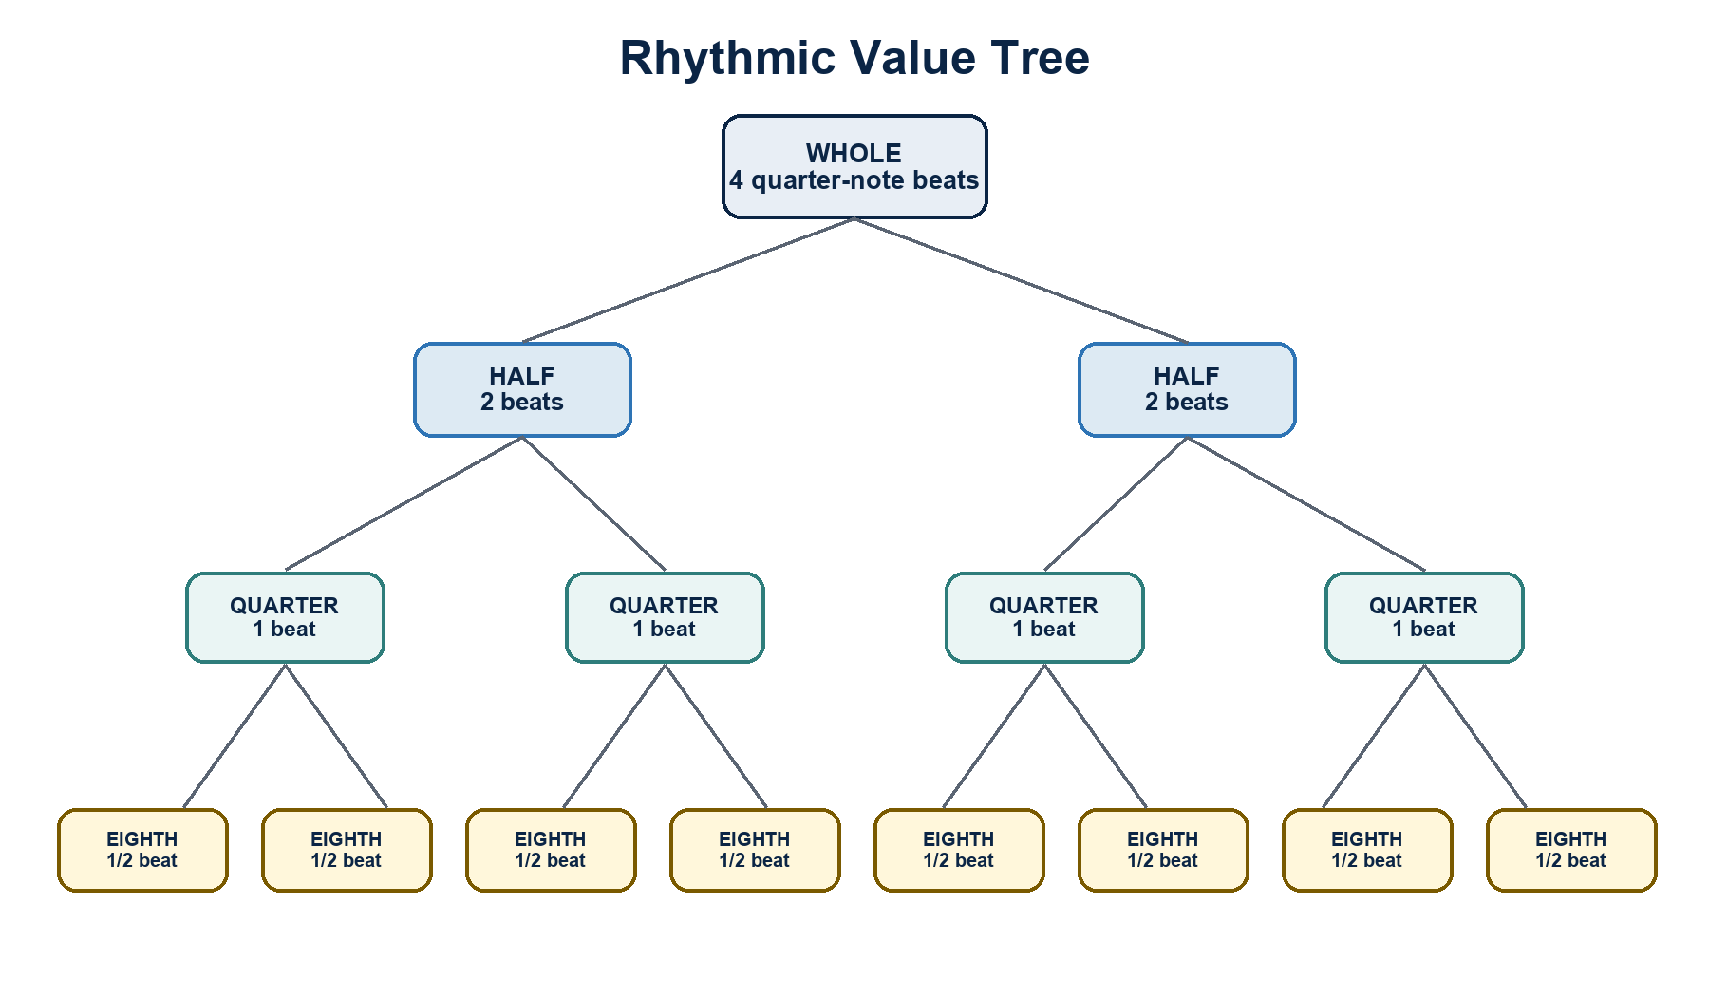
Rhythm Value Tree. A hierarchy showing relationships among common note values and subdivisions.

Circle of Fifths
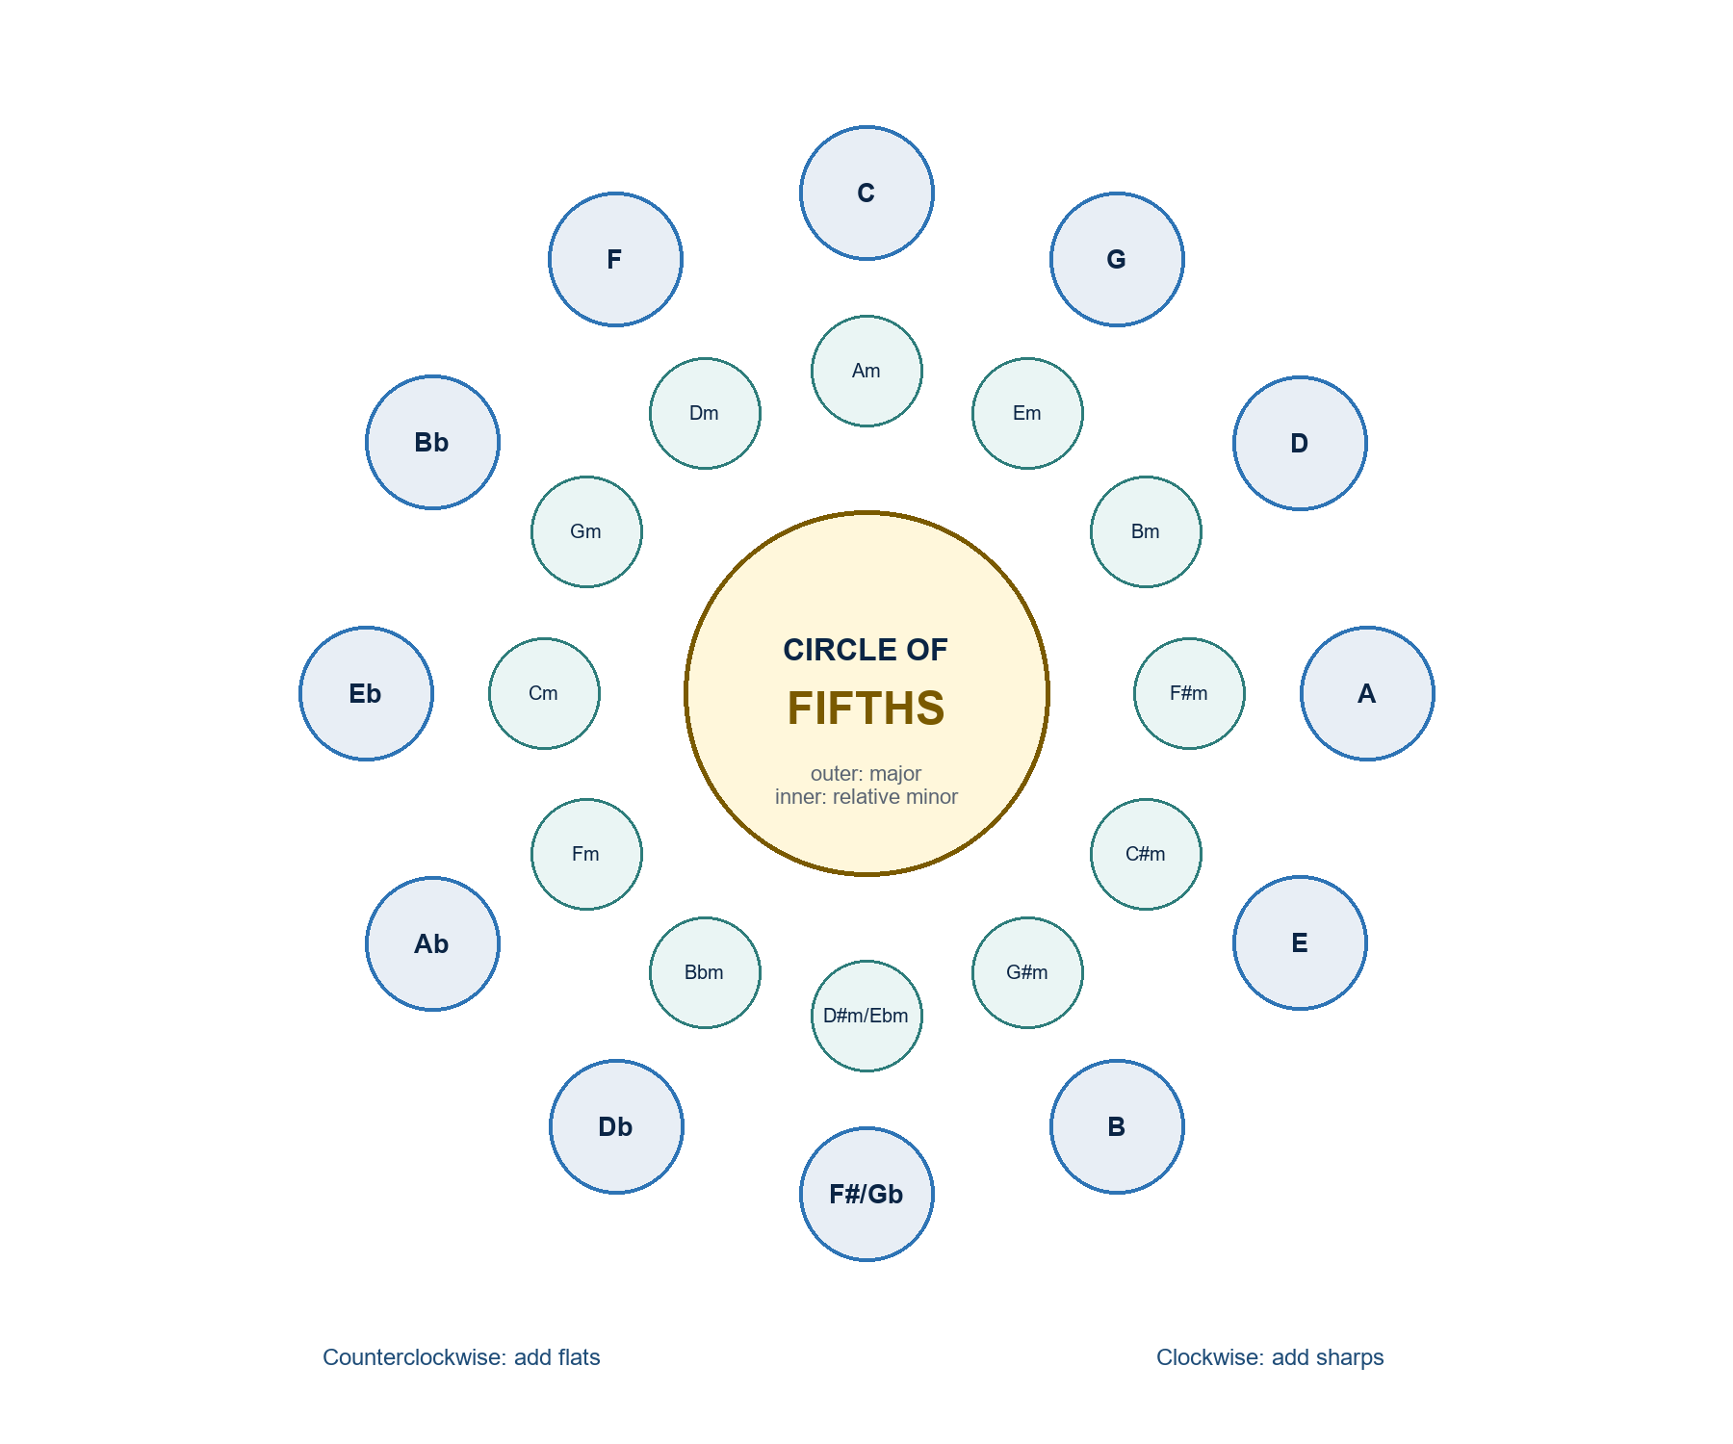
Circle of Fifths. A circle diagram linking key signatures, relative keys, and fifth relationships.
TEACHING RESOURCES
Music Fundamentals: Visual-Aid Appendix (continued)

Interval Identification Flow
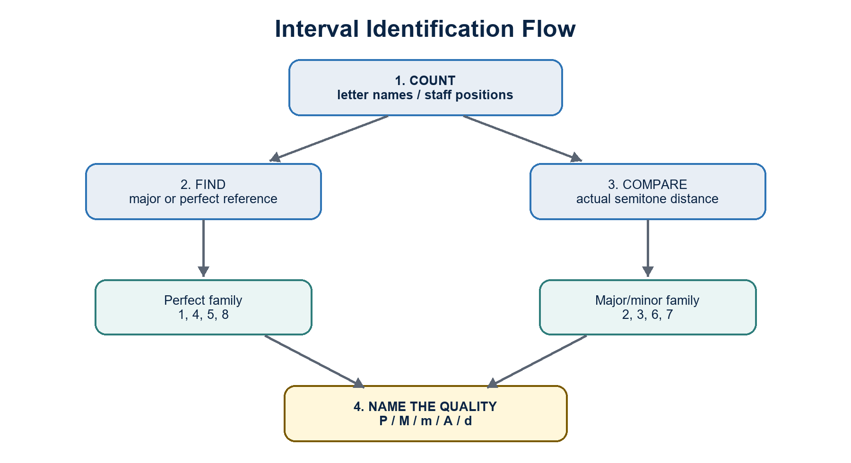
Interval Identification Flow. A decision flow for counting interval number and determining quality.

Tonal Function Map
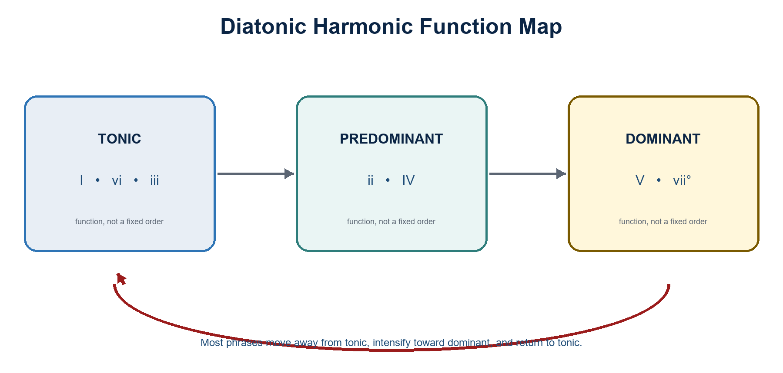
Tonal Function Map. A functional map connecting tonic, predominant, and dominant harmony.
ASSESSMENT APPENDIX
Music Fundamentals: Rubric and Implementation Checklist
Publish task-specific scoring priorities before students begin.

Music Literacy Task Rubric
Criterion | 4 - Exemplary | 3 - Proficient | 2 - Developing | 1 - Beginning
Notation accuracy | Symbols, placement, and spelling are consistently correct. | Minor errors do not obscure meaning. | Several errors show partial control. | Frequent errors prevent a readable answer.
Concept application | Chooses and applies the correct process independently. | Process is sound with small slips. | Needs prompts to select or finish the process. | Uses an unsuitable or incomplete process.
Aural-symbol link | Connects sound, notation, and terminology precisely. | Connection is generally accurate. | Connection is inconsistent. | Connection is not yet demonstrated.
Revision | Diagnoses and corrects errors with a clear reason. | Corrects most errors after feedback. | Corrects some errors with support. | Does not yet use feedback effectively.

Scoring note: Use for notation, rhythm, scales, intervals, and chord-construction tasks. Convert the four criteria to the task's announced point value.

Instructor implementation checklist
- Insert the official course code, term, section, schedule, room, consultation hours, and contact channel.
- Map each week to exact textbook units/exercises/pages and the approved academic calendar, including holidays and examination dates.
- Publish the university's current grading equivalents, attendance, make-up, integrity, accessibility, privacy, and emergency procedures.
- Prepare accessible visual aids, lawful excerpts, answer keys, differentiated examples, and a plan for students without personal devices.
- Calibrate rubric examples, moderation procedures, feedback turnaround, and secure storage of grades and recordings.
- After each week, record evidence, reteaching needs, pacing changes, and materials to replace before the next offering.

Instructor approval
Prepared by: ____________________________________ Date: ____________________
Reviewed by: ____________________________________ Date: ____________________
Approved by: ____________________________________ Date: ____________________

