COLLEGE MUSIC TEACHING PACKAGE
Music Theory II
Course Syllabus, Weekly Learning Map, Activities, Rubric, Visual Aids, and Detailed Lesson Plans
Course purpose: A continuation of tonal theory emphasizing seventh chords, tonicization, modulation, chromatic predominant harmony, mixture, altered harmony, formal function, analysis, and composition.

Course-at-a-glance
Recommended load: Recommended: 3 units / 54 contact hours
Primary text: Theory for Piano Students, G. Schirmer (Benner)
Planning model: Suggested model: three 60-minute meetings weekly; adjust to the approved institutional schedule.
Edition note: Insert exact chapter, unit, exercise, and page numbers from the edition owned by the class; page numbering varies by printing.

Before releasing to students
- Replace all bracketed institutional fields and publish the official course code and contact hours.
- Align grading equivalents, attendance rules, and make-up procedures with current university policy.
- Confirm room, piano/keyboard, projection, LMS, printing, and approved recording arrangements.
- Choose examples that are public-domain, licensed, teacher-composed, or institutionally cleared.

INSTRUCTOR SETUP
Music Theory II: Course Setup
Complete the fields below before circulation.

Institutional information
Institution: [Insert college/university]
College/Department: [Insert unit]
Instructor: [Insert name and credentials]
Academic term: [Insert term and AY]
Class schedule: [Insert days/time/room]
Consultation: [Insert office hours/contact]

Catalog and delivery profile
Course code: [Insert course code]
Units/contact hours: Recommended: 3 units / 54 contact hours
Prerequisite: Music Theory I or equivalent.
Primary text: Theory for Piano Students, G. Schirmer (Benner)
Delivery mode: In-person, blended, or online as approved by the institution.
Learning platforms: [Insert LMS, notation software, recording platform, or approved alternatives].

Required and recommended materials
- Assigned textbook and staff paper; pencil, eraser, and folder or digital portfolio.
- Access to a piano/keyboard or approved virtual keyboard for pitch and harmony checks.
- Headphones and an institution-approved recording method when an assessment requires audio.
- Instructor-provided excerpts, worksheets, and visual aids in accessible print/digital formats.

SYLLABUS CORE
Music Theory II: Outcomes and Assessment
Outcome-aligned evidence with a built-in cycle of attempt, feedback, correction, and demonstration.

Course learning outcomes
Code | By the end of the course, students can... | Primary evidence
T2.1 | analyze and resolve diatonic and chromatic seventh chords | analysis and writing
T2.2 | identify and use secondary dominants and leading-tone chords | tonicization studies
T2.3 | distinguish tonicization from modulation and map pivot-chord processes | modulation analysis
T2.4 | analyze and write modal mixture, Neapolitan, and augmented-sixth sonorities | chromatic harmony labs
T2.5 | interpret altered chords through voice leading and harmonic function | oral/written defense
T2.6 | relate chromatic harmony to phrase, sequence, and larger form | formal analysis
T2.7 | compose and revise a short tonal passage using controlled chromaticism | capstone composition
T2.8 | compare multiple plausible analyses using evidence | analysis colloquium

Assessment weights
Assessment component | Weight | What it measures
Quizzes and chord constructions | 15% | Fast, accurate chromatic spelling and labeling
Problem sets / analytical annotations | 20% | Consistent application and evidence
Keyboard, listening, and composition labs | 15% | Sound-symbol transfer
Midterm examination | 20% | Seventh chords, tonicization, modulation
Chromatic analysis-composition capstone + final | 25% | Integrated explanation, creation, and revision
Professional learning habits | 5% | Preparation, discussion, feedback practice

Grade calculation: Calculate the weighted raw score above, then apply the official university grading or transmutation system. Publish the approved equivalent table in the LMS or course handout.

Evidence cycle
- Prepare through a short reading, listening, writing, keyboard, or vocal task.
- Attempt a low-stakes first try that reveals current understanding.
- Diagnose the specific musical issue using shared vocabulary.
- Coach and revise with one targeted strategy and timely feedback.
- Demonstrate independently, then archive the evidence in the course portfolio.

STUDENT GUIDE
Music Theory II: Learning and Course Policies
Adapt the bracketed items to official institutional policy; never let this section override university rules.

Attendance and participation
Policy: Music literacy develops through cumulative guided practice. Follow the institution's approved attendance policy. Students should notify the instructor through the official channel and complete the announced recovery task after an absence.

Late and make-up work
Policy: Insert the department-approved window, documentation requirements, and procedure for quizzes, examinations, performances, and technical disruptions. Equivalent make-up tasks may use different musical material.

Academic integrity
Policy: Submitted analysis, notation, composition, recordings, and reflections must represent the student's own work except where collaboration is explicitly assigned. Credit every borrowed score, recording, image, or idea in the format required by the instructor.

Generative AI and automated tools
Policy: AI, notation playback, tuners, analyzers, and answer-generating tools may be used only for the purposes explicitly permitted on an assignment. Students must disclose permitted assistance and remain able to perform, explain, and revise the work independently. Undisclosed or prohibited assistance is handled under institutional academic-integrity policy.

Accessibility and inclusive participation
Policy: Students may request reasonable accommodations through the authorized campus office. Provide accessible copies, clear notation, usable contrast, flexible demonstration modes when outcomes allow, and an appropriate vocal octave or range. Accommodation does not lower the stated musical outcome.

Recording and privacy
Policy: Record students only when institutionally authorized and educationally necessary. State the purpose, storage location, access, retention period, and non-recording alternative. Do not post class recordings publicly without valid consent and approval.

Copyright and repertoire
Policy: Use lawfully acquired textbooks and public-domain, licensed, teacher-composed, or institutionally cleared excerpts. Do not distribute scans or recordings beyond the permitted educational use.

Respectful musicianship
Policy: Critique the musical evidence, not the person. Use names and pronouns correctly, support developing voices and instruments, and maintain a rehearsal environment where students can attempt, recover, and improve safely.

COURSE SCHEDULE
Music Theory II: Weekly Plan
Weeks 1-6 | Assign exact textbook pages from the edition in use.
Wk | Focus / assigned reading | Learning target | Activity + visual aid | Evidence
1 | Diagnostic; review of diatonic function | Restore Theory I fluency | Function-map recall; chorale repair; V5/V6 | Diagnostic task
2 | Diatonic seventh chords in context | Analyze inversion and resolution | Resolution web; keyboard cycles | Quiz 1
3 | Sequences and expanded progression | Track pattern and function | Sequence strip puzzle; bass map | Analysis 1
4 | Secondary dominants | Spell and resolve V/x | Target-tonic game; arrow analysis | Problem set
5 | Secondary leading-tone chords | Spell and resolve vii°/x and vii°7/x | Chromatic spelling relay | Quiz 2
6 | Tonicization vs modulation | Use duration, cadence, and hierarchy as evidence | Evidence sort; listening timeline | Short response

Instructor preparation: Select short examples that match student voices and instruments; use public-domain, licensed, teacher-composed, or institutionally cleared excerpts. Provide printed and projected versions.

COURSE SCHEDULE
Music Theory II: Weekly Plan
Weeks 7-12 | Assign exact textbook pages from the edition in use.
Wk | Focus / assigned reading | Learning target | Activity + visual aid | Evidence
7 | Pivot-chord modulation | Identify common chord and new-key confirmation | V3 route map; pivot passport | Modulation lab
8 | Direct/common-tone modulation; phrase plan | Compare modulatory techniques | Before/after recomposition | Analysis 2
9 | Midterm review and examination | Integrate tonicization and modulation | Colloquium review; exam | Midterm
10 | Mode mixture / borrowed chords | Explain mixture by scale-degree alteration | Parallel-key overlay; color coding | Quiz 3
11 | Neapolitan chord | Spell, voice-lead, and contextualize N6 | Predominant comparison lab | Writing study
12 | Augmented-sixth chords | Distinguish It+6, Fr+6, Ger+6 | Interval-expansion model; resolution singing | Problem set

Instructor preparation: Select short examples that match student voices and instruments; use public-domain, licensed, teacher-composed, or institutionally cleared excerpts. Provide printed and projected versions.

COURSE SCHEDULE
Music Theory II: Weekly Plan
Weeks 13-18 | Assign exact textbook pages from the edition in use.
Wk | Focus / assigned reading | Learning target | Activity + visual aid | Evidence
13 | Altered dominants and enharmonic reinterpretation | Trace voice-leading purpose | Enharmonic pivot puzzle | Quiz 4
14 | Chromatic sequences and linear harmony | Separate local voice-leading from global function | Reduction workshop | Analysis 3
15 | Phrase/form with chromatic harmony | Relate harmonic events to formal function | Form-harmony timeline | Capstone proposal
16 | Capstone composition lab | Use chromaticism with structural purpose | Compose-play-sing-revise cycle | Draft + conference
17 | Analysis colloquium and portfolio revision | Defend an interpretation with evidence | Poster session; peer questions | Capstone final
18 | Final examination and reflection | Demonstrate cumulative analytical control | Analysis/writing exam; reflection | Final exam

Instructor preparation: Select short examples that match student voices and instruments; use public-domain, licensed, teacher-composed, or institutionally cleared excerpts. Provide printed and projected versions.

TEACHING TOOLKIT
Music Theory II: Activity Toolkit
Ready-to-run protocols; scale the examples for mixed year levels.

Tonicization Target Game
Time: 30 minutes
Setup: Prepare destination-chord cards and blank staff paper.
Process: Students draw a diatonic target, construct its applied dominant or leading-tone chord, resolve it, and explain altered tones. Advanced students create a two-link chain.
Evidence: Correct spelling, resolution, and functional explanation.

Modulation Route Map
Time: 45 minutes
Setup: Provide a short teacher-composed score that changes key.
Process: Students mark old key, pivot, reinterpretation, dominant preparation, cadence, and new key; then compare alternate readings.
Evidence: Annotated score and evidence statement.

Chromatic Predominant Laboratory
Time: 40 minutes
Setup: Prepare parallel phrase frames ending on V.
Process: Groups realize N6, It+6, Fr+6, and Ger+6 versions, sing critical voice-leading lines, and compare color and spacing.
Evidence: Four realizations plus comparison paragraph.

Analysis-Composition Colloquium
Time: Two class meetings
Setup: Students bring capstone score and one-page harmonic map.
Process: Presenters perform/play the passage, explain chromatic choices, answer evidence-based questions, and revise after feedback.
Evidence: Final score, analysis, presentation, revision memo.

MUSIC THEORY II
Week 1 Lesson Plan
Diagnostic; review of diatonic function
Weekly target: Restore Theory I fluency
Textbook focus: Theory for Piano Students, G. Schirmer (Benner) - assign the matching unit, exercise, and page numbers from the class edition.
Materials / visual aids: Textbook, staff paper or score, board/projector, piano or keyboard, playback/recording only when approved; use the visual-aid appendix and the weekly visual code when named.

Measurable objectives
- Identify and explain the central features of diagnostic; review of diatonic function.
- Demonstrate this learning target: Restore Theory I fluency.
- Produce, perform, or submit the announced evidence: Diagnostic task.

Meeting A - Hear and map
Focus activity: Function-map recall.
Flow: 5 min retrieval; 8 min aural/visual hook; 12 min concise model; 20 min guided practice; 10 min independent check; 5 min exit ticket.
Student evidence: Annotated example or accurately modeled first attempt.

Meeting B - Analyze and realize
Focus activity: chorale repair.
Flow: 5 min warm-up; 10 min error review; 20 min coached application; 15 min transfer task; 7 min peer feedback; 3 min reflection.
Student evidence: Completed application with peer/instructor feedback marked.

Meeting C - Defend and revise
Focus activity: V5/V6.
Flow: 5 min retrieval; 10 min misconception mini-lesson; 20 min synthesis or creation; 15 min assessed evidence; 7 min correction/retry; 3 min assignment briefing.
Student evidence: Independent evidence: Diagnostic task.

Assessment, differentiation, and follow-through
Formative checks: Cold/warm response, one-minute construction or performance, error annotation, partner explanation, and exit ticket. Record only the evidence needed for the stated outcome.
Support: Use a chromatic-spelling scaffold, circle-of-fifths route map, reduction template, keyboard drone, and a limited choice of destination keys.
Extension: Require enharmonic reinterpretation, an alternate modulation or analysis, recomposition with a different chromatic predominant, or a formal-function defense.
Assignment / practice: Complete the corresponding Benner section, annotate altered tones and resolutions, test the progression at keyboard, and revise with a written evidence statement.
Instructor reflection: What evidence showed learning? Which misconception or barrier needs reteaching? What will change in the next meeting? ______________________________

MUSIC THEORY II
Week 2 Lesson Plan
Diatonic seventh chords in context
Weekly target: Analyze inversion and resolution
Textbook focus: Theory for Piano Students, G. Schirmer (Benner) - assign the matching unit, exercise, and page numbers from the class edition.
Materials / visual aids: Textbook, staff paper or score, board/projector, piano or keyboard, playback/recording only when approved; use the visual-aid appendix and the weekly visual code when named.

Measurable objectives
- Identify and explain the central features of diatonic seventh chords in context.
- Demonstrate this learning target: Analyze inversion and resolution.
- Produce, perform, or submit the announced evidence: Quiz 1.

Meeting A - Hear and map
Focus activity: Resolution web.
Flow: 5 min retrieval; 8 min aural/visual hook; 12 min concise model; 20 min guided practice; 10 min independent check; 5 min exit ticket.
Student evidence: Annotated example or accurately modeled first attempt.

Meeting B - Analyze and realize
Focus activity: keyboard cycles.
Flow: 5 min warm-up; 10 min error review; 20 min coached application; 15 min transfer task; 7 min peer feedback; 3 min reflection.
Student evidence: Completed application with peer/instructor feedback marked.

Meeting C - Defend and revise
Focus activity: keyboard cycles.
Flow: 5 min retrieval; 10 min misconception mini-lesson; 20 min synthesis or creation; 15 min assessed evidence; 7 min correction/retry; 3 min assignment briefing.
Student evidence: Independent evidence: Quiz 1.

Assessment, differentiation, and follow-through
Formative checks: Cold/warm response, one-minute construction or performance, error annotation, partner explanation, and exit ticket. Record only the evidence needed for the stated outcome.
Support: Use a chromatic-spelling scaffold, circle-of-fifths route map, reduction template, keyboard drone, and a limited choice of destination keys.
Extension: Require enharmonic reinterpretation, an alternate modulation or analysis, recomposition with a different chromatic predominant, or a formal-function defense.
Assignment / practice: Complete the corresponding Benner section, annotate altered tones and resolutions, test the progression at keyboard, and revise with a written evidence statement.
Instructor reflection: What evidence showed learning? Which misconception or barrier needs reteaching? What will change in the next meeting? ______________________________

MUSIC THEORY II
Week 3 Lesson Plan
Sequences and expanded progression
Weekly target: Track pattern and function
Textbook focus: Theory for Piano Students, G. Schirmer (Benner) - assign the matching unit, exercise, and page numbers from the class edition.
Materials / visual aids: Textbook, staff paper or score, board/projector, piano or keyboard, playback/recording only when approved; use the visual-aid appendix and the weekly visual code when named.

Measurable objectives
- Identify and explain the central features of sequences and expanded progression.
- Demonstrate this learning target: Track pattern and function.
- Produce, perform, or submit the announced evidence: Analysis 1.

Meeting A - Hear and map
Focus activity: Sequence strip puzzle.
Flow: 5 min retrieval; 8 min aural/visual hook; 12 min concise model; 20 min guided practice; 10 min independent check; 5 min exit ticket.
Student evidence: Annotated example or accurately modeled first attempt.

Meeting B - Analyze and realize
Focus activity: bass map.
Flow: 5 min warm-up; 10 min error review; 20 min coached application; 15 min transfer task; 7 min peer feedback; 3 min reflection.
Student evidence: Completed application with peer/instructor feedback marked.

Meeting C - Defend and revise
Focus activity: bass map.
Flow: 5 min retrieval; 10 min misconception mini-lesson; 20 min synthesis or creation; 15 min assessed evidence; 7 min correction/retry; 3 min assignment briefing.
Student evidence: Independent evidence: Analysis 1.

Assessment, differentiation, and follow-through
Formative checks: Cold/warm response, one-minute construction or performance, error annotation, partner explanation, and exit ticket. Record only the evidence needed for the stated outcome.
Support: Use a chromatic-spelling scaffold, circle-of-fifths route map, reduction template, keyboard drone, and a limited choice of destination keys.
Extension: Require enharmonic reinterpretation, an alternate modulation or analysis, recomposition with a different chromatic predominant, or a formal-function defense.
Assignment / practice: Complete the corresponding Benner section, annotate altered tones and resolutions, test the progression at keyboard, and revise with a written evidence statement.
Instructor reflection: What evidence showed learning? Which misconception or barrier needs reteaching? What will change in the next meeting? ______________________________

MUSIC THEORY II
Week 4 Lesson Plan
Secondary dominants
Weekly target: Spell and resolve V/x
Textbook focus: Theory for Piano Students, G. Schirmer (Benner) - assign the matching unit, exercise, and page numbers from the class edition.
Materials / visual aids: Textbook, staff paper or score, board/projector, piano or keyboard, playback/recording only when approved; use the visual-aid appendix and the weekly visual code when named.

Measurable objectives
- Identify and explain the central features of secondary dominants.
- Demonstrate this learning target: Spell and resolve V/x.
- Produce, perform, or submit the announced evidence: Problem set.

Meeting A - Hear and map
Focus activity: Target-tonic game.
Flow: 5 min retrieval; 8 min aural/visual hook; 12 min concise model; 20 min guided practice; 10 min independent check; 5 min exit ticket.
Student evidence: Annotated example or accurately modeled first attempt.

Meeting B - Analyze and realize
Focus activity: arrow analysis.
Flow: 5 min warm-up; 10 min error review; 20 min coached application; 15 min transfer task; 7 min peer feedback; 3 min reflection.
Student evidence: Completed application with peer/instructor feedback marked.

Meeting C - Defend and revise
Focus activity: arrow analysis.
Flow: 5 min retrieval; 10 min misconception mini-lesson; 20 min synthesis or creation; 15 min assessed evidence; 7 min correction/retry; 3 min assignment briefing.
Student evidence: Independent evidence: Problem set.

Assessment, differentiation, and follow-through
Formative checks: Cold/warm response, one-minute construction or performance, error annotation, partner explanation, and exit ticket. Record only the evidence needed for the stated outcome.
Support: Use a chromatic-spelling scaffold, circle-of-fifths route map, reduction template, keyboard drone, and a limited choice of destination keys.
Extension: Require enharmonic reinterpretation, an alternate modulation or analysis, recomposition with a different chromatic predominant, or a formal-function defense.
Assignment / practice: Complete the corresponding Benner section, annotate altered tones and resolutions, test the progression at keyboard, and revise with a written evidence statement.
Instructor reflection: What evidence showed learning? Which misconception or barrier needs reteaching? What will change in the next meeting? ______________________________

MUSIC THEORY II
Week 5 Lesson Plan
Secondary leading-tone chords
Weekly target: Spell and resolve vii°/x and vii°7/x
Textbook focus: Theory for Piano Students, G. Schirmer (Benner) - assign the matching unit, exercise, and page numbers from the class edition.
Materials / visual aids: Textbook, staff paper or score, board/projector, piano or keyboard, playback/recording only when approved; use the visual-aid appendix and the weekly visual code when named.

Measurable objectives
- Identify and explain the central features of secondary leading-tone chords.
- Demonstrate this learning target: Spell and resolve vii°/x and vii°7/x.
- Produce, perform, or submit the announced evidence: Quiz 2.

Meeting A - Hear and map
Focus activity: Chromatic spelling relay.
Flow: 5 min retrieval; 8 min aural/visual hook; 12 min concise model; 20 min guided practice; 10 min independent check; 5 min exit ticket.
Student evidence: Annotated example or accurately modeled first attempt.

Meeting B - Analyze and realize
Focus activity: Chromatic spelling relay.
Flow: 5 min warm-up; 10 min error review; 20 min coached application; 15 min transfer task; 7 min peer feedback; 3 min reflection.
Student evidence: Completed application with peer/instructor feedback marked.

Meeting C - Defend and revise
Focus activity: Chromatic spelling relay.
Flow: 5 min retrieval; 10 min misconception mini-lesson; 20 min synthesis or creation; 15 min assessed evidence; 7 min correction/retry; 3 min assignment briefing.
Student evidence: Independent evidence: Quiz 2.

Assessment, differentiation, and follow-through
Formative checks: Cold/warm response, one-minute construction or performance, error annotation, partner explanation, and exit ticket. Record only the evidence needed for the stated outcome.
Support: Use a chromatic-spelling scaffold, circle-of-fifths route map, reduction template, keyboard drone, and a limited choice of destination keys.
Extension: Require enharmonic reinterpretation, an alternate modulation or analysis, recomposition with a different chromatic predominant, or a formal-function defense.
Assignment / practice: Complete the corresponding Benner section, annotate altered tones and resolutions, test the progression at keyboard, and revise with a written evidence statement.
Instructor reflection: What evidence showed learning? Which misconception or barrier needs reteaching? What will change in the next meeting? ______________________________

MUSIC THEORY II
Week 6 Lesson Plan
Tonicization vs modulation
Weekly target: Use duration, cadence, and hierarchy as evidence
Textbook focus: Theory for Piano Students, G. Schirmer (Benner) - assign the matching unit, exercise, and page numbers from the class edition.
Materials / visual aids: Textbook, staff paper or score, board/projector, piano or keyboard, playback/recording only when approved; use the visual-aid appendix and the weekly visual code when named.

Measurable objectives
- Identify and explain the central features of tonicization vs modulation.
- Demonstrate this learning target: Use duration, cadence, and hierarchy as evidence.
- Produce, perform, or submit the announced evidence: Short response.

Meeting A - Hear and map
Focus activity: Evidence sort.
Flow: 5 min retrieval; 8 min aural/visual hook; 12 min concise model; 20 min guided practice; 10 min independent check; 5 min exit ticket.
Student evidence: Annotated example or accurately modeled first attempt.

Meeting B - Analyze and realize
Focus activity: listening timeline.
Flow: 5 min warm-up; 10 min error review; 20 min coached application; 15 min transfer task; 7 min peer feedback; 3 min reflection.
Student evidence: Completed application with peer/instructor feedback marked.

Meeting C - Defend and revise
Focus activity: listening timeline.
Flow: 5 min retrieval; 10 min misconception mini-lesson; 20 min synthesis or creation; 15 min assessed evidence; 7 min correction/retry; 3 min assignment briefing.
Student evidence: Independent evidence: Short response.

Assessment, differentiation, and follow-through
Formative checks: Cold/warm response, one-minute construction or performance, error annotation, partner explanation, and exit ticket. Record only the evidence needed for the stated outcome.
Support: Use a chromatic-spelling scaffold, circle-of-fifths route map, reduction template, keyboard drone, and a limited choice of destination keys.
Extension: Require enharmonic reinterpretation, an alternate modulation or analysis, recomposition with a different chromatic predominant, or a formal-function defense.
Assignment / practice: Complete the corresponding Benner section, annotate altered tones and resolutions, test the progression at keyboard, and revise with a written evidence statement.
Instructor reflection: What evidence showed learning? Which misconception or barrier needs reteaching? What will change in the next meeting? ______________________________

MUSIC THEORY II
Week 7 Lesson Plan
Pivot-chord modulation
Weekly target: Identify common chord and new-key confirmation
Textbook focus: Theory for Piano Students, G. Schirmer (Benner) - assign the matching unit, exercise, and page numbers from the class edition.
Materials / visual aids: Textbook, staff paper or score, board/projector, piano or keyboard, playback/recording only when approved; use the visual-aid appendix and the weekly visual code when named.

Measurable objectives
- Identify and explain the central features of pivot-chord modulation.
- Demonstrate this learning target: Identify common chord and new-key confirmation.
- Produce, perform, or submit the announced evidence: Modulation lab.

Meeting A - Hear and map
Focus activity: V3 route map.
Flow: 5 min retrieval; 8 min aural/visual hook; 12 min concise model; 20 min guided practice; 10 min independent check; 5 min exit ticket.
Student evidence: Annotated example or accurately modeled first attempt.

Meeting B - Analyze and realize
Focus activity: pivot passport.
Flow: 5 min warm-up; 10 min error review; 20 min coached application; 15 min transfer task; 7 min peer feedback; 3 min reflection.
Student evidence: Completed application with peer/instructor feedback marked.

Meeting C - Defend and revise
Focus activity: pivot passport.
Flow: 5 min retrieval; 10 min misconception mini-lesson; 20 min synthesis or creation; 15 min assessed evidence; 7 min correction/retry; 3 min assignment briefing.
Student evidence: Independent evidence: Modulation lab.

Assessment, differentiation, and follow-through
Formative checks: Cold/warm response, one-minute construction or performance, error annotation, partner explanation, and exit ticket. Record only the evidence needed for the stated outcome.
Support: Use a chromatic-spelling scaffold, circle-of-fifths route map, reduction template, keyboard drone, and a limited choice of destination keys.
Extension: Require enharmonic reinterpretation, an alternate modulation or analysis, recomposition with a different chromatic predominant, or a formal-function defense.
Assignment / practice: Complete the corresponding Benner section, annotate altered tones and resolutions, test the progression at keyboard, and revise with a written evidence statement.
Instructor reflection: What evidence showed learning? Which misconception or barrier needs reteaching? What will change in the next meeting? ______________________________

MUSIC THEORY II
Week 8 Lesson Plan
Direct/common-tone modulation; phrase plan
Weekly target: Compare modulatory techniques
Textbook focus: Theory for Piano Students, G. Schirmer (Benner) - assign the matching unit, exercise, and page numbers from the class edition.
Materials / visual aids: Textbook, staff paper or score, board/projector, piano or keyboard, playback/recording only when approved; use the visual-aid appendix and the weekly visual code when named.

Measurable objectives
- Identify and explain the central features of direct/common-tone modulation; phrase plan.
- Demonstrate this learning target: Compare modulatory techniques.
- Produce, perform, or submit the announced evidence: Analysis 2.

Meeting A - Hear and map
Focus activity: Before/after recomposition.
Flow: 5 min retrieval; 8 min aural/visual hook; 12 min concise model; 20 min guided practice; 10 min independent check; 5 min exit ticket.
Student evidence: Annotated example or accurately modeled first attempt.

Meeting B - Analyze and realize
Focus activity: Before/after recomposition.
Flow: 5 min warm-up; 10 min error review; 20 min coached application; 15 min transfer task; 7 min peer feedback; 3 min reflection.
Student evidence: Completed application with peer/instructor feedback marked.

Meeting C - Defend and revise
Focus activity: Before/after recomposition.
Flow: 5 min retrieval; 10 min misconception mini-lesson; 20 min synthesis or creation; 15 min assessed evidence; 7 min correction/retry; 3 min assignment briefing.
Student evidence: Independent evidence: Analysis 2.

Assessment, differentiation, and follow-through
Formative checks: Cold/warm response, one-minute construction or performance, error annotation, partner explanation, and exit ticket. Record only the evidence needed for the stated outcome.
Support: Use a chromatic-spelling scaffold, circle-of-fifths route map, reduction template, keyboard drone, and a limited choice of destination keys.
Extension: Require enharmonic reinterpretation, an alternate modulation or analysis, recomposition with a different chromatic predominant, or a formal-function defense.
Assignment / practice: Complete the corresponding Benner section, annotate altered tones and resolutions, test the progression at keyboard, and revise with a written evidence statement.
Instructor reflection: What evidence showed learning? Which misconception or barrier needs reteaching? What will change in the next meeting? ______________________________

MUSIC THEORY II
Week 9 Lesson Plan
Midterm review and examination
Weekly target: Integrate tonicization and modulation
Textbook focus: Theory for Piano Students, G. Schirmer (Benner) - assign the matching unit, exercise, and page numbers from the class edition.
Materials / visual aids: Textbook, staff paper or score, board/projector, piano or keyboard, playback/recording only when approved; use the visual-aid appendix and the weekly visual code when named.

Measurable objectives
- Identify and explain the central features of midterm review and examination.
- Demonstrate this learning target: Integrate tonicization and modulation.
- Produce, perform, or submit the announced evidence: Midterm.

Meeting A - Hear and map
Focus activity: Colloquium review.
Flow: 5 min retrieval; 8 min aural/visual hook; 12 min concise model; 20 min guided practice; 10 min independent check; 5 min exit ticket.
Student evidence: Annotated example or accurately modeled first attempt.

Meeting B - Analyze and realize
Focus activity: exam.
Flow: 5 min warm-up; 10 min error review; 20 min coached application; 15 min transfer task; 7 min peer feedback; 3 min reflection.
Student evidence: Completed application with peer/instructor feedback marked.

Meeting C - Defend and revise
Focus activity: exam.
Flow: 5 min retrieval; 10 min misconception mini-lesson; 20 min synthesis or creation; 15 min assessed evidence; 7 min correction/retry; 3 min assignment briefing.
Student evidence: Independent evidence: Midterm.

Assessment, differentiation, and follow-through
Formative checks: Cold/warm response, one-minute construction or performance, error annotation, partner explanation, and exit ticket. Record only the evidence needed for the stated outcome.
Support: Use a chromatic-spelling scaffold, circle-of-fifths route map, reduction template, keyboard drone, and a limited choice of destination keys.
Extension: Require enharmonic reinterpretation, an alternate modulation or analysis, recomposition with a different chromatic predominant, or a formal-function defense.
Assignment / practice: Complete the corresponding Benner section, annotate altered tones and resolutions, test the progression at keyboard, and revise with a written evidence statement.
Instructor reflection: What evidence showed learning? Which misconception or barrier needs reteaching? What will change in the next meeting? ______________________________

MUSIC THEORY II
Week 10 Lesson Plan
Mode mixture / borrowed chords
Weekly target: Explain mixture by scale-degree alteration
Textbook focus: Theory for Piano Students, G. Schirmer (Benner) - assign the matching unit, exercise, and page numbers from the class edition.
Materials / visual aids: Textbook, staff paper or score, board/projector, piano or keyboard, playback/recording only when approved; use the visual-aid appendix and the weekly visual code when named.

Measurable objectives
- Identify and explain the central features of mode mixture / borrowed chords.
- Demonstrate this learning target: Explain mixture by scale-degree alteration.
- Produce, perform, or submit the announced evidence: Quiz 3.

Meeting A - Hear and map
Focus activity: Parallel-key overlay.
Flow: 5 min retrieval; 8 min aural/visual hook; 12 min concise model; 20 min guided practice; 10 min independent check; 5 min exit ticket.
Student evidence: Annotated example or accurately modeled first attempt.

Meeting B - Analyze and realize
Focus activity: color coding.
Flow: 5 min warm-up; 10 min error review; 20 min coached application; 15 min transfer task; 7 min peer feedback; 3 min reflection.
Student evidence: Completed application with peer/instructor feedback marked.

Meeting C - Defend and revise
Focus activity: color coding.
Flow: 5 min retrieval; 10 min misconception mini-lesson; 20 min synthesis or creation; 15 min assessed evidence; 7 min correction/retry; 3 min assignment briefing.
Student evidence: Independent evidence: Quiz 3.

Assessment, differentiation, and follow-through
Formative checks: Cold/warm response, one-minute construction or performance, error annotation, partner explanation, and exit ticket. Record only the evidence needed for the stated outcome.
Support: Use a chromatic-spelling scaffold, circle-of-fifths route map, reduction template, keyboard drone, and a limited choice of destination keys.
Extension: Require enharmonic reinterpretation, an alternate modulation or analysis, recomposition with a different chromatic predominant, or a formal-function defense.
Assignment / practice: Complete the corresponding Benner section, annotate altered tones and resolutions, test the progression at keyboard, and revise with a written evidence statement.
Instructor reflection: What evidence showed learning? Which misconception or barrier needs reteaching? What will change in the next meeting? ______________________________

MUSIC THEORY II
Week 11 Lesson Plan
Neapolitan chord
Weekly target: Spell, voice-lead, and contextualize N6
Textbook focus: Theory for Piano Students, G. Schirmer (Benner) - assign the matching unit, exercise, and page numbers from the class edition.
Materials / visual aids: Textbook, staff paper or score, board/projector, piano or keyboard, playback/recording only when approved; use the visual-aid appendix and the weekly visual code when named.

Measurable objectives
- Identify and explain the central features of neapolitan chord.
- Demonstrate this learning target: Spell, voice-lead, and contextualize N6.
- Produce, perform, or submit the announced evidence: Writing study.

Meeting A - Hear and map
Focus activity: Predominant comparison lab.
Flow: 5 min retrieval; 8 min aural/visual hook; 12 min concise model; 20 min guided practice; 10 min independent check; 5 min exit ticket.
Student evidence: Annotated example or accurately modeled first attempt.

Meeting B - Analyze and realize
Focus activity: Predominant comparison lab.
Flow: 5 min warm-up; 10 min error review; 20 min coached application; 15 min transfer task; 7 min peer feedback; 3 min reflection.
Student evidence: Completed application with peer/instructor feedback marked.

Meeting C - Defend and revise
Focus activity: Predominant comparison lab.
Flow: 5 min retrieval; 10 min misconception mini-lesson; 20 min synthesis or creation; 15 min assessed evidence; 7 min correction/retry; 3 min assignment briefing.
Student evidence: Independent evidence: Writing study.

Assessment, differentiation, and follow-through
Formative checks: Cold/warm response, one-minute construction or performance, error annotation, partner explanation, and exit ticket. Record only the evidence needed for the stated outcome.
Support: Use a chromatic-spelling scaffold, circle-of-fifths route map, reduction template, keyboard drone, and a limited choice of destination keys.
Extension: Require enharmonic reinterpretation, an alternate modulation or analysis, recomposition with a different chromatic predominant, or a formal-function defense.
Assignment / practice: Complete the corresponding Benner section, annotate altered tones and resolutions, test the progression at keyboard, and revise with a written evidence statement.
Instructor reflection: What evidence showed learning? Which misconception or barrier needs reteaching? What will change in the next meeting? ______________________________

MUSIC THEORY II
Week 12 Lesson Plan
Augmented-sixth chords
Weekly target: Distinguish It+6, Fr+6, Ger+6
Textbook focus: Theory for Piano Students, G. Schirmer (Benner) - assign the matching unit, exercise, and page numbers from the class edition.
Materials / visual aids: Textbook, staff paper or score, board/projector, piano or keyboard, playback/recording only when approved; use the visual-aid appendix and the weekly visual code when named.

Measurable objectives
- Identify and explain the central features of augmented-sixth chords.
- Demonstrate this learning target: Distinguish It+6, Fr+6, Ger+6.
- Produce, perform, or submit the announced evidence: Problem set.

Meeting A - Hear and map
Focus activity: Interval-expansion model.
Flow: 5 min retrieval; 8 min aural/visual hook; 12 min concise model; 20 min guided practice; 10 min independent check; 5 min exit ticket.
Student evidence: Annotated example or accurately modeled first attempt.

Meeting B - Analyze and realize
Focus activity: resolution singing.
Flow: 5 min warm-up; 10 min error review; 20 min coached application; 15 min transfer task; 7 min peer feedback; 3 min reflection.
Student evidence: Completed application with peer/instructor feedback marked.

Meeting C - Defend and revise
Focus activity: resolution singing.
Flow: 5 min retrieval; 10 min misconception mini-lesson; 20 min synthesis or creation; 15 min assessed evidence; 7 min correction/retry; 3 min assignment briefing.
Student evidence: Independent evidence: Problem set.

Assessment, differentiation, and follow-through
Formative checks: Cold/warm response, one-minute construction or performance, error annotation, partner explanation, and exit ticket. Record only the evidence needed for the stated outcome.
Support: Use a chromatic-spelling scaffold, circle-of-fifths route map, reduction template, keyboard drone, and a limited choice of destination keys.
Extension: Require enharmonic reinterpretation, an alternate modulation or analysis, recomposition with a different chromatic predominant, or a formal-function defense.
Assignment / practice: Complete the corresponding Benner section, annotate altered tones and resolutions, test the progression at keyboard, and revise with a written evidence statement.
Instructor reflection: What evidence showed learning? Which misconception or barrier needs reteaching? What will change in the next meeting? ______________________________

MUSIC THEORY II
Week 13 Lesson Plan
Altered dominants and enharmonic reinterpretation
Weekly target: Trace voice-leading purpose
Textbook focus: Theory for Piano Students, G. Schirmer (Benner) - assign the matching unit, exercise, and page numbers from the class edition.
Materials / visual aids: Textbook, staff paper or score, board/projector, piano or keyboard, playback/recording only when approved; use the visual-aid appendix and the weekly visual code when named.

Measurable objectives
- Identify and explain the central features of altered dominants and enharmonic reinterpretation.
- Demonstrate this learning target: Trace voice-leading purpose.
- Produce, perform, or submit the announced evidence: Quiz 4.

Meeting A - Hear and map
Focus activity: Enharmonic pivot puzzle.
Flow: 5 min retrieval; 8 min aural/visual hook; 12 min concise model; 20 min guided practice; 10 min independent check; 5 min exit ticket.
Student evidence: Annotated example or accurately modeled first attempt.

Meeting B - Analyze and realize
Focus activity: Enharmonic pivot puzzle.
Flow: 5 min warm-up; 10 min error review; 20 min coached application; 15 min transfer task; 7 min peer feedback; 3 min reflection.
Student evidence: Completed application with peer/instructor feedback marked.

Meeting C - Defend and revise
Focus activity: Enharmonic pivot puzzle.
Flow: 5 min retrieval; 10 min misconception mini-lesson; 20 min synthesis or creation; 15 min assessed evidence; 7 min correction/retry; 3 min assignment briefing.
Student evidence: Independent evidence: Quiz 4.

Assessment, differentiation, and follow-through
Formative checks: Cold/warm response, one-minute construction or performance, error annotation, partner explanation, and exit ticket. Record only the evidence needed for the stated outcome.
Support: Use a chromatic-spelling scaffold, circle-of-fifths route map, reduction template, keyboard drone, and a limited choice of destination keys.
Extension: Require enharmonic reinterpretation, an alternate modulation or analysis, recomposition with a different chromatic predominant, or a formal-function defense.
Assignment / practice: Complete the corresponding Benner section, annotate altered tones and resolutions, test the progression at keyboard, and revise with a written evidence statement.
Instructor reflection: What evidence showed learning? Which misconception or barrier needs reteaching? What will change in the next meeting? ______________________________

MUSIC THEORY II
Week 14 Lesson Plan
Chromatic sequences and linear harmony
Weekly target: Separate local voice-leading from global function
Textbook focus: Theory for Piano Students, G. Schirmer (Benner) - assign the matching unit, exercise, and page numbers from the class edition.
Materials / visual aids: Textbook, staff paper or score, board/projector, piano or keyboard, playback/recording only when approved; use the visual-aid appendix and the weekly visual code when named.

Measurable objectives
- Identify and explain the central features of chromatic sequences and linear harmony.
- Demonstrate this learning target: Separate local voice-leading from global function.
- Produce, perform, or submit the announced evidence: Analysis 3.

Meeting A - Hear and map
Focus activity: Reduction workshop.
Flow: 5 min retrieval; 8 min aural/visual hook; 12 min concise model; 20 min guided practice; 10 min independent check; 5 min exit ticket.
Student evidence: Annotated example or accurately modeled first attempt.

Meeting B - Analyze and realize
Focus activity: Reduction workshop.
Flow: 5 min warm-up; 10 min error review; 20 min coached application; 15 min transfer task; 7 min peer feedback; 3 min reflection.
Student evidence: Completed application with peer/instructor feedback marked.

Meeting C - Defend and revise
Focus activity: Reduction workshop.
Flow: 5 min retrieval; 10 min misconception mini-lesson; 20 min synthesis or creation; 15 min assessed evidence; 7 min correction/retry; 3 min assignment briefing.
Student evidence: Independent evidence: Analysis 3.

Assessment, differentiation, and follow-through
Formative checks: Cold/warm response, one-minute construction or performance, error annotation, partner explanation, and exit ticket. Record only the evidence needed for the stated outcome.
Support: Use a chromatic-spelling scaffold, circle-of-fifths route map, reduction template, keyboard drone, and a limited choice of destination keys.
Extension: Require enharmonic reinterpretation, an alternate modulation or analysis, recomposition with a different chromatic predominant, or a formal-function defense.
Assignment / practice: Complete the corresponding Benner section, annotate altered tones and resolutions, test the progression at keyboard, and revise with a written evidence statement.
Instructor reflection: What evidence showed learning? Which misconception or barrier needs reteaching? What will change in the next meeting? ______________________________

MUSIC THEORY II
Week 15 Lesson Plan
Phrase/form with chromatic harmony
Weekly target: Relate harmonic events to formal function
Textbook focus: Theory for Piano Students, G. Schirmer (Benner) - assign the matching unit, exercise, and page numbers from the class edition.
Materials / visual aids: Textbook, staff paper or score, board/projector, piano or keyboard, playback/recording only when approved; use the visual-aid appendix and the weekly visual code when named.

Measurable objectives
- Identify and explain the central features of phrase/form with chromatic harmony.
- Demonstrate this learning target: Relate harmonic events to formal function.
- Produce, perform, or submit the announced evidence: Capstone proposal.

Meeting A - Hear and map
Focus activity: Form-harmony timeline.
Flow: 5 min retrieval; 8 min aural/visual hook; 12 min concise model; 20 min guided practice; 10 min independent check; 5 min exit ticket.
Student evidence: Annotated example or accurately modeled first attempt.

Meeting B - Analyze and realize
Focus activity: Form-harmony timeline.
Flow: 5 min warm-up; 10 min error review; 20 min coached application; 15 min transfer task; 7 min peer feedback; 3 min reflection.
Student evidence: Completed application with peer/instructor feedback marked.

Meeting C - Defend and revise
Focus activity: Form-harmony timeline.
Flow: 5 min retrieval; 10 min misconception mini-lesson; 20 min synthesis or creation; 15 min assessed evidence; 7 min correction/retry; 3 min assignment briefing.
Student evidence: Independent evidence: Capstone proposal.

Assessment, differentiation, and follow-through
Formative checks: Cold/warm response, one-minute construction or performance, error annotation, partner explanation, and exit ticket. Record only the evidence needed for the stated outcome.
Support: Use a chromatic-spelling scaffold, circle-of-fifths route map, reduction template, keyboard drone, and a limited choice of destination keys.
Extension: Require enharmonic reinterpretation, an alternate modulation or analysis, recomposition with a different chromatic predominant, or a formal-function defense.
Assignment / practice: Complete the corresponding Benner section, annotate altered tones and resolutions, test the progression at keyboard, and revise with a written evidence statement.
Instructor reflection: What evidence showed learning? Which misconception or barrier needs reteaching? What will change in the next meeting? ______________________________

MUSIC THEORY II
Week 16 Lesson Plan
Capstone composition lab
Weekly target: Use chromaticism with structural purpose
Textbook focus: Theory for Piano Students, G. Schirmer (Benner) - assign the matching unit, exercise, and page numbers from the class edition.
Materials / visual aids: Textbook, staff paper or score, board/projector, piano or keyboard, playback/recording only when approved; use the visual-aid appendix and the weekly visual code when named.

Measurable objectives
- Identify and explain the central features of capstone composition lab.
- Demonstrate this learning target: Use chromaticism with structural purpose.
- Produce, perform, or submit the announced evidence: Draft + conference.

Meeting A - Hear and map
Focus activity: Compose-play-sing-revise cycle.
Flow: 5 min retrieval; 8 min aural/visual hook; 12 min concise model; 20 min guided practice; 10 min independent check; 5 min exit ticket.
Student evidence: Annotated example or accurately modeled first attempt.

Meeting B - Analyze and realize
Focus activity: Compose-play-sing-revise cycle.
Flow: 5 min warm-up; 10 min error review; 20 min coached application; 15 min transfer task; 7 min peer feedback; 3 min reflection.
Student evidence: Completed application with peer/instructor feedback marked.

Meeting C - Defend and revise
Focus activity: Compose-play-sing-revise cycle.
Flow: 5 min retrieval; 10 min misconception mini-lesson; 20 min synthesis or creation; 15 min assessed evidence; 7 min correction/retry; 3 min assignment briefing.
Student evidence: Independent evidence: Draft + conference.

Assessment, differentiation, and follow-through
Formative checks: Cold/warm response, one-minute construction or performance, error annotation, partner explanation, and exit ticket. Record only the evidence needed for the stated outcome.
Support: Use a chromatic-spelling scaffold, circle-of-fifths route map, reduction template, keyboard drone, and a limited choice of destination keys.
Extension: Require enharmonic reinterpretation, an alternate modulation or analysis, recomposition with a different chromatic predominant, or a formal-function defense.
Assignment / practice: Complete the corresponding Benner section, annotate altered tones and resolutions, test the progression at keyboard, and revise with a written evidence statement.
Instructor reflection: What evidence showed learning? Which misconception or barrier needs reteaching? What will change in the next meeting? ______________________________

MUSIC THEORY II
Week 17 Lesson Plan
Analysis colloquium and portfolio revision
Weekly target: Defend an interpretation with evidence
Textbook focus: Theory for Piano Students, G. Schirmer (Benner) - assign the matching unit, exercise, and page numbers from the class edition.
Materials / visual aids: Textbook, staff paper or score, board/projector, piano or keyboard, playback/recording only when approved; use the visual-aid appendix and the weekly visual code when named.

Measurable objectives
- Identify and explain the central features of analysis colloquium and portfolio revision.
- Demonstrate this learning target: Defend an interpretation with evidence.
- Produce, perform, or submit the announced evidence: Capstone final.

Meeting A - Hear and map
Focus activity: Poster session.
Flow: 5 min retrieval; 8 min aural/visual hook; 12 min concise model; 20 min guided practice; 10 min independent check; 5 min exit ticket.
Student evidence: Annotated example or accurately modeled first attempt.

Meeting B - Analyze and realize
Focus activity: peer questions.
Flow: 5 min warm-up; 10 min error review; 20 min coached application; 15 min transfer task; 7 min peer feedback; 3 min reflection.
Student evidence: Completed application with peer/instructor feedback marked.

Meeting C - Defend and revise
Focus activity: peer questions.
Flow: 5 min retrieval; 10 min misconception mini-lesson; 20 min synthesis or creation; 15 min assessed evidence; 7 min correction/retry; 3 min assignment briefing.
Student evidence: Independent evidence: Capstone final.

Assessment, differentiation, and follow-through
Formative checks: Cold/warm response, one-minute construction or performance, error annotation, partner explanation, and exit ticket. Record only the evidence needed for the stated outcome.
Support: Use a chromatic-spelling scaffold, circle-of-fifths route map, reduction template, keyboard drone, and a limited choice of destination keys.
Extension: Require enharmonic reinterpretation, an alternate modulation or analysis, recomposition with a different chromatic predominant, or a formal-function defense.
Assignment / practice: Complete the corresponding Benner section, annotate altered tones and resolutions, test the progression at keyboard, and revise with a written evidence statement.
Instructor reflection: What evidence showed learning? Which misconception or barrier needs reteaching? What will change in the next meeting? ______________________________

MUSIC THEORY II
Week 18 Lesson Plan
Final examination and reflection
Weekly target: Demonstrate cumulative analytical control
Textbook focus: Theory for Piano Students, G. Schirmer (Benner) - assign the matching unit, exercise, and page numbers from the class edition.
Materials / visual aids: Textbook, staff paper or score, board/projector, piano or keyboard, playback/recording only when approved; use the visual-aid appendix and the weekly visual code when named.

Measurable objectives
- Identify and explain the central features of final examination and reflection.
- Demonstrate this learning target: Demonstrate cumulative analytical control.
- Produce, perform, or submit the announced evidence: Final exam.

Meeting A - Hear and map
Focus activity: Analysis/writing exam.
Flow: 5 min retrieval; 8 min aural/visual hook; 12 min concise model; 20 min guided practice; 10 min independent check; 5 min exit ticket.
Student evidence: Annotated example or accurately modeled first attempt.

Meeting B - Analyze and realize
Focus activity: reflection.
Flow: 5 min warm-up; 10 min error review; 20 min coached application; 15 min transfer task; 7 min peer feedback; 3 min reflection.
Student evidence: Completed application with peer/instructor feedback marked.

Meeting C - Defend and revise
Focus activity: reflection.
Flow: 5 min retrieval; 10 min misconception mini-lesson; 20 min synthesis or creation; 15 min assessed evidence; 7 min correction/retry; 3 min assignment briefing.
Student evidence: Independent evidence: Final exam.

Assessment, differentiation, and follow-through
Formative checks: Cold/warm response, one-minute construction or performance, error annotation, partner explanation, and exit ticket. Record only the evidence needed for the stated outcome.
Support: Use a chromatic-spelling scaffold, circle-of-fifths route map, reduction template, keyboard drone, and a limited choice of destination keys.
Extension: Require enharmonic reinterpretation, an alternate modulation or analysis, recomposition with a different chromatic predominant, or a formal-function defense.
Assignment / practice: Complete the corresponding Benner section, annotate altered tones and resolutions, test the progression at keyboard, and revise with a written evidence statement.
Instructor reflection: What evidence showed learning? Which misconception or barrier needs reteaching? What will change in the next meeting? ______________________________

TEACHING RESOURCES
Music Theory II: Visual-Aid Appendix
Project, print, or post these aids in an accessible format. Pair every diagram with spoken and written explanation.

Circle of Fifths
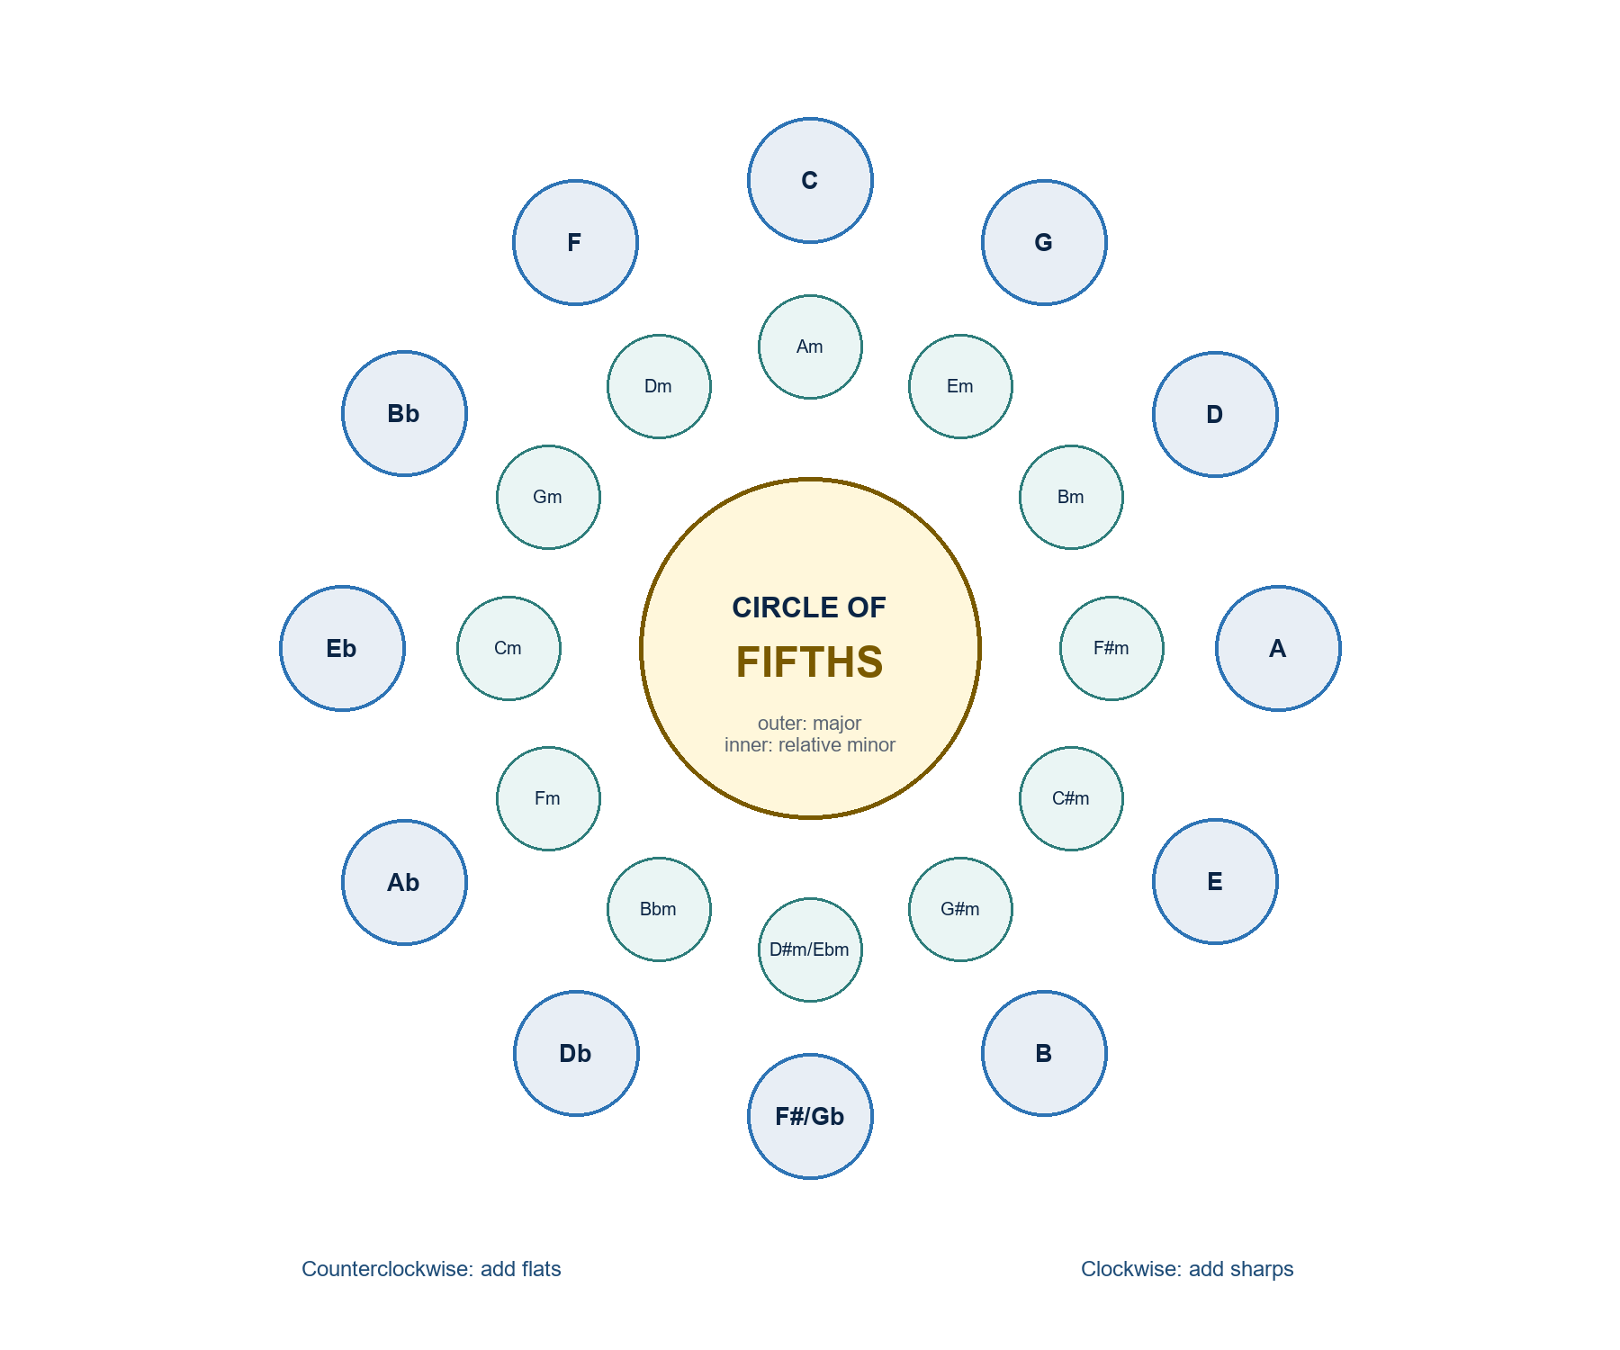
Circle of Fifths. A key-relationship map for tonicization and modulation routes.

Tonal Function Map
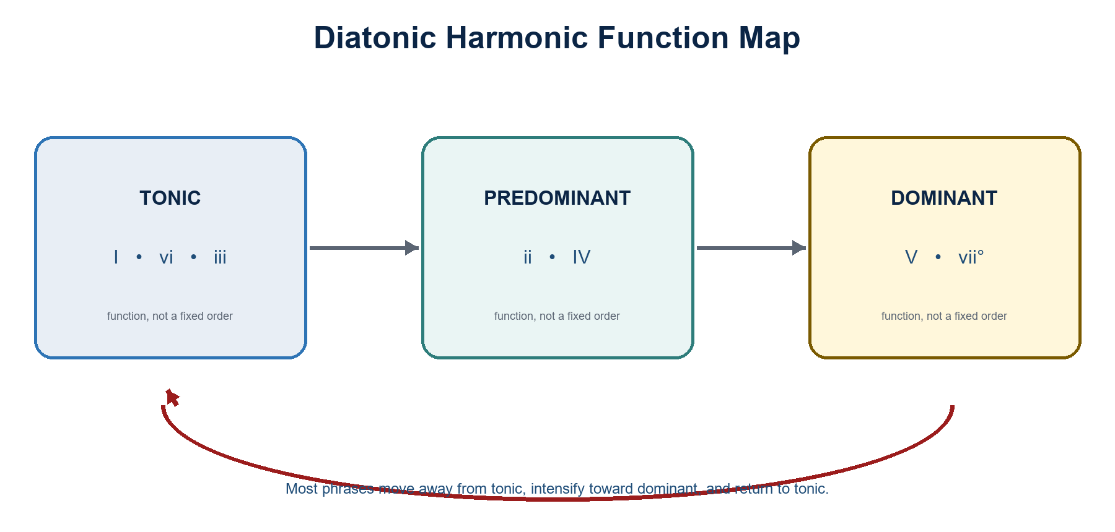
Tonal Function Map. A function map extended through applied and chromatic harmony.
TEACHING RESOURCES
Music Theory II: Visual-Aid Appendix (continued)

Chromatic Voice-Leading Checklist
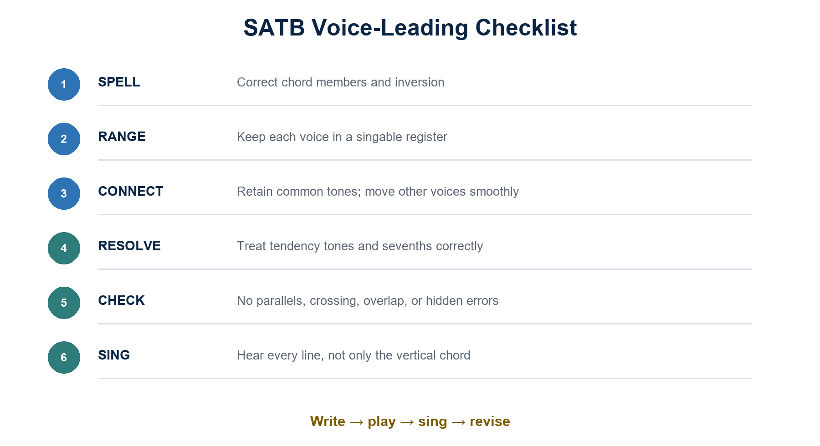
Chromatic Voice-Leading Checklist. A checklist for altered tones, tendency tones, spacing, and resolution.
ASSESSMENT APPENDIX
Music Theory II: Rubric and Implementation Checklist
Publish task-specific scoring priorities before students begin.

Chromatic Analysis-Composition Rubric
Criterion | 4 - Exemplary | 3 - Proficient | 2 - Developing | 1 - Beginning
Chromatic accuracy | Altered tones, chord identity, inversion, and resolution are consistently correct. | Minor slips do not change function. | Several spelling or resolution errors weaken control. | Errors prevent a coherent chromatic reading.
Functional/formal reasoning | Relates local voice leading to key, phrase, and form with strong evidence. | Reasoning is sound with small gaps. | Reasoning is partial or inconsistent. | Functional claims are unsupported.
Compositional control | Chromaticism has structural purpose and persuasive musical effect. | Chromaticism is functional and mostly controlled. | Effect is uneven or mechanically applied. | Chromatic choices lack resolution or purpose.
Communication and revision | Score, map, defense, and revision are precise and professional. | Materials are clear and revisions mostly succeed. | Clarity or revision is inconsistent. | Materials are incomplete or unclear.

Scoring note: Use for modulation analyses, chromatic-harmony writing, colloquia, and the analysis-composition capstone.

Instructor implementation checklist
- Insert the official course code, term, section, schedule, room, consultation hours, and contact channel.
- Map each week to exact textbook units/exercises/pages and the approved academic calendar, including holidays and examination dates.
- Publish the university's current grading equivalents, attendance, make-up, integrity, accessibility, privacy, and emergency procedures.
- Prepare accessible visual aids, lawful excerpts, answer keys, differentiated examples, and a plan for students without personal devices.
- Calibrate rubric examples, moderation procedures, feedback turnaround, and secure storage of grades and recordings.
- After each week, record evidence, reteaching needs, pacing changes, and materials to replace before the next offering.

Instructor approval
Prepared by: ____________________________________ Date: ____________________
Reviewed by: ____________________________________ Date: ____________________
Approved by: ____________________________________ Date: ____________________

