

**NAME; EZRA NKHATA**

**STUDENT ID; 202201656**

**COURSE; IT PROJECT MANAGEMENT**

**LECTURER; MR NGUNI**

**IT PROJECT: AI-Powered Smart Speed Trap System for Zambia**

**1. Brainstorming**

When developing a solution to address the problem of road safety violations, particularly speeding in Zambia, several ideas were considered. Among these were systems that could detect and deter over-speeding to reduce road accidents, and enhance enforcement of speed regulations. The team brainstormed various project ideas, and ultimately decided to focus on an AI-powered smart speed trap system.

One idea discussed was an AI-powered public transportation scheduling system that could monitor real-time traffic conditions and dynamically adjust schedules to reduce delays. Another concept was an AI-based road condition monitoring system that uses predictive models to detect and anticipate road wear, allowing proactive maintenance. This would enhance safety and reduce disruption due to road repair. Also considered was an AI-powered system that could integrate environmental considerations by optimizing routes to minimize fuel consumption and emissions, which would ultimately contribute to a greener transport network.

After careful consideration, the most relevant idea to address the immediate and ongoing problem of traffic safety was the AI-powered smart speed trap system. This system would help mitigate the high rate of road accidents and fatalities in Zambia due to speeding.

**2. Project Selection**

The selected project was the development of an AI-Powered Smart Speed Trap System designed to identify and capture instances of speeding across Zambia. The choice of this project was influenced by the significant road safety concerns across the country. With a rapidly growing number of vehicles on Zambian roads, speeding has become one of the primary causes of accidents, leading to both loss of life and substantial economic losses.

The current enforcement mechanisms are either insufficient or inefficient, relying largely on manual processes or outdated systems that are unable to cope with modern traffic demands. Speed enforcement is often undermined due to a lack of resources and inconsistent monitoring. Consequently, there is a need for an advanced solution that utilizes AI to monitor, detect, and enforce speed limits more effectively.

The AI-powered system will use real-time data from strategically placed speed cameras and sensors to detect vehicles exceeding the legal speed limits. The system will automatically capture images of speeding vehicles, including the license plate, and will send this data to traffic authorities for enforcement actions. This will reduce the workload on traffic officers, allowing for more consistent and accurate enforcement of speed regulations.

**3. Project Definition**

**Problem Statement**

Zambia faces a significant challenge in road safety, with speeding being one of the primary causes of road accidents and fatalities. The current manual system for enforcing speed limits is inadequate to handle the scale of traffic in major cities and highways across the country. There is an urgent need for a more efficient, reliable, and scalable system that can automatically detect and respond to speeding violations, contributing to the reduction of road accidents and fatalities.

**Project Goal**

The goal of this project is to design and implement an AI-powered smart speed trap system that will monitor traffic in real-time, detect speeding violations, and automatically initiate enforcement actions. This system is expected to significantly reduce the incidence of speeding-related accidents, thus enhancing road safety throughout Zambia.

**Objectives**

The primary objective is to develop an AI-based system that will automatically monitor and enforce speed limits across key road networks in Zambia. The system will aim to reduce speeding violations by 50% within the first 12 months of implementation. It will also be designed to decrease road accident rates by 30%, contributing to overall public safety.

The system will achieve this by utilizing data from high-definition cameras and ground-based sensors to detect speeding vehicles. It will be integrated with traffic databases to enable authorities to issue fines automatically. This project will focus on major highways and city roads initially, with plans to extend coverage nationwide.

The project will be completed in phases over a 24-month period. Each phase will involve detailed research, data collection, system development, testing, pilot implementation, and finally, full deployment.

**Target Audience and Stakeholders**

The primary users of this system will be Zambia’s traffic management authorities, who will use the data and tools provided by the system to enhance enforcement of speed regulations. Other beneficiaries include local law enforcement agencies, the Ministry of Transport, and motorists across Zambia, as the system will ensure greater compliance with speed limits. Road safety organizations, public transportation operators, and community leaders also stand to benefit as the project will create a safer road environment.

**Stakeholders**

The key stakeholders include Zambia’s Road Transport and Safety Agency (RTSA), traffic police, the Ministry of Transport and Communications, road safety advocates, local government authorities, and private transport operators. They all play a crucial role in ensuring the success and widespread adoption of the system.

**4. Project Scope**

The scope of the AI-powered speed trap system is to design and implement an automated, AI-driven mechanism capable of detecting speeding violations and enforcing speed limits in real time. This system will be deployed on major roads and highways in Zambia, with the initial focus on the busiest and most accident-prone areas. The system will rely on a network of high-resolution speed cameras and roadside sensors to monitor vehicle speeds.

The project will include the following elements:

* The design and development of AI algorithms for detecting speeding vehicles.
* Integration with existing traffic control and law enforcement databases for the automatic issuance of speeding tickets.
* Installation of additional cameras and sensors in key areas.
* Pilot testing in selected locations to assess the system’s performance before a wider rollout.

Exclusions from the project include new road infrastructure development, which is beyond the scope of this initiative. The system will work with existing road networks and traffic management infrastructure. Full nationwide implementation is also outside the current project scope; the focus is on high-risk zones as the first phase.

The project assumes the availability of reliable internet and electrical power for the continuous operation of the system. Cooperation from traffic authorities and access to historical traffic data for training the AI models are critical assumptions.

Constraints include potential budget limitations, the availability of trained personnel to operate and maintain the system, and infrastructure limitations in rural or underdeveloped areas.

**5. Work Breakdown Structure (WBS)**

The project will be broken down into several major tasks to ensure systematic development and deployment of the AI-powered smart speed trap system.

The first task is the planning and research phase, where detailed traffic analysis will be conducted to identify high-risk areas for speeding. Data will be collected to inform the design of the AI models that will drive the system. During this phase, stakeholder engagement will be critical to ensure that the system aligns with the needs and requirements of traffic authorities, law enforcement, and the public.

The second task involves the development of the AI system itself. This includes acquiring and processing the necessary data, developing machine learning algorithms that can accurately detect speeding vehicles, and testing these algorithms to ensure they perform optimally in real-world conditions. The AI system will be integrated with traffic control systems to enable real-time monitoring and enforcement of speed limits.

The third task is the installation of hardware, including the setup of speed cameras and sensors along major highways and in urban areas. These devices will be connected to the central AI system, and the necessary networking infrastructure will be established to ensure data can be transmitted reliably and efficiently.

Once the system is set up, the fourth task involves pilot testing at selected locations. The system will be calibrated and optimized based on its performance in real-world conditions. Feedback from stakeholders will be incorporated into the final system adjustments before full deployment.

The final tasks are training and full deployment. Traffic authorities and relevant personnel will be trained to use the system effectively, and public awareness campaigns will be conducted to inform drivers about the new system and the importance of adhering to speed limits. Full deployment will take place in the selected pilot areas, and the system’s performance will be evaluated over time, with recommendations made for potential expansion across Zambia.

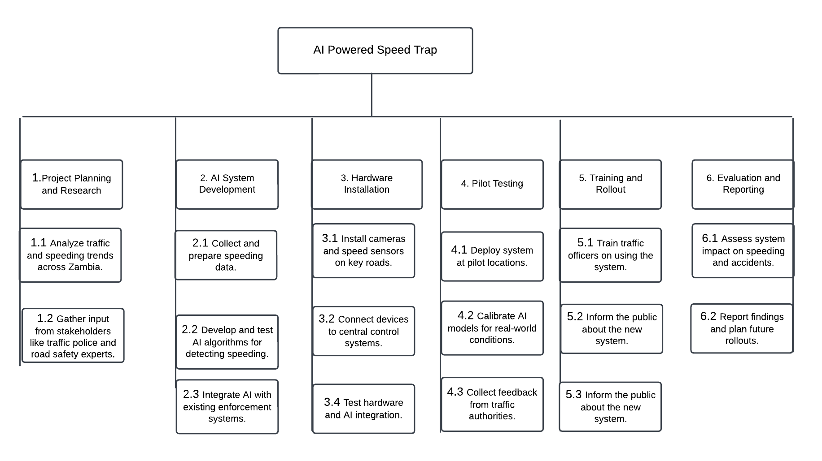

**6. Project Schedule**

The AI-powered speed trap system project will span 24 months from initiation to full deployment, with a high-level schedule of milestones.

The project will kick off in November 2024, beginning with research and data collection, which is expected to take approximately four months. This will be followed by the development of the AI system, which will require six months of dedicated effort. By mid-2025, the hardware installation will begin, taking about three months to complete.

Pilot testing will start in late 2025 and continue into early 2026. Based on the outcomes of the pilot, adjustments to the system will be made before full deployment in selected high-traffic areas. By the end of 2026, the system will be operational in these zones, and plans for expansion will be prepared.

Each phase is dependent on the successful completion of the previous one. For example, the development of the AI system cannot begin until sufficient data has been collected. Similarly, hardware installation must be completed before pilot testing can commence.

**7. Project Budget**

The estimated budget for this project totals approximately K6,800,000. This will cover all the resources required for AI development, hardware procurement and installation, and ongoing system support.

A significant portion of the budget, about K2,000,000, will be allocated to the AI development team, consisting of data scientists, machine learning engineers, and software developers. This team will be responsible for designing and testing the algorithms that will detect speeding vehicles in real time.

Another substantial cost will be the procurement of traffic cameras and sensors, which will require approximately K1,600,000. High-definition cameras equipped with motion detection and night vision capabilities will be essential for ensuring 24/7 monitoring across key roadways.

Networking infrastructure, including routers, switches, and cables, will account for around K700,000, ensuring that data from the cameras and sensors is transmitted to the central system for processing. Software licenses for machine learning frameworks and cloud computing services will also be necessary, with an estimated cost of K600,000.

Installation and integration will require skilled labor, and a budget of K900,000 will be allocated for technicians responsible for setting up the cameras, sensors, and networking infrastructure. An additional K300,000 will be reserved for training traffic management authorities on how to operate and maintain the system, ensuring that they are equipped to manage its day-to-day operations effectively.

Public awareness campaigns, crucial for informing drivers about the new speed enforcement measures and encouraging adherence to speed limits, will require K400,000. These campaigns will be conducted through various media channels, including television, radio, and social media, to reach as many motorists as possible.

The remaining K300,000 will serve as a contingency fund, reserved for unforeseen expenses that may arise during the development, installation, or deployment phases of the project. This ensures that the project can continue smoothly even if unexpected challenges or additional costs are encountered.

**8. Risks and Mitigation**

Several risks could impact the success of this AI-powered smart speed trap system, but mitigation strategies will be implemented to minimize their effects.

One of the major risks is the potential for technical failures in either the hardware (cameras, sensors) or the AI system. These failures could result in inaccurate detection of speeding vehicles or a complete system breakdown. To mitigate this risk, a comprehensive testing and maintenance plan will be developed. The system will undergo rigorous testing during the pilot phase to identify and correct potential issues. Moreover, regular maintenance schedules will be established to ensure that the hardware components are functioning optimally.

Another risk is resistance from the public or motorists who may view the system as overly intrusive or punitive. To address this, public awareness campaigns will be launched well in advance of the system’s deployment, educating motorists on the importance of speed regulation and how the system aims to enhance road safety. Clear communication regarding the benefits of reduced accidents and fatalities will be emphasized, demonstrating how the system is ultimately for the public’s well-being.

Budget constraints also pose a risk, particularly if the project exceeds its financial resources. This could delay the project’s timeline or reduce its scope. To mitigate this, a detailed financial management plan will be developed, and close monitoring of expenses will be conducted throughout the project. Additionally, potential partnerships or collaborations with public or private stakeholders could provide additional funding if necessary.

Finally, there may be challenges related to the legal and regulatory framework. For example, integrating the AI-powered system with existing traffic databases and ensuring compliance with privacy laws may pose legal hurdles. To mitigate this risk, the project team will work closely with legal experts and government authorities to ensure that all regulations are followed and that the system’s design complies with Zambia’s legal requirements.

**9. Conclusion**

The AI-powered smart speed trap system represents a transformative solution to Zambia’s growing road safety problem. By leveraging advanced AI technology, this system will provide an efficient, automated means of detecting speeding vehicles, thereby reducing road accidents and saving lives.

Through careful planning, a phased approach, and collaboration with key stakeholders, this project aims to modernize Zambia’s traffic management system and create safer roads for all. With its potential to significantly reduce speeding and its associated risks, this system stands to make a meaningful contribution to public safety across the country.

In conclusion, the development and deployment of this AI-powered speed trap system is not only an innovative response to a pressing issue but also a vital step toward enhancing the overall quality of life in Zambia by ensuring that the roads are safer for all. With the right resources, commitment, and ongoing support, the project is poised to deliver long-term benefits that extend far beyond the immediate goal of speed enforcement, contributing to broader efforts in road safety, law enforcement efficiency, and technological advancement in Zambia.

REFERENCES

1. Goodall, N. J. (2014). Machine learning in autonomous vehicles: The ethical issues. *IEEE Intelligent Systems, 29*(5), 56-60. https://doi.org/10.1109/MIS.2014.77

2. Lu, H., Li, Y., Chen, M., Kim, H., & Serikawa, S. (2018). Brain intelligence: Go beyond artificial intelligence. *Mobile Networks and Applications, 23*(2), 368-375. https://doi.org/10.1007/s11036-017-0932-8

3. Farah, H., & Toledo, T. (2010). A safety impact evaluation framework for intelligent speed adaptation systems. *Accident Analysis & Prevention, 42*(2), 333-340. https://doi.org/10.1016/j.aap.2009.09.013

4. Tettamanti, T., Varga, I., & Szalay, Z. (2016). Impacts of autonomous cars from a traffic engineering perspective. *Periodica Polytechnica Transportation Engineering, 44*(4), 244-250. https://doi.org/10.3311/PPtr.9464

5. Abdel-Aty, M., & Haleem, K. (2011). Intelligent transportation systems and safety: A critical review. *Public Works Management & Policy, 16*(2), 115-126. https://doi.org/10.1177/1087724X10392319

6. Bifulco, G. N., Galante, F., Pariota, L., & Russo, F. (2014). An empirical study on drivers' adaptation to an intelligent speed adaptation system. *Transportation Research Part F: Traffic Psychology and Behaviour, 22*, 42-51. https://doi.org/10.1016/j.trf.2013.10.001

7. Menéndez, M., & Fogue, M. (2016). Assessing the effectiveness of Intelligent Speed Adaptation. *Transportation Research Procedia, 14*, 164-173. https://doi.org/10.1016/j.trpro.2016.05.054