The client code

**#include** <string.h>

**#include** <stdio.h>

**#include** <arpa/inet.h>

**#include** <sys/socket.h>

**#include** <unistd.h>

int **main**(int argc, char **const**\* argv**[]**)

{

**const** int port = 3400;

**const** char *host_service = "127.0.0.1";

int socket_sock_cn = 0, value_read, client_instance;

**struct** sockaddr_in serv_addr;

char* hello = "This is the message from the client";

char buffer[1024] = { 0 };

**if** ((socket_sock_cn = **socket**(AF_INET, SOCK_STREAM, 0)) **<** 0) {

**printf**("\n Could not create the socket connection\n");

**return** -1;

}

serv_addr**.**sin_family = AF_INET;

serv_addr**.**sin_port = **htons**(port);

// *Convert IPv4 and IPv6 addresses from text to binary*

**if** (**inet_pton**(AF_INET, host_service, &serv_addr**.**sin_addr)

**<=** 0) {

**printf**(

"\n The address format passed is not supported \n");

**return** -1;

}

**if** ((client_instance

= **connect**(socket_sock_cn, (**struct** sockaddr*)&serv_addr,

**sizeof**(serv_addr)))

**<** 0) {

**printf**("\nConnection Failed \n");

**return** -1;

}

**send**(socket_sock_cn , hello, **strlen**(hello), 0);

**printf**("Message from the client has been sent to the server\n");

value_read = **read**(socket_sock_cn, buffer, 1024);

**printf**("%s\n", buffer);

// *closing the connected socket*

**close**(client_instance);

// *return an integer value as the function is of type integer*

**return** 5;

}

The server code

**#include** <stdio.h>

**#include** <stdlib.h>

**#include** <string.h>

**#include** <netinet/in.h>

**#include** <sys/socket.h>

**#include** <unistd.h>

int **main**(int argc, char **const** *argv**[]**)

{

**const** int port = 3400;

int server_intance, new_socket, value_read;

**struct** sockaddr_in address;

int opt = 1;

int addrlen = **sizeof**(address);

char buffer[1024] = {0};

char *hello = "Hello from the server :)";

// *Creating socket file*

**if** ((server_intance = **socket**(AF_INET, SOCK_STREAM, 0)) **<** 0)

{

**perror**("socket failed");

**exit**(EXIT_FAILURE);

}

// *Forcefully attaching socket to the port 3400*

**if** (**setsockopt**(server_intance, SOL_SOCKET,

SO_REUSEADDR | SO_REUSEPORT, &opt,

**sizeof**(opt)))

{

**perror**("setsockopt");

**exit**(EXIT_FAILURE);

}

address**.**sin_family = AF_INET;

address**.**sin_addr**.**s_addr = INADDR_ANY;

address**.**sin_port = **htons**(port);

// *Forcefully attaching socket to the port 3400*

**if** (**bind**(server_intance, (**struct** sockaddr *)&address,

**sizeof**(address)) **<** 0)

{

**perror**("bind failed");

**exit**(EXIT_FAILURE);

}

**if** (**listen**(server_intance, 3) **<** 0)

{

**perror**("listen");

**exit**(EXIT_FAILURE);

}

**if** ((new_socket = **accept**(server_intance, (**struct** sockaddr *)&address,

(socklen_t *)&addrlen)) **<** 0)

{

**perror**("accept");

**exit**(EXIT_FAILURE);

}

value_read = **read**(new_socket, buffer, 1024);

**printf**("%s\n", buffer);

**send**(new_socket, hello, **strlen**(hello), 0);

**printf**("Hello message sent\n");

// *closing the connected socket*

**close**(new_socket);

// *closing the listening socket*

**shutdown**(server_intance, SHUT_RDWR);

// *return an integer value as the function is of type integer*

**return** 5;

}

Code Results

Starting the server

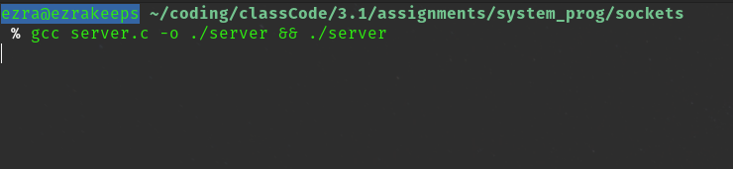

Send data from the client

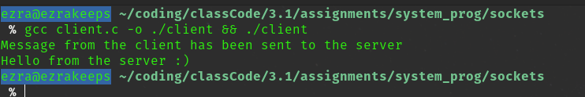

Response from server

