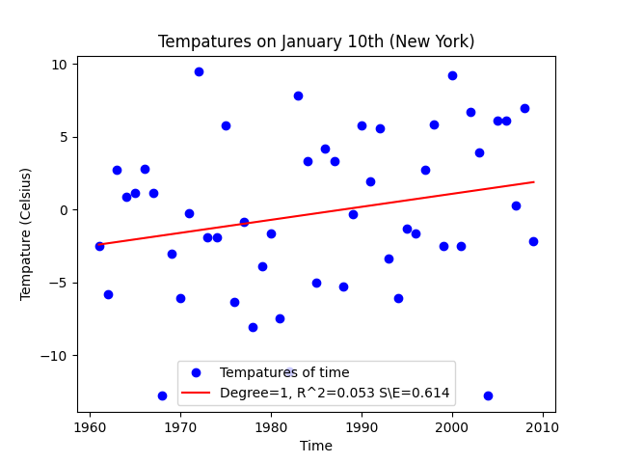  
  
  
  
  
  
  
  
  
  
  
  
  
  
  
  
  
  
  
Figure 4.I

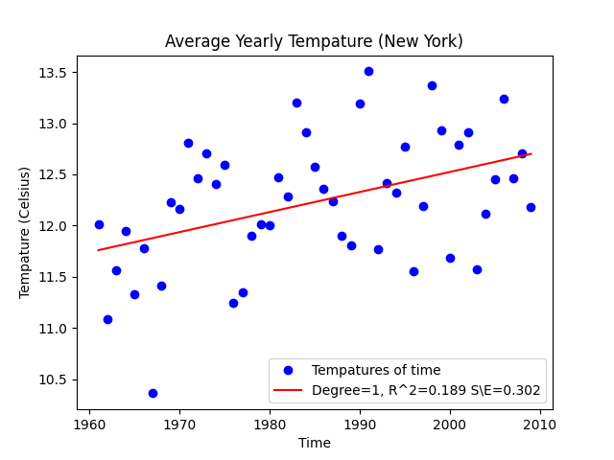  
  
  
  
  
  
  
  
  
  
  
  
  
  
  
  
  
  
Figure 4.II

\*\*Full sized figures found in ./plots directory\*\*

Question: What difference does choosing a specific day to plot the data versus calculating the yearly average have on our graphs (i.e., in terms of the R^2 values and the fit of the resulting curves)? Interpret the results.

Answer: Are R^2 value is slightly better taking the average of a year, and taking the yearly average does seem to reduce the noise in the data.

Question: Why do you think these graphs are so noisy? Which one is more noisy?

Answer: The graphs are noisely mainly due to the unpredictablility and randomness of nature, weather is not an easy thing to predict. Figure A.I is slightly more noisey then A.II, I believe that due to the lower R^2 value on our linear fit and the overall shape of the data displayed.

Quesiton: How do these graphs support or contradict the claim that global warming is leading to an increase in temperature? The slope and the standard error to slope ratio could be helpful in thinking about this.

Answer: I don’t think these graphs show very much supporting evidence, due to the low R^2 values, these linear models don’t seem to be a accurate representation of how the weather is increasing, but there certaintly are some upward trends. I believe that more data is needed before any conclusions could be made.