Intro

This document briefly introduces the eZ Multi Upload extension and explains how to install it and how to set it up.

Feature Description

Today in eZ Publish, there is no possibility to upload multiple files at the same time without using WebDav.
WebDav has some drawbacks: handle differently on different platforms, limited control with user feedback, have to use a 3rd party desktop application.

The concept is to create new functionality that enables direct upload of multiple files at the same time. Use case is: uploading of pictures to gallery, uploading documents to an intranet or publishing multiple OpenDocument/Word articles with one click.

Implementation Details

This extension uses Yahoo! UI Library: Uploader <http://developer.yahoo.com/yui/uploader/>.
This is a flash, Ajax based upload system for handling multiple file uploads.

How It Works

Once you install eZ Multi Upload on eZ Pblish and go through the simple set up, you see eZ Multi Upload icon on Web Site toolbar. By clicking the icon, the file uploading page opens and you can upload files to the page you are located.

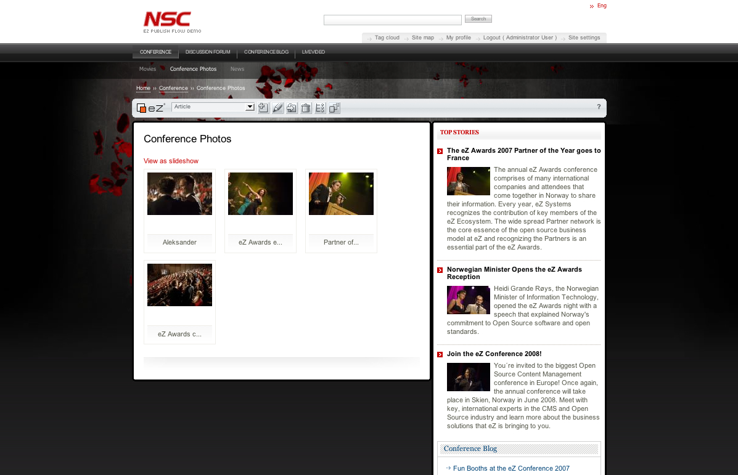
Here, you see the example of adding pictures to the existing gallery by using the extension.

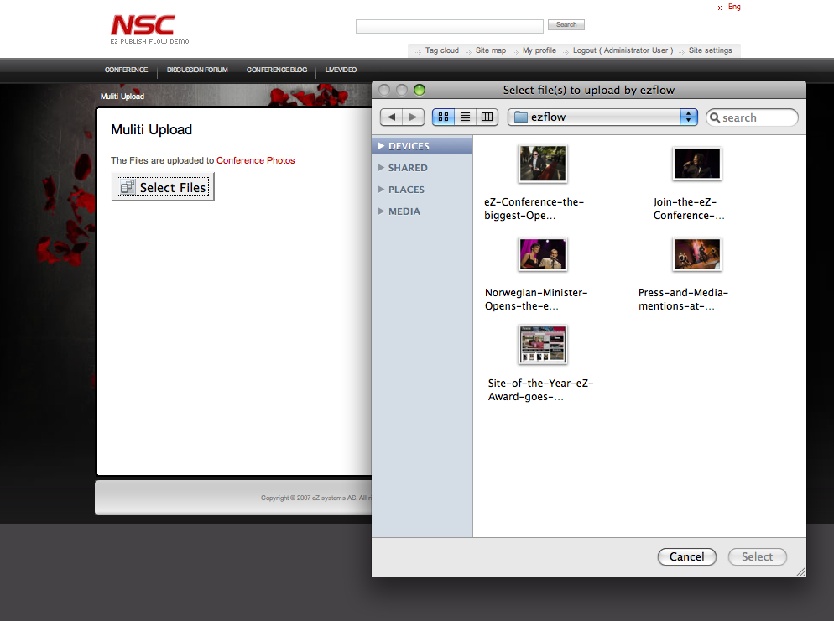
By clicking the eZ Multi Upload icon, uploading file page opens and there you can select the pictures to upload. It can be a single file upload or multi file upload.

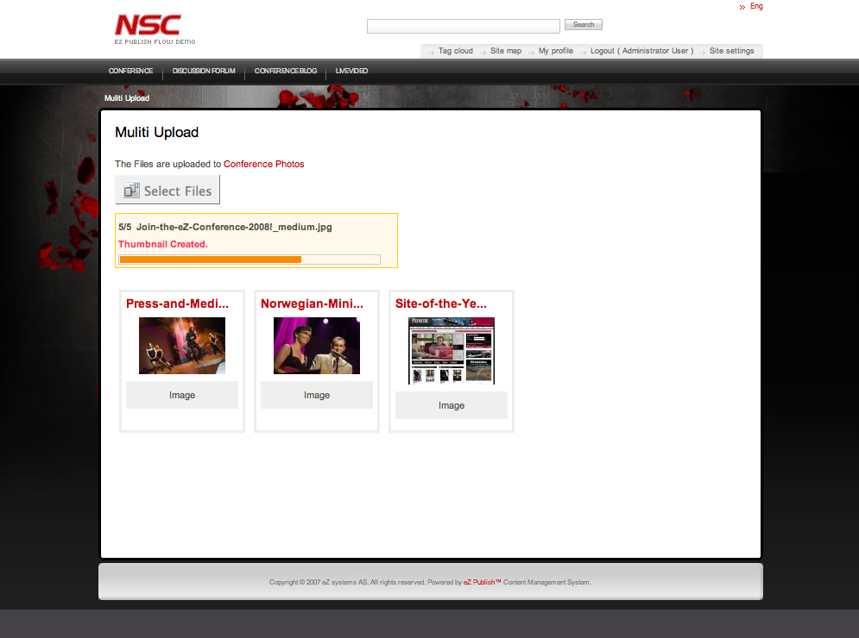
Once you select files to upload, click on “Select” and the upload starts automatically.
When the file upload is completed, you will see the uploaded files displayed on the page.
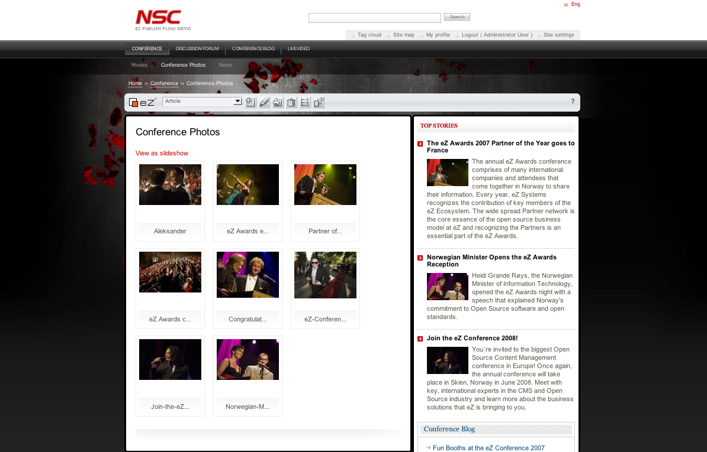

When you go back to the Gallery page, you see all the pictures are now added.


Another example is to upload .odt files and .flv files to News page.

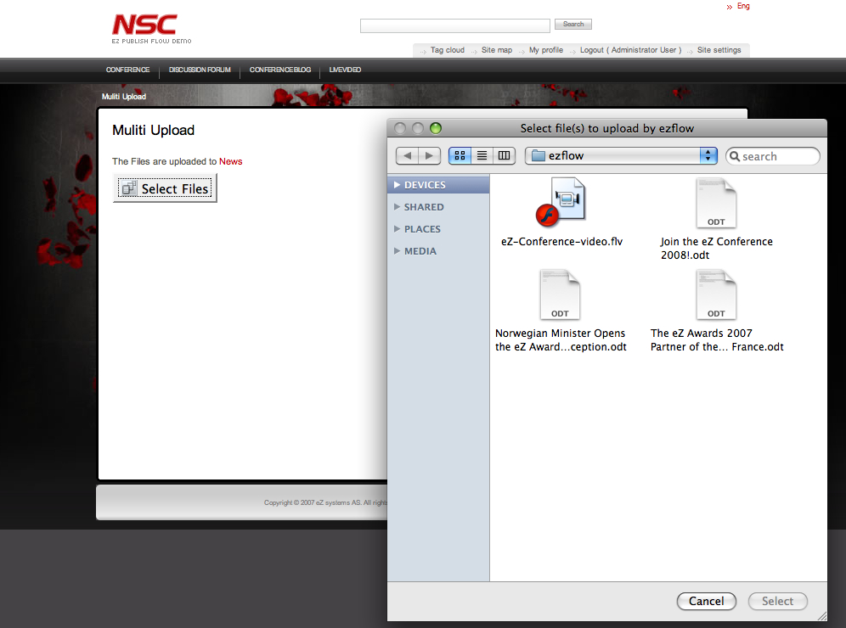
Move to News page and click on eZ Multi Upload icon.

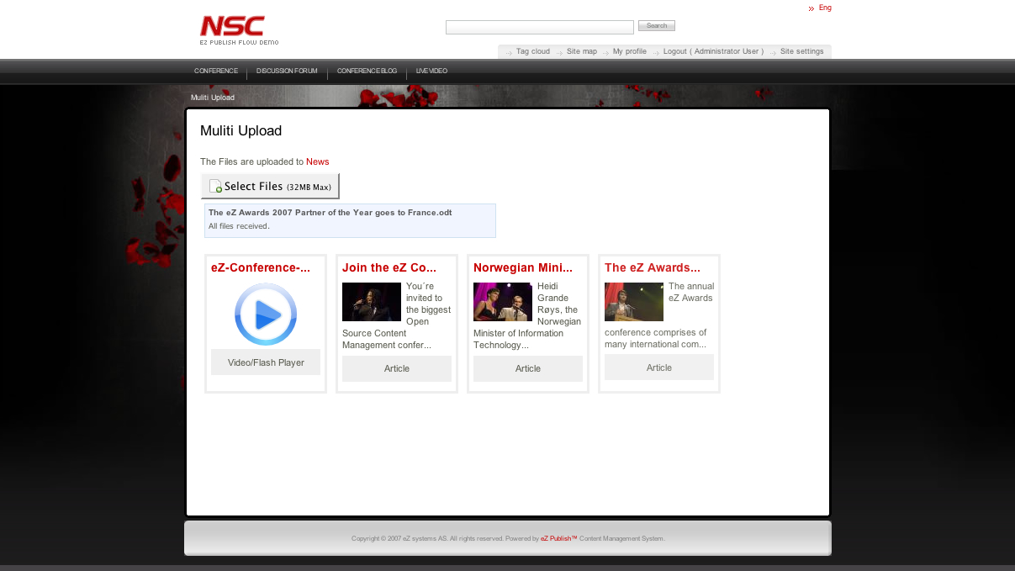
Select the files to upload and start uploading by clicking “Select” button. Once file upload is completed, the files appears on the page.

Installation

- Locate ezmultiupload extension in the extension folder.

- Enable ezmultiupload extension in site.ini.append.php

[ExtensionSettings]
ActiveExtensions[]=ezmultiupload

- website_toolbar.tpl uses the following template.

ezmultiupload/design/standard/templates/parts/website_toolbar.tpl

*If the website uses website_toolbar.tpl, please add the following code to website_toolbar.tpl.

{include uri='design:ezmultiupload/ezmultiupload_ezwt_upload.tpl'}

- Clear the cache

Setting file “ezmultiupload.ini.append.php”

In ezmultiupload.ini.append.php, you can set up available file types for uploading per class or/and subtree node.
The default settings are as following.

<?php /*

[MultiUploadSettings]
AvailableClasses[]
AvailableClasses[]=folder
AvailableClasses[]=gallery

AvailableSubtreeNode[]

[FileTypeSettings_folder]
FileType[]
FileType[]=*.odt
FileType[]=*.flv

[FileTypeSettings_gallery]
FileType[]
FileType[]=*.jpg
FileType[]=*.png
FileType[]=*.gif

*/ ?>

"AvailableClasses[]=folder" and "[FileTypeSettings_folder]" is a pre-defined set.
Therefore, with the default setting, the node created by “Folder Class” can upload only ".odt file" and ".flv file"

Here is an example of using AvailableSubtreeNode.

<?php /*

[MultiUploadSettings]
AvailableSubtreeNode[]=69

[FileTypeSettings_69]
FileType[]
FileType[]=*.jpg
FileType[]=*.png
FileType[]=*.gif

*/ ?>

"AvailableSubtreeNode[]=69" and " [FileTypeSettings_69]" becomes a pre-defined set.
Therefore, the node (node_id=69) can now upload " .jpg file "," .png file " and " .gif file".

When a "AvailableSubtreeNode[]" setting and a "AvailableClasses[]" setting have a conflict, "AvailableSubtreeNode[]" setting is the superior setting.

The Filetype settings can use the regular expression.

