Intro
This document briefly introduces the eZ Multiupload extension and explains how to install it and how to set it up.

Feature Description
Today in eZ Publish, there is no possibility to upload multiple files at the same time without using WebDav. WebDav has some drawbacks: handle differently on different platforms, limited control with user feedback, have to use a 3rd party desktop application.

The concept is to create new functionality that enables direct upload of multiple files at the same time. Use case is: uploading of pictures to gallery, uploading documents to an intranet or publishing multiple OpenDocument/Word articles with one click.

Implementation Details
This extension uses Yahoo! UI Library: Uploader <http://developer.yahoo.com/yui/uploader/>.
This is a flash, Ajax based upload system for handling multiple file uploads.

Requirements
- Adobe Flash Player version 9.0.45 or higher is required.
- eZ Publish 4.1 or higher is required for ezmultiupload extension due to enhancements implemented in eZSession class.

NOTE: This extension can work with eZ Publish 4.0.x series, however uploading from administration interface is not supported, eZ Publish 4.1 or higher is officially supported version.

Installation
- Extract the ezmultiupload archive to the extension folder.

- Enable ezmultiupload extension in site.ini.append.php

[ExtensionSettings]
ActiveExtensions[]=ezmultiupload

Alternatively, activate it in the Administration Interface. First, click the Extensions link in the Setup tab. Then, mark the checkbox corresponding to the “ezmultiupload” entry and click the Apply changes button.

- Grant access to the “ezmultiupload” module for the users and user groups who will need to use the eZ Multiupload functionality.

- Update autoload array by executing following command from eZ Publish root:

$ php bin/php/ezpgenerateautoloads.php -e

NOTE: Update script require eZ Components.

- Upload interface is accessible by pointing your web browser to /ezmultiupload/upload/NODE_ID. For example: http://www.example.com/ezmultiupload/upload/2 or by including a following template parts/websitetoolbar/ezmultiupload.tpl {include uri='design:parts/websitetoolbar/ezmultiupload.tpl'} in website toolbar template. ezmultiupload icon will appear automatically in ezwebin 1.4/ezflow 1.1 and higher website toolbar.

- Clear the cache

Setting file “ezmultiupload.ini.append.php”
In ezmultiupload.ini.append.php, you can set up available file types for uploading per class or/and subtree node.

The default settings are as following.

<?php /*

[MultiUploadSettings]
AvailableClasses[]
AvailableClasses[]=folder
AvailableClasses[]=gallery

AvailableSubtreeNode[]

MultiuploadHandlers[]

[FileTypeSettings_folder]
FileType[]
FileType[]=*.odt
FileType[]=*.flv
FileType[]=*.xap
FileType[]=*.doc

[FileTypeSettings_gallery]
FileType[]
FileType[]=*.jpg
FileType[]=*.png
FileType[]=*.gif

*/ ?>

"AvailableClasses[]=folder" and "[FileTypeSettings_folder]" is a pre-defined set.
Therefore, with the default setting, the node created by “Folder Class” can upload only ".odt file", ".flv file", ".xap file" and the ".doc file".

Here is an example of using AvailableSubtreeNode.

<?php /*

[MultiUploadSettings]
AvailableSubtreeNode[]=69

[FileTypeSettings_69]
FileType[]
FileType[]=*.jpg
FileType[]=*.png
FileType[]=*.gif

*/ ?>

"AvailableSubtreeNode[]=69" and " [FileTypeSettings_69]" becomes a pre-defined set.
Therefore, the node (node_id=69) can now upload " .jpg file "," .png file " and " .gif file".

The Filetype settings can use the regular expression.

How It Works
Once you install eZ Multiupload on eZ Publish and go through the simple set up, you see eZ Multiupload icon on Website Toolbar. By clicking the icon, the file uploading page opens and you can upload files to the page you are located.
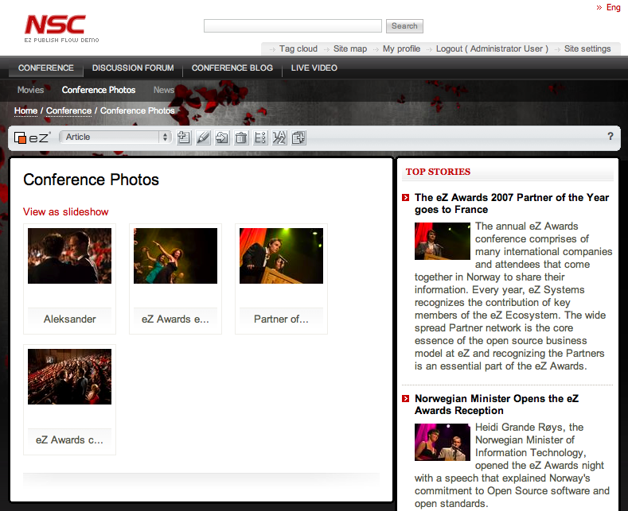

Here, you see the example of adding pictures to the existing gallery by using the extension.

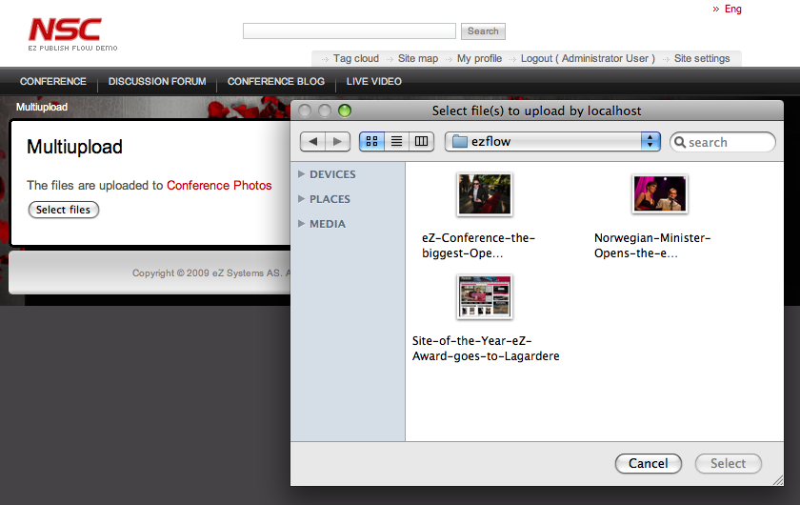

By clicking the eZ Multiupload icon, uploading file page opens and there you can select the pictures to upload. It can be a single file upload or multi file upload.
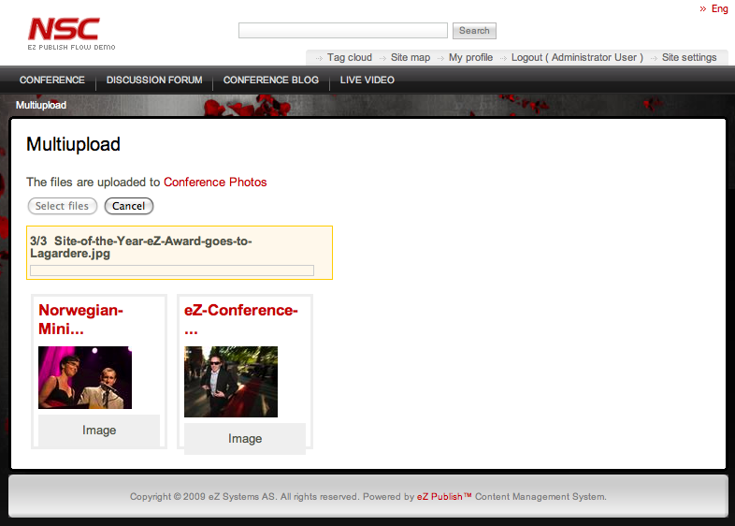

Once you select files to upload, click on “Select” and the upload starts automatically.
When the file upload is completed, you will see the uploaded files displayed on the page.
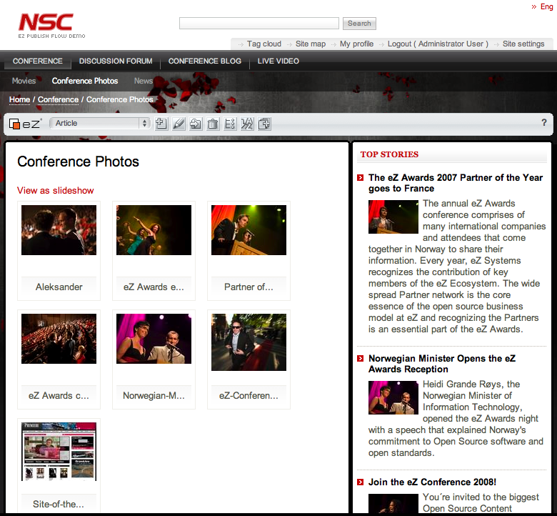
When you go back to the Gallery page, you see all the pictures are now added.

