eZ publish OpenOffice.org extension
Documentation
The eZ publish OpenOffice.org extension is an integration between eZ publish 3.5.x and OpenOffice.org Writer documents. It supports both import and export of OpenOffice.org Writer documents.

Requirements
To get this extension up and running you need to have eZ publish 3.5. or later installed.
You also need either to have the zlib extension enabled in your PHP version or you need to have the command line versions of 'zip' and 'unzip' available on your operating system. This is needed to create and unpack the zip files which makes up the OpenOffice.org documents.

Install extension
Unpack the tar.gz archive and place the oo folder under the extension folder in eZ publish, normally "extension". Then go to the setup tab in eZ publish and enable the oo extension under the Setup->Extensions menu.
Note: if you want to upload large documents you need to increase the upload memory limit in PHP. This is configured in php.ini.

Microsoft Word import configuration
To install the Microsoft Word import support you need to do the following:
- Install OpenOffice.org 2
- Install document conversion macros in OOo
- Start the document conversion deamon
The reason you need to have OpenOffice.org installed is that eZ publish uses it to convert the unknown file formats to OpenDocument Text format which is then imported. Tested formats include .doc and .rtf.

Installation of OpenOffice.org macros
Go to the macro editing interface in OpenOffice.org. This is done via the menus in OpenOffice.org:
- Tools -> Macros -> Organize Macros -> OpenOffice.org Basic
Choose MyMacros -> Standard -> Module1 and click edit.
Enter the macro code shown below and click Store. The macro code is also stored in the file extensions/oo/doc/macro.txt.
REM eZ publish document conversion macros

Sub convertToOOo(strFile as string)
Dim oDoc as Object
Dim strFilterSubName as String

strUrl = ConvertToUrl( strFile )
oDoc = StarDesktop.loadComponentFromURL( strUrl, "_blank", 0, array(MakePropertyValue("Hidden",true)))

oDoc.storeToUrl( ConvertToUrl( "/tmp/ooo_converted.odt" ), Array())

oDoc.close(True)
End Sub

Sub convertToPDF(strFile as string)
Dim oDoc as Object
Dim strFilterSubName as String

strUrl = ConvertToUrl( strFile )
oDoc = StarDesktop.loadComponentFromURL( strUrl, "_blank", 0, array(MakePropertyValue("Hidden",true)))

cURL = ConvertToURL( "/tmp/ooo_converted.pdf" )

oDoc.storeToURL( cURL, Array( MakePropertyValue( "FilterName", "writer_pdf_Export" ) )

oDoc.close(True)
End Sub

Sub convertToDoc(strFile as string)
Dim oDoc as Object
Dim strFilterSubName as String

strUrl = ConvertToUrl( strFile )
oDoc = StarDesktop.loadComponentFromURL( strUrl, "_blank", 0, array(MakePropertyValue("Hidden",true)))

cURL = ConvertToURL( "/tmp/ooo_converted.doc" )

oDoc.storeToURL( cURL, Array( MakePropertyValue( "FilterName", "MS Word 97" ) )

oDoc.close(True)
End Sub

Function MakePropertyValue( Optional cName As String, Optional uValue ) As com.sun.star.beans.PropertyValue
oPropertyValue = createUnoStruct( "com.sun.star.beans.PropertyValue" )
If Not IsMissing( cName ) Then
oPropertyValue.Name = cName
EndIf
If Not IsMissing( uValue ) Then
oPropertyValue.Value = uValue
EndIf
MakePropertyValue() = oPropertyValue
End Function

Todo: In future releases the socket deamon can be installed on a different computer so you do not have to have OpenOffice.org 2 installed on the webserver.

Starting the document conversion deamon
The document conversion deamon is a php script which is bundled with the extension. It communicates with OpenOffice.org and does the actual conversion of documents.
The script needs to be started with the cli version of PHP, which means that you need to execute the following command from the command line
$ php extension/oo/deamon.php

That's it.

Note: The document conversion deamon will only run under Linux since the socket support in PHP does not work under Windows.

Note: To get the deamon to work you need to have compiled PHP with the following switches:
--enable-cli
--enable-pcntl
--enable-sockets

Import
To import OpenOffice.org Writer documents into eZ publish you need to access the URL example.com/index.php/oo/import. Replace the example.com/index.php part with the correct URL for the administration interface of your eZ publish site.
When accessing the /oo/import URL in your eZ publish the screen shown below is shown. Here you browser for the .sxw file you would like to import followed by clicking the “Upload file” button.
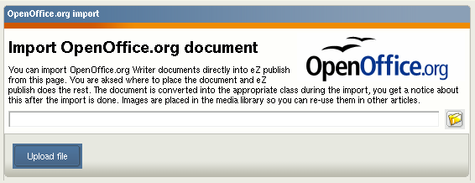
After selecting the file to import you need to select where the file should be imported to. You are then presented the standard eZ publish browse window as shown below. Select the folder you wish to import your file to and click “Ok”. If you want to cancel the import simply press “Cancel”.

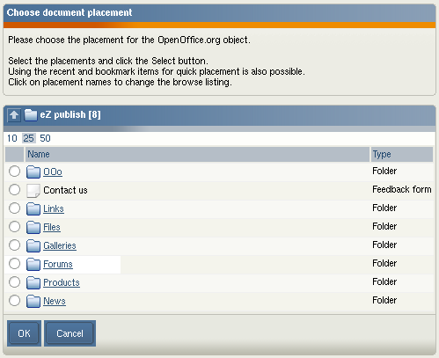
If the import is successful the screen below is shown. Here you get a link to the imported object and a link to import more files.

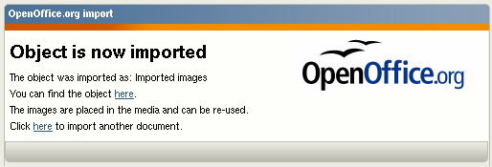
Configuring imported documents
There are two possibilities of importing OOo Writer documents into eZ publish. The first is to use a standard OOo document which imports into the default eZ publish content class in eZ publish. Here the title of the object is set from the filename and the actual contents of the document is stored in the attribute defined in oo.ini.
See the settings below for configuration example where documents are imported as articles and the title is stored in the title attribute and the document contents in the body attribute.
[OOImport]
DefaultImportClass=article
DefaultImportTitleAttribute=title
DefaultImportBodyAttribute=body

You have the possibility of defining several different types of content in eZ publish. You can define sections in OpenOffice.org Writer documents which can map to eZ publish attributes. E.g. you can define a section in OOo for title, introduction and body and this can be imported automatically to an article while another document is imported as a product.
This is configured in oo.ini. See the examples for sample documents in the examples folder for this extension.
There are some documents under examples/ in the oo extension which you can use to test the import to eZ publish.

Supported datatypes
When importing OpenOffice.org Writer documents there are some limitation on the datatypes it can import content to. Currently the following datatypes are supported:
- Text line
- Text fields
- XML Text

Supported formatting
When importing text into XML Text fields the following formatting is supported:
- Normal text
- Bold and italic text span
- Text links
- Numbered and un-numbered lists (one level)
- Headers (multiple levels)
- Tables (without collapsed rows or columns)
- Embedded images
  - Alignment and size are supported
  - Image captions are not supported

Export
Any content object in eZ publish can be exported to OpenOffice.org Writer documents. There are however some limitations on the datatypes supported.

Supported datatypes
The following datatypes are currently supported:
- Text line
- Text field
- XML Text field

Supported formatting
When exporting XML Text fields the following formatting is currently supported.
- Normal text
- Text links
- Headers
- Numbered/un-numbered lists
- Tables (without collapsed rows or columns)
- Embedded Images

Exporting
To do the actual object export you need to access the URL /oo/export in your eZ publish installation. The initial export screen is shown in the screenshot below.
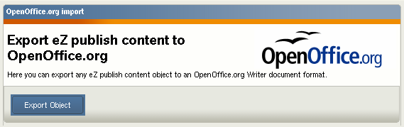
Click the export object button to proceed to the browse screen shown below. Here you navigate and select the object you want to export. Note: Currently only one object is supported for export, sub objects are not included in the export.
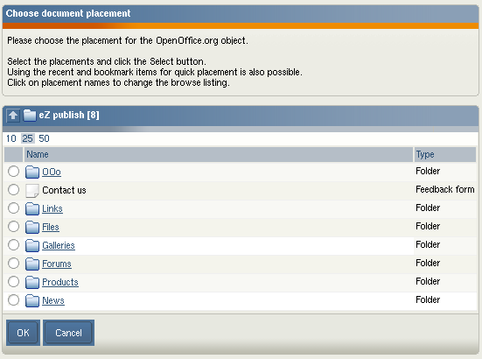
After selecting the object for export and cliking on the “Ok” button eZ publish will start the actual export. The document is served via the browser, you can choose do either download the document or open it directly in OpenOffice.org Writer (if properly installed on your computer). The screenshot below shows a preview of an exported object via eZ publish. Noticethe headers and footers, these are defined in standard OpenOffice.org Writer templates.

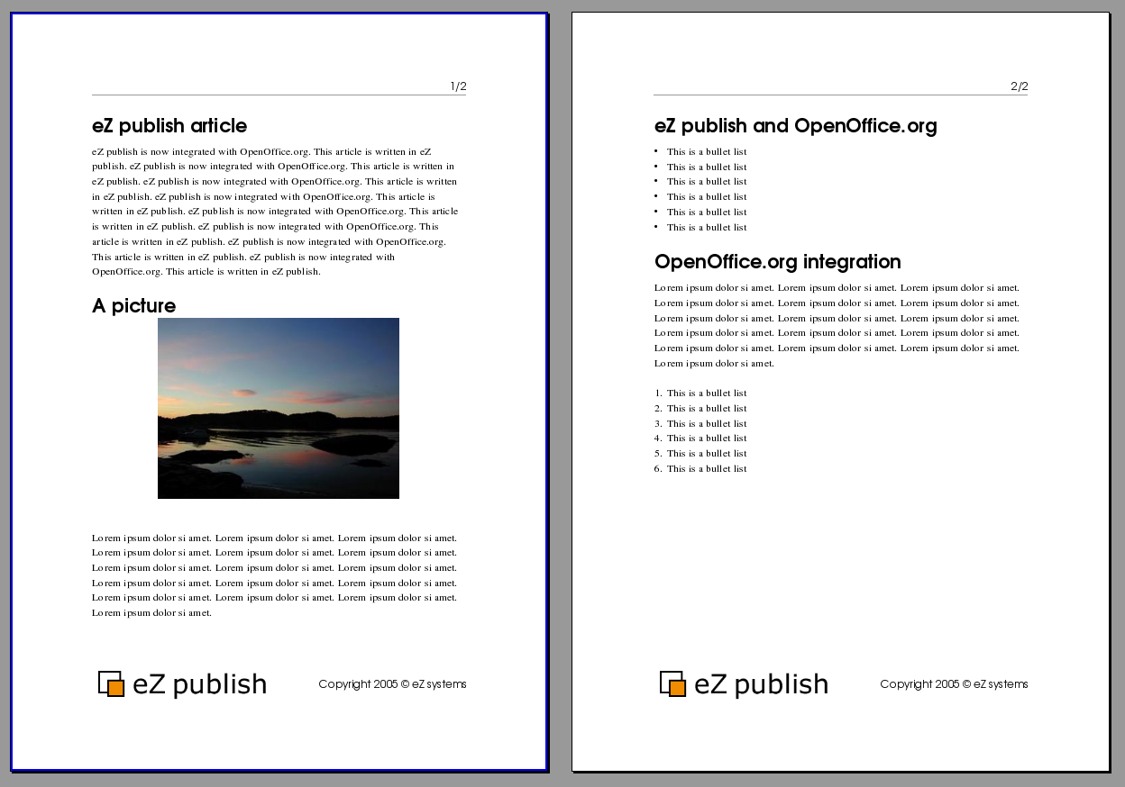

Export templates
You can make eZ publish export OpenOffice.org Writer documents using either the default OpenOffice.org styles or you can use an existing OpenOffice.org Writer template file. This is configured in the oo.ini file. Set UseTemplate to true to enable the export using templates. The actual template used needs to be placed under the extension/oo/templates/. The name of the file is set with TemplateName. Both of these settings are under the OOExport section in the oo.ini file. Below you can see an example of this configuration.
[OOExport]
UseTemplate=true
TemplateName=eztemplate.stw

