Technical description
-
OpenOffice.org menu integratio

Table of contents
About 3
Introduction 4
Backend 4
OpenOffice.org menu 4
Technical description 5
Backend 5
OpenOffice.org frontend 5
Interfaces 5

About
This document describes the technical aspects of the OpenOffice.org menu for eZ Publish. This document is intended for developers.

Introduction
The OpenOffice.org menu should allow easy access to eZ Publish articles, etc. The solution contains 2 main parts. A REST based backend, and a package for OpenOffice.org.

Backend
The backend is rest based, and provides some key functions.

OpenOffice.org menu
The OpenOffice.org menu contains functionality to browse the eZ Publish installation and select document for either retrieval or storing.

Technical description

Backend
The backend is REST based and provides functions intended for use by the OpenOffice.org menu.
Name | Description | Returns
login | Log in user | User Id
ezodfGetTopNodeList | Gets list of top nodes. | XML structure describing top nodes.
ezodfGetChildren | Get tree structure | XML structure describing tree result
ezodfGetNodeInfo | Get node and object information | Node information ( xml structured )
ezodfFetchOONode | Fetch node for editing. | OpenOffice.org document
putOONode | Store OO document to a specified location.
replaceOONode | Replace an existing object.

OpenOffice.org frontend
The OpenOffice.org frontend contains functionality for performing regular operations on eZ Publish like open, save and save as. The OpenOffice.org frontend is also capable of strong server and user name information.
Functionality:
Name | Description
save | Save document to eZ Publish ( will replace existing document in eZ Publish, or create new version ).
saveAs | Save document to selected destination.
Open | Open document from selected destination.

Interfaces
The browse dialog allows server selection. The 10 latest servers will be stored in ~/.eZPublish/history.xml .
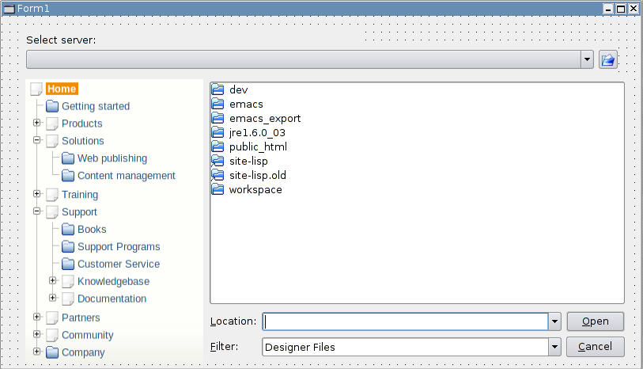Illustration 1: eZ Publish browse dialog

http://en.wikipedia.org/wiki/REST

