

OASIS OpenDocument extension
Documentation

eZ systems as | 2006

Version | v0.1
Author | Benoit Thiell (bt@ez.no)
Last revision | 30.08.2006, Benoit Thiell


Preface
This document is the documentation for the OASIS OpenDocument extension.
Document history
- Version 0.1: 29.08.2006 by Benoit Thiell <bt@ez.no>

Table of Contents
Preface 3
Document history 3
1. Introduction 5
2. Requirements 5
2. 1. Server requirements 5
2. 2. Workstation requirements 5
3. Installation 6
3. 1. The OASIS OpenDocument extension for eZ publish 6
3. 1. 1. Normal installation 6
3. 1. 2. Microsoft Word import configuration (optional) 6
3. 2. The eZ extension for OpenOffice.org 7
3. 2. 1. Install the OpenOffice.org macro 7
3. 2. 2. The servers configuration file 7
3. 2. 3. Installing the eZ extension for OpenOffice.org in a shared mode 8
3. 2. 4. Removing the eZ extension for OpenOffice.org 8
4. Export : from eZ publish to OpenOffice.org document 9
4. 1. Exporting a document via the eZ publish web interface 9
4. 2. Exporting a document using the OpenOffice.org 10
4. 3. Supported datatypes 11
4. 4. Supported formatting 11
4. 5. Export templates 12
5. Import : from an OpenOffice.org document to eZ publish 13
5. 1. Importing via the eZ publish web interface 13
5. 2. Using OpenOffice.org : importing a new document 14
5. 3. Using OpenOffice.org : overwriting an existing document 15
5. 4. Configuring imported documents 16
5. 5. Supported datatypes 16
5. 6. Writing standards 16
5. 6. Supported formatting 17

1. Introduction
The eZ publish OASIS OpenDocument extension is an integration between eZ publish 3.5.x and OpenOffice.org Writer documents. It supports both import and export of OpenOffice.org Writer documents.

2. Requirements

2. 1. Server requirements
To get this extension up and running you need to have eZ publish 3.5. or later installed.
You also need either to have the zlib extension enabled in your PHP version or you need to have the command line versions of 'zip' and 'unzip' available on your operating system. This is needed to create and unpack the zip files which makes up the OpenOffice.org documents.
If you wish to import Microsoft Office documents, you will need an OpenOffice.org 2 installation on the server side. The reason for this is that the extension uses a conversion macro running in OpenOffice.org.

2. 2. Workstation requirements
If you wish to manage the import/export of documents with OpenOffice.org, each workstation must have OpenOffice.org 2 installed. If not, there is no special requirements.

3. Installation

3. 1. The OASIS OpenDocument extension for eZ publish

3. 1. 1. Normal installation
Unpack the tar.gz archive and place the oo folder under the extension folder in eZ publish, normally "extension". Then go to the setup tab in eZ publish and enable the oo extension under the Setup->Extensions menu.
Note: if you want to upload large documents you need to increase the upload memory limit in PHP. This is configured in php.ini.

3. 1. 2. Microsoft Word import configuration (optional)
By default, the extension works with .odt file format. If you wish to work with .doc and .rtf formats, you'll have to install the conversion daemon on the server.
To install the Microsoft Word import support you will need to do the following:
- Install the OpenOffice.org conversion macro
Go to the package manager interface in OpenOffice.org (Tools -> Package Manager).
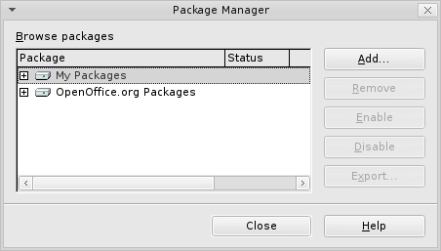
Choose My Packages and click Add... Then browse to the extension directory and select the file [TODO] name of the file.
- Start the document conversion daemon
The document conversion daemon is a php script which is bundled with the extension. It communicates with OpenOffice.org and does the actual conversion of documents.
The script needs to be started with the command-line version of PHP, which means that you need to execute the following command from the command line
$ php extension/oo/deamon.php

Note: The document conversion daemon will only run under Linux since the socket support in PHP does not work under Windows.
Note: To get the daemon to work you need to have compiled PHP with the following switches:
--enable-cli
--enable-pcntl
--enable-sockets

3. 2. The eZ extension for OpenOffice.org
If you wish to import/export documents from OpenOffice.org, you will need to follow this installation process.

3. 2. 1. Install the OpenOffice.org macro
- Download and unpack the archive
- Launch OpenOffice.org
- Select Tools -> Package Manager
- Click on Add... and select the file [TODO] file name located in the unpacked directory
- Relaunch OpenOffice.org
The installation is not finished yet because you have to create the servers configuration file.

3. 2. 2. The servers configuration file
The configuration file must be placed in the OpenOffice.org user configuration directory. You can find the path of this directory by opening the OpenOffice.org options (Tools -> Options...) and look in the OpenOffice.org-Paths section. The configuration directory path is named “User Configuration”.
Edit the document and create a new server entry. Each entry is composed of 4 options which have the same identifier number. For example the following entry adds a server which URL is http://example.com/. The user name is “User23” and the password is “foofoo”. The server alias option is used to identify the server during the use of the extension.
ServerAlias[0]=MyServer
ServerURL[0]=http://example.com/
ServerUsername[0]=User23
ServerPassword[0]=foofoo

The servers identifier numbers starts from 0.

3. 2. 3. Installing the eZ extension for OpenOffice.org in a shared mode
This installation method is applicable only by advanced users. You should be able to use a terminal (change directory and write a command).
The normal installation process allows only one user to use the extension. If you want to allow all the users of a computer to use the extension, these are the steps to follow :
- download and unpack the extension
- open a terminal window
- run the unopkg command located in <OOo installation directory>/program. The syntax is :
unopkg --shared add <path to eZExtension.uno.pkg>

Note: By default, each user has its own servers configuration file.

3. 2. 4. Removing the eZ extension for OpenOffice.org
- Remove the eZ extension for OpenOffice.org using the Package Manager (Tools -> Package Manager)
- Relaunch OpenOffice.org in order to finalize the removal
- Remove the configuration file from the OpenOffice.org user configuration directory.

4. Export : from eZ publish to OpenOffice.org document
Any content object in eZ publish can be exported to OpenOffice.org Writer documents. There are however some limitations on the datatypes supported.

4. 1. Exporting a document via the eZ publish web interface
To do the actual object export you need to access the URL /oo/export in your eZ publish installation. The initial export screen is shown in the screenshot below.
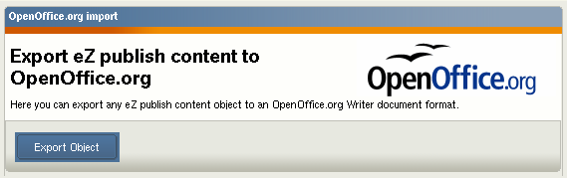
Click the export object button to proceed to the browse screen shown below. Here you navigate and select the object you want to export. Note: Currently only one object is supported for export, sub objects are not included in the export.
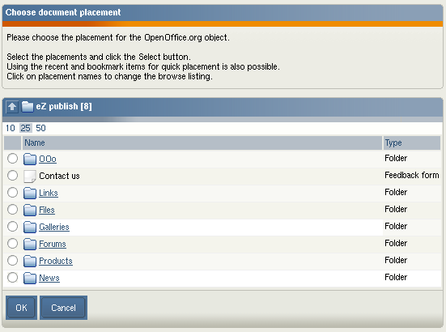
After selecting the object for export and cliking on the “Ok” button eZ publish will star0t the actual export. The document is served via the browser, you can choose do either download the document or open it directly in OpenOffice.org Writer (if properly installed on your computer). The screenshot below shows a preview of an exported object via eZ publish. Notice the headers and footers, these are defined in the OpenOffice.org template provided with the extension.
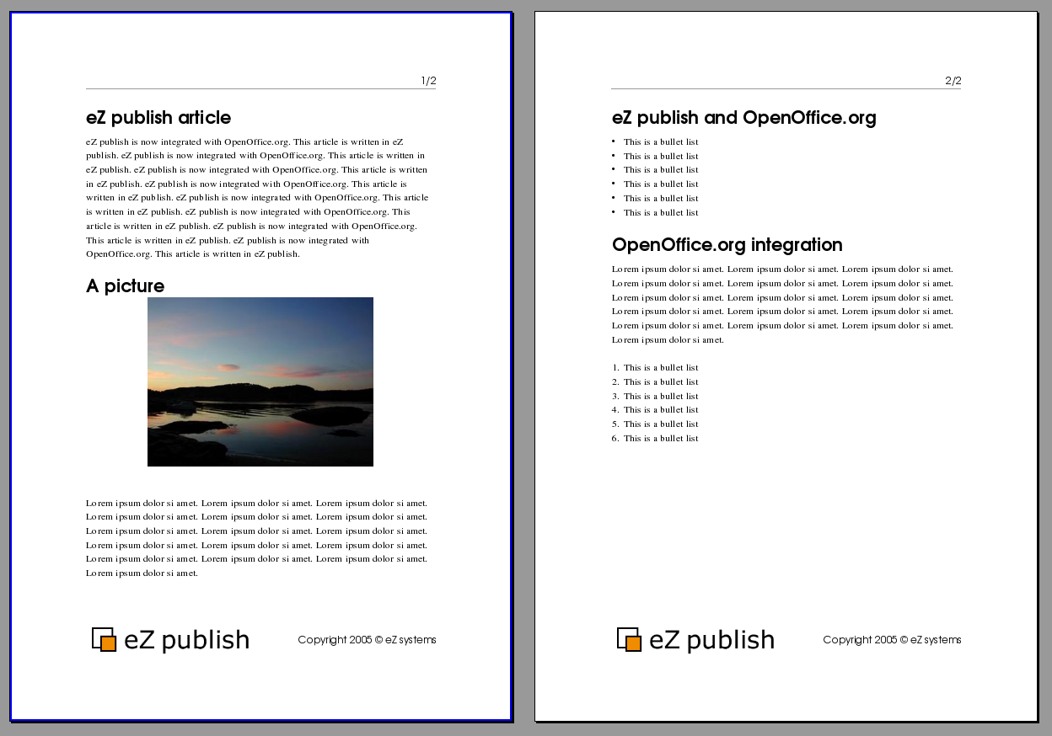

4. 2. Exporting a document using the OpenOffice.org
In order to export a document to OpenOffice.org, click the “Open” button in the add-on toolbar.

Open
A pop-up window will then open.
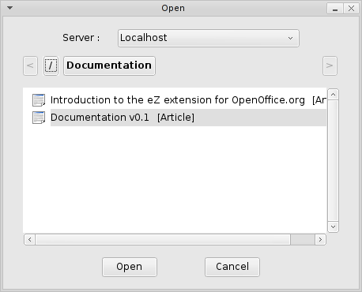

In the dialog, choose your server and the document you want to open. Click on the document you want to open so that it is highlighted. Then click the Open button. If your current OpenOffice.org document is the default blank document, the exported document will use this document, otherwise the exported document will be displayed in a new OpenOffice.org window.

4. 3. Supported datatypes
The following datatypes are currently supported:
- Text line
- Text block
- XML block
- Matrix
- Image
- Date
- Date and time

4. 4. Supported formatting
When exporting XML Text fields the following formatting is currently supported.
- Normal text
- Text links
- Headers
- Numbered/un-numbered lists
- Tables (without collapsed rows or columns)
- Embedded Images

4. 5. Export templates
You can make eZ publish export OpenOffice.org Writer documents using either the default OpenOffice.org styles or you can use an existing OpenOffice.org Writer template file. This is configured in the oo.ini file. Set UseTemplate to true to enable the export using templates. The actual template used needs to be placed under the extension/oo/templates/. The name of the file is set with TemplateName. Both of these settings are under the OOExport section in the oo.ini file. Below you can see an example of this configuration.
[OOExport]
UseTemplate=true
TemplateName=eztemplate.stw

5. Import : from an OpenOffice.org document to eZ publish
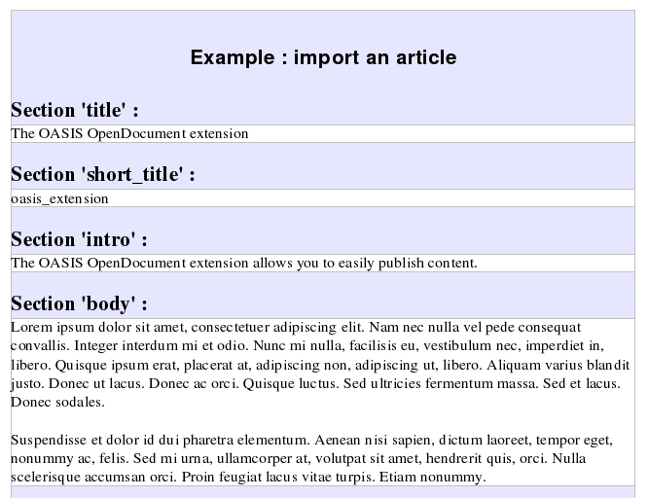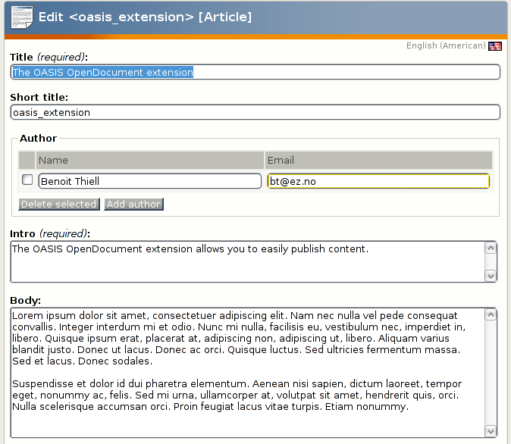
Text line
Text line
XML block
XML block

5. 1. Importing via the eZ publish web interface
To import OpenOffice.org Writer documents into eZ publish you need to access the URL example.com/index.php/oo/import. Replace the example.com/index.php part with the correct URL for the administration interface of your eZ publish site.
When accessing the /oo/import URL in your eZ publish the screen shown below is shown. Here you browser for the .sxw file you would like to import followed by clicking the “Upload file” button.
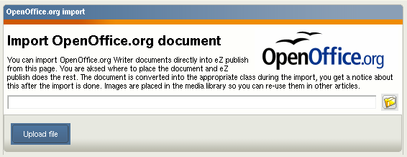
After selecting the file to import you need to select where the file should be imported to. You are then presented the standard eZ publish browse window as shown below. Select the folder you wish to import your file to and click “Ok”. If you want to cancel the import simply press “Cancel”.
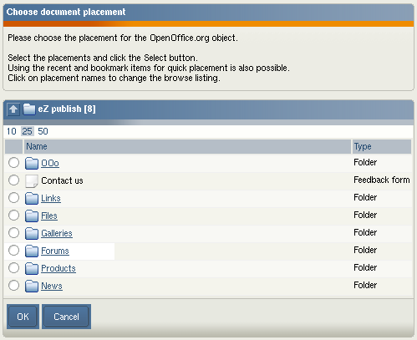
If the import is successful the screen below is shown. Here you get a link to the imported object and a link to import more files.
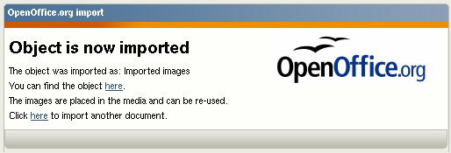

5. 2. Using OpenOffice.org : importing a new document
Click on “Save as...” button and in the dialog choose the server and the destination folder.
Save as
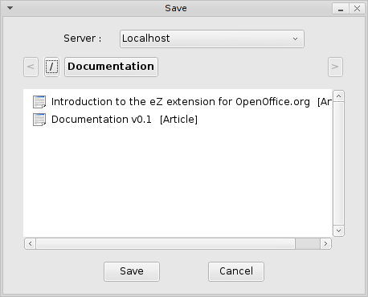
The folder in which you will save the document is the folder whose content is currently displayed. After a successful export, you will have a confirmation window as shown below. Otherwise you'll get an error message describing the encountered problem.
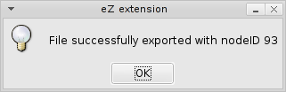

5. 3. Using OpenOffice.org : overwriting an existing document
After having exported a document, you have the possibility to change it and overwrite the previous document on the server. In order to do this, click on “Save”. There is no dialog as the eZ publish parameters are stored in the document.
Save

5. 4. Configuring imported documents
There are two possibilities of importing OOo Writer documents into eZ publish. The first is to use a standard OOo document which imports into the default eZ publish content class in eZ publish. Here the title of the object is set from the filename and the actual contents of the document is stored in the attribute defined in oo.ini.
See the settings below for configuration example where documents are imported as articles and the title is stored in the title attribute and the document contents in the body attribute.
[OOImport]
DefaultImportClass=article
DefaultImportTitleAttribute=title
DefaultImportBodyAttribute=body

You have the possibility of defining several different types of content in eZ publish. You can define sections in OpenOffice.org Writer documents which can map to eZ publish attributes. E.g. you can define a section in OOo for title, introduction and body and this can be imported automatically to an article while another document is imported as a product.
This is configured in oo.ini. See the examples for sample documents in the examples folder for this extension.
There are some documents under examples/ in the oo extension which you can use to test the import to eZ publish.

5. 5. Supported datatypes
When importing OpenOffice.org Writer documents there are some limitations on the datatypes it can import content to. Currently the following datatypes are supported:
- Text line
- Text block
- XML block
- Matrix
- Image
- Date
- Date and time

5. 6. Writing standards
In order to import a document using OpenOffice.org, you will have to follow some writing rules.
- each attribute must have an equivalent section.
- the name of one section is the identifier of the attribute
- the content of one section must follow the writing rules from eZ publish (no carriage return in a Text line attribute p.e.)
Note 1: the format of date is “dd/mm/yyyy”.
Note 2: the format of date and time is “dd/mm/yyyy hh:mm”.
Example: importing an article in eZ publish
The article content class has 4 attributes which are supported in OpenOffice.org (cf 5.5). These are : Title, Short title, Intro, Body. You can choose not to use an attribute by changing the oo.ini.php file. In this example we will use the four attributes. Create one section for each attribute (Insert -> Section). The sections will be named title, short_title, description, body.
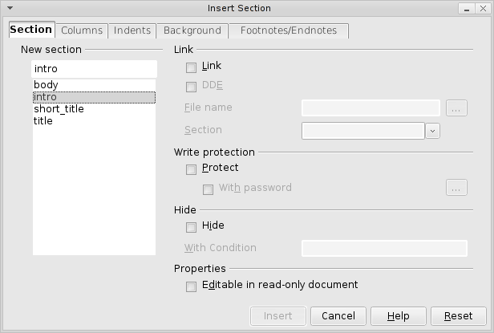
Use the writing rules of eZ publish i.e. no return carriage in title attribute and short title and less than 255 characters.

5. 6. Supported formatting
When importing text into XML Text fields the following formatting is supported:
- Normal text
- Bold and italic text span
- Text links
- Numbered and unnumbered lists (one level)
- Headers (multiple levels)
- Tables (without collapsed rows or columns)
- Embedded images
  - Images : Alignment and size are supported
  - Image captions are not supported
Note : in order to keep the alignment of an image during the import, the image must anchored to paragraph.

