eZ Open Document Format (eZODF) Extension

Documentation
version 2.0

Table of Contents
1.Introduction 3
1.1.Target audience 3
1.2.Conventions 3
1.3.More resources 3
1.4.Contacting eZ 4
1.5.Copyright and trademarks 4
2.Requirements 4
3.Installation 4
3.1.Microsoft Word import configuration 4
3.1.1.Installation of OpenOffice.org macros 5
3.1.2.Starting the document conversion daemon 5
4.Importing 5
4.1.Configuring imported documents 7
4.2.Supported datatypes 7
4.3.Supported formatting 7
5.Exporting 8
5.1.Supported datatypes 8
5.2.Supported formatting 8
5.3.Export action 8
5.4.Export templates 10

Introduction
The eZ Open Document Format (eZODF) extension integrates eZ Publish (version 3.8 and higher) with OpenDocument Text (.odt) documents. It supports both importing and exporting .odt documents. Documents can be written and read in either the OpenOffice.org Writer application or in Microsoft Word. Microsoft Word documents are converted to OpenDocument Text format via an installation of OpenOffice.org installed in the web server.

Target audience
This manual describes how to perform basic importing and exporting operations with the eZODF version 2.0 extension. It is intended for anyone working with this extension in the Administration Interface or the Website Interface. For information on how to use and navigate the Administration Interface, refer to the eZ Publish User Manual at http://ez.no/doc. For information about using the Website Interface, refer to http://ez.no/doc/extensions/website_interface.

Conventions
- Code samples, functions, variable names, and on are printed in monospace font.
- Filenames and paths are printed in monospace italic font.
- Commands are printed in monospace bold font.
- Elements of graphical user interfaces (such as buttons and field labels) are printed in bold font.
- Component names (such as an application) are capitalized, for example “Administration Interface”.
- In sample URLs, replace “example.com” with the domain name of your site.
- The screenshots in this document might have been modified to fit the page or to illustrate a point, and therefore might not exactly match the display on your site.

More resources
For assistance with eZODF or eZ Publish, refer to the following resources:
- eZ Publish documentation: eZODF is an extension to eZ Publish. Documentation for shared features is not reproduced in these manuals. Instead, where appropriate, there are links in this document to the online versions of the eZ Publish documentation, located at http://www.ez.no/doc.
- eZ Publish forums: The forums on the eZ Systems website are a valuable community-driven resource, where eZ Publish users provide assistance and support to each other. Accessing the forums is free. The forums are located at http://ez.no/community/forum.
- Support from eZ Partners: eZ's global network of partners provide professional assistance for all eZ products. To find a partner, contact sales@ez.no.
- Other eZ solutions: For information about other solutions provided by eZ Systems, refer to http://ez.no/products/solutions.
- Training and certification: eZ Systems and eZ Partners offer training courses and certifications for eZ Publish. Contact sales@ez.no or visit http://ez.no/services/training for more information.
- Open Document Format: For information about the specification, refer to http://www.oasis-open.org/committees/tc_home.php?wg_abbrev=office

Contacting eZ
For non-technical questions regarding eZODF, eZ Publish or eZ Systems, please contact us:
- http://ez.no/company/contact
- info@ez.no
We welcome your suggestions and comments on this manual. Please write to team-knowprod@ez.no.

Copyright and trademarks
Copyright © 2007 eZ Systems AS. Permission is granted to copy, distribute and/or modify this document under the terms of the GNU Free Documentation License, Version 1.2 or any later version published by the Free Software Foundation; with no Invariant Sections, no Front-Cover Texts, and no Back-Cover Texts. A copy of the license is included in the section entitled "GNU Free Documentation License".
Other product and company names mentioned in this manual may be the trademarks of their respective owners. We use trademark names in an editorial fashion to the benefit of the trademark holder; therefore, these names are not marked with trademark symbols. All terms known to be trademarks have been appropriately capitalized. We cannot attest to the accuracy of this usage, and usage of a term in this book should not be regarded as affecting the validity of any trademark or servicemark.

Requirements
This extension supports eZ Publish 3.8 and later. It might work on earlier versions back to version 3.5, but this is not officially supported or recommended.
Either the zlib extension must be enabled in your PHP installation or you need to have the command-line versions of zip and unzip available on your operating system. These are needed to create and unpack the zip files that make up OpenDocument Text (.odt) documents.

Installation
Unpack the tar.gz archive and place the ezodf folder under the extension folder in the eZ Publish installation. Enable the eZODF extension in the eZ Publish Administration Interface under the Setup->Extensions menu.
Note: if you want to upload large documents you need to increase the upload memory limit in PHP. This is configured in the php.ini configuration file.

Microsoft Word import configuration
To install Microsoft Word import support you need to do the following on your web server:
- Install OpenOffice.org 2.x
- Install document conversion macros in OOo
- Start the document conversion daemon
The reason you need to have OpenOffice.org installed is that eZ Publish uses it to first convert the Word file formats to OpenDocument Text format, which is then imported. Tested formats include .doc and .rtf.

Installation of OpenOffice.org macros
Go to the package manager interface in OpenOffice.org. This is found under Tools -> Package Manager...
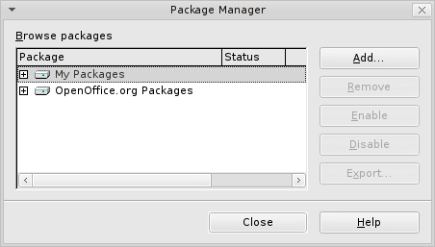
Choose My Packages and click Add...
Then, select the file extension/ezodf/doc/eZconversion.zip.

Starting the document conversion daemon
The document conversion daemon is a PHP script bundled with the extension. It communicates with OpenOffice.org and does the actual conversion of documents.
The script needs to be started with the CLI version of PHP, which means that you need to execute the following command from the command line:
$ php extension/ezodf/daemon.php

Note: PHP must have been compiled with the following switches:
--enable-cli
--enable-pcntl
--enable-sockets

Also, the document conversion daemon will only run under Linux, as socket support in PHP does not work under Windows.

Importing
To import OpenDocument Text (.odt) documents to eZ Publish, access the URL example.com/index.php/ezodf/import. (Replace “example.com/index.php” with the URL for the Administration Interface of your eZ Publish site.)
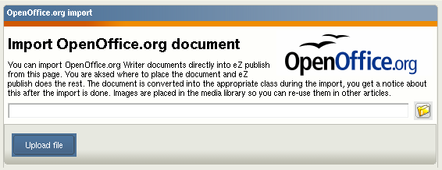
The import screen is shown below. Browse your local filesystem for the .odt file to import, then click the Upload file button.
After uploading the file, you need to place it in the eZ Publish content node tree. The eZ Publish tree browser window is shown below. Find the container under which you wish to import the file, select the corresponding radio button, then click the OK button. To cancel the import, simply press the Cancel button.
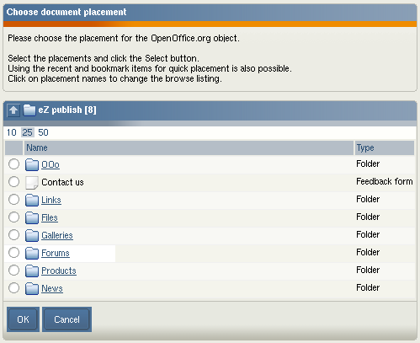
If the import is successful you will see the screen below that provides a link to the imported object and the option to import more files.

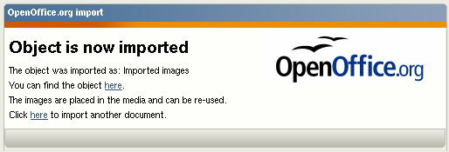
Configuring imported documents
OpenDocument Text (.odt) documents are imported into the default eZ Publish content class as specified in the odf.ini configuration file. The title of the object is derived from the filename and the contents of the document are stored in the attributes defined in the odf.ini configuration file located in the extensions/odf/settings/ folder.
The settings below show a configuration example where documents are imported as articles, the title is stored in the title attribute and the document contents are stored in the body attribute.
[ODFImport]
DefaultImportClass=article
DefaultImportTitleAttribute=title
DefaultImportBodyAttribute=body

Sections in .odt documents map to eZ Publish attributes. (Refer to the “Section” chapter in the OpenOffice.org documentation for information about configuring document sections.) For example, you can define sections in an .odt document that map to the title, introduction and body attributes, while another document can be imported as a product content class.
The sample documents in the examples/ folder in the eZODF extension can be used for testing and as a guideline for configuring your site.

Supported datatypes
When importing OpenDocument Text (.odt) documents, there are some limitations to the datatypes that can store imported content. Currently the following datatypes are supported:
- Text line
- Text fields
- XML text
- Image
- Date
- Date and time
- Matrix

Supported formatting
When importing text into XML text fields, the following formatting styles are supported:
- Normal text
- Bold and italic text spans
- Text links
- Custom tags (such as a factbox)
- Numbered and bulleted lists (one level)
- Headers (multiple levels)
- Tables (without collapsed rows or columns)
- Embedded images
  - Alignment and size are supported
  - Image captions are not supported

Exporting
Any content object in eZ Publish can be exported to an OpenDocument Text (.odt) format document. There are, however, some limitations on the supported datatypes.

Supported datatypes
The following datatypes are currently supported:
- Text line
- Text field
- XML text
- Image
- Date
- Date and time
- Matrix

Supported formatting
When exporting XML text, the following formatting styles are supported:
- Normal text
- Text links
- Custom tags (such as a factbox)
- Headers
- Numbered and bulleted lists
- Tables (without collapsed rows or columns)
- Embedded images

Export action
To export an object, access the URL example.com/index.php/ezodf/export. (Replace “example.com/index.php” with the URL for the Administration Interface of your eZ Publish site.) The initial export screen is shown in the screenshot below.
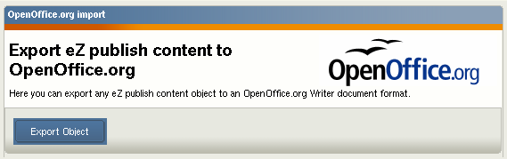
Click the Export Object button to proceed to the object browser screen shown below. Navigate to the object to export. Currently you can only export one object at a time; sub items are not included in the export.
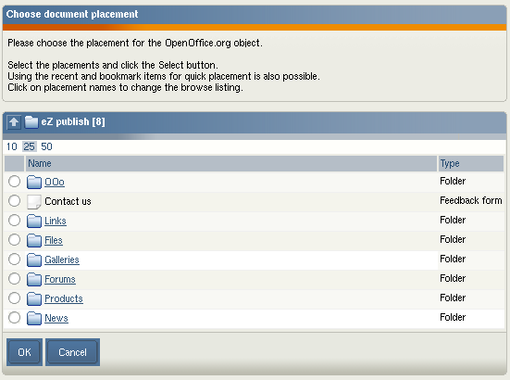
After selecting the object for export and clicking the OK button, eZ Publish will perform the export. The document is served via the browser; you can choose to either download the document or open it directly in OpenOffice.org Writer (if it is installed on your computer and associated with the file type) or a similar word processor that supports .odt documents. The screenshot below shows a preview of an exported object. Notice the headers and footers; these are defined in OpenOffice.org Writer templates (described below).

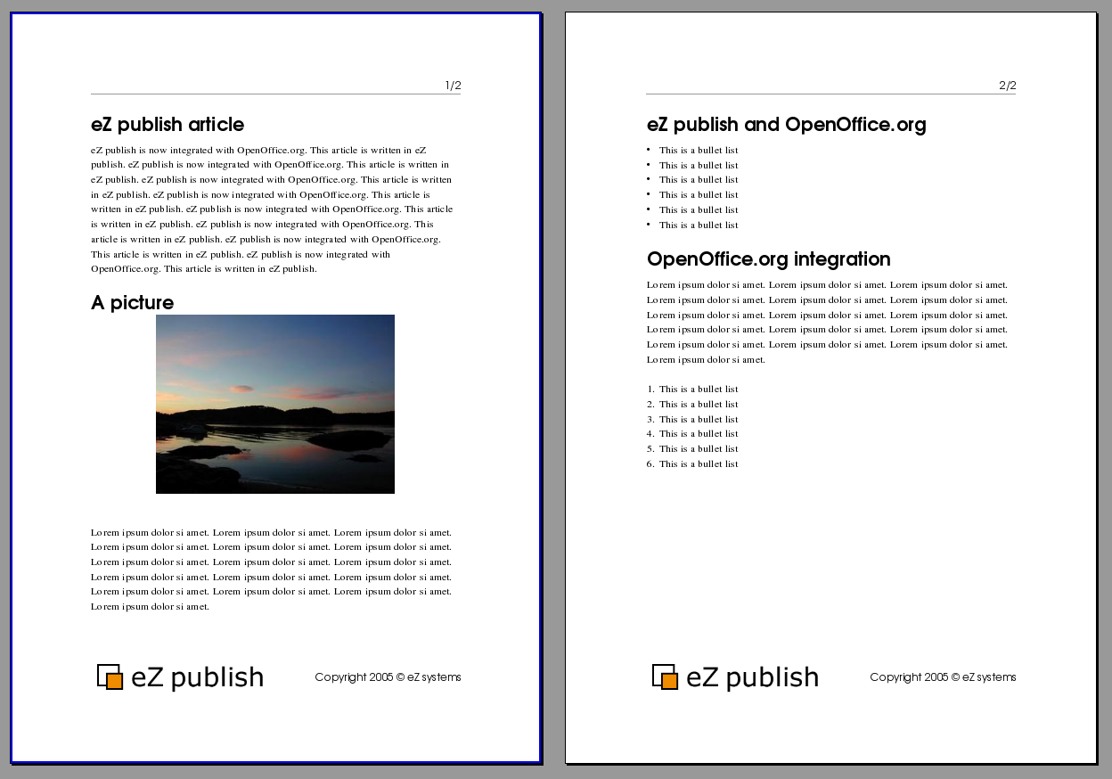

Export templates
OpenDocument Text (.odt) documents can be exported using either the default OpenOffice.org styles or using a custom OpenOffice.org Writer template file. This is configured in the ODFExport section of the odf.ini configuration file. Set UseTemplate to true to enable the use of export templates. The actual template used needs to be placed in the extension/ezodf/templates/ folder. The name of the template is specified in the TemplateName setting. Below is an example of this configuration.
[ODFExport]
UseTemplate=true
TemplateName=eztemplate.stw

