Introduction to the
“eZ Online Editor MCE”

Date: February 11 2008
Document status: draft
By: André Rømcke
Mail: ar@ez.no

All content (images and text) are to be treated as is, and might not represent the final version of the “new Online Editor” in its form or functionality!

Updates: 18. February 2008 updated text to reflect current progress.

Table of contents
1. Intro 3
What is TinyMCE 3
What is “eZ Online Editor MCE” 3
Why replace a XML editor with a (x)html editor? 3
Some known missing features: 3
2. For Users 4
Edit area 4
Tool bar 4
Content 5
Right click menu 5
XML tag path 5
Properties poup windows 6
3. For Developers 7
Buttons customizations 7
Tinymce Plugins 7
Theming / skinning 7
Styling Editor Content 7
Custom attributes 8
Cusom tag 8
Image filters 8
SVN 8
Forum 8
Extension page 8

1. Intro
This document tries to give a introduction to the new Online Editor in it's current form and the differences from the old editor.

What is TinyMCE
TinyMCE is a small, fast and highly customizable WYSIWYG editor. It supports Internet Explorer, Firefox, Opera and Safari out of the box and is used in a lot of CMS / blog / wiki / community engines on the net. It is LGPL licensed, and like eZ Publish, backed by a commercial company: Moxiecode Systems AB (Sweden)
More: http://tinymce.moxiecode.com/

What is “eZ Online Editor MCE”
“eZ Online Editor MCE” / “OE MCE” are code names for our up coming TinyMCE 3.0 based editor that are scheduled to replace the eZ Online Editor 4.x as the content editor in eZ Publish 4.1.
The name of the extension is currently eztinymce, but we may end up calling it Online Editor 5.0 or Online Editor MCE 1.0 when its final!

Why replace a XML editor with a (x)html editor?
OE has never really been a true “XML editor”, just as the new editor it uses built in html editing support in the browsers and has a custom php xml handler included in the extension to handle xml -> xhtml conversion and xhtml -> xml parsing and validation. The reason why the 'old' OE doesn't work in IE7 on Vista is that it uses a deprecated version of the html editing component in IE, and Microsoft removed this from Vista.

Some known missing features:
* Translations (make TinyMCE use eZ Publish translations and complete translations of new dialogs)
* 'Browse' functionality on links is missing
* Object relations are not updated correctly in the editor before you click 'save draft'
* Summary on tables are still missing, this is planned to go inn as default custom attribute and add support for this in ezwebin and ezflow.

2. For Users
Collection of changes and new features for users / editors using eZ Publish.

Edit area
Why not start with a full blown example of the difference between the new and the current editor:
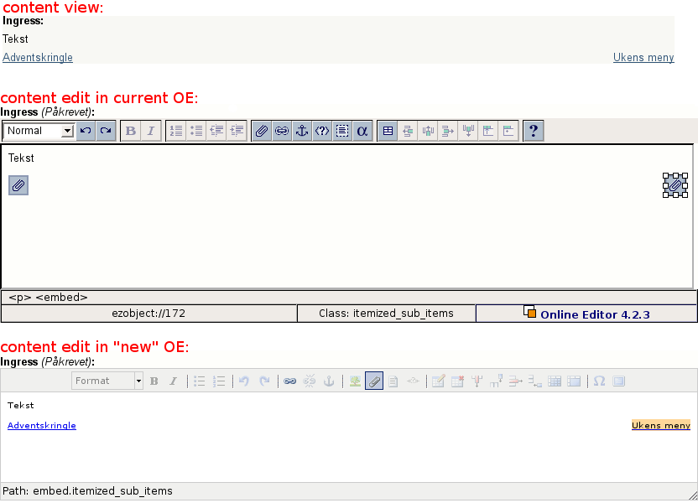

Tool bar
The tool bar has a couple of new buttons, one button for images is simply to make it more intuitive for new users, the difference between the image and the object (paper clip) button is the content that is presented, as in when you click the image button only images are shown as 'existing relations' and in the search result.
The two last buttons are 'character map' and 'full screen', so by clicking on the last button you'll be able to edit your content using the whole browser window.

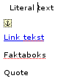
Content
As you can see from the comparison image earlier, the paper clip for relations (embed and embed-inline tags) are no more. All these screenshots are taken from the admin interface where there are no overrides for embed tags, and just like the content view, the content of the new editor will show a list of last 5 items inside the editor area while editing if the same content had been edited in a ezwebin frontend. This is however still “work in progress” since there are some styling and updating when embed tags are edited 'issues' left to solve.

Right click menu
This menu is not included in the new editor for several reasons: most users didn't realize they could right click unless being told anyway and it blocked access to the browsers spell checker! Access to properties are now by clicking tag related buttons or tag in path.

XML tag path
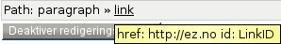
Path now shows the correct name of the xml tag selected (paragraph, literal, custom, link, anchor...) and instead of having a piece of the bottom toolbar show link and selected class, this is now showed as tooltip if you hold your mouse over the tag name. But more interestingly you can now click the tag in the path to open the 'properties' window where you change attributes and classes (the equivalent of the one you had to right click and click properties on before ).
On the right side of the path area there is also a significant new feature, dragging this side will let you resize the height of the edit area directly.

Properties poup windows
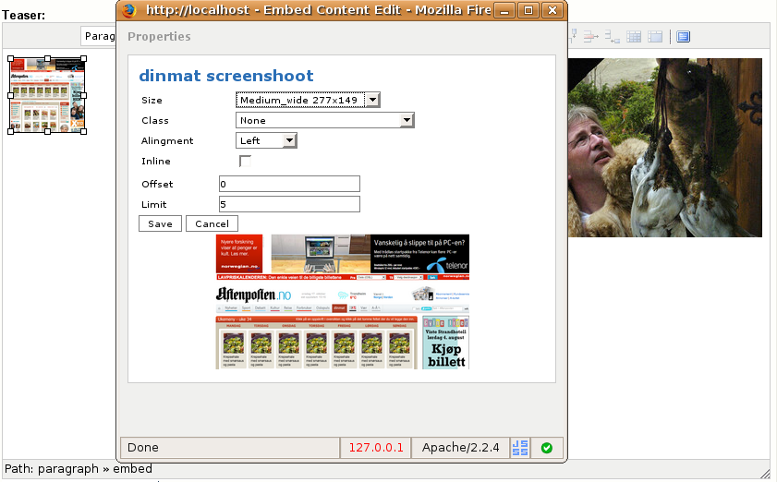
Embed (Image) properties: size in pixels on image size(only the one with width/height scaling or cropping) and previewing the size. On Object relations there is no preview and view mode is shown instead of size drop down.
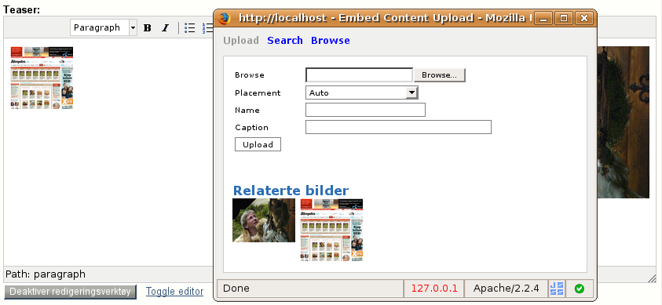
Embed (Image) upload: Directly search or browse for images (work in progress), directly type caption on image. Difference on object upload is that related files / objects are shown instead, all content is search able / browse able and you can type content for 'description' attribute instead of 'caption' attribute.
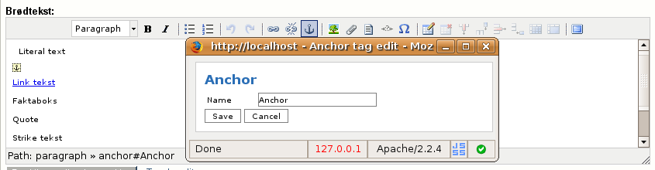
Anchor properties: This is how all general tags are displayed, if this tag had any custom attributes they would have been shown beneath 'Name' like 'Offset' and 'Limit' in the embed properties window.

Custom attributes: it's now possible to define drop down selections on custom attributes, more technical info in section 3.

3. For Developers

Buttons customizations
TinyMCE will let you specify the button layout very freely, this is customized a bit in eZ Online Editor MCE. We use one line of buttons, but it is floated, so it will break to several lines if there isn't enough width for all buttons. You can specify buttons in eztinymce.ini.

Tinymce Plugins
To define custom buttons with new functionality you'll need to create your own TinyMCE plugin. Currently you have to place it in design/standard/javascript/plugins/. But this can be solved later by preloading the plugins based on ini setting instead of letting TinyMCE load the plugins itself, so basically support loading plugins (also overriding existing ones) from custom extensions.
You can specify plugins in eztinymce.ini.

Theming / skinning
Two skins are included, 'default' as shown in the screenshots and a 'Office 2007' skin. These are included in the 'ez' theme since this is a fork of the 'advance' theme in TinyMCE. (It was needed to create a independent theme to be able to override the 'path' and some of the properties windows managed by the theme itself). For adding custom skins you currently have to place it in design/standard/javascript/themes/ez/skins/, these are loaded by the theme ('ez'), so we can make it support including skins from external extensions if needed.
You can specify skin in eztinymce.ini.

Styling Editor Content
TODO: plans are to support the custom css ini setting used in the old OE, so you can style the editor content. Tags used internally in the editor has changed a lot, it is now easier to style customs tags for instance with css.
Simplified custom tag example from OLD editor:
<table id=”custom” type=”factbox” custom_attribute=”title|Factboxattribute_seperatoralign|left”><tr><td>Factbox text</td></tr></table>
Complete custom tag example from new editor:
<span class=”factbox” style=”display:block” custom_attribute=”title|Factboxattribute_seperatoralign|left”>Factbox text</span>
If you want to know exactly what xhtml markup is generated to the editor, take a look in ezxmltext/handlers/input/eztinymcexmlinput.php from line ~772 onwards.

Custom attributes
Some new features are added in the editor.
new setting [<tag_name>]CustomAttributesNames is added in content.ini so you can set a better descriptive name on the custom attributes.
new setting [<tag_name>]concat('CustomAttribute', $custom_attribute_identifier|upfirst, 'Selections') is added in content.ini to define selections as opposed to just text fields.
Other custom attribute types might go in later, since they are currently open for funding, suggested are: int, float, checkbox, node_id and object_id. Where the last two would have a browse / search button to get the correct id, and a box next to it displaying the object name or the text 'invalid' if it doesn't exist.

Cusom tag
added [CustomTagSettings]CustomTagsDescription, it works the same way as [<tag_name>]ClassDescription on normal tags, letting you have more human readable text in the drop down.

Image filters
added GUIName setting to define human readable name for the image filters.
added HideFromRelations=enabled setting to let developers hide specific filters from OE drop down.

SVN
http://svn.ez.no/svn/extensions/eztinymce

Forum
http://ez.no/developer/forum/extensions/call_for_testers_new_online_editor

Extension page
http://ez.no/developer/contribs/applications/ez_oe_mce

