Introduction to the
“eZ Online Editor 5.0”

Date: February 11 2008
Document status: draft
By: André Rømcke
Mail: ar AT ez no

All content (images and text) are to be treated as is, and might not represent the final version of Online Editor 5.0 in its form or functionality!

Updates:
26. April 2010 updated ezoe links to point to projects.ez.no
18. February 2008 updated text to reflect current progress.
14. March 2008 updated text for version 0.98
02. May 2008 added information on skin variations
11. August 2008 updated screen shoots with version 5.0.0rc2
02. February 2009 Updated text for version 5.0.0rc12

Table of contents
1. Intro 3
What is TinyMCE 3
What is “eZ Online Editor MCE” 3
Why replace a XML editor with a (x)html editor? 3
Some known missing features: 3
2. For Users 4
Edit area 4
Tool bar 4
Content 5
Right click menu 5
XML tag path 5
Re enabling Paper Clip 5
Properties poup windows 6
3. For Developers 7
Buttons customizations 7
Tinymce plugins 7
Theming / Skinning / Skin variations 7
Styling editor content 7
Custom attributese 8
Cusom tag 8
Image filters 8
SVN 8
Forum 8
Extension page 8

1. Intro
This document tries to give a introduction to the new Online Editor (5.0) compared to the old editor (4.x).

What is TinyMCE
TinyMCE is a small, fast and highly customizable WYSIWYG editor written in Javascript. It supports Internet Explorer, Firefox, Opera, Safari and Google Chrome out of the box and is used in a lot of CMS / blog / wiki / community engines on the net. It is LGPL licensed, and like eZ Publish, backed by a commercial company: Moxiecode Systems AB (Sweden)
More info: http://tinymce.moxiecode.com/

What is “eZ Online Editor MCE”
“eZ Online Editor MCE” / “OE MCE” where code names for eZ Online Editor 5.0 that replaced eZ Online Editor 4.x as the default content editor in eZ Publish 4.1.
The name of the extension is ezoe, and the full name is eZ Online Editor 5.0!

Why replace a XML editor with a (x)html editor?
OE has never really been a “XML editor”, just like TinyMCE it uses built in html editing support in the browsers and like OE 5.0 has a custom php xml handler included in the extension to handle xml -> xhtml conversion and xhtml -> xml parsing and validation. The reason why the 'old' OE doesn't work in IE7 on Vista is that it uses a deprecated version of the html editing component in IE, and Microsoft removed this from Vista.

2. For end users
Collection of changes and new features for users / editors using eZ Publish.

Edit area
Why not start with a full blown example of the difference between the new and the current editor:
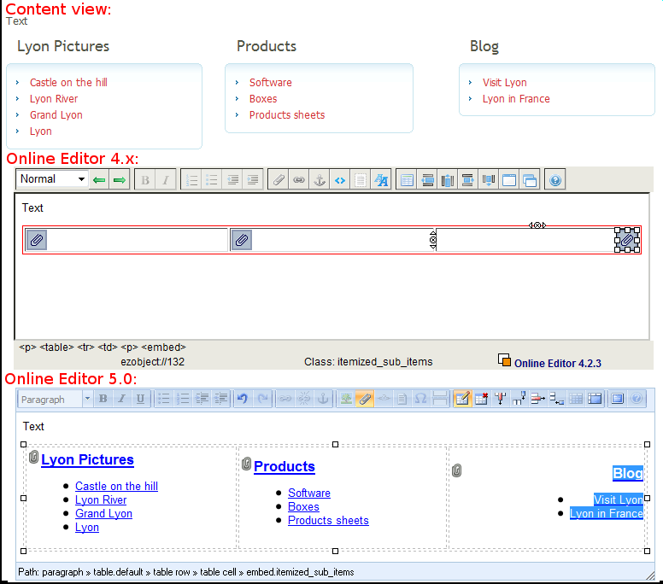
As you can see there are several changes to the new editor compared to the old one, and we'll walk over them one by one.
One thing to note though, as you can see the paper clip image is by default 'gone', it's still a small paper clip icon there as a style background, just to show that the element is an attachment. There are ups and downs to both the new and old approach, so therefor Online Editor 5.0 supports both the new approach with preview of the content and an improved variant of the old approach with a simple image to represent the attachment (paper clip image). Read more about this in 'Re enabling Paper Clip'.

Toolbar
The toolbar has a couple of new buttons, one button for images is simply to make it more intuitive for new users, the difference between the image and the object (paper clip) button is the content that is presented, as in when you click the image button only images are shown as 'existing relations' and in the search result.
The two last buttons are 'full screen' and help, so by clicking on the full screen button you'll be able to edit your content using the whole browser window.
It's possible to activate and deactivate buttons simply by changing settings, more on that in the developer section.

Right click menu
This menu is not included in the new editor for several reasons: most users didn't realize they could right click unless being told so and it blocked access to the browsers spell checker! Access to properties are now by clicking tag related buttons(if they glow) or tag in path(as seen in the picture below).

XML tag path
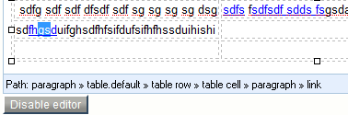
Path now shows a simplified name of the xml tag selected (paragraph, literal, custom, link, anchor...) and instead of having a piece of the bottom toolbar show link and selected class, this is now showed as tooltip if you hold your mouse over the tag name. But more interestingly you can now click the tag in the path to open the 'properties' window where you change attributes and classes (the equivalent of the one you had to right click and click properties on before ).
On the right side of the path area there is also a significant new feature, dragging this side will let you resize the height of the edit area directly.

Re enabling Paper Clip
If you for some reason need to re enable the old behavior on some classe, you can do that by specifying the class as image even though the class doesn't have a image attribute.
One example would be the flash_player class included in ezflow, that causes problems in the editor because it contains inline javascript in the view template:
settings/override/site.ini.append.php:
[MediaClassSettings]
ImageClassIdentifiers[]=flash_player

If you instead want to make this change globally, meaning you want to use paper clips on everything that is not an image. Then you can enable this setting in ezoe.ini:
[EditorSettings]
CompatibilityMode=enabled

Properties popup windows
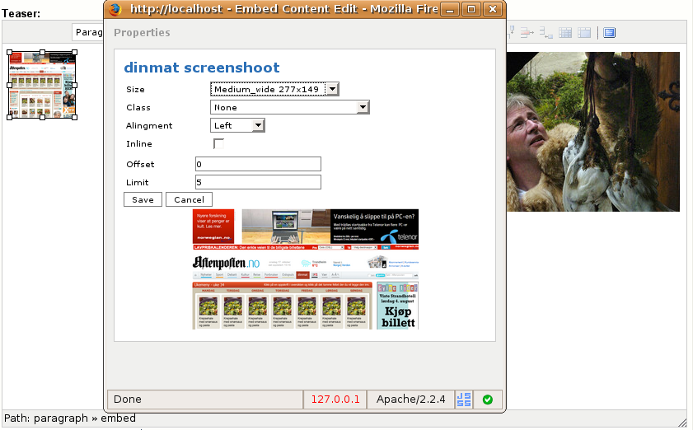
Embed (Image) properties: size in pixels on image size(only the one with width/height scaling or cropping) and previewing the size. On Object relations view mode is shown instead of size drop down.
(Here the editor is shown with a different skin!)
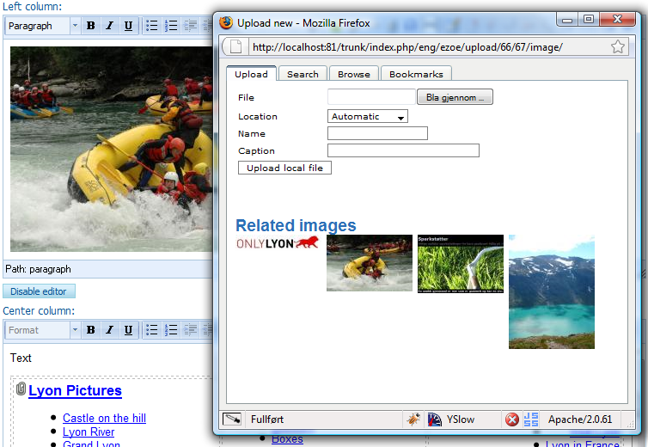
Embed (Image) upload: Directly search or browse for images, type caption on image when you upload. Difference on object upload is that related files / objects are shown instead, all content is search able / browse able and you can type content for 'description' attribute instead of 'caption' attribute.

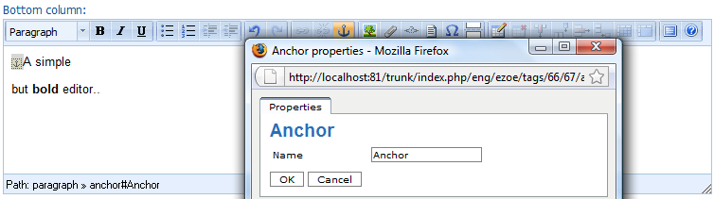
Anchor properties: This is how all general tags are displayed, if this tag had any custom attributes they would have been shown beneath 'Name' like 'Offset' and 'Limit' in the embed properties window.

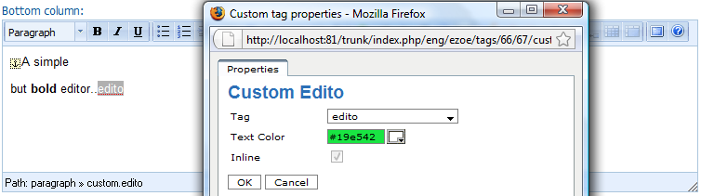
Custom attributes: (see 'Text Color' in screen shoot) it's now possible to define custom attributes as several different types like drop down, int, color picker, check box.... on custom attributes, more technical info in section 3.

3. For Developers

Buttons customizations
TinyMCE will let you specify the button layout very freely, this is customized a bit in OE 5.0. We use one line of buttons, but it is floated, so it will break to several lines if there isn't enough width for all buttons. The buttons will also be grouped based on where you place the button split (|) in browsers that supports it (FF 2, Opera 9.5, Safari 3 and IE 8 and higher). You can specify buttons in ezoe.ini settings.

Tinymce plugins
To define custom buttons with new functionality you'll need to create your own TinyMCE plugin.
Plugins needs to be placed in the following path: <your_design>/javascript/plugins/<your_plugin>/editor_plugin.js
Take a look at the TinyMCE web page for more info, or at the included extensions.
You enable plugins in ezoe.ini.

Theming / Skinning / Skin variations
Two skins are included, 'default', the grey skin as shown in some of the screenshots and a 'Office 2007' skin as used out of the box. These are included in the 'ez' theme, a fork of the 'advance' theme in TinyMCE. (It was needed to create a independent theme to be able to override the 'path' and some of the properties windows managed by the theme itself). For adding custom skins you have to place it in <your_design>/stylesheets/skins/<skin_name>/ui.css
You also have to add two other files in that folder to make it complete: content.css and dialog.css.
Alternatively you can use skin variations if you only want to change the skin on the editor (not content and dialogs as well). Included skin variations in the Office 2007 skin is 'silver' and 'black' .
If you want to create your own skin variation, place your css in:
<your_design>/stylesheets/skins/<skin_name>/ui_<skin_variation>.css

You can change skin and skin variation in ezoe.ini.

Styling editor content
If you only want to customize the styling of the content, you can use the EditorCSSFileList setting in design.ini, here you can append your own css to be used for the editor content just like you could in the old editor. Take a look in the design.ini file in this extension for more info.
Simplified custom tag example from OLD editor:
<table id=”custom” type=”factbox” custom_attribute=”title|Factboxattribute_seperatoralign|left”><tr><td>Factbox text</td></tr></table>
Complete custom tag example from new editor:
<div class=”factbox” type=”custom” custom_attribute=”title|Factboxattribute_seperatoralign|left”><p>Factbox text</p></div>
If you want to know exactly what xhtml markup is generated to the editor, take a look in ezxmltext/handlers/input/ezoexmlinput.php from line ~772 onwards.
Or you can enable the code button in ezoe.ini to be able to see the html content at any time.
On both places you will also see that custom inline tags have a SPAN tag internally and not DIV like custom block tags.

Custom attributes
Some new features are added in the editor, you can set label name, type (string, int, float, color, htmlsize....) and so on.
But this is better explained in the settings/ezoe_customattributes.ini with examples.

Custom tag
added [CustomTagSettings]CustomTagsDescription, it works the same way as [<tag_name>]ClassDescription on normal tags, letting you have more human readable text in the drop down.

Image filters
added GUIName setting to define human readable name for the image filters.
added HideFromRelations=enabled setting to let developers hide specific filters from OE drop down.

SVN
http://svn.projects.ez.no/ezoe/

Forum
http://ez.no/developer/forum/extensions/call_for_testers_new_online_editor

Extension page
http://projects.ez.no/ezoe/

