Documentation: eZ Publish Style Editor
This document contains a documentation for eZ Publish Style Editor solution. It covers requirements, installation, configuration as functional part of the solution.

About
The eZ Publish Style Editor is JavaScript based application written on top of Yahoo! User Interface Library (YUI in short) as well as using power of ezjscore, the eZ Publish Ajax framework. It provides set of features which allows visual styles editing for eZ Publish based solutions such as Website Interface and eZ Flow, but not only that. It can be plugged to almost every existing eZ Publish installation and configured for custom styles and various DOM structures. It allows to change overall look&feel of eZ Publish based websites in visual edit mode.

Requirements
This section covers requirements for the eZ Publish Style Editor solution. This is recommended set of requirements in order to make eZ Publish Style Editor work properly.
- eZ Publish 4.2.x or higher
  - ezjscore 1.0.1 or higher extension must be enabled
- PHP 5.2.x or higher
  - JSON extension must be enabled
  - DOM extension must be enabled
- RDBMS
  - MySQL 5.x or higher
  - PostgreSQL 8.x or higher
  - Oracle (TODO: figure out version)
- Web browser
  - Internet Explorer 6 or higher
  - Mozilla Firefox 3.0.x or higher
  - Safari 4.0.x or higher
  - Opera 10.x or higher

Installation
This section covers eZ Publish Style Editor installation instructions. In order to install eZ Publish Style Editor make following steps:
- Extract ezstyleeditor-1.0.0.tgz archive in the eZ Publish extension folder
- Enable ezcsseditor extension in the administration interface Setup->Extensions or manually in the settings/override/site.ini.append.php
[ExtensionSettings]
[...]
ActiveExtensions[]=ezstyleeditor
ActiveExtensions[]=ezwebin
[...]
- Update PHP autoload array by executing following script from eZ Publish root folder:
php bin/php/ezpgenerateautoloads.php -e -p
- Import SQL script with schema relevant for your database. Currently supported are MySQL, PostgreSQL and Oracle. Following MySQL example presents how to import DB schema:
$ mysql --host=<mysql_host> --port=<port> -u <mysql_user> -p<mysql_password> < extension/ezstyleeditor/sql/mysql/mysql.sql
- Place following code in the <head> section of your website:
{if is_set( $display_styleeditor_visualtoolbar )}
{include uri="design:styleeditor/visual.tpl"}
{/if}
- Configure a image repository INI setting in extension/ezstyleeditor/settings/ezstyleeditor.ini.[StyleEditor].ImageRepository
- Clear the cache by executing following command from eZ Publish root folder:
php bin/php/ezcache.php --clear-all --purge

Configuration
By default eZ Publish Style Editor is configured for the Website Interface and eZ Flow solutions. However you can provide your own configuration for DOM structure. In order to change configuration edit following file: extension/ezstyleeditor/design/standard/templates/styleeditor/visual.tpl

Configuration is provided in the JSON format and stored in the eZ Publish Style Editor variable YAHOO.ez.StyleEditor.elements. It is an array of objects which format is following:

{
selector: "",
group: "",
groupname: "",
alias: "",
element: {
name: "body",
id: "",
classname: ""
},
overlay: true
}

Property | Description
selector | This is a CSS selector
alias | It is a human readable alias for editable DOM element.
group | Group identifier. When defined a new group will be created. Use with groupname to add a human-readable name.
groupname | Defines a human-readable group name available to end-user in the Elements menu.
element | A editable DOM element:
  Property | Description
  name | DOM element name
  id | DOM element id
  classname | DOM element CSS class name
overlay | When set to true style editor will draw a red line around editable DOM element.

Following example defines a group configuration for a custom tag called “Quote”.
{
group: "customtags",
groupname: "Custom tags",
alias: "Quote",
elements: [
{
selector: "div.quote",
alias: "open-quote",
element: {
name: "",
id: "",
classname: ""
},
overlay: false
},
{
selector: "div.quote-design",
alias: "close-quote",
element: {
name: "",
id: "",
classname: ""
},
overlay: false
}
],
overlay: false
}

Styling
The eZ Publish Style Editor provide a visual interface for styling your website. The visual editing interface is available from the Website Toolbar:
When visual editing interface is loaded for the first time a new site style is created. You can start editing using a default site style or create a new one.

Creating new site style
In order to create a new site style choose from eZ Publish Style Editor menu item with label “Styles”.
A new dialog box will be open where a new custom site style can be add. Name for the new site style is required thus it should be provided in the text input field.
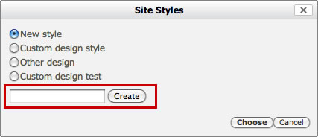
In order to choose a new working site style select on from the list and confirm by pressing “Choose” button.

Editing CSS properties
Adding styles to the available elements on page can be done using two methods. Outlined elements on page give direct access to the Properties window. Simple click on the area marked with red lines around the outlined element. Properties window will prove access to the all properties defined for current element.
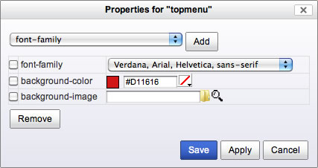
In order to add new CSS property to the currently edited element, choose from dropdown list a property and press “Add” button.
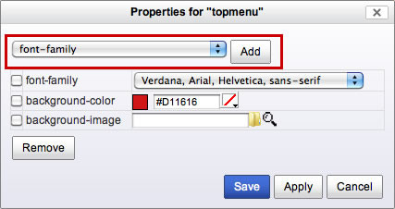
Properties window contains button such as “Save” which stores all your changes in the database and a “Apply” button which simply apply all styles without saving it (like a preview).

Grouped elements
It is possible to enable editor to style more advanced design elements which usually require complete set of CSS rules. This kind of elements can be grouped together.
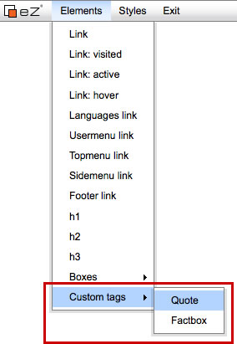
The CSS rules for grouped elements are organized in simple tree. In order to access CSS properties for a group element simply click on the name on left hand side.
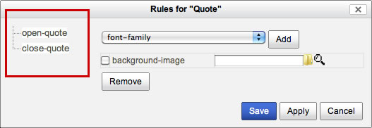

Exiting visual editor
Once your work on new site style is finished you can exit CSS visual editor by pressing “Exit” button located in the top menu bar.

