EZ XML Export Extension

User manual

Création : 12/10/09
Modification : 12/10/09
Version : 1.0

Table des matières
1 What does eZXMLExport do ? 3
2 eZXMLExport concepts 4
2.1.1 Customer 4
2.1.2 Export 4
2.1.3 Slicing mode 4
2.1.4 FTP target 4
2.1.5 Compression 4
2.1.6 XSLT transformation 4
2.1.7 Related object handling 4
3 Content class definition configuration 5
3.1.1 Knowing if a class is exportable or not 5
3.1.2 Making a class available for XML export 6
3.1.3 List of available datatypes 7
4 Exporting content class definition as XML Schema 15
Creating a new export 16
4.1.1 Adding a new customer 16
4.1.2 Defining a new export 17
5 Launching the export 19

What does eZXMLExport do ?
EZXMLExport is an extension which exports content class definitions in XML Schema and exports content objects relative to this XML schema specification. Since It is possible to transform any exported file with XSLT it is possible to translate a document from one XML paradigm to another.

eZXMLExport concepts
EZXMLExport introduces a few concepts that are worth knowing:

Customer
eZXMLExport has been designed with enterprise concepts in mind. Basically you sell your content to another company as XML so it is easier for both parties to export and import new content easily. This is why we created the concept of “customer”. A customer in ezXMLExport is only a representation of what a customer could be in real life, with a name and a few words for description and a remote target accessible over FTP so you can upload exported contents automatically.

Export

An export is the entity which contains the definition of the content you want to export as XML.
An “export” is related to a customer. A customer can have an unlimited number of different exports.
Defining an export without creating a customer first is not possible.

Slicing mode
An export can be exported in two different modes :
- « N mode » : the export generates multiple files for export, usually it is one file per exported content object. Once the export has been done the XSLT transformation is applied on each file.
- « 1 mode » : the export generates one file which will contain all the exported content objects. Once those object are exported the XSLT transformation will be applied on this single file only.

FTP target
It is possible to define an FTP target for both a customer and an export. This target is composed of a standard connection string. EZXMLExport is able to choose the correct FTP informations based upon what has been configured. If there is an FTP connection string for an export, this one will be used, otherwise the one defined for the customer will be used. If you do not need to upload anything over FTP, then you can leave the according form fields empty or set [FTPSettings]/FTPShipment=disabled in the ezxmlexport.ini file of your eZ Publish installation.

Compression
It is possible to compress the whole export when the « 1 mode » or « N mode » is used. The only compression format available for now is .tar.gz which is a standard compression format.

XSLT transformation
Once content objects have been exported, it is possible to transform the generated XML Schema compatible file into any other XML file by using a dedicated XSLT file.

Related object handling
Two modes can be chosen to handle related objects :
- Level 1 : related objects are only referenced by their nodeID in the export file
- Level 2 : related objects are exported as well but only if the content class they belong to is defined as exportable.

Content class definition configuration
Configuring a content class to be exportable is a two steps procedure :

Knowing if a class is exportable or not
Go to the « Setup » tab in your Administration Interface, and select « Classes » in the left menu. Here choose any content class you want and go to its definition.
For example, for the « folder » content class you should get the following screen :
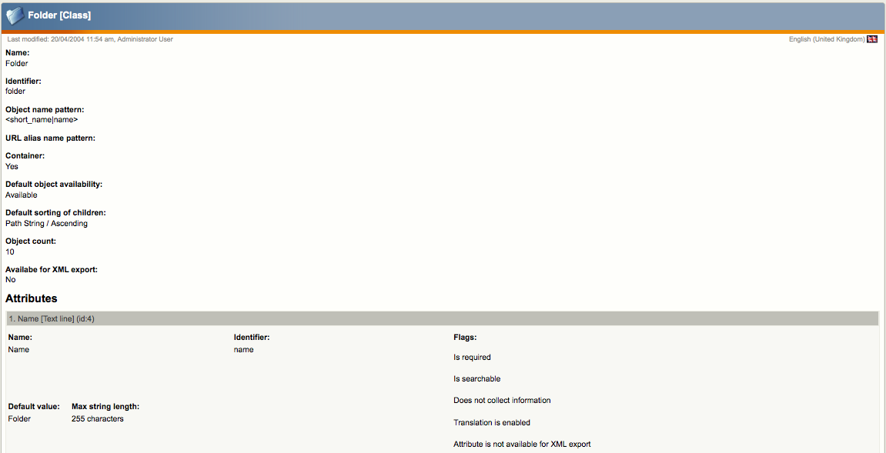
Below the « Object count » line you should see the following title « Available for XML export » if the value of this attribute is « No » then you will not be able to export any content of this content class. For each attribute you can also choose wether it is exportable or not. In the above screenshot we see that the « Name » attribute is not available for the export : « Attribute is not available for XML export »
If a content class is not defined as available for XML export then none of its attribute will be available for XML export as well.

Making a class available for XML export
Because not all content classes (or even all their attributes) need to be exportable, users themselves can decide which classes they want to be able to export. The only thing users have to do is to edit the content class by clicking on the « Edit » button available at the bottom of the content class definition. You should get something like this :
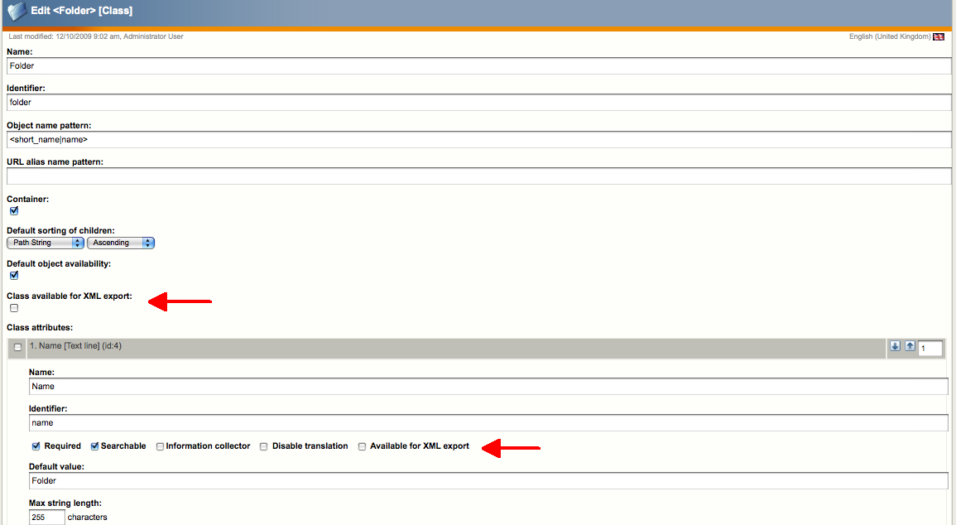
Click on the « Class available for XML export « checkbox first, and then for each attribute you want to export click on the « Available for XML export » checkbox. Once you have defined the content class and all the attributes you want to export, just click on the « OK » or « Apply » button to save your changes.

List of available datatypes
You will find below the list of eZ Publish datatypes that are currently available for XML rendering in eZXMLExport. Below this table you will find the XML Schema definition of each datatype.
Datatype name | EZ Publish internal name | Handled in ezxmleport ?
Authors | ezauthor | Yes
Checkbox | ezcheckbox | Yes
Country | ezcountry | Yes
Date | ezdate | Yes
Date and time | ezdatetime | Yes
E-mail | ezemail | Yes
Enum | ezenum | Yes
File | ezfile | Yes
Float | ezfloat | Yes
Identifier | ezidentifier | Yes
Image | ezimage | Yes
Ini | ezinisetting | No
Integer | ezinteger | Yes
ISBN | ezisbn | Yes
Keywords | ezkeywords | Yes
Matrix | ezmatrix | Yes
Media | ezmedia | Yes
Multi-option | ezmultioption | No
Multi-option2 | ezmultioption2 | No
Multi-price | ezmultiprice | No
Object relation | ezobjetrelation | Yes
Object relations | ezobjectrelationlist | Yes
Option | ezoption | No
Package | ezpackage | No
Price | ezprice | No
Product | ezproduct | No
Range | ezrange | No
Selection | ezselection | No
Subtree | ezsubtree | No
Text Block | eztext | Yes
Text Line | ezstring | Yes
Time | eztime | Yes
URL | ezurl | Yes
User Account | ezuser | No
XML Block | ezxmltext | Yes

eZAuthor
<xs:complexType name="ezauthor">
<xs:sequence>
<xs:element name="id" type="xs:integer"/>
<xs:element name="name" type="xs:string"/>
<xs:element name="email" type="xs:string"/>
</xs:sequence>
</xs:complexType>

eZCheckbox
<xs:complexType name="ezcheckbox">
<xs:simpleContent>
<xs:extension base="xs:boolean"/>
</xs:simpleContent>
</xs:complexType>

eZ Country
<xs:complexType name="ezcountry">
<xs:simpleContent>
<xs:extension base="xs:string"/>
</xs:simpleContent>
</xs:complexType>

eZDate
<xs:complexType name="ezdate">
<xs:simpleContent>
<xs:extension base="xs:time"/>
</xs:simpleContent>
</xs:complexType>

eZDateTime
<xs:complexType name="ezdatetime">
<xs:simpleContent>
<xs:extension base="xs:time"/>
</xs:simpleContent>
</xs:complexType>

eZEmail
<xs:complexType name="ezemail">
<xs:simpleContent>
<xs:extension base="xs:string"/>
</xs:simpleContent>
</xs:complexType>

eZEnum
<xs:complexType name="ezenum">
<xs:sequence>
<xs:element name="key" type="xs:string"/>
<xs:element name="value" type="xs:string"/>
</xs:sequence>
</xs:complexType>

eZFile
<xs:complexType name="ezfile">
<xs:simpleContent>
<xs:extension base="xs:string"/>
</xs:simpleContent>
</xs:complexType>

eZFloat
<xs:complexType name="ezfloat">
<xs:simpleContent>
<xs:extension base="xs:float"/>
</xs:simpleContent>
</xs:complexType>

eZIdentifier
<xs:complexType name="ezidentifier">
<xs:simpleContent>
<xs:extension base="xs:string"/>
</xs:simpleContent>
</xs:complexType>

eZImage
<xs:complexType name="ezimage">
<xs:simpleContent>
<xs:extension base="xs:string"/>
</xs:simpleContent>
</xs:complexType>

eZISBN
<xs:complexType name="ezisbn">
<xs:simpleContent>
<xs:extension base="xs:string"/>
</xs:simpleContent>
</xs:complexType>

eZKeywords
<xs:complexType name="ezkeyword">
<xs:simpleContent>
<xs:extension base="xs:string"/>
</xs:simpleContent>
</xs:complexType>

eZMatrix
<xs:complexType name="ezmatrix">
<xs:sequence>
<xs:element name="key" type="xs:string"/>
<xs:element name="value" type="xs:string"/>
</xs:sequence>
</xs:complexType>

eZMedia
<xs:complexType name="ezmedia">
<xs:simpleContent>
<xs:extension base="xs:string"/>
</xs:simpleContent>
</xs:complexType>

eZObjectRelation
<xs:complexType name="ezobjectrelation">
<xs:sequence>
<xs:element name="object_id" type="xs:integer" minOccurs="0" maxOccurs="unbounded"/>
</xs:sequence>
</xs:complexType>

eZObjectRelationList
<xs:complexType name="ezobjectrelationlist">
<xs:sequence>
<xs:element name="object_id" type="xs:integer" minOccurs="0" maxOccurs="unbounded"/>
</xs:sequence>
</xs:complexType>

eZSelection
<xs:complexType name="ezselection">
<xs:sequence>
<xs:element name="key" type="xs:string"/>
<xs:element name="value" type="xs:string"/>
</xs:sequence>
</xs:complexType>

eZText
<xs:complexType name="eztext">
<xs:simpleContent>
<xs:extension base="xs:string"/>
</xs:simpleContent>
</xs:complexType>

eZString
<xs:complexType name="ezstring">
<xs:simpleContent>
<xs:extension base="xs:string"/>
</xs:simpleContent>
</xs:complexType>

eZTime
<xs:complexType name="eztime">
<xs:simpleContent>
<xs:extension base="xs:time"/>
</xs:simpleContent>
</xs:complexType>

eZURL
<xs:complexType name="ezurl">
<xs:simpleContent>
<xs:extension base="xs:string"/>
</xs:simpleContent>
</xs:complexType>

eZXMLText
<xs:complexType name="ezxmltext">
<xs:simpleContent>
<xs:extension base="xs:string"/>
</xs:simpleContent>
</xs:complexType>

Restrictions on a few datatypes like ISBN, URL or email are defined globally in the XML Schema because it is not possible to define restrictions directly in complex types. The export also adds a few meta data for each exported content object :
- creation date
- modification date
- language code in ISO format
- published version number
- creator identifier

<xs:attributeGroup name="objectinfo">
<xs:attribute name="creation_date" type="xs:dateTime" use="required"/>
<xs:attribute name="modification_date" type="xs:dateTime" use="required"/>
<xs:attribute name="publication_date" type="xs:dateTime" use="required"/>
<xs:attribute name="lang" type="xs:string" use="optional"/>
<xs:attribute name="version" type="xs:integer" use="required"/>
<xs:attribute name="creator_id" type="xs:integer" use="required"/>
</xs:attributeGroup>

Exporting content class definition as XML Schema
Once you have chosen which content classes (and attributes) you would like to export, you can export all their definitions in a single XML Schema file.
In the Administration Interface go to « Setup » → « Classes » and you should get the following screen :
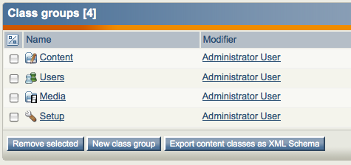
By clicking on the « Export content classes as XML Schema » button all the classes of content defined as exportable will be exported. Save the result on your disk.
If you cancelled the download, a copy of this schema is save at the following location :

/path/to/your/ezpublish/directory/extension/ezxmlexport/xsd/contentclassdefinition.xsd
If you want to validate the XML Schema definition, you can do so by using Exchanger XML Editor available at the following website :
- http://www.freexmleditor.com/fxeeditor/downloads.html?x=78&y=14

Creating a new export
In order to create new export you have to create a new customer first and then add a new export for this customer. Go to « Setup » → « XML export »
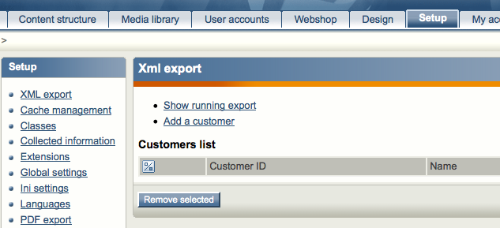

Adding a new customer
In order to add a new customer you have to click on the « Add a customer » button, and you should get the following screen
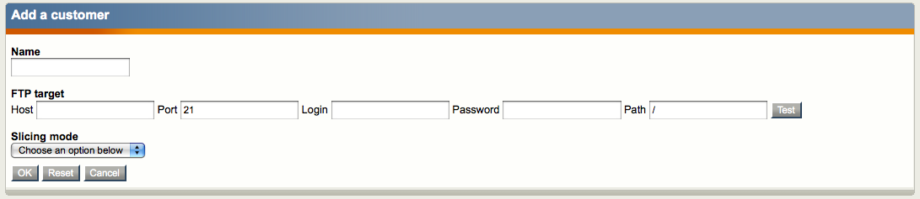
The name and the slicing mode are mandatory. The FTP informations are optional.

Defining a new export
Once you created a new customer you should get the following screen
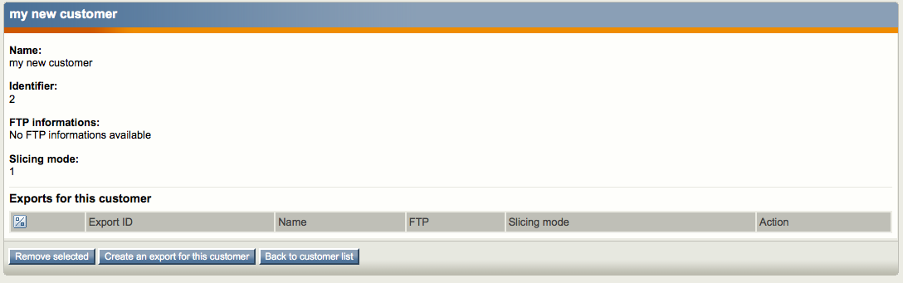
In order to create a new export for this customer, click, on the « Create an export for this customer » button so you get the following screen
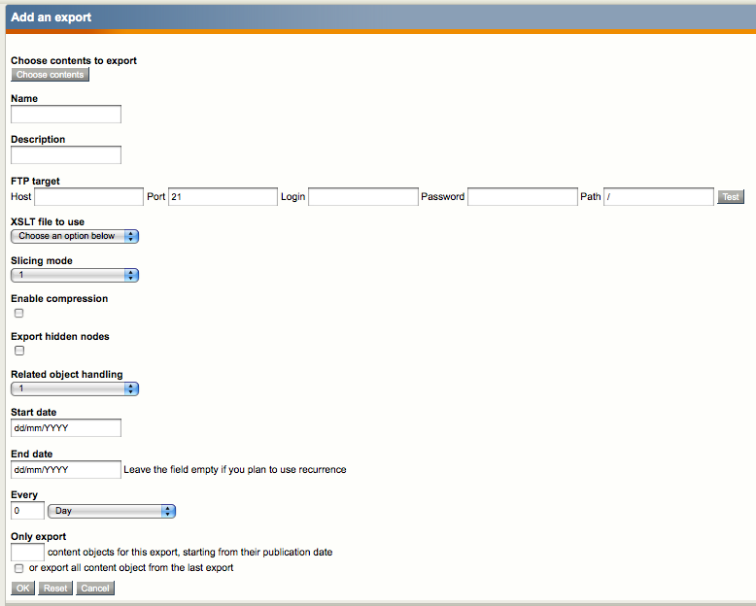
Fill in the fields as you want to validate by clicking on the « OK » button.

Content export

XSLT stylesheet management
Adding XSLT stylesheets is trivial the only thing you have to do is to upload a new XSLT file in the design/standard/xsl/ folder of the extension. There is already an empty “test.xsl” file available. Removing the XML source after the XSLT transformation must be defined explicitly in the XSLT stylesheet. The processed XML file will not be deleted otherwise.

Launching the export
Launching the export is quite easy, the only thing you have to do it to launch the following cronjob :

php runcronjobs.php -s your_siteaccess ezxmlexport
Since the export has been designed to export more than 200 000 content objects and depending on how much objects you have to export the time to run the full export can be important. This is why we recommend you run this cronjob once a night because it generates a lot of heavy operations on the database.

Export process schema

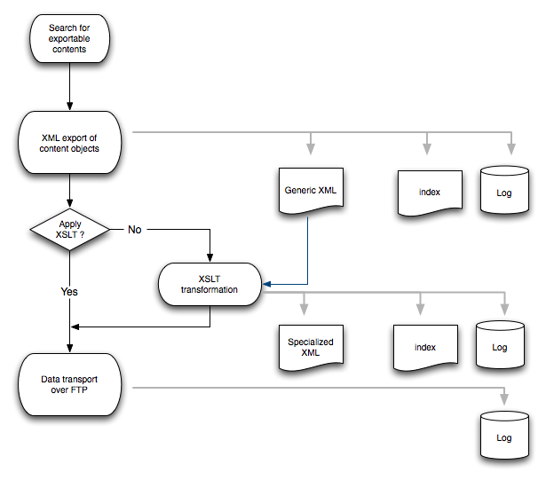

Operation logger
The extension is bundled with an XML logging system. The XML file stores the list of exported objects as well as a few meta data. Here is an example below :
<?xml version="1.0" encoding="UTF-8"?>
<export>
<generalinformations>
<startdate>timestamp</startdate>
<enddate>timestamp</enddate>
<appliedXSLTtransformation>XSLT command</appliedXSLTTransformation>
<ftpinformations>ftp://user@host/path</ftpinformations>
</generalinformations>
<exportedobjects>
<object id="objectID"
startexporttime="timestamp"
endexporttime="timestamp"
generatedxmlfile="path/to/xmlfile">
</object>
...
</exportedobjects>
</export>

